

University of Wales Trinity Saint David – Birmingham INCL
Module: Data Handling and Business Intelligence (LCBB5014)
Name: Marinela Valentina Pana Donichian
Student ID: 2238837
Date: 21st November 2025

Table of contents
1.Introduction .............................................................................3
2.Data understanding. Cleaning and Preparation .....................3-4
3.Descriptive Statistics .............................................................4-6
4.Trend Analysis ........................................................................ 7-9
5.Statistical Analysis ................................................................. 9-11
6.Insights and Recommendations ................................................ 12

Reference list .......................................................................................12

- Introduction

The purpose of this assignment is to help me understand, practice, and eventually build a set of practical skills in data analysis. I will do this by interpreting using Excel and SPSS, using a real-world example of a dataset. The data set is about the classification of movies, including the genre, directors, ratings, runtimes, fans, likes and more. By analysing and exploring this data, I will be able to identify trends and viewer behaviour patterns and investigate the factors contributing to high ratings. I will also use data manipulation, visualization, and statistical methods to get insights. Based on the insights I will explain how data driven decisions can improve business performance and efficiency. Now the objectives of the analysis will be achieved in multiple steps in this document. Firstly, I will conduct some data cleaning and preparation on Excel, this includes handling data, checking for inconsistencies, and documenting changes. The following step will be the descriptive statistics and summary; this is about statistics using both software. The next objective is the trend analysis and visualization, exploring and visualising the trends. The last objective is the Statistical Analysis using only SPSS, I will be conducting different tests and present the outputs and results.

- Data Cleaning and Preparation
The first data handling error I have noticed was the cases of the attributes at the top and I have decided to edit the error so it has a more standardized look and so later it can be detected by Excel and SPSS, avoiding errors later. This is how it looked before the change: “Film_title” and this is the corrected version “Film_Title.” I have done this for all applicable fields. There were also some attributes that had missing fonts and changed those too, so the table will be nicer and be easier to read. Afterwards I’ve deleted the first row containing numbers because it’s not needed as the cell number is shown in excel and can be found this way and by the film title Using the find and select tool, I have checked for any missing data in cells but did not find any cells that had missing data. The next thing I did was to round the average rating to 2 decimal points so I can standardize the column and make it more appealing. I have included some pictures below: Image 1 and 2. The highlighted cells are the ones that had been changed with 2 different examples. For the Runtime column, I have rounded the cells value that contained inconsistencies to the nearest whole number. The next action that I took was to set the genres and studios columns to one each. Because there were multiple fields that had many genres and studios listed. I consider that the first should be the main genre on of the film and main production studio. I have done this using the trim formula. This ensured that the data is accurate and does not include the same genres or studio twice due to brackets and quotation mark which I noticed some did. Shown in image 3. (Goyle, Xie & Goyle, 2023) (Frazer, 2024)

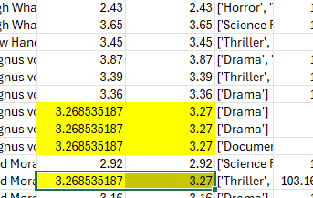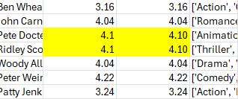
Image 1 Image 2
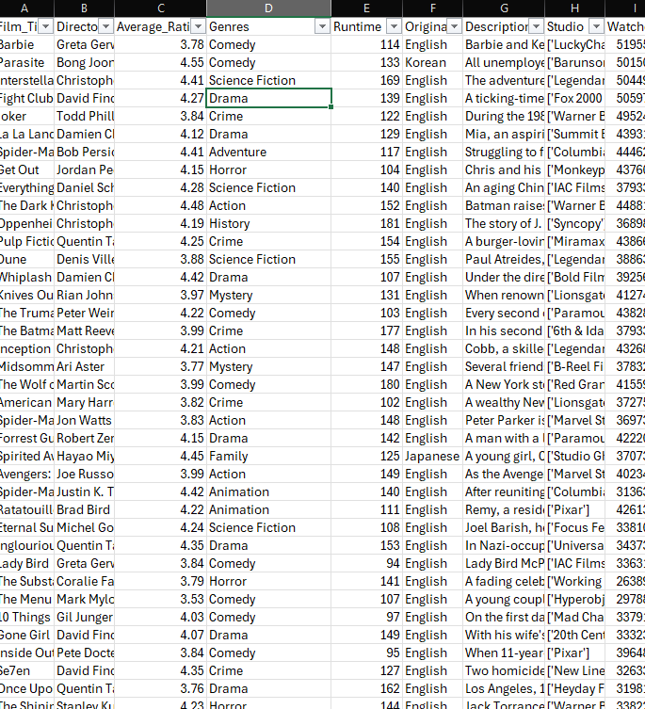
Image 3

- Descriptive Statistics and Summary
The first step to get the descrptive statistics was to decide which ones to choose from. And I choose the following columns: average rating, watches, fans and runtime. I have taken screenshots and saved those in my excel file. In order to get the statistcs I used the data analysis tool under the data tab. The first one that im going to explain is average rating. The average(mean) in the average rating is 3.27. Our largest rating out of any movie is 4.71 and the smallest is 1.08. Our most encountered number (mode) is 3.27. This is shown in image 4. The next one is the watches column. The mean for this is 170315. The number that appears the most is 226 and the median 4585, so far I can tell that most movies don’t go over 1 million watches. So a big part is less popular movies. The movie with the smallest number of views only has 2, while the most viewed has 5195503 watches. This is shown in image 5 . The next column is the fans shown in image 6. The average number of fans across all 10000 movies is 1653. The median number is 24 which in my opinion is surprsing. This is because half of the films have little to no fans. Moving on the number that appears the most is 0, not surprising. Obviously this is also the smallest number in the set, while on the other hand the highest number of fans is 32600, I was expecting a larger number of fans, when I first checked the spreadsheet. The next one is Runtime which has a mean average of 103 minutes and 17 seconds. The middle value is 99 minutes. While the numbers that appears the most is 90 minutes, which was expected. The movie with the least run time only has 2 minutes and the longest has 907 minutes in runtime. An intersting figure is that for all 10000 films the acumulated total run time of 1031694 minutes. This is shown in image 7. The numbers were rounded to the nearest whole number or decimal place accordingly but in the table kept as it is to ensure accuracy.I have created a frequency chart for the languages. The most popular language was english with a staggering 80% with 8074 movies, the following language is italian with only 396 movies which is a big difference compared to english. Then Japanese is third and French the 4th. The total number of languages is 60. This is shown in the images 8-9 divided in 2 parts. (Ganti & Das Sarma, 2013), (Amrhein, Trafimow & Greenland, 2019), (Ho & Yu, 2015)

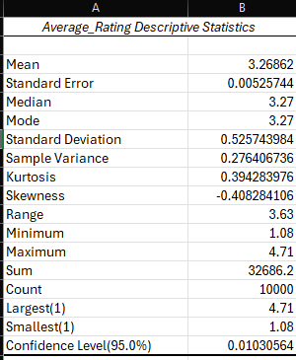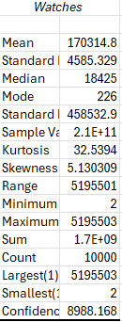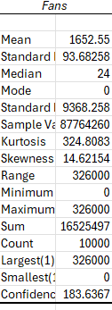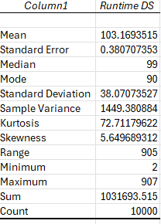
Image 4 Image 5 Image 6 Image 7

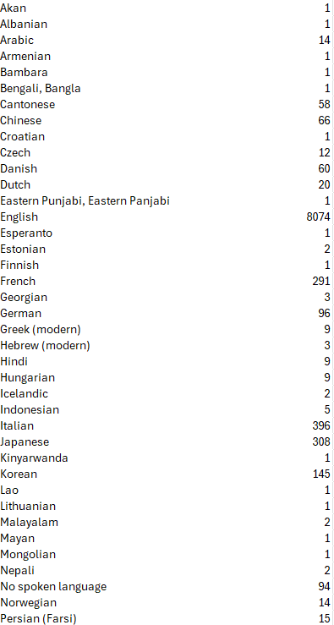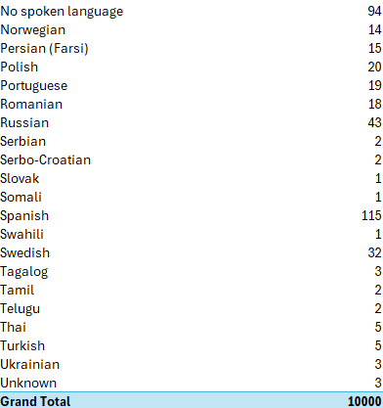
Image 8- part 1 Image 9 – part 2

- Trend Analysis and Visualization
Trend analyses are particularly important in business because the trends will influence future business decisions and if inaccurate can lead to bad decisions and can result in significant financial strain on that business. The first trend analysis I did is based on the 50 most rated movies from the list and wanted to see the languages of the movies. I first used the sort of feature to sort in descending order of the total ratings. Then I selected the first 50 lines and create a pivot table and afterwards selected the languages. The results came with English leading the way with 48 movies and 1 each for Japanese and Koren. The most rated film is Barbie which is English, the second is Parasite in Korean and Japan’s most rated movie is Spirited Away on the 24th place on our list of 50. This is visible in image 10. The next trend that I visualised and created a pivot table and added a line graph is the Count of genres. There are 20 genres in the spreadsheet. Although one of these genres is called unknown and has 24 movies under this category. The most popular genre is Drama with 2232 movies. The second genre is comedy with 1423 titles and third is horror with 867 titles The least popular is the Epic Heroes genre with only 2 entries. The table is shown in image 11. The next trends I analysed are regarding the likes and the fans. I have created a table containing the sum of likes and fans for each genre so I can visualize the trends, shown in image 12 and 13. The one with most likes is Drama and it has the most fans of them all, this is expected as Drama holds a 22.3% of all movies in the list. However, the genre with the third most fans is romance with 1281998 fans but its on the 9th place considering the number of likes. Once again, the Epic hero’s genre is on the last place for both the categories. I have created a Treemap showing the distribution of genres considering the number of fans, this is visible in image 14. The clustered column in image shows the difference between the sum of likes and sum of fans compared of all the genres. From this I can tell that the number of likes is drastically bigger compared to the sum of the fans. So, viewers often like movies even though they do not consider themselves as fans. (Knowledgemotion Ltd. & APMonitor.com, 2021), (McFedries, 2023), (Selwyn, 2022)
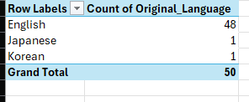
Image 10
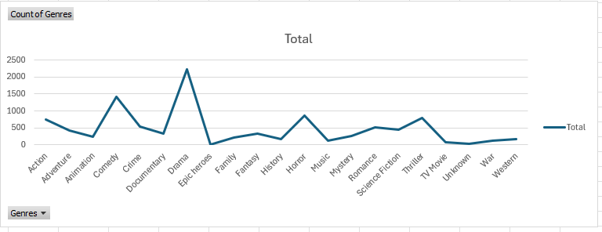
Image 11 – line graph

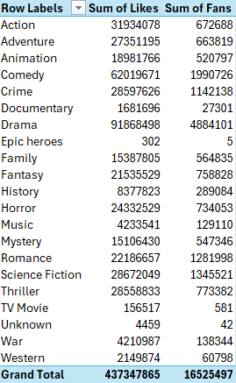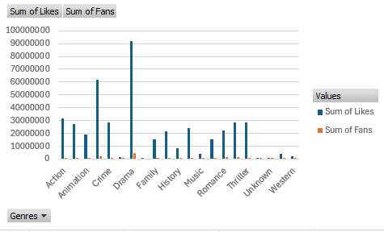
Image 12 Image 13

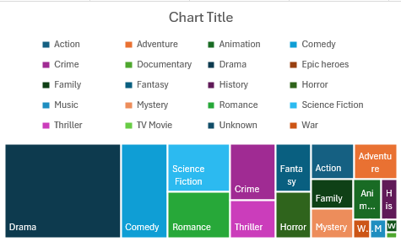
Image 14

- Statistical Analysis using SPSS.
The first part of my practice with IBM SPSS was to create a test comparing some of the variables in the spreadsheet. I have decided to compare the statistics between Runtime, Average rating, and language. To this I had to create a grouping variant by going to the transform tab and then choosing Recode into Different variables. English became 1 and all other languages became 2. I had to this to avoid errors when conducting the t test. In this T test I will compare the difference between the English and non-English film in run time and average rating. In the group statistics I can see that mean average rating for non-English films (2) is 3.51 which is higher than the mean average rating for English films (1) is 3.21. So non-English movies have a higher average rating than English movies even if they account for 19% of all movies. Non-English films have also a higher mean runtime which is 104.2 minutes compared to that of English films with 102.9. So, there is significant difference in ratings of English and non-English films. And a small difference in run time. The result of the t test is shown in image 14. The next step that I did was to calculate the correlation between the runtime and watches of the movies so I can analyse the data. To calculate the correlation, I had to go into analyse tab go down to corelate and choose bivariate and then inserted the 2 into the box. So, after looking at the result my interpretation is that there is weak but statistically significantly positive relationship between the films runtime and the number of watches. So, the movies with slightly longer run time tend to gain more watches, but runtime explains a small part of variation in watches. The result is shown in image 15. For the regression analysis I have used the languages and the list appearances to be compared. The analysis is shown in image 16. The regression shows that language has a small but significant effect on list appearances. English films (coded as 1) tend to appear in more lists, while non-English films (coded as 2) appear in around 11,000 fewer lists on average (B = –10,971.60, p < .001). Although the model was statistically significant, it only explained about 0.6% of the variation in list appearances (R² = .006), which means language on its own is not a strong predictor. Overall, English films are listed more often, but the effect is small considering the large sample size. (Elliott & Woodward, 2020), (Courtney, 2018)

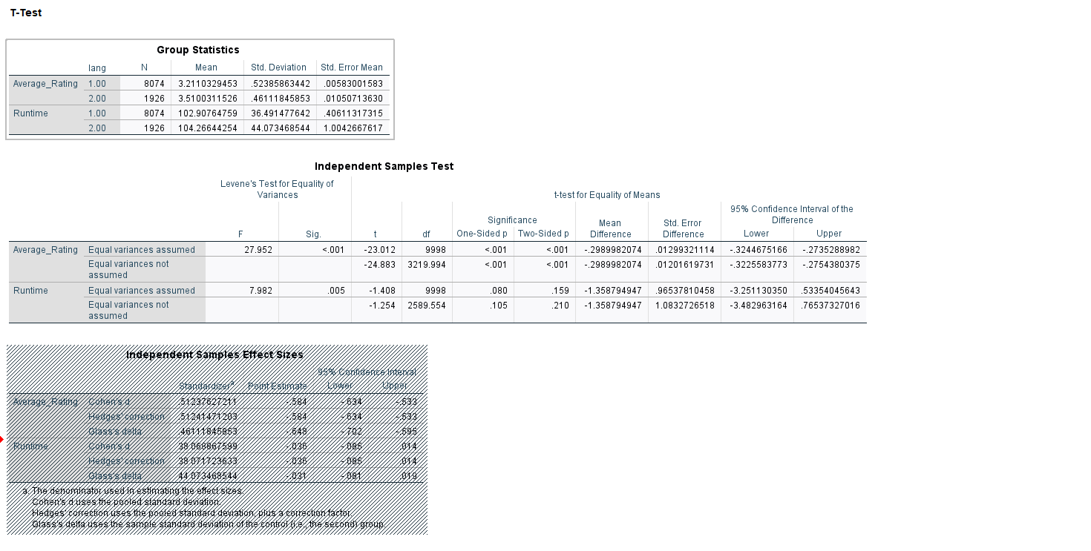
Image 14 – t test

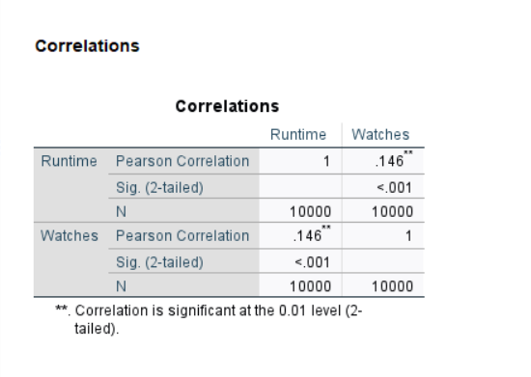
Image 15

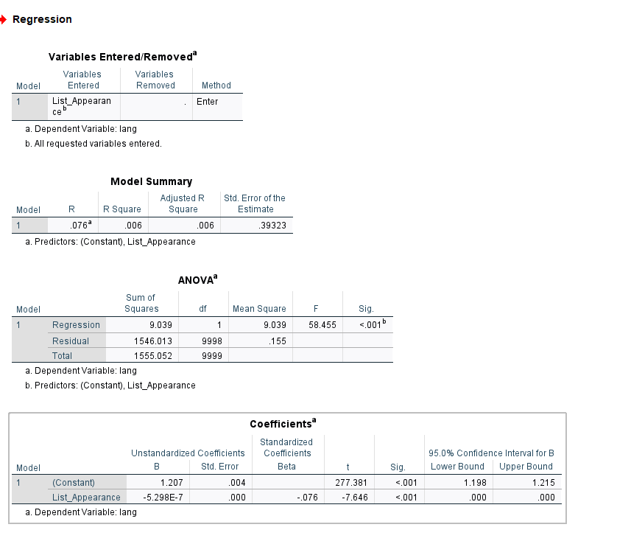
Image 16
- Insights and Recommendations
The analysis conducted in this assignment has helped me reveal some important trends and statistics about the database. The main conclusion of the trends is that films in English dominate the database with 80%. While movies in other language tend to have slightly higher average ratings. The most common genres were drama, comedy, and horror. The most liked genre and with the highest number of fans was Drama. I have used multiple images detailing these statistics. The regression analysis showed that language has a small but significant impact on list appearances with English movies having more list appearances on average. My recommendations are to prioritize movies that tend to have higher engagement; these are genres such as drama and comedy. These titles had also had a higher number of entries in our database so its suggests that these genres are popular. My other recommendation is to allow for more movies to be in other languages because international films are appreciated more by the audiences. My last recommendation is for film makers to accurately conduct this sort of analysis on the recently released movies so they can get a higher chance of success with their productions, allowing them to reach new audiences. The only limitation that I consider is that the data base does not represent the real global film market.
References

- Amrhein, V., Trafimow, D. and Greenland, S. (2019) ‘Inferential Statistics as Descriptive Statistics: There Is No Replication Crisis if We Don’t Expect Replication’, The American statistician, 73(sup1), pp. 262–270. Available at: https://doi.org/10.1080/00031305.2018.1543137.
- Courtney, M. (2018) ‘SPSS’, The SAGE Encyclopedia of Educational Research, Measurement, and Evaluation. Edited by B.B. Frey. Thousand Oaks, California: SAGE Publications, Inc.
- Elliott, A.C. and Woodward, W.A. (2020) Quick guide to IBM® SPSS®: statistical analysis with step-by-step examples. Third edition. Thousand Oaks, California: SAGE Publications, Inc.
- Frazer, G. (2024) Data cleaning with power BI the definitive guide to transforming dirty data into actionable insights. Place of publication not identified: Packt Publishing. Available at: https://portal.igpublish.com/iglibrary/search/PACKT0007091.html.
- Ganti, V. and Das Sarma, A. (2013) Data cleaning : a practical perspective. San Rafael, California (1537 Fourth Street, San Rafael, CA 94901 USA): Morgan & Claypool. Available at: https://doi.org/10.2200/S00523ED1V01Y201307DTM036.
- Goyle, K., Xie, Q. and Goyle, V. (2023) ‘DataAssist: A Machine Learning Approach to Data Cleaning and Preparation’. Available at: https://doi.org/10.48550/arxiv.2307.07119.
- Ho, A.D. and Yu, C.C. (2015) ‘Descriptive Statistics for Modern Test Score Distributions: Skewness, Kurtosis, Discreteness, and Ceiling Effects’, Educational and psychological measurement, 75(3), pp. 365–388. Available at: https://doi.org/10.1177/0013164414548576.
- Knowledgemotion Ltd., film distributor and APMonitor.com, publisher (2021) Analyze stock data with Microsoft Excel. Place of publication not identified: APMonitor.com.
- McFedries, P. (2023) Teach yourself visually Excel 365. Hoboken, New Jersey: John Wiley & Sons, Inc.
- Selwyn, N. (2022) ‘“Just playing around with Excel and pivot tables” - the realities of data-driven schooling’, Research papers in education, 37(1), pp. 95–114. Available at: https://doi.org/10.1080/02671522.2020.1812107.

