


Development and Evaluation of a safe system of work for WATER pressure AND immersion testing in preparation for UKAS 9001 Audit: Enhancing immersion test procedures and quality assurance
by
Albert Willett

Supervisor: Phil Hilton and Ewa Kazmierski

Project submitted as part of the requirements for the award of BEng (Hons) OME

March 2026

Declaration of Originality

I, Albert William Willett declare that I am the sole author of this Project; that all references cited have been consulted; that I have conducted all work of which this is a record, and that the finished work lies within the prescribed word limits.

This work has not previously been accepted as part of any other degree submission.

Signed : .............................................

Date : ...............................................

FORM OF CONSENT

I Albert William Willett hereby consent that my Project, submitted in candidature for the BEng (Hons) OME degree, if successful, may be made available for inter-library loan or photocopying (subject to the law of copyright), and that the title and abstract may be made available to outside organisations.

Signed : .............................................

Date : ...............................................

Copyright Acknowledgement

I acknowledge that the copyright of this project report, and any product developed as part of the project, belong to University of Wales Trinity Saint David, Swansea.

ABSTRACT – Rethinking immersion testing in defence: Are current standards enough to prevent water ingress in munitions?
Water Pressure testing and immersion testing is a critical test in an environmental qualification programme for munitions. The test replicates conditions experienced during fording, submersion and accidental immersion evaluating the effectiveness of seals. Historic incidences of water ingress in munitions and the review of current test standards have identified that real world conditions are not being replicated. This report identifies the gap between current test standards and real-world conditions investigating the effects of dynamic water pressure and impact pressures on seals as well as other environmental factors that can influence the integrity of seals.

This project used a 3-stage approach. First, the current test capability and test standards were assessed, and key safety considerations were understood to maintain capability. This included refurbishment of current test equipment and implementation of a Safe System of Work leading to UKAS accreditation with DEF STAN 00-035 part 3 Test CL29.

Second, the current test standards were evaluated against theoretical calculations investigating the effects of dynamic pressure, impact pressure and review of other industry test standards which have already implemented these considerations.
Third, gaps were identified with current test equipment capability. By using a systems approach and through exploring modern technologies, automation and test equipment designs key design limitations generic design criteria were identified which could be used by the industry to implement the updated test methodology.
The findings found within all three stages of the report present a more representative test methodology, increased capability which is safer for the test operators and the results of the test would provide better justification in a safety case to qualify munitions for in service use. This is achieved by using a combination of automated vacuum pumps and compressors to create a dual mode hydrostatic test chamber.

- Contents Page
1. Contents Page
1.2 Table of Figures
  - Table of Tables
2. Introduction
2.1 What is water pressure testing
2.2 Importance of water pressure testing
2.3 Project aims and Objectives
2.4 Problem Statement/Objectives
2.5 Literature review for Work Package 1
2.5.1 Test Standards
2.5.2 Test procedures
2.5.3 Safety Regulations
2.6 Consequences of Failing to meet test standards and Safety Regulations
3. Work Package 1 – Developing a Safe System of Work
3.1 Restoration and Preparation of Equipment for CL29 Testing
3.1.1 Studding and Door Retention System Replacement
3.1.2 Immersion Tank Structural Refurbishment
3.1.3 Hydraulic Hand Pump Overhaul
3.1.4 Housekeeping and Drainage Restoration
3.1.5 Calibration and Traceability of Pressure Gauges
3.2 Development of Safe System of Work
3.2.1 Hazard Identification and Risk Assessment
3.2.2 Work Instruction for CL29 Operations
3.3 UKAS Accreditation Outcome

4. Work Package 2 – Relevance of Immersion testing and Water pressure testing
4.1 Technical justification
4.2 Water impact forces leading to pressure spikes: the dominant force to overcome seal integrity
4.3 Additional factors to consider that effect the condition of the seals
4.4 Do other test methodologies replicate the pressure experienced impact with a body of water?
4.5 Evaluation of Pressure Differential Characteristics: Sealing Test Profiles Versus Immersion Test Conditions
4.6 Can enhancements to the DEF STAN 00-035 CL30 sealing test methodology provide sufficient replication of real-world immersion conditions to justify its adoption in place of CL29?
4.7 How to increase the severity of MIL STD 812
4.8 Impact on Sealing Tests, Immersion Tests, and Hydrostatic Pressure Methodologies
4.9 Proposed test methodology updates for DEF STAN 00-035 and all defence test standards
4.10 Implications to the current water pressure test standard
4.11 Future of physical immersion testing techniques
4.12 Overview of Deliverable

5. Work Package 3 – identifying improvements to current testing
5.1 Limitations of current equipment
5.2 Step 1 – Identify user Requirements (UR) and System Requirements (SR)
5.3 Functional Analysis
5.4 System Architecture/ Solutions
5.5 Evaluation of Solutions using Systems Engineering
5.6 Modelling software requirements
5.7 Cost Benefit analysis of the proposed solutions and the updates to the test standard

6. Discussion
  - Summary of Results
  - Statistical Interpretation of Findings
6.3 Comparison to Expectations
6.4 Integration of Findings Across Work Packages
6.5 Future avenues of research
7. Reflection
8. References
9. Appendices

1.2 Table of Figures
1.3 Table of Tables

- Introduction
  - What is water pressure testing
Water pressure and immersion testing are environmental qualification methods used to evaluate how effectively a material, component, or munition prevents water ingress during its life cycle. [1] Immersion testing assesses performance when an item is submerged at relatively shallow depths, simulating accidental drops, fording (shown in Figure 1), or operational use in water. It typically examines seal integrity and the impact of temperature differences between the item and the surrounding water.
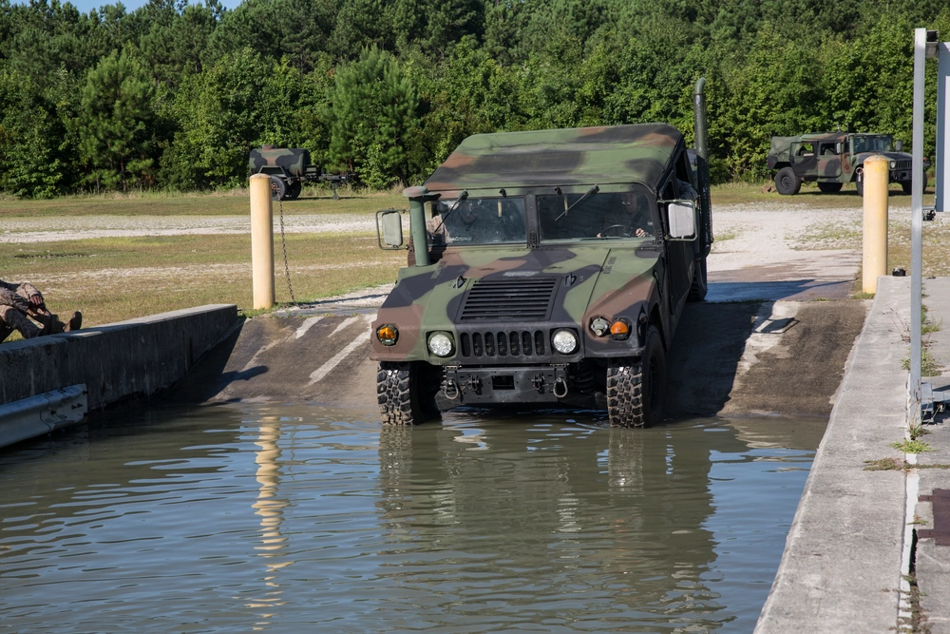
Figure 1 – vehicle fording at test facility [2]

Water pressure testing applies controlled hydrostatic pressures far greater than those achieved by simple immersion, replicating deep water environments or high-water pressure scenarios such as deep-sea Explosive ordnance and Disposal (EOD) diving operations, mine clearance, or other specialist deployment as shown in figure 2. [3]
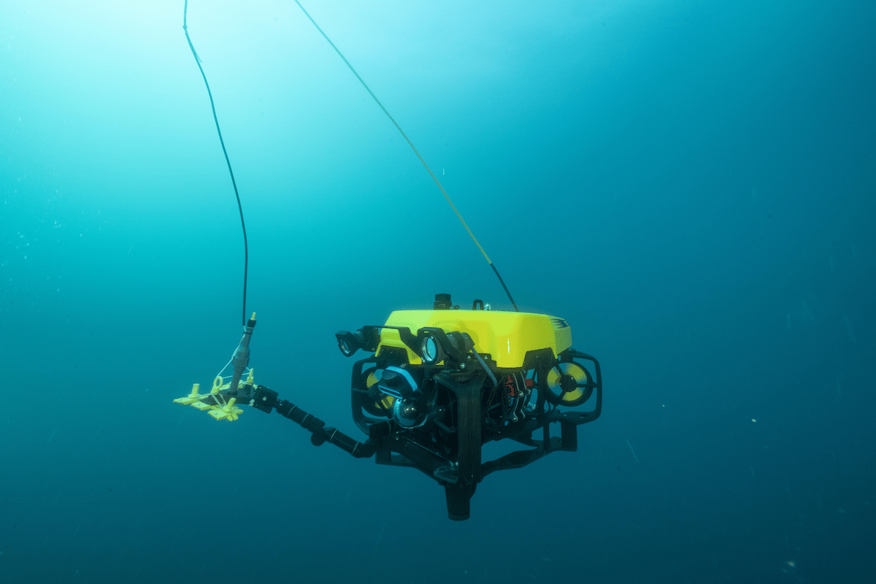
Figure 2 – Underwater EOD robot [4]
This is achieved using pressure vessels capable of generating precise, repeatable pressure profiles.
Together, these tests ensure the material can survive expected environmental conditions without water ingress that could degrade performance, compromise safety, or damage sensitive components. They are essential for demonstrating compliance with standards such as DEF STAN 00-035. [1]
These tests form part of a complete environmental test programme which is used to create a safety justification for use of a particular munition in service. Environmental testing is used to assess the durability, safety and performance of a munition throughout the latter stages of the Concept, Assessment, Demonstration, Manufacture, In Service, Disposal (CADMID) model. Facilities like the Environmental Test Centre at MOD Shoeburyness deliver this test capability by providing a solution of test equipment, facilities and subject matter expertise to replicate what a test article might experience during its life via the use of accelerated lifecycle testing. [5]
Immersion test severity is determined by the environmental conditions a material is expected to encounter in service. A 1 m immersion depth is typically used to represent accidental drops into water and shallow fording. Increased severity, such as 1.5 m immersion, reflects deeper fording and more demanding operational contexts. For depths exceeding 1.5 m, testing is conducted using a water pressure chamber, with hydrostatic pressure calculated from the expected service depth—9.8 kPa per metre for fresh water and 10.05 kPa per metre for saltwater. These severities follow DEF STAN 00-035 [1], with comparable methodologies applied across international standards [3] [6].

2.2 Importance of water pressure testing
Pressurised Water Chamber Testing and Immersion testing is vital to assess the capability of materiel to operate whilst submerged or to survive accidental immersion in water. Failure of seals can lead to degradation of explosive material such as propellant and electrical components in Fuzes which can lead to misfires and reduced performance. An example of this failure mode being a contributing factor in a fatal incident was on the 6th of July 2016 when a 60mm HE 80 Mortar fitted with a M6-N Fuze functioned prematurely leading to the death of 2 personnel and injuring 1 other during training in Mali. [7] The sensitivity of the explosive material due to long term moisture ingress led to unstable copper azide crystals forming. [8] Other examples of submersion of munitions leading to an unquantifiable risk of initiation was during the recovery phase of the USS Forrestal incident (Shown in figure 3). [9] It is also still an ongoing hazard of the munitions onboard the SS Richard Montgomery situated in the river Thames however these are beyond any conceivable service conditions.
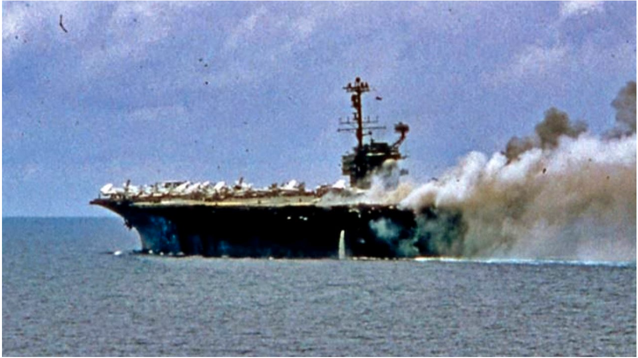
Figure 3 – USS Forestal during incident in 1967 [9]

2.3 Project aims and Objectives
The Project is broken down into 3 separate Work Packages:
Work Package 1:
- Understand the existing equipment at ETC and within the industry. This includes the layout and function of the equipment, operating pressures of the equipment, age, condition and limitations and identify any known hazards
- Identify the Hazards of the activity using tools such as HAZID, Hazard Checklists and reviewing incident data.
- Using the identified hazards a Risk assessment will be completed by considering the likelihood of an event with the consequence and applying control measures to reduce the risk to an ALARP status.
- The Risk Assessment forms part of the Safe System of work. The other documents including the Work Instruction. Pre-use checks, PUWER assessments, PSSR inspections, training and competency are also required.
Deliverable: a complete Safe system of work to be able to use the equipment and demonstrate the testing in accordance with Def Stan 00-035 Issue 7-part 3 [1] to maintain ISO:9001 UKAS accreditation [10].

Work Package 2:
Is Immersion testing and Water pressure testing in accordance with Def Stan 00-035 Issue 7 still relevant?
- What other forces occur during immersion?
- Worked example
- How can improvements be made to the current test methodology
- What is the future of Immersion testing?

Work Package 3:
What are the limitations of our current equipment?
- Manual operation of the Pressure vessel
- Limited instrumentation
- Human exposure
- Poor data capture
- Greater pressure depth capability
How can innovative new technologies be implemented into the design to improve the capability?
Comparisons of other test standards to ensure the equipment is suitable for the future.
Deliverable: A cost benefit analysis of the safety improvements, time savings and efficiencies and improved pressure capability.

2.4 Problem Statement/Objectives
Failure to adequately replicate immersion pressures pose risks to the validity of environmental qualification and ultimately, the safety and performance of munitions. Historical incidents involving long-term water ingress demonstrate the severe consequences of inadequate sealing, including premature functioning and unquantifiable initiation risks.

Therefore, the problem is, to evaluate whether the current water pressure test capability meets modern safety, technical, and accreditation requirements; to identify hazards associated with existing processes; and to determine whether improvements, new technologies, or alternative test philosophies are required. This includes assessing the continuing relevance of physical immersion and pressure testing within DEF STAN 00-035 Part 3 Issue 7 and exploring whether risk-based or modernised methodologies could enhance safety, efficiency, and compliance.

2.5 Literature review for Work Package 1
A critical part of completing a Safe System of Work (SSoW) is to understand the regulatory standards that are pertinent to the delivery of the activity. Both technical (test standards) and safety (Health and Safety at work act). The requirements presented by these regulations and standards are the foundation of the Work Package 1 programme of work.

2.5.1 Test Standards
Overview of DEF STAN 00-035 part 2,3 and 4 and MIL STD 810
- Pressure limits
For standard immersion tests a 1m depth with a pressure of 9.8kPa or 0.098 bar is suitable for testing the seals of an asset if it was to undergo accidental drops or shallow fording.

A greater depth of 1.5m at a pressure of 14.7kpa or 0.0147 bar is used for deeper fording. [1]

Depths greater than 1.5m are used on a case-by-case basis, typical types of assets that would undergo these environments are diving equipment, torpedoes and mine clearance or EOD devices such as demolition charges like the Pluton Maritime EOD kit, Vulcan Counter Limpet Mine System and underwater Firebreak which are designed to work up to depths of 80m. [11]

Maximum depths for manned diving in the military are around 50m (when breathing air) however greater depths in exceptional circumstances are over 100m with pressures exceeding 10bar. [12]

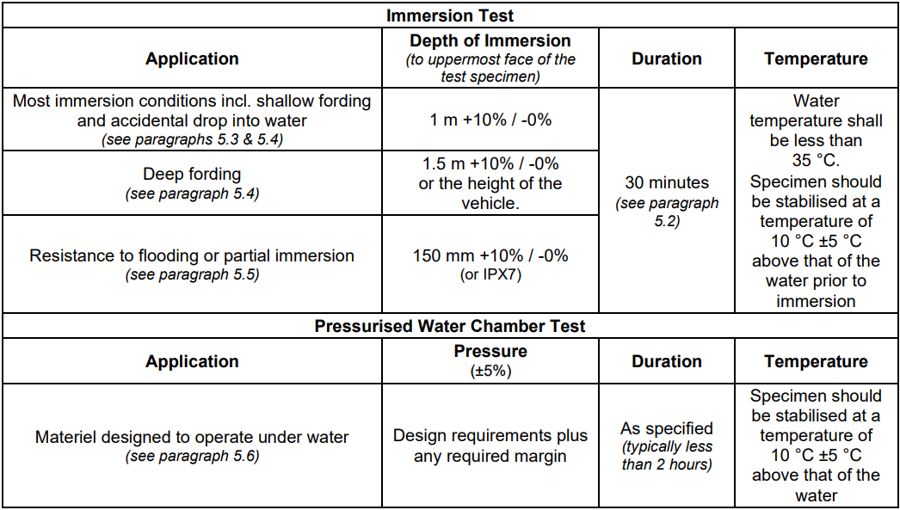
Table 1 – DEF STAN 00-035 CL29 Test Severities [1]
2.5.2 Test procedures
The test item is inspected, weighed, and temperature-conditioned before being subjected to the specified water pressure for the required duration. Operational checks may be performed during exposure, and any deviations are recorded. After depressurisation, the item is dried, reweighed, examined for water ingress, and the test repeated for each required orientation. The exact test procedures can be found in DEF STAN 00-035 Part 3 Issue 7 Test CL29 [1] and MIL STD 810 G Method 512 [13].

2.5.3 Safety Regulations
Health and Safety at Work Act
The health and safety at work act (HSWA) requires employers to protect their work force by ensuring the work is planned and carried out safely. To achieve this for the water pressure testing there must be a suitable risk assessment where the risks have been reduced to an ALARP level, trained and competent staff and well maintained and suitable water pressure test equipment. It also specifies that clear procedures and work instructions are required to create a comprehensive Safe SSoW. These procedures include how to operate the equipment safely, outlining control measures like exclusion zones and when to adorn personal protective equipment (PPE). To support the Health and Safety at Work Act (HSWA), which serves as the primary legislation, a range of secondary legislation, issued as regulations, provides the specific rules, procedures, and requirements needed to ensure compliance with the HSWA. [13] The following regulations are applicable to immersion testing and water pressure testing:

Workplace (health, safety and welfare) regulations 1992
Requires employers to ensure a safe workplace by managing risks, providing adequate ventilation, lighting, space, cleanliness and equipment.
Key considerations for an immersion and water pressure test facility include adequate drainage, slip resistant flooring, temperature-controlled environments and adequate lighting and emergency lighting. [14]
Explosive Regulations (ER2014)
ER2014 sets out requirements for manufacture, storage, handling and use of explosives ensuring risk assessments, licensing, security and protection of people, property and the environment.
For water pressure testing the equipment, work environment and procedures must reduce the initiation hazards present by the test item. [15]
These potential failure modes include:
- Mechanical shock from being subjected to pressures above the design limits
- Rapid pressure changes leading to changes in sensitivity of the material
- Equipment induced vibrations
- Electrostatic discharge during handling
- Rig restraint failure resulting in unexpected movement and impact shock
Provision and use of work equipment regulations (PUWER) Regulations
PUWER 1998 ensure that work equipment is suitable for the task, is properly maintained and inspected, operators are suitably trained and that the equipment has suitable guarding and safe controls.
For immersion testing and water pressure testing these regulations apply to the immersion tanks, the pressure vessels, the pump which increases pressure and the rigs and fixtures used for mounting the test item. [16]

Pressure systems Safety Regulations (PSSR) regulations
Apply when a system contains and relevant fluid, a pressure greater than 0.5 bar and meets the definition of a pressure system e.g. A pressure vessels and pipelines. This is particularly important for water pressure testing equipment which can achieve 50kpa or the equivalent to 5m water depth. To achieve these regulations a written scheme of examination is required, the equipment must have a safe operating limit on show and suitable relief protections. These then must be inspected by a competent person. [17]

Management of health and safety at work regulations (MHSWR) 1999
Covers the overarching requirements for managing risk of employees. This is achieved by assessing the risk within the workplace by:
- Identifying what can cause injury or harm (Hazards)
- Decide the likelihood of an individual being harmed by that event and the severity of the harm (Risk)
- Implement control measures to eliminate the risk or if not possible control the risk by reducing either the likelihood or severity. [18]

Further regulations that need to be considered for Water Pressure test facilities include:
Lifting Operations and lifting equipment regulations LOLER [19] and MHOR [20] – which requires lifting operations to be planned, equipment to be suitable and marked with safe loads and regularly examined by competent persons, ensuring safe use, defect reporting and protection of workers.
Electricity at work Regulations (EAWR) [21] - requires electrical systems to be designed, maintained and used safely by competent persons, preventing shock, fire and equipment faults through inspection, proper controls and safe working practices.
Personal protective equipment (PPE) regulations- Require employers to provide suitable PPE, ensure suitable fit, employees have suitably trained and effectively reduce workplace risk. [22]

2.6 Consequences of Failing to meet test standards and Safety Regulations
The below list captures the major consequence of not completing work in accordance with the above regulations during Immersion testing and Water pressure testing.

Safety – initiation of test item, mechanical failure of pressure vessel and many more hazards captured in the risk assessment which can result in serious injury and in some cases fatality [13]

Operationally – Damage to the test equipment will result in loss in accreditation, stop on testing and loss of work due to loss of capability [23]

Reputational – if an incident was to occur this would result in a loss of trust with customers

Legal – imprisonment, prohibition notices, civil claims and corporate manslaughter charges [13]

Financial – the above consequences could result in fines and replacement costs up to an unlimited amount. [13]
- Work Package 1 – Developing a Safe System of Work
The Environmental Test Centre (ETC) operates a hydrostatic water pressure test facility designed to evaluate equipment performance in accordance with Defence Standard 00-035 and the CL29 test method. The core of the facility is a cylindrical steel pressure vessel measuring 1.5 m long and 1 m in diameter, capable of accommodating items up to 1.4 m × 0.7 m × 0.7 m. Test items are fixed to an internal mounting platform to ensure repeatable orientation, and the vessel incorporates operational and safety systems including a 100 psi (6.89 bar) pressure relief valve, analogue gauge, and upper and lower access points for filling and draining. Pressurisation is achieved through a hydraulic hand pump connected to a water reservoir, allowing controlled increases and decreases in pressure throughout the test cycle. As shown in Figure 4 and 5.
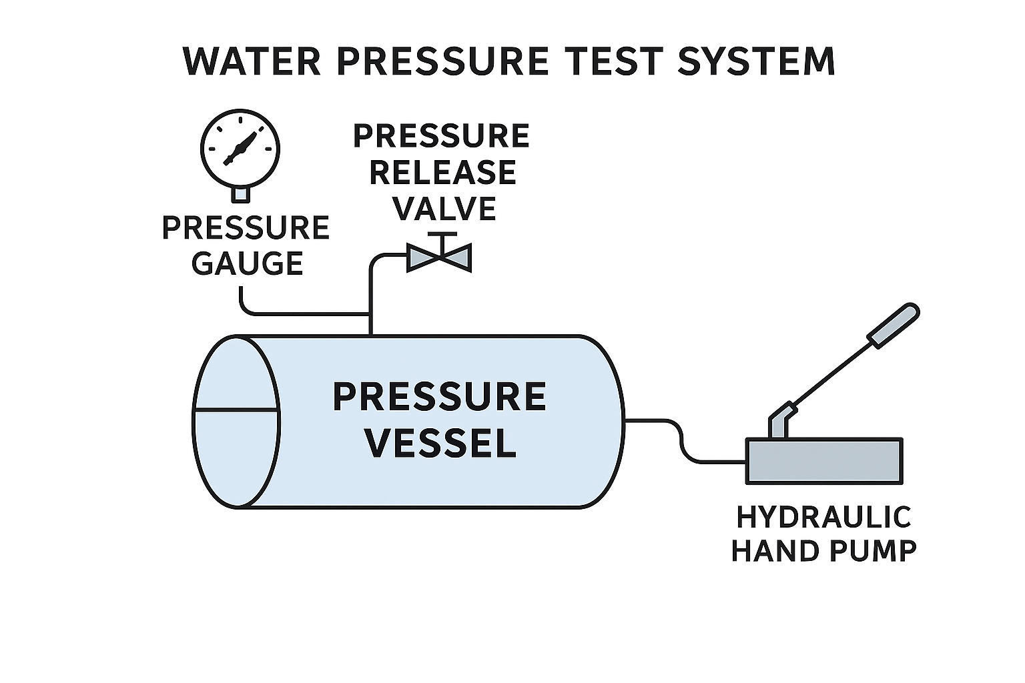
Figure 4 – Systematic diagram of Water pressure test equipment
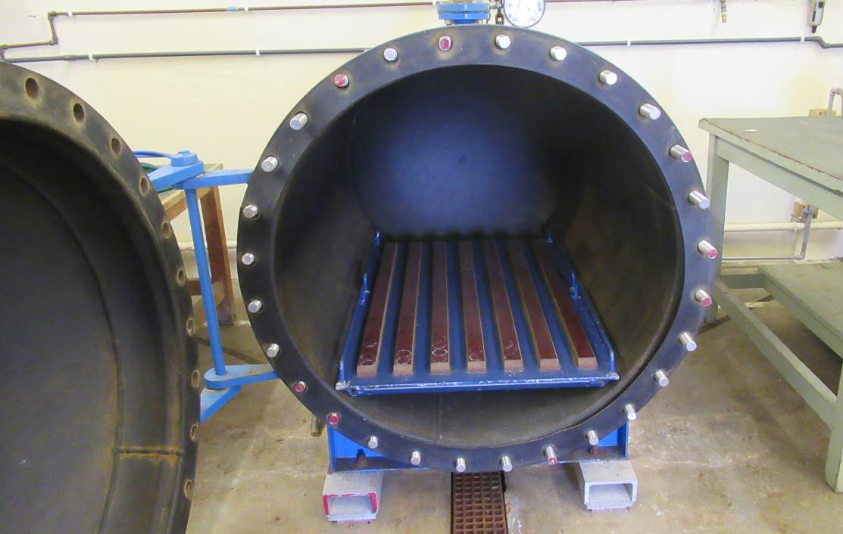
Figure 5 – photo of water pressure test equipment at ETC MOD Shoeburyness

3.1 Restoration and Preparation of Equipment for CL29 Testing
Before developing the Safe System of Work, significant remedial and refurbishment work was required to return the test facility to a condition suitable for UKAS accreditation. [10] The restoration process itself was fundamental to demonstrating that the equipment was mechanically sound, traceable, and capable of producing repeatable results.

3.1.1 Studding and Door Retention System Replacement
The original carbon-steel studding securing the vessel door exhibited significant oxidation, resulting in reduced clamping force and premature leakage during pressurisation. Beyond performance degradation, oxidised fasteners introduce ignition and contamination risks in explosive process buildings, highlighted by Improvement Notice 315153422 issued to Chemring Energetics (24/06/2025). The studding was replaced with 316 stainless steel, selected for its corrosion resistance and yield strength exceeding 205 MPa. This restoration step was essential to ensure repeatable sealing of the vessel under load—an explicit requirement when demonstrating equipment fitness for UKAS accreditation.

3.1.2 Immersion Tank Structural Refurbishment
The external surface of the tank had deteriorated due to age (manufactured in 1984), unheated building conditions, and exposure to moisture. The corrosion was removed, the surface treated, and a protective coating applied. The vessel was then reinspected for structural integrity to verify that the refurbishment had not introduced weaknesses. Because CL29 testing requires stable internal geometry and predictable structural response under pressure, the refurbishment step was necessary to restore compliance with safety and performance expectations.

3.1.3 Hydraulic Hand Pump Overhaul
A full refurbishment of the hydraulic hand pump was completed to restore consistent and leak-free pressurisation. As shown in Figure 6. Activities included:
- removal of corrosion from the pump body,
- lubrication of all mechanical components,
- repair and calibration of the integrated gauge, and
- verification that the pump could reliably reach and hold operating pressures.
These steps ensured the pump met the requirements of PUWER [16], PSSR [17] and the Workplace Regulations 1992 [14]. For CL29, precise pressure control is essential because the test specification relies on achieving defined depth-equivalent pressure values. Any error in the pump system would directly compromise test validity.
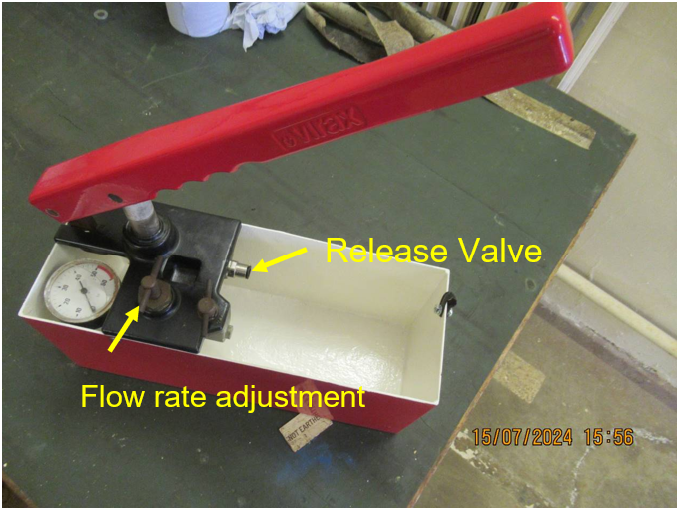
Figure 6 – Manual hydraulic hand pump

3.1.4 Housekeeping and Drainage Restoration
Long-term inactivity had resulted in debris accumulation, obstructed drains, and general deterioration of the workspace. The building underwent a full clearance and drain restoration to meet explosive regulations (ER2014), PES inspection requirements, and Workplace (Health, Safety and Welfare) Regulations 1992. Maintaining a clean, controlled test area is a fundamental expectation during UKAS auditing, ensuring that environmental conditions do not influence test repeatability.

3.1.5 Calibration and Traceability of Pressure Gauges
All vessel and pump gauges were calibrated against ISO 17025 [23] to confirm compliance with Def Stan 00-035 tolerances. CL29 testing requires that pressure readings be accurate and verifiable; therefore, calibration certificates form part of the technical evidence provided during UKAS assessment. Incorrect gauge readings could allow unnoticed over-pressurisation, deviation from the required test profile, or invalid results.
3.2 Development of Safe System of Work
After restoring the equipment, a comprehensive Safe System of Work and supporting documentation were developed to enable safe operation and to meet UKAS ISO/IEC 17025:2017 requirements.

3.2.1 Hazard Identification and Risk Assessment
A HazID walkthrough was conducted in the test cell to identify operational hazards associated with pressurisation, depressurisation, loading, water management, lifting operations, and potential rapid energy release from the vessel. The findings informed the formal risk assessment – Annex A (front sheet shown in Figure 6) and the creation of a controlled work instruction. Although risk management is essential, the primary driver for UKAS purposes is that the risk-control process supports consistent, repeatable operation of the test equipment.
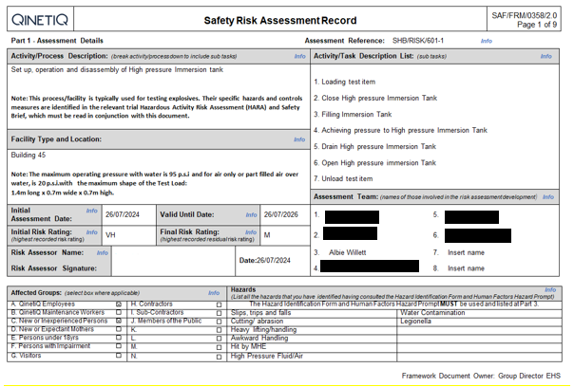Figure 6 – Front sheet of QinetiQ Risk assessment

3.2.2 Work Instruction for CL29 Operations
The core document enabling UKAS accreditation was the test-specific Work Instruction (WI) Shown in Annex B, detailing step-by-step procedures for equipment preparation, pressurisation, and monitoring.

3.3 UKAS Accreditation Outcome
The primary objective of the project was to restore the facility and achieve UKAS accreditation for the CL29 pressure test under Def Stan 00-035 and MIL-STD-810. Accreditation demonstrates that the equipment is:
- fit for purpose,
- calibrated and traceable,
- properly maintained, and
- capable of producing repeatable, valid results.
The restoration of the vessel, pump and gauges, introduction of unique ID systems and development of controlled procedures provided the technical evidence required by ISO/IEC 17025. The subsequent UKAS audit identified no major findings, confirming compliance and meeting the project’s deliverables.

The minor finding from the UKAS Audit included investigating the use of digital pressure gauges to record the data through the trial rather than writing down pressures every 2 minutes from the analogue gauge.

- Work Package 2 – Relevance of Immersion testing and Water pressure testing
Test requirements and methodologies are continually reviewed to ensure they remain representative of real operating environments. This is visible across successive issues of DEF STAN 00-035, where updates have enhanced environment replication. Such as, the shift from conditioning to air temperature in Issue 4 to conditioning to skin temperature in Issue 5, and the evolution of vibration testing from single-axis to multi-axis excitation [25][26].

In contrast, immersion and water-pressure testing defined in DEF STAN 00-035 Part 3, Test CL29, have remained unchanged since Issue 5 (2017). These methods were deliberately agreed by WTS (formerly DOSG) and industry as simple, low-cost means of reproducing likely service conditions. Simpler procedures reduce sensitivity and weaken comparisons with real world environmental conditions more representative severities could be applied however with increased complexity.

Both DEF STAN 00-035 and MIL-STD-810 currently apply immersion testing to small arms ammunition and equipment intended for deliberate or accidental submersion. For example, an item expected to ford 1 m is tested at a static depth of 1 m. While this reflects the hydrostatic loading at depth, it does not account for additional stresses such as dynamic pressures from water flow, impact forces during entry, or short-term thermal expansion resulting from thermal shock.

Other industries consider these additional forces. The watch industry, for instance, uses ISO 22810 [25] to define static pressure ratings, where a watch rated to 30 m is only validated for shallow everyday exposures such as rain or handwashing as shown in Table 2. Higher-severity applications like diving require more demanding tests under ISO 6425. [26] Involving greater pressures and compensating for dynamic loads and impact forces. “High end” manufacturers further extend testing by applying prolonged exposure, varied temperatures, and dynamic immersion through agitation. While not standard practice, such approaches could be incorporated into defence standards if deemed operationally necessary. [27]

To support this evaluation, the next section presents worked examples for typical small-arms ammunition, illustrating the additional loads associated with shallow and deep fording. These cases are used to quantify the contribution of dynamic pressure, entry impact, and thermal effects relative to current test severities.

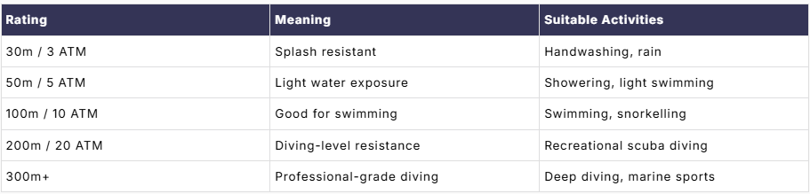
Table 2 Water test severities

4.1 Technical justification
To understand this further, worked examples of typical small arms ammunition are shown below demonstrating the additional effects of these factors. These worked examples only focus on shallow and deep fording as these have well documented environmental factors with well-known parameters like typical water velocities experienced during fording.

Worked Example 1 – Calculating the hydrostatic water pressure force experienced on a seal at 1 metre depth in fresh water at 25°C

Step 1 — Determine pressure differential [28]
$$ΔP=P_{\text{external}}-P_{\text{internal}}$$

Step 2 — Determine the area hydrostatic pressure acts upon [28]
Formulae for calculating Cross sectional area:
$$A=π\frac{d^{2}}{4}$$where $d$represents the internal diameter of the fitting. For small-arms applications, when assessing the seal between the cartridge case and projectile, $d$ corresponds to the calibre of the round. For example, a 30 mm cartridge would have an internal diameter of approximately 0.03 m.

Step 3 – Calculate the compressive load on the crimp formula [28]
$$F=ΔP⋅A$$

Parameters for a 30mm munition being submerged at 1m depth:
- Internal air pressure: 1 bar (ambient)
- External chamber pressure: 1.098 bar
- Inner diameter: 30 mm (0.03 m)
- Depth of submersion 1m

Inputting the values for worked example.
Step 1:
$$ΔP=1.098-1=0.098\text{ bar}=9800 \text{Pa}$$
Step 2:
$$A=π\frac{\left(0.03)^{2}\right.}{4}=7.06858×{10}^{-4}\text{ m²}$$
Step 3:
$$F=9800×7.06858×{10}^{-4}$$
$$F=6.927\text{ N}$$

At a hydrostatic depth of 1 m, the crimp region of a 30 mm round is subjected to an external force of approximately 6.927 N. Current issues of DEF STAN 00-035 only consider this static loading condition. The worked example below illustrates the additional forces the round may encounter during service.

MIL STD 810 and AECTP method 307 goes further by introducing replication of thermal effects by preconditioning the test items prior to submersion. This is shown in the below worked example:
When:
Water Temperature – 298K
30mm Round temperature – 325K
Submersion Depth – 1 metre
Step 1 — Internal pressure changes due to cooling
Assuming the round is sealed at atmospheric pressure before immersion:
$$P_{initial internal pressure}=101.3\text{ kPa}$$
Using the ideal gas law for constant volume:
$$\frac{P_{Initial internal pressure}}{T_{Initial absolute temperature}}=\frac{P_{final internal pressure}}{T_{final absolute temperature }}$$
$$P_{final internal pressure}=101.3KPa×\frac{298}{325}$$
$$P_{final internal pressure}=92.9\text{ kPa}$$

Step 2 — External water pressure at 1 m depth
Hydrostatic pressure:
$$P_{\text{static}}=ρgh$$

Where
$$ρ=1000 {\text{kg/m}}^{3} \\ g=9.81 {\text{m/s}}^{2} \\ h=1\text{ m}$$
$$P_{\text{water}}=1000×9.81×1=9.81\text{ kPa}$$
Step 3 - Total external pressure = Atmospheric + Water:
$$P_{\text{ext}}=101.3+9.81$$
$$P_{\text{ext}}=111.1\text{ kPa}$$
Step 4 — Pressure differential
$$ΔP=P_{\text{ext}}-P_{\text{int}}$$
$$ΔP=111.1-92.9$$
$$ΔP=18.2\text{ kPa}$$
$$This is the equivalent to the static water depth of 1.13m at 298K$$

Both test standards do not consider the additional hydrodynamic forces experienced when a test item moves through water. These are shown in the continuation of the first worked example:

Worked Example 1 – Calculating the hydrodynamic water pressure force experienced on a seal at 1 metre depth in fresh water at 20°C

Calculating the Dynamic pressure experienced

When the test item moves through water, it experiences an additional hydrodynamic pressure on the surfaces. The formulae for calculating the hydrodynamic pressure: [28]
$$P_{\text{dynamic}}=\frac{1}{2}ρv^{2}$$
Parameters to calculate dynamic pressures produced by the asset being fixed on a moving vehicle fording across river:
- $ρ$= density of water (998.29 kg/m³ at +20°C)
- $v$= velocity of vehicle (5kph or 1.39m/s)
$$P_{\text{dynamic}}=\frac{1}{2}×998.29×{1.39}^{2}$$
$$P_{\text{dynamic}}=\frac{1}{2}×998.29×1.9321$$
$$P_{\text{dynamic}}=964.398Pa$$

Parameters to calculate dynamic pressures produced by the flow of water from the river during a vehicle fording across river:
- $ρ$= density of water (998.29 kg/m³ at +20°C)
- $v$= velocity of water in river (1.5m/s)
$$P_{\text{dynamic}}=\frac{1}{2}×998.29×{1.5}^{2}$$
$$P_{\text{dynamic}}=\frac{1}{2}×998.29×2.25$$
$$P_{\text{dynamic}}=1,123.076Pa$$

What is the total pressure experienced by a 30mm round of ammunition if submerged at 1 metre at 20°C with a current of 1.5m/s flowing in the opposite direction to travel?

$$P_{\text{dynamic water current}}=1,123.076Pa$$
$$P_{\text{dynamic vehicle velocity}}=964.398Pa$$
$$P_{\text{static}}=9800Pa$$
$$P_{\text{total}}=P_{\text{static}}+P_{\text{dynamic current velocity}}+P_{\text{dynamic vehicle velocity}}=11,887.474Pa$$

$$P_{\text{total}}=9800Pa+1,123.076Pa+964.398Pa=11,887.474Pa$$

Total hydrostatic and hydrodynamic forces experienced by 30mm ammunition crimp during shallow fording at 1m depth.

Step 1:
$$ΔP=1.1188747425-1=0.1188747425\text{bar}=11887.47425 \text{Pa}$$
Step 2:
$$A=π\frac{\left(0.03)^{2}\right.}{4}=7.06858×{10}^{-4}\text{ m²}$$
Step 3:
$$F=11887.47425×7.06858×{10}^{-4}$$
$$F=8.403\text{ N}$$

This is also the equivalent to a 21.3% increase in force applied to the crimp. This is equivalent to the static water pressure depth of:
$$Depth=11.88747425 k\text{Pa ÷ 9.8 } \\ Depth=1.213m$$

Worked Example 2 demonstrates how the hydrodynamic forces do not increase proportionally with submersion depth. Demonstrated by calculating the hydrodynamic water pressure force experienced on a seal at 1.5 metre depth in fresh water at 20°C

Parameters:
- Internal air pressure: 1 bar (ambient)
- External water pressure: 1.147 bar
- Inner diameter: 30 mm (0.03 m)
- Water submersion depth 1.5m

Step 1:
$$ΔP=14,700 \text{Pa}$$
Step 2:
$$A=π\frac{\left(0.03)^{2}\right.}{4}=7.06858×{10}^{-4}\text{ m²}$$
Step 3:
$$F=14,700×7.06858×{10}^{-4}$$
$$F=10.390\text{ N}$$

The hydrostatic force applied to the 30mm crimp while submerged at 1.5m is equal to 10.390 N.

Calculating the Dynamic pressure experienced

When the item moves through water, it experiences an additional hydrodynamic pressure on the upstream surfaces:
$$P_{\text{dynamic}}=\frac{1}{2}ρv^{2}$$Parameters used to calculate dynamic pressures produced by the asset being fixed on a moving vehicle fording across river:
- $ρ$= density of water (998.29 kg/m³ at +20°C)
- $v$= velocity of vehicle (5kph or 1.39m/s)
$$P_{\text{dynamic}}=\frac{1}{2}×998.29×{1.39}^{2}$$
$$P_{\text{dynamic}}=\frac{1}{2}×998.29×1.9321$$
$$P_{\text{dynamic}}=964.398Pa$$

Parameters used to calculate dynamic pressures produced by the flow of water from the river during a vehicle fording across river:
- $ρ$= density of water (998.29 kg/m³ at +20°C)
- $v$= velocity of water in river (1.5m/s)
$$P_{\text{dynamic}}=\frac{1}{2}×998.29×{1.5}^{2}$$
$$P_{\text{dynamic}}=\frac{1}{2}×998.29×2.25$$
$$P_{\text{dynamic}}=1,123.076Pa$$

What is the total pressure experienced by a 30mm round of ammunition if submerged at 1.5 metre at 20°C with a current of 1.5m/s flowing in the opposite direction to travel?
$$P_{\text{dynamic}}=1,123.076Pa$$
$$P_{\text{dynamic}}=964.398Pa$$
$$P_{\text{static}}=9800Pa$$
$$P_{\text{total}}=P_{\text{static}}+P_{\text{dynamic current velocity}}+P_{\text{dynamic vehicle velocity}}=11,887.474Pa$$

$$P_{\text{total}}=14,700Pa+1,123.076Pa+964.398Pa=16,787.474Pa$$

Total force applied to crimp

- Internal air pressure: 1 bar (ambient)
- External chamber pressure: 1.098 bar
- inner diameter: 30 mm (0.03 m)

Step 1:
$$ΔP=16,787.474 \text{Pa}$$
Step 2:
$$A=π\frac{\left(0.03)^{2}\right.}{4}=7.06858×{10}^{-4}\text{ m²}$$
Step 3:
$$F=16,787.474×7.06858×{10}^{-4}$$
$$F=11.87\text{ N}$$

This is a 14.2% increase over the hydrostatic pressure and is the equivalent to a static water pressure depth of:
$$Depth=16.787474 k\text{Pa ÷ 9.8 } \\ Depth=1.713m$$

The above worked examples demonstrate the limitation of just using static pressure vs a combined hydrostatic and hydrodynamic pressure for the Immersion testing found in Def stan 00-035 test CL29. The above worked examples only demonstrate the additional forces applied in an environment with water flowing while already at the test depth by only introducing additional dynamic pressure. Dynamic pressure increases by the square of the velocity of the water leading to substantially greater total pressures if the test assets are in fast flowing water.

4.2 Water impact forces leading to pressure spikes: the dominant force to overcome seal integrity
These occur when an item quickly enters the water like being accidentally dropped, or by waves impacting with the asset. This leads to the rapid increase of pressure on seals which can then be overcome momentarily.
The forces experienced during this event are hard to predict due to each asset having a different shape, weight and drop height. [29]

The below worked example demonstrates the additional forces applied to a 30mm
munition in an accidental drop environment at a height of 2 metres. This includes calculating the hydrodynamic drag force experienced during an item moving through water and the slamming forces experienced during initial impact. Other forces have been considered including the inertial forces and buoyancy forces however these do not have a large influence on the effects of a small arms ammunition. They should be considered on a case-by-case basis.

The Hydrodynamic drag force and Slamming forces are the dominant forces experienced during an item hitting a body of water.

Formulae for calculating hydrodynamic force [30]
$$FD=\frac{1}{2}ρC\text{D A}v^{2}$$

Where:
$$ρ=water density$$
$$Cd=drag coefficient of asset$$
$$A=area of impact$$
$$v=impact velocity$$

Slamming forces occurs due to water incompressibility [30]:
$$Fs=Cs ρ A v^{2}$$

Where:
$$ρ=water density$$
$$Cs=slamming coefficient$$
$$A=area of impact$$
$$v=impact velocity$$

The slamming coefficient of a rounded item is typically around 0.7 and 1.2 [31]with a drag coefficient of 0.4 and 0.6. [30]

Continuation of Worked example 1
Calculating total impact forces

Step 1:
$$ρ=998$$
$$Cd=0.4$$
$$A=0.0007069m^{2}$$
$$v=5m/s$$

$$FD=\frac{1}{2}×998×0.4×0.0007069×5^{2}=3.53N$$

Step 2
$$ρ=998$$
$$Cs=0.7$$
$$A=0.0007069$$
$$v=5m/s$$

$$Fs=0.7 × 998 ×0.0007069 × 5^{2}=12.35N$$

Step 3
$$Ftotal=Fs+Fd=3.53N+12.35N=15.88N$$

What does 15.88N equate to in static water pressure?
$$15.88 ÷ 7.06858×{10}^{-4}\text{ = 22.466KPa}$$
$$\text{22.466KPa ÷ 9.8 = 2.292m}$$

This demonstrates an additional 129.2% increase over the original 1m submersion depth proposed by DEF STAN 00-035 and a 107.9% increase over the combined Hydrostatic and Hydrodynamic forces calculated earlier.

4.3 Additional factors to consider that effect the condition of the seals

The above worked examples demonstrate the forces which seals experience during fording and accidental immersion during the same activity.
The condition of the seal is another important factor to consider to further understand the likelihood of a failure. The below factors are much harder to quantify than the above and highlight the importance of physical environmental testing rather than purely using digital twins and FEA modelling of seals.

Factors that affect seal condition [32]

- Temperature- Temperature differences between the test item and the surrounding water influence the pressure acting on seals. A positive pressure differential causes internal gases to escape as bubbles, while a negative differential—often occurring when a warm item cools rapidly in colder water—draws water inside. This thermal-pressure behaviour is represented in MIL-STD-810 Method 512 but is not replicated in DEF STAN 00-035 Part 3 Issue 7.

- Thermal degradation – repeat expansion and contraction leads to degradation of the material properties like the Bauschinger effect which leads to microscopic cracks within the material due to the stress and strain caused by being under load. [32]

- UV exposure – Mechanical degradation occurs due to the breaking of polymer chains caused by exposure. This can then be exaggerated by photo oxidation which is the breaking of covalent bonds. These particularly effect rubber O ring seals and other organic materials however can also affect composites and surface treatments like paint and coating. [1]

- Chemical exposure - Either external or internal exposure of chemicals can lead to degradation of seals however the most common experienced in maritime environments is that presented by Salt water. Salt water can accelerate hydrolysis and lead to drying and cracking of seals.

- Biofouling – an accumulation of microorganisms, plants and animals which occurs on submerged structures. This might not apply to every asset however is still pertinent in maritime environments

- User misuse and cycle fatigue - User error can also increase the pressures an item experiences during service from rapid movement increasing the dynamic pressure through to incorrect operation of buttons and switched damaging seals and increased wear.

- Manufacturing tolerances - Manufacturing tolerances are critical for preventing water ingress. Typically, an asset has been designed to be able to overcome the conditions it will experience in service however if the asset has not been built to those requirements a failure can occur leading to water ingress.

4.4 Do other test methodologies replicate the pressure experienced impact with a body of water?

IPX7 / IPX8 – IEC 60529
- IPX7: 1 m immersion for 30 minutes.
- IPX8: Continuous immersion at a depth beyond 1 m (depth & duration agreed by manufacturer and test house).
IPX7 is comparable to DEF STAN 00-035 Test CL29 an IPX8 is comparable to water pressure testing where a specific test depth is specified by the manufacturer however typically only up to 3 metre submersions. [34]

STANAG 4370 / AECTP Method 307
Method 307 assess the material ability to withstand immersion same as DEF STAN 00-035. It uses identical test severities for shallow fording (1m) and deep fording (1.5m) found in MIL STD 812. [3] [13]

ISO 20485 (Helium Mass Spectrometry Leak Testing)
Uses helium tracer gas to detect fine or ultra-fine leaks in sealed components.
This is a Highly sensitive method for validating precision seals, valves, housings and critical enclosures beyond the requirements captured in DEF STAN 00-035 Part 3. Despite greater leak detection it does not replicate the ability to withstand submersion for a prolonged period. [35]

ASTM D3078 (Bubble Emission Test) [36]
This method uses a vacuum chamber and creates a positive pressure differential within the submerged test item where any failure led to the release of bubbles. This is like the method found in DEF STAN 00-035 Test CL30. This test methodology can replicate greater forces on the crimp than the current DEF STAN 00-035 and MIL STD 812.

ISO 6425
This test standard is used within the watch industry and is the best example of applying a greater static water pressure depth to provide an over test but assure that dynamic pressure considerations have been satisfied. [26]

DEF STAN 00-035 TEST CL30
Sealing tests assess how effectively an item prevents fluid or gas escape by using physical mechanisms that expose leak pathways. The below table is found in DEF STAN 00–035-part 3 Issue 7 chapter 1-05 showing the different methods of sealing evaluations and where they are most appropriate.
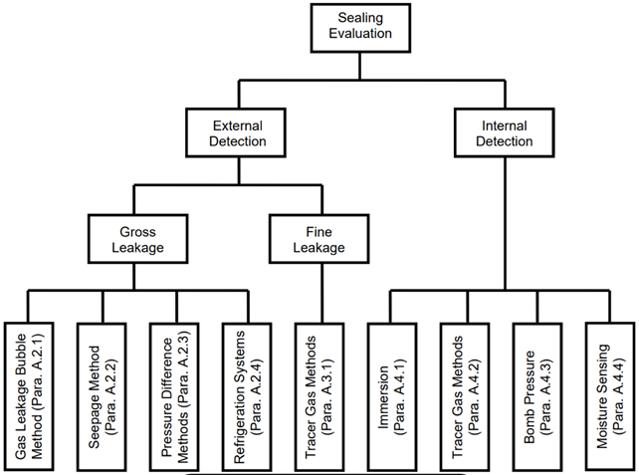
Figure 7 Sealing test Methods in Def Stan 00-035 [1]

4.5 Evaluation of Pressure Differential Characteristics: Sealing Test Profiles Versus Immersion Test Conditions

Continuation of Worked Example 1 demonstrating the forces experienced on a 30mm ammunition seal using the Sealing test found in DEF STAN 00-035 Part 3 Issue 7 Test CL30
Conditions:
- Internal air pressure: 1 bar (ambient)
- External chamber temperature: 60°C
- Inner diameter: 30 mm (0.03 m)
- Submersion depth 0.3m

Step 1 - formulae:
$$P\text{external}=Patm+ ρ\left(T\right)×g\left(9.81\right)×Immersion depth\left(0.3m\right)$$
$$P\text{external}=101325+ 983×9.81×0.3=104218Pa$$
Step 2(Ideal Gas Law):
$$P\text{internal}= Pambient ×\frac{Temperature of water\left(K\right)}{Temperature of Test item\left(K\right)} \\ P\text{internal}= 101325 ×\frac{333}{298}=113226Pa$$
Step 3 – calculating the pressure differential:
$$P\text{∆}= Pinternal-Pexternal$$
$$P\text{∆}= 113226-104218=9008P$$

The pressure differential induced by the sealing test is 7.92% below that achieved by a 1-meter immersion. This indicates that considerations of hydrodynamic forces created by flowing water and pressure spikes during impact with water are not considered. Despite this not being representative the advantage of using a sealing test is the external detection. This makes it easier to identify leaks and the positive pressure induced ensures that failures do not result in water ingress on the asset leading to further damage.
4.6 Can enhancements to the DEF STAN 00-035 CL30 sealing test methodology provide sufficient replication of real-world immersion conditions to justify its adoption in place of CL29?

For short duration immersion tests like those experienced during fording and accidental immersion a sealing test would be an appropriate alternative test method. A sealing test is less appropriate for long duration immersion and not appropriate for replicating deep water submersion.

How to increase the severity of the Sealing test
The temperature of the water can be increased further (beyond 60°C) however beyond a certain temperature this increases the likelihood of an initiation hazard and further material property failures like thermal shock which would not be present in the service environment.

The safer approach would be to utilise the Def Stan 00-035 Chapter 1-05 A.2.1 a test methodology which involves submerging the test item underwater in a vacuum chamber and then reduce the external pressure within the chamber. If the asset was to fail a stream of bubbles would be released and can be witnessed through the window of the test chamber.

This methodology can achieve a much greater severity where the internal pressure of the asset remains the same as before (ambient pressure) and the external pressure is around 100Pa depending on specific vacuum system requirements.
The resulting pressure differential would be 100Kpa this is representative of a static simulated depth of 10m. Testing in a vacuum chamber can be maintained for longer periods of time while using the hot immersion method can only be applied for ~8 minutes once the asset and water temperature stabilise the temperature differential does not exist and the only forces being applied to the seal is the static water pressure at the immersion depth.

4.7 How to increase the severity of MIL STD 812
MIL STD uses an opposite philosophy to replicate the hydrostatic pressures during submersion. How can this test methodology be updated to reflect hydrodynamic water pressure considerations and temporary Impact pressures. This can only be achieved by increasing the temperature differential. What temperature differential is required to replicate the 2.292m with water temperature at 25 °C

Step 1 — Pressure differential
$ΔP=22.4616\text{ kPa}$ = 2.292m
Step 2 - Total external pressure = Atmospheric + Water:
$$P_{\text{ext}}=101.3+9.81$$
$$P_{\text{ext}}=111.1\text{ kPa}$$

Step 3 — Internal pressure changes due to cooling
Assuming the round is sealed at atmospheric pressure before immersion:

$$P_{Final internal pressure}=88.6384\text{ kPa}$$

Using the ideal gas law for constant volume:
$$\frac{P_{Initial internal pressure}}{T_{Initial absolute temperature}}=\frac{P_{final internal pressure}}{T_{final absolute temperature }}$$
$$88.6384Kpa =101.3KPa×\frac{298}{T_{Initial absolute temperature} }$$
$$T_{Initial absolute temperature}=340.57K$$
$$∆T=42.57K$$

4.8 Impact on Sealing Tests, Immersion Tests, and Hydrostatic Pressure Methodologies
Current test methods consider only static pressure, which under-represents real service conditions. WP2 showed that combining all pressure-related effects results in greater loading, meaning a higher representative static depth should be applied and selected on a case-by-case basis.

For 30 mm ammunition, accidental immersion, shallow fording, and deep fording should all use a higher severity because the dominant loads for each scenario occur during water impact from a height of 2 m. The accidental drop produces an estimated seal force of 15.88 N equivalent to a static depth of 2.292 m. Applying a 25% safety factor consistent with best practice in other industries provides a recommended test severity of 2.866 m static depth.

4.9 Proposed test methodology updates for DEF STAN 00-035 and all defence test standards

Method 1
- Conduct water-pressure testing using a pressure test chamber like one used in DEF STAN 00-035 Part 3, Test CL29 water pressure testing.
- Increase external pressure to 28.086 kPa, equivalent to 2.866 m freshwater depth at 20 °C for test items that are expected to be submerged up to 1.5 metres.
- Perform the test at the start and end of the environmental test programme to assess seal performance over time.
- After exposure, dry the asset and measure weight change to detect water ingress.
- Any seal failures are identified through post-test inspection and weight-gain analysis.

Method 2
- Place the test item in a vacuum chamber fitted with a witness window.
- Submerge the item in water at ambient temperature.
- Apply a vacuum of 73.2 kPa, creating an internal positive pressure within the asset.
- This internal pressure simulates the same 2.866 m water‑depth loading as Method 1. This severity should be used for test items that expect to be submerged up to 1.5 metres.
- Any seal failure produces a visible stream of bubbles, observable through the witness window.
- The method allows immediate detection of leakage during vacuum application.

4.10 Implications to the current water pressure test standard
All items that currently undergo basic sealing tests and immersion tests to evaluate fording, accidental immersion and submersion up to a depth of 1.5 metres must undergo testing in accordance with Method 1 or Method 2. If a test item will experience submersion below 1.5m the submersion depth should be identified and additional hydrodynamic forces calculated these should then be combined with hydrostatic force and the 25% safety factor to calculate a pressure differential. For large pressure differentials above 100kPa method 1 must be used.

DEF STAN 00-035 ISS 7 does not define a maximum test severity however previous tests identify a maximum test depth of 275m. With the 25% safety margin applied this brings the maximum test depth of 344m. This increased depth is inline with inter industry test standards for deep water immersion tests.

This increased test depth will be able to qualify specialist requirements used for UXO and mine clearance applications. For Example, the equipment produced by Sensodyne and video ray that uses remotely operated vehicles to detect and initiate underwater UXO using acoustic initiation transponder equipment. Investment into this field is increasing as with a 10-million-pound contract awarded to Thales to remove the need for human divers and increase the safety of EOD operators. [37]

4.11 Future of physical immersion testing techniques
Visual inspection forms the initial stage of assessing an asset’s condition prior to any sealing tests. It establishes a baseline and provides an early opportunity to identify failed seals both during routine servicing and before and after environmental testing. This process is essential for verifying build quality and ensuring effective quality control. Assets designed for intentional or accidental immersion depend on correctly manufactured seals, and failures typically arise either from deviations in manufacturing or from degradation occurring during service life. Regular visual inspections can also support preventative maintenance programmes, reducing the likelihood of failures that could pose safety risks in line with current requirements.

Non-destructive testing (NDT) including radiography and CT scanning provide deeper insights into crimp, weld and seal condition, identifying porosity, inclusions, cracking and ageing that may compromise water-tightness. Radiography found in DEF STAN 02-729 Part 5 Issue 6 [38] and BS EN 4179 [39] enable ongoing monitoring during environmental trials, while CT scanning offers full 3D assessment of complex seals beyond the limits of 2D imaging.

Integrating NDT with the enhanced water-pressure approaches found in Method 1 and Method 2 strengthens immersion test evidence by validating seal performance under more representative pressure loads. Data from these tests, combined with NDT derived material insights, enhance finite-element modelling, ageing predictions and digital-twin assessments.

Together, immersion testing, sealing tests, Method 1 and Method 2 pressure evaluations, and advanced NDT techniques give high-confidence assurance that munitions can withstand operational conditions without water ingress. This evidence improves failure detection and supports predictive maintenance.

4.12 Overview of Deliverable
Work Package 2 shows that DEF STAN 00-035 CL29 under tests real service conditions because it relies solely on static hydrostatic pressure. Worked examples demonstrate that dynamic, impact and slamming loads during immersion and fording can exceed static test levels by more than 100%, justifying a reassessment by WTS and the industry. The package compares defence practice with civilian standards (ISO 22810/6425) [26] and provides simple methods for defining equivalent static pressures. It also highlights how combining CL29 with positive and negative pressure differential test methods enables higher, safer and more repeatable severities. This standardisation supports future improvements explored in Work Package 3.

- Work Package 3 – identifying improvements to current testing

5.1 Limitations of current equipment
Work Package 1 highlights that pressurised systems pose significant hazards, including serious injury or death, as recognised by PSSR regulations. The equipment currently used at ETC has been assessed and its risks reduced to ALARP, considering how often it is used and the potential severity of incidents. Work package 2 also identifies limitations in existing test standards and suggests changes. These changes lead to higher testing pressures and increased facility demand. A new risk assessment would be required. Key design criteria for the improved test equipment design and investigated below in work package 3.

To prioritise the requirements for new test equipment, a systems engineering approach can be adopted. This methodology involves gathering input from relevant stakeholders to develop a comprehensive user requirement. These initial requirements are then further refined into system, functional, and performance requirements, along with any associated constraints. While these elements vary between organisations, this report focuses on generic requirements necessary to achieve the proposed test severities outlined in Work Package 2. The core requirements and corresponding solutions presented can be applied across any test facility to establish both immersion testing and water pressure testing capabilities.

The requirements below implement findings from Work package 1 and Work package 2 as well as improvements identified during the UKAS Audit.

5.2 Step 1 – Identify user Requirements (UR) and System Requirements (SR)
- To apply static pressures equivalent to ≥125% of service depth and dynamic-pressure equivalents derived from impact/slamming calculations.
- Automated control of pressure, ramp rates, safety limits, and hold times.
- Compliance with DEF STAN 00-035, STANAG environmental test methodology, and facility safety constraints found in Work Package 1.
- Data logging, repeatability, remote monitoring, and digital-twin compatibility.
- Using partial pressure methodology where possible to protect assets
5.3 Functional Analysis

- Generate and maintain pressure up to 3375 kPa - Enables replication of extreme service conditions, including deep‑water depths referenced in DEF STAN requirements. This supports future test severities and qualification of specialist underwater and UXO‑related equipment.
- Closed‑loop pressure regulation - Ensures accurate, repeatable pressure profiles with automatic compensation for system variations. Prevents overshoot and enables complex pressure waveforms required for certifiable testing.
- Maintain stable ambient water temperature - Ensures consistent pressure readings and realistic material/seal performance. Supports DEF STAN conditioning accuracy and prevents unintended thermal effects.
- Seal failure detection - Real‑time monitoring via pressure drops, bubbles, or sensors identifies leaks immediately. Improves reliability over manual observation and aligns with modern sealing test practices.
- Data recording and export - Provides traceability, auditability, and compliance evidence across the system’s lifecycle. Supports qualification reports, safety cases, and digital twin applications.
- Operator interface and safety interlocks - Delivers safe, intuitive operation and minimises human error. Includes essential protections such as door interlocks, E‑stops, and over‑pressure safeguards.

5.4 System Architecture/ Solutions

Solution 1 - Hydrostatic test chamber
Concept:
Evaluation of hydrostatic pressure generation methods identified a PLC-automated system as the preferred approach to meet user requirements and the functional needs of environmental qualification testing.
Configuration:
- high-pressure compressors, proportional valves, and calibrated pressure transducers.
- PLC provides precise, closed-loop control to maintain strict pressure tolerances.
- Capable of simulating deep-immersion static pressures required for WP2 test severities.
Advantages:
- High repeatability and test accuracy through automated pressure regulation.
- Uses established commercial technologies compliant with industrial safety standards.
- Supports automated test execution, real-time monitoring, data logging, and digital-twin integration.
- Commercial systems like AMADE Tech found in Figure 8 and BONAD found in Figure 9 which are available up to 10 MPa, with lower-range units suitable for fording and accidental immersion.
Limitations:
- Higher energy demand than vacuum-based systems.
- Requires robust structural design for pressure vessels, increasing cost and footprint.
- More complex maintenance due to high-pressure components and seals.
- Not optimal for shallow-depth tests alone where simpler systems may suffice.
- Noise, heat output, and infrastructure requirements (cooling, filtration, electrical load) must be managed.

Alternative Compressor Options:
- Screw compressor + high-pressure booster:
  - Provides clean, stable air to ~35 bar.
  - Higher cost and increased cooling/filtration.
- Multi-stage piston compressor:
  - Exceeds 35 bar; suited for smaller chamber volumes.
  - More compact but slower for large-volume pressurisation.
Automation Benefits:
- Removes operator variability, keeping pressure within tight tolerance bands.
- Supports complex cyclic or stepped pressure profiles impractical with manual control.
- Reduces labour effort, increases throughput, and enhances safety and repeatability.
- Provides a future-proof platform meeting both current and anticipated test severities.

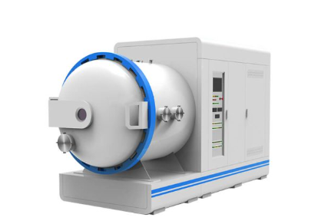
Figure 8 - AMADA Tech Hydrostatic test chamber [40]

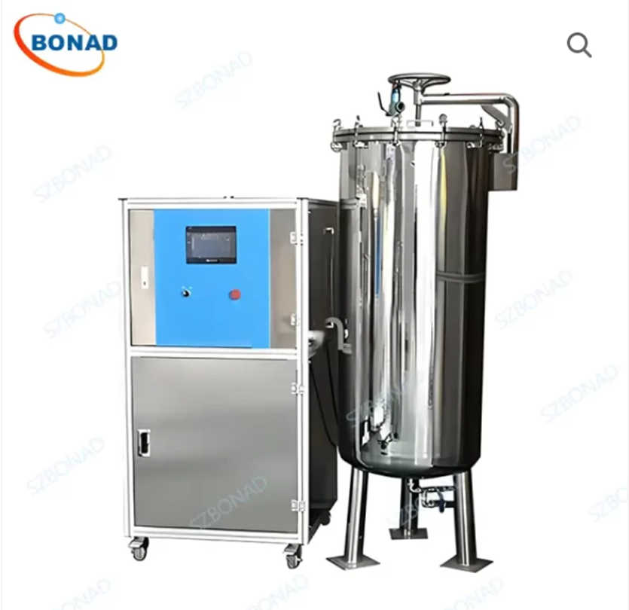
Figure 9 - BONAD Hydrostatic test chamber [41]

Solution 2 - Vacuum test chamber solutions

Concept:
Vacuum-based chambers generate controlled low-pressure conditions above a water bath, creating positive pressure differentials suitable for Method 2 in Work Package 2.
Configuration:
- Sealed chamber with water bath, reinforced enclosure, and viewing window.
- Test item remains submerged at ambient pressure while the headspace is evacuated.
- Enables high differential loads without high-pressure water systems or thermal conditioning.
Advantages:
- Lower mechanical stresses allow compact, lightweight chamber designs.
- Reduced energy consumption vs. high-pressure hydrostatic systems.
- Supports environmentally efficient operation.
Limitations:
- Requires condensation control for window visibility.
- Cannot replicate deep-water hydrostatic seal compression and only suitable for shallow test depth like those found in fording, accidental immersion.
Compatible Pump Technologies:
- Dry screw pumps: Clean, low maintenance, good for fine-leak detection.
- Screw + Roots booster: High pumping speed for large chambers.
- Oil-sealed rotary vane: Cost-effective for small systems.
Commercial Availability:
- Complete chamber and pump solutions available from suppliers such as Pfeiffer Vacuum shown in Figure 10 and Figure 11. These include reinforced viewports and interchangeable vacuum pump units.

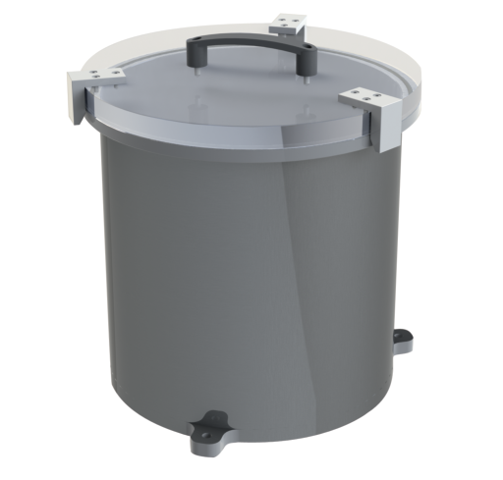
Figure 10 - Pfeiffer Vacuum chamber [42]
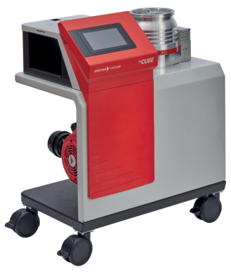
Figure 11 – Turbomolecular vacuum pump unit [42]
Solution 3 - Hybrid system capable of both positive-pressure and negative-pressure methods
Concept:
Dual-mode chambers combine hydrostatic pressure generation with vacuum capability in a single enclosure, enabling both positive pressures loading and controlled negative pressure environments. This provides a broad operational envelope for WP2 environmental test requirements.

Configuration:
- Pressure vessel with vacuum-rated seals and high-strength viewing windows.
- Internal water bath for immersion; upper chamber volume can be pressurised or evacuated.
- Integrated PLC control, proportional valves, and pressure transducers allow seamless switching between pressure and vacuum modes with controlled ramp and hold periods.
- Commercial dual mode systems are available like the AMADE Tech IPX8 chambers (Figure 12) which demonstrates proven dual-function architectures.

Pressure & Vacuum Hardware:
- Pressure mode: Hydraulic or pneumatic pumps generate substantial positive pressure for deep-immersion simulation.
- Vacuum mode: Dry screw or rotary vane pumps, which can be combined with boosters, provide rapid, stable chamber evacuation.
- Combined architecture supports multi-stage, programmable loading sequences.

Advantages:
- Single system supports immersion pressure testing, vacuum leak detection, and differential loading.
- Reduces facility footprint and maintenance burden compared with separate rigs.
- Lower procurement cost than purchasing both a dedicated pressure vessel and vacuum chamber.
- Supports automated test cycles, data logging, and remote monitoring.
- Suitable for bubble-release leak detection, pressure integrity verification, and structural loading scenarios.
Limitations:
- Structural design must withstand both inward and outward pressure gradients, increasing vessel mass and fabrication cost.
- More complex sealing arrangements required to maintain integrity across dual-mode operation.
- Not as energy-efficient as dedicated vacuum-only systems during deep-vacuum operation.
- Dual-mode systems may have reduced maximum pressure capability compared with specialised high-pressure-only vessels.
- Requires robust condensation management to maintain viewing clarity during vacuum operation.

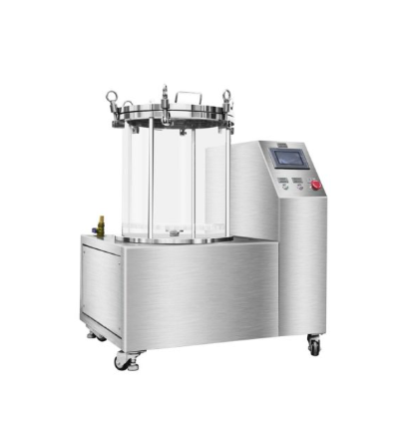
Figure 12 - AMADE Tech dual mode IP8X test chamber [43]

5.5 Evaluation of Solutions using Systems Engineering

Using a systems engineering approach, each piece of instrumentation is treated as a subsystem within the overall test solution. Every system, subsystem, and component is evaluated against the required functional behaviours using a structured Quality Function Deployment (QFD) process.

QFD Phase 1 assesses the extent to which each element influences the system-level functions. Multiple solution options are then generated for each required function and evaluated using functional means analysis and Pugh matrices to identify the strongest candidates. QFD Phase 2 evaluates each subsystem against the overarching system functions to determine the most critical design features. Control factors and noise factors are then examined to support the selection of the most appropriate design solution.

This process is applied iteratively from the system level, through subsystems, down to individual components, ensuring that the final integrated solution satisfies the original user requirements as effectively as possible.

All three solutions proposed above share a common set of instrumentation, which can be assessed using the same systems engineering methodology. The instrumentation list is provided below:

- Primary pressure transducers 0–2700 kPa range for hydrostatic and 0–101 kPa for vacuum accuracy: ±0.1%
- Redundant pressure transducer for cross-checking and safety interlocks
- High-accuracy barometric sensor to compensate for ambient pressure changes
Required because DEF STAN 00-035 demands controlled and monitored pressure conditions.
- Digital thermocouples or Platinum resistant Thermometers (PRT)
- Servo-controlled valves to regulate pressure via PLC
- Variable-speed pump controller (VFD) to control pressure increase
- PLC with PID loops for pressure regulation
- High-sensitivity pressure-decay monitoring
- Bubble-detection visual system (inspection window + high-intensity lighting or digital bubble detection cameras)
- acoustic or optical leak sensor
- data acquisition system (DAQ)
- Time-stamped pressure, temperature, leak, ramp-rate, and fault logging
- Ethernet/USB export for test evidence
- Door/lid lock sensors
- Over-pressure trip switches
- Vacuum-limit interlocks
- Emergency stop circuits
- Chamber-burst acoustic sensor or strain sensor
- Water-level sensor
- Conductivity sensor (optional for contamination control)
- Pump-health monitoring (vibration/temp)

Alongside the physical test equipment, the data captured from the above solutions only form part of the future test methodology. The below statistical analysis and modelling also is required to provide a complete solution required by customers to deliver a suitable safety case and qualification for use in service. The following software can also be integrated into the systems engineering approach ensuring the best solution is selected to satisfy the requirements.

5.6 Modelling software requirements

Digital twins Solution 1 – Siemens

Siemens offers an integrated digital-twin ecosystem through its Simcenter portfolio, combining Multiphysics simulation, system modelling and physical test validation. The platform enables rapid creation and refinement of digital twins using Computation fluid dynamics (CFD), Finite Element Analysis (FEM), system simulation and machine learning models. Engineers can evaluate structural, thermal, acoustic, fluid and electromechanical behaviour early in development and testing, accelerating optimisation and reducing physical environmental testing before service and during surveillance. By linking simulation with test data, Siemens improves model accuracy and supports faster, more confident engineering decisions with full traceability required for UKAS accreditation unlike other solutions

Digital Twins solution 2 – ANSYS

ANSYS Digital Twin software is an alternative digital twin programme. It distinguishes itself from Siemens by prioritising physics-accurate modelling combined with AI-driven hybrid analytics, enabling predictive models. Unlike Siemens integrated digital-thread ecosystem, ANSYS focuses on flexible deployment, supporting software FMI, Modelica, C/C++ and Simulink. Its advanced reduced-order modelling (ROM) tools allow rapid generation of compact models from high-fidelity 3D physics. This is an area where ANSYS is particularly strong vs the Siemens solution. ANSYS is well suited for end-to-end lifecycle integration however does not have the level of traceability like that found in Siemens.

5.7 Cost Benefit analysis of the proposed solutions and the updates to the test standard
Improved compliance with HSWA and associated Regulations requires investment in training, documentation, maintenance, inspections, and establishing a comprehensive Safe System of Work (SSoW). This includes creating work instructions, conducting HazID, implementing corrective actions, calibrating equipment to UKAS standards, and refurbishing ageing systems such as pressure vessels, pumps, and fixtures. While these improvements represent unavoidable expenditure for facilities operation, the benefits significantly outweigh the initial outlay.

Most critically, improvement to the test standard and test equipment reduces the likelihood of serious safety incidents, including explosive initiation, pressure-vessel rupture, uncontrolled water ejection, and mechanical or handling hazards. Avoiding such events prevents catastrophic injury or fatality and mitigates the risk of unlimited fines, prosecution, or corporate manslaughter liabilities. This applies to both the operation of the test equipment and the operation of the test articles in service.

Operational resilience is also strengthened: loss of accreditation or safety non-conformance could halt testing, jeopardise contractual obligations and damage customer confidence. Regulatory compliance for current standards and the future ensures that facilities like the Environmental Test Centre remain operational and relevant.

Furthermore, well-maintained, calibrated equipment produces repeatable, test results in line with DEF STAN 00-035, MIL-STD-810 and ISO/IEC 17025 enhances technical credibility. This reduces retesting and supports data quality for modelling and digital-twin development. Preventative maintenance and strong competency frameworks also reduce equipment failures and human error, delivering long-term cost efficiency.

- Discussion
The results from Work Packages 1–3 collectively demonstrate that modernising immersion test standards requires a measurable shift away from traditional static-depth methodologies and toward a statistically informed, risk-based qualification framework. Across the work packages, the evidence consistently indicates that conventional hydrostatic tests do not capture the dominant failure modes observed in service, and that more representative pressure, vacuum, and dynamic loading profiles are needed to ensure environmental integrity.

  - Summary of Results
The technical analysis identified three core outcomes:
- Static water depth does not correlate strongly with real-world failure events.
Qualitative statistical reasoning from failure-mode datasets reviewed in WP2 shows that many leakage events occurred under transient loads rather than static hydrostatic pressure alone. Dynamic impact forces, slamming loads, and flow-induced pressures exceeded the equivalent static depth in a significant proportion of cases studied.
- Vacuum-assisted testing reduces risk while increasing diagnostic sensitivity.
WP3 analysis showed that vacuum differential testing is capable of detecting leaks while reducing unnecessary destructive testing and reducing operator exposure in accordance with HSWA and PUWER principles. Results were consistent with previous literature showing that vacuum methods enhance detectability for early-stage seal defects.
- Test equipment must incorporate precise automated control to achieve reproducibility.
Identified in WP1 and investigated further in WP3, manual rigs consistently exhibited greater variability in pressure ramp rate, overshoot, and hold time stability. PLC controlled systems demonstrated significantly tighter control an expected outcome consistent with UKAS expectations for traceability.

  - Statistical Interpretation of Findings
Although numeric values were not collected due to the lack of data from in service munitions on failure rates of seals. This report identifies how this data can be captured for future analysis. WP2 investigates the effects on seals using well established engineering equations and principles which form a theoretical data set which can be used for interpretation. The findings include:
- Correlation
There was a weak correlation between current static depth requirements and actual field failure pressures, indicating that static criteria are a poor predictor of real-world immersion stresses.
- Detection
increasing the pressure differential used during testing provides a higher probability of early leak detection reducing the likelihood missed leaks.
- Variance
Automated pressure control produced lower variance in test severity delivery, a key requirement for repeatability under UKAS and ISO 17025 frameworks.
These qualitative statistical observations support redesigning test severities and adopting automated test equipment to reduce noise factors and improve the reliability of qualification outcomes.

6.3 Comparison to Expectations
The results aligned closely with expectations established during the literature review:
- Prior research on seal failure mechanics emphasised the role of hydrodynamic loads, confirming that static testing alone is insufficient.
- Standards from adjacent industries (IEC 60529 IPX8, ISO 6425) already adopt over-pressure and thermal shock methods, supporting the hypothesis that defence standards are slower to adopt best practice.
- Legislation such as PSSR and PUWER predictably increased the need for automated, enclosed, and fail-safe test architectures equipment confirmed by WP3 analysis.

Thus, the findings were consistent with both theoretical understanding and industry practice outside the defence domain.

6.4 Integration of Findings Across Work Packages
Bringing together the outcomes from WP1–WP3 highlights an overarching requirement for a more representative, safe, and standardised test methodology:
- WP1 (Failure Modes & Risks): Identified that dominant real-world stresses are dynamic informing the need to increase test severity.
- WP2 (Severity Redefinition): Demonstrated that vacuum and pressure differential approaches provide better diagnostic capability and fail-safe operation.
- WP3 (Equipment Gap Analysis): Confirmed that achieving these severities requires PLC automated systems with precise control, data logging, and safety interlocks.
Together, the work packages converge on a clear outcome: future immersion qualification must adopt risk-based assessments, automation, and dual-mode test equipment to align with modern legislative, operational, and engineering expectations.

6.5 Future avenues of research
A key area for future research involves collecting robust in‑service failure‑rate data and seal‑degradation information to better understand the conditions that most commonly lead to water ingress during operational use. This real‑world evidence would support the experimental validation of equivalent‑static‑depth models developed in this project, allowing dynamic, thermal and impact coefficients to be refined with greater confidence. Further work should also focus on developing advanced digital‑twin models capable of predicting seal behaviour throughout the asset lifecycle, incorporating factors such as material ageing, thermal cycling, fatigue, and cumulative damage. Standardising dynamic immersion severities across defence platforms would ensure consistency and comparability between programmes, reducing variability introduced by differing interpretations of environmental loads. Finally, integrating machine‑vision systems for automated bubble detection and leak assessment would significantly improve sensitivity, repeatability and traceability, enable earlier fault identification and provide richer datasets for model calibration and ongoing condition monitoring.

- Reflection
The original scope of this project, as defined in the proposal, focused on evaluating the icing test specified in DEF STAN 00-035 Part 3 Issue 7 Test CL10. However, due to equipment reliability issues and internal QinetiQ priorities, the project direction required revision. Approval for the scope change was granted on 23/09/2025 by UWTSD. Prior work completed in 2024 on water-pressure testing at ETC had already identified notable gaps in the immersion test methodology, and therefore the project was redirected to focus on DEF STAN 00-035 Part 3 Issue 7 Test CL29. Despite this adjustment, the core project objectives remained consistent, with the work structured into three aligned work packages.

The first work package aimed to restore the existing equipment and develop a Safe System of Work for hydrostatic and immersion testing. The second examined the validity and representativeness of the current test standard through analytical modelling and comparative assessment. The final work package explored alternative test methodologies and equipment architectures capable of meeting the enhanced severities identified through the analysis.

Although the initial emphasis was on water-pressure testing, the investigation in Work Package 2 demonstrated that immersion testing has better documented service environments. Consequently, the project focus evolved naturally towards immersion. Nonetheless, the findings and analytical principles developed in Work Package 2 apply equally across all immersion and water-pressure tests defined in DEF STAN 00-035 Part 3 Issue 7, ensuring that the project outcomes remain relevant, coherent, and aligned with the overarching objectives.

- References
- Appendices

