Guidance Notes for Seminars

These guidance notes are purely for those that were not able to present their seminars before the University suspended direct class teaching.

As I mentioned in the email, as you are unable to directly present your seminar to the class we are asking you to write detailed notes about how you would have demonstrated your ethical dilemma with your peers.
Within your notes you need to identify clearly the different activities that you were planning to do with your class and acknowledge any resources that you might have been using.
You also need to state how you would have ensured that you kept within the time frame.
In your notes you need to show how you might have asked questions and explore what you would have done to make sure that every person was able to answer something within your seminar.
It is a full overview of your seminar…you are just telling me how you would have completed it.

When you are ready to submit I have put up a Turnitin Portal for you. I haven’t included a Draft on this occasion as this wasn’t the case with the original either.
You will notice that within this single portal there are two sections (see image)
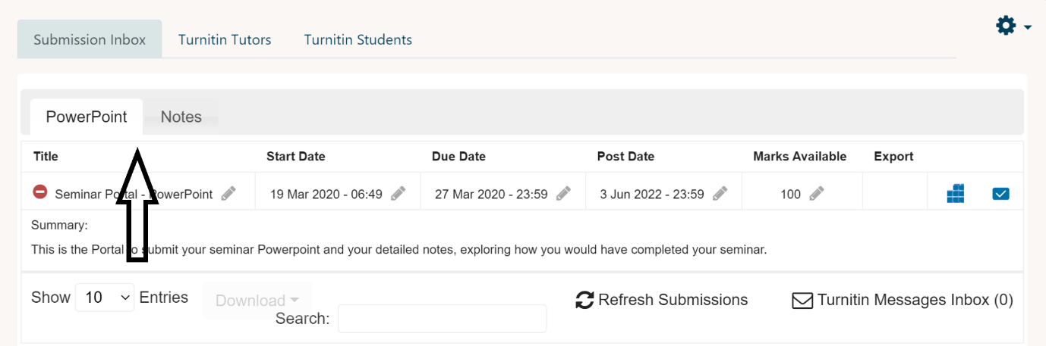

It’s fairly self-explanatory, but please put your PowerPoint slides into one section and your notes into the second section. The reason I’ve had to do this is because Turnitin doesn’t show notes when submitting the PowerPoint Files.
When I have marked everyone’s work you will find the feedback and mark in the Feedback Portal (not this one). This is to make sure that everyone’s is in the same place.

I hope that this is all clear for you, please do get in touch if something doesn’t make sense or you need to ask a question about it.

