MODULE CODE LCBB4001

ACCOUNTING FUNDAMENTALS

STUDENT
Georgiana Sima (1919082)

LECTURER
Widin Bongasu Sha’ven

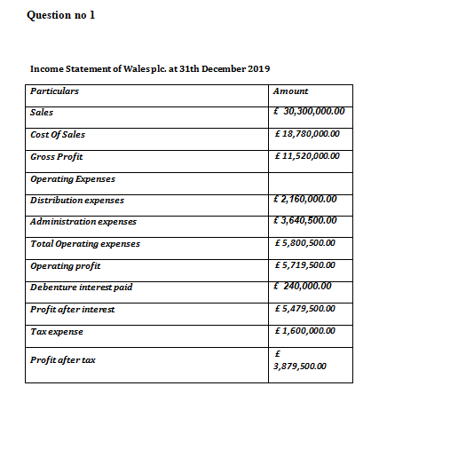

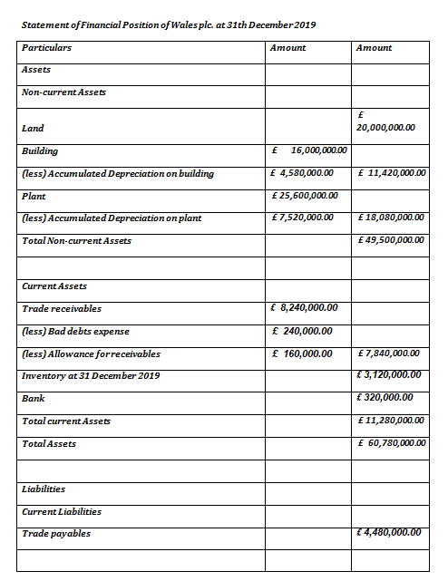

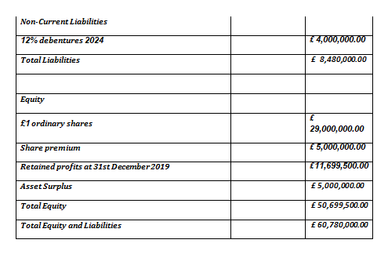

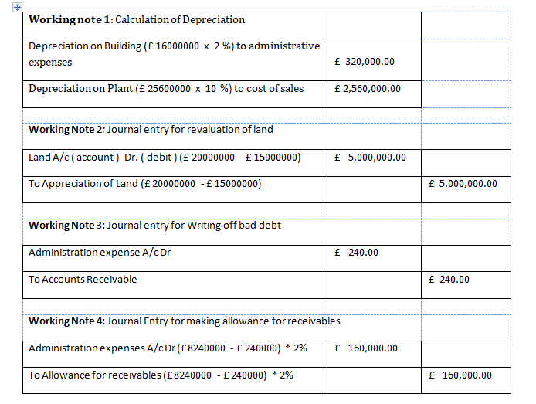

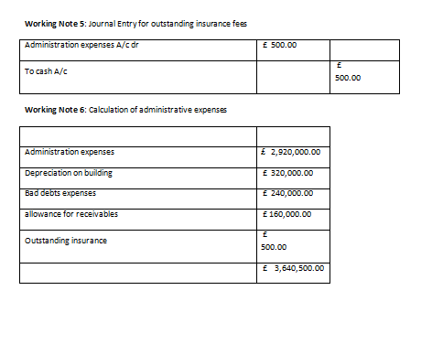

Question 2

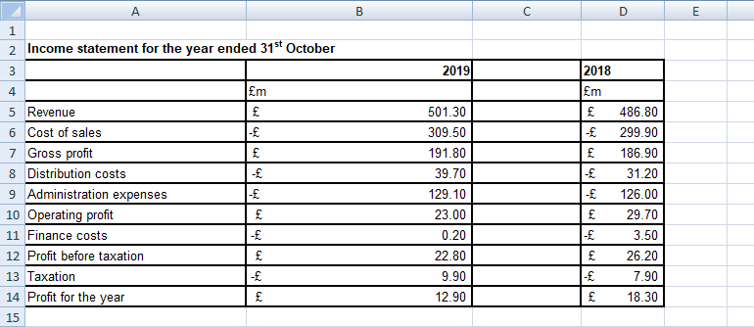
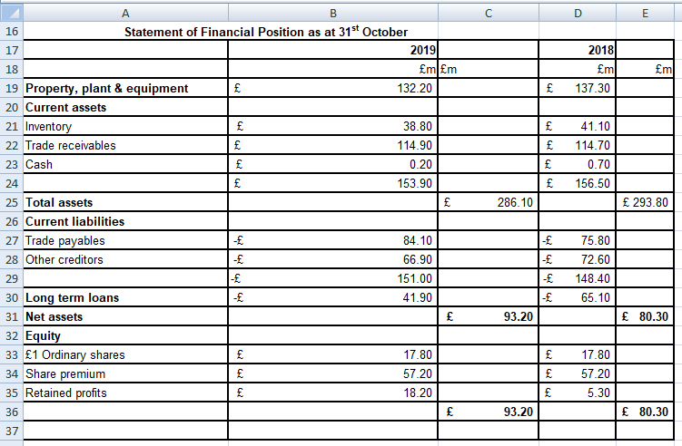

A ) Working notes

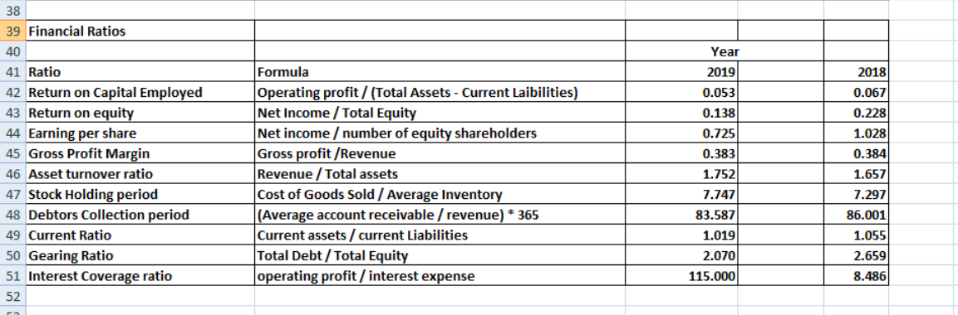

B) Question 2
1. Return on capital employed is used to measure the company’s ability in generating return and profit from the capital that has been invested by the company (Agburuga, 2019). Capital employed includes equity capital, non-current liabilities including debt fund and funds from other debt instruments except short term borrowings. Company’s ROCE for the year 2018 was 0.067 or 6.7 %, this means company generated 6.7 % profit on its capital in 2018 and in 2019 ROCE decreased to 0.053 or 5.3 %, the reason behind this decline was that company made lower profit in 2019 as compared to 2018.
2. Earnings per share(EPS) ratio used to measure the company’s ability in providing return to each shareholder. It is calculated by dividing number of share outstanding with the net profit after tax (Al-Attabi, 2018). EPS is an important measure used by investors for taking investment decision, higher EPS indicates better profitability whereas lower EPS shows poor profitability. Company’s EPS for year £ 1.028 in 2018 and in 2019 it was £ 0.725, company had higher EPS in 2018 as compared to 2019, this shows that company did well in 2018 in terms of providing return to its capital and shareholder as compared to 2019.
3. Return on equity (ROE) allows owners to compare in the same period of time the amount of profit they are entitled to based of their average investments for the exact same time cicle (Atrill and McLaney 2016). In the present case ROE in 2018 was bigger than 2019 , decreasing in 2019 to 0.138 revealing that company made lower profits.
4. Asset turnover ratio is used to measure the ability of company in generating revenue from the assets of company (Thathera2019). It represents the amount of pound that is generated as revenue for each pound of assets. Higher asset turnover ratio represents higher efficiency of company in generating revenue and vice versa. Company’s asset turnover ratio for year 2018 was 1.657, this means company earned £ 1.657 per £ of assets and it was 1.752 in 2019, company’s asset turnover ratio was higher in 2019 because of higher revenue in 2019.
5. Stock holding period is used to measure the company’s ability in turning its inventory into final goods and services. It shows number of times that company’s replaced and sold inventory during a specific period of time (Kwak, 2019). Company’s stock holding period for year 2018 was 7.29, this means company replaced its inventory by 7.29 times it was 7.74 in 2019, company’s stock holding period was higher in 2019 because of higher revenue and Cost of goods sold in 2019.
6. Gearing ratio is used to identify the company’s mixture of funds that is from inside sources like equity share capital and the funds that is from outside sources such as debentures, loan etc (Adabuge, 2018). Company’s gearing ratio for year 2018 was 2.65 and it decreased to 2.070 in 2019, this shows company’s gearing position improved.

Question 3

A) Different users of financial statements.
According to Atrill et al. (2016) there are many groups of users interested in the financial accounting statements but they are more likely to have different needs of information and this will determine what kind of ratio they think useful for decision making .
Shareholders they will be more likely interested in having good returns in relation with their investment associated risk.
Lenders ( credit suppliers of services and goods )on the other half being external users they inclined more likely on the company ability to pay back the owing in a short period of time.
According to Wood et al. (2011), government agencies and competitors may have a specific interest in a company ‘s financial analysis therefore there is no such things as specific points in the financial analysis that can be useful to all users , but there are information that they find to be relevant , in this case they will make further investigation if necessary.

B) Advantages and disadvantages of a regulated regime
According to Weetman (2013), unlike internal users of accounting, external users don’t have access of the business information. And they have to count the integrity and judgment of management to reveal reliable and quality information. However, not all the time information can be reliable, therefore in time have been found that regulation is needed.
Since 2005, regulation of financial reporting has been separated in two different routes depending of the company type. Based on this, we can emphasise that by having regulated reporting regime external users can count on the information answering to some vital questions on the company financial aspects, offering more flexibility depending by the method adopted, but that benefit can lead to manipulation of standards to make a business seem more secure. Reduce the time and effort and it’s helpful to newer investors and in the same time increases some costs of implementation.

C) Limitations of financial ratios
Financial statements reveal us information ,in financial terms , that already happened, information that is in the past. Is almost not possible to closely compare two different businesses who are different just by looking at the financial statements e.g. to compare a car renting company figures with Library would not make sense .Financial statements have sometimes lack of information, but still, is better than having no information at all ( Wood and Sangster, 2011). Based on the historical nature the financial statement is unable to provide present accurate information. Further more there are many factors that are not revealed by past focused in the interests of being subjective in order to manipulate the figures.

References
Umobong, A.A. and Agburuga, U.T., 2019. Agency Cost of Equity and Growth Rate in Relation to Returns on Capital Employed and High and Low Leveraged Firms in Nigeria. International Journal of Economics, Business and Management Studies, 6(2), pp.318-337.
Al-Hisnawi, S.S. and Al-Attabi, S.J., 2018. The possibility of using quantitative models to predict financial failure and its impact On Earnings Per Share: A study of a sample of companies listed in the Iraqi Stock Exchange. Al Kut Journal of Economics Administrative Sciences, 1(30), pp.74-85.
Yadav, P.S. and Thathera, D.R.K., 2019.Impact of Non-Performing Assets (NPAs) on Assets Turnover Ratios of Punjab National Bank Limited.
Atrill, P. and McLaney, E. 2016 2017. Accountig and Finance for Non-Specialists. 10th Ed. Harlow, England: Pearson, pp. 203.
Kwak, J.K., 2019. Analysis of Inventory Turnover as a Performance Measure in Manufacturing Industry.Processes, 7(10), p.760.
Valogo, M.K., Shafiwu, A.B. and Adabuge, J., 2018. Analysis of the Relationship between Interest Rates and Gearing Ratios of Banks Listed on the Ghana Stock Exchange. Asian Journal of Economics, Business and Accounting, pp.1-8.
Atrill, P. and McLaney, E. 2016 2017. Accountig and Finance for Non-Specialists. 10th Ed. Harlow, England: Pearson, pp. 198.
Weetman, P., 2013. Financial Accounting. 6th Ed. Harlow: Pearson Education, pp:85-86-87.
Wood, F. and Sangster, A., 2011. Frank Wood’s Business Accounting 1. 12th Ed. Financial Times Pretince Hall/Pearson pp. 644-645 657

