Name; Dana Bagy
Student Id:2208667

Executive Summary
The opening of Diversity Hotel & Spa in Hong Kong signifies an important milestone in the global hospitality sector. The expansion represents a positive trend in the sector's growth and diversification, with anticipated substantial effects on the broader economic environment. Understanding and integrating local cultural values is essential in this new context. Hong Kong exhibits a unique blend of Eastern traditions and Western influences, highlighting the importance of family, respect, hierarchy, and Confucian values. The GLOBE Project's research on Hong Kong reveals a notable power distance and a strong performance orientation, characterised by a hierarchical organisational structure and a focus on goal setting and merit-based rewards. Cultural intelligence has a notable impact on trust-building, customer experience improvement, and conflict resolution within the hospitality sector. The General Manager must have operational knowledge and cultural competence for the visit. This report examines the cultural dynamics of Hong Kong, points out the significance of cultural sensitivity in our industry, and offers strategic recommendations for respectful and effective development.
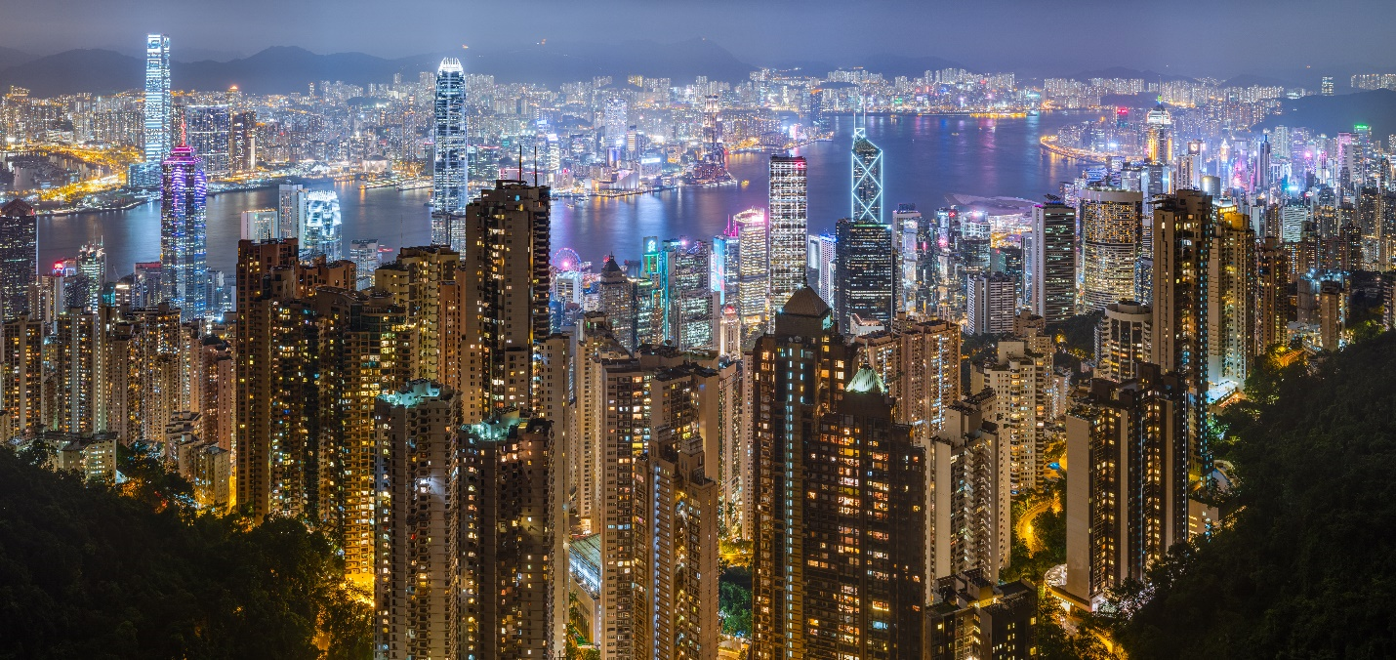

Content Table
Introduction 3
Overview of Hong Kong's Culture 3
GLOBE Project's Country Analysis on Hong Kong 5
Importance of Cultural Intelligence and Sensitivity in the Hospitality Industry 6
Conclusion 8
Recommendation 8
References 10
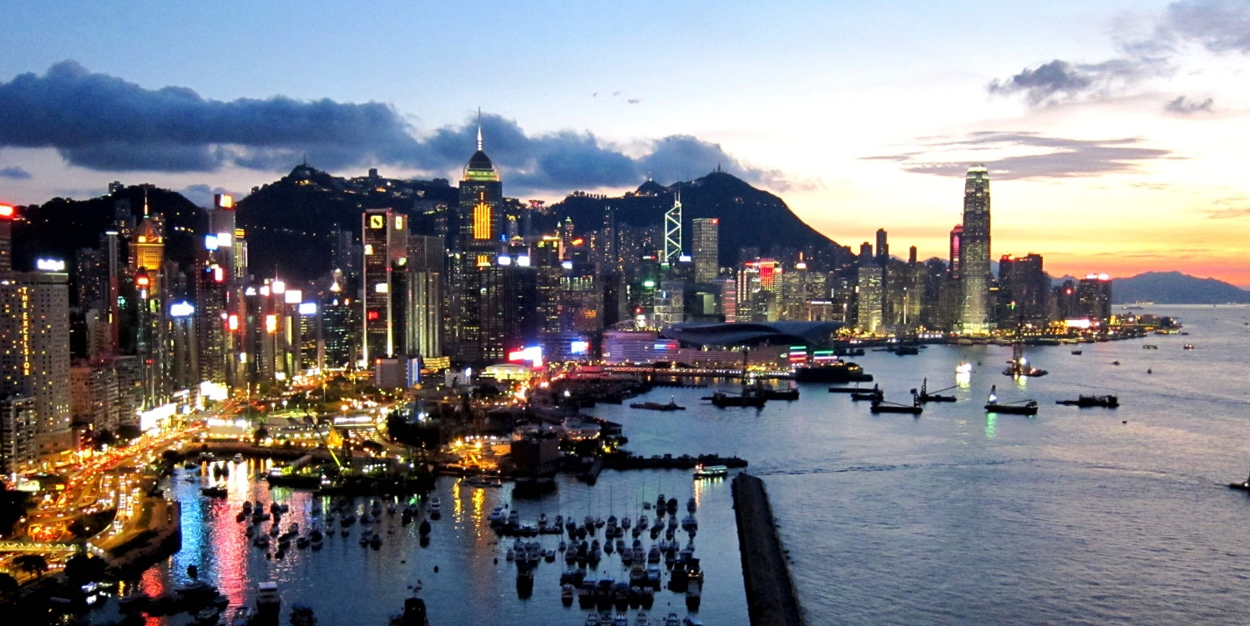

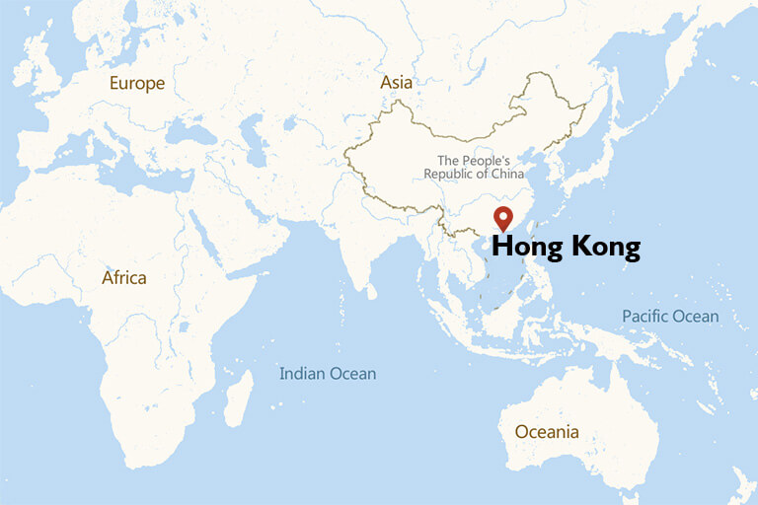
Introduction
The opening of The Diversity Hotel & Spa to Hong Kong represents a significant milestone in our journey, presenting both opportunities and challenges. Understanding the cultural foundation of this metropolis is crucial as we strive to establish a presence. Hong Kong's workplace dynamics and communication styles are distinct due to its historical dimension and the blending of Eastern and Western values. This report seeks to provide a thorough analysis of the cultural details in the region, utilising established frameworks such as the GLOBE Project. With this knowledge, a General Manager can effectively lead training initiatives to align brand standards with local customs and expectations.
2. Overview of Hong Kong's Culture
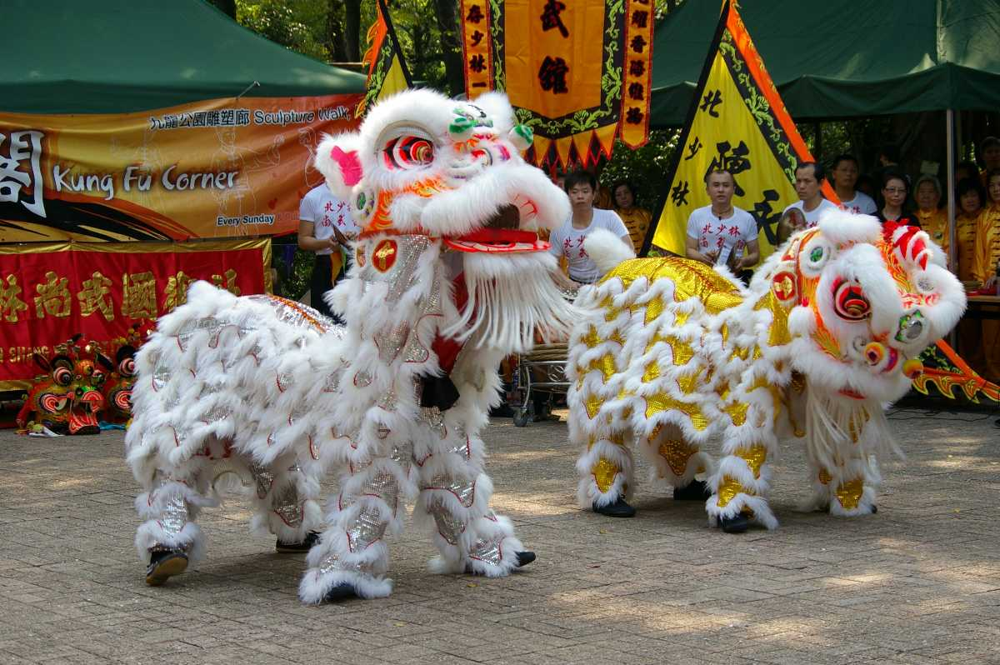
Hong Kong's culture, named "the pearl of the Orient," is a mash-up of its colonial past with traditional Chinese traditions. The country's existence being a British colony has left behind a heritage of Western influences that blend smoothly with ancient Eastern traditions. The city's deep harbour and advantageous location have also contributed to its cosmopolitan character by making it a melting ground for many Asian civilizations (Quah, 2018).
2.1 Historical Context
Hong Kong, a former British colony until its handover to China in 1997, has skillfully blended Western modernism with traditional Eastern values. The distinct combination is apparent in its architectural style, culinary offerings, cultural celebrations, and everyday social exchanges (Ng, 2009).


2.3 Workplace Dynamics in Hong Kong
The Hong Kong workplace often reflects these societal values. According to Nicolson (2016) hierarchy is upheld, with leaders expected to demonstrate care for their subordinates, reflecting familial values. Decision-making is typically hierarchical but also illustrates the achievement of collective agreement, highlighting the significance of maintaining harmony.
2.4 Communication Styles and Etiquette
According to Gurung (2017) communication in Hong Kong is typically subtle and indirect, aligning with its high-context culture. Non-verbal cues, like body language and tone, are essential. Politeness and face-saving are highly valued, necessitating outsiders to engage in interactions with sensitivity and respect.

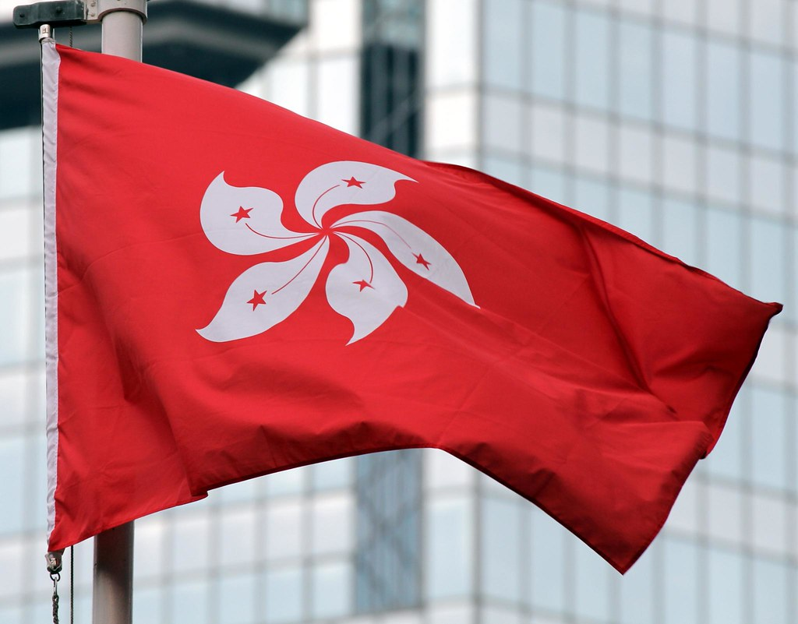
3. GLOBE Project's Country Analysis on Hong Kong
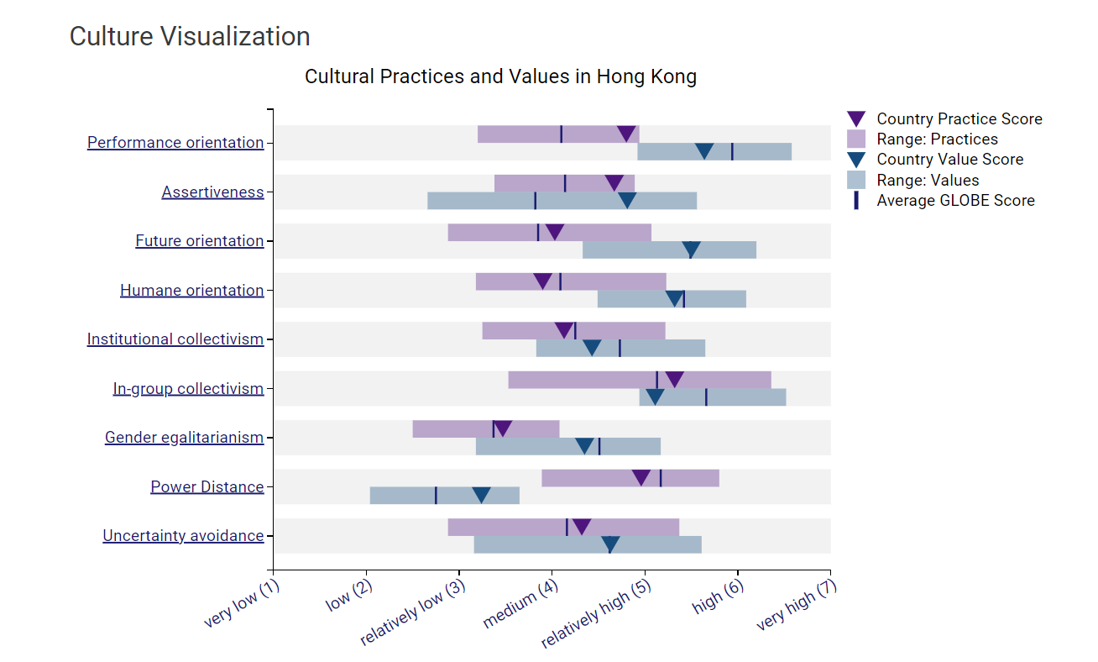The GLOBE Project's research offers valuable insights into the cultural orientations of various countries, providing a structured lens for understanding Hong Kong's complex cultural substance.
3.1 Power Distance
Hong Kong demonstrates a high-power distance, indicating a societal acceptance and anticipation of power disparities and hierarchical structures. In professional settings, there is typically a hierarchical structure where employees rely on their supervisors for direction (Javidan and Dastmalchian, 2009).
3.2 Uncertainty Avoidance
The territory shows a moderate degree of uncertainty avoidance. The residents of Hong Kong possess adaptability and resilience, yet they exhibit a preference for structured environments, particularly in professional settings (Tung and Verbeke, 2010).
3.3 Collectivism
Hong Kong exhibits a preference for collectivism rather than individualism. This highlights the significance of collectives, such as groups, families, or organisations, in comparison to individuals. In business contexts, this often entails making decisions collectively and prioritising teamwork (Javidan and Dastmalchian, 2009).
3.4 Performance Orientation
According to Tung, and Verbeke (2010) Hong Kong prioritises achievements, results, and actions due to its strong performance orientation. Businesses are typically driven by goals and commonly employ merit-based reward systems.
3.5 Insights from Hall’s High and Low Context Cultures
Hong Kong, being a high-context culture, heavily relies on non-verbal cues and communication context. Comprehending this nuance is vital for successful interpersonal communication (Cardon, 2008).

4. Importance of Cultural Intelligence and Sensitivity in the Hospitality Industry
Cultural intelligence and sensitivity are crucial factors in the success or failure of ventures in the global hospitality industry, particularly in diverse regions such as Hong Kong.
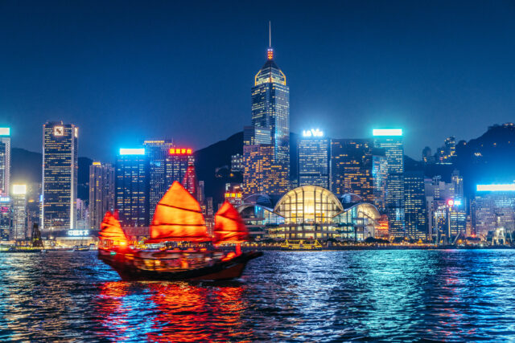
4.1 Building Trust and Relationships
Cultural sensitivity promotes trust. Acknowledging and valuing local customs and values improves relationships with employees, suppliers, and partners, leading to more seamless operations and collaborations (Lam, Cheung, and Lugosi, 2021).
4.2 Enhancing Customer Experience
Hotel guests come from diverse cultural backgrounds. Staff equipped with cultural intelligence can provide customised services, anticipate requirements, and prevent potential social blunders, improving the overall guest experience (Lam, Cheung, and Lugosi, 2021).


4.3 Conflict Resolution in a Diverse Setting
Misunderstandings frequently arise from differences in culture. A high level of cultural intelligence allows individuals to accurately interpret the underlying intentions behind actions or words, leading to the resolution of conflicts at their fundamental source rather than addressing them on a superficial level (Chan, and Goto, 2003).
4.4 Collaborative Work Environment
A culturally sensitive environment promotes inclusivity. When teams perceive themselves as valued and understood, it results in enhanced collaboration, innovation, and job satisfaction.
In the hospitality industry, where human interactions are central to business, developing cultural intelligence is not only desirable but also strategically necessary (Belias and Koustelios, 2014).
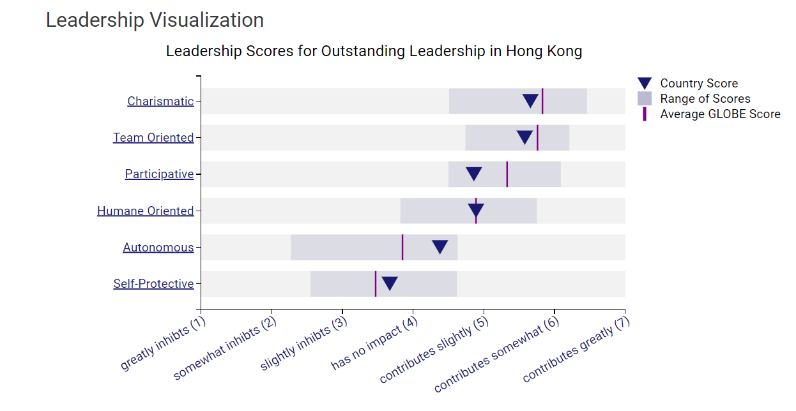

5. Conclusion

Cultural intelligence is crucial for the successful operation of The Diversity Hotel & Spa in Hong Kong. Hong Kong's cultural fusion of Eastern and Western elements, along with its distinct work environment and communication approaches, offer both advantages and challenges. By utilising insights from the GLOBE Project and recognising the importance of cultural sensitivity, particularly in the hospitality industry, we are more prepared to navigate this unfamiliar environment. Incorporating cultural differences and adhering to brand standards will facilitate a prosperous and harmonious expansion in this dynamic city.

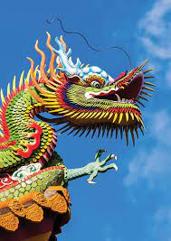
Recommendations for Cultural Sensitivity in Hong Kong
According to a journal conducted by Kaur (2016) on cultural competence, the following recommendations have a significant impact on cultural sensitivity in Hong Kong:
1. Respect for Hierarchy: Hong Kong's high-power distance means that individuals often respect authority and seniority. Address customers with titles like "Mr." or "Ms." unless advised otherwise.
2. Gift-giving Etiquette: When presenting gifts, it is important to use both hands for giving and receiving. To prevent any negative connotations, it is advisable to refrain from using white wrapping, which is traditionally associated with mourning. Similarly, it is prudent to avoid sets of four, as this number is commonly linked to notions of bad luck.
3. Personal Space: Personal space is highly valued, despite its density. Minimise physical contact, particularly with individuals of the opposite gender.
4. Respect for Traditions: Familiarise with prominent festivals and customs, such as the Lunar New Year and the Mid-Autumn Festival. Please stay away from scheduling significant meetings on these particular days.
5. Dining Etiquette: Wait for the eldest person to start eating first. If using chopsticks, never stick them upright into a bowl of rice—it resembles a funeral ritual.
6. Dress Code: Hong Kong tends to have conservative tendencies. Appropriate attire, characterised by professionalism and modesty, is crucial, particularly in the context of business meetings.
7. Business Card Etiquette: When given a business card, it is customary to receive it with both hands and briefly examine it as a sign of courtesy, before carefully storing it.

References

- Belias, D. and Koustelios, A., 2014. Organizational culture and job satisfaction: A review. International review of management and marketing, 4(2), pp.132-149.
- Cardon, P., 2008. A Critique of Hall's Contexting ModelA Meta-Analysis of Literature on Intercultural Business and Technical Communication. Journal of Business and Technical Communication.https://www.researchgate.net/publication/240709593_A_Critique_of_Hall's_Contexting_ModelA_Meta-Analysis_of_Literature_on_Intercultural_Business_and_Technical_Communication
- Chan, D.K.S. and Goto, S.G., 2003. Conflict resolution in the culturally diverse workplace: Some data from Hong Kong employees. Applied Psychology, 52(3), pp.441-460.
- Gurung, S., 2017. Legal interpreters for ethnic minorities in Hong Kong: identities and cultural mediation (Doctoral dissertation, Hong Kong Baptist University).
- Javidan, M. and Dastmalchian, A., 2009. Managerial implications of the GLOBE project: A study of 62 societies. Asia Pacific Journal of Human Resources, 47(1), pp.41-58
- Kaur, B., 2016. Cultural competent care in Hong Kong. International Journal of Social Science and Humanity.
- Lam, R., Cheung, C. and Lugosi, P., 2021. The impacts of cultural and emotional intelligence on hotel guest satisfaction: Asian and non-Asian perceptions of staff capabilities. Journal of china tourism research, 17(3), pp.455-477.
- Ng, J., 2009. Paradigm city: Space, culture, and capitalism in Hong Kong. SUNY Press.
- Nicolson, K., 2016. Landscapes lost and found: appreciating Hong Kong’s heritage cultural landscapes. Hong Kong University Press.
- Quah, E., 2018. Choreographing and Reinventing Chinese Diasporic Identities-An East-West Collaboration.
- Tung, R.L. and Verbeke, A., 2010. Beyond Hofstede and GLOBE: Improving the quality of cross-cultural research. Journal of International Business Studies, 41, pp.1259-1274.
- Tung, R.L. and Verbeke, A., 2010. Beyond Hofstede and GLOBE: Improving the quality of cross-cultural research. Journal of International Business Studies, 41, pp.1259-1274.

