Saba Parveen-2014411
Module code- BMHP5003_BIRM
Muhammad Humza Saeed
iNTRODUCTION TO PYSIOLOGY PART 2-REPORT

Contents
Introduction 2
Case report 3
Normal and abnormal physiology and anatomy of the respiratory system. 4
Care plan- recommendations 6
Conclusion 9
References 9

Introduction
This case study report is based on an individual called Sally who suffers from asthma. The aim of this case study is to develop a health assessment plan which will include all elements of the physiology of the respiratory system looking into the normal and abnormal physiology, identify health issues and discuss the impact and contribution to normal and abnormal physiology of the respiratory system. I will then conclude by summarising the key findings and reflect on my learning.

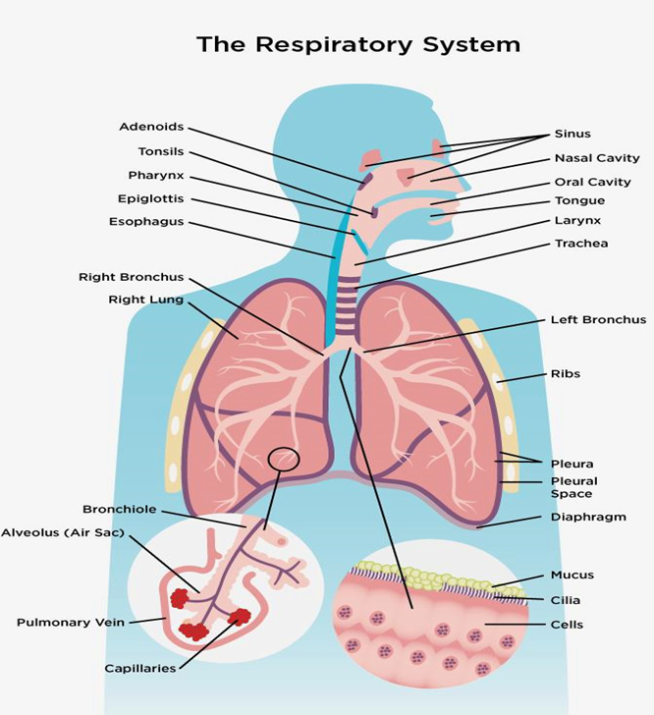

Case report
This case study will focus on Sally who is a 36-year-old who suffers with a condition called Asthma. A health assessment report was taken, and her current health state was revealed in a recent health assessment questionnaire. Sally’s height is 5ft5 with a weight of 118kg. Her body mass index (BMI) is 35. This shows that she is classified as obese. Obesity is generally defined as a BMI of 30 to 39.9 or higher for adults (NHS, 2019). Sally smokes between 8-9 cigarettes a day. She has a family history of asthma and heart attacks as her mother and grandmother are both asthmatic and her mother has suffered a heart attack at a very early age of 35. Sally also suffers from depression and anxiety. She lives with her partner. Her lifestyle is consisting of very little to no exercise and her diet is poor which consists of eating a mixture of meats, regular chips and fries and eating frozen meals 3-4 times a week. Sally has recently developed this condition a year ago and due to her smoking addiction of years, causes frequent breathing difficulties resulting in regular asthma attacks. The aim of this study is to create a care plan for Sally to follow in order to maintain and manage her health at home.

Normal and abnormal physiology and anatomy of the respiratory system.
The network of organs and tissues that makes it possible for you to breathe is known as the respiratory system. It is made up of your lungs, blood vessels and airways which includes muscles that move the lungs. Together, these parts move oxygen around the body and get rid of waste gases such as carbon dioxide Cleveland Clinic, (2020). The production of energy for the organs and muscles requires oxygen which is needed to live. The process of exchanging gases is how the respiratory system removes carbon dioxide from the blood and replaces it with new oxygen to the blood (Hirsch, 2018). The lungs are important organs of the respiratory system which form a pyramid structure and are paired. They are connected to the trachea by the right and left bronchi. These organs are separated into two sections: the upper respiratory tract and the lower respiratory tract (Iftikhar, 2018).
The way in which a normal respiratory system works is when air enters the upper airways via the nasal cavity and travels down to the back of the throat where it enters the windpipe, which is separated into bronchial tubes. As the bronchial tubes move through the lungs, the divided into smaller airways called bronchioles. Alveoli are tiny air sacs at the end of the bronchioles. The tiny blood vessels that surround the alveoli are called capillaries (Ratini, 2021). This is where oxygen from inhaled air passes into the blood. Blood returns to the heart after it has taken in oxygen. When it reaches the cells of tissues and organs, it is transported through the body by the heart. Carbon dioxide is released into the bloodstream when cells utilise oxygen. Exhalation rids the body of carbon dioxide as it returns to the lungs via the bloodstream (Canadian Lung Association, 2019). Oxygen and carbon dioxide are exchanged in the body via inhalation and exhalation. The diaphragm, a big dome shaped muscle located under the lungs, aid in the process (Nursing Times, 2018).

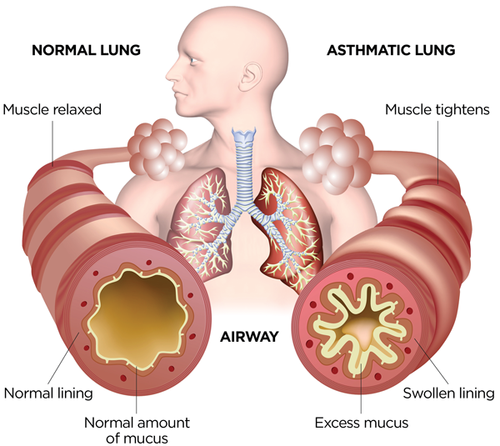

Asthma is a long-term lung condition that Sally suffers with. There are 5.4 million people in the UK who suffer from asthma (Asthma UK, 2021). This is where airways become constricted and swollen, and the body may create more mucous that normal. This can make it harder to breathe, which in turn can cause coughing, a whistling sound, wheezing, and shortness of breath (Mayo Clinic, 2022). There are many subtypes of asthma, and these differ according to the underlying reasons or triggers that cause asthma symptoms. Although asthma is not infectious, there is a correlation between having family of the condition and an increased risk of developing asthma. It typically manifests itself throughout childhood, however, it can occasionally manifest itself in adulthood later in life (Vitaminology, n.d.).
Swelling (inflammation) of the airways that carry air in and out of the lungs is what causes asthma. The tubes become extremely sensitive as a result, and they momentarily narrow. It might occur at random or upon exposure to a trigger such as: allergies to pet dander, house and dust mites, flowers, smoke, pollution and chilly weather, and cold and flu type infections (NHS, 2021). An inhaler, a little device that allows you to breathe in medicine, is typically used to treat asthma. Asthma inhalers can be divided into two categories: relieved inhalers, which are used only when immediate relief from asthma symptoms is required and preventer inhalers, which are used daily to avoid the onset of asthma symptoms (National Asthma Council Australia, 2019).

Care plan- recommendations
Sally’s case report states that her mother also suffers from this condition which indicates that it could be a family related condition. Asthma is a multifaceted condition that can be caused by both hereditary and environmental factors (Bijanzadeh, Mahesh and Ramachandra, 2011).
To effectively manage asthma, it is important to identify the variables that bring on an episode and then take precautions to avoid those triggers. The following will state some triggers, and recommendations on tips to avoid them.

Smoking
Sally smokes anything between 8-9 cigarettes a day. Tobacco smoke contains irritants that can get lodged in the moist lining of a person’s airway when they take a drag. These compounds have the potential to bring on an asthma attack (https://www.facebook.com/WebMD, 2002). Sally first step into her care plan can be to reduce her tobacco intake by taking the stop smoking treatments. Stop smoking treatments are designed to reduce your desire to smoke and eventually lead to quit smoking altogether. Some ways to help people stop smoking use nicotine. Because nicotine is addicting, it can be hard to stop smoking, however, the amount of nicotine in products that help people to stop smoking is lower than in tobacco and the way the nicotine is delivered for example: in patches or gum makes it less addictive then smoking. Asthma risk is greatly reduced if you quit smoking, as the lungs begin to rid themselves of the pollutants and the symptoms of asthma should subside within a few days (Asthma UK, 2020).
Diet
Sally needs to adjust her diet as her diet is very poor with very little to no intake of fruit and vegetables. She should reduce the unhealthy foods such as frozen meals 3/4 times a week. Eating to maintain a healthy weight is important as being overweight can worsen asthma. Sally’s weight is 118kg and has a BMI of 35 which is exceptionally high. The range of 18.5 to 24.9 is what medical professionals agree constitutes a healthy BMI for women (www.medicalnewstoday.com, 2020). Good nutrition is essential for everyone, but especially for those with long-term health conditions. People with asthma may benefit from eating foods and taking supplements with vitamin D, vitamin C, vitamin E, beta carotene, antioxidants like selenium and flavonoids, and whole grains.
Vitamin D- It improves lung function and reduces upper respiratory infections. Salmon, tuna, and mackerel are good sources of vitamin D.
Fresh fruits and vegetables- Consuming a diet rich in fresh fruit and vegetables are good as they are a good source of antioxidants, which may help reduce lung swelling and irritation caused by chemicals known as free radicals. These chemicals are known to damage cells in the body (Li, 2017).
Vitamins- antioxidants are found in large amounts in fresh fruits and vegetables. These hep the body get rid of toxins that can harm tissues. Citrus fruits, kiwi fruit, strawberries, broccoli, and tomatoes are all high in vitamin C. Nuts, sunflower seeds and broccoli are good sources of vitamin E and carrots, sweet potatoes, leafy greens such as spinach are good sources of beta carotene. Foods that contain flavonoids include apples, berries and grapes, and foods that contain selenium include dairy products, bread, cereal, eggs, and poultry. Foods that contain whole grains include whole wheat pasta, whole oats, and bulgur wheat (www.medicalnewstoday.com, 2020).
Exercise
Sally must make time in her schedule to engage in physical activity. This can be done by going for a 10-15 minute walk daily to start with and then gradually increasing the time of these walks every day. The benefits of exercise include an increase in lung capacity as well as a reduction in inflammation, both of which contribute to overall improvement in lung health. Regular exercise will also help sally to lose weight resulting in a healthy weight which will also benefit her health (Healthline, 2020). It is in Sally’s best interest to work toward achieving a healthy weight. She will need to burn more calories than her intake to successfully lose weight. This will require her to consume less food and drink while simultaneously increasing the amount of physical exercise she engages in. The quality of life, lung function and overall health that can be achieved via regular physical exercise should be encouraged for those with asthma. Weight loss should be an advocated in obese asthmatic patients, since it has several health benefits, including a reduction in asthma symptoms (Stoodley et al., 2019).

Anxiety and depression
Sally also suffers from anxiety and depression. The reason for this is unknown however asthma patients who are depressed are more likely to have poorer outcomes. Having depression may make asthma symptoms worse. For example, if you are already feeling apprehensive, the sensation of breathlessness may be even more uncomfortable (Asthma.net, 2016). To avoid these triggers, Sally can introduce the mindful breathing and observation in her lifestyle. The first step in mindful breathing is to take slow breaths in and out. Then you take a breath in through the nose and out through the mouth for 7 seconds. You then take a deep breath in for 7 seconds, hold it for 7 seconds and let it out for 7 seconds. This helps to let go of other thoughts and just live in the moment. This is usually carried out 3 times. Research has demonstrated that practising mindful breathing and observation can lower stress levels and improve overall health (www.aafa.org, n.d.).
As discussed above, it is recommended that Sally adapts the above care plan in her lifestyle to maintain overall good health. Choices in lifestyle and health behaviours can have a significant impact on a person’s level of exposure to asthma triggers, however, it is possible to live a long and healthy life with asthma despite the fact there is currently no cure for the condition (How Lifestyle Affects Asthma Among Washington Residents, 2015).

Conclusion
This case study was based on Sally, a 36-year-old with asthma. Her BMI revealed that she is identified as obese. She has only recently developed this chronic condition and with her smoking addiction and poor lifestyle, results in regular asthma attacks. Sally’s asthma is not the only cause for concern but also her being obese as it is stated that being overweight can worsen asthma. The objective is to get Sally to implement some lifestyle changes. This includes changing her diet and introducing a combination of fresh fruit and vegetables along with Vitamins. Sally also needs to reduce her smoking intake by taking the stop smoking treatments which can eventually lead to her quitting altogether. Regular exercise, going on 10–15-minute walks and gradually increasing them to get her down to a healthy weight is important. Regular exercise will also help sally to lose weight resulting in a healthy weight which will also benefit her health (Healthline, 2020). Sally suffers with anxiety and depression, and this can have an impact on asthma. It is significant that Sally introduces the mindful breathing techniques into her lifestyle. This is believed to lower stress levels and improve overall health. Although it is stated that there is no cure for asthma, it is still possible for Sally to live a long and healthy life by implementing these changes.

References

- Asthma UK (2020). Quit smoking. [online] Asthma UK. Available at: https://www.asthma.org.uk/advice/manage-your-asthma/quit-smoking/.

- Asthma UK (2021). What is asthma? [online] Asthma UK. Available at: https://www.asthma.org.uk/advice/understanding-asthma/what-is-asthma/.

- Asthma.net. (2016). How Is Asthma Related To Anxiety And Depression? [online] Available at: https://asthma.net/symptoms/anxiety-and-depression.

- Bijanzadeh, M., Mahesh, P.A. and Ramachandra, N.B. (2011). An understanding of the genetic basis of asthma. The Indian Journal of Medical Research, [online] 134(2), pp.149–161. Available at: https://www.ncbi.nlm.nih.gov/pmc/articles/PMC3181014/#:~:text=It%20is%20a%20complex%20dise

- Canadian Lung Association (2019). Respiratory system | the lung association. [online] Lung.ca. Available at: https://www.lung.ca/lung-health/lung-info/respiratory-system.

- Cleveland Clinic (2020). Respiratory System: Functions, Facts, Organs & Anatomy. [online] Cleveland Clinic. Available at: https://my.clevelandclinic.org/health/articles/21205-respiratory-system#:~:text=The%20respiratory%20system%20is%20the.

- Healthline. (2020). Exercise for Asthma: Best Exercises, Benefits, and More. [online] Available at: https://www.healthline.com/health/asthma/exercise-for-asthma#when-to-see-a-doctor.

- Hirsch, L. (2018). Lungs and Respiratory System (for Teens) - KidsHealth. [online] Kidshealth.org. Available at: https://kidshealth.org/en/teens/lungs.html.

- How Lifestyle Affects Asthma Among Washington Residents. (2015). [online] Available at: https://doh.wa.gov/sites/default/files/legacy/Documents/8380//345-340-AsthmaLife-en-L.pdf.

- https://www.facebook.com/WebMD (2002). Smoking and Asthma. [online] WebMD. Available at: https://www.webmd.com/asthma/guide/smoking-and-asthma.

- Iftikhar, N. (2018). Breathtaking Lungs: Their Function and Anatomy. [online] Healthline. Available at: https://www.healthline.com/human-body-maps/lung#respiratory-system.

- Li, J. (2017). Asthma diet: Does what you eat make a difference? [online] Mayo Clinic. Available at: https://www.mayoclinic.org/diseases-conditions/asthma/expert-answers/asthma-diet/faq-20058105.

- Mayo Clinic (2022). Asthma - Symptoms and causes. [online] Mayo Clinic. Available at: https://www.mayoclinic.org/diseases-conditions/asthma/symptoms-causes/syc-20369653#:~:text=If%20you%20have%20asthma%2C%20the.

- www.medicalnewstoday.com. (2020). Asthma diet: What to eat and avoid. [online] Available at: https://www.medicalnewstoday.com/articles/asthma-diet#Foods-to-avoid.

- National Asthma Council Australia (2019). The National Asthma Council Australia. [online] Nationalasthma.org.au. Available at: https://www.nationalasthma.org.au/understanding-asthma/how-is-asthma-managed.

- NHS (2019). Obesity. [online] www.nhs.uk. Available at: https://www.nhs.uk/conditions/obesity/.

- NHS (2021). Asthma. [online] NHS. Available at: https://www.nhs.uk/conditions/asthma/.

- Nursing Times (2018). Every breath you take: the process of breathing explained | Nursing Times. [online] Nursing Times. Available at: https://www.nursingtimes.net/clinical-archive/respiratory-clinical-archive/every-breath-you-take-the-process-of-breathing-explained-08-01-2018/.

- Ratini, M. (2021). How the Lungs and Respiratory System Work. [online] WebMD. Available at: https://www.webmd.com/lung/how-we-breathe.

- Stoodley, I., Williams, L., Thompson, C., Scott, H. and Wood, L. (2019). Evidence for lifestyle interventions in asthma. Breathe, 15(2), pp.e50–e61. doi:10.1183/20734735.0019-2019.

- Vitaminology. (n.d.). What Causes Asthma? [online] Available at: https://www.vitaminology.co/articles/respiratoryandlung/what-causes-asthma [Accessed 24 Jul. 2022].

- What Happens in Your Airways When You Have Asthma? | Asthma and Allergy Foundation of America (aafa.org)

- www.aafa.org. (n.d.). Emotions Can Trigger Asthma Symptoms | AAFA.org. [online] Available at: https://www.aafa.org/emotions-stress-depression.aspx#:~:text=Strong%20emotions%20and%20stress%20are.

- www.le.ac.uk. (n.d.). Anatomy and Physiology of Respiratory System Tutorial. [online] Available at: https://www.le.ac.uk/pa/teach/va/anatomy/case2/frmst2.html.

- www.medicalnewstoday.com. (2020). BMI for women: Calculator, chart, and pros and cons. [online] Available at: https://www.medicalnewstoday.com/articles/bmi-for-women.

LIFESTYLE QUESTIONNAIRE

Introduction:

In order to help us focus our Health Promotion activities in the practice, we would be grateful if you could fill in this short questionnaire. If you have already completed one on a previous visit, please return this questionnaire to the receptionist.

Name Sally Jones Date of Birth 26/05/1986
Do you smoke? Yes [ ] No [ ]
smoke less than 1 | cigarette/day |  | [ | ]
1 – 9 | cigarettes/day |  | [ | ]
10-19 | cigarettes/day |  | [ | ]
20-39 | cigarettes/day |  | [ | ]
more than 40 | cigarettes/day |  | [ | ]
smoke a pipe |  |  | [ | ]
smoke cigars |  |  | [ | ]
If No, have you –

never ever smoked  given up smoking in the last year not smoked for more than 1 year |  | [  [  [ | ]  ]  ]

Do you have high blood pressure? | Yes | [ | ] | No | [ | ]
Have you ever had a heart attack or suffered from angina? | Yes | [ | ] | No | [ | ]

Have you ever had a stroke, “shock”
or any weakness down one side? Yes [ ] No [ ]

Have any of the following – mother, father, brothers or sisters had:
a heart attack below the age of 60 | Yes | [ | ] | No | [ | ]
a heart attack above the age of 60 | Yes | [ | ] | No | [ | ]
a stroke | Yes | [ | ] | No | [ | ]
trouble with very high cholesterol | Yes | [ | ] | No | [ | ]

………………………………………………………………………………………

Practice Use Only
Health Education Smoking ………….
BP 90 / 60
Height 5ft5
Weight 118kg

EXERCISE

Healthy exercise usually involves activity that lasts for at least 20 minutes, raises your pulse and produces hard breathing. In younger people this might be running, cycling or sport, or brisk walking for older people.

Do you take this type of exercise –

daily [ ]
3 times weekly [ ]
once weekly [ ]
once monthly [ ]
seldom [ ]

I cannot take exercise because of disability [ ]

DIET

Please tick the one category which is closest to your usual eating pattern.

I eat no meat, fish, or dairy produce [ ]
I eat no meat [ ]
I eat a mixture including daily fruit and vegetables [ ]
I eat a mixture including regular chips and fries [ ]
I eat frozen meals (e.g. TV dinners) 3 or 4 times/week [ ]
I eat mainly snacks [ ]
I eat a special medical diet [ ]

Please specify ………………………………………………………………………

ALCOHOL

Please tick the statement which most closely describes your usual average alcohol intake. (1 unit is 1 glass wine, ½ pint beer or a single measure of spirit.)

I never drink alcohol [ ]
I drink less than 1 unit per day [ ]
I drink between 1 and 2 units a day [ ]
I drink between 3 and 6 units a day [ ]
I drink between 7 and 9 units a day [ ]
I drink more than 9 units a day on average [ ]

……………………………………………………………………………………….

Practice Use Only

Health Education Alcohol [ ]
Alcohol Brief Intervention [ ]

