
Managing Projects within the Organisation of Macmillan.

Index.

Page 1 Managing Projects within the Organisation Macmillan.
Page 2 1.0, Introduction to Project Management, what is Project Management,
Page 3 2.0 What is Project Life Cycle?
2.1 Project Initiation Phase and Conceptualisation.
Page 4 2.2 Project Planning Phase.
Page 5 2.2 Project Planning Phase.
Advantages and Disadvantages of a Quad Chart.
2.23 Conducting a Stakeholder Analysis.
Page 6 Advantages and disadvantages of a Stakeholder Analysis.
2.3 Project Execution Stage.
Page 7 2.3 Project Execution Stage.
Work Breakdown Structure.
Page 8 Advantages and Disadvantages of a WBS.
GANTT Chart.
Page 9 Advantages and Disadvantages of a GANTT Chart.
Page 10 2.4 Project Closure
Risk Analysis.
Page 11 Risk Analysis Factors Drawn upon within a PESTLE Analysis.
Project Evaluation.
Page 12 Project Evaluation.
Conclusion,
Page 13 Conclusion.
Project Flyer.
Recommendations.
Page 14 Recommendations.
References.
Page 15 References.

Macmillan Financial Awareness Project.

1.0
Introduction.

This report was created for The Macmillan Organisation on the 05/07/2022. The aim of this report is to discuss the management of Project Macmillan Finance Awareness and how each stage of the project was implemented in creating the desired end result which was an awareness information flyer. The project was constructed by a group of 4 students with an aim of creating financial support awareness for the Macmillan Cancer organisation. There was an investigated lack of advertency in this area, and as a group there had been personal relations and strengthened mutual experiences recognising the benefits of such a project. Stages of the report will involve discussion about each stage of Project Life Cycle and what tools are needed to be implemented to carry out the project successfully. There will be discussions on how each tool is applied practically with critically analysing the pros and cons of the tools managed within each stage. There will be many forms of evidence used to support the report such as textbooks, website pages and journals to evaluate each part of the project.

What is Project Management?
The definition of a project described by (PMI, 2013, p. 6) is “an applied knowledge of tools, skills and techniques carried out to protect activities in order to meet project requirements. There is accomplishment in Project Management through application and integration of project management processes by which five groups are composed being initiating, planning, executing, monitoring, and controlling, and closing”.

2.0
What is Project Life Cycle?
Everything we do in life whether it be trivial tasks or complex business ideas can be classed as a project as long as there is an outcome, beginning and an end. Project Life cycle is the utilisation of specific tools and techniques which allow construction of different phases throughout a cycle consisting of planning, execution, and control. This allows the user to perform a what-if analysis by interacting through different tables and charts and gaining a better understanding for the information needed in a Project Life Cycle. This establishes learning concepts from the interactive tools used such as quad charts, work breakdown structures, GANTT Charts, stakeholder analysis and risk analysis. These create dynamic break down images to call upon and create a step-by-step approach in achieving the projects’ main goal (Noori Afshar. M, 2018).

2.1
Project Initiation Phase and conceptualisation.
The success of any project and its accomplishment relies on the importance of its Initiation phase processes. The most crucial phase being the initiation phase as the importance of making any major decisions that are made regarding the project and any allocation around resource decision are made Kim Heldman (2007, p. 285).
Conceptualisation of the whole project was important in requiring what was wanted to be achieved for Macmillan Financial Awareness in asking the right questions:
What problem needed to be solved?
Will the development of the project solve this?
What are the specific goals?
What resources are available to us?
(S. R. Noor, 20018).

However, the initiation phase of the project needed the requirement of forming Belbin’s Team roles being an important factor and need of a multidisciplinary team to achieve optimal performance within the group. Four team roles were appointed being a coordinator, implementor, resource investigator and shaper. As with any project there requires an adaptability to pick up any role if required. The coordinator had the job role of team leader giving direction and decision making. This allowed the natural role to come forward interfacing between the third party and the team helping to maintain an equilibrium within the development stages. The implementor role having a high degree of efficiency and reliability meaning that quick actions from ideas being made with little effort. The resource investigator exploring opportunities and developing contacts and the shaper thriving on pressure and overcoming obstacles. However, each person needed responsibility of writing the content of their allocated subject. With each delegation ready to achieve optimum performance the project management can charter what the vision, objective, and goal is of the project identifying the level of scope and deliverables. This enables feasibility, cost, and identification of stakeholders by which who it effects and what are their needs (Gibson. A, Nesbit. T, 2006).
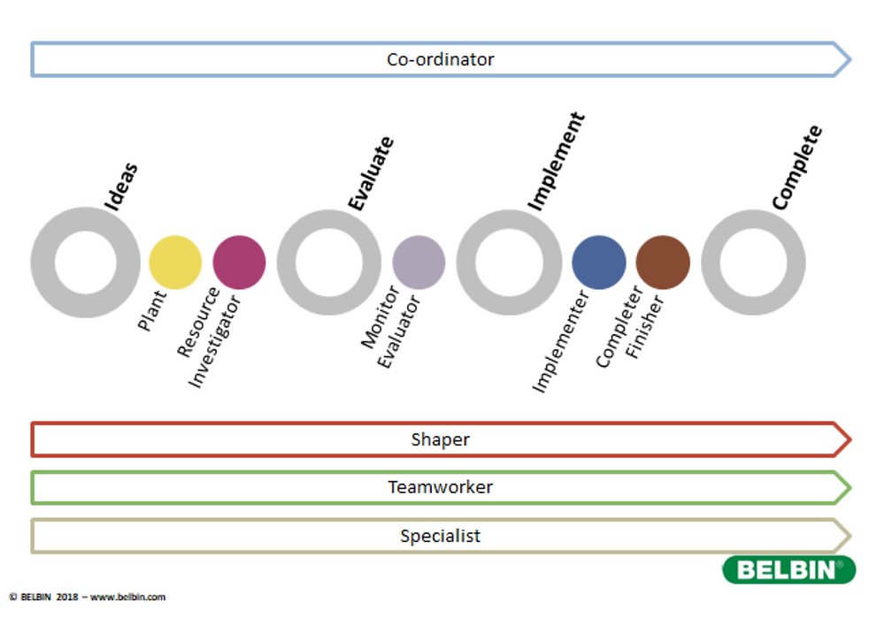

2.2
Project Planning Phase.
In order for the project to be created successfully the costs, benefits, aims objectives and scope needed to be defined which involved creating a planning phase. The first steps in doing this was the creation of a quad chart. The quad chart was used as a strategic tool in clearly and concisely defining these aims objectives to define measures of success and desired outcomes. The quad chart defines specific goals within the aims and objectives to plan the operation of activities and research undertaken for the project. This was practically implemented by identification of what was needed to be done to achieve awareness by creating a physical flyer providing information to availability financial services. Then identification of customers and stakeholders that needed to be communicated with in order to produce project deliverables and analyse these through measures of success. Measures of success within the quad chart are then evaluated through qualitative and quantitative methods gathered through feedback and data from the activities structured throughout the project. Activities that were undertaken to achieve these results were gathered from designing a questionnaire, identifying candidates for conducting interviews, discovering the financial factors through the Macmillan organisation, creating a whatts app group for communicating, and extensive research. All of these activities then completed for achieving the end desired result within the quad chart being a practical flyer ready to be distributed through social media (Riz. P, 2017).
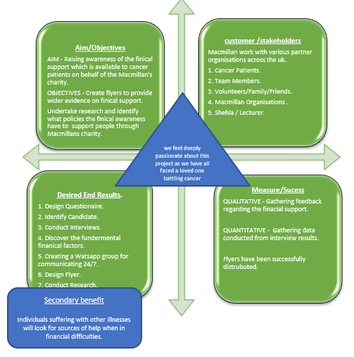

In accomplishing successful project delivery, project management is more than just working within predefined project construct and constraints. Team motivation is also a major additional development and as the team shares a common interest in the project through personal reasons the motivation is intrinsic. The benefits of motivation being intrinsic throughout the project is that each team member had spontaneous satisfaction within achieving the goals of each activity with interest. This allowed the reward system within the project to become a tangible objective (Gagne & Deci, 2005).

Advantages and Disadvantages of a Quad Chart.

The advantages of having a quad chart enables the team and stakeholders to have a clearer visual understanding of the information within the project task so that it is easier to absorb by the audience. It provides information in a quick and direct way that’s visually more dynamic and easily structured to follow through stages of the project aims, objectives, measures, and deliverables. Key findings of data are also emphasized so that key implications can easily be highlighted.
Disadvantages however is that the design can also likely not be as precise as the raw data. As you gather data that is qualitive and quantifiable a chart decreases the specificity of that information. Although it can indicate how one category flows or exceeds another it would not be as informative or apparent as the raw data. Although quad charts can excel in presenting data in visual ways it also limits various important aspects of the data in which a chart is not designed for (Campbell. P, 2018).

2.23
Conducting a Stakeholder Analysis.

When determining success factors or the failure of the project a stakeholder framework is essential. Internal and external criteria was needed to this approach for the dimensions of the project success. This important tool was used for identifying and assessing the influence and importance of key people within the project being the internal and external drivers and the priority of these drivers in a high, medium, and low format. This then manages the interests, needs and viewpoints of the stakeholders as they are vital to the survival and success of the project or organisation. The information from the analysis helped the group to understand the projects objectives and aims which helps to identify the long-, medium- and short-term scope and dimensions (Brugha. A, Vavasovsky. Z, 2020).
The stakeholder analysis chart identifies the stakeholders in a high to low priority of importance. High being the champions of the drivers being Macmillan, the cancer patients and team members who are engaged the most within the project. Low importance but believers in the project being family members, lecturers, and friends helping identify who is most critical to the project (Morphy. T, 2008).
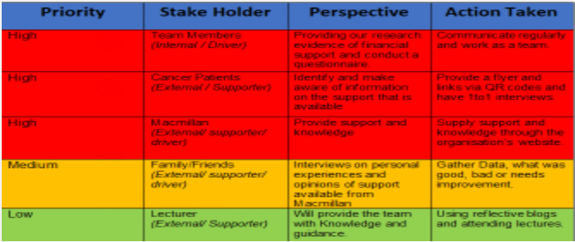
Advantages and disadvantages of the stakeholder analysis.
With a more in-depth analysis of a project spread over a longer duration a more detailed assessment can be made with larger stakeholders, networks, and influencers. With this being greater a more detailed analysis can be undertaken for the success of the project specially if more major resources and policy implications are involved (O.U.P, 2000).
Advantages of the analysis would be that frequent communications with stakeholders helped support the group with them understanding what was fully going on and helping shape the project within the early stages. With the analysis yielding useful and accurate information it can provide input into other analysis tools implemented throughout project lifecycle which helps devise action plans to increase support and planning purposes (Schmeer. K, 1999).

2.3
Project Execution Stage.

Execution is the third phase within Project Life Cycle where actual work of the project is formed. The procurement of all information and resources are transformed into the intended project deliverable. More critical success factors are hypothesized to dominate within this phase of development through the use of two important tools known as the Work Breakdown Structure (WBS) and a GANTT Chart. These technical tasks within the tools were found to be critical where trouble shooting, and tactical issues were more apparent in its strategy and planning functions (Prescott. E. J, Pinto. K. J, 1988).
Implementation of all the project planning activities through the use of these tools helped control project management processes which were monitored and controlled for the outputs being the deliverables of the project. These deliverables being physically constructed from the activities structured within the WBS and GANTT (Westland. J, 2017).

Work Breakdown Structure.
An essential part of Project life Cycle is the WBS for the timeline and planning which evolved around a hierarchy of the tasks needed to be implemented to identify the flow of the project within a designed timeline set out by the project manager. This represents the decomposition of all work that the project encompasses from beginning to end. This is important to manageably break down all components of tasks in a hierarchical structure defining tasks that can be completed independently facilitating allocation of recourses, assignment responsibilities, measurement, and control of the project. This is structured in a top to bottom approach within the diagram below and project management responsible for the creation of the tool along with assistance of input with other members of the team. This starts by decomposing all of the deliverables identified breaking them down into smaller chunks of work. These deliverables are mapped out within box three of the quad chart which match up with the desired end results (T. Rajani Devi, Shobha Reddy, 2012).

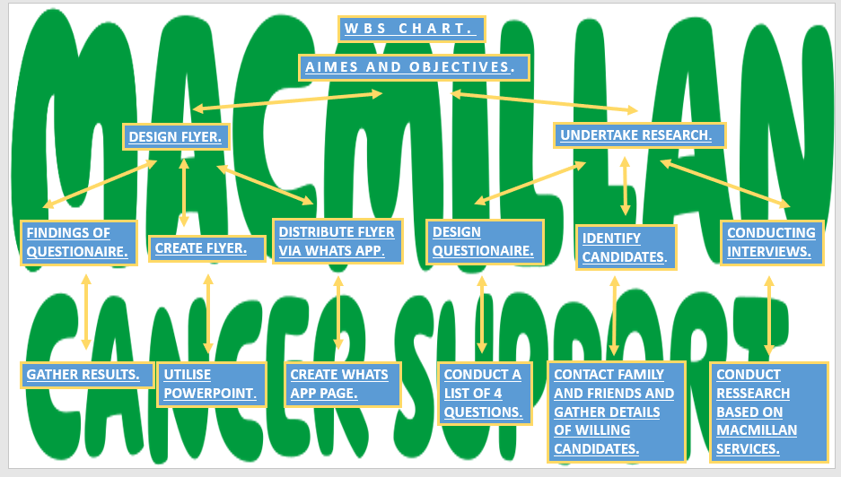

Advantages and disadvantages of a WBS chart.

An advantage of the WBS is the flexibility where project teams can be assembled to the task at hand. Team members from different disciplines with the same teamwork and coordination make it easier to achieve project goals when they share the same common goal and have the same project manager.
Disadvantages can be the temporary nature to the project structure where efficiency and effectiveness are not achieved if resources are not adequately pooled. A project’s organisational structure of its limited life can create anxiety and uncertainty about the team members future roles, mainly in the final stages and information between project teams is not flowing easily. Another major problem within the structure can be division of tasks. It is important to allocate the tasks based on strengths within the roles and activities so that the budget restraints, time efficiency and resources are not violated or overloaded (G. Boaz, S. Avraham, 2001).

GANTT Chart.

Construction of the GANTT Chart gave the groups ability to display each status of an activity at a glance. This tool was used to follow each activity from the WBS chart as a planning production method in a time phased dependant demand approach. This is used in a top-down manner linking the end desired results within the quad chart to their constituent components in a time phased production. This time phased approach allowed tasks to be completed tracking each activity in a proper planning and controlled balance of who did what and within what time frame that it needed to be completed. The table then displays exactly what was delivered and highlighting any discrepancies for remedial action if needed. It identifies tasks to be produced, the number to be completed within each time frame, and the date of each task within start to finish. Difficulties within reaching assigned dates of tasks can be identified if needed with assigned causes wherever possible, but with the benefit of quality management approaches then becoming appreciated. This comprehensive planning method created controlled individual operations of tasks coordinating the work timings with other stakeholders (W. M. James, 2003).

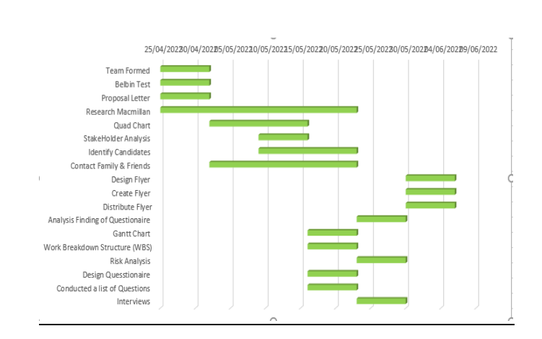
Advantages and Disadvantages of GANTT Charts.

The benefits in the effectiveness of GANTT charts are useful in displaying schedules but presenting a great deal of information in what activities run, when and for how long. This is a highly adaptable method that can readily focus on issues that affect project managers. This is an effective way of facilitation between analysts and the user but also a powerful interacting and implementation method in approaches to scheduling.
Limitations within GANTT charts are although they are widely implemented in smaller projects, they can become quite unwieldly in projects that have 30 activities or more and can communicate relatively little information without the combination of other tools involved. Also, if two projects are the same number of days behind schedule it can cause an impact on resource utilisation (KPVIDA, 2008).

2.4
Project Closure.

With the acceptance of all project deliverable being achieved all the projects objectives will have been met and ready for closure. This being the last phase of Project Life Cycle it must be conducted formally so that the end deliverables are fully realised, and all activities have been undertaken and concluded to achieve the end result being the information flyer. Winding up of the project will include determining all criteria being met within project completion, identifying any outstanding activities, risks, or issues, meeting all deliverables, releasing all resources, and communicating the closure to stakeholders.
This will include a report to be documented and submitted, and the project manager being responsible for undertaking all activities that were identified within the report. A final review of the project will need to take place of its success and how well the performance was against all the defined objectives. This will be determined by how well it performed; did it result in the benefits defined? The achievement of the objectives, the operations within the scope of the project and deliverables met within the quality of the plan.
The results, key achievements and lessons learned are then documented within a post implementation review and presented to the Macmillan Organisation for approval. This will then be a completion of the project life cycle overview (Westland. J, 2006).
Project Monitoring and evaluation is the key success in the objectives to succeed in overall efficiency and planning through frameworks such as Risk analysis. This helps identify limits and weaknesses by looking at what could happen? What the impacts may be? And what can we do to mitigate those factors? This helps by understanding how to minimise the impact on the project. These risks are ranked in order of high, medium, and low understanding the likelihood and mitigating circumstances in order to be managed effectively by the team. As uncertainties are needed to be accounted for then modelling these through a PESTLE Analysis can adjust the plan for contingencies (Trumper. M, 2018).
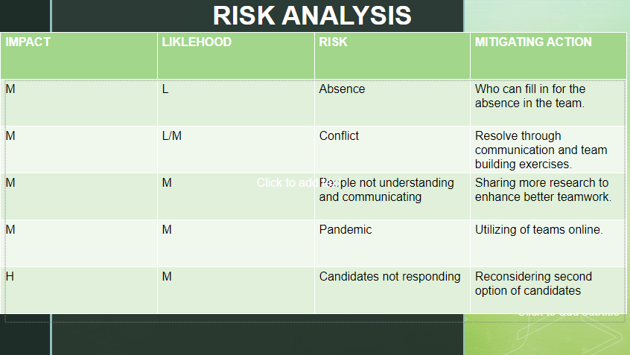
Risk Analysis Factors drawn upon within PESTLE Analysis.

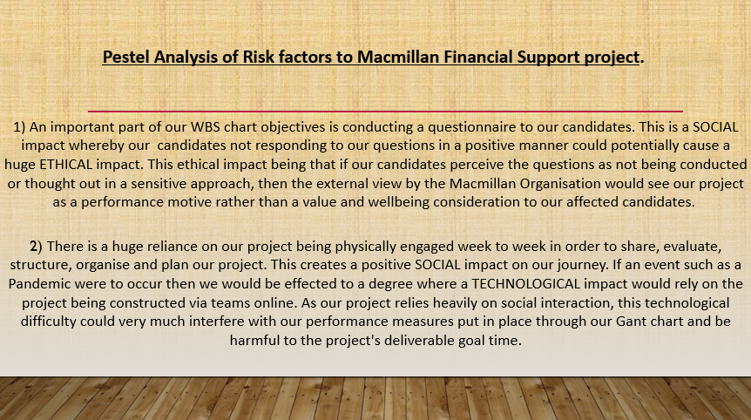

Project Evaluation.

Tracking the development through monitoring and evaluation is critical as this allows potential problems to be identified. These identifications can be made through the process and recognition of hard and soft outcomes which influenced the success, not only recognising the differences but the but developed approaches bringing retrospective success rates together. Soft issues are identified as the success factors which had a high impact in benefits of information support of the flyer, reactions from the questionnaire and communication of a better understanding of the services available. Hard outcomes being responses from the questionnaire, quantitative interviews conducted and distribution of flyers (Crawford, L, & Pollack, J. 2004).
The hard/soft dichotomy philosophy evolves also around subjective and objective approaches. Hard outcomes rooted around objectively and independently measured tasks whilst soft outcomes depended on subjective measurement of the individuals’ assessments of the group. All stakeholders’ perspectives need to be considered in this assessment. Below is a graph by the group demonstrating the hard and soft outcomes where support in soft outcome through feedback and stakeholders became both illuminative and precipitative and demonstrated sharing experience. Stakeholder impact through feedback and evidence from flyers, questionnaires and interviews were both informative and summative. A revised look at the project, however, would be that if undertaking the project, a second time then a more time measured plan of activities and greater information would benefit in more formative and summative outcomes. The yielding of information could be gathered in other practical ways measured through the tools however, this being on a larger scale as demonstrated through GANTT and WBS would require a larger group of multidisciplinary skills and greater resources via stakeholders.
Linking this with box four of the quad chart in measures of success there would be far more qualitative and quantitative information gathered to benefit the hard outcomes of the project.
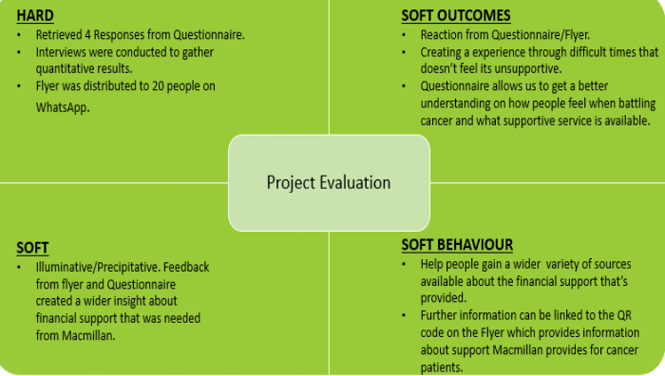

Performance as a project manager in relation to coordinator within Belbin’s Team Roles helped achieve structure within the group and delegation of tasks. Completion of tasks were more effective in this way, accompanied by communication of completed activities within the GANTT chart to monitor the development of the Project Life Cycle and eliminating risk factors of overlapping activities. However, diversification of skills could be achieved such as resource investigation in more inventive ways and more physical interaction of stakeholders.

Conclusion.

The implementation of Project Lifecycle has proved to be an invaluable system of approach in devising any project and the management of that project. The use of tools throughout this approach is strategically soundproof as one tool cannot work without another. The methodology of initiating, planning, execution, and closure is effective in following through every purpose of a project do deliver the outcomes, without sacrificing efficiency.
Every stage within the groups project offered comprehensive understandings of practical processes for a successful delivery of the desired outcome. The teamwork and skill set of each member brought together cohesiveness within the environment as intrinsic goals were met without any conflict within the project. The management of this was extremely important within a short time frame as many projects do not share the same intrinsic value and can take time for a group to form a harmonious team development.
Understanding team members strengths and weaknesses as project manager allowed appropriate delegation of activities from WBS so risk limitations were reduced to time constraints within the GANTT chart.
The marriage of the conceptualisation and project mission resulted in the execution of its success where project management paid attention to specific sets of critical factors within each of the four stages. This demonstrated a powerful impact on the end result flyer which was an important and meaningful endeavour to help support people who have been affected by cancer. Retrospectively the group would have undertaken the same project within a longer time frame, yielding more formative and summative information to complete the project. However, the success was genuinely accepted within the given timeframe.

Project Flyer.



Recommendations.

If to anticipate challenges better within the project, then an understanding of the processes much better in the early stages will establish a much clearer project strategy.
When attacking the project from a resource an information perspective then working more closely with the organisation representatives can offer more qualitative insight into what they would like to achieve with what the groups own goals were. This can offer a far better relationship of information flow between the groups desired end results and the organisations desired goals.
Careful consideration needs to be taken into account with the subtlety of the questions asked and the layering of those questions with topics such as illnesses and diseases. Even with good intentions, the project is approaching a sensitive issue in which quality consideration and understanding are imperative in retrieving quality feedback.

References

Angela Gibson & Trever Nesbit (2006). Belbin Team Roles, Organisational Patterns and E. Learning, A case study. Available at: fullpapers_19june.indd (psu.edu). Assessed: 01/07/2022.
Boaz Galany & Avraham Shtub, (2001). Work breakdown Structure. Available at: material_de_apoio_19-07-2010(1).pdf (inpe.br). Assessed: 04/07/2022.
Crawford, L, & Pollack, J. (2004) Hard and soft projects: a framework for analysis. International Journal of Project Management, 22, 645-653. Assessed: 04/07/2022.
Deci, E. L. (1971). Effects of externally mediated rewards on intrinsic motivation. Journal of personality and social psychology, 18(1), 105-115. Assessed: 02/07/2022.
Heldman, K (2007). Project Management Professional Exam Study Guide. Indiana: Willey Publishing, Inc. Assessed: 01/07/2022.
James M. Wilson, (2003). GANTT CHARTS, A Centenary Appreciation. Available at: doi:10.1016/S0377-2217(02)00769-5 (psu.edu). Assessed: 04/07/2022.
Jason Westland, (2017). The Project Management Lifecycle). Available at: ThePLC_R4 (maxwideman.com). Assessed: 03/07/2022.
Jefferey K. Pinto & John E. Prescott (1988). Variations in Critical Success Factors Over the Stage in Project Life Cycle. Available at: Variations-in-Critical-Success-Factors-Over-the-Stages-in-the-Project-Life-Cycle.pdf (researchgate.net). Assessed: 03/07/2022.
Joseph Heagney (2016) The Fundamentals of Project Management. Available at: Fundamentals of Project Management - Google Books. Assessed: 30/06/2022.
Kammi K. Schmeer (1999). Stakeholder Analysis guidelines. Available at: Divider1 (watsanmissionassistant.org). Assessed: 3/07/2022.
KPVIDAS WEB LOG (2008). What is a Gantt Chart? Available at: Work Breakdown Structure | Kpvida's Weblog (wordpress.com). Assessed: 04/07/2022.
Mehryar Noori Afshar (2018). The Effectiveness of a Lifecycle Approach to Learning Project Management. Available at: The Effectiveness of a Lifecycle Approach to Learning Project Management (europeanpublisher.com). Assessed: 31/06/2022.
Michael Trumper, (2018). The Surprising Benefits of Project Risk Analysis. Available at: The Surprising Benefits of Project Risk Analysis (planacademy.com). Assessed: 04/07/2022.
Noor Rahman Sahak (2018). Critical Success Factors Across the Project Lifecycle. Available at: 1988__Critical_success_factors_across_the_project_life_cycle-with-cover-page-v2.pdf (d1wqtxts1xzle7.cloudfront.net). Assessed: 01/07/2022.
Pasha Riz (2017). How to use Stephen Coveys Four Quadrants to be Productive. Available at: How To Use Stephen Covey's 4 Quadrants To Be Productive - Succeed Feed. Assessed: 01/07/2022.
Pete Campbell, (2018). What are the Advantages and Disadvantages of creating a Quad chart? Available at: undefined (synonym.com). Assessed: 02/07/2022.
T Morphey, (2008). Stakeholder Analysis, Project Management, Templates and Advice. Available at: Stakeholder matrix - key matrices for stakeholder analysis (stakeholdermap.com). Assessed: 02/07/2022.
T. Rajani Devi, Shobha Reddy, (2012). Work Breakdown Structure of the Project. Available at: DJ22683686-with-cover-page-v2.pdf (d1wqtxts1xzle7.cloudfront.net). Assessed: 04/07/2022.
Zsuza Varavasovsky & Ruairi Brugha, 2020. A Stakeholder Analysis. Available at: 150338.pdf (silverchair.com). Assessed: 02/07/2022.

