
Skills for the Workplace
Module Assignment Submission

Student Name: | Kirstie draper
Student Number: | 1918596
Module No: | BMSK4008
Module Title: | Academic and Research Skills

Statement of Confirmation of Authenticity
By the act of making this submission, the student declares that this is the work of the student named above. The work has not, in whole or in part, been knowingly presented elsewhere for assessment, or where assessment has been built on a previous assessment, this has been identified. Where materials have been used from other sources it has been properly acknowledged. If this statement is untrue, the student acknowledges that an assessment offence has been committed.
Attention is drawn to the plagiarism and unfair practice policies of both the University and of ILM.

Permission for ILM to use this script
ILM uses learners’ submissions – on an anonymous basis – for assessment standardisation. By submitting, both the centre and the learner agree that ILM may use this script on condition that identifying information is removed. However, if you are unwilling to allow ILM use this script, please refuse by ticking the box: □

Table of Contents
Managing Remotely: Is it the Way Forward? ................................................................................. 3
Part 1 ............................................................................................................................................... 3
1.1 Introduction ............................................................................................................................ 3
1.2 Research ............................................................................................................................... 3
1.3 Findings ........... 5https://www.rapidgrowthmedia.com/features/illustrationleaguerapidblog.aspx
1.4 Conclusion ............................................................................................................................. 5
Part 2 ............................................................................................................................................... 6
Personal Reflection on Managing Remotely .................................................................................. 6
2.1 Description ............................................................................................................................ 6
2.2 Feelings ................................................................................................................................. 7
2.3 Evaluation .............................................................................................................................. 7
2.4 Analysis ................................................................................................................................. 8
2.5 Conclusion ............................................................................................................................. 8
References .................................................................................................................................... 10
Appendix 1 .................................................................................................................................... 11 Appendix 2 .................................................................................................................................... 12

Managing Remotely: Is it the Way Forward?

Part 1

1.1 Introduction
World wide pandemic started in march 2020, changing the way we work; most of the population now have to work remotely due to social distancing and closure of the workplace, schools, colleges and universities. While many of us already work remotely, many haven't and are new to this way of working.
With the power of today technology and virtual team structure, it gives us the ability to work remotely.
When the pandemic began, things had to change fast and change fast when learning; Many more employees had no choice but to work from home. Will this be temporary while the pandemic is around, or is this what life is changing to remote learning.
Managing remotely can be very complicated in many ways. As organizations working part-time or full time from home, we need to understand what managers need to lead when employees are remote learning.
For remote working to be successful, managers must set expectations from the beginning.

1.2 Research

Online learning is here to stay and is becoming more popular, not just with the pandemic that is affecting us all, but remote learning is here to stay because it has a lot of benefits and its moving with the times that are changing in this decade
There are benefits and struggles when working remotely
Benefits
*Ability to have a flexible schedule
*Flexibility to work anywhere
*Not having to commute
*Ability to spend time with family
*Ability to work from home
*saving money
When you can have a flexible schedule, it can be one of the benefits of working remotely. It allows you to adjust your time to work if you have children. You can work around school time.
It also saves you on travel time back and fore to work, increasing stress level, especially when we have to travel at peak times. Working remotely gives you the advantages to work anywhere
and at any time of the day, and it also allows us to spend more time with the family when we work from home. It also allows some of us to save money when travelling back and fore to work it can become costly, so when we work from home, we can save money on petrol, parking and even car repairs so it can have quite a few benefits. Still, there can also be struggles when we work remotely, and some people find they cant adapt to working remotely.

*being overwhelmed
*Collaboration and communication
*loneliness
*not being able to unplug
*Distraction at home
*Being in a different timezone than teammates
*Staying motivated
you can become very overwhelmed with changing to remote learning; some students need more attention than others from their tutor, especially at more difficult parts of your course
Managing a workforce can have drawbacks when working remotely; communication is crucial, and managers need to book face-to-face meetings to identify if their employees are doing a good job.
Loneliness can be another struggle. If you don't have family living at home, it can get very lonely for employees; they can feel isolated and miss other employees' interaction.
Working remotely from home can also be a struggle because you can get distracted at times, and it can become very noisy, and you can become less motivated.
Employees can lose connection with work colleagues when working remotely, which can significantly impact their work performance.

1.3 Findings
My findings are that due to a pandemic, remote working had to be a way forward for many workplaces to continue to carry on working with offices being closed. They didn't have the choice to keep their business open, and remote working was the only way for many and the only way for them to keep trading. There would have been many businesses closing down with remotely working due to not being able to go to work, so remote learning has saved many companies from trading online.
Many managers also had to adapt to this change and manage the workforce remotely. While they found some staff had no problem adjusting, many can struggle with the change. They also have to adapt to this change, manage staff differently, and see that some team members will struggle with this change.
Managers should monitor their employees daily; they should check their performance and know if their employees are doing the work expected of them or won't know if an employee is guessing their performance. Taking the time to have one to one with employees will give the chance to provide maximum performance. Some new joiner may struggle if managers and work colleagues are not available.
The feeling of isolation in employees can be a struggle for team members, and managers need to be aware that this can be a problem with remote learning. To have a happy and healthy team, we must recognize and manage a high-stress environment that our employees can create when working remotely

1.4 Conclusion
Remote working is now the way forward. It is the future way most industrials are adapting, and employees and employers are adapting to this change. Ninety-nine per cent of employees are pleased to carry on working remotely for the near future, and they would recommend other employees to do the same. The whole world is now working remotely, giving the right advice to employees from their manager is so very important, and you can have great results when you work together.
Managers must encourage employees to connect; there are many ways to do this, via whattsup, messenger, phone calls, facetime and teams and if all work together, you can achieve great result

Part 2

Personal Reflection on Managing Remotely

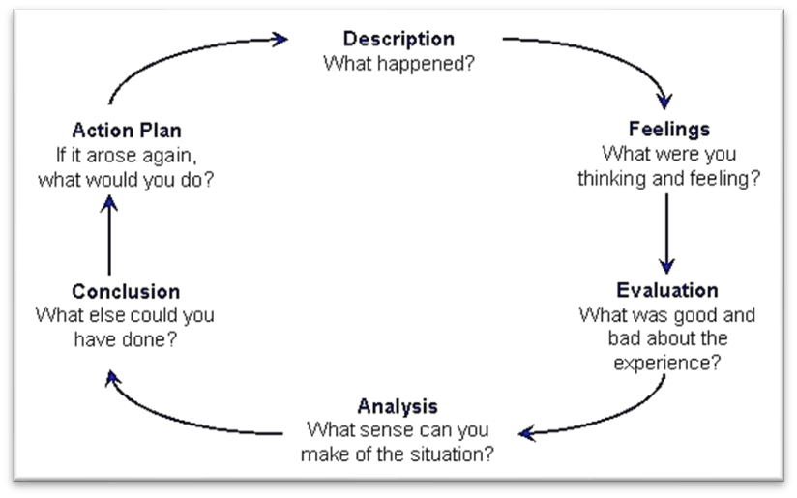
Gibbs (1988)

2.1 Description

Due to the pandemic that started to affect us in 2020, learning and working had changed so much. I had just begun a business which required me to do a course. These courses had to be done in a classroom but suddenly had to be cancelled due to the pandemic. ; online learning was the only way to do this due with the pandemic. This requires working with a tutor online through an online app called craft-master; this allows me to communicate and be taught the necessary course and watch videos and talk online rather than attended classes.

I started skills in the workplace last March 2020; we began this course by going to university and learning in the classroom with other students. Due to the pandemic, no one was allowed to go to the classrooms, so we all had to change the way we learnt to work remotely, being online through teams once or twice a week, which I struggled with and had to drop out. Whilst I was learning from home, I struggled because of the distractions and my children being there.
Now has time has gone past, and everything has been all through working at home and everything online. I have now updated to this and reapplied onto the course.

2.2 Feelings

When I learnt that I had to start learning remotely, I was very concerned about doing it; I had never worked online before and not very good at using a computer. I got very anxious about this and thought, this is not for me. I can't do it; I am not good at the computer. I wouldn't have any students working with me, and I would feel isolated and not get the right help with my course work. I thought, how am I going to do this with a two-year-old running around? I would never get anything done. I would be distracted by her because she is a very busy two-year-old. I also have a fourteen-year-old who would be at home all the time; I did start to worry about this, and I thought I would not like doing this. There is no way I will be able to cope, so I thought.
Everything was going over and over in my head. The thought of a pandemic going on was stressful enough without this.
I was also very disappointed with my new business venture. I was so looking forward to starting it up I felt this was a setback and was feeling relatively low about it all. I had so many plans; now I thought it was all gone.
I had to keep myself motivated to get into a good routine and stay positive.

2.3 Evaluation

I've never worked remotely from home before, which was challenging at first. Still, once I adapted to this new way of working/learning, I found that this was a good thing if I got into a routine working around the children. I could do it at my pace; for example, when the children were in bed, I could do my online work then found I was tired after a day in the house looking after the children and cooking and cleaning. It was great that it allowed me to spend more time with my family but finding time on my own in a busy house was hard.
Working/learning remotely allowed me to have a flexible schedule, and I needed to find a work-life balance, which enables me to work the hours best for me. I also found that things that would help me other than just a routine were a familiar environment, such as making sure the noise level was calm and a min level

2.4 Analysis

I found that I miss out on learning in the classroom because I like to socialize with other students and discuss the course together. You can't do this with remote learning because students and tutors are not available simultaneously. When you are stuck on something, it could take hours or maybe days to get help, I then feel isolated, and I leave my work for another day. I get behind on my work and then start to lose interest if I fall behind with my course work. When you are in a classroom, you only focus on your uni work, and there is also help available when you need it; students can help each other more when working together in the classroom, and my course seems to be more interesting.
I make my situation because I would prefer to work in a classroom with other students. It would be a lot easier for me with having a busy household. It was complicated and too busy with the children.

2.5 Conclusion

I think that remote working is the way forward for many industrials, and it works well, but for myself, I find it would not work due to being a carer and having a hands-on job. Also, I struggle with my uni work due to putting things off for another day and not going back to it because something comes up and distracts me again, leaving me behind. If I were in a classroom with other students, I would concentrate on my uni work with other students.
While working from home, I find too many distractions due to having a two-year-old to look after. Still, I also find remote working can also help because, in the evenings, I get time to do some of my studying when she is in bed, but then when I get stuck, there is no one available to help.
It has positive and negative effects; I need to get a better home and work-life balance that keeps me motivated, so I don't lose interest and get stress out.
Action plan
If this situation arose again, I think I would have to prepare myself for the changes by making arrangements for the children to be taken out by their dad in the daytime to do my studies because I find working in the evening tiresome. I would set up a time table to work with and stick to it. That way, I could fit everything in and not get too stressed out with it all; I could then communicate with other students and my tutor in the day time.
I feel that having an action plan would help me succeed in working remotely. By doing this, I can move forward with how learning has changed because, at this moment in time, we don't know how long this pandemic is going to continue and if we go into a third wave. So I have to be open-minded that remote learning is the way forward and is here for the stay.

References

Gibbs, G. (1988) Learning by doing; A guide to teaching and learning methods. London: FEU https://www.rapidgrowthmedia.com/features/illustrationleaguerapidblog.aspx
Papanikolaou, D. and Schmidt, L.D., 2020. Working remotely and the supply-side impact of COVID19 (No. w27330). National Bureau of Economic Research.
Faith, B., Flynn, J., Hernandez, K. and Roberts, T., 2020. The Future of Work: Findings of research commissioned by the Oxfam Empower Youth for Work Program.
Ozturk, P., Avci, C. and Pazarbasi, C.K., 2021. The Effect of Remote Collaborative Work on Design Processes During the Pandemic. Strategic Design Research Journal, 14(1), pp.114-123.
Varela, D.G. and Fedynich, L., 2020. Leading schools from a social distance: Surveying south texas school district leadership during the COVID-19 pandemic. In National Forum of Educational Administration and Supervision Journal (Vol. 38, No. 4)
.
Stropkovics, K., 2019. The pros and cons of working remotely

Vancouver

Appendix 1
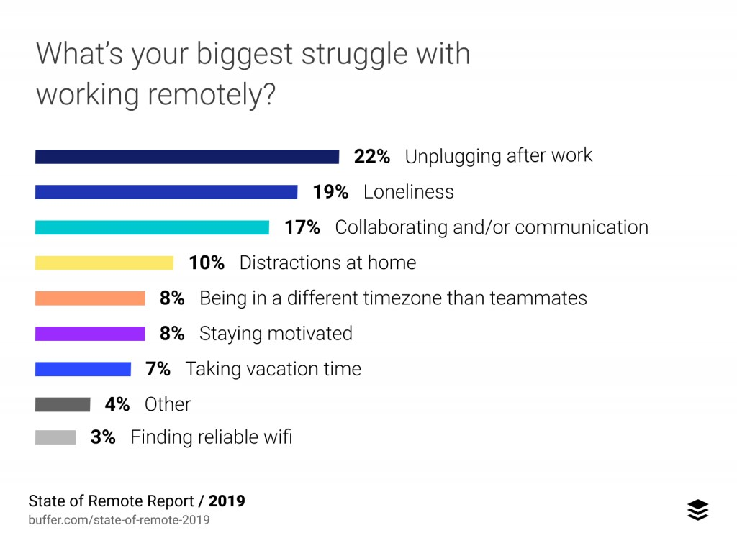

Appendix 2



