ECIE4003

Additional Needs in Context

Portfolio

Student Number: 2115500

Elisa Parry

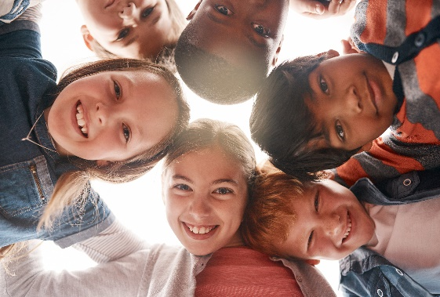

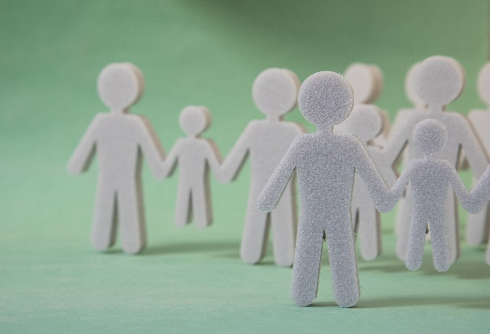

Resources

When caring for children with additional needs, it is imperative that you have the correct resources that will cater for the child’s needs. Resources should stimulate the child (but not overly) to gain their attention, visual stimulation and encourage communication. An excellent resource to encourage all of this is a bubble tube containing fish. (tts, 2022). It is extremely calming and remarkably good for children with additional needs. Another great resource is ‘talking buttons’. A command can be recorded onto them, and this can help a child who has communication difficulties. This will enable themselves to be heard and get their point across depending on their need. (Amazon, 2022)
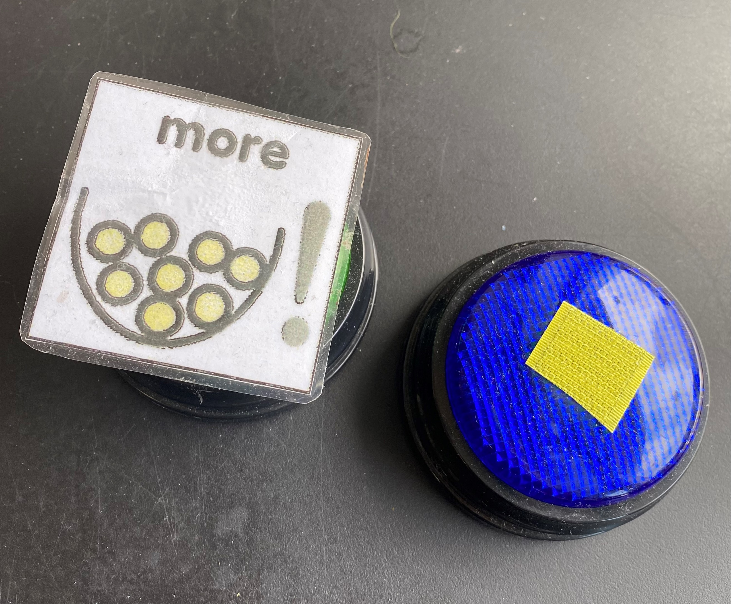

Routines/Transitions

Providing routines is an essential element in providing care/support for learners. Visual timetables are an excellent way of showing the routine of the day in a clear and concise way (Kelly, 2022) Children like to be aware of the situation and if not can become quite distressed.
We as practitioners need to prepare the children for any transitions that may occur throughout the child’s day and any change to their schedule. Children with a specific learning need may not cope well with a transition and may become very vulnerable and extremely anxious when they are unfamiliar with their surroundings and routine or anything different from the ‘norm’ (Early Education, 2021)

Element 1

Good practice in supporting learners with a specific learning need



The cogs above symbolise the ‘multi agency’ approach where agencies/organisations/ practitioners all work together to ensure the best outcome for the learner and to ensure all their needs are met (Early Education, 2021)

Environment

Adapting the environment would mean that you are supporting the learners needs. Removing toys so there is not so many to play with because sometimes this can be too overwhelming and quite often the child would move around the room pulling all the resources out and not actually benefitting from this. Putting lids on boxes can be effective so the children can only access certain toys at any one time. Labelling the boxes, along with a picture of the toys inside is good practice so the child is aware what is inside and can request for that particular box to be open. (Kelly, 2022)


Inclusion

Being inclusive is vital to a child’s education and well-being and being available to offer the correct support to an individual is essential. Vygotsky’s theory was one of scaffolding and preparing the learner (Bates, 2019) This theory would mean:
- Breaking down a task into smaller pieces to enable the learner to grasp the concept easier
- Modelling ways of completing the task in hand
- Being able to support the learner to overcome any barriers they may have due to their need

The ‘scaffolding’ idea would be that you work with the learner to model and show and then gradually retract and allow the learner to complete the tasks individually.

It is imperative when thinking about good practice to ensure that ALL children are able to thrive, develop, reach goals and to achieve their full potential in life. Maslow’s Hierarchy of Needs Pyramid shows that we need to experience all these things in life to achieve our full potential. From basic needs to Self-fulfilment and as practitioners - WE CAN HELP AND SUPPORT THE CHILDREN TO DO THIS!
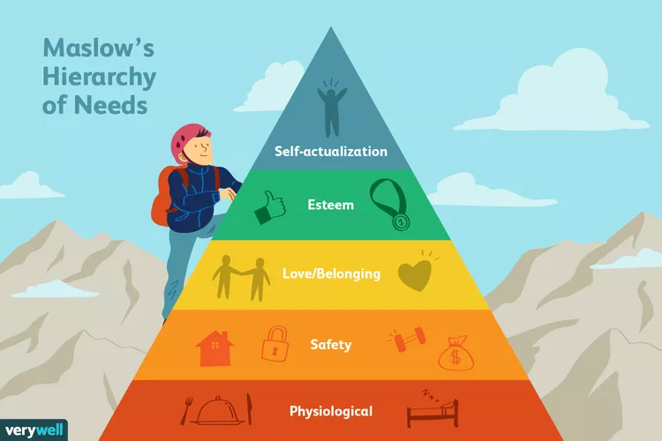

References
Amazon, 2022. Amazon.
Available at: http;//www.amazon.co.uk
(Accessed: 6 October 2022).
Bates, B., 2019. Learning Theories Simplified. 2nd ed. London: Sage Publications.
Cheminais, R., 2009. Effective Multi Angency partnerships: Putting every child matters into practice. 1st ed. London: Sage Publications.
Early Education, 2021. Birth to 5 Matters.
Available at: https://www.birthto5matters.org.uk/transitions/
(Accessed: 4 October 2022).
Flying Start, 2017. Gov.wales.
Available at: https://gov.wales/sites/default/files/publications/2019-07/flying-start-health-programme-guidance_0.pdf
(Accessed: 10 October 2022).
Inclusion London, 2022. Inclusion London.
Available at: http://www.inclusionlondon.org.uk
(Accessed: 25 October 2022).
Kelly, 2022. Early Years Careers.
Available at: www.earlyyearscareers.com//eyc/latest-news/adapting-the-environment
(Accessed: 3 October 2022).
Scope, 2022. Scope.
Available at: http://www.scope.co.uk
(Accessed: 15 October 2022).
Sense, 2022. About us: The social model of disabilty.
Available at: http://www.sense.org.uk
(Accessed: 26 October 2022).
tts, 2022. tts-group.
Available at: http://www.tts-group.co.uk
(Accessed: 6 October 2022).
Unicef, 2022. https://www.unicef.org.uk/wp-content/uploads/2010/05/UNCRC_united_nations_convention_on_the_rights_of_the_child.pdf.
Available at: http://www.unicef.org.uk
(Accessed: 24 October 2022).

Element 2
Essay - Explore the wide and complex spectrum of additional needs
The spectrum of additional needs is vast and wide and can take many different forms and the type of support needed can vary quite dramatically in each individual. Children can encounter many problems and have to jump over many hurdles in their everyday life to reach their goals and desires. Scope suggests that ‘positive attitudes help disabled people fulfil their potential’ (Scope, 2022) Social and medical models of disability are evident in all individuals and both models look at each disability in different ways.
Additional Learning Needs are extremely relevant in today’s society especially in children than it ever was in years gone by and it is imperative that it is identified as early as possible. Early identification of any additional need is essential and therefore early intervention can be put in place to make a difference to a child’s life. (Gov.wales, 2021) Flying Start thrive themselves on early intervention and offer an excellent service for children and their families in the most disadvantaged areas within Wales. Flying Start offers free childcare for children between 2 and 3 years old, parenting courses, dedicated Health Visitors and Speech and Language Therapists who when collaboratively work together using a multi-agency approach can make a difference offering an all-round support service for the families in those disadvantaged areas. (Flying Start, 2017)
Multi agency working is so important when you have children with additional learning needs as this can benefit the child in many ways. This is when all the different agencies come together to discuss the best options and outcome for the child going forward, ensuring the child is paramount. All their expertise of each organisation are pooled together to offer support and advice to the child and their family. Occasionally, multi-agency working does not run smooth. There are both advantages and disadvantages that can benefit and hinder the working relationship of all parties, but generally the good outweighs the bad. There will be continuity in decision making for the benefit of the child where joined up working will put systems in place to collect and share relevant data of that child. (Cheminais, 2009)
Disability comes in the form of two models - the medical model and the social model. The medical model has become somewhat outdated as it looks at the person who has the disability and thinking that the problem is with them and focussing on what they cannot do rather than what they can do. This can cause people to lose their independence and have low self-esteem which in turn will leave them feeling very disheartened, hence placing barriers up towards society. (Scope, 2022) This model looks at their individual needs but in a more negative way, for example, a school might say - she cannot write so she cannot do the exam, but really it should be looking at ways in which she WOULD be able to take part by allowing her to use a scribe.
However, the social model is the preferred model as it will look at society as the problem and not the actual person. It looks at the wider picture and the barriers that disabled people face. An example of this problem is the badly designed buildings that exist around the country where they do not have ramps or lifts installed to enable a disabled person to enter and use that building. (Inclusion London, 2022) and also when there is inaccessible transport where wheelchairs users are not able to access this service. If these ‘concrete’ barriers were removed, then it will enable disabled people to live more independently, making how they live with their disability so much easier. (Scope, 2022) Disability activists came up with the idea of the social model in the late 20th century after their experiences of being excluded from society. (Sense, 2022)
A positive outcome for ‘good practice’ where there needs to be some reasonable adjustments made to assist the learner in a specific area to support their individual needs. In my school for example: we looked after a child who had cerebral palsy and he wouldn’t be able to sit on a ‘school chair’ without falling off straight away. Chairs were supplied from Occupational Health in which he was able to sit securely in the chair which had arms and a lap strap to ensure that he was kept safe and sitting still while eating and also during circle time. The United Nation Convention on the Rights of the Child Article 23 states that ‘a child has a right to special care and support if you have a disability so that they can lead a full and independent life’ (Unicef, 2022)
Abraham Maslow stated through his Hierarchy of Needs pyramid that all learners should reach certain requirements to fulfil their needs, starting with the most basic of needs being food, warmth and rest, leading up to reach ones full potential (Bates, 2019, pp. 66-67) In addition to this Article 3 of the United Nations Convention of the Rights of the Child states that everyone who works with children should always do what is best for each child. (Unicef, 2022) This is specific to all children and children with a disability too and they can also be supported by various organisations like Scope and Sense who are excellent at being the individual’s voice. But it is the role of the local authority who will identify if a child has an additional learning need, and they will support them with working documents like Additional Learning Provisions unique to that child. (Gov.wales, 2021) This will ensure they have specific targets to reach by using intervention techniques within the daily routine.
We as a nation and all around the world need to change our perception of additional needs and the way in which we deal with disability in general. Inclusion is imperative and should be applied in all schools, mainstream settings and in all public places. No child/individual should be made to feel excluded in any situation just because of their disability. We also need to educate others in using the correct ‘language’ when talking and referring to individuals with a disability, as some terms used can be offensive. The general public have improved the way in which they interact with individuals who have a disability but there are still improvements to be made.

References
Bates, B., 2019. Learning Theories Simplified. 2nd ed. London: Sage Publications.
Cheminais, R., 2009. Effective Multi Angency partnerships: Putting every child matters into practice. 1st ed. London: Sage Publications.
Flying Start, 2017. Gov.wales.
Available at: https://gov.wales/sites/default/files/publications/2019-07/flying-start-health-programme-guidance_0.pdf
(Accessed: 10 October 2022).
Gov.wales, 2021. The additional learning needs code for Wales 2021.
Available at: http://www.gov.wales/additional-learning-needs-code
(Accessed: 26 October 2022).
Inclusion London, 2022. Inclusion London.
Available at: http://www.inclusionlondon.org.uk
(Accessed: 25 October 2022).
Scope, 2022. Scope.
Available at: http://www.scope.co.uk
(Accessed: 15 October 2022).
Sense, 2022. About us: The social model of disabilty.
Available at: http://www.sense.org.uk
(Accessed: 26 October 2022).
Unicef, 2022. https://www.unicef.org.uk/wp-content/uploads/2010/05/UNCRC_united_nations_convention_on_the_rights_of_the_child.pdf.
Available at: http://www.unicef.org.uk
(Accessed: 24 October 2022).

Element 3
Explore and summarise the additional learning needs of a pupil using a person-centred planning approach.
(Based upon Section 1C IDP : Profile (About me)
and
2A IDP : Description of the child or young person’s additional learning needs (ALN))

Element 3 on Page 8

Section 1C: Profile (About me)


My name: Bella Parry (name has been changed) and I am 4 years old.

D.O.B. 15th June 2018

I like: To play independently, singing, drawing, balloons, painting, Peppa Pig, water/sand, climbing, putting things in my mouth

I dislike: sitting on the carpet (circle time), wearing shoes inside, new routines, wearing aprons.

Health: I do not have any health problems and have NO ALLERGIES

Important people in my life are: Mummy, Daddy, my brothers Huw and Ryan, Nanny/Grampa M, Nanny/Bampi A, Auntie Karen, Didi (teddy) Miss Gedrin my 1:1 support.

The best way for people to support me is: Using consistent routines, visual timetables/schedules and objects of reference so I am aware of what to expect and what is coming next.

Help me to make choices e.g. snack time, coloured pens and books, activities

What people like and admire about me: My smiles and eye contact when I am happy, my interest in music and songs, my independence.

• What is important to the learner
- To be able to have my toy (Peppa Pig) with me at all times
- To enable me to take my shoes off when I am inside
- To have some time on the iPad

• What is important for the learner
- To express myself in communicating what i want
- To follow a routine using a visual schedule
- To enjoy the time, I am in school

• What is working and should be built on
- Putting my shoes on when I go outside to play
- Lining up nicely to go into the hall for lunch
- Walking into school and going straight into class

• What is not working and needs to change
- Coming into school with no shoes
- Sitting on the carpet for at least a couple of minutes and build up from there
- To follow my timeline and when I have completed some work, I can use the ipad for a short period of time

Section 2A: Description of the child or young person’s additional learning needs (ALN)

Diagnosis

Bella is a happy little girl who attends for 4 hours a day supported by a 1:1 support worker and has been diagnosed as being autistic. She has a limited attention span and has difficulty allowing adults to join in with her play. She has significant speech and language delay and social communication difficulties and uses lots of learned phrases. Bella has no aware of any danger and therefore must be supervised at all times. When she is feeling overwhelmed, colouring is an excellent activity for her as this will help to deregulate her. Bella likes to chew and put inedible objects into her mouth so supervision is extremely important to ensure her safety. Her motor skills are very good and she is a strong little girl.

Bella doesn’t like to wear shoes within the classroom but it is essential that she wears them outside when playing. If she doesn’t want these shoes she will fall to the floor. More often than not she protects her head from the floor but on occasions she has banged her head.

Bella has additional learning needs relating to the following areas of learning:

Cognition and Learning
- Limited complex imaginative play
- Play is sensory and formal
- Skills not easily generalising between settings

Communication and Interaction
- Learning is affected daily in everyday routines
- Delayed Expressive and receptive language
- Socially, works to her own agenda

Behaviour, Emotional and social development
- Limited social play
- Limited social interaction with other children
- Emotional regulation still developing

As identified by the ALN Manager for Powys County Council it is evident that Bella needs additional support especially while she attends mainstream school. Bella’s parents, the school setting, Consultant Paediatrician, Speech and Language Therapist, Educational Psychologist all had a part to play in collating and submitting the information so in order they could come to an agreed diagnosis and then going forward to support Bella’s needs.

Element 4
Discuss the potential support provided to your chosen pupil (utilising the key principles, approaches and policies that guide inclusive practice).
Based upon Section 2B IDP : Description and delivery of the child or young person’s additional learning provision (ALP)

I have provided 4 section boxes in this template 2B1, 2B2, 2B3, 2B4.
This will provide space for 4 ALPs

If you require more, copy and paste the section box as needed – each ALP should be contained in its’ own individual section box.

n.b. Each section box contains 858 title words – these do not count towards your word count for this element

Section 2B1: Description and delivery of the child or young person’s additional learning provision (ALP)
2B1.1) Intended outcome:  These outcomes should be SMART (Specific, Measurable, Achievable, Realistic,  Timebound). | To use visuals with Bella to enhance communication and understanding
2B1.2) ALP to be provided:  This should include how often (daily, weekly); the type of support; who provides the support. The description of the Additional Learning Provision (ALP) should be very clear and precise, the above could then be split into smaller goals and targets. |  | 2B1.3) Should the ALP be provided in Welsh? | 2B1.4) Organisation/  Service to provide the ALP, (e.g. NHS, Inclusion Service, Specialist Teacher, etc.): | 2B1.5) Start date: | 2B1.6) End / Review date:
The visuals used are in conjunction with Bella’s everyday learning within school. To request Bella to undertake certain activities that you as a practitioner require her to do.  Photos are taken for example of the snack table, so when wanting Bella to come to the table for snack you must show her the picture of the table along with saying ‘snack time’ to enable her to understand what is required of her.  Photos should be laminated and placed on a lanyard around the staff members neck so they are accessible at all times to show Bella what is required of her.  Objects of reference are also used to support Bella’s understanding aiding communication.  Along with these visuals, Makaton can be used to enhance communication and understanding and to also encourage Bella to use some Makaton together with staff to enable her needs to be met, to reduce frustration and social communication difficulties. |  | Yes / No unless requested | Llanfaes C P School 1:1 Support worker | Jun 22 | Dec 22
2B1.7) Rationale for the ALP listed above:  If there is a difference of opinion it should be recorded here e.g. a difference of opinion between the child, child’s parent or young  person and professionals. The section could explain how different opinions have been taken into consideration before a particular decision was reached  . |  | To aid communication and understanding by showing Bella a picture of what is required. Visuals are easy to use and will have some great effects.  To encourage and initiate interaction with adults to enable adults but most importantly Bella to get her point across.

Section 2B2: Description and delivery of the child or young person’s additional learning provision (ALP)
2B2.1) Intended outcome:  These outcomes should be SMART (Specific, Measurable, Achievable, Realistic,  Timebound). | For Bella to sit at a table or on the floor and engage in an adult led activity for 1-2 minutes
2B2.2) ALP to be provided:  This should include how often (daily, weekly); the type of support; who provides the support. The description of the Additional Learning Provision (ALP) should be very clear and precise, the above could then be split into smaller goals and targets. |  | 2B2.3) Should the ALP be provided in Welsh? | 2B2.4) Organisation/  Service to provide the ALP, (e.g. NHS, Inclusion Service, Specialist Teacher, etc.): | 2B2.5) Start date: | 2B2.6) End / Review date:
This ALP and the outcomes should be concentrated on and used daily to engage Bella in an activity which is adult led.  To use a now and next board so Bella can see that if she completes the activity that is being asked of her that she will be able to do something more enjoyable ‘next’ and will be an activity that she is more interested in and of her choice.  Place a highly motivating activity on the ‘next’ section and an adult led activity on the ‘now’ section to ensure Bella is interested and will want to engage.  Keep the ‘now’ activity short to begin with, maybe just a minute and work up from there to ensure Bella’s attention is captured, increasing this as some engagement is reached.  Use a timer and build up from 2+ minutes. Rewards will be given to Bella when she achieves the intended outcome, encouraging her to engage next time. |  | Yes / No unless requested | Llanfaes C P School 1:1 Support worker | Jun 22 | Dec 22
2B2.7) Rationale for the ALP listed above:  If there is a difference of opinion it should be recorded here e.g. a difference of opinion between the child, child’s parent or young  person and professionals. The section could explain how different opinions have been taken into consideration before a particular decision was reached. |  | Bella is having difficulty undertaking adult led activities and usually has her own agenda in wanting to engage in activities of her own choice. This will ensure that Bella, will engage in some work first, before play as this is normally a battle.

Section 2B3: Description and delivery of the child or young person’s additional learning provision (ALP)
2B3.1) Intended outcome:  These outcomes should be SMART (Specific, Measurable, Achievable, Realistic,  Timebound). | For Bella to use her own work station to sit down to engage in activities
2B3.2) ALP to be provided:  This should include how often (daily, weekly); the type of support; who provides the support. The description of the Additional Learning Provision (ALP) should be very clear and precise, the above could then be split into smaller goals and targets. |  | 2B3.3) Should the ALP be provided in Welsh? | 2B3.4) Organisation/  Service to provide the ALP, (e.g. NHS, Inclusion Service, Specialist Teacher, etc.): | 2B3.5) Start date: | 2B3.6) End / Review date:
This workstation can be used on a daily basis, throughout the day for Bella to engage in activities having less distraction around her, enabling her to concentrate on activities.  The workstation will be decorated with ‘familiar’ things like her photo on the wall and also her visual schedule allowing her to see what is happening now and next, also being careful not to overload it with too many things as this can be too distracting and also have little meaning.  The visual schedule needs to be clear and include photos and symbols, so Bella can understand easily which can then be placed in the ‘finished’ box. All staff to engage in this schedule with Bella to ensure understanding of routines and continuity.  The workstation will have everything to hand and will include Bella’s own draws at the side containing prepared activities and resources which will be part of the visual schedule that is displayed. |  | Yes / No unless requested | Llanfaes C P School 1:1 Support worker | Jul 22 | Jan 23
2B3.7) Rationale for the ALP listed above:  If there is a difference of opinion it should be recorded here e.g. a difference of opinion between the child, child’s parent or young  person and professionals. The section could explain how different opinions have been taken into consideration before a particular decision was reached. |  | This workstation will be very beneficial to Bella as there are 30 children in the class so the class can be extremely noisy. This work station being away from the where the other children work is where Bella can allow herself to complete activities without distraction.

Section 2B4: Description and delivery of the child or young person’s additional learning provision (ALP)
2B4.1) Intended outcome:  These outcomes should be SMART (Specific, Measurable, Achievable, Realistic,  Timebound). | To use pictoys, humber activities and WellComm to enhance Bella’s understanding and to also expand her vocabulary.
2B4.2) ALP to be provided:  This should include how often (daily, weekly); the type of support; who provides the support. The description of the Additional Learning Provision (ALP) should be very clear and precise, the above could then be split into smaller goals and targets. |  | 2B4.3) Should the ALP be provided in Welsh? | 2B4.4) Organisation/  Service to provide the ALP, (e.g. NHS, Inclusion Service, Specialist Teacher, etc.): | 2B4.5) Start date: | 2B4.6) End / Review date:
This can be used through daily routines and everyday activities. Also with the 1:1 support worker for 10 minutes everyday and with parents 2-3 times a week.  Bella will be able to follow 2 key word level instructions e.g. ‘put the cat on the chair’ ‘brush the dolls hair’ (understanding of language) using pic toys and Humber.  To understand a range of describing words e.g. big, small, wet dry using Humber activities.  To use 2 word phrases to request and comment e.g. ‘boy sleeping’ ‘play cars’ ‘teddy wet’ using pic toys and WellComm  Routines like snack and lunch times during the day can create lots of opportunities to combine words.  Reduce distractions by using a time when the area is quiet. (e.g. break time for the other children) and keep the time short to begin with.  SLTA Mrs James to demonstrate and support Bella twice a month. |  | Yes / No unless requested | Llanfaes C P School 1:1 Support worker | May 22 | Dec 23
2B4.7) Rationale for the ALP listed above:  If there is a difference of opinion it should be recorded here e.g. a difference of opinion between the child, child’s parent or young  person and professionals. The section could explain how different opinions have been taken into consideration before a particular decision was reached. |  | Bella is understanding instructions of 1 key word. This target aims to support her in understanding longer instructions of 2 key words and the use of 2 word phrases. She is also presenting with a reduced vocabulary in general and this aims to expand Bella’s receptive vocabulary.

