E-Portfolio

Wayne Howell (2207408)
Changemakers: Creativity and Value Creation (ACCA5033)
BSC2-PT Computing: Data & Information Systems
University of Wales Trinity Saint David
Table of Contents
E-Portfolio 3
Task 1: Moodle Unit 1 – Section 1 & Mind Map 4
Question 1: Mind Map 4
Question 2: Research/Project Idea 6
Task 2: Moodle Unit 1 – What’s the Problem 8
Question 1 8
Question 2 9
Question 3 11
Task 3: Moodle Unit 2 – The worst possible idea 12
Question 1 12
Question 2 14
Question 3 15
References 16
Appendix 18
Unit 1 – Topic 1 18
Unit 1 – Topic 2 19
Unit 1 – Topic 3 20
Unit 1 – Topic 4 21
Unit 2 – Section 1 21
Unit 2 – Section 2 22
Forum Posts 23

E-Portfolio

As a requirement for this assignment, I am expected to develop an e-portfolio to serve as a central location for all assignment tasks. I utilised wix.com for the completion of this task. Below, you will find an image of the homepage alongside a hyperlink to the e-portfolio.



Figure 1: E-Portfolio Home Page

E-Portfolio Link: https://2207408.wixsite.com/website

Task 1: Moodle Unit 1 – Section 1 & Mind Map

Question 1: Mind Map
The mind map examines the impact of innovation on the world. First, I establish what innovation is, listing several strengths (with explanations) that are linked to the idea of innovation. The following phase in the mind map entails the development of ideas, where I provide a cycle of an idea consisting of several stages that build upon one another to bring an idea to fruition. Then, I have identified the impact of innovation at societal and individual levels. Subsequently, I have listed personal research/project ideas of interest and have highlighted my selected project.
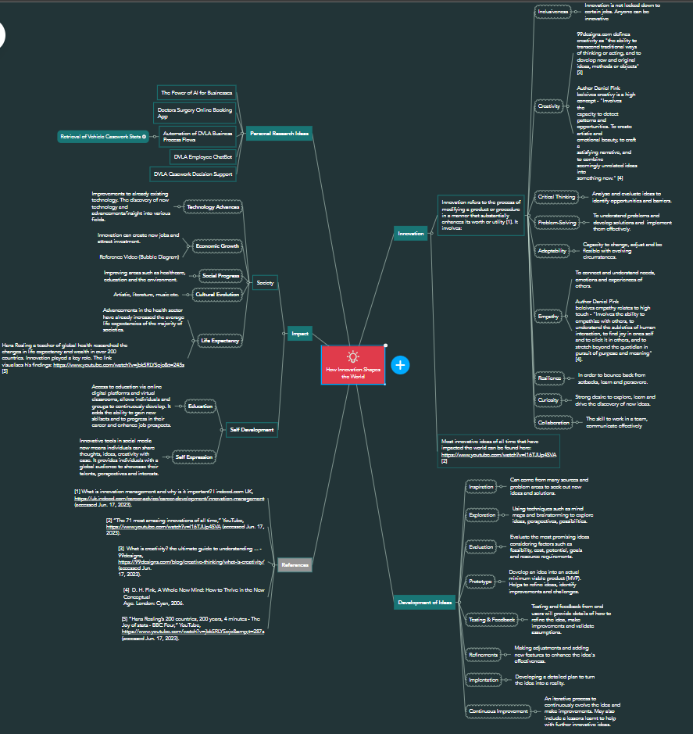
Figure 2: Mind Map “How Innovation Shapes the World”
Mind Map Link: Mind Map
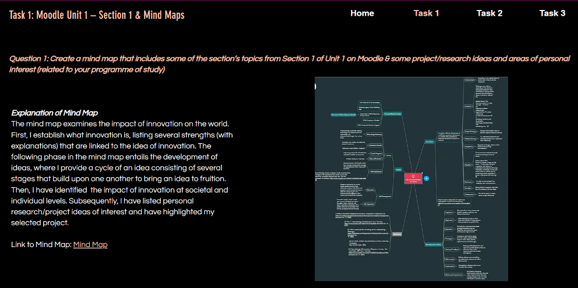
Figure 3: E-Portfolio: Task 1, Question 1

E-Portfolio Link: Task 1 - Question 1

Question 2: Research/Project Idea

I have opted to research the automation of a business process in the Drivers & Vehicles Licensing Agency (DVLA). I have selected to research one of its operational procedures, the retrieval of Vehicle Casework statistics. This impacts various reports that focus on DVLA backlogs, receipts of transactions and resource management. The aim of the project is to explore methods of enhancing efficiency, security, accuracy, and reliability, while also improving customer (staff) experience and reducing resource-intensive procedures.
The mind map below shows the methodology I would follow to produce a minimum viable product (MVP). With each step, I have elaborated further to justify its inclusion.

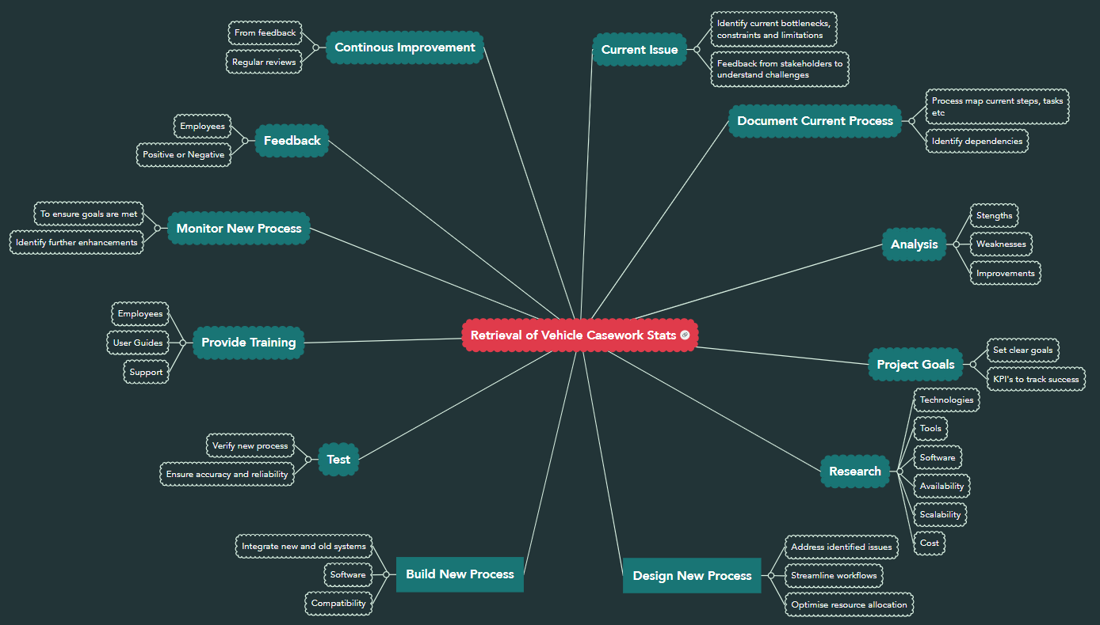
Figure 4: Mind Map of Research/Project Idea
Mind Map Link: Research/Project Idea Mind Map

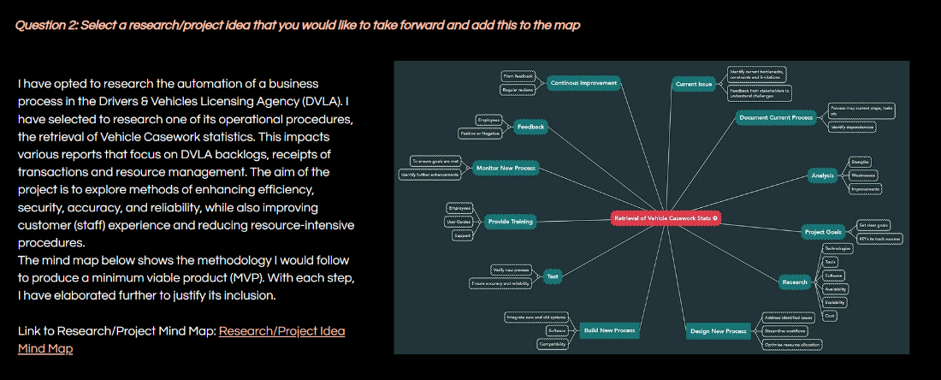
Figure 5: E-Portfolio: Task 1, Question 2
E-Portfolio Link: Task 1 - Question 2
N.B. The references in the mind map can also be found in the references section within this document (referenced 1 to 5).
Task 2: Moodle Unit 1 – What’s the Problem

Question 1

After conducting study on the several research philosophies discussed in section 2, I have found that each one has a unique set of advantages and disadvantages that are applicable to my research project. My perspective on research is one that is scientific, and I think that to get the most out of it, it would be necessary to adopt an epistemological research philosophy, more especially positivism.

Positivism is a philosophy that places an emphasis on knowledge acquired through observation and measurement. In positivism studies, researchers gather and interpret data objectively, putting aside personal values. The strategy is based on quantifiable data and statistical analysis. [6].

Applying positivism research to my project will bring several benefits:

- Objectivity
- Systematic Approach
- Quantitative Data Analysis
- Decomposition
- Efficiency
- Progressing Knowledge

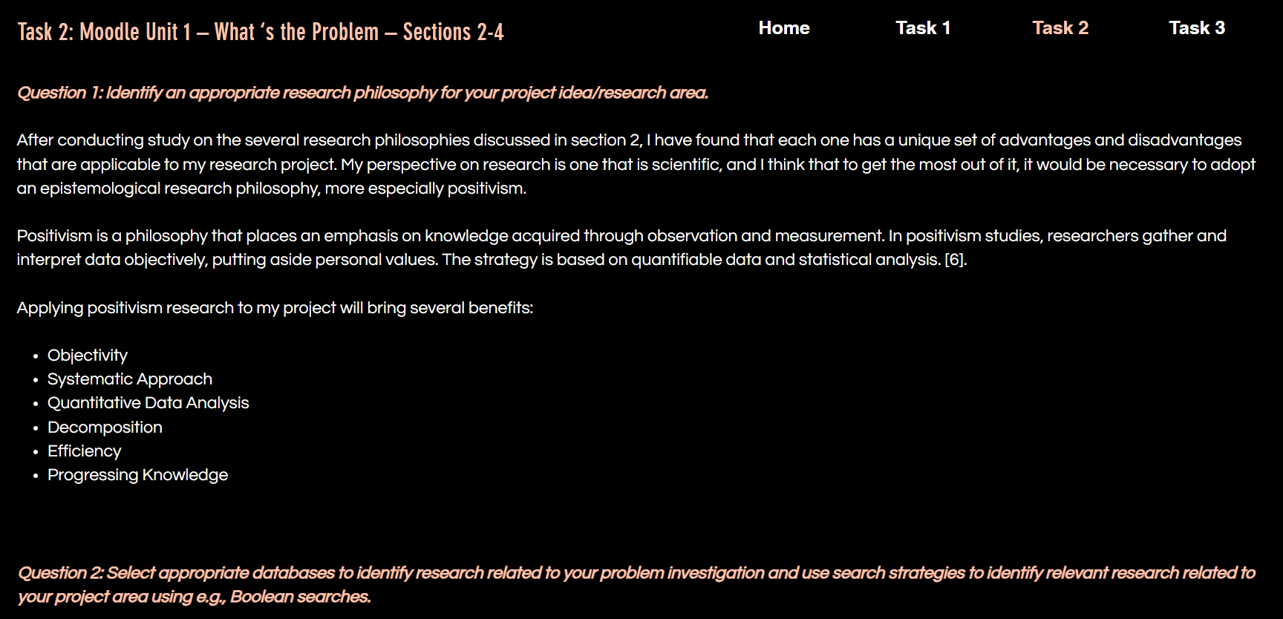
Figure 6: E-Portfolio: Task 2 - Question 1
E-Portfolio Link: Task 2 - Question 1

Question 2

A database is a compilation of data or information that has been specially organised for rapid computer retrieval [7]. My research will employ the following reputable databases.

- University Library
- Google Scholar
- JSTOR
- IEEE Xplore
- ACM Digital Library
- ProQuest
- ResearchGate

Search strategies such as keywords are core for narrowing down database search results. Adopting the following keyword principles will help yield greater research results.

- Remove words that have no specific meaning from the research statement.
- Two to four keywords per search is usually enough to produce sufficient results.
- Make keywords distinct and targeted.
- If less than 4 keywords have been identified, broaden, and narrow the concepts of each key word to generate more (if necessary).
- When keywords contain more than one word, use speech marks to indicate it is a keyword.
- If keywords are theme based use the *Asterix symbol to search it in all its forms.
- Use Boolean logic as parameters e.g., AND, OR and NOT to include/exclude searches.
- Search multiple databases.
- If lack of results, look at synonyms of keywords.

Having found research material, it is imperative that we assess the credibility, dependability, and precision of our sources. By employing the CRAAP test, I will be able to assess the credibility of the information presented.

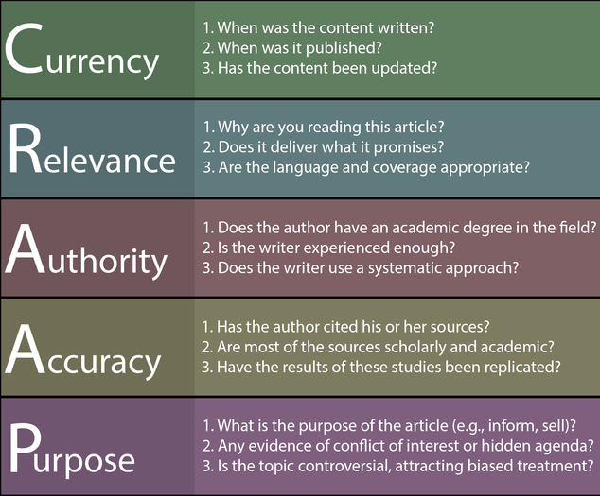
Figure 7: CRAAP Test [8]

Finally, utilising concept maps will introduce structure to my research. Concept maps “are essentially graphic tools for organising and representing knowledge” [9].

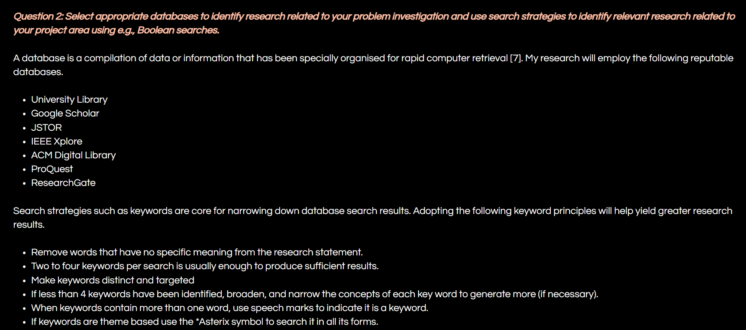

Figure 8: E-Portfolio: Task 2 - Question 2
E-Portfolio Link: Task 2 - Question 2

Question 3

Primarily, to collect data and gather feedback I need to create an engaging research question to trigger enough debate. It needs to be focused, problematic, complex, relevant, feasible, and researchable. Framing the question with a strong hypothesis is a fantastic way of initiating debate. A hypothesis is a specific and verifiable statement that outlines the anticipated result of a research study as predicted by the researcher(s). It is indicated at the beginning of the study [10].
To gather the data, I will use several research strategies to aid the automation process of retrieving Vehicle Casework statistics.
- Search engines
- Databases
- Online Journals & Articles
- University Libraries
- Anonymous Surveys
- Interviews
- Create focus groups.
- Disseminate feedback forms with suggestions.
- Observations
After collecting the necessary data and gathering feedback, I will proceed to take the next steps to enhance my project.

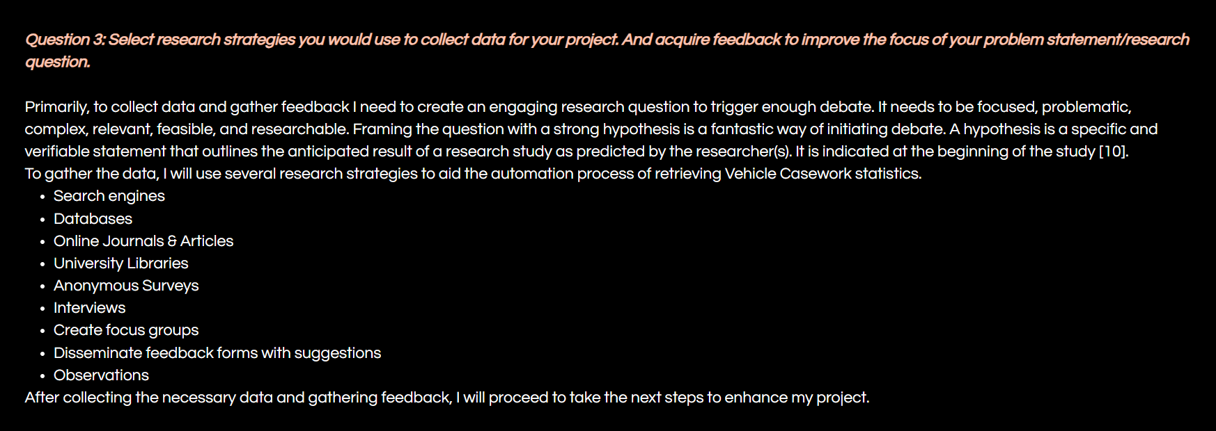
Figure 9: E-Portfolio: Task 2 - Question 3
E-Portfolio Link: Task 2 - Question 3

Task 3: Moodle Unit 2 – The worst possible idea

Question 1

Quantitative research involves the collection and analysis of numerical data. It can be used to identify patterns and averages, make predictions, examine causal relationships, and predict results to larger populations [11].
Qualitative research comprises of collecting and analysing nonnumerical data (e.g., text, video, or audio) to comprehend concepts, opinions, or experiences. It can be used to gain in-depth understanding of a problem or to generate new research ideas [12].
The table below compares quantitative and qualitative research strategies.
 | Quantitative | Qualitative
Purpose | To test theories and hypothesis in a structured approach | To explore ideas, uncover insights and to formulate theories or hypothesis
Focus | Numerical data, statistical analysis | Experiences, user feedback
Analysis Method | Mathematics and statistical analysis | Summarising, categorising, and interpreting
Sample Size | Needs many respondents to give credibility | Needs very few respondents to give credibility
Data Collection Methods | Surveys (closed questions), experiments, existing datasets | Interviews, surveys (open ended questions), literature reviews
Conclusions | Displays precise measurable results in tables and graphs. | Results are expressed in words that capture descriptive findings.

A combination of both will be used to automate the retrieval of Vehicle Casework Statistics.
Quantitative Research will be used to analyse performance metrics, to identify bottlenecks and provide the numerical data to optimise the process.
Qualitative Research will capture user experiences, highlight challenges/barriers, and provide insights into employee perspectives.

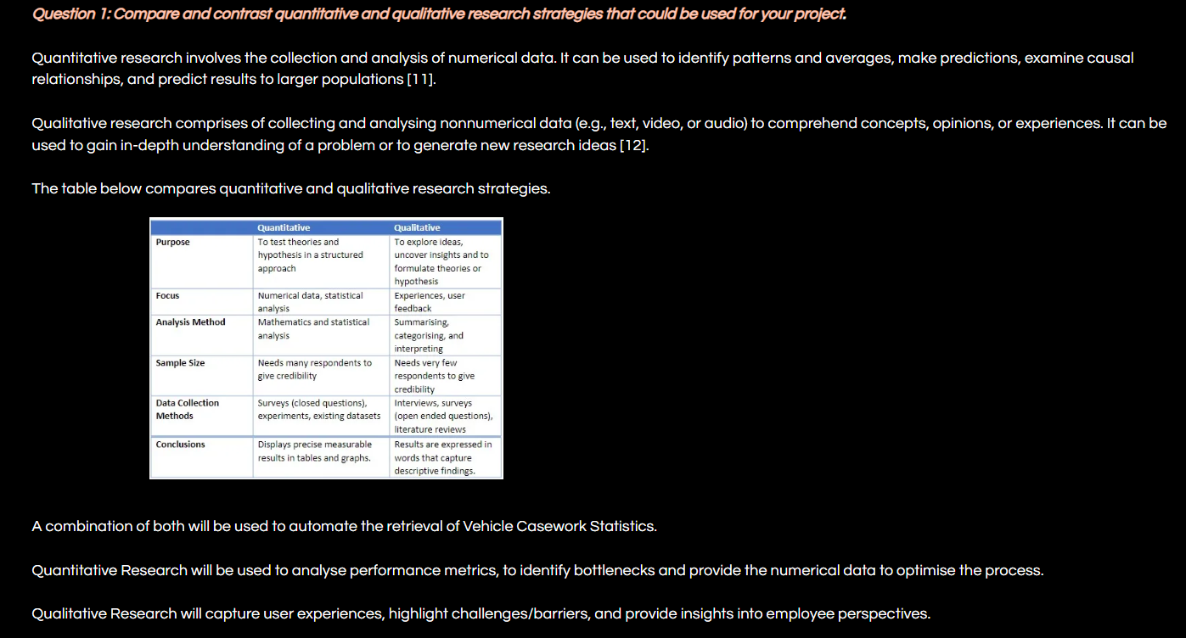
Figure 10: E-Portfolio: Task 3- Question 1
E-Portfolio Link: Task 3 - Question 1

Question 2

To enhance validity, reliability, and generalisability of my research data, I have identified the following strategies:
- Combine primary and secondary data to increase the credibility of the research.
Primary data refers to data collected directly by a researcher or a team of researchers for a specific research topic or objective [13].
Secondary data is pre-existing information collected by other individuals or organisations for a different purpose [14].
- Be aware of the Hawthorne Effect and consider ways to mitigate it.
The Hawthorn effect refers to the improvement in performance of individuals who are observed, monitored, and given special consideration by researchers [15].
- Acknowledge limitations of data collection due to time constraints and restricted knowledge.
- Define the targeted participants.
- Gather a sample that represents the targeted population as much as possible.
- For quantitative research adopt probability sampling such as random, systemic, stratified or cluster sampling to ensure unbiased statistics.
- For qualitative research embrace non-probability sampling.
- Focus on narrowing the population to have more precise conclusions.

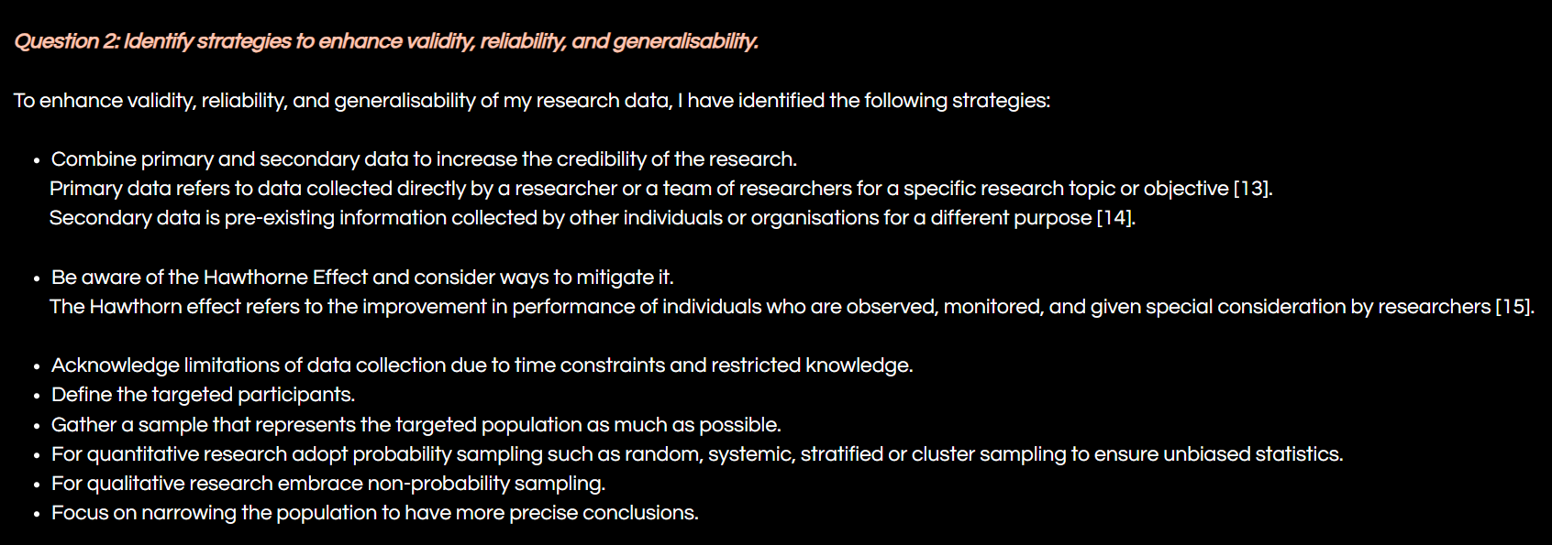

Figure 11: E-Portfolio: Task 3- Question 2

E-Portfolio Link: Task 3 - Question 2

Question 3

To automate the Vehicle Casework statistics, I need to gather a variety of data. Below is a systematic plan I have designed to collect the data I need. This will be deployed after I have defined the purpose of my research to participants.

Action | Data Collection Method | Purpose
Define Data Sources | Document Analysis | To identify the sources, we need to gather data from.
Identify Key Performance Indicators (KPI’s) | Conducting thorough analysis of the current system/process. | To provide a baseline to evaluate success and define how to measure variables.
Staff Feedback | Surveys, Interviews, Focus Groups. | To collect qualitative data on user experience, satisfaction, and to highlight issues.
Staff Work Processes | Observations | To record behaviours, interactions, events.
System Processes | System software and analytical tools | To capture quantitative data such as response times, throughput, cycle time, error rates.
Sampling Size | Purposive sampling | To uses individuals who have the knowledge and expertise who will provide valuable insights.

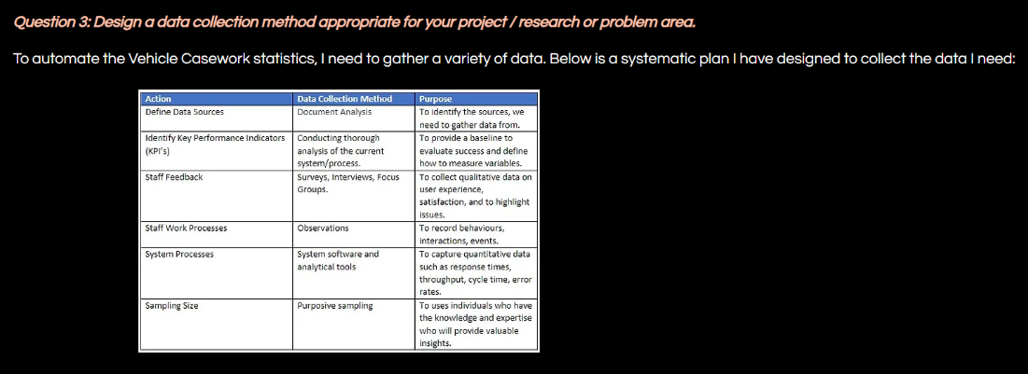
Figure 12: E-Portfolio: Task 3- Question 3

E-Portfolio: Task 3 - Question 3

References

[1] What is innovation management and why is it important? | indeed.com UK, https://uk.indeed.com/career-advice/career-development/innovation-management
(accessed Jun. 17, 2023).

[2] “The 71 most amazing innovations of all time,” YouTube, https://www.youtube.com/watch?v=I16TJUp4SVA (accessed Jun. 17,
2023).

[3] What is creativity? the ultimate guide to understanding ... - 99designs, https://99designs.com/blog/creative-thinking/what-is-creativity/ (accessed Jun.17, 2023).

[4] D. H. Pink, A Whole New Mind: How to Thrive in the New Conceptual Age. London: Cyan, 2006.

[5] “Hans Rosling’s 200 countries, 200 years, 4 minutes – The Joy of stats - BBC Four,” YouTube,
Hans Rosling's 200 Countries, 200 Years, 4 Minutes - The Joy of Stats - BBC Four (accessed Jun. 17, 2023).

[6] “Positivism - research methodology,” Research, https://research-methodology.net/research-philosophy/positivism/ (accessed Jun. 20, 2023).
[7] “Database,” Encyclopædia Britannica, https://www.britannica.com/technology/database (accessed Jun. 20, 2023).
[8] “What is the craap test?,” Psychology Today, https://www.psychologytoday.com/us/blog/finding-new-home/202001/what-is-the-craap-test (accessed Jun. 21, 2023).
[9] I. M. Kinchin, D. Streatfield and D. B. Hay, "Using Concept Mapping to Enhance the Research Interview," International Journal of Qualitative Methods, vol. 9, (1), pp. 52-68, 2010. Available: https://www.proquest.com/scholarly-journals/using-concept-mapping-enhance-research-interview/docview/2342353728/se-2. DOI: https://doi.org/10.1177/160940691000900106.
[10] S. Mcleod, “Research hypothesis: Definition, types, & examples,” Simply Psychology, https://www.simplypsychology.org/what-is-a-hypotheses.html (accessed Jun. 22, 2023).
[11] P. Bhandari, “What is quantitative research?: Definition & methods,” Scribbr, https://www.scribbr.co.uk/research-methods/introduction-to-quantitative-research/ (accessed Jun. 22, 2023).
[12] P. Bhandari, “What is qualitative research?: Methods & examples,” Scribbr, https://www.scribbr.com/methodology/qualitative-research/ (accessed Jun. 22, 2023).
[13] M. Hassan, “Primary data - types, methods and examples,” Research Method, https://researchmethod.net/primary-data/ (accessed Jun. 22, 2023).
[14] “Secondary Data,” NCVO, https://www.ncvo.org.uk/help-and-guidance/strategy-and-impact/impact-evaluation/measuring-your-impact/secondary-data/#/ (accessed Jun. 22, 2023).
[15] A. Perera and A. PereraResearcherB.A, “Hawthorne effect: Definition, how it works, and how to avoid it,” Simply Psychology, https://www.simplypsychology.org/hawthorne-effect.html (accessed Jun. 22, 2023).

Appendix

Unit 1 – Topic 1
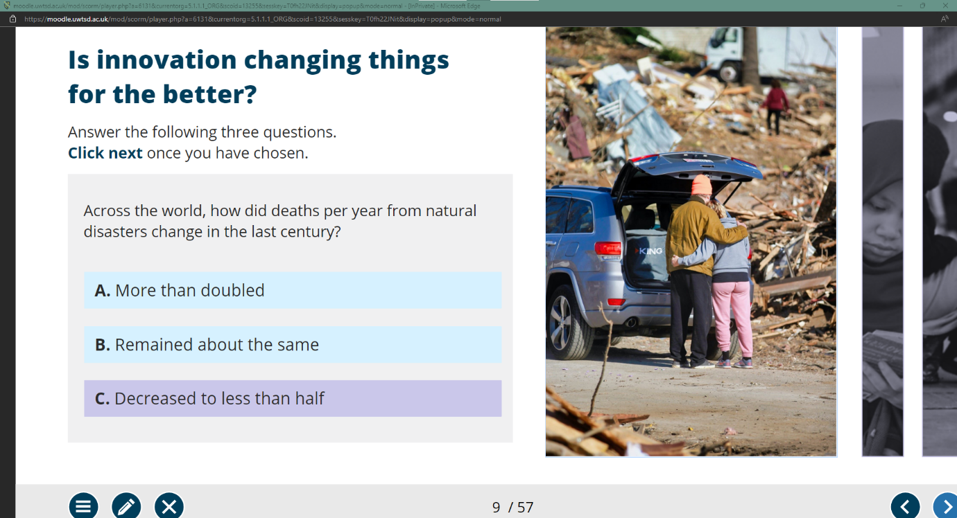

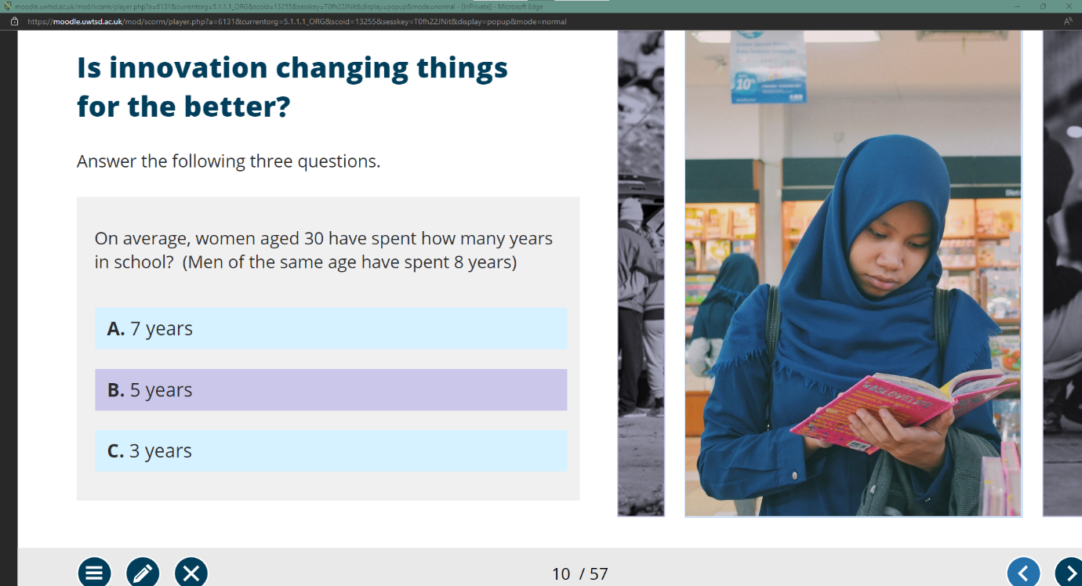

Unit 1 – Topic 2

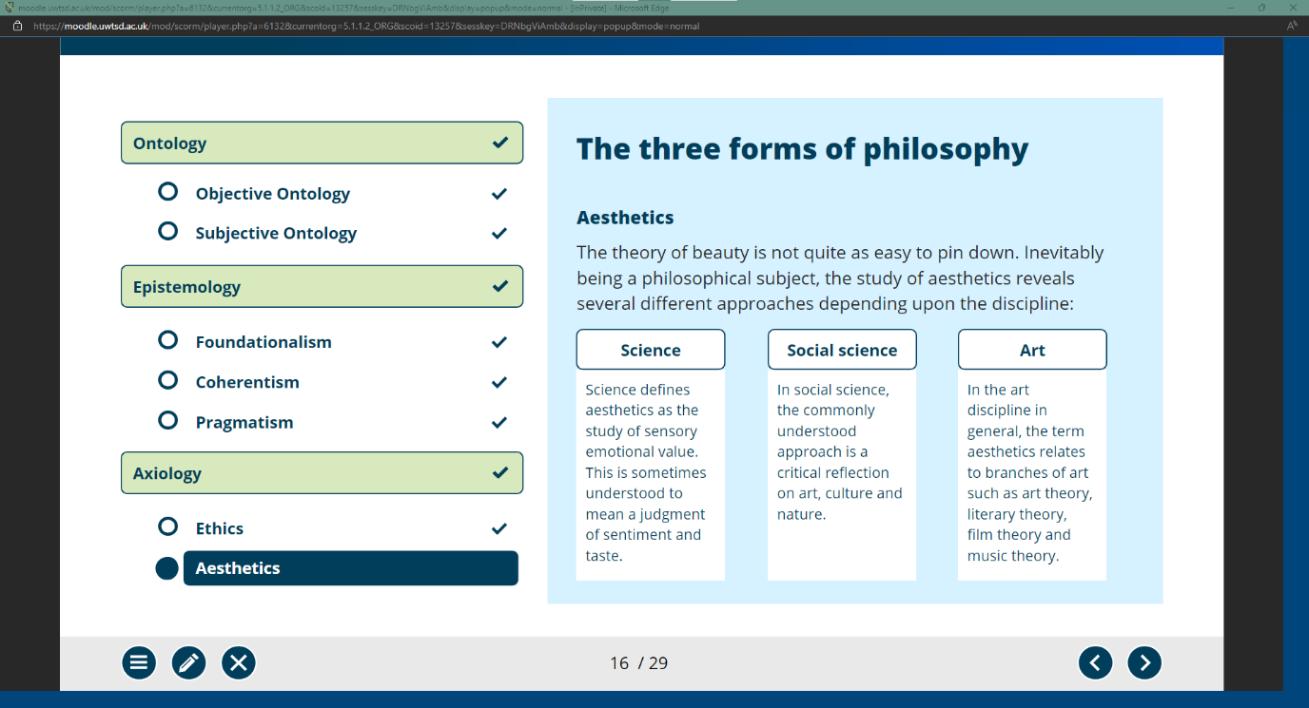

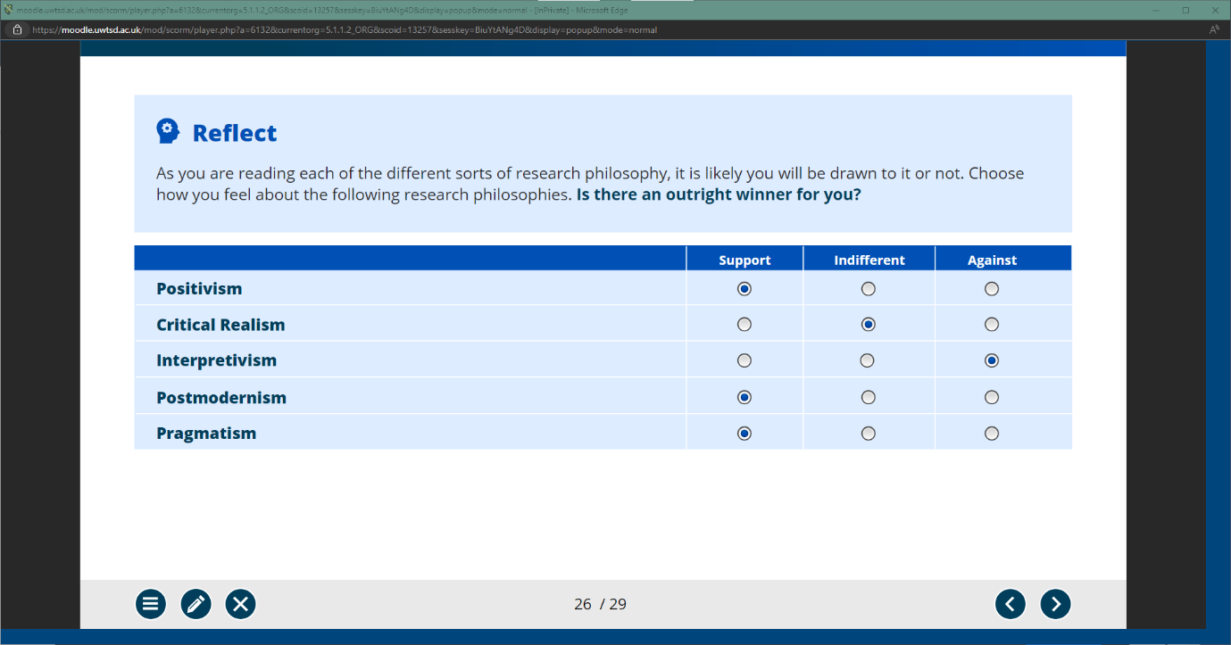

Unit 1 – Topic 3

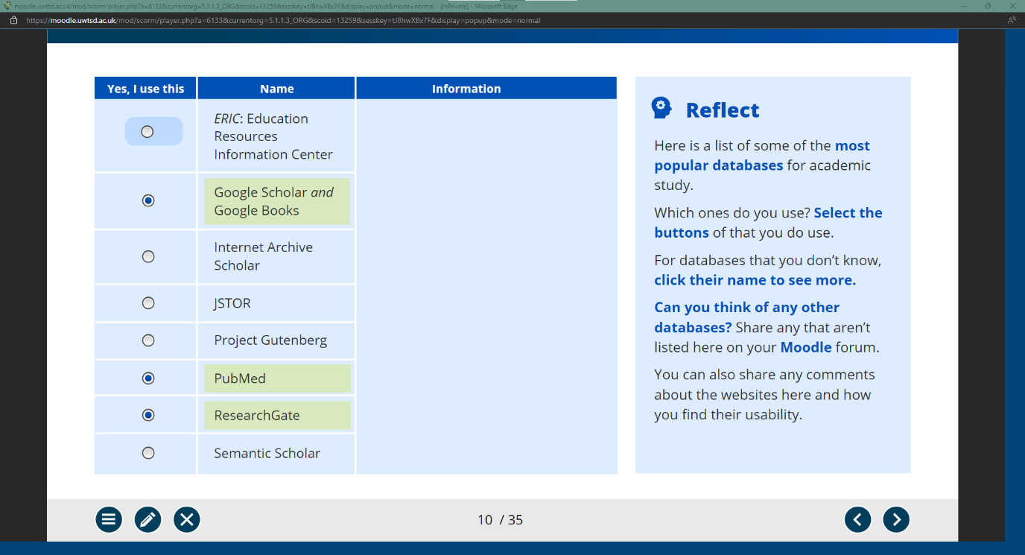

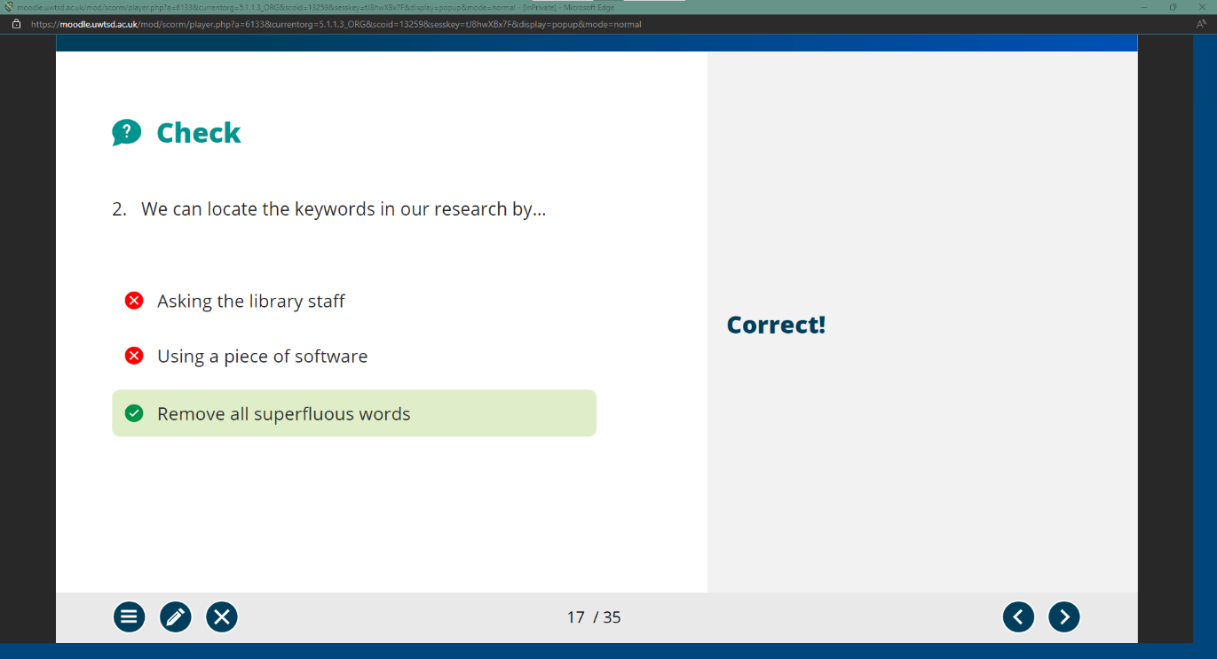

Unit 1 – Topic 4

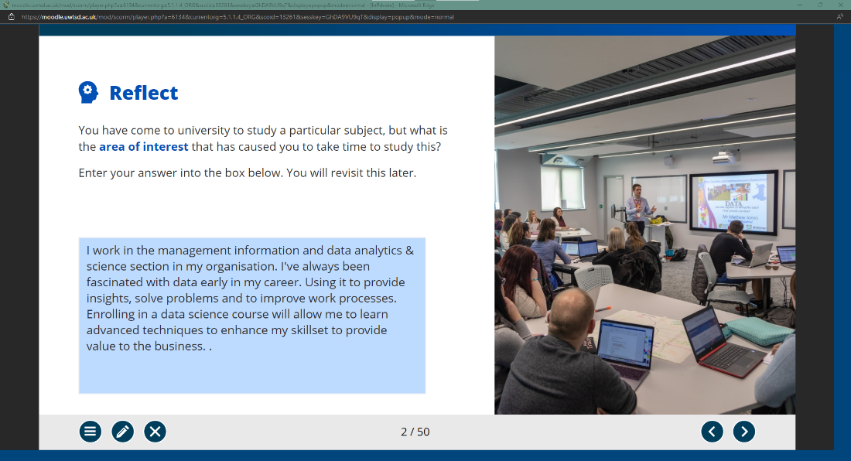

Unit 2 – Section 1

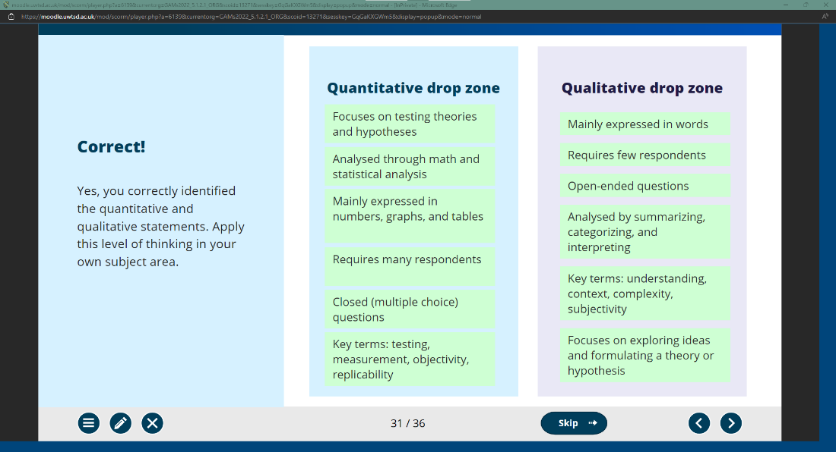

Unit 2 – Section 2

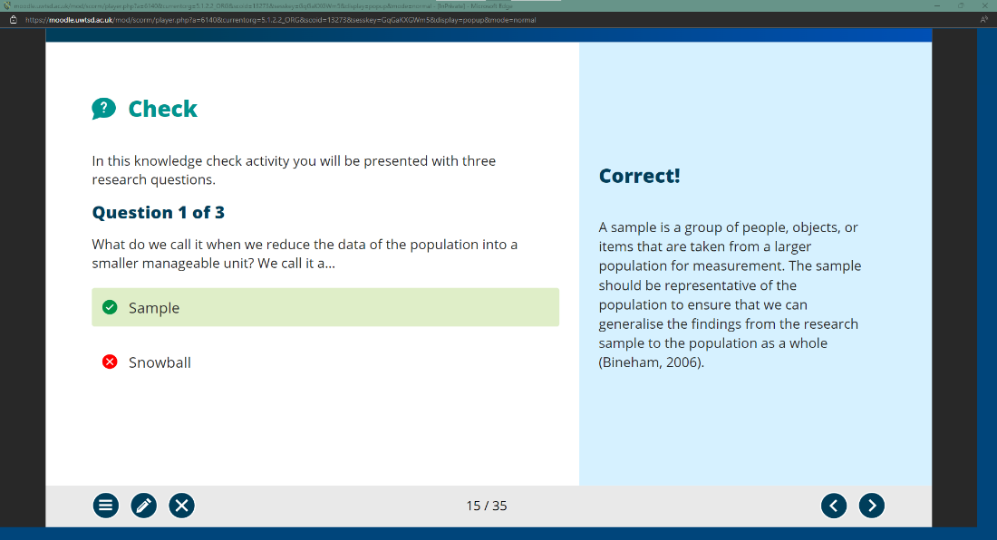

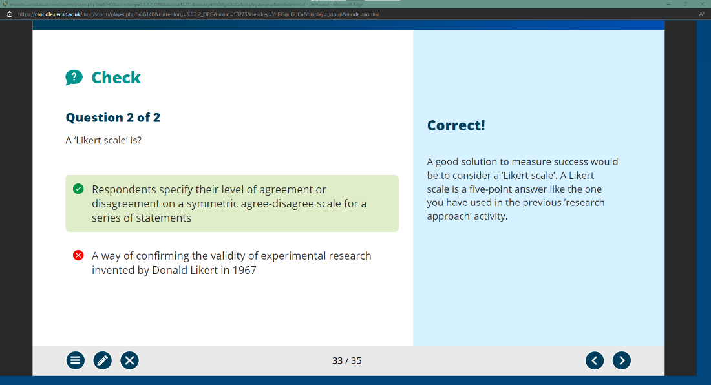

Forum Posts



