

Programme: MASTER OF BUSINESS ADMINISTRATION
Module: INTERNATIONAL BUSINESS CONCEPTS
Module code: LCMB7034
Assignment Title: A REPORT ON THE DEVELOPMENT OF UK RETAIL INDUSTRY
Lecturer name: Syed Mansoob Murshed
Student name: Harshil Bharatkumar Desai
Student ID number: 2504765
Word count: 5064
Date of submission: Friday 20/03/2026 by 2pm
Executive summary
This report is focused on analysing the competitiveness of the United Kingdom grocery retail industry and its development in the global market. The study shed light on sector’s economic importance and how it is attracting global retailers with a major consumer base of over 66 million people to develop one of the largest consumer markets. The industry contributes majorly to the UK economy while supporting higher number of job placement in the region. The structure of the sector and how it is dominated by key players like Sainsbury, and multinational corporations like Aldi and Lidl. Use of the Porter’s diamond model has been helpful in analysing how the region’s various factors influence competitiveness, infrastructure, and demand for any particular brand.
A further segment has critically analysed the competitiveness of the UK-based online grocery retail industry through evaluating the position of Amazon in this market. In this regard, Porter’s Five Forces framework emphasizes the role of developed infrastructure, high demand of the consumers, and stiff competition on the industry dynamics. However, the finding of the analysis highlights that Amazon has a leading position in the UK based on its technological advantage, logistical network and marketplace business model despite the fact that regulatory forces, economic instability and stiff competition from the other retailers that affect its success in the long term. Moreover, the reflective analysis through Kolb’s reflective cycle also supported in gaining an understanding of how the report helped in gaining and enhancing skills while considering how I aim to utilise them in the future.
Table of Contents

Section 1: Business report 5
1. Introduction to the report 5
2. Industry and Country Overview 6
3. Michael Porter’s Diamond Model of National Advantage 9
4. Critical Evaluation of Factors Influencing the Success of Amazon in the UK Retail Industry 11
4.1 Amazon as a dominant player in the UK-based online retail industry 11
4.2 Porter’s five Forces to analyse macro-factors of Amazon in the UK 12
4.3 Overall Market Attractiveness with respect to political, economic, legal and cultural factors 16
5. Conclusion to the report 18
Section 2: Reflection 19
References 22

List of figures
Figure 1: Annual net sales of Amazon in the UK (Million Dollars) (2010-2025) 6
Figure 2: sales growth of the UK grocery retail sector 7
Figure 3: Porter’s diamond Model 9
Figure 4: Online sales by retail sector in the UK, 2019-24 12
Figure 5: Porter’s Five Forces Analysis 12
Figure 6: Kolb’s experiential learning reflective cycle 19

Section 1: Business report

1. Introduction to the report
The retail industry is among the most impactful industries for any country, like for the United Kingdom, allowing it to support its economic structure. In various contexts like economic output, employment, and consumer spending, retail activity majorly impacts them. The retail sector’s economic output was £114.7 billion in 2024, which is 4.4% of the total economic output and was an increase of 1.4% from that of the level of 2023 (Parliament UK, 2025). The government report also showcased how the industry has supported approximately 2.6 million jobs in 2024 alone, highlighting how it is supporting the country’s economic growth and labour market. The sector has also gone through major shifts in recent times for the growth of e-commerce, technological advancements, and changing consumer behaviour.
Wadud et al. (2025) stated that the online retail sector has been a major factor with rapid expansion and with digital platforms shaping how consumers search, purchase, and receive products. Among the key companies with influence on this transformation, Amazon, a major multinational corporation has become a most influential retail platform operating in the UK market. In 2024, Amazon gained major revenue of approximately 37.9 billion dollars in the UK, showing its growth over the years in the region, as also identified in Figure 1 (Oosterhout, 2025).
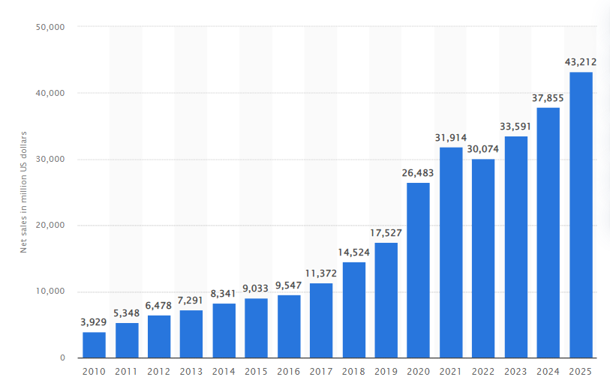

Figure 1: Annual net sales of Amazon in the UK (Million Dollars) (2010-2025)
(Source: Ma, 2026)
Thus, the report aims to focus on the UK grocery retail industry, with a specific focus on the omnichannel and e-commerce retail segment, and its competitiveness. It is focused on providing an overview of the sector, and how grocery retailers have adapted to omnichannel and e-commerce while considering key frameworks like Porter’s Diamond Model of National advantage, and PESTLE analysis. These will support in analysing the industry competitiveness while providing a critical analysis of Amazon and its operations in the UK market.

2. Industry and Country Overview
The online grocery retail industry is a major contributing force to the economic context of the United Kingdom, allowing for a better balance among employment, regional economy, and consumption. With time, the UK grocery retailing environment has gone through major changes due to technological adaptations, omnichannel growth, and changings of preferences, which have impacted how products are marketed and sold. For the economic scale perspective, it is analysed that the UK retail market size has reached $992.4 billion in 2024. It is further expected to reach $1440.2 billion by 2033 (Imarcgroup, 2024). Industry insights showcase that the retail sales in Great Britain were estimated to reach nearly £517 billion in 2024. As shown in figure 2, this is an increase of 1.4% from 2023 values, showing the major purchasing power of the UK consumers also showing a steady growth (Ward, 2025). Employment is also promising in this sector, with 2.76 million jobs as of March 2025 (Leonards, 2025). Furthermore, the omnichannel commerce market is also projected to reach $47.9 billion by 2032, showcasing strong growth of companies to compete with online grocery retailers like Amazon (mobility foresights, 2026).
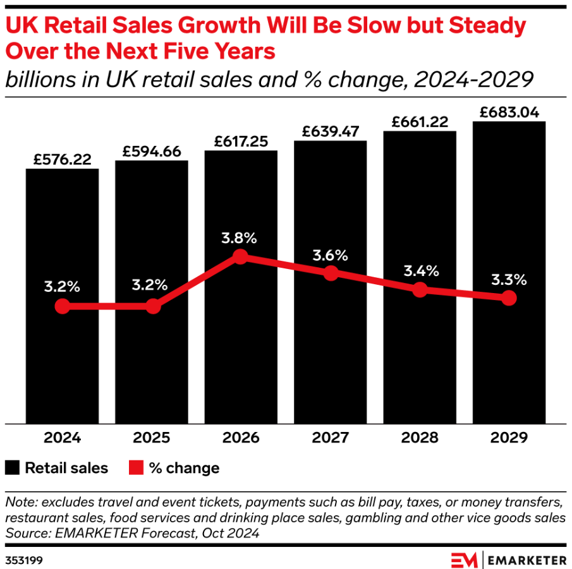

Figure 2: sales growth of the UK grocery retail sector
(Source: Lamb et al., 2025)
The UK retail sector is focused on a diverse scope with clothing, fashion, grocery, and e-commerce being separate segments of it. Retail can also be closely aligned with other industries like logistics, transport, and digital services. This can be supported through the context that the expansion of e-commerce has resulted in an increase in warehousing, distribution centres, and proper fast delivery networks (Kostikov et al. 2021). As time passed, e-commerce has gained major influence on the retail sector of the UK, with significant growth in online retail, identifying consumer behaviour and its influence through digital platforms. In the UK grocery retail market, it can be identified through various domestic retailers and multinational companies. Some of the major domestic firms that are dominating the omnichannel segment include Sainsbury, and Tesco, with major e-commerce presence. Among these, Tesco is the dominant retailer in the UK grocery market with a significant grip on the e-commerce or online retail segment (Roy, 2024). This company has gained its competitive advantages through large-sized store networks, effective supply chain capability, and diverse product offering. These retailers have utilised their omnichannel and e-commerce retailing approaches to compete with fully e-commerce platforms like Amazon. On the other hand, Sainsbury is an omnichannel retailer with a focus on quality and private-labelled food products, making it among the key players of the domestic UK-based retail industry in the e-commerce segment (gov UK, 2019).
These domestic companies ensure strong brand recognition and competitiveness with a focus on developing a trusting relationship with the UK consumers and thus holding major market shares. Besides these domestic companies, the UK retail sector is also having major investment from multinational companies which aim to utilise the large consumer base of the UK market. Various German major discounting supermarket chains like Aldi and Lidl have rapidly expanded in the region with low-cost operating models and focusing on the price-sensitive consumers through efficient supply chains and competitive pricing approaches. The strategy is mostly focused on efficient supply chains, private-label products and smaller store formats, which allows for competing in a more aggressive manner for price with the existing major market players (Petto, 2025).
It is despite the fact that one of the most competitive multinational retailers in the UK is Amazon in the e-commerce retail industry. Being a US-based company, Amazon has been able to expand in the UK market effectively while changing the retail context completely. The keen focus on online shopping, rapid delivery, and the effective digital marketplace for third-party sellers, Amazon has been able to introduce new opportunities for the UK retail market to shift from traditional approaches (Billingsley, 2025). Based on this analysis, it can be said that the UK retail industry is highly competitive and shifting rapidly with time. Price sensitivity, competitive pricing, technological advancements, and discounting approaches are key influential factors of the industry. As stated by Har et al. (2022), the combination of domestic and international retailers is also changing the industry, with domestic competitors focusing on physical stores while multinational companies gaining an advantage through online and technologically advanced approaches in the UK retail sector. Thus, the combination of various business models and major competition is managing the structure and enhanced performance of the UK retail market, specifically e-commerce and omnichannel segment in the global context.

3. Michael Porter’s Diamond Model of National Advantage
The chosen framework of Porter’s diamond Model of national advantage is often utilised in the case of analysing why particular industries in a country can become internationally competitive with a focus on four key areas as highlighted in Figure 3 (Dzreke, 2025). Through the use of this model in the UK grocery retail industry, particularly the e-commerce and omnichannel, the study will be able to analyse why the sector is among the most developed and competitive markets in the European region.
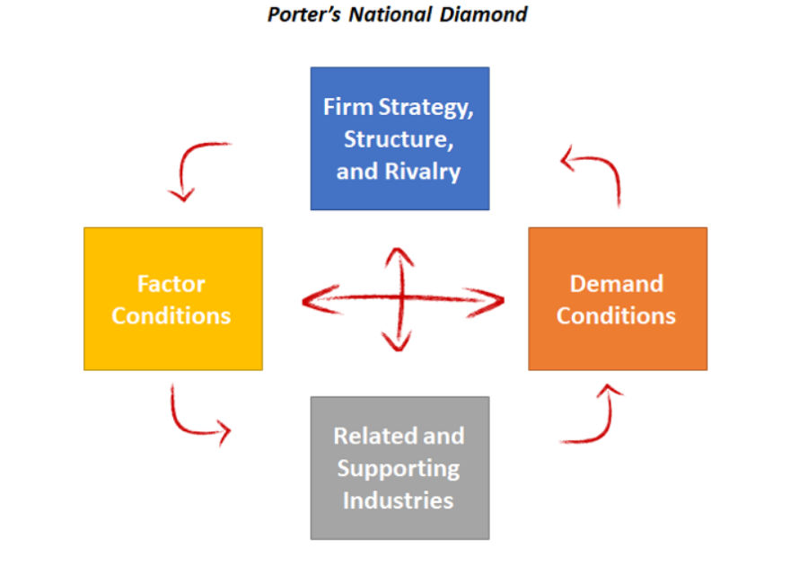

Figure 3: Porter’s diamond Model
(Source: Meirc, 2020)
Factor conditions
Factor conditions refer to the resources which are available in a country that support the development of an industry (Erboz, 2020). In the context of the UK grocery retail sector, there are various advantages for competitiveness. In this aspect, one key factor is the highly developed infrastructure and logistics network of the UK (Icttm, 2025). The UK has a major, extensive road, rail, and port system that focuses on efficiency for supplying goods among suppliers, warehouse and retail stores. Furthermore, the growth of the large distribution centres and fulfilment facilities has improved supply chain efficiency across the sector. Furthermore, the condition is the availability of skilled labour force and the advanced digital infrastructure. The UK also has better smartphone usage, penetration, and rapid e-commerce growth. Online retail sales accounted for 27% in 2022, which is a major portion of the total retail sales in the UK (Parliament UK, 2025).
Demand conditions
Demand conditions refer to the type of consumer demand in the domestic market. The UK’s major and diverse consumer base with higher purchasing power is supporting the businesses. The UK has a population of over 66 million people with relatively higher purchasing power, providing one of the largest consumer markets in the complete European region (Rose, 2024). British consumers are also highly aligned for adapting to new technologies, which in this case is online commerce or e-commerce in various shopping and retail formats (Ou, 2025). Consumers focus on higher-level expectations from grocery items with a focus on competitive pricing, product varieties, and fast deliveries. This has, therefore, mandated grocery retailers to innovate and enhance efficiency order for competitiveness. Wadud et al., (2025) added that the rising popularity of e-commerce and home delivery has developed shifts. Furthermore, economic pressures like inflations and rising cost of living are potentially influencing the industry (Mintel, 2023).
Related and supporting industry
As the industry becomes more complex, support becomes even more crucial in the UK retail aspect where the businesses growth primarily relies on the suppliers for affordable access to high-quality inputs within a domestic market. In this regard, the industry enjoys a global competitiveness which is strongly aided by the existence of developed related and supportive industries like logistics, digital infrastructure, and financial technology also (Har et al., 2022). The retail sector of the country maintains one of the best logistics and distribution networks in Europe. In such cases, Ayawei and Odunlami (2025) showed that online retailers deliver their parcels efficiently through Royal Mail and DPD also. As per the data, the transport and storage sector added more than £140 billion to the UK economy, which shows the magnitude of logistical capacity behind the retail sector (Logistics UK, 2025). In addition to these, the high growth rates of digital payments and financial technologies (PayPal) enable safe purchases online, which is a necessity when it comes to the development of e-commerce. Operation efficiency and scalability is further improved by the fact that there are great technology providers and cloud computing infrastructure which strengthen the digital retail ecosystem in order to help the industry to compete successfully in digital markets across the world (Wadud et al., 2025).
Firm strategy, structure and rivalry
Due to the association of high level of competitive rivalry and strategic innovation that enhances its competitiveness on the global level, the giant retailers of the UK use various business schemes with a combination of digital and physical outlets to cope with the evolving consumer behaviour. As defined by Samadzadeh (2024), the most popular stores like Tesco and Sainsbury compete with online stores like Amazon by creating omnichannel retail, incorporating e-commerce platforms into physical distribution systems. Statistically, the UK eCommerce sales also increased by nearly 30% in 2024-2025 as the third-biggest online retailing market in the world which is expected to increase its average growth rate of 7.01% by 2029 (U.S. Department of Commerce, 2026).

4. Critical Evaluation of Factors Influencing the Success of Amazon in the UK Retail Industry

4.1 Amazon as a dominant player in the UK-based online retail industry
As one of the leading global grocery retail brands, Amazon has also achieved the status of the most powerful digital retailer in the United Kingdom. In this regard, it is leveraging the well-developed environment of e-commerce and digitally oriented consumers in the country. Despite the retail sector going through a prolonged period of upheaval after the pandemic of COVID-19 and worldwide inflationary issues, the total sales of the UK retail sector amounted to approximately £517 billion in 2024 with the increasing rate of online retail purchase (Rhodes, 2018). Amazon grabbed a superior market position in this environment and controls approximately 30% of the UK ecommerce business, which is magnitudes higher than its competitors like eBay (approximately 9.8%) as well as Sainsbury’s (4.6%) and Tesco (4.5%) also.
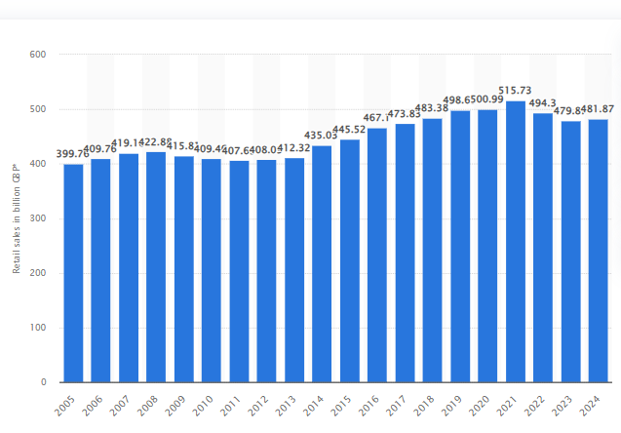

Figure 4: Online sales by retail sector in the UK, 2019-24
(Source: Statista, 2025)

4.2 Porter’s five Forces to analyse macro-factors of Amazon in the UK
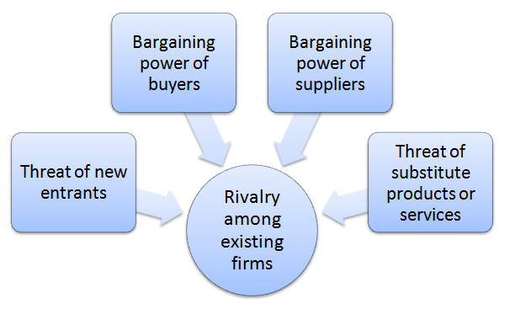

Figure 5: Porter’s Five Forces Analysis
(Source: Dudovskiy, 2022)

The performance and the long-term success of the retail brands are highly influenced by the competitive environment of the online retail industry of the UK. In addition, the UK is one of the most digitally advanced retail markets in the world, and online purchases make up about 30% of the overall retail activity and bring about approximately $43.2 billion in 2025 (Statista, 2024). In this aspect, despite having a perfect omnichannel approach, existing brands are also focusing towards the online retail sector to compete with the entire online retail brand like Amazon. In this context, the Five Forces framework developed by Porter is a convenient tool in critically examining the competitiveness in the industry by using its 5 core aspects. From the perspectives of Ningsih et al. (2025), this includes rivalry amongst already established firms, the threat of new entrants, the power of suppliers, the power of buyers, and the threat of substitutes.

Competitive Rivalry (high):
The competition within the UK e-commerce retail sector is highly stiff due to the existence and high dominance of the established chains of supermarkets as well as specialised online retailers that compete in various product segments. Although Amazon has dominated the UK e-commerce with controlling 30% market share, high level of competition with eBay, Tesco, Sainsbury and ASOS can vie for market share. According to Lasky (2025), Tesco’s brick-and-mortar operations need to follow compliments of its online business and integrate effectively innovative strategies to reach global and diverse customers and dominate the online market through home delivery and click-n-collect services.
Despite the integration of the platform model which allows Amazon to sell through diverse product lines, competitors have employed differentiated strategies, in which the omnichannel retailing aspect of Sainsbury and Tesco need to be considered while the specialised online retailer like ASOS invested on specific product category on the basis of the evolving consumer demands (Roy, 2024). This type of strategic differentiation can impact the competition level where Amazon has to innovate in the field of logistics, pricing, and customer experience to sustain the leadership. On the other hand, Shahzad et al. (2024) stated that rising ethical awareness among the competitive brand can also weaken scale and brand recognition of Amazon, in which the intense competition can create pressure for high levels of technological advancement even in the high inflationary pressure in the UK.
Threat of New Entrants (moderate):
The risk of new entrants in the UK-based online retail business is moderate and has relevant structural barriers. While digital technologies have reduced the entry barrier of the small business as entrepreneurs can create online stores with a relatively small investment, the fragmented digital retail market with high number of sellers increases the competition in certain product lines (Statista Research Department, 2025). Nonetheless, it is incredibly challenging to scale the operations to compete with Amazon due to its developed logistic system and capital investment, the emergence of local brands in the UK retail aspects can influence the price-comparison behaviour during economic downturns. In this regard, reduced consumer purchasing power can not only limit overall transaction volume across its marketplace but also highlight the differences between online marketplaces and traditional retail formats (Rhodes, 2018). Amazon has big fulfilment centres and developed distribution systems that enable it to deliver products within one or two days (De Silva et al., 2020).

Bargaining power of the suppliers (low to moderate):
The supplier’s bargaining power within the retail industry in the UK depends on the strength of the brand and product differentiation, in which Amazon has the power of maintaining strong appeal towards its products or services that cannot be easily replaced. According to Casano (2023), a vast range of small and middle-size retailers are dependent on the Amazon market to reach customers, and this aspect makes their bargaining power considerably less. On the other hand, the research of Kim et al., (2024) stated that pricing transparency and contractual terms between large digital platforms and independent sellers might raise the bargaining power of the suppliers. Nevertheless, the economic and logistical impacts of Brexit can be seen as a major influential factor that may enhance new customs processes and supply-chain complications for Amazon in order to impact its cross-border trade between the UK and European markets (Cecil, 2024). Due to the dependency of the brand towards the global supply chain, regulatory changes can increase the operational cost as well as bargaining issues within the international supply chains which further affect its operational costs as well as create challenges in maintaining higher compliance cost.

Bargaining Power of Buyers (high):
The buyer power of the e-commerce retail market in the UK is also relatively high as consumers can access a number of competing platforms and easily compare prices over the Internet as well as the in-store based retailers partnering with apps and directly competing with e-commerce brands like Amazon (Statista, 2025). Digital adoption has been high with the UK having over 62 million e-commerce users with over 90% of internet users frequenting online product purchases (Electro Growth, 2025). With this transparency, the brand’s success can not only be influenced by the technological availability but also can enhance threat issues, in which customers can easily change the retailers once better offers are found in terms of price or delivery aspect. As per the research data, discretionary consumer expenditure has decreased in the UK due to the ongoing cost-of-living issue and inflationary pressures, especially in non-essential goods categories. Reduced consumer purchasing power may limit the total volume of transactions in Amazon's marketplace, even though the company profits from price-comparison behaviour during recessions. On the other hand, the competitive approach of other brands (Argos) regarding the pricing and delivery aspect of Amazon is followed in the UK platform, which might enhance the buyer’s bargaining power through the evaluation of competing offers across multiple channels (MSN News, 2024).

Threat of Substitute (high):
According to Ellahi et al., (2024), the threat of substitutes in the UK online retail ecosystem has mainly been influenced by the alternative purchasing channel instead of completely differing products. In this regard, the existences of brick-and-mortar retailers are still offering alternatives to online shopping through instant product availability and customer service. On the other hand, Tesco and Sainsbury supermarket chains appeal to customers by providing the convenience of the physical store along with the online grocery solutions. In this aspect, grocery-related websites like the operational aspect of Ocado in Amazon need to be considered which are dedicated to high-quality online food delivery (Ocado Group, 2025). By offering more niche products within a particular market and having a higher brand loyalty, these niche competitors may pose a threat to Amazon. However, as defined by Maddock-James (2025) that despite huge competition in the market against omnichannel stores from the existing brands, targeted e-commerce platforms are still rather high. As a result, the integrative ecosystem and constant investment in logistics innovations allows Amazon to maintain its leading roles in the e-commerce-based grocery retail market (Statista, 2024).

4.3 Overall Market Attractiveness with respect to political, economic, legal and cultural factors
The United Kingdom is one of the most favourable foreign markets for e-commerce and online grocery retail platforms because of its stable political environment, developed economic environment along with the well-developed legal frameworks, and digitally oriented consumer culture (Statista, 2025). These factors determine the environment in which Amazon operates and influence its sustainability initiatives in the UK retail sector.
Political factor:
The UK presents a relatively stable political system and well-established regulatory bodies which are favourable to business investment. As defined by Tiwasing et al., (2022), the government policies to enhance the digital economy have also contributed to the development of e-commerce infrastructure and the provision of online retail services. Regarding this aspect, one of the notable examples is the Digital Markets, Competition and Consumers Act 2024 that enables the UK Competition and Markets Authority to regulate large online platforms in order to enhance fair competition within online markets (Ozili, 2025). In the case of giant grocery retailers like Amazon, such a regulatory framework would provide a more transparent and predictable business environment, as well as consumer protection and fair market practices in the fast-growing e-commerce industry in the UK. On the other hand, Brexit has posed some challenges to multinational retailers by introducing new customs procedures and changes in cross-border regulation which have added complexity and costs to logistics for the MNCs that depend on international supply chains for operating in the UK retail environment (Dehani and Hägerström, 2021).

Economic factor:
The UK continues to be one of the largest retail markets in Europe due to its total £517 billion in 2024, which reflects its high consumer spending capacity along with the high penetration of online retail shopping. According to the competition law perspective by Geradin and Smith (2023), the hybrid business model of the company allows it to invest in economies of scale, sophisticated logistics, and a marketplace ecosystem by third-party sellers that solidifies its market dominance, especially in the online grocery retail sector. In spite of these opportunities, consumer purchasing power has been restricted over the last few years due to inflationary pressures and the current cost-of-living crisis. However, by using the 20 distribution sites in the UK, Amazon's sales have grown at an astounding rate over the past decades within the country, with net sales rising from about $4 billion to approximately $43.2 billion in 2025 (Statista, 2024). Furthermore, the mandate of Competition Act 1998 is a pertinent regulatory framework that affects pricing behaviour, in which the competition regulator of the UK can interfere when companies use unfair prices that affect the consumers or limit competition in the market (Cseres, 2020).

Legal factor:
The legal environment in the UK is also very critical in determining the market attractiveness. As defined by Haddara et al. (2023), data privacy regulations and strict consumer protection laws such as the UK General Data Protection Regulation demand high data security and transparency levels in online transactions by online retailers. Furthermore, the Consumer Rights Act of 2015 introduces explicit legal rights of consumers buying goods and services over the Internet, such as the right to a refund, guarantee of product quality, and the right to transparent pricing (Sutherland, 2023). These policies demand that online retailers including Amazon should guarantee that online transactions are contained within stringent customer protection guidelines. Saluja and Kaur (2025) stated that although these legal frameworks may make retailers more compliant and more expensive to operate, it has the power to influence consumer loyalty towards the brand’s online retail platforms and may build long-term growth in the competitive market of the UK.

Cultural factor:
There is a strong preference for digital grocery retailing platforms and e-commerce marketplaces, especially after the pandemic of COVID-19 (Statista, 2025). In this regard, the value proposition of platforms like Amazon is further influenced by the convenience-oriented lifestyles and high-speed delivery aspects of the UK consumers. Regarding the market position of Amazon in the country-industry pair, integration of Amazon Prime ecosystem helps the brand to stand in opposition to its large competitors like Tesco and Sainsbury that keeps its dominance through extensive physical stores along with the click-and-collect services and loyalty programmes (Statista Research Department, 2025). However, these differences allow the company to expand its Amazon UK Service through a wider range of product categories, including fashion, electronics, and home products in one platform by prioritising convenience and time efficiency also (Statista, 2024).

5. Conclusion to the report
By critically evaluating the competitiveness among the omnichannel and online grocery retail sector and analysing how Amazon has placed itself strategically in these rapidly changing aspects, the study has concluded that the e-commerce-based retail market of the UK is an extremely developed and globally competitive industry that is supported by the effective infrastructure, highly digitized industry and a large consumer base. Using the Diamond Model of Michael Porter, the analysis has concluded the favourable factor conditions, advanced consumer demand, closely related industries, and high market competition as a set of conditions that positively influence the international competitiveness of the industry.
In addition, the Porter’s Five Forces analysis indicated that Amazon is exposed to a very competitive environment that is characterised by high buyer power, increasing substitutes, and unending strategic competition with other retailers like Tesco and Sainsbury. However, the entire report has concluded the reason behind the high favourable aspect of the UK market in the global retail industry in spite of regulatory pressures, economic uncertainties, and changing consumer expectations, owing to its high levels of digital ecosystem and e-commerce adoption.

Section 2: Reflection
Reflection practices are crucial for academic learning as it allows for analysing the personal experience and identifying areas for enhancements (Yadav and Bhatia, 2024). For this reflective approach, the Kolb’s Reflective cycle provides a proper framework for shedding light on the process of four stages, including concrete experience, reflective observations, abstract conceptualisation, and active experimentation.


Figure 6: Kolb’s experiential learning reflective cycle
(Source: Schieber, 2020)
Concrete experience
The first stage in the Kolb’s reflective cycle is the focus on describing the experience (Wijnen-Meijer et al., 2022). In this assignment, the key task has been focused on researching and preparing a detailed business report to analyse how the UK grocery retail industry is competitive on a global scale. The report required developing the need for analysing academic frameworks like Porter’s Diamond model, and PESTLE analysis while analysing how other competing companies are operating in the industry. For this, I have relied on the case study of Amazon a key company for analysis due to its major influence on the online retail development in the United Kingdom. The process started with collection of reliable information for the retail industry, such as statistical data determining the actual market size. In this process, I was able to analyse various sources like government publications, statistical databases, and peer-reviewed journal articles. The application of Porter’s diamond model and analysis of Amazon’s operations in the UK market allowed me to gain in-depth understanding of the grocery retail industry in the UK and ways companies manage their competitive positioning. The experience allowed me to understand how to utilise these frameworks while learning to combine the research findings with theoretical perspectives to produce properly structured findings.
Reflective observation
As stated by Wijnen-Meijer et al., (2022), this stage assists learners to step backwards to lay emphasis on review, analysis, and interpretation of some previous concrete experiences. In this stage, one of the most proper aspects of the complete study process was the wider available data for the UK grocery retail industry. Reliable data from some authentic online data sources has allowed me to effectively analyse the context while ensuring to support the analysis with real datasets. I was able to properly understand how the global companies operate in various markets. With a keen focus on Amazon’s operations in the UK, allowed me to analyse how MNCs can operate through adapting their approaches based on local consumers and competitions. This supported me in developing a better understanding of international business environments and how market conditions influence business success. Yet, for me, there have been some challenges in this process. For an example, I faced challenges while selecting the most relevant data from large available database. During the use of academic frameworks like the Diamond model, I faced issues with implementation. It needed careful analysis of each factor in relation to the UK retail industry. For me understanding how each aspect like demand conditions, factor conditions, are existing in the industry, required me to go for a more in-depth analysis of the topic via critical thinking.
Abstract conceptualisation
In this study, I was able to develop various insights for the research process and the retail industry. Among lessons learned, understanding how theoretical frameworks can be utilised for analysing the real-world industries is highly crucial. Before conducting this study, I initially considered frameworks like the Diamond model as a just theoretical aspect, and after the application of it in the UK grocery retail industry, it allowed me to gain a better understanding of how these frameworks can be utilised for analysing why particular industries are competitive in the international market. I have also been able to identify the cruciality of the use of credible and reliable sources for academic writing. It also allowed me to verify any data with authentic sources, which also supported the reliability of the findings of this study. The research process provided me the opportunity to shed light on the importance of digital transformation in the retail industry. Factors like digital payment systems, advanced logistics, and online grocery retailing are highly prevalent in the UK market. The focus on Amazon's success in the UK market also highlighted how technological innovations can develop new types of competitive advantages and how they are influenced through technological and economic shifts. I was able to improve my ability for analytical thinking. Breaking the report into sections like industry overview, the competitive analysis, and Amazon’s operations have helped organize the research more efficiently.
Active experimentation
The lessons learned from the report is highly crucial for me in future context, for example the crucial need for planning research activities in a more systematic manner is clearer for me now. In future similar works, development of a clear research plan at the start can support me to manage the sources more efficiently and reduce the time for completing the study. I also focus on enhancing my critical analysis approaches in future context. While the collection of data is crucial, analysing them in a more detailed manner and linking them to the theoretical frameworks, like in this study, is also important. Practicing these skills will allow me to develop more analytical and insightful academically supported reports. My academic writing skills is also enhanced with this report as I learned to maintain clarity and logical structure in a report, that supports in simple understanding of complicated information. Thus, based on the complete experience, I can say that in future research and report writing, I can utilise the key experiences of this research for data analysis, critical thinking, and academic research. Through reflecting on the process in Kolb’s reflective cycle, it can also be said that both the challenges and achievements contributed to the development of strong analytical and research abilities. Taking these into account, I can use these insights for future academic and professional works that will include any industry analysis and strategic evaluation of companies in it.

References

Ayawei, E.D. and Odunlami, A., (2025). Navigating Brexit and Beyond: Optimizing UK Export Strategies for Effective Shipping Solutions. Sch J Econ Bus Manag, 8, pp.220-227. https://www.saspublishers.com/media/articles/SJEBM_128_220-227C.pdf

Billingsley, J., (2025). The Power of Amazon Marketplace for British Brands in 2025. Available at: https://www.bingdigital.com/the-power-of-amazon-marketplace-for-british-brands-in-2025/ [Accessed on 07.03.2026].
Casano, C., (2023). Cloud computing and sustainable supply chain management: meeting sustainability reporting standards. https://www.theseus.fi/bitstream/handle/10024/817361/Casano_Cline.pdf?sequence=2

Cecil, P., (2024). Cross-Border supply chain optimization: strategies for managing international operations while maintaining speed and cost efficiency. Int. J. Sci. Res. Manage.(IJSRM), 12(05), pp.6565-6588. https://www.researchgate.net/profile/Kuku-Oluwamayowa/publication/390666191_Cross-Border_Supply_Chain_Optimization_Strategies_for_Managing_International_Operations_While_Maintaining_Speed_and_Cost_Efficiency/links/67f8004c60241d51400ad2cb/Cross-Border-Supply-Chain-Optimization-Strategies-for-Managing-International-Operations-While-Maintaining-Speed-and-Cost-Efficiency.pdf

Cofaceuk, (2025). UK Sector Snapshot – Retail Trends. Available at: https://www.coface.uk/news-economy-and-insights/uk-sector-snapshot-retail-trends [Accessed on 10.03.2026].
Cseres, K., (2020). Integrate or separate: institutional design for the enforcement of competition law and consumer law. Amsterdam Law School Research Paper, (2013-03), pp.2013-01. https://papers.ssrn.com/sol3/Delivery.cfm?abstractid=2200908

De Silva, C.K., Sano, K. and Hatoyama, K., (2020). Exploring the relationship between urban form and spatial organisation of Amazon fulfilment facilities in the United Kingdom and Japan. Transportation Research Procedia, 46, pp.149-156. https://www.sciencedirect.com/science/article/pii/S2352146520303756/pdf?md5=837e7724ccbf05631e1264cd78320198&pid=1-s2.0-S2352146520303756-main.pdf
Dehani, A. and Hägerström, K., (2021). The impacts of Brexit on United Kingdom and European Union trades and logistics-Impacts on import/exports, trades and logistics through the perspective of Sweden and online retails in Ireland. https://odr.chalmers.se/bitstreams/6f7586e7-6be1-4c78-b2a2-5c564acc0167/download
Dudovskiy, J. (2022) Amazon Porter’s Five Forces analysis. Available at: https://research-methodology.net/amazon-porters-five-forces-analysis-2/ [Accessed on 08.03.2026].
Dzreke, S.S., (2025). The 22% patriotism premium: How US brands navigate nationalist expectations while protecting global supply chains. Available at: https://www.researchgate.net/publication/395296771_The_22_patriotism_premium_How_US_brands_navigate_nationalist_expectations_while_protecting_global_supply_chains [Accessed on 11.03.2026].
Electro Growth, (2025) UK online shopping statistics: The numbers reshaping British retail. Electro Growth. Available at: https://electrogrowth.co.uk/online-shopping-statistics-uk/ [Accessed on 10.03.2026].

Ellahi, A., Ain, Q.U., Rehman, H.M., Hossain, M.B., Illés, C.B. and Tanweer, A., (2024). The impact of omnichannel integration towards customer interest in alternatives: retailer uncertainty and web rooming in retailing. Cogent Business & Management, 11(1), p.2316931. https://www.tandfonline.com/doi/pdf/10.1080/23311975.2024.2316931

Erboz, G., (2020). A qualitative study on industry 4.0 competitiveness in Turkey using Porter diamond model. Journal of Industrial Engineering and Management (JIEM), 13(2), pp.266-265. https://www.econstor.eu/bitstream/10419/261718/1/174121002X.pdf
Geradin, D. and Smith, T., (2023). Spinning Amazon’s Flywheel: How Amazon's Business Model Harms Competition--A View from Europe. Available at SSRN 4398725.
Govuk, (2019). Anticipated merger between J Sainsbury PLC and Asda Group Ltd. Available at: https://assets.publishing.service.gov.uk/media/5cc1ec1340f0b64031cfa6f0/Final_reportSA.pdf [Accessed on 07.03.2026].
Haddara, M., Salazar, A. and Langseth, M., (2023). Exploring the impact of GDPR on big data analytics operations in the E-commerce industry. Procedia Computer Science, 219, pp.767-777. https://www.sciencedirect.com/science/article/pii/S1877050923003599/pdf?md5=9fca28f8040a8d064a5877e631b21a71&pid=1-s2.0-S1877050923003599-main.pdf
Har, L.L., Rashid, U.K., Te Chuan, L., Sen, S.C. and Xia, L.Y., (2022). Revolution of retail industry: from perspective of retail 1.0 to 4.0. Procedia Computer Science, 200, pp.1615-1625. https://www.sciencedirect.com/science/article/pii/S1877050922003714/pdf?md5=56c589da87d840baf027c2de2108553a&pid=1-s2.0-S1877050922003714-main.pdf

Icttm, (2025). UK Highlights Logistics as Cornerstone of National Growth and Supply Chain Strength. Available at: https://icttm.org/uk-highlights-logistics-as-cornerstone-of-national-growth/ [Accessed on 11.03.2026].

Imarcgroup, (2024). United Kingdom Retail Market Report by Product (Food and Beverages, Personal and Household Care, Apparel, Footwear and Accessories, Furniture, Toys and Hobby, Electronic and Household Appliances, and Others), Distribution Channel (Supermarkets and Hypermarkets, Convenience Stores, Specialty Stores, Online Stores, and Others), and Region 2025-2033. Available at: https://www.imarcgroup.com/united-kingdom-retail-market [Accessed on 07.03.2026].
Kim, K., Ryoo, Y., Zdravkovic, S. and Yoon, S., (2024). Price transparency in international retailing on digital platforms. International Marketing Review, 41(5), pp.1133-1160. https://www.emerald.com/imr/article-pdf/41/5/1133/9526148/imr-12-2023-0352.pdf

Kostikov, E., Jílkova, P. and Kotatkova Stranska, P., (2021). Optimization of e-commerce distribution center location. Marketing i menedžment innovacij, (2), pp.166-178. https://savearchive.zbw.eu/bitstream/11159/6841/1/1796167134_0.pdf
Lamb et al., (2025). UK Ecommerce Forecast 2025. Available at: https://www.emarketer.com/content/uk-ecommerce-forecast-2025 [Accessed on 05.03.2026].
Lasky, J. (2025) Tesco PLC. EBSCO Research Starters: Business and Management. Available at: https://www.ebsco.com/research-starters/business-and-management/tesco-plc [Accessed on 07.03.2026].

Leonards, A., (2025). UK retail jobs down by more than 360,000 in a decade. Available at: https://retail-systems.com/rs/UK_Retail_Jobs_Down_By_More_Than_360000_In_A_Decade.php [Accessed on 05.03.2026].
Logistics UK, (2025) The Logistics Report 2025. Logistics UK. Available at: https://logistics.org.uk/CMSPages/GetFile.aspx?guid=43278074-995a-42c6-8209-237f9911a1f4&lang=en-GB [Accessed on 05.03.2026].

Ma, Y., (2026). Amazon annual net sales in the United Kingdom (UK) from 2010 to 2025. Available at: https://www.statista.com/statistics/1035592/net-sales-amazon-united-kingdom-uk/?srsltid=AfmBOop8OiFlVryodNhuhurLqL3W3YVtTa5IB29qRHkRWcGrdtk4KpYZ [Accessed on 07.03.2026].
Maddock-James, J.,( 2025). Supply-chain infrastructure as architecture: a case study of Amazon in Darlington, UK. Mobilities, 20(5), pp.986-1001. https://www.tandfonline.com/doi/pdf/10.1080/17450101.2025.2477173

Meirc, (2020). Porter’s Diamond Model and the Competitive Advantage of Nations. Available at: https://www.meirc.com/articles/porters-diamond-model-and-the-competitive-advantage [Accessed on 08.03.2026].
Mintel, (2023). UK Consumers and the Cost of Living 2023. Available at: https://store.mintel.com/report/uk-consumers-and-the-cost-of-living-market-report [Accessed on 08.03.2026].
Mobility foresights, (2026). UK Omni Channel Commerce Solutions Market Size, Share, Trends and Forecasts 2032. Available at: https://mobilityforesights.com/product/uk-omni-channel-commerce-solutions-market#:~:text=The%20UK%20Omni%20Channel%20Commerce%20Solutions%20Market%20is%20projected%20to,physical%20commerce%20touchpoints%20in%20UK. [Accessed on 16.03.2026].
MSN News, (2024) Pricehub in the UK: Striking a balance between Amazon and local retailers. MSN. Available at: https://www.msn.com/en-us/news/other/pricehub-in-the-uk-striking-a-balance-between-amazon-and-local-retailers/ar-AA1G4Ug5[Accessed on 07.03.2026].
Ningsih, F., Ilham, M. and Awaluddin, M., (2025). Industrial Competitiveness through Porter's Five Forces Framework. Al-Kharaj: Journal of Islamic Economic and Business, 7(2). https://ejournal.iainpalopo.ac.id/index.php/alkharaj/article/download/7370/4422
Ocado Group, (2025) Smart, scalable, seamless: online grocery fulfilment – the Ocado way. Available at: https://www.ocadogroup.com/newsroom/stories/smart-scalable-seamless-online-grocery-fulfilment-the-ocado-way [Accessed on 10.03.2026].
Oosterhout, A. V., (2025). Amazon grows 8.7% in Germany, 12.7% in UK. Available at: https://ecommercenews.eu/amazon-grows-8-7-in-germany-12-7-in-uk/ [Accessed on 10.03.2026].
Ou, X., (2025). Online shopping behavior in the United Kingdom (UK) - statistics & facts. Available at: https://www.statista.com/topics/7887/online-shopping-behavior-in-the-uk/?srsltid=AfmBOooAeOA8FaSkb-xux7RmggVXwflfOYqtGY3jSh9n0dAv-By-o26V#topicOverview [Accessed on 04.03.2026].
Ozili, P., (2025). Digital markets: formative components, regulation, challenges and insights from the European Union Digital Markets Act. Digital Policy, Regulation and Governance, 27(6), pp.687-702. https://papers.ssrn.com/sol3/Delivery.cfm?abstractid=5175605
Parliament UK. (2025). Retail sector in the UK. Available at: https://researchbriefings.files.parliament.uk/documents/SN06186/SN06186.pdf [Accessed on 08.03.2026].
Petto, A., (2025). Private Label Growth in UK Supermarkets. Available at: https://www.grocerytradenews.com/private-label-growth-in-uk-supermarkets/ [Accessed on 07.03.2026].
Rhodes, C. (2018) Retail sector in the UK. House of Commons Library Briefing Paper No. SN06186, 29 October. Available at: https://researchbriefings.files.parliament.uk/documents/SN06186/SN06186.pdf [Accessed on 10.03.2026].
Rose, E, L., (2024). Establishing a Business in the UK: Benefits and Opportunities for Success. Available at: https://runcapital.partners/en/establishing-a-business-in-the-uk-benefits-and-opportunities-for-success/ [Accessed on 09.03.2026].

Roy, B.A.S.I.L., (2024). Digital Transformation Strategies in Traditional Retail Industries: A Case of Tesco PLC. https://www.researchgate.net/profile/Basil-Roy-4/publication/387298621_DIGITAL_TRANSFORMATION_STRATEGIES_IN_TRADITIONAL_RETAIL_INDUSTRIES_A_CASE_OF_TESCO/links/6766dc87c1b0135465ee0e6a/DIGITAL-TRANSFORMATION-STRATEGIES-IN-TRADITIONAL-RETAIL-INDUSTRIES-A-CASE-OF-TESCO.pdf
Saluja, H.K. and Kaur, R., (2025). CONSUMER TRUST AND BRAND LOYALTY IN COMPETITIVE MARKETS. Emerging Paradigms in Knowledge Integration and Academic Research, p.17.
Samadzadeh, M., (2024). Investigating Successful E-Commerce and Digital Marketing Strategies for Major Supermarkets in the UK. https://www.researchgate.net/profile/Mohammadreza-Samadzadeh-3/publication/387491235_Investigating_Successful_E-Commerce_and_Digital_Marketing_Strategies_for_Major_Supermarkets_in_the_UK/links/67703cf8117f340ec3e067af/Investigating-Successful-E-Commerce-and-Digital-Marketing-Strategies-for-Major-Supermarkets-in-the-UK.pdf

Schieber, J., (2020). Counselling in Times of the Coronavirus and Beyond. In European Distance and E-Learning Network (EDEN) Conference Proceedings (No. 2, pp. 323-331). European Distance and E-Learning Network. https://eden-europe.eu/proceedings/wp-content/uploads/2021/05/RW11_Proc_v3.pdf#page=332 c
Shahzad, M.F., Yuan, J., Husnain, M. and Ma, G., (2024). Exploring the complexities of CSR and firm performances: Unveiling the relationship between social responsibility, ethical conduct, and consumer perceptions. Sustainable Development, 32(4), pp.3541-3554. https://www.researchgate.net/profile/Muhammad-Shahzad-155/publication/376734151_Exploring_the_complexities_of_CSR_and_firm_performances_Unveiling_the_relationship_between_social_responsibility_ethical_conduct_and_consumer_perceptions/links/6889f6e4253dcb78df892fe3/Exploring-the-complexities-of-CSR-and-firm-performances-Unveiling-the-relationship-between-social-responsibility-ethical-conduct-and-consumer-perceptions.pdf
Statista Research Department, (2024) Amazon: net sales in the United Kingdom (UK) from 2010 to 2023. Statista, 10 May. Available at: https://www.statista.com/statistics/1035592/net-sales-amazon-united-kingdom-uk [Accessed on 07.03.2026].
Statista Research Department, (2025) E-commerce in the United Kingdom (UK) – statistics & facts. Statista, 25 September. Available at: https://www.statista.com/topics/2333/e-commerce-in-the-united-kingdom/ [Accessed on 07.03.2026].
Statista Research Department, (2025) Retail sales (quantity bought) in Great Britain from 2005 to 2024. Statista, 8 September. Available at: https://www.statista.com/statistics/409405/retail-sales-volume-great-britain-uk/ [Accessed on 08.03.2026].
Statista Research Department, (2025) Tesco PLC – statistics & facts. Statista, 16 May. Available at: https://www.statista.com/topics/3807/tesco-plc/ [Accessed on 09.03.2026].

Statista, (2024) Amazon in the United Kingdom (UK) – statistics & facts. Available at: https://www.statista.com/topics/5592/amazon-in-the-uk/ (Accessed: 16 March 2026).
Statista, (2025) UK shoppers that will mostly shop online by category. Available at: https://www.statista.com/statistics/1232115/uk-shoppers-that-will-mostly-shop-online-by-category/ (Accessed: 16 March 2026).
Statista, (2025) United Kingdom: top online grocery stores by e-commerce net sales. Available at: https://www.statista.com/forecasts/870373/top-online-stores-food-beverages-united-kingdom-ecommercedb/ (Accessed: 16 March 2026).
Sutherland, T. (2023) Key consumer protection considerations when running a retail store. Available at: https://legalvision.co.uk/startups/retail-store/ [Accessed on 09.03.2026].
Tiwasing, P., Clark, B. and Gkartzios, M., (2022). How can rural businesses thrive in the digital economy? A UK perspective. Heliyon, 8(10). https://www.cell.com/heliyon/pdf/S2405-8440(22)02033-3.pdf
U.S. Department of Commerce, (2026) United Kingdom – eCommerce. International Trade Administration, Country Commercial Guides. Available at: https://www.trade.gov/country-commercial-guides/united-kingdom-ecommerce [Accessed on 07.03.2026].
Wadud, I., Liang, Y.D. and Polkinghorne, M., (2025). Digital Transformation in the UK Retail Sector. Available at: https://www.researchgate.net/publication/395493797_Digital_Transformation_in_the_UK_Retail_Sector
Wadud, I., Liang, Y.D. and Polkinghorne, M., (2025). Digital Transformation in the UK Retail Sector. Encyclopaedia, 5(3), p.142.https://www.mdpi.com/2673-8392/5/3/142
Ward, M., (2025). Retail sector in the UK. Available at: https://commonslibrary.parliament.uk/research-briefings/sn06186/ [Accessed on 12.03.2026].
Wijnen-Meijer, M., Brand Huber, T., Schneider, A. and Berber at, P.O., (2022). Implementing Kolb s experiential learning cycle by linking real experience, case-based discussion and simulation. Journal of medical education and curricular development, 9, p.23821205221091511. https://journals.sagepub.com/doi/pdf/10.1177/23821205221091511

Yadav, D.K. and Bhatia, D., (2024). Effect of reflective practices on student learning in higher education—A real life approach. International Journal of Educational Reform, 33(3), pp.308-322. https://journals.sagepub.com/doi/pdf/10.1177/10567879221094298

