Description
M&S employee over 80.000 people and clearly states treating everyone with respect, committed to an active Equal Opportunities Policy (M&S, 2019) and work ethically (M&S Carer, 2019). Which means all workers within M&S should be entitled to have access to all of the organisation’s facilities at every stage of employment (EOC, 2010). Their aim is also to be a leader on transparency (Barry, 2019). In 2016 as a part of supply chain transparency they have created an online content about their wool, tea, coffee and farming sourcing. Interactive Supply Chain Map gives an opportunity for the customers to find where some of the product and raw materials come from. I would like to connect the attitude of treating everyone with respect and work ethically to their value of transparency.
Analysis
Marks and Spencer Organization is well known from their high standards of treating employees: pay rate, work culture, flexible working, supporting working parents, supporting carers, supporting the community (Employee Benefits Awards’ Winners 2014: Best flexible benefits plan). There are a lot of different opportunities, benefits and chances for their directly employees, but what about intermediate labour market?
Labour is an essential element of any development process, it is more than a factor of production (Scarpetta, 2015) it makes companies growing. In 2019 the M&S revenue was £10.4bn in the UK and internationally (Statista, 2019) where £3.5bn comes from Clothing and Home products (M&S Key Fact, 2019). Because clothes are almost one third of annual revenue, I have decided to have a closer look at their supply base. The picture below shows M&S Interactive map with information about factories where their clothes are produced.
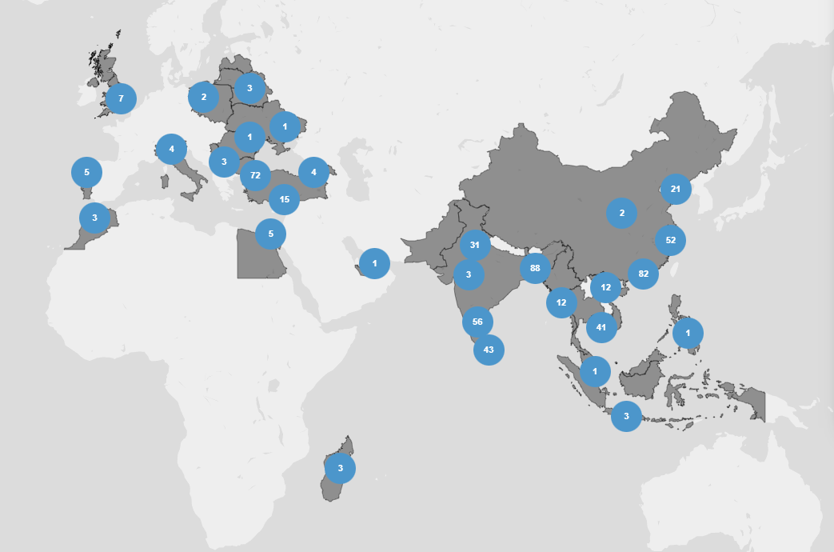
Figure 1 M&S Interactive Map, 2019.

Out of 577 factories:
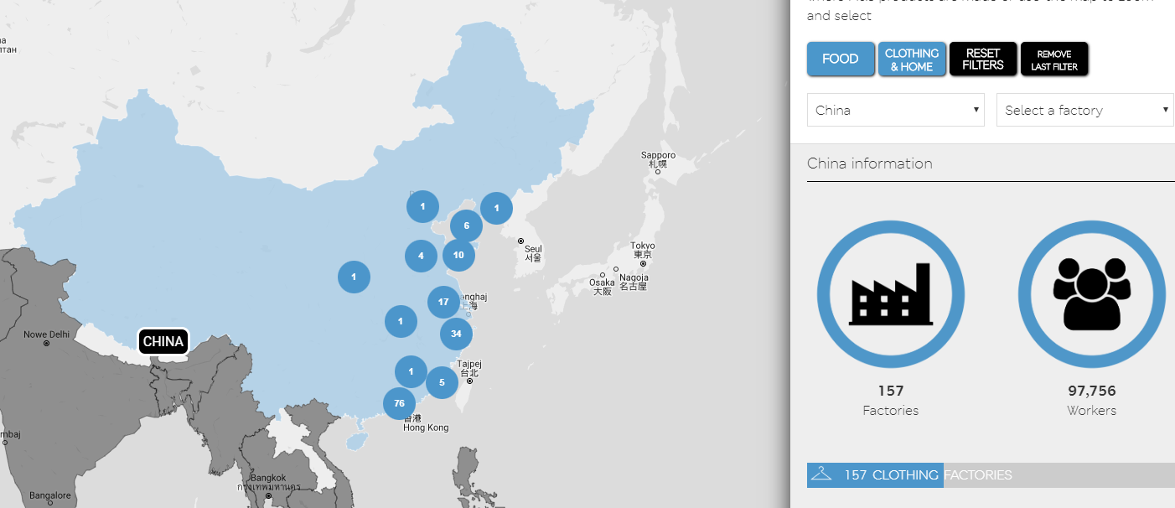
- 157 are in China with 97,756 workers
Figure 2 M&S Interactive Map, 2019.

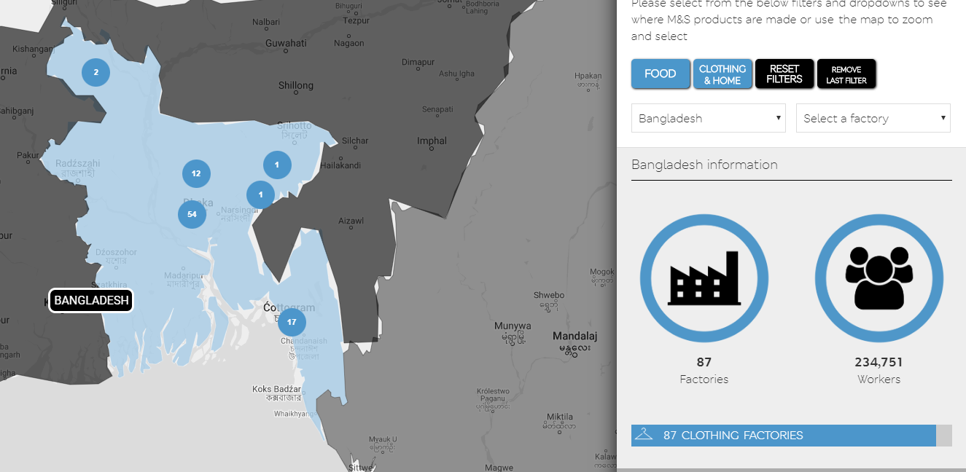
- 87 factories are in Bangladesh with 234,751 workers
Figure 3 M&S Interactive Map, 2019.

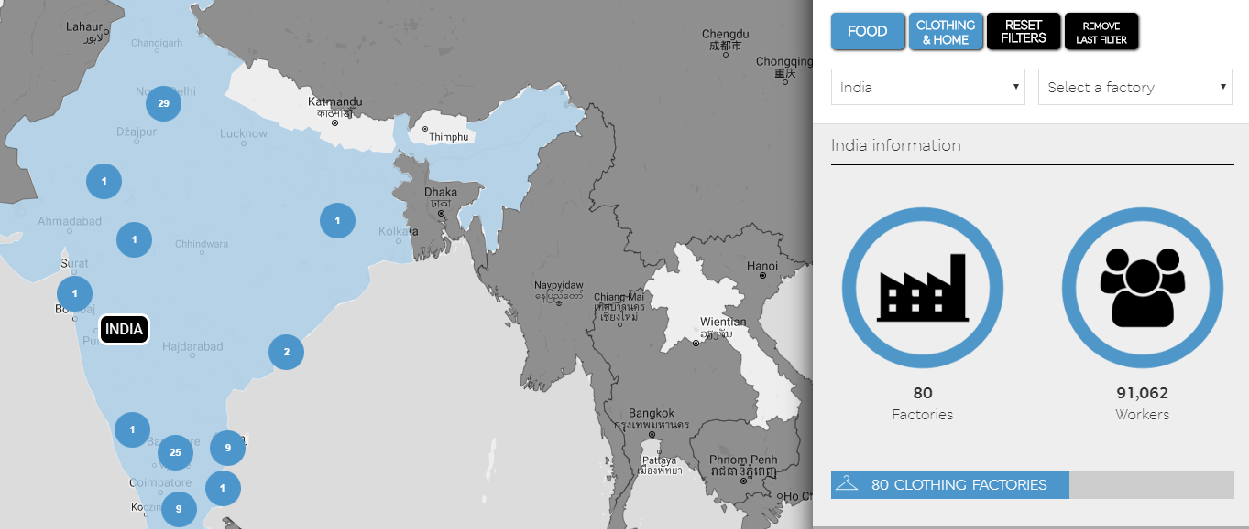
- 80 factories are in India with 91,062 workers
Figure 4 M&S Interactive Map, 2019.
It is nothing new that an organisation choice is to purchase abroad because it is so much cheaper and quicker (CIPS, 2018) but how M&S is dealing with it?
- They publish information on the supplier and partners with whom they work
- People working for suppliers are to be treated with respect and basic human rights
- Product production site are visited by representative of M&S
- Global Sourcing Principles
Evaluation
Governments but also consumers are aware of above issue. Organization can suffer reputation damage if they are found to be sourcing from suppliers which use exploitative labour but unfortunately there is still 29.8m people in modern slavery (Walk Free Foundation, 2013).
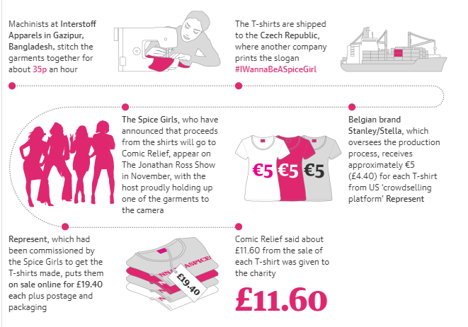
There is so many questions without answer, so many issues around factories and wages in Asia. Is it alright that we are buying the Spice Girls T-shirt for 19.40 pounds when Bangladesh worker stitch the garments together for about 35p for an hour of work? Can we call it according to the M&S attitudes: work ethically? It all depends on our own values; do I want to know the story of the pair of jeans which I am selling (as an employee) or I want to buy (as a customer). Stimulated thinking is not making people to think what I am thinking but make them to think.
Figure 5 Guardian graphic, 2018.

Reference:
Barry, M. (2019) Sustainable Business Director Statement. Available at: https://corporate.marksandspencer.com/sustainability/report2018 (Accessed: 18 November 2019).
CIPS (2018) Ethical and Sustainable Procurement, Walk Free Foundation. Available at: https://www.cips.org/Documents/About%20CIPS/CIPS_Ethics_Guide_WEB.pdf (Accessed: 18 November 2019).
EOC (2010) What Does Equal Opportunities Mean? Available at: https://www.eoc.org.uk/ (Accessed: 18 November 2019).
Mark & Spencer (2019) Careers. Available at: https://careers.marksandspencer.com/why-work-here (Accessed: 18 November 2019).
Mark & Spencer (2019) M&S is a leading retailer. Available at: www.corporate.marksandspencer.com/documents/msar-2019/strategic-report.pdf (Accessed: 18 November 2019).
Scarpetta, S. (2015) Development and Employment: A Mutual Relationship, International Encyclopedia of the Social & Behavioural Sciences, United States: Elsevier.
Statista (2019) Mark and Spencer share of the clothing and footwear market in the United Kingdom. Available at: https://www.statista.com/statistics/413641/clothing-market-share-marks-and-spencer-mands-united-kingdom-uk-by-segment/ (Accessed: 18 November 2019).
Walk Free Foundation (2013) The Global Slavery. Available at: www.globalslaveryindex.org (Accessed: 18 November 2019).

Bibliography:
Judge, T. A and Scott, B. A. (2009) “Hostility, Job Attitudes, and Workplace Deviance: Test of a Multilevel Model”, Journal of Applied Psychology, 91(1), pp. 126 –138. DOI: 10.1037/0021-9010.91.1.126.
Rawlins, B. R. (2008) “Measuring the relationship between organizational transparency and employee trust”, Public Relations Journal, 2(2), pp. 1-21.

Global Sourcing Principles of M&S www.corporate.marksandspencer.com/documents/plan-a-our-approach/global-sourcing-principles.pdf

