
PROJECT MANAGEMENT
LCBB6006_LON -Assignment 1

28 November 2025
student: janina-eveline oros
ID: 2128948 LECTURER: DR. Zainab Atta
Hotel Sustainability Program Implementation

Table of Contents
1.0 Project Purpose and Justification 3
2.0 Project Objectives 3
3.0 Project Scope 4
4.0 Key Stakeholders 5
5.0 Deliverables 7
6.0 Timeline / Milestones 7
7.0 Budget Estimate 9
8.0 Risks and Mitigation 10
9.0 Assumptions 11
10.0 Approval Signatures 12
Reference list 13

Table of Figures:
Figure 1: Schedule Table 7
Figure 2: Gantt chart 8
Figure 3: Network diagram 8
Figure 4: WBS diagram 9

Table of Tables:
Table 1: Stakeholders Table 5
Table 2: Budget Table 9
Table 3: Risks and Mitigation Table 10
Table 4: Approval Signature Table 12

1.0 Project Purpose and Justification
The Hotel Sustainability Program aims to achieve drastic outcomes in terms of environmental impact of a hotel chain through the application of environmental honesty to the consumption of resources and some of these include energy consumption, water use, the handling of waste, as well as processes within its supply chain. The project will be based on the introduction of environmentally-conscious technologies and will comprise the introduction of energy-efficient lamps, water-saving devices, waste minimization, and better operational performances to decrease the utilization of resources (Mandal, Raju and Yadav, 2024). One of the key objectives of the program is to improve the brand image of the hotel by branding it as a sustainability leader that will appeal to the environmentally conscious visitors and make it stand out among the other competitors.
The appeal to comply with regulatory requirements in sustainability and to deal with the increasing consumer demands on the sustainability approach in the hospitality industry is what drives this project. Tourists are also putting higher priorities to environment-friendly lodging facilities, and the program intends to seize this market, as well as save on operational expenses in terms of energy conservation and minimization of wastes. It will also enhance satisfaction to the guests that would also give them a more sustainable and responsible hotel experience. In the long-term, the program will help to strengthen the competitive stance on the market, and the hotel chain will not lose its popularity with environmentally conscious tourists. This is aimed at ensuring a more sustainable, cost efficient, reputable hospitality business is established.

2.0 Project Objectives
To ensure the success of the project with the measurement of its success within filmable and time-limited goals, the Hotel Sustainability Program Implementation intends to accomplish five major goals by the end of 31/12/2026.
- Objective 1: This aimed at introducing the initiatives to save energy, e.g., LED lights and energy-efficient HVAC systems in at least three hotels by 30/09/2026 (Callegaro, 2024). It is aimed at cutting energy usage by 20 percent to decrease the operating expenses and make an environmentally friendly contribution.
- Objective 2: It seeks to minimize the use of water by the 30 percent amount per hotel of the chain by installation of water saving appliances i.e., low flow faucets and showerheads by 31/12/2026.
- Objective 3: It aims at reducing waste by 25 percent through improving waste separation, recycling, and limiting the consumption of single use plastic. This goal will assist in minimizing the environmental impact of the hotel as well as enhance the waste management aspect of the organization.
- Objective 4: It aims to ensure that customer satisfaction on sustainability initiatives is of an 85 percent rate, according to feedbacks that will be gathered on at least 500 guests during the first six months of operation.
- Objective 5: aims at reaching break-even sustainability investment revenue in 12 months. This will be achieved by cost reductions by sustainable practices and using environmental marketing as a tool to get the environmentally conscious guests.

3.0 Project Scope
In Scope:
- Energy-Saving Retrofits: Retrofitting of the old hotel buildings with energy saving features, like LED lights and energy saving HVAC systems.
- Water Conservation Technologies: installation of water-saving technology, such as low flow faucets, toilets and additional rain-water harvesting systems.
- Waste Management Practices: Initiation of sustainable waste management practices such as recycling, organic waste composting and the alleviation of single-use plastics (Eby. 2019).
- Staff Training and Engagement: Training the hotel staff on sustainable procedures (E.g. saving energy, waste disposal) and promoting guests participation in sustainability initiatives through awareness campaigns.
- Marketing and Promotion: Development and implementation of a marketing program to spread sustainability performance, environmental friendliness certifications, and green programs of the hotel to appeal to the environmentally friendly visitors.
Out of Scope:
- New Hotel Construction: New hotel constructions or developments that are not included in the present portfolio of the property are not included in this project (Anatolіі Mazaraki et al., 2022).
- Major Renovations: This phase will not involve the large-scale renovations that are not connected to the sustainability goals (e.g., aesthetics, luxurious upgrades).
- Expansion to new Locations: An expansion of the sustainability program to other hotels beyond the current areas or regions not mentioned in the first stage of the project will not come in the picture.

4.0 Key Stakeholders
Table 1: Stakeholders Table
Role | Name | Responsibility
Executive Sponsor | Michael Brown | Funds, strategically directs and oversees the project.
Project Manager | Sarah Green | Plans project delivery, resources and schedules.
Operations Manager | Olivia Harris | Monitors the process of implementing the sustainable practices in all the hotels.
Suppliers | EcoTech Ltd. | Provides energy efficient systems and green products.
Marketing Lead | David Lee | Grows the marketing programs to facilitate sustainability initiatives.
Sustainability Expert | Dr. Jane Collins | Recommends sustainable operations, certification, and environmental effects.
Hotel Staff Trainers | Emma Williams | Trains employees about sustainability and dealing with guests.
The critical stakeholders who participated in the Hotel Sustainability Program Implementation, and the roles they play to make the project successful is identified in the Key Stakeholders table (Khalil et al., 2022).
- Executive Sponsor (Michael Brown): The Executive Sponsor is the person who represents the most instrumental leader of the project since he will ensure that the required funding is provided, hence, will act as the guiding force and manager of the entire project. They make sure that the project is in line with the overall business interest of the hotel and it has the resources to be successfully implemented.
- Project Manager (Sarah Green): The Project Manager will be in charge of the project delivery. They control resources, timeframes and direct activities to make the project run successfully. This position will entail superb planning and management competencies.
- Operation Manager (Olivia Harris): The Operations Manager would be significant in executing sustainable practices in the hotels (Katarzyna Piwowar-Sulej et al., 2023). They also have the role of overseeing the operational component of the sustainability activities and making sure that energy saving technologies, waste management systems as well as other practices are well incorporated.
- Suppliers (EcoTech Ltd.): This firm has the mandate of delivering the energy saving systems and sustainable products that are required to upgrade the hotel in terms of environmental friendliness. They are essential in the provision of the required materials needed in the implementation.
- Marketing Lead (David Lee): The Marketing Lead will involve the development of marketing campaigns that will inform the people about the sustainability activities of the hotel, which will attract customers who are environmentally conscious.
- Sustainability Expert (Dr. Jane Collins): The Sustainability Expert guides the team on what is good about sustainable design and operations, ensures that laws are observed in the environment, and assists the hotel on how to get sustainability certification.
- Hotel Staff Trainers (Emma Williams): Hotel staff trainers will be the on-the-job employees who's responsibility will involve educating the Hotel employees on green practices and to involve the others in hotel green initiatives (Abdelaziz and Naama, 2023). This will make sure that the staff is prepared to achieve the sustainability objectives and persuade the guests to do so.

5.0 Deliverables
- Deliverable 1: 3 pilot hotels should have an energy efficient lighting and HVAC system installed by 30/09/2026.
- Deliverable 2: The introduction of water saving systems and practices in all the participating hotels by 31/12/2026.
- Deliverable 3: Final waste management program that will encompass recycling bins, waste audits and staff training.
- Deliverable 4: Advertising initiatives and green branding resources are available to the general audience by 01/11/2026.
- Deliverable 5: Customer feedback report that indicates satisfaction with 30/06/2026 sustainability efforts (Nelli Kononova et al., 2025).
- Deliverable 6: Final project assessment and maintenance report together with savings and environmental outcome by 31/12/2026.

6.0 Timeline / Milestones
The table, Timeline / Milestones, depicts the important milestones in the project in the Hotel Sustainability Program Implementation. It enumerates certain activities, deadlines and people (Project Management Institute, 2013). This starts with 01/06/2026 and site selection and assessment and then 30/06/2026 on the format of energy efficient systems. Parts should be purchased on 31/07/2026. The task of staff training along to sustainability will be completed by the end of 31/08/2026. The next milestones such as energy and water-saving installations by 30/09/ 2026 and 31/10/ 2026 respectively, will be followed with the ultimate marketing launch on 01/11/2026 and final assessment on 31/12/ 2026.
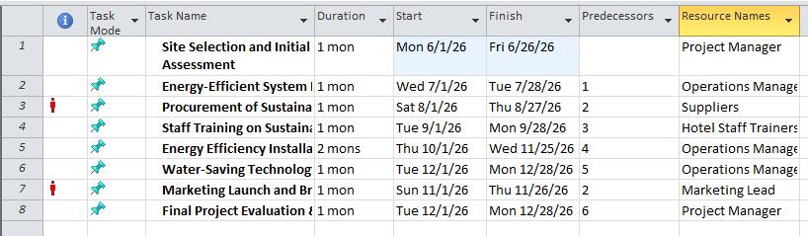
Figure 1: Schedule Table
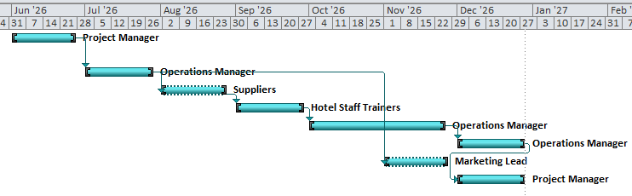
Figure 2: Gantt chart
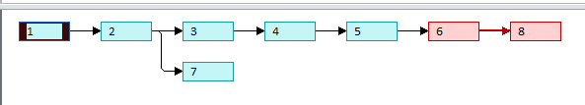
Figure 3: Network diagram
Gantt chart:
The Gantt chart graphically identifies the project time. All tasks are presented by the colourful bars, showing the time of work and start/end date. As an example, there is Site Selection and Initial Assessment between June 6, 2026, and June 26, 2026, that is allocated to the Project Manager (Ibach, 2024). This chart has overlapping tasks, resources, and time progress that gives a clear illustration of the project milestones.
Network Diagram:
The network diagram identifies the task dependencies as well as the critical path of the project. It depicts the interconnection between tasks (e.g., Task 2 is impossible to start without doing Task 1). This network identifies the chronological sequence of the tasks and the critical path that may affect the project timeline in case of its delay.
Schedule Table:
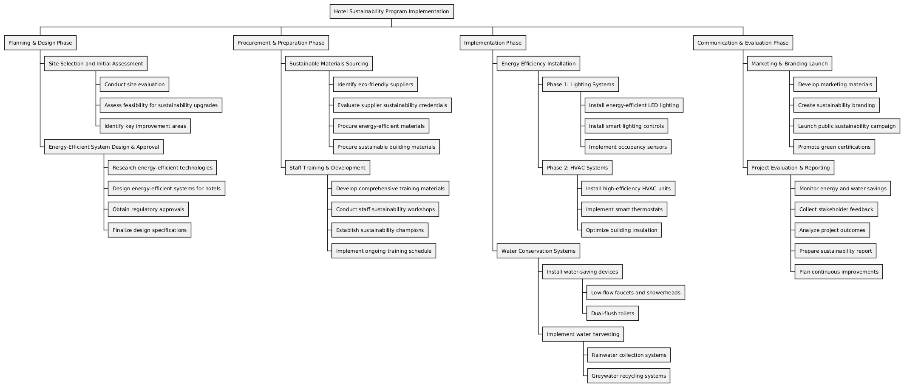
The schedule table will provide the detailed description of the duration, start and finish dates, predecessors and responsible resources of every task. An example is the Task 2 (Energy-Efficient System Design and Approval) that comes after Task 1 and is undertaken by the Operations Manager (Hedeman and Seegers, 2009). The table will be useful to monitor the progress and distribution of resources, and the implementation should be carried out smoothly.
Figure 4: WBS diagram

7.0 Budget Estimate
Table 2: Budget Table
Category | Estimated Cost (£)
Energy Efficiency Upgrades | £40,000
Water Conservation Systems | £25,000
Waste Management Program | £10,000
Staff Training Programs | £5,000
Marketing Campaign | £15,000
Operational Costs (staff, utilities) | £30,000
Miscellaneous | £5,000
Total Estimated Budget | £130,000
The Budget Estimate table is a table with financial breakdown of the Hotel Sustainability Program Implementation. The biggest reimbursement is, the 40,000 investigation of energy efficiency upgrades, which involve retrofitting the hotel with environmentally friendly technologies (Vanja Vejzagić and Schmidt, 2021). 25000 on the water conservation systems and 10000 in waste management program implementation. The sustaining sustainability will require staff training programs at the cost of £5,000 and the marketing campaign will cost the business £15,000. The staff and utilities are estimated to be £30,000 and miscellaneous items such as miscellany expenses will be allocated £5000 which will make the budget to be £130,000.

8.0 Risks and Mitigation
Table 3: Risks and Mitigation Table
Risk | Impact | Mitigation Strategy
Adverse Energy Price Increases | High | Secure long-term contracts for energy supply and explore renewable energy options.
Staff Resistance to New Processes | Medium | Conduct continuous training and create incentives for staff to embrace sustainability practices.
Supply Chain Delays for Eco-Friendly Materials | High | Build relationships with multiple suppliers and maintain backup inventory for critical materials.
Budget Overruns due to Implementation Complexity | High | Monitor project expenses regularly and secure contingency funding.
Regulatory Delays in Sustainability Certifications | Medium | Work with sustainability experts and local authorities to ensure timely certification processes.
The Risks and Mitigation table shows possible challenges in the Hotel Sustainability Program Implementation and suggest strategies to overcome this.
- Unfavorable Energy Cost Rises (High Impact):
Budget and operations may be influenced by changes in the cost of energy. In its effort to curb the same, by contracting long term energy deals and considering alternatives to fossil fuel energy such as solar power can help stabilize the cost.
- Resistance to New Processes by the staff (Medium Impact):
The employees can be unwilling to accept new sustainability practices. The staff will be motivated to adopt such changes through continuous training and rewards (Nowak, 2023).
- High Impact/Supply chain Delays of material that is eco-friendly (High Impact):
Delays on the eco-friendly materials may upset the project. The remedy is to be in good terms with various suppliers and maintain reserve stocks of raw materials of key products.
- Budget Overruns (High Impact):
Unexpected costs may be caused by complex implementation. Budgets overruns will be avoided by increasing frequency in monitoring expenses, and contingency funds.
- The Regulatory Delays (Medium Impact):
This may be disrupted by the time it takes to get sustainability certifications. The cooperation with sustainability professionals and local government guarantees the timely certification.

9.0 Assumptions
- Availability of premises: The hotels are in a position to be retrofitted without much interference to operations.
- Suppliers: All environmentally-friendly materials and systems will be provided according to the schedule of the project.
- Staff involvement: Hotel employees will take an active involvement in training on sustainability (Simon and Murray-Webster, 2018).
- Regulatory compliance: The project will follow all the local regulations and the requirements of the sustainability certifications.

Reference list
Abdelaziz, M. and Naama, A. (2023). The Impact of Digital Transformation Dimensions on the Employees Job Performance: Applying on Four- and Five-Star Hotels in the Red Sea Governorate. Journal of Association of Arab Universities for Tourism and Hospitality, 24(1), pp.436–466. doi:https://doi.org/10.21608/jaauth.2023.241768.1512.
Anatolіі Mazaraki, Svitlana Melnychenko, Liudmyla Bovsh, Tkachuk, T., Nataliia Zikiі and Romanchuk, L. (2022). FINANCIAL AND INVESTMENT PREDICATES OF SECURITY OF HOTEL REAL ESTATE DEVELOPMENT. (2022). Fìnansovo-kreditna dìâlʹnìstʹ: problemi teorìï ta praktiki, 6(47), pp.182–196. doi:https://doi.org/10.55643/fcaptp.6.47.2022.3912.
Callegaro, N. (2024). The potential of smart home for comfort and energy use optimization in residential buildings. Unitn.it, pp.1–315. doi:https://doi.org/10.15168/11572_417290.
Eby, K. (2019). Free Project Charter Templates and Guidelines, Smartsheet. Available at: https://www.smartsheet.com/blog/project-charter-templates-and-guidelines-every-business-need.
Hedeman, B. and Seegers, R, (2009). PRINCE2 2009 Edition: A Pocket Guide. 2009 ed. Zaltbommel: Van Haren Pub.
Ibach, V. (2024). Revisualising Projects : Applying Johanna Drucker’s Visualisation Theories For Project Management.DIVA. Available at: https://www.diva-portal.org/smash/record.jsf?pid=diva2:1901439.
Katarzyna Piwowar-Sulej, Malik, S., Olatunji Abdul Shobande, Singh, S. and Vishal Dagar (2023). A Contribution to Sustainable Human Resource Development in the Era of the COVID-19 Pandemic. Journal of Business Ethics. doi:https://doi.org/10.1007/s10551-023-05456-3.
Khalil, N., Che Abdullah, S.N., Haron, S.N. and Hamid, M.Y. (2022). A review of green practices and initiatives from stakeholder’s perspectives towards sustainable hotel operations and performance impact. Journal of Facilities Management, 22(4). doi:https://doi.org/10.1108/jfm-03-2022-0025.
Mandal, S., Raju, S.S. and Yadav, N. (2024). Sustainability Through Technology. Advances in hospitality, tourism and the services industry (AHTSI) book series pp.309–336. doi:https://doi.org/10.4018/979-8-3693-7127-5.ch012.
Nelli Kononova, Juraschek, M., Franzè, C., Behrend, C., Agirre, J., Revilla, O., Silva, G.V. and Herrmann, C. (2025). From goals to actions: Insights on how European SMEs plan and implement sustainability projects. Procedia CIRP, 135, pp.588–593. doi:https://doi.org/10.1016/j.procir.2024.12.069.
Nowak, R.M. (2023). How resistance to change impairs innovation. Journal of Strategy and Management, 16(4), pp.609–629. doi:https://doi.org/10.1108/jsma-08-2022-0144.
Project Management Institute, (2013). A Guide to the Project Management Body of Knowledge (PMBOK Guide). 5th ed. Newtown Square, Pennsylvania: Project Management Institute.
Simon, P. and Murray-Webster, R. (2018). Starting Out in Project Management. 3rd ed. Buckinghamshire: Association for Project Management
Singh, T. (2025). Project Charter_ Nikhil, Scribd. Available at: https://www.scribd.com/document/465671576/Project-Charter-Nikhil.
Vanja Vejzagić and Schmidt, P. (2021). Environmental Investments in Hotel Budgets: A Case Study on Croatian Hotels. Contributions to economics, pp.161–176. doi:https://doi.org/10.1007/978-3-030-74632-2_11.

