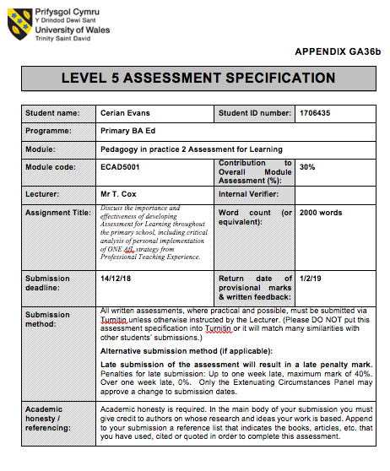

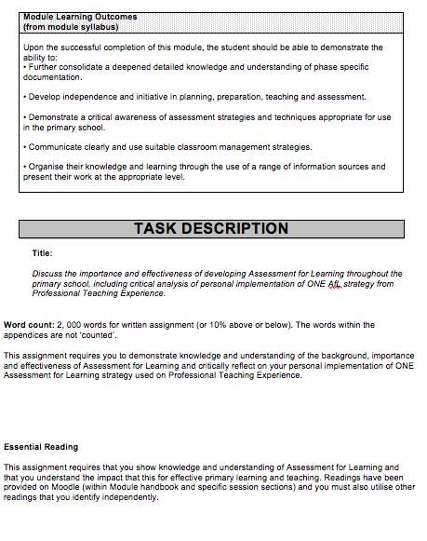

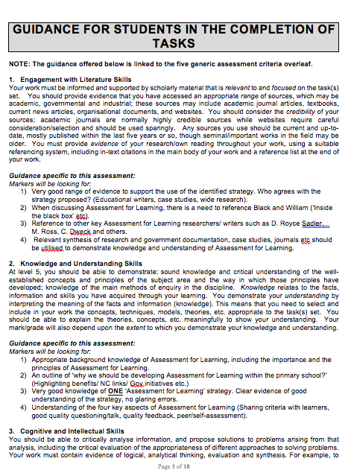
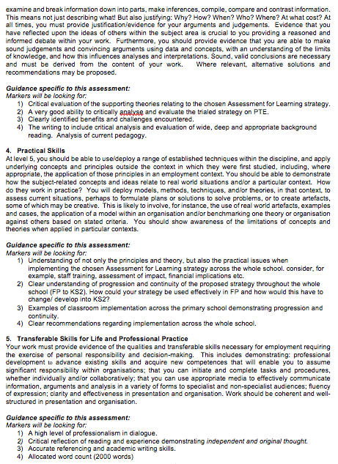
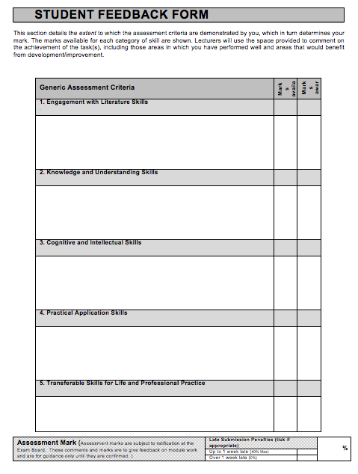

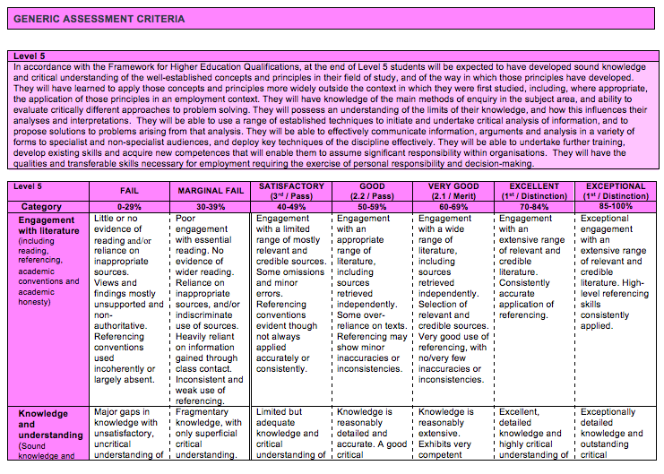
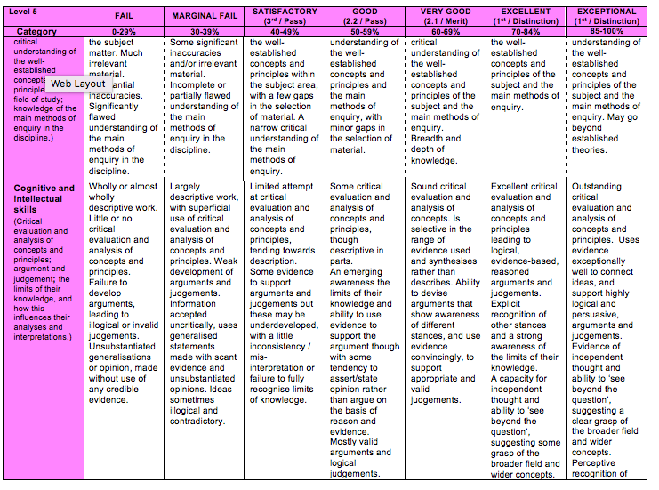
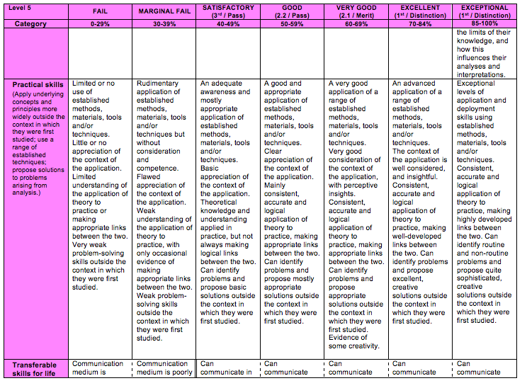
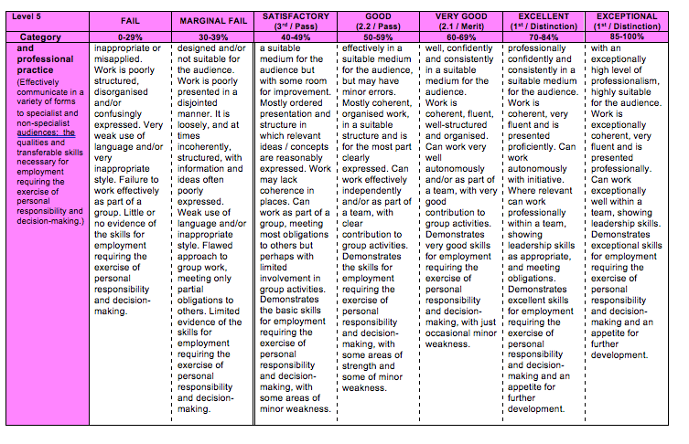

Discuss the importance and effectiveness of developing Assessment for Learning throughout the primary school, including critical analysis of personal implementation of one AFL strategy from Professional Teaching Experience

Assessment is a course to gather, record, interpret and to report information about the learner’s achievements and attainments (NCCA, 2018). Conducting summative and formative assessments in schools provide effective teaching and learning which is now delivered throughout education (Fautley and Savage, 2008). However, summative assessments have become problematic putting learners at a disadvantage with different learning styles not being addressed, providing inaccurate results (Teach Thought, 2018). Yet, providing summative assessments at the beginning and the end of their primary education would highlight the learner’s improvements far significantly than formative assessments (CCEA, 2018). On the other hand, formative assessments provide firm examples of different elements in order to improve the learning of the learners. Thus, the teachers will be able to identify where the learners are, what they need to do next and how this will be achieved (The Assessment Reform Group, 2002; Sadler, 1989).

The concept of assessment for learning (AFL) was published by Black and Wiliam (1998). In this matter, four different elements of AFL have been considered: questioning, sharing criteria, feedback and, peer and self-assessment. Primarily, introducing AFL within schools has been found difficult. Several teachers have lacked understanding of the meaning of assessments. This is as a result of AFL being very diverse and no clear practices have been announced (Cizek, 2010). With the use of the word ‘assessment,’ many schools have prioritised the use of summative assessments as assessment is often associated with exams. In this matter, Black and Wiliam (1998) anguish the use of the word (Stewart, 2012). Nonetheless, Black and Wiliam (1998) outlined four main recommendations in order for AFL to be delivered with success. Learners should be given the opportunity to receive additional time to think and answer questions, should be provided constructive comments, should be encouraged to assess each other’s work and should be involved in designing the success criteria.

Vygotsky (1978) highlights that learners will begin to use their zone of proximal development in order to process their next steps in their learning from the implementations of AFL strategies. This process allows independent learning which is necessary within primary schools. Currently, too much teaching and learning consists of teacher lead-instructions. Therefore, implementing AFL within schools is crucial in order to have a variation in the learner’s learning (Black and Wiliam, 1998). Furthermore, this process is constant which allows the teacher to regulate the learning and understanding within the classroom (Marshall, 2002). As a result of this, introducing AFL is potent, with opportunity to raise the standards of the learning, especially for lower attaining pupils. However, several studies have shown that this is not effective to some individuals. 30% of learners from a study showed a negative impact from an AFL strategy used within a school (Kluger and DeNisi, 1996).

Evidently, implementing a range of AFL strategies allow learners to understand excellent outcomes and ways in which this can be achieved (Hatties, 2009). One effective whole group AFL strategy is known as ‘pose, pause, pounce, bounce.’ A question is posed by the teacher: sufficient time are given to the children: the learner will pounce an answer: learner can challenge their peers (Grigg, 2010). This is a questioning strategy, but one in which highlights three of the four elements composed by AFL: questioning, self-assessment and feedback. This implementation is important as this provides instant feedback to the teacher, which can support the pace of the learning (Hopkins, 2009). Consequently, this allows the teacher to adapt their teaching and learning styles in order for the learners to understand. Using puppets to represent each of the stages allowed the learners to engage and visualise their learning was found useful within the Foundation Phase. For example, the character Tigger can be used to represent bounce as this is one of his favourite movements. These puppets might not be considered for Key Stage Two but should provide an environment which is positive, engagement in their own learning and promote plenty of thought and thinking. Adaptations to the questions can be made in order to adapt this strategy within each phase.

Pose, pause, pounce bounce has been found effective when implemented within the Foundation Phase. This strategy can be used throughout lessons to observe the understanding of all the learners and to ensure that learners are able to achieve their full potential. Using AFL within the classroom can provide an additional eight months of teaching and learning each year (William, 2009). However, the opposing view is delivered by Hatties (2009). He believes that feedback to both the individual and teacher is the element which bring fundamental improvements to learning. He believes that feedback has a greater significance and importance to be delivered as an AFL strategy (Hatties, 2009). In contrast, written feedback from marking received by the teachers often lack detail. Moreover, young learners lack the skills required in order to read this feedback, impacting on their learning with no further guidance received (OFSTED, 1996).

Although it is believed that questioning delivers feedback to the individual, this is uncertain. As witnessed, teachers do not often evaluate and extend the answers of the learners. This is as a result not wanting to emphasise that the answer by the learner is incorrect. In contrast, observations from the use of questioning strategy can be used in order to plan future lessons or future interventions to support certain individuals, seen to be an essential part of teaching (Black et al, 2006; Pollard, 2014). Notably, questioning not only provides opportunity for the teacher to measure their cognitive but also the learner’s physical responses (Morgan and Saxton, 2002). From this, the teacher can engage and allow learners to participate accordingly, a useful strategy delivered within PTE.

Communication is the true foundation of learning which can be achieved through the implementation of AFL strategies. Dialogue teaching is necessary, which enhances the learner’s knowledge and understanding, confidence and engagement (Alexander, 2008) Moreover, through dialogue, this is when learners understand what they are aiming for and how they are going to achieve this, being a key aim of AFL strategies (Pollard, 2014). From experience, having the opportunity to communicate is beneficial when teaching the Foundation Phase. Some learners within this phase rely on communication more than others, with many less advanced to use the skills of reading and writing. Implementing a range of AFL strategies is therefore beneficial. Questioning strategies allow learners to interact with the teachers, which is believed to be what matters the most to young learners (Lee-Corbin and Denicolo, 1998). Furthermore, assessing the learners through questioning is effective with the use of different types of questions that can be asked (Kerry, 1982). Despite this, this was found difficult within PTE. Ensuring that each of the learners are asked is absurd due to the shortage of time.

Effective understanding will acquire the teacher to set questions at different cognitive levels. As initial knowledge is developed, learners can be challenged with higher order thinking questions. Hence, pose, pause, pounce, bounce provides the opportunity to differentiate the learning of the individuals (Black and Wiliam, 1998). Bloom’s Taxonomy can be studied in order to introduce questioning. Three domains have been considered (cognitive, affective and psychomotor) which grants differentiation, providing the opportunity to amend words used (Grigg, 2010; Bloom, 1956). On the opposing hand, many teachers view this as a linear perception whereby the learners move along the diagram. In order for the learners to understand, they must understand the underlying concepts first. Thus, this should not be a higher-level thinking skills as each stage as important as its previous (Edglossary, 2014). Due to the six different foundations, remembering these words were found difficult, especially to word questions differently to scaffold the learning of the learner. Furthermore, some words are weasel, providing it difficult to measure. However, learners might feel valid when questions are answered correctly. Donaldson (2015) states that individuals should be healthy, confident individuals.

This strategy ensures that efficient time is implemented which is important within primary schools. It is recorded that learners take up to eleven seconds to form an answer (Irvine and Garling, 2018). With this strategy requiring the teacher to wait, they increase the participation of the learners and reduces the chances for failure. Providing time allowed learners contained more detail than in previous times when concluding their answers within PTE. This is important in order to ensure that the learners thrive (Black et al, 2006). Bruner (1996) argues that implementing time into learning ensures that the learners are provided the opportunity to think. From this, they are able to truly understand which can only be achieved with time. However, during PTE, this was found challenging with this disregarded at times. Estyn (2011) encompasses the shortfall delivery of teachers improving their thinking skills of young learners. No justification can be delivered with local authorities providing training for this to be executed.

As seen within the Foundation Phase, learners often interrupted the silence, providing the answer too soon. Additionally, several of the learners were eager to answer questions, raising their hands which became a challenge. Discouragement of the use of hands up was addressed during PTE. William found that 25% of individuals did not participate when this technique was used (Doc Zoo, 2012). From this, this strategy moves away from initiation, response and evaluation proposed by the teacher (Solution Tree, 2009). This ensures that the teacher observes and addresses the understanding of the learners for each of the lessons. In this case, this effectively allows teachers to directly focus on individuals who did not understand the task.

On the contrary, humanists believe that the needs of the learners should be considered. Research suggests that school systems destroy the emotions of young people, emphasised in Maslow’s hierarchy of needs (McLeod, 2017). As argued by Holt (1964), learners should only be assessed when they are comfortable. In contrast, as argued by constructivists, learners learn best by carrying out activities and should require understanding throughout. Here the learners have the opportunity to think for themselves. Questioning strategies allow learners to connect between new and old learning which is required in order for learners to progress in their learning. As highlighted by Piaget (1936) cognitive development is as a result of producing knowledge from experiences and the environment around them. They construct understanding through constructing understanding of what they already know with what they do not. From this, interaction with others allow the learners to develop their understanding further in the delivery of AFL used. Watson (1924) highlights that repetition of questioning will allow the learners to allow the learners to remember this information effectively.

This highlights that AFL provides opportunity for failure and risk taking, something in which high-achieving learners lack (Dweck, 2006). As a result of the teacher presents opportunity for mistake, this allows learners to achieve their full potential. Moreover, the learners will be able to improve their outcomes in the future, something which is necessary, delivered by the use of AFL. Positively, after time the learners will develop their confidence of themselves around others (Cambridge Assessment, 2018). Providing an environment where the learners feel valid and safe is important, despite their belief on failure. This is seen difficult within the Foundation Phase with learners less understanding on the situation. Some learners may react negatively as a result of providing the incorrect answer. Should this happen, the teacher must react in a positive way to ensure that they participate in the near future.

Implementing AFL strategies within primary schools will require time and practise to achieve the best outcomes. Outstanding teachers will be able to question and challenge individuals with open ended questions in order for the learners to achieve their full potential (Smith, 2005; Gershon, 2013). In essence, AFL strategies implemented within schools will overcome this with a wide range of strategies to choose from, taken account of the policy of the school. This approach needs to be prioritised throughout the school for maximal progress of the learners to be present (Black et al, 2006). Estyn (2011) found that there has been a weakness from observing learners within schools, which becomes problematic to identify the learners progress. As seen, introducing pose, pause, pounce, bounce within PTE was found difficult with the learners not being familiar with this strategy.

To conclude, implementing AFL strategies within primary schools is a continuous progress, one in which can raise the standards of the teaching within schools with a wide variety of strategies to develop. Furthermore, implementing AFL within schools can also allow learners to ‘close the gap’ by learners identifying what they know and how their learning can be progressed (Sadler, 1989). In addition, AFL strategies such as questioning identify all aspects of the industrial core: teaching and learning strategies, student engagement and the curriculum. This is important to provide learners with an effective education which can be integrated within every subject or areas of learning (Hopkins, 2009). Although implications are met when introducing different strategies, personal experience supports that AFL used within primary schools are an effective way to observe and assess the learners. Positively, many of these AFL strategies do not require funding provided by schools.

Bibliography:

Alexander, R. (2008) Towards Dialogic Teaching: Rethinking Classroom talk. 4th edn. York: Dialogos.

Black, P and Wiliam, D. (1998) Inside the Black Box: Raising Standards Through Classroom Assessment. School of Education, King’s College: London, United Kingdom.

Black, P. et al. (2006) Assessment for Learning: Putting it into Practice. Berkshire: Open University Press.

Bloom, B. (1956) Taxonomy of educational objectives handbook. New York, NY: David MCKay Company, Inc.

Bruner, J. (1996) The Culture of Education. Cambridge, MA: Harvard University Press.

Cambridge Assessment (2018) Getting Started with Assessment for Learning. Available at: https://cambridge-community.org.uk/professional-development/gswafl/index.html (Accessed: 5th December 2018).

CCEA (2018) What is Formative Assessment. Available at: http://ccea.org.uk/curriculum/assess_progress/types_assessment/summative (Accessed: 2nd December 2018).

Cizek, G. (2010) ‘An introduction to formative assessment’ in Handbook of Formative Assessment, H. Andrade and G. Cizek, Eds., Routledge: New York, NY, USA.

Doc Zoo (2012) The Classroom Experiment (EP.1) [Video]. Available at: https://www.youtube.com/watch?v=J25d9aC1GZA (Accessed: 1st December 2018).

Donaldson, G. (2015) Successful Futures. Crown Copyright. Available at: http://gov.wales/docs/dcells/publications/150317-successful-futures-en.pdf (Accessed: 2nd December 2018).

Dweck, C. S. (2006) Mindset: The New Psychology of Success. New York: Random House.

Edglossary (2014) Bloom’s Taxonomy. Available at: https://www.edglossary.org/blooms-taxonomy/ (Accessed: 3rd December 2018).

Estyn (2011) The Skills Framework at Key Stage Two: An Evaluation of the Impact of the Non[statutory Skills Framework for 3 to 19-year-old in Wales at Key Stage Two. Crown Copyright. Available at: https://www.estyn.gov.wales/sites/default/files/documents/The%20Skills%20Framework%20at%20key%20stage%202%20-%20July%202011.pdf (Accessed 3rd December 2018).

Fautley, M. and Savage, J. (2008) Assessment for Learning and Teaching. Exeter: Learning Matters.

Gershon, M. (2013) ‘Elongate their learning’, Times Educational Supplement, 15 February.

Grigg, R. (2010) Becoming an Outstanding Primary School Teacher. Harlow: Pearson.

Hatties, J. (2009) Visible Learning, Abingdon: Routledge.

Holt, J. (1964) How Children Fail. United States: Pitman Publishing Company.

Hopkins, D. (2009) Confronting the Elephant in the Classroom Strategies for Addressing the Industrial Core. Article library. Available at: https://library.teachingtimes.com/articles/slt-elephant-in-the-classroom.htm (Accessed: 4th December 2018).

Irvine, A. and Garling, B. (2018) Questioning Techniques for the Classroom. Word Press. Available at: https://questioninganddiscussionforteaching.wordpress.com/wait-time/ (Accessed: 5th December 2018).

Kerry, T. (1982) Effective Questioning: A Teaching Skills Workbook. Basingstoke: Macmillan Education.

Kluger, A. N. and DeNisi, A. (1996) The effects of feedback interventions on performances: a historical review, a meta-analysis, and a preliminary feedback intervention theory. Psychological Bulletin, 119(2): 254-84.

Lee- Corbin, H. and Denicolo, P. (1998) Recognising and Supporting Able Children in Primary Schools. London: David Fulton.

Marshall, B. (2002) ‘Thinking Through Assessment: An interview with Dylan William’ English in Education, vol. 36, no. 3, pp.47-60.

McLeod, S. A. (2017) Maslow’s Hierarchy of Needs. SimplyPsychology. Available at: https://www.simplypsychology.org/simplypsychology.org-Maslows-Hierarchy-of-Needs.pdf (Accessed: 9th December 2018).

Morgan, N. and Saxton, J. (2002) Asking Better Questions. 2nd edn. Portland, ME: Stenhouse.

NCCA (2018) Assessment. Available at: https://www.ncca.ie/en/primary/assessment (Accessed: 1st December 2018).

OFSTED (1996) Subject and Standards: Issues for School Development Arising from OFSTED Inspection Findings 1994-5. London: HMSO.

Piaget, J. (1936). Origins of intelligence in the child. London: Routledge and Kegan Paul.

Pollard, A. (2014) Reflective teaching in schools. London: Bloomsbury.

Sadler, R. D. (1989) Formative Assessment and the Design of Instructional Systems. Instructional Science, 18, pp.119 – 144. DOI: 10.1007/BF00117714.

Smith, C. (2005) Teaching Gifted and Talented Pupils in the Primary School: A Practical Guide. London: Paul Chapman.

Solution Tree (2009) Solution Tree: Dylan Williams, Content Then Process [Video]. Available at: https://www.youtube.com/watch?v=029fSeOaGio (Accessed: 5th December 2018).

Stewart, W. (2012) ‘Think you’ve Implemented Assessment for Learning?’ Times Educational Supplement, 13 July.

Teach Thought (2018) 6 Reasons why Standardized Testing Is, At Best, Problematic. Available at: https://www.teachthought.com/pedagogy/6-reasons-standardized-testing-is-at-best-problematic/ (Accessed: 2nd December 2018).

The Assessment Reform Group (2002) Assessment for Learning: Research-based Principles to Guide Classroom Practice. Available at: http://www.hkeaa.edu.hk/DocLibrary/SBA/HKDSE/Eng_DVD/doc/Afl_principles.pdf (Accessed: 3rd December 2018).

Vygotsky, L. S. (1978) Mind in society: The development of higher psychological processes. Cambridge, MA: Harvard University Press.

Watson, J. B. (1924) Behaviourist. New York: W. W. Norton.

William, D. (2009) Assessment for Learning: why, what and how? London: Institute of Education.

