Marketing Fundamentals

Assignment 1

Blogging to communicate

Maya Boteva
ID:2112590

Table of Contents
The segmentation criteria 3
The Marketing Mix 4
The product 5
The Pricing Strategy 6
The Place (distribution) 7
Promotion 8
Digital marketing 9
References 10

The segmentation criteria
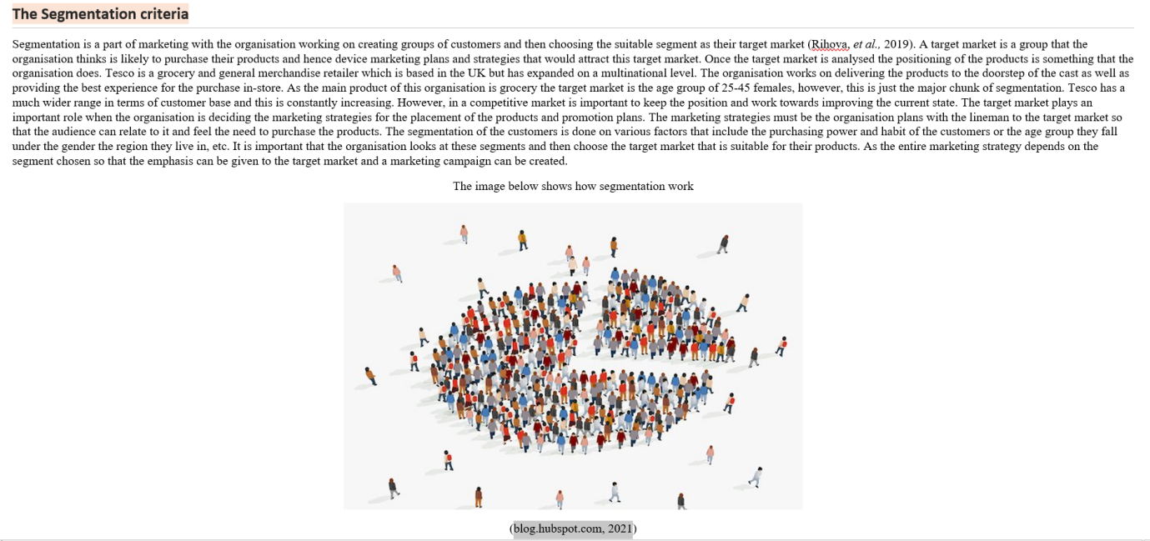
Segmentation is a part of marketing with the organization working on creating groups of customers and then choosing the suitable segment as their target market (Rihova, et al., 2019). A target market is a group that the organization thinks is likely to purchase their products and hence device marketing plans and strategies that would attract this target market. Once the target market is analyzed the positioning of the products is something that the organization does. Tesco is a grocery and general merchandise retailer which is based in the UK buthas expanded on a multinational level. The organization works on delivering the products to the doorstep of the cast as well as providing the best experience for the purchase in-store. As the main product of this organization is grocery the target market is the age group of 25-45 females, however, this is just the major chunk of segmentation. Tesco has a much wider range in terms of customer base and this is constantly increasing. However, in a competitive market is important to keep the position and work towards improving the current state. The target market plays an important role when the organization is deciding the marketing strategies for the placement of the products and promotion plans. The marketing strategies must be the organization plans with the lineman to the target market so that the audience can relate to it and feel the need to purchase the products. The segmentation of the customers is done on various factors that include the purchasing power and habit of the customers or the age group they fall under the gender the region they live in, etc. It is important that the organization looks at these segments and then choose the target market that is suitable for their products. As the entire marketing strategy depends on the segment chosen so that the emphasis can be given to the target market and a marketing campaign can be created.

The Marketing Mix
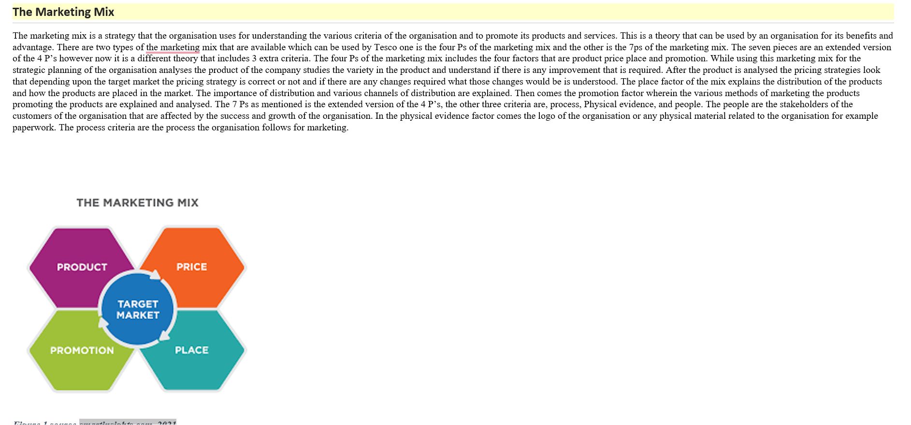

The marketing mix is a strategy that the organization uses for understanding the various criteria of the organization and to promote its products and services. This is a theory that can be used by an organization for its benefits and advantage. There are two types of the marketing mix that are available which can be used by Tesco one is the four Ps of the marketing mix and the other is the 7ps of the marketing mix. The seven pieces are an extended version of the 4 P’s however now it is a different theory that includes 3 extra criteria. The four Ps of the marketing mix includes the four factors that are product price place and promotion. While using this marketing mix for the strategic planning of the organization analyses the product of the company studies the variety in the product and understand if there is any improvement that is required. After the product is analyzed the pricing strategies look that depending upon the target market the pricing strategy is correct or not and if there are any changes required what those changes would be is understood. The place factor of the mix explains the distribution of the products and how the products are placed in the market. The importance of distribution and various channels of distribution are explained. Then comes the promotion factor wherein the various methods of marketing the products promoting the products are explained and analyzed. The 7 Ps as mentioned is the extended version of the 4 P’s, the other three criteria are, process, Physical evidence, and people. The people are the stakeholders of the customers of the organization that are affected by the success and growth of the organization. In the physical evidence factor comes the logo of the organization or any physical material related to the organization for example paperwork. The process criteria are the process the organization follows for marketing.

The product
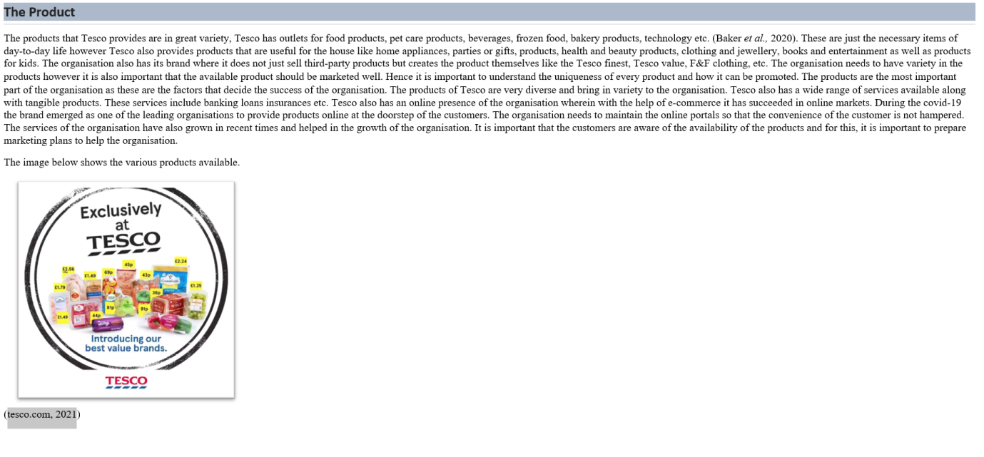
The products that Tesco provides are in great variety, Tesco has outlets for food products, pet care products, beverages, frozen food, bakery products, technology etc. (Bakeret al., 2020). These are just the necessary items of day-to-day life however Tesco also provides products that are useful for the house like home appliances, parties or gifts, products, health and beauty products, clothing and jewelry, books and entertainment as well as products for kids. The organization also has its brand where it does not just sell third-party products but creates the product themselves like the Tesco finest, Tesco value, F&F clothing, etc. The organization needs to have variety in the products however it is also important that the available product should be marketed well. Hence it is important to understand the uniqueness of every product and how it can be promoted. The products are the most important part of the organization as these are the factors that decide the success of the organization. The products of Tesco are very diverse and bring in variety to the organization. Tesco also has a wide range of services available along with tangible products. These services include banking loans insurances etc. Tesco also has an online presence of the organization where in with the help of e-commerce it has succeeded in online market organization needs to maintain the online portals so that the convenience of the customer is not hampered. The services of the organization have also grown in recent times and helped in the growth of the organization. It is important that the customers are aware of the availability of the products and for this, it is important to prepare marketing plans to help the organization

The Pricing Strategy
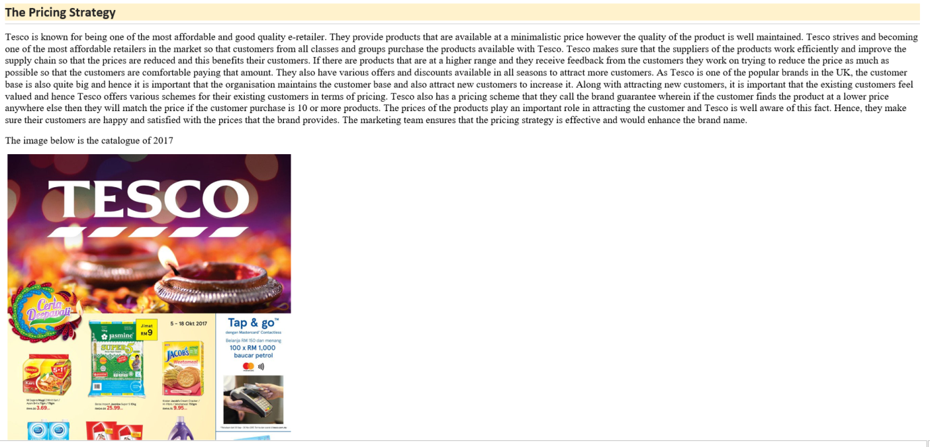
Tesco is known for being one of the most affordable and good quality e-retailer. They provide products that are available at a minimalistic price however the quality of the product is well maintained. Tesco strives and becoming one of the most affordable retailers in the market so that customers from all classes and groups purchase the products available with Tesco. Tesco makes sure that the suppliers of the products work efficiently and improve the supply chain so that the prices are reduced and this benefits their customers. If there are products that are at a higher range and they receive feedback from the customers they work on trying to reduce the price as much as possible so that the customers are comfortable paying that amount. They also have various offers and discounts available in all seasons to attract more customers. As Tesco is one of the popular brands in the UK, the customer base is also quite big and hence it is important that the organization maintains the customer base and also attract new customers to increase it. Along with attracting new customers, it is important that the existing customers feel valued and hence Tesco offers various schemes for their existing customers in terms of pricing. Tesco also has a pricing scheme that they call the brand guarantee wherein if the customer finds the product at a lower price anywhere else then they will match the price if the customer purchase is 10 or more products.

The Place (distribution)
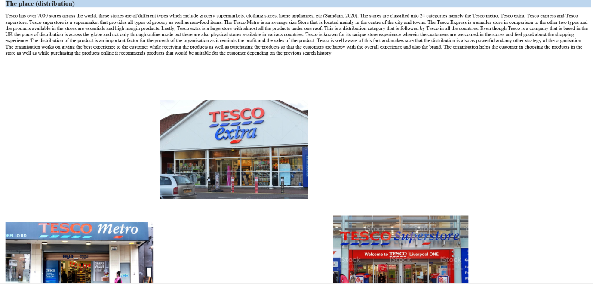
Tesco has over 7000 stores across the world, these stories are of different types which include grocery supermarkets, clothing stores, home appliances, etc. (Samdani, 2020). The stores are classified into 24 categories namely the Tesco metro, Tesco extra, Tesco express and Tesco superstore. Tesco superstore is a supermarket that provides all types of grocery as well as non-food items. The Tesco Metro is an average size Store that is located mainly in the centre of the city and towns. The Tesco Express is a smaller store in comparison to the other two types and the products available in the stores are essentials and high margin products. Lastly, Tesco extra is a large store with almost all the products under one roof. This is a distribution category that is followed by Tesco in all the countries. Even though Tesco is a company that is based in the UK the place of distribution is across the globe and not only through online mode but there are also physical stores available in various countries. Tesco is known for its unique store experience wherein the customers are welcomed in the stores and feel good about the shopping experience. The distribution of the product is an important factor for the growth of the organization as it reminds the profit and the sales of the product. Tesco is well aware of this fact and makes sure that the distribution is also as powerful and any other strategy of the organization. The organization works on giving the best experience to the customer while receiving the products as well as purchasing the products so that the customers are happy with the overall experience and also the brand..

Promotion
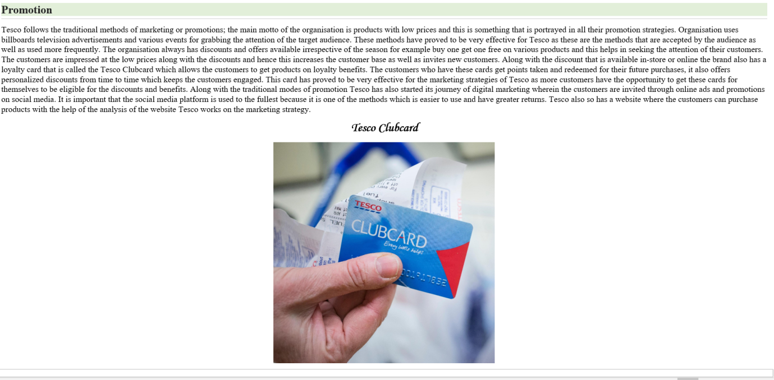
Tesco follows the traditional methods of marketing or promotions; the main motto of the organization is products with low prices and this is something that is portrayed in all their promotion strategies. Organisation uses billboards television advertisements and various events for grabbing the attention of the target audience. These methods have proved to be very effective for Tesco as these are the methods that are accepted by the audience as well as used more frequently. The organization always has discounts and offers available irrespective of the season for example buy one get one free on various products and this helps in seeking the attention of their customers. The customers are impressed at the low prices along with the discounts and hence this increases the customer base as well as invites new customers. Along with the discount that is available in-store or online the brand also has a loyalty card that is called the Tesco Clubcard which allows the customers to get products on loyalty benefits. The customers who have these cards get points taken and redeemed for their future purchases, it also offers personalized discounts from time to time which keeps the customers engaged. This card has proved to be very effective for the marketing strategies of Tesco as more customers have the opportunity to get these cards for themselves to be eligible for the discounts and benefits. Along with the traditional modes of promotion Tesco has also started its journey of digital marketing wherein the customers are invited through online ads and promotions on social media. It is important that the social media platform is used to the fullest because it is one of the methods which is easier to use and have greater returns.

Digital marketing
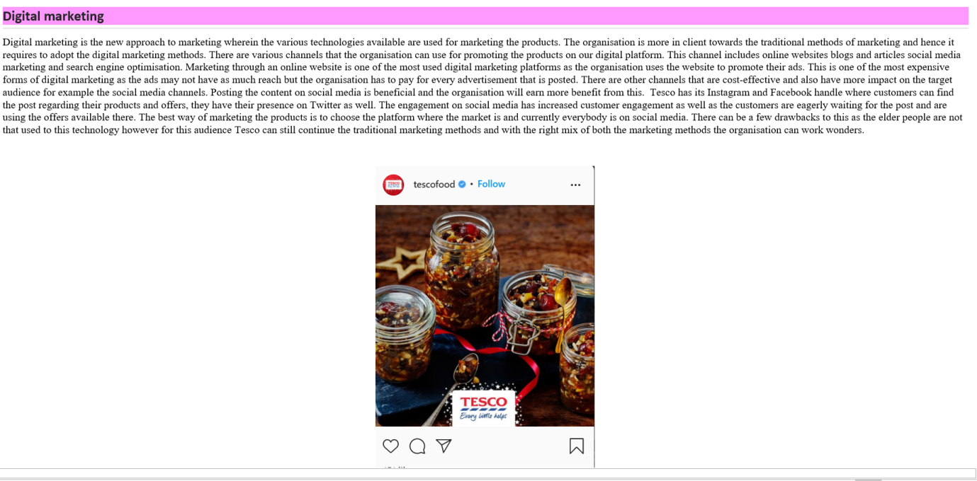
Digital marketing is the new approach to marketing wherein the various technologies available are used for marketing the products. The organization is more in client towards the traditional methods of marketing and hence it requires to adopt the digital marketing methods. There are various channels that the organization can use for promoting the products on our digital platform. This channel includes online websites blogs and articles social media marketing and search engine optimization. Marketing through an online website is one of the most used digital marketing platforms as the organization uses the website to promote their ads. This is one of the most expensive forms of digital marketing as the ads may not have as much reach but the organization has to pay for every advertisement that is posted. There are other channels that are cost-effective and also have more impact on the target audience for example the social media channels. Posting the content on social media is beneficial and the organization will earn more benefit from this. Tesco has its Instagram and Facebook handle where customers can find the post regarding their products and offers, they have their presence on Twitter as well. The engagement on social media has increased customer engagement as well as the customers are eagerly waiting for the post and are using the offers available there. The best way of marketing the products is to choose the platform where the market is and currently everybody is on social media.

References
Baker, P., Machado, P., Santos, T., Sievert, K., Backholer, K., Hadjikakou, M., Russell, C., Huse, O., Bell, C., Scrinis, G. and Worsley, A., 2020. Ultra‐processed foods and the nutrition transition: Global, regional and national trends, food systems transformations and political economy drivers. Obesity Reviews, 21(12), p.e13126.
bbc.com, 2021 [online]. Available at < www.bbc.com>, [accessed on 7th Dec, 2021]
blog.hubspot.com, 2021 [online]. Available at < www.blog.hubspot.com>, [accessed on 7th Dec, 2021]
durian.runtuh.com, 2017 [online]. Available at < www.durian.runtuh.com >, [accessed on 7th Dec, 2021]
Rihova, I., Moital, M., Buhalis, D. and Gouthro, M.B., 2019. Practice-based segmentation: taxonomy of C2C co-creation practice segments. International Journal of Contemporary Hospitality Management.
Samdani, T., 2020. Impact of Tesco's Private Label brands on buying behaviour of Millennials in terms of brand preference in Irish market (Doctoral dissertation, Dublin, National College of Ireland).
smartinsights.com, 2021 [online]. Available at < www.smartinsights.com>, [accessed on 7th Dec, 2021]
tesco.com, 2021 [online]. Available at < www.tesco.com>, [accessed on 7th Dec, 2021]
thetimes.co.uk, 2019 [online]. Available at < www.thetimes.co.uk>, [accessed on 7th Dec, 2021]

