Assignment Title: Transportation in Hospitality

Your name: Viktoria Benko

Student number: 2130343

The module title and module code: Sustainable Hospitality &Tourism Management BMIH5006

Lecturer’s name: Giulia Chifari

Number of words: 2374

Executive Summary
This report explores the ecological impact of different transportation methods within the tourism sector, with a primary focus on tour buses. As an essential element of the hospitality and travel industry, tour buses significantly contribute to tourism by providing convenient mobility for travellers. However, they also generate pollution, greenhouse gas emissions, and excessive resource consumption. With the growing demand for sustainable travel alternatives, it is imperative to identify strategies that can make tour bus transport more eco-friendly.
The report highlights the environmental challenges associated with conventional tour buses, including their dependency on fossil fuels, substantial emissions, and overall environmental footprint. It also presents forward-thinking solutions that have been introduced to mitigate their negative effects, such as the implementation of electric and hybrid buses, advancements in fuel efficiency, and the incorporation of sustainable initiatives within tourism transport companies.
Additionally, the report offers key recommendations to facilitate the shift toward more sustainable tour bus operations. These include government incentives for greener transportation, investment in renewable energy technologies, optimized route planning to reduce fuel consumption, and greater public awareness campaigns promoting environmentally responsible travel choices.

Table of Contents
Executive Summary 2
Introduction 3
Tour Buses in Hospitality Transportation 3
Damage mode of transport causing 5
1. Environmental Consequences 6
2. Traffic and Overcrowding 9
3. Infrastructure Strain 9
4. Cultural and Social Disruptions 10
5. Economic Dependence on Tourism 11
Possible solutions to remedy and respond to the damage caused 11
Infrastructure & Traffic Optimization 12
Adoption of Eco-Friendly Transportation 12
Regulatory & Policy Approaches 13
Community & Environmental Support Initiatives 13
Awareness & Incentives for Sustainable Tourism 13
Conclusion 13
Recommendations 14
References 16

Introduction

Hospitality transport refers to the transportation services provided to guests, visitors, and tourists within the hospitality industry for example shuttle services, private transfers, group transportation, and tour buses. High-end hotels and resorts, often offer luxury transport options such as private cars, chauffeurs, or even yachts, while budget accommodations provide shared shuttle services. The transport system is designed to meet the specific needs of travellers, offering everything from airport pickups to intercity transfers, including guided tours providing efficient, safe, and comfortable transportation that enhances the guest’s overall experience. Also ensuring a seamless and pleasant travel experience to and from hotels, resorts, and other destinations.

Tour Buses in Hospitality Transportation

Tour buses are an essential part of the transportation industry by offering a suitable, comfortable, and structured way for customer to survey destinations. These coaches cater essentially to tourists focus to explore cities, landmarks, and natural attractions. They are especially popular in destinations with numerous points of interest, where organized tours provide the easiest and most cost-effective way to travel. The tour buses have different sizes, from small minibuses accommodating a handful of guests to large buses that hold 50 or more travellers.

These buses provide more than just transportation; they present a full experience with the all the enjoyment of a tour guide. Also tour buses come with guides who provide commentary on historical insights, and cultural information about the locations visited, enhancing the overall experience.

In addition to that tour buses are used for city sightseeing, trips to natural attractions, or short excursions to nearby towns and landmarks. They are especially popular in areas with high tourist activities, including major cities, historic sites, and well-known holiday destinations. For example, in cities like New York, Paris, or Rome, hop-on-hop-off buses are widely available, enabling travellers to discover various attractions at their own convenience. The tourism business encompasses a wide range of industries that thrive on tourism, including transportation, hotels, restaurants, accommodation providers, tour operators, and ancillary service providers. (Bodhanwala & Bodhanwala, 2022-08,)

A key benefit of utilizing tour buses is their convenience. Rather than figuring out public transportation or handling the complexities of renting a car, travellers can experience a hassle-free trip, as the tour company takes care of transportation, route coordination, and logistics. This allows guests to focus more on sightseeing and less on navigation or parking concerns.

Additionally, tour buses often offer extra comfort and features, such as climate control, adjustable seats, onboard Wi-Fi, and even refreshments which improve the guest experience. Many tour providers plan trips to be as seamless and enjoyable as buses also have environmental benefits and can also be more cost effective than flying (Sarikamis, 2022).

Beyond traditional sightseeing tours, buses are also utilized for specialized experiences, such as wine tastings, eco-tours, and cultural or gastronomic adventures. For instance, in renowned wine regions like Napa Valley or Bordeaux, tour buses shuttle guests between vineyards, allowing them to fully enjoy the experience without the concern of driving.

Sustainability has become an increasing priority in the hospitality sector. Many tour providers now adopt eco-conscious initiatives, such as utilizing hybrid or electric buses to minimize the environmental impact of group travel. This not only caters to the rising demand for sustainable tourism but also aligns with the growing ecological awareness of travellers.

Damage mode of transport causing

The sectors of transportation and tourism coexist and function both separately and together. They have intricated, engaging, yet predominantly unsustainable connections. However, studies on sustainable tourism have frequently concentrated on static aspects, without fully addressing the extensive effects of tourism-related mobilities. (Hopkins, 2020-02,).
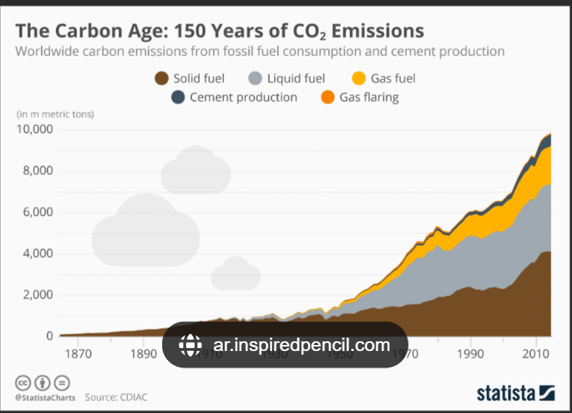
Figure 1: Image showing Carbon Age
Source: internet

While tour buses play a vital role in the tourism and hospitality industries, they can also contribute to several environmental, social, and infrastructural challenges. Below are some of the key adverse effects associated with bus tours and transportation:

1. Environmental Consequences
Air Pollution: Conventional tour buses, particularly older models, run on diesel or other fossil fuels, releasing large amounts of carbon dioxide (CO2) and harmful pollutants into the air. This exacerbates climate change and degrades air quality, especially in highly frequented tourist areas. For example, during lockdown, the concentration of black carbon in some areas was reduced by half and some areas by 30% improving ozone level (Guha, 2025). This proves that the more unsustainable vehicle types that we have on the roads the more pollution they emit.

- The carbon dioxide emissions generated by industrial production are contributing to climate change, which is currently one of humanity's most critical environmental issues. Rising sea levels, the growing frequency of natural disasters, the decline in agricultural yield capacity, and the loss of biodiversity are all closely linked to climate change. The widespread reliance on fossil fuels in production processes is mainly accountable for the significant carbon dioxide emissions (Chen, et al., 2023-10, ).

- Carbon Emissions: Although tour buses can be more efficient than individual car travel in terms of passenger capacity, they still produce significant greenhouse gas (GHG) emissions. In destinations with heavy tourist traffic, outdated or non-eco-friendly buses can contribute to rising carbon levels.
Hence the need to focus on addressing these unsustainable practises across hotel operations (Willy Legrand, 2022).

- Minimizing greenhouse gas (GHG) emissions in the transportation sector is one of the most significant hurdles. Moreover, sustainable progress extends beyond just reducing GHG emissions. Other environmental, social, and economic factors should not be overlooked. Therefore, a thorough sustainability evaluation for passenger vehicles is carried out for the years 2020 and 2050 (Haase, et al., 2022-12, ). Image showing how greenhouse emissions occur.
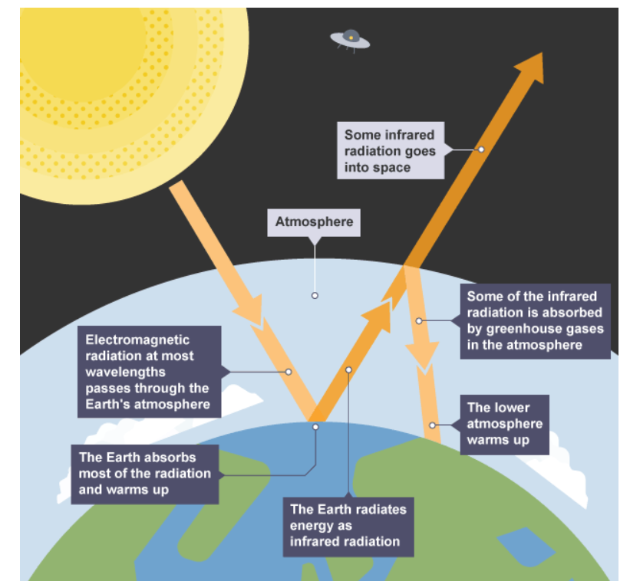
Figure 2: How greenhouse emissions process
Source: Internet

- Noise Disturbance: Tour buses generate substantial noise, particularly in urban centres or tranquil natural areas. Especially second-hand fleets not maintained properly adversely affects road safety and environmentally sustainability (Joseph Kamau Muguro, 2024). This can also disrupt wildlife, disturb the serenity of scenic locations, and negatively impact the daily lives of residents.

- Transportation networks within parks affect the natural environment. Parks often face challenges related to infrastructure and conservation, such as neglected roads, pollution, traffic congestion, closed paths, and noise disturbances impacting wildlife. Travel in rural areas and on highways has risen significantly in recent years worldwide. (Templeton, et al., 2023-01, )

2. Traffic and Overcrowding
- Traffic congestion has been a prominent concern globally for a long time. In addition to congestion caused by daily travellers, heavy traffic during public holidays is also quite common. The number of vehicles on the road often surges sharply during holidays, placing immense pressure on road capacity and leading to serious congestion. This is particularly evident at the start and end of holiday periods. (Bao, et al., 2017-10, )

- Overcrowding at Attractions: When large tour groups visit attractions simultaneously, they can create overcrowding, diminishing the visitor experience and placing strain on historical landmarks, natural wonders, and cultural sites.

In other hotspots the political sphere is increasingly challenged to find multi-dimensional, inclusive, inter and transdisciplinary solutions to minimise the problems of overcrowding caused by overcrowding (Elisa Innerhofer, 2019).

3. Infrastructure Strain
- Road Deterioration: Large tour buses exert significant pressure on roadways, particularly in areas not originally built to accommodate heavy vehicles. This can lead to faster road wear and tear, increasing maintenance costs for local governments. Buses fall under the category of heavy vehicles, and studies have indicated that such vehicles are the primary contributors to pavement deterioration and the expenses required for repairs. (Maria Boilé, 2003)

- Public Service Burden: Transportation is more than merely moving from one place to another; it serves as a vital link for social inclusion. In rural regions, where distances are vast and public transit is limited, the absence of transportation can result in social isolation, especially for seniors, young individuals, and those without access to a private vehicle. Smaller buses help close this gap by offering consistent and accessible travel options. By connecting residents to schools, medical centres, workplaces, and community gatherings, these buses play an essential role in strengthening social bonds and ensuring that everyone has the chance to actively engage in society. (Anon., 2024 )

4. Cultural and Social Disruptions
- Over-Tourism: If we consider overtourism as more than just a matter of visitor numbers, it can be understood as an evolving dynamic between the local population and travellers. In this regard, the underlying causes also stem from an increasing recognition among residents that tourism does not always bring positive outcomes. (Anon., n.d.)

- Disruption of Local Communities: Tourism frequently includes exploring distinctive cultural landmarks and interacting with local communities. However, uncontrolled tourism expansion can result in the degradation of local customs and traditions. Responsible tourism advocates for the protection of cultural heritage, fosters considerate engagement between visitors and residents, and bolsters local economies, ensuring the authenticity and preservation of cultural destinations. (Bartolozzi, 2023)

5. Economic Dependence on Tourism
- Financial Instability: Areas that are highly dependent on tourism are especially susceptible to economic instability. External influences such as global financial recessions, natural calamities, political unrest, and health emergencies can greatly affect tourist activity. For instance, the COVID-19 pandemic caused an unparalleled decline in travel and tourism, leading to severe financial upheaval in tourism-reliant regions across the globe. The abrupt decrease in visitor numbers triggered widespread job losses, business shutdowns, and substantial reductions in local income. (Wallace, 2024)

Possible solutions to remedy and respond to the damage caused

Have inspectors to check potential hazards tour bus routes for example low overhanging tree and potholes for example the loud band which came after tour
bus hit a low overhanging tree was like a bomb which not only affected the tourists but also whole neighbourhood (Glanfield., 2015).
Representatives from both sides, to reduce the number of accidents, tour bus companies and local authorities can use of organisations like The Institute for Transportation and Development Policy (ITDP) is a non-profit, non-governmental organization dedicated to enhancing urban mobility and specializes in developing bus rapid transit (BRT) systems, advocating for cycling, walking, and other forms of non-motorized transportation. ITDP strives to merge transportation with intelligent urban planning to transform cities and suburban areas into vibrant, sustainable environments that stimulate economic growth, promote low-carbon lifestyles, and appeal to residents (Anon., n.d.).
Electric vehicles (EVs) have been in use since the early 1900s. However, despite their initial presence, the rise and effectiveness of internal combustion engines led to a considerable decline in EV adoption for road transport. Challenges such as environmental degradation, resource scarcity, the increasing expense of petroleum-based fuels, and the quest for energy self-sufficiency have recently rekindled interest in EVs as an alternative means of mobility. Propelled by technological advancements and a dedication to ecological preservation, the transportation industry is undergoing a substantial shift toward sustainability. While EVs have advanced in promoting cleaner and more sustainable mobility, progress is still ongoing (Chen & Cho, (2024):7797).

Addressing the negative effects of tour buses requires a combination of sustainable strategies aimed at reducing environmental harm, preserving local infrastructure, and encouraging responsible tourism. Here are some key approaches:

Infrastructure & Traffic Optimization

- Dedicated Bus Lanes & Parking Zones: Assign specific routes and designated parking areas to ease congestion and minimize road damage (Anon., 2025)

- Weight Regulations & Road Strengthening: Enforce vehicle weight limits on delicate roads and reinforce infrastructure where needed.
- Strategic Drop-Off Points: Establish designated unloading zones near attractions to prevent excessive wear on sensitive locations.
Adoption of Eco-Friendly Transportation:
- Electric & Hybrid Tour Buses: Promote or require the use of low-emission, energy-efficient vehicles.
- Compact Shuttle Services: Replace oversized buses with smaller, fuel-efficient shuttles to reduce environmental impact.
- Integration with Public Transport: Align tour routes with existing public transit systems to cut down on unnecessary bus usage.

Regulatory & Policy Approaches
- Tour Bus Limitations: Cap the number of buses permitted per day in ecologically or culturally sensitive areas.
- Eco-Fees & Permits: Introduce charges based on environmental impact to encourage greener operations.
- Timed Entry Systems: Distribute visitor flow by implementing scheduled access to popular attractions.

Community & Environmental Support Initiatives
- Investment in Local Infrastructure: Allocate tourism-generated revenue toward maintaining roads, sidewalks, and public amenities.
- Green Buffer Zones & Tree Planting: Offset carbon emissions by establishing green spaces along travel routes.
- Collaboration with Local Businesses: Promote walking and cycling tours to support small enterprises and reduce reliance on buses.

Awareness & Incentives for Sustainable Tourism
- Responsible Tourism Awareness Campaigns: Educate travellers and operators on how to minimize their footprint.
- Recognition for Green Operators: Provide incentives, certifications, or awards for businesses that prioritize sustainability.
- Diversification of Tourism Destinations: Encourage visits to lesser-known locations to distribute the impact more evenly.

Conclusion

Incorporating sustainable practices into tour bus operations is crucial for minimizing environmental impact while preserving high-quality travel experiences. By adopting fuel-efficient technologies, shifting to electric or hybrid fleets, optimizing travel routes, and implementing carbon offset programs, tour bus companies can substantially reduce emissions and support an eco-friendlier future.
Furthermore, encouraging passengers to make environmentally conscious travel choices and partnering with local communities to foster sustainable tourism efforts will further promote ecological and social responsibility. As the industry evolves, embracing innovation and sustainability will not only protect the planet but also ensure long-term operational efficiency and enhance customer satisfaction.
By focusing on sustainability, tour bus operators can pave the way for a cleaner, more conscientious tourism industry—one that harmonizes economic development with environmental responsibility for the benefit of future generations.

Recommendations

To minimize environmental impact and support sustainability, tour bus operators should adopt the following approaches:
Switch to Eco-Friendly Vehicles
- Invest in hybrid, electric, or biofuel buses.
- Maintain vehicles regularly for better fuel efficiency.
Adopt Fuel-Efficient Driving Habits
- Train drivers in eco-friendly practices.
- Use GPS to plan efficient routes.
Minimize Waste & Promote Recycling
- Provide recycling bins on buses.
- Offer digital tickets to reduce paper waste.
Collaborate with Sustainable Tourism
- Partner with eco-conscious hotels and attractions.
- Educate passengers on sustainable tourism.
Offset Carbon Emissions
- Invest in tree-planting and renewable energy projects.
- Let passengers contribute to carbon offset efforts.
Educate Staff & Passengers
- Provide sustainability training for employees.
- Raise awareness on eco-friendly travel.

By adopting these practices, tour bus operators can lessen their environmental footprint while promoting responsible tourism.

References
Anon., 2024 . The Benefits of Small Buses: Connecting Communities and Bridging Gaps in Rural Transportation. [Online]
Available at: https://mellorbus.com/
Anon., 2025. https://cehd.gmu.edu/features/2023/05/04/four-ways-in-which-the-tour-bus-industry-can-alleviate-climate-change/. [Online]
Available at: https://cehd.gmu.edu/features/2023/05/04/four-ways-in-which-the-tour-bus-industry-can-alleviate-climate-change/
[Accessed 07 03 2025].
Anon., n.d. Institute for Transportation and Development Policy. [Online]
Available at: https://en.wikipedia.org/
Anon., n.d. Overtourism: A Challenge for the Future of Tourism. [Online]
Available at: https://www.etifor.com
Bao, Y., Xiao, F., Gao, Z. & Gao, Z., 2017-10, . Investigation of the traffic congestion during public holiday and the impact of the toll-exemption policy. Oxford: Elsevier Ltd; Transportation research. Part B: methodological, , Volume Vol.104, , pp. p.58-81.
Bartolozzi, P., 2023. Tourism cultural exploitation. [Online]
Available at: https://www.skaleurope.org
Bodhanwala, S. & Bodhanwala, R., 2022-08,. Exploring relationship between sustainability and firm performance in travel and tourism industry: a global evidence. Social responsibility journal,, Volume Vol.18 (7),, pp. 1251-1269.
Chen, L. et al., 2023-10, . Artificial intelligence-based solutions for climate change: a review. Cham: Springer International Publishing; Environmental chemistry letters, , Volume Vol.21 (5), , pp. p.2525-2557.
Chen, Y. & Cho, S. S., (2024):7797. Exploring Electric Vehicle Patent Trends through Technology Life Cycle and Social Network Analysis. Sustainability;, Vol. 16 ( Iss. 17, ).
Elisa Innerhofer, G. E. H. P., 2019. Overtourism Tourism Management and Solutions. Oxford: Taylor and Francis.
Glanfield., A. W. a. E., 2015. Mailonline. [Online]
Available at: https://www.dailymail.co.uk/news/article-3184025/Four-people-injured-packed-tourist-bus-roof-ripped-hitting-tree-central-London.html
[Accessed 06 03 2025].
Guha, D., 2025. Hospitality Industry Risk Analysis in Epidemics. Delhi: Educohack Press.
Haase, M. et al., 2022-12, . Multi-criteria decision analysis for prospective sustainability assessment of alternative technologies and fuels for individual motorized transport. Berlin/Heidelberg: Springer Berlin Heidelberg; Clean technologies and environmental policy,, Volume Vol.24 (10), , pp. p.3171-3197.
Hopkins, D., 2020-02,. Sustainable mobility at the interface of transport and tourism: Introduction to the special issue on 'Innovative approaches to the study and practice of sustainable transport, mobility and tourism'. Journal of sustainable tourism,, Volume Vol.28 (2), pp. p.129-143,.
Joseph Kamau Muguro, P. W. N. M. S., 2024. Public Transportation in Kenya (A Phenomenological Study of Transport Issues). Dubai: Bentham Science Publishers.
Maria Boilé, P. N. K. O., 2003. Impact of Buses on Highway Infrastructure. Case Study for New Jersey State, Volume 1841.
Sarikamis, S., 2022. Sustainable Tourism Tourism Paradisms. s.l.:WORLD BOOKS STORE.
Templeton, A. J., Fyall, A. & Tasci, A. D. A., 2023-01, . Electric Vehicle Infrastructure as a Driver of the Sustainability Agenda in the US National Park System. Urbana: Sagamore Publishing LLC; Journal of park and recreation administration, , Volume Vol.41 (2),, pp. p.1-26.
Wallace, J., 2024. The Economic Challenges of Regions Highly Dependent on Tourism. [Online]
Available at: https://city-countyobserver.com/
Willy Legrand, J. S. C. G. C. M. L., 2022. Sustainability in the Hospitality Industry Principles of Sustainable Operations. Oxford : Taylor and Francis.

