HNC Process Operations Engineering Year 1
Imogen Reynolds
22/04/2020
Process Automation
Industrial Process Operations and Control PCPO4004
Contents

Task 1 2
Exercise 1 2
Exercise 2 4
Exercise 3 8

Task 2 10

Table of Figures 11
Bibliography 12

Task 1

Exercise 1
Prior to carrying out the pump swap from P_101A to P_101B, visual checks should be carried out by the plant operator to ensure P_101B is satisfactory for the running requirements i.e. no leaks or obvious damage. Depending on the pump and its process will determine the procedure required in order to carry out the task safely and correctly.
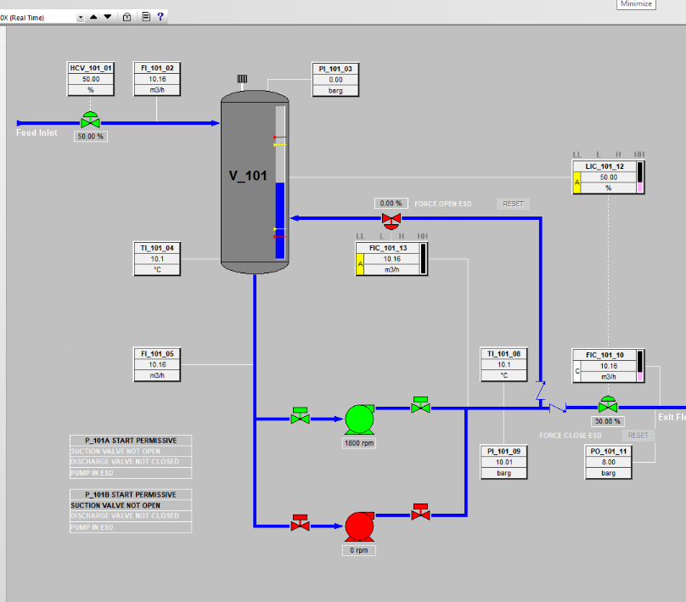

Figure 1- Correct Running System of Plant

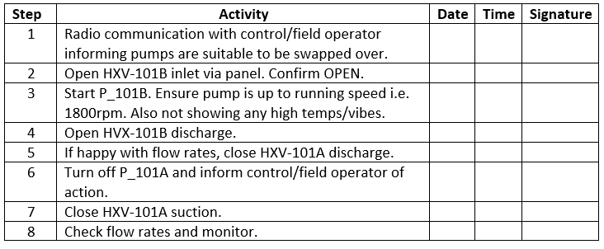
Procedure for Swapping Over Pumps
Figure 2 - SOP for Changeover of P_101A to P_101B

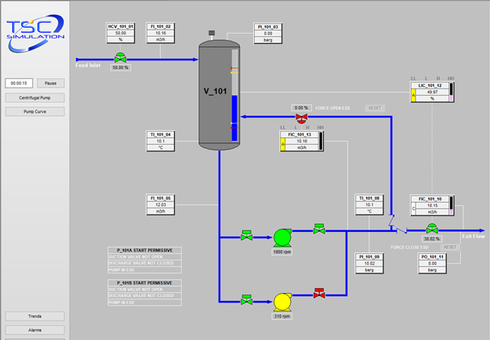

Figure 3 – Step 3 of SOP

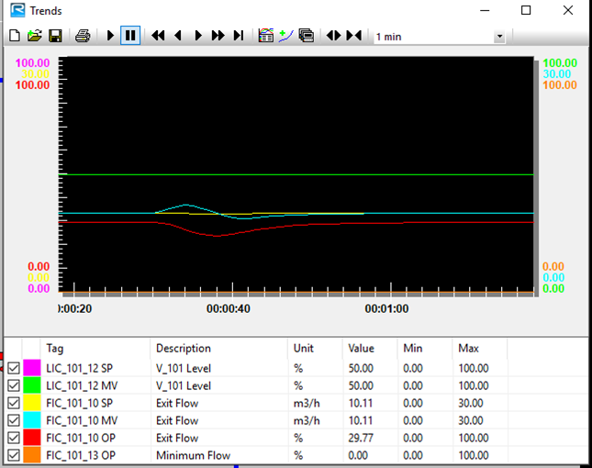

Figure 4 - Flow Rates

As seen in figure 4 there was a slight surge in upset when the pumps were swapped over, but the flow maintained and eventually steadied out.

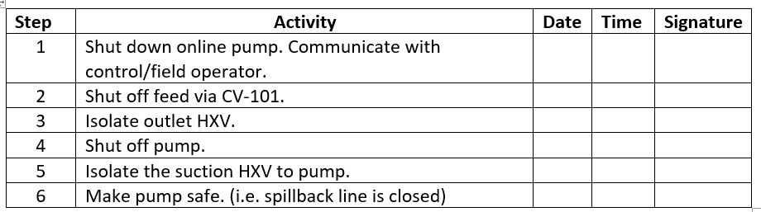
Emergency Shut Down Procedure
Figure 5 - SOP for Emergency Shut Down

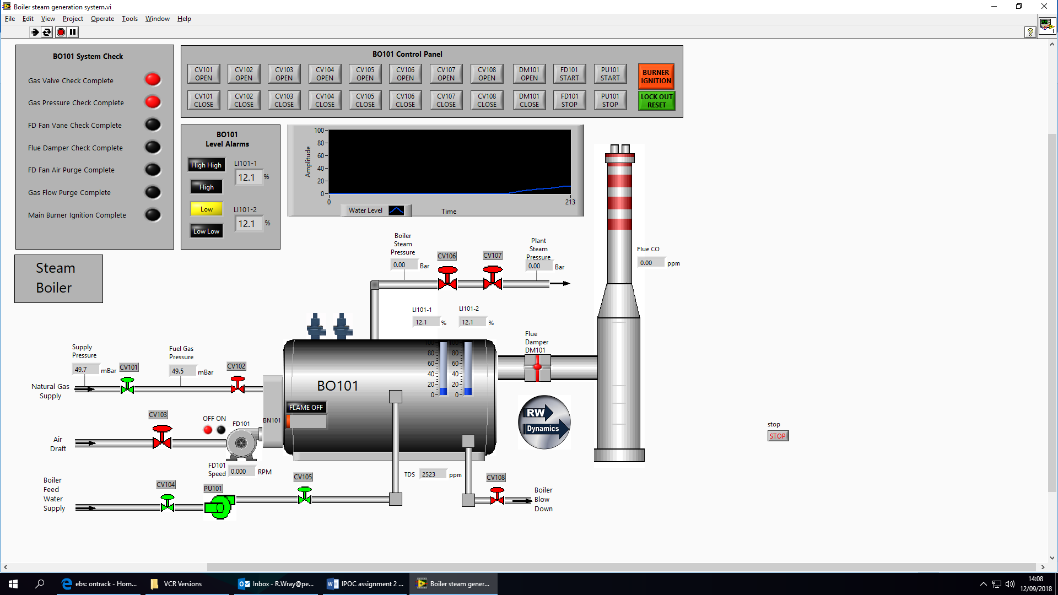
Exercise 2

Figure 6 - Steam Generation Exercise

The purpose for Boiler 101 is to produce steam. Boiler Feed Water (BFW) is transformed into steam which contains a significant amount of kinetic energy which can be used for powering steam driven turbines or as heating medium. BFW is pumped into BO-101 via CV-104 into the suction of PU-101 through CV-105 outlet prior to entering BO-101, the level in the boiler is controlled via CV-108 and sent to the sites blowdown system. In order to heat the BFW, the combustion tringle is required. An automatic burner ignition is obtained via BN-101, CV-101 and CV-102 are used to route natural gas via the site fuel gas header into the system. CV-102 can be shut off in an event of an emergency. Air is provided via a forced draft fan, CV-103 controlling the rate of air into FD-101 into BN-101 to create the three sources in order to heat the BFW. Any undesirable flue gases are removed from BO-101 via DM-101 into the stack to atmosphere, the CO content is monitored and analysed by analysers to meet the emission requirement standards. The stack damper can also control the heat inside of BO-101 depending on its application purpose. The steam pressure inside of BO-101 is controlled via CV-106 and CV-107 to the plant. BO-101 level is indicated via alarms on the panel, level instrumentation is in place to ensure a low-low level or high-high level does not occur which would result in excessive damage to the boiler or the system tripping.
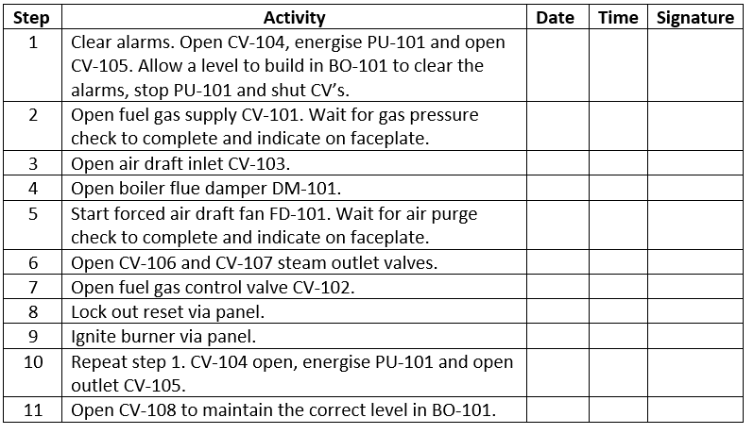
SOP for Boiler-101
Figure 7 - SOP for correct operation of BO-101
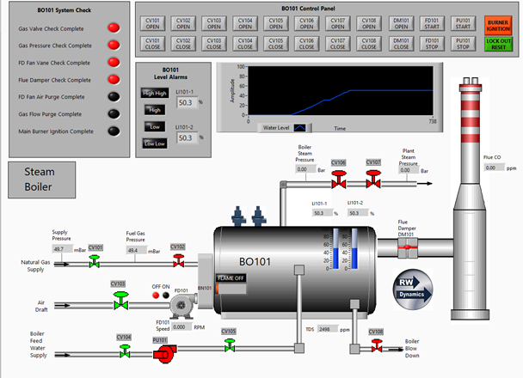

Figure 8 - Step 4 of SOP
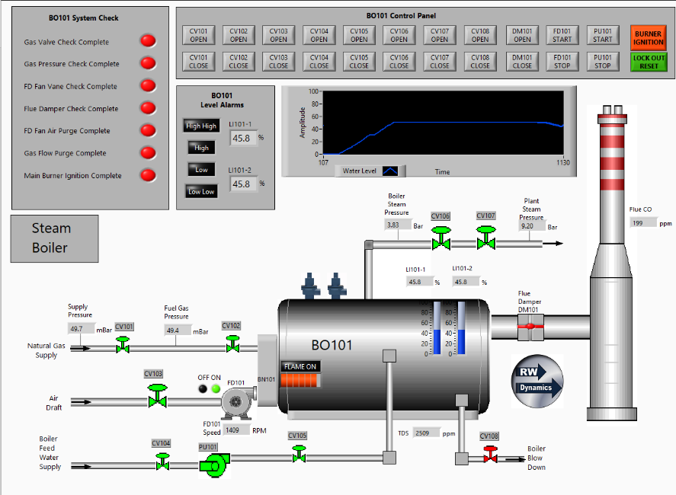
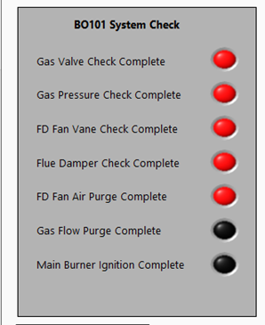

Figure 9 - Step 5 of SOP
Figure 10- Step 10 of SOP

Timing checks for system
System Checks | Duration (seconds)
Gas Valve Check | 0
Gas Pressure Check | 60
FD Fan Vane Check | 0
Flue Damper Check | 0
FD Fan Air Purge | 45
Gas Flow Purge | 0
Main Burner Ignition | 0

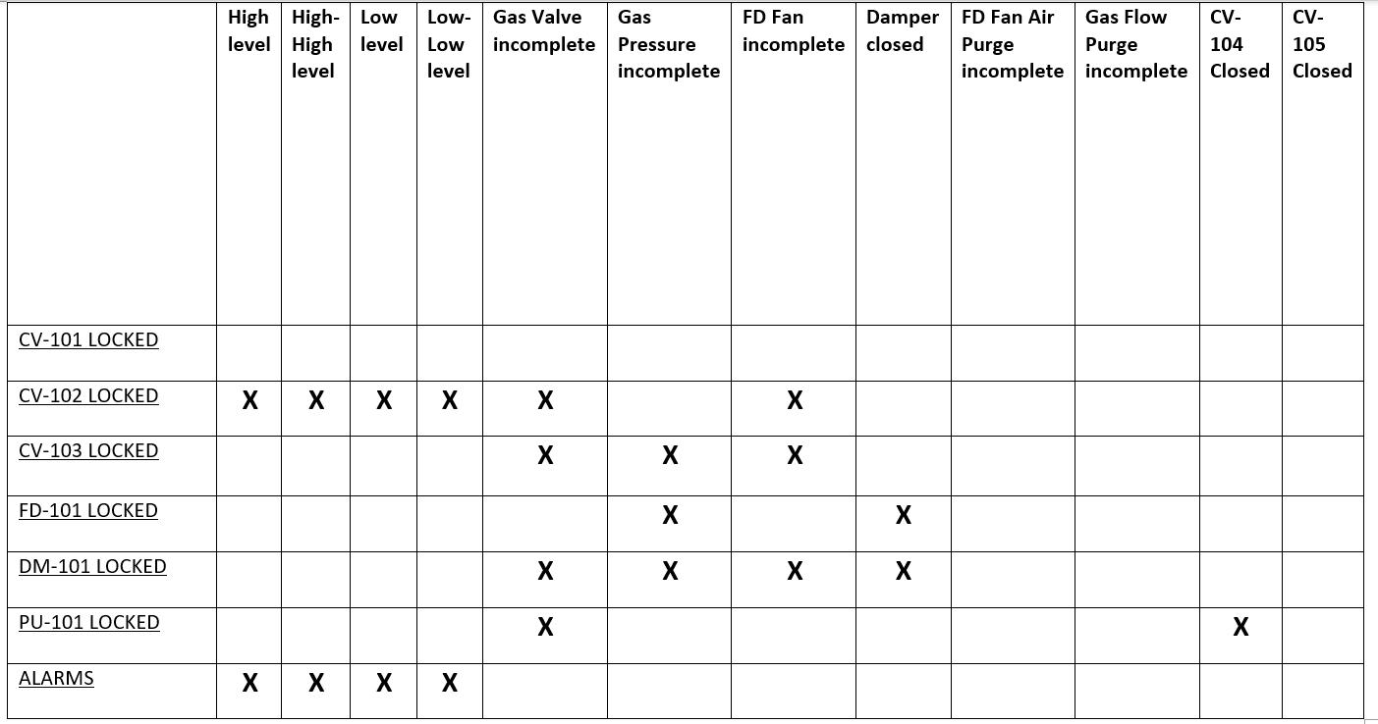
Matrix Interlock
Figure 11- Interlocks

Fault Finding Guide
If the boiler has tripped and will not reset. It is the job of both the field and control operator to carry out basic checks on the plant to help identify the source that has either caused the trip or the source preventing the boiling re-firing:
- CV-102 must be closed if not already to prevent fuel gas entering the system. Prior to start up.
- Lock Out Reset button is selected prior to attempting to re-fire the boiler.
- Alarms are cleared, via CV-108 if level is high in BO-101 or if a low level is present CV-104 is opened, PU-101 is energised and CV-105 is also opened to fill BO-101 with BFW.
- CV-101 and CV-102 are open and not stuck closed in the field although showing open on the panel.
- FD-101 is online when attempting to re-fire the boiler and running satisfactory in the field.
- DM-101 is opened in the field and not stuck closed as it will affect the boiler operating safely.
If all the above steps have been carried out prior to the start-up procedure being followed and BO-101 is still not re-firing, then the operations team should contact the maintenance department immediately to help investigate the fault.
Potential Trips
The boiler may have tripped due to a piece of equipment failing within the process:
- If DM-101 has tripped or slammed closed, try to reset damper locally or remotely.
- If FD-101 has tripped, ensure the suction inlet CV-103 is open and supplying air to the fan. If CV-103 is closed try to reset the control valve via the panel if not, by-pass the CV until maintenance can look at the valve. Although if CV-103 is open, ensure that DM-101, CV-106 and CV-107 are also open and not stuck closed.
- If PU-101 has tripped, try a reset straight away to prevent a low-low level in BO-101 which will lead to the whole process tripping. If PU-101 will not reset, shut CV-108 to maintain a level in BO-101. Check to ensure both CV-104 and CV-105 are open and not shut closed. If shut and will not reset via panel by-pass CV’s until maintenance can investigate fault.

Exercise 3
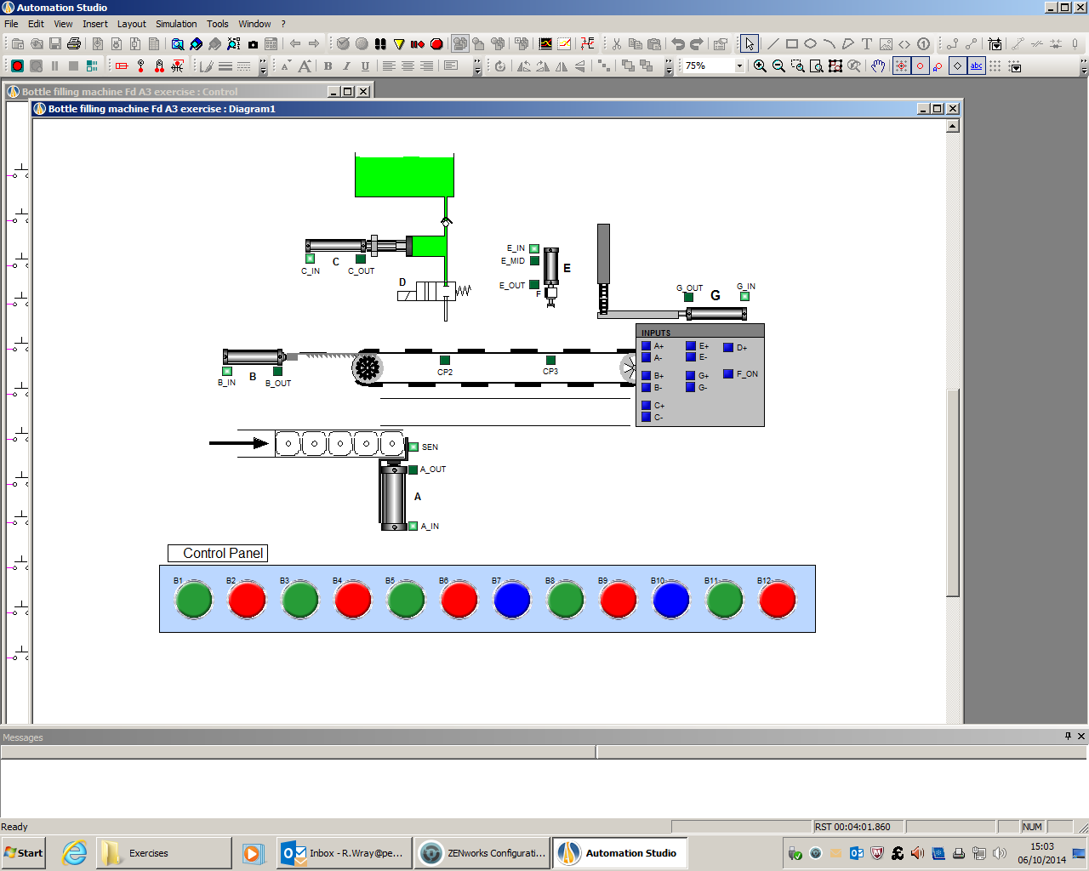

Figure 12- Bottle Filling

Sequential control is an automated process used to carry out a set of instructions in sequence. This is specific for a repetitive task that is carried out constantly the same without change every time. This system is a way of triggering a series of steps to perform a given task, this is usually done via electrical or mechanical actuators i.e. sensors, which have been programmed to operate at a certain point within a process. By using sequential control for the operation shown in figure 12, it is the most efficient way to carry out the task and ensuring all bottles are filled and capped the same.

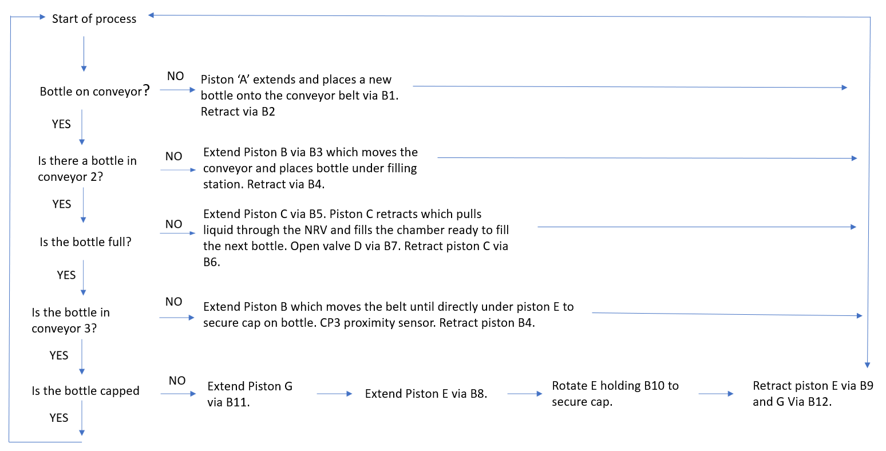
Flow Diagram
Figure 13- Flow Chart of Bottle Filling

The steps in order to operate the bottle filling machine correctly to achieve a desirable outcome can be seen in figure 13. The flow diagram indicates step by step on how to control the machine. Starting with ensuring that there is a bottle on the conveyor belt via piston A, in order to then move the conveyor belt piston B must be extended to move the empty bottle along to the filling station ensuring piston A is extracted to allow B to move forward. Piston C and valve D are then activated to fill the bottle, before piston B is extracted to move the conveyor belt. The next section is where the bottles are capped via piston G and E, piston G must be extracted to allow piston E to collect the bottle lids from the mid-point of piston G. B10 is then held to secure the cap onto the bottle, piston G must be retracted to allow piston E to extract. If the chart is followed the conveyor will always operate smoothly.

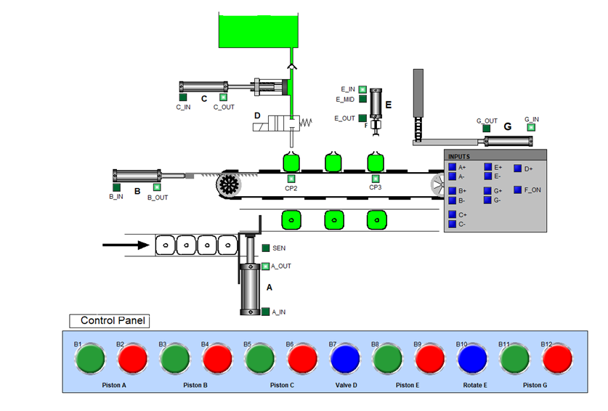

Figure 14 - Sequential Control in Practice

Task 2

Supervisory Control and Data Acquisition (SCADA) is a system used within a big industry that is required to monitor and control a system. SCADA displays and examines via processing date in real time. SCADA is composed of a collection of both software and hardware components that allow the supervision of plants both remotely and locally to take place. The signal input to output is monitored, controlled and compared within the control room, it is also a way of ensuring any standing alarms are picked up and dealt with. In order for the system to work a piece of instrumentation is required to send a signal via a transmitter to the Human Machine Interface (HMI) which is in effect an interface that connects a person to a system.
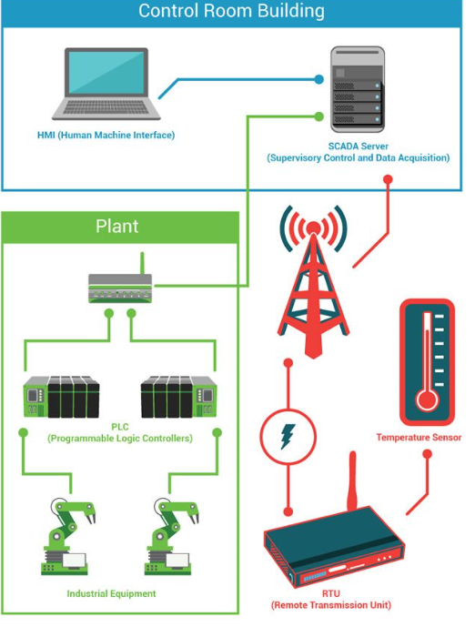
HMIs are a huge advantage in industry being able to monitor inputs and outputs to a process, visually displaying the data and trends to produce historical data can result in significant discoveries for the company. The analysed data can be exported out of the control room to offices anywhere in the world for further analysing. Being able to do this allows superior companies to look into their statistical rates and areas to improve in order to benefit both them and the consumer. For Valero who possess 15 refineries worldwide, using SCADA systems is an important factor in the day to day running of the plant, being able to communicate and send analysed data to the headquarters for comparison against the other refineries is a way of comparing the performances from each of the refineries as well as identifying issues with plant such as deterioration of equipment, that may have been missed in the control room or in the field. Figure 15 shows a basic concept to how signals are transmitted and receive in order to achieve the desirable information.

Figure 15- SCADA

The structural design of a SCADA system begins with the Remote Terminal Units (RTU’s) or PLC’s. The microprocessors that communicate and interact with field devices such as pumps, valves, sensors and HMI’s. The data is routed from the processors to the SCADA computers were the data is determined and therefore allowing the operator to analyse and react. The SCADA system requires a communication protocol that a processor can utilise, data collect from the field devices and pass through either a PLC or RTU. The data is then distributed to a system or networked devices. The devices such as HMI’s or servers, show a graphical representation of operations which may also be used to enhance plant production and troubleshooting.
In terms of using a PLC for an application, programming is required depending on the software will depend upon the programming language required. Using a PLC to control a complex system can lead to the programming becoming difficult and messy for the user and troubleshooting also becomes a big problem. PLC’s are ideally better for a much smaller system, while RTU’s are much more advanced and are much more suitable and beneficial to use for larger industrial applications, although PLC’s are still a popular choice to use.
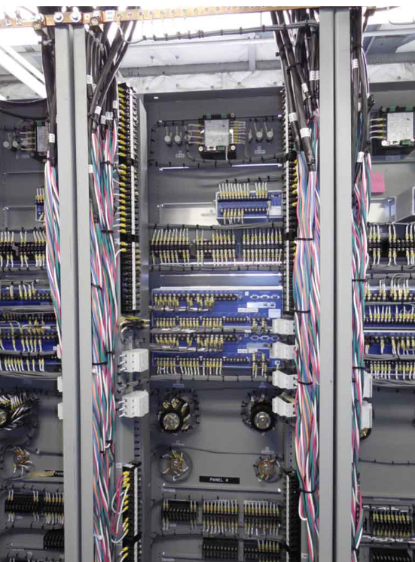

Figure 16- RTU’s

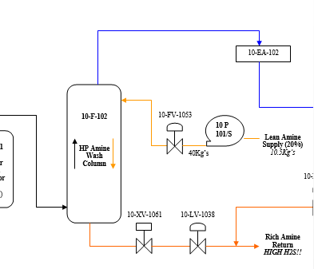
Figure 16 illustrates an example of an RTU system, this is a common system found at Pembroke refinery with designated rack rooms located on units. One example can be seen on plant 10, a high pressure amine wash column has various level sensors, when the level reaches 90% the XV will open and dump the liquid level to the ARU on site. The column has a local gauge and a remote sensor which will transmit the level in the column back to the control room so the panel can also monitor the level remotely. The level transmitter will have certain alarm points such as high and high-high or low-low which will send the signal from the sensor through the RTU to the HMI in the control room.
Figure 17- LPRGU
XV dump valve will open when level reaches high-high alarm.

Level control valve will operate to maintain level in column.

Mid 70’s seen the introduction into SCADA systems, these were standalone units from there the next few decades saw computer software systems getting smaller and HMI software was able to connect and relate to systems although, the communication was typically proprietary which meant the connections outside of a particular vendor were not vailed. In the 2000’s SCADA implement open systems with communications that were not vendor specific, which therefore allowed connections with other vendor systems. An issue was later found when Structured Query Language (SQL) was introduced leading to SCADA becoming out of date due to rapid IT changes. Years later saw SCADA systems adapted once again to the changes in IT and allowed real time plant information to be accessed. Now we see how SCADA is widely implemented within industries and how it plays a massive part with ensuring safety and efficiently within a company such as Valero.

Table of Figures

Figure Number | Source of Reference if Applicable
1 | Correct Running System of Plant
2 | SOP for Changeover of P_101A to P_101B
3 | Step 3 of SOP
4 | Flow Rates
5 | Figure 5 - SOP for Emergency Shut Down
6 | Steam Generation Exercise
7 | SOP for correct operation of BO-101
8 | Step 4 of SOP
9 | Step 5 of SOP
10 | Step 10 of SOP
11 | Interlocks
12 | Bottle Filling
13 | Flow Chart of Bottle Filling
14 | Sequential Control in Practice
15 | SCADA
16 | RTU Rack Room
17 | Training Manual - LPGRU

Bibliography

- Automation, I., 2018. What is HMI?. [Online]
Available at: https://inductiveautomation.com/resources/article/what-is-hmi.
[Accessed 04 05 2020].
- Online, P. P. &. A., 2019. SCADA System (Supervisory Control and Data Acquisition): What is SCADA?. [Online]
Available at: https://www.plcacademy.com/scada-system/
[Accessed 05 05 2020].
- Repairs, R., 2020. What is the difference between SCADA and HMI?. [Online]
Available at: https://realpars.com/difference-between-scada-and-hmi/
[Accessed 05 05 2020].
- Wikipedia, 2020. SCADA. [Online]
Available at: https://en.wikipedia.org/wiki/SCADA
[Accessed 05 05 2020].

