University of Whales Trinity Saint David


Human Resource Management
Assignment 2

Submitted by
Pavlin Petkov Hristov
(2023214)

MBA 2021/2022
Lecturer: Gladius David Kulothungan

Primark’s origin comes from Ireland and its operating in many different countries around Europe. The retailer has shops in Spain, Portugal, France, Germany, Netherlands, Belgium, Austria, UK, Ireland and USA. It was founded and headquartered in Dublin, Ireland.

Currently, Primark has more than 27,000 employees who are doing all the best of their abilities so the company could run smooth and continue generating a lot of profits

PRIMARK is an absolute sensation in today’s world. The company is a synonym of a trendy cat walk fashion at an affordable price to its customers.

The company really believes in its merchandise and the cheap and affordable prices which brings more and more customers to the shops who once been there they know where all the cheap, affordable clothes and accessories are for the future. That strategy really works and convinces the customer to stay a loyal customer of Primark.

Primark has over 370 stores across 12 countries.

- Staffing: Recruitment and availability of skilled local labour
Primark stores has a very various recruitment and selection process. For the past few years job vacancies were advertised in very different ways which includes advertisements in the store, Job Centre announcements and also through the Internet. As we know Primark are not really focused on internet so if you want to become a part of Primark’s team there was no other way than going straight to the shop or directly in the Job Centre to search for a vacancy.
Recruitment Process for Sales Operatives
The recruitment process of Primark Stores includes a few stages. On the first stage the candidate needs to fill an online application form in order to get register. On the second stage there is a set of questionnaires involving themes like customer service and retail environment. Right after that the proper candidate is invited over for a 1-to-1 interview.
Recruitment for Management Positions
The same process is used when someone is applying for a manager’s position.
- Job opportunities are advertised on Primark’s website.
- Candidates are given an online questionnaire with questions including managing the business or real life situations.
- On successful completion of questionnaires, candidate is issued an application reference number and is invited for a Panel Interview.
- This interview session can be a panel interview or one – to – one interview and candidate is tested on the basis of his education, expertise and communication skills.
- The ability to handle different day to day situations with customers is analyzed as well.
- If the interview is completed successfully, the candidate is invited in the assessment centre where he has to work in team on a different tasks and presentations which finally can give the HR team the answer if the candidate is suitable for the role or not.

- Compensation
Primark Stores compensate its employees in many different ways. There is a big staff discount for everyone on board which is the main source of motivation. They are offered opportunities to be trained in different Primark stores.
- The salaries are good and are subject to a yearly review in order to get more
- Training and development programs for helping career growth
- Promotions and staff discounts
- Pension scheme in which you can contribute in order to retire early
- Childcare benefits including vouchers
- Annual leave entitlement
- Health insurance which depends on the position and level of experience
- Bonus scheme which depends on the position and level of experience
- Flexible working hours for all the leading roles
- Flexible shift patterns which are suitable for students
- A competitive Salary and 28 days paid holidays are given to the employees with a permanent contract with the company.

- Learning and Development

For Primark a good training for every single employee is a priority. Providing different opportunities for career growth through different promotions in the store and various training activities. Primark Stores Ltd has always paid immense amount of attention towards the development & training of staff.

Support for New Starters

As we all know every company wants to have a well-trained staff who knows how to adequate take decisions in every situation. Primark especially considers training very important when it comes to future career development of its staff. Every newcomer had to go through a very detailed full day of induction so they know in details all the procedures and company policies about health and safety, hazards, fire and evacuation schemes and the basic customer service skills.

Learning
While working every staff member will learn things from the experienced managers and will understand how to deal with different problems when they occur. Honey and Mumford (1989) described four stages in the learning:
- activity
- reflectors
- theory building
- pragmatists
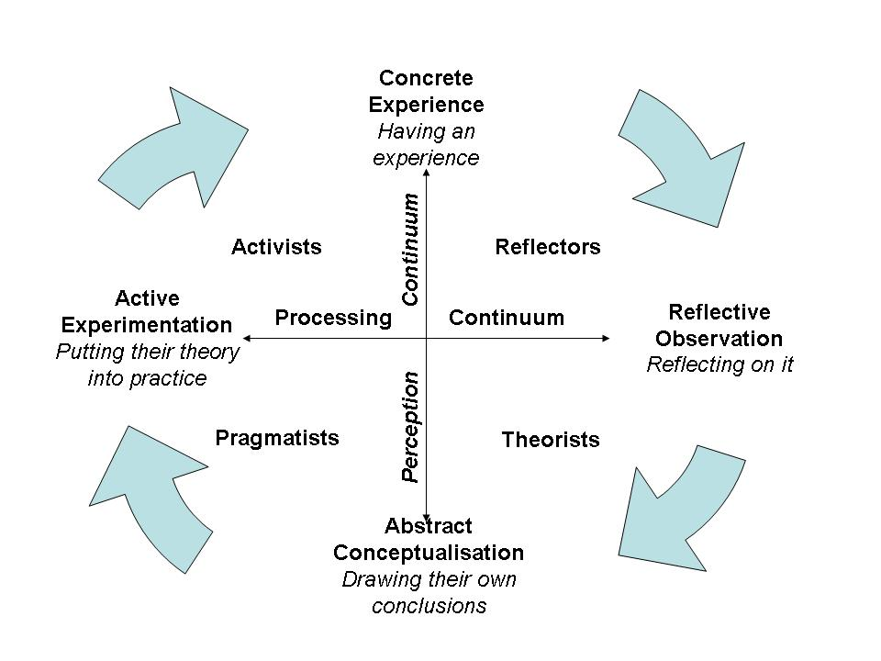
The people who are trying something out without a preparation, they usually are more likely to do role play tasks and are capable to manage with stressful situations and can easy take risks in the working environment These people are usually called Activists.

Career development
When it comes to career development every single employee in whatever position he is at the moment can upgrade themselves with skills and knowledge in the retail business so they overcome different career setback. Most of the organization in this modern world will advice there, support, and encourage in individual career planning and management by giving them the career grids, feedbacks, opportunities for employee career exploration. Primark use this as a image for their organization.

Conclusion
The culture in the organization and the role of Primark when it comes to the development of its staff as an organization that knows how to learn and gives examples is very good. A well prepared and effective HR strategy can help in achieving the goals of the organization. Primark values all of its employees and know how to treat this resource in an effective manner. The success Primark is having today is because of its Business Strategy which was very well backed with Organizational and HR Strategy.

References:
- "Primark revenue 2007-2019". Statista. Retrieved 23 December 2019.
- ^ Jump up to:ª ^{b} "About Us". Primark. Retrieved 15 February 2016.
- ^ Jump up to:ª ^{b} ^{c} ^{d} A household Irish name built from humble beginnings: The Penneys storyTheJournal.ie, 1 March 2015; Retrieved 14 April 2016
- ^ Jump up to:ª ^{b} ^{c} "Annual Report and Accounts 2019" (PDF). Associated British Foods. 2019. Retrieved 23 December 2019.
- ^ Jump up to:ª ^{b} "Snapshot: Primark Stores Limited", Bloomberg; Retrieved 11 February 2016
- ^ Helena Horton (15 August 2017). "Primark reveals how to pronounce its name". The Telegraph. Telegraph Media Group. Retrieved 16 August 2017.
- ^ "Primark Holdings". SoloCheck.ie.
- ^ Jump up to:ª ^{b} "Fashion swing is felt by Penneys' owners". Independent.ie. Independent News and Media. Reuters. 11 July 2008.
- ^ Jump up to:ª ^{b} ^{c} Louise O'Neill (19 January 2014). "Why Penneys is no longer our little secret". Irish Examiner. Retrieved 9 December 2016.
- ^ "78/193/EEC: Commission Decision of 23 December 1977 relating to a proceeding under Article 85 of the EEC Treaty (IV/29.246 - Penneys)". Commission of the European Communities. 23 December 1977. Retrieved 9 December 2016.
- http://www.primark.com/en/our-ethics
- http://en.wikipedia.org/wiki/Primark
- http://www.theguardian.com/business/primark

