Student’s Name: Elena Deprez

Student Number: 2021159
Module Code: BMSW4006
Module Title: Managing Enterprises in the 21st
Century Lecturer’s Name: Nadeem Mirza

Assignment Title: Managing Enterprises in the 21st Century

Executive Summary
This report covers an overview of The Look, a beauty salon that would offer personal beauty care services for women using natural ingredients of products, eventually with reach and growth will do the same for men. The Look will be located in London at first, and secondly in manchester, with time more outlets will be organized all around the Uk and worldwide. The main mission and value proposition of The Look is to offer personal care using chemical-free products, safe for the skin which is also one of their competitive advantages. The target market of the business would be young and middle-aged people concerned about personal care. The features of the service are innovation; The Look will produce their own products from natural ingredients, technology advancement; the business will focus on better technology-based service to make it more convenient for the customer, etc. Also, SWOT and porter’s five forces analysis have been conducted to find out the current market position of the industry, and lastly, PEST analysis has been conducted to evaluate the outer environmental factors so that The Look can be well prepared with the target market and promotional strategy in that region. Some key milestones have been mentioned to show the enterprise’s future visions for the business in the last part of the report.

Table of Contents
Executive Summary 2
Introduction 4
Business Description 5
Business Structure 5
Service Description 6
Market Analysis 8
Operations & Management 13
Key Milestones & Developments 13
Conclusion 14
References 15

Introduction
In the 21st century, managing enterprises depends on using knowledge and understanding at its best to utilize people and processes in the business’s favor so that the goal and mission can be met smoothly in a sustainable approach. And, with time the approach of managing enterprises has changed its ways and strategies by the advancement of technology, leveraging of knowledge, development in market research areas, etc. (Hatten, 2015). In this report, a business plan regarding “The look”, a beauty salon will be demonstrated from scratch to give an overview of how to manage an enterprise in the 21st century. Here, evaluating the business idea for The Look, a business plan would be prepared accordingly conducting related researches and understanding the business type and scenario. The demonstration will include business structure and description of The Look, product details, market analysis, target market, operations, and lastly a probable financial data.

Business Description

Business Structure
The legal name of the business is “The Look”. It would be a beauty salon for personal beauty care services using only natural and organic items of its own. The business structure and services of The Look, fall under the personal care services industries. The Look will be providing all the beauty salon services, like hair care, spa, body massages, facials, styling, etc. At first, the services will be available only for women, but with time and progress, it might introduce services for men in the future. The venture will focus on enhancing personal beauty care for a healthy and confident lifestyle using organic and natural ingredients. The mission of the enterprise would be to enhance someone’s inner beauty in a way to define their overall outer look and lifestyle in a healthier, confident, and lively version while ensuring comfort and relaxation for the customers avoiding chemical products. The target market will be mostly the young generation and middle-aged people. These range of people have a fascination regarding fast forward lifestyle and beauty care, and mindful of personal beauty care (Jeon, 2018). It will be an all-year beauty salon; the staff will be hired accordingly focusing on the knowledge and enthusiasm about beauty care and the ability to deal with customers patiently to provide them comfort and relaxation. The business would expand step by step, so at first, the venture would be small with limited investments.

Geographical Reach
As a new venture, The Look will be only serving in the UK, but with time and reach, it might expand the service in other parts of the world. Firstly, as London is one of the most fashion-forward cities in the UK, so the first outlet would be opened in London where the beauty salons are highly in demand for the comfortable and luxurious lifestyle (Abrams, 2013). Secondly, an outlet will be organized in the Manchester in future.

Service Description
Services that will be offered by The Look are mainly personal and beauty care services for women currently, precisely, haircut and hair cares, body massages, nail care, facial packages, waxing, personal care. The services will be customize-able, and according to customers’ conveniences. The prior focus would be delivering someone a feeling of satisfaction and comfort through personal care. The fast-forward trends and advanced technology will be focused on providing better customer service as well. The unique feature of The Look would be the usage of natural ingredients, all the personal care services it would offer will ensure that the customer is being served with chemical-free products. This would be the competitive edge for the business, as now everyone is sincere about their skin and health, and knows how chemicals might affect adversely (Shankararaman, 2012). So, focusing on natural products for our services would be the strategy for dominating the competitive market. In the future, The Look would also expand the services for men. The main features:

Innovation
As the beauty salon services will be managed by organic ingredients, so all the products for the service will be made within the business from scratch. The products used for the customers will be formulated by The Look. Also, special research will be conducted to ensure that the products are safe for the customers and declare that no harmful or artificial chemicals have been used in the formula. And lastly, these products will be sued to provide the services by the salon.

Natural Components
As Mentioned, only natural substances will be used for the beauty salon services in The Look, no harsh chemical would be used to the skin. So, it would be a diversification in the mass polluted world considering the global focus on chemical-free lifestyle (Berry and Wilson, 2016).

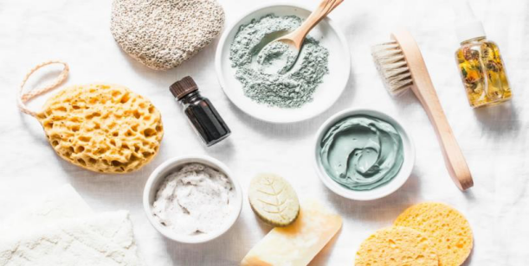
Figure 1: Natural Components Skin Care (Berry and Wilson, 2016)

Fast technology
Advanced technological accessories will be used for ensuring the best quality service. The process and services will be arranged in a manner that customers can get any information as much easy as possible and the work procedure runs smoothly (Shankararaman, 2012).

Functionality
The functionality of any beauty salon service be providing a comfort and relaxation experience to the customers along with enhancing their personal beauty and hygiene (Abrams, 2013). Also, in case of The Look, services will be customize-able as the main focus is customers’ satisfaction here, and with time the services will be upgraded to cope up with changes and demands.

Market Analysis
Market analysis is the procedure to research the current market to identify its feasibilities, pros, and cons for entering with a new business plan in the competitive industry. Firstly, the market analysis should be done to understand the customers’ demands, and how to conduct the business (Hair et al., 2019).

SWOT Analysis
The internal factors of The Look have been addressed to identify the competitive advantage and goal of marketing strategy. Here, a SWOT analysis has been conducted to identify the business’s potential strengths, weaknesses, opportunities, and threats.


Figure 2: SWOT Analysis (Malhotra et al., 2017).

Strengths
- Provides service using natural ingredients
- Formulates its own products to use
- Have a good upcoming plan to expand services for men as well
- Technology-based service (Saptura et al., 2020).
- Concentrates on different values than the competitors

Weaknesses
- Acceptability could be tough initially with the natural products
- The impact of the service through natural ingredients takes more time than chemical ones (Malhotra et al., 2017).

- Limited service initially
- Would be a bit costly comparatively for the use of natural ingredients (Saptura et al., 2020)

Opportunities
- The business plan might be a kick-start as a good market potential believe in natural substances of skincare rather than chemical ones
- With fast fashion, new trends can be introduced for expanding the service (Hair et al., 2019)
- Introducing a brand of The Look’s natural personal care products could be a chance to expand in future

Threats
- Changing customer’s demand from the beauty salon industry
- The economic impact of the pandemic can affect the people’s life standard to think of personal care as a luxury (Jarnagin, 2019)
Having a unique value proposition, The Look has quite a few options to expand the business in the future if the threats and weaknesses are dealt with effectively.

Porter’s Five factors
To define the business’s market position and potential, porter’s five forces have been conducted.
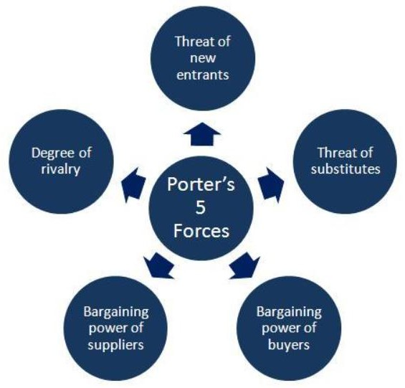

Figure 3: Porter's Five Forces (Berry and Wilson, 2016).

Bargaining Power of Suppliers: The bargaining power of the suppliers is low as The Look will be making their service products, so they will only need natural ingredients for the products.
Bargaining Power of Buyers: The bargaining power of buyers will be moderate as the beauty salon industry is quite growing (Hair et al., 2019). But the value proposition of this business is different which would be a reason for the buyers to offer more value in return for the service.
The Threats of New Entrants: The threat of new entrants is high, as people do consider beauty salons as a good start-up option but having the same value proposition might not be regular (Hair et al., 2019).
The Threats of New Substitutes: The threat of new substitutes would be moderate, as The Look will offer services with natural products. But in the UK market quality service of natural beauty care is not quite common in the current market (Jarnagin, 2019).
Competitive Rivalry: Competitive rivalry is moderate, for the different value propositions of The Look. This type of USP would be a game ahead if the business plan works out and grabs the market.

PEST Analysis
Research the outer environmental factors is important in the case of starting up a new business.
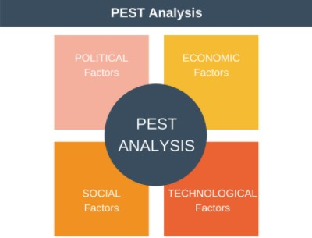

Figure 4: PEST Analysis (Abrams, 2013).

Political Factors: The UK is politically moderately stable, in 2019 it was 0.52 (United Kingdom Political stability - data, chart | TheGlobalEconomy.com, 2021). To ensure product safety the FDA is strictly followed in the country (Malhotra et al., 2017). Here, The Look has already planned to conduct the FDA research of the products they would use for the services. The Brexit can hinder the regulations and business procedure of The Look in that geographical area.
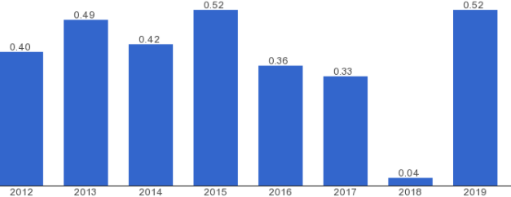

Figure 5: Political stability index of the UK (United Kingdom Political stability - data, chart | TheGlobalEconomy.com, 2021).
Economic Factors: The beauty industry is quite resistant to economic recessions. The UK has a good life standard to have a luxury life to available personal care services which is a plus point. In 2018, around 1.3% of GDP was generated by beauty industry service in the UK which is around
28.4 billion dollars (Jeon, 2018). This is an advantage for The Look to be hopeful about the business. But the tax rate is quite high in this region which might be a problematic issue for this industry.
Social factors: The UK has a good influence on fashion and sense of beauty, so the consumers of beauty care are quite consistent which is a hit for the industry (Berry and Wilson, 2016). Also, the importance of using natural ingredients has been popular in the area recently, which could be a turn for The Look.
Technological Factors: In 2020, the technological advancement of the country was in 4th position in innovation GII, it is the 4th leading technologically advanced country in the world (Saputra, 2020). Consequently, that improves the communication and service procedure in the country for The Look to function better.

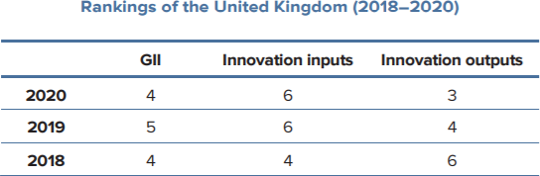

Figure 6: The UK's Rank in Global Innovation Index (Saputra, 2020).

Target Market
The Look’s target market is quite a niche, mainly young and middle-aged people as they are mostly concerned about personal beauty care. The age is between 16 to 30 for the young target market and 30 to 45 for the middle-aged people. The functions and services are customize-able for the same reason so that potential customers can find the services convenient. Also, recently the UK has a great change in the perception of beauty care which shifted the value of natural ingredients positively (Hair et al., 2019). So, a potential consumer would be that certain people who are concerned about skin but in an environment-friendly and chemical-free approach.

Market Positioning & Promotional Strategy
The market positioning of The Look is “Natural Substances for enhancing the personal beauty to make you look better”. This is the value proposition of the business, to provide chemical-free, safe, and self-made products to treat the customers while giving the utmost satisfaction and relaxation of personal care. Currently, market positioning is an important factor to draw customers’ attention to any organization making a perspective in their head (Emerald et al., 2016).
The Look has planned some promotional strategies:

- Will develop a strong online presence through all the social media
- Use digital marketing to reach the target customers
- Focus on customize-able services, and regular upgrades with time
- Promotion the salon focusing on the unique value proposition

Operations & Management
For a new business, setting up the whole plan for a business also includes the operational plan and strategies to turn the goals into achievements (Reuvid, 2011). Initially, the operations will be limited, and different customer surveys will be conducted to know the customers’ demands better. As the service will be only in one outlet so supervising will be easier. Timely slots will be divided among the workers to make the service procedure flexible and comfortable; customers will be able to know the products and the person in their assistance, and they will be able to customize the services. The R&D sector will be more focused primarily as The Look will be producing its products from scratch. Suppliers will be fixed to ensure organic and fresh materials for that. The quality of the service will be maintained to be consistent in the market through regular FDA tests.

Key Milestones & Developments
- Introducing service for the men in the next year
- Opening for outlets around the UK within 2 years of operations
- Focusing on a niche and loyal customer base
- Adding more values and facilities for the regular customers
- Making the brand international in a few years if the business works well

Conclusion
The business plan of The Look has demonstrated how to start up a beauty salon business from scratch, and what are the components that should be considered before planning anything for the business. The Look has different types of unique selling points which might be a lead to make the business more sustainable and prosperous in near future, the value proposition of natural products would be a hit if the opportunities are utilized and threats are dealt with significance. The report shows a brief overview of the business plan of “The Look” demonstrating its structure and functions, competitive edges, market proposition, operational activities, and lastly the key milestones the business is focusing on in upcoming growth.

References
Abrams, R.M. (2013). The successful business plan: secrets & strategies. The Planning Shop.

Berry, T. and Wilson, D. (2016). On Target: The Book on Marketing Plans: how to Develop and Implement a Successful Marketing Plan. Palo Alto Software, Inc.

Black, P. (2014). The beauty industry: Gender, culture, pleasure. Routledge.

Dayan, N. and Kromidas, L. eds. (2018). Formulating, packaging, and marketing of natural cosmetic products. John Wiley & Sons.

Emerald, M., Emerald, A., Emerald, L. and Kumar, V. (2016). Perspective of natural products in skincare. Pharm Pharmacol Int J, 4(3), p.00072.

Hair Jr, J.F., Bush, R.P. and Ortinau, D.J. (2019). Marketing research. McGraw-Hill/Irwin.

Hatten, T.S. and Hatten, T.S. (2015). Small business management: Entrepreneurship and beyond (p. 528). Boston: Houghton Mifflin.

Jarnagin, R.A. (2019). BEAUTY SALON ESTABLISHMENT IN THE TWENTY-FIRST CENTURY.

Jeon, H. (2018). The effect of experiential marketing on customer satisfaction and revisit intention of beauty salon franchise stores. Journal of Fashion Business, 17(3), pp.109-121.

Malhotra, N.K., Nunan, D. and Birks, D.F. (2017). Marketing research: An applied approach. Pearson Education Limited.

Reuvid, J. (2011). Start Up and Run Your Own Business: The Essential Guide to Planning Funding and Growing Your New Enterprise. Kogan Page Publishers.

Saputra, V., Eng, K.I., Purnama, J. and Galinium, M. (2020) September. Business Analysis and Design of Online Marketplace for Beauty Care Services. In Proceedings of the International Conference on Engineering and Information Technology for Sustainable Industry (pp. 1-6).

Shankararaman, V. ed. (2012). Business Enterprise, Process, and Technology Management: Models and Applications: Models and Applications. IGI Global.
TheGlobalEconomy.com. 2021. United Kingdom Political stability - data, chart | TheGlobalEconomy.com. [online] Available at: <https://www.theglobaleconomy.com/United- Kingdom/wb_political_stability/> [Accessed 13 July 2021].

