Student Name
Student Number
Module Title: BMBM6012 – Leading and Developing People
Essay Title

Overview of the Chosen Leader (Aliko Dangote)
Early Life, Education, and Career Beginnings
Aliko Dangote was born on 10 April 1957 in Kano, northern Nigeria, into a family with a long-standing commercial heritage (XXXXXXXXX). Growing up in an environment where trading and enterprise were integral to daily life exposed him early to the dynamics of commerce and entrepreneurship (XXXXXXXXX). This formative context played a significant role in shaping the entrepreneurial orientation that would later underpin one of the most influential business careers in Africa.
Dangote pursued higher education at Al-Azhar University, where he obtained a degree in Business Management (XXXXXXXXX). His formal education, combined with early practical exposure to trading, provided the managerial skills and strategic perspective that later supported his large-scale industrial ventures. Over time, Dangote has become one of the most prominent entrepreneurs in Africa. According to Forbes rankings, he consistently appears among the world’s wealthiest individuals. By 2026, he was listed as the 91st richest person globally, with a net worth exceeding $30 billion (XXXXXXXXX).
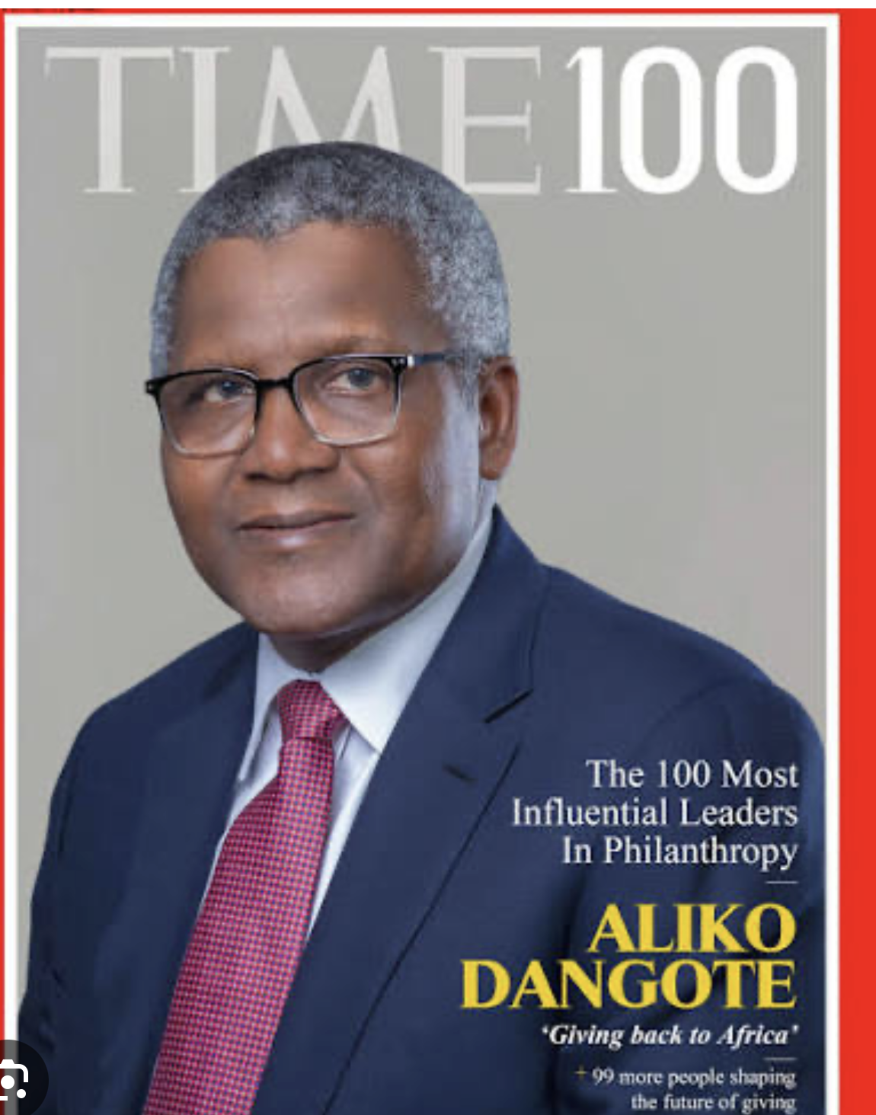
https://www.google.com/imgres?imgurl=https
Dangote’s entrepreneurial journey began in 1977 with small-scale trading activities focused on commodities such as sugar, salt, and other essential food products (XXXXXXXXX). During the 1980s, he expanded these operations and formally established the Dangote Group, which evolved into one of Africa’s largest industrial conglomerates. As part of his early ventures, he also founded Blue Star Services.
Recognising the rapid expansion of Nigeria’s construction and real estate sectors, Dangote identified cement as a strategically important commodity with strong domestic demand (XXXXXXXXXX). His initial involvement in cement importation later transitioned into local production. In the early 1990s, he established his first cement manufacturing plant, marking a pivotal shift from trading to large-scale industrial manufacturing (XXXXXXXXXX). This strategic move significantly reduced Nigeria’s reliance on imported cement and strengthened the company’s dominance within regional markets.
Between 2023 and 2024, Dangote commissioned the Dangote Refinery in Lagos to address Nigeria’s long-standing dependence on imported refined petroleum products (XXXXXXXXXX). With a refining capacity of approximately 650,000 barrels of crude oil per day, the project represents one of the largest industrial developments on the African continent (XXXXXXXXX). This project is aimed at enhancing national energy self-sufficiency while strengthening Nigeria’s position within global petroleum markets.

Leadership Trajectory, Strategic Milestones, Contemporary Role, and Institutional Impact
Aliko Dangote, founder and Chairman of the Dangote Group, remains one of the most influential industrial leaders in Africa. The conglomerate ranks among the largest in the region and is widely recognised as one of the biggest private-sector employers in West Africa (XXXXXXXXXX). As of early 2025, Dangote was again ranked the wealthiest individual in Africa and has frequently been identified as the richest Black person globally.
His leadership trajectory is characterised by a sustained commitment to industrialisation, economic diversification, and long-term capital investment. Managing a conglomerate of this scale requires disciplined governance, strategic foresight, and organisational cohesion (XXXXXXXXX). Under his direction, the Dangote Group has expanded operations to more than ten African countries, contributing to job creation, infrastructure development, and regional economic growth.
Beyond industrial expansion, Dangote is widely recognised for philanthropic engagement. His collaboration with the Bill & Melinda Gates Foundation has supported major public-health initiatives, particularly immunisation programmes across Africa (XXXXXXXXX). This demonstrates a commitment to social investment alongside commercial growth.
A statement often attributed to Dangote, “We do not keep money in the bank; we fully invest whatever we have and continue investing”, captures his reinvestment philosophy and growth-oriented mindset (XXXXXXXXX). This approach aligns with contemporary theories of entrepreneurial leadership that emphasise strategic orientation, opportunity recognition, innovation, and proactive decision-making. His career reflects these principles through sustained expansion, vertical integration, and the delivery of large-scale industrial projects.
Leadership at this level also depends on robust corporate governance. Dangote’s enterprises operate through formal boards of directors and professional management teams that support strategic decision-making, risk management, and regulatory compliance (XXXXXXXXX). These governance structures strengthen accountability, enhance stakeholder engagement, and promote long-term organisational sustainability (XXXXXXXXX).
Furthermore, his leadership style reflects elements of transformational leadership. By articulating a compelling long-term vision, investing in major infrastructure, and prioritising operational excellence, he has influenced organisational culture and workforce commitment (XXXXXXXXXX). His emphasis on efficiency, responsibility, and performance accountability demonstrates a leadership model that combines strategic ambition with institutional discipline.
Overall, Dangote’s trajectory illustrates how visionary leadership, supported by structured governance and sustained investment, can drive corporate growth while contributing to national and continental development.

Leadership Analysis

According to XXXXX, leadership theories seek to explore why certain individuals emerge as effective leaders. These theories examine the characteristics, behaviours, and cognitive patterns that distinguish influential leaders (XXXXXXXX). While also identifying qualities that can be cultivated to enhance leadership capability. By analysing such frameworks in relation to Aliko Dangote as a case study, a psychological and theoretical perspective can be developed to assess whether leadership is primarily innate or acquired through experience and environmental influence (XXXXXXXXX).

In Dangote’s case, his early exposure to commerce, having been born into an entrepreneurial family, suggests that environmental factors may have played a formative role in shaping his leadership orientation (XXXXXXXXXX). This aligns with broader scholarly debates concerning the interaction between inherited traits and learned behaviours in leadership development.

Over the past century, extensive research has been undertaken to understand the psychological foundations of leadership. These studies have attracted the attention of psychologists and management. Scholars who have sought to identify recurring patterns among presidents, industrial magnates, innovators, and chief executive officers. Trait-based approaches, in particular, attempt to isolate personal attributes that appear consistently among high-performing leaders (XXXXXXXXXX).

According to XXXX, prominent leaders often display qualities such as charisma, confidence, intellectual capacity, emotional intelligence, and advanced social skills. These attributes are believed to strengthen ambition, strategic thinking, and the capacity to inspire others (XXXXXXXXX). However, contemporary scholarship increasingly recognises that while certain predispositions may facilitate leadership emergence, effective leadership is also shaped by learning, situational demands, and sustained professional development.

Thus, leadership theory provides a structured lens through which figures such as Dangote can be analysed. By integrating psychological insight with practical observation to better understand the foundations of enduring leadership success.

Leadership Theories
The Great Man Theory has long suggested that some individuals are naturally destined to become leaders (XXXXXXXXX). This perspective argues that leadership ability originates from innate personal qualities that can be recognised from a very early age, sometimes even from infancy. Historically, this theory has been strongly linked with influential political figures and military commanders, where leadership is often portrayed as heroic, mythic, or divinely destined (XXXXXXXXXX). Within this view, leadership is not seen as something that can be learned through training or development, but rather as a natural gift possessed by a limited number of people.
Closely related to this perspective is Trait Theory, which also emphasises the importance of personal characteristics in leadership development. However, Trait Theory adopts a more structured approach by identifying particular qualities such as self-confidence, courage, resilience, decisiveness, and emotional stability (XXXXXXXXXX). These attributes may be influenced by early role models and social environments and gradually develop into leadership capability. Although many individuals may demonstrate some of these characteristics, effective leadership depends on how strongly these traits are developed and how well they are applied within organisational settings.
In contrast, Contingency Theories emphasise that leadership effectiveness depends largely on the surrounding environment and situational factors. This approach argues that there is no single leadership style that works in all circumstances (XXXXXXXXXXX). Instead, successful leadership emerges from the interaction between personal characteristics and the context in which leadership occurs. In the case of Aliko Dangote, his upbringing within a family of entrepreneurs can be viewed as a significant environmental influence that shaped his business mindset and strategic thinking (XXXXXXXXXX). According to White & Hodgson XXXXX, effective leadership involves balancing behaviour, context, and organisational needs. Leaders are most successful when they understand their followers, provide motivation, and create opportunities for growth and achievement.
Similarly, Situational Theories propose that leadership develops through experience and the ability to respond appropriately to changing circumstances. Leaders may emerge because of their practical knowledge and their ability to adapt to different challenges (XXXXXXXXXX). This perspective highlights leadership as a flexible and evolving process rather than a fixed personal attribute.
Behavioural Theories move the focus away from natural traits and instead concentrate on observable actions. From this viewpoint, leadership is not simply inherited but can be learned through education, training, and experience (XXXXXXXXX). Communication style, decision-making, and interpersonal skills are therefore seen as essential elements of leadership effectiveness.
Participative theories, often associated with democratic leadership, highlight the importance of involving team members in decision-making (XXXXXXXX). Leaders who adopt this approach encourage participation and value contributions from others, which can strengthen commitment, accountability, and team performance.
Management Theories, also known as transactional leadership theories, emphasise supervision, structure, and reward systems (XXXXXXXXX). Leadership within this framework focuses on performance management, where employees are motivated through incentives and clearly defined expectations to achieve organisational goals. Finally, Relationship Theories, frequently linked to transformational leadership, emphasise the connection between leaders and followers (XXXXXXXXXX). These theories highlight the role of inspiration, trust, and motivation in improving individual and organisational performance. Transformational leaders encourage growth, promote shared vision, and inspire followers to exceed expectations.
Overall, these leadership theories demonstrate that leadership cannot be explained by a single perspective. Instead, leadership is best understood as a combination of personal traits, learned behaviours, environmental influences, and strong relationships between leaders and followers.

Operating Environment and Megatrends Affecting Dangote

The operating environment of the Dangote Group is undergoing rapid transformation as the Dangote Refinery strengthens its strategic position from 2025 onward (XXXXXXXXX). As a diversified industrial conglomerate active across multiple African markets, the Group is firmly established in manufacturing, cement production, and petroleum refining. With a refining capacity of 650,000 barrels of petroleum products per day, the refinery stands among the largest single-train facilities globally and represents a major milestone in the industrial development of Nigeria (XXXXXXXXXX).

This expansion, however, has brought complex challenges. The scale and influence of operations have increased regulatory scrutiny, compliance obligations, and negotiation pressures within Nigeria’s petroleum sector (XXXXXXXXXX). Although the refinery is expected to generate significant foreign-exchange savings and contribute meaningfully to national economic strategy. The tensions persist among domestic regulators, international oil markets, and local producers (XXXXXXXX). These pressures are intensified by broader macroeconomic instability, including continued Naira depreciation.

Historically, petroleum imports accounted for approximately 2–3% of Nigeria’s total imports, but volatility in global oil prices and foreign-exchange shortages has elevated the strategic importance of domestic refining (XXXXXXXXX). Over the long term, the refinery is expected to reduce dependence on imported refined products while easing pressure on foreign-exchange demand.

Key Megatrends Affecting Dangote

Several major structural megatrends are shaping the Group’s future trajectory. First, Africa is experiencing a strong shift away from import dependence toward domestic industrial production. This trend aligns with Dangote’s ambition to support revenue generation targets projected to exceed $100 billion by 2030, positioning the Group as a key driver of African industrialisation (XXXXXXXXXX).

Second, the global transition toward net-zero emissions presents both opportunities and risks. Africa’s rapidly growing population is increasing demand for infrastructure, particularly cement and construction materials (XXXXXXXXXX). Dangote’s dominant presence across West and Central Africa provides a strong competitive advantage to meet this demand. Nevertheless, global decarbonisation pressures continue to intensify.

The proposed 5% Carbon Tax (CAT) framework suggests potential annual emissions reductions of 0.23%–0.36%, highlighting the growing use of fiscal and regulatory tools to lower carbon output (XXXXXXXXX). This trend reflects increasing expectations for large industrial organisations to integrate renewable energy, strengthen carbon reporting, and gradually transition away from carbon-intensive production models.

Dangote’s vertical integration strategy, controlling cement, manufacturing inputs, and refining operations, enhances supply-chain efficiency and market influence (XXXXXXXXX). However, it may also increase competitive tensions and exposure to evolving global sustainability regulations.

Overall, Dangote operates within a high-growth yet high-pressure environment characterised by industrial expansion, macroeconomic volatility, regulatory oversight, and accelerating decarbonisation (XXXXXXXXXX). Long-term resilience will depend on the Group’s ability to balance large-scale industrial growth with adaptive strategies aligned to the global shift toward a lower-carbon economy.

Innovation and Adaptation of Dangote

Critical Evaluation of Leadership Effectiveness
- Strengths of leadership approach
- Weaknesses and criticisms
- Balanced academic evaluation

8. Conclusion
- Summary of key findings
- Best fitting leadership approaches
- Final evaluation of effectiveness

9. References
- Harvard referencing
- Minimum 20 sources

