‘…and the Truth Will Set You Free’ (John 8:32)
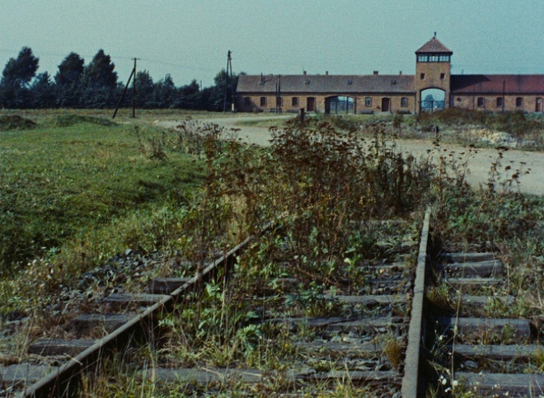
Auschwitz-Birkenau Concentration Camp Night and Fog, 1956; Alain Resnais

Simon Howlett
Student Number: 1803426
Adventure Documentary: Theory (HPMF7002)
3284 Words


University of Wales Trinity Saint David
Film and Video
Carmarthen

‘…and the Truth Will Set You Free’ (John 8:32)
This essay examines the ways that filmmakers have used actual events as the basis for artistic construction including the ways in which the fiction film and news broadcasting media has influenced, and has been influenced by documentary. It starts with a discussion of some general principles of documentary theory before proceeding to the distinct and often juxtaposed functional relationships to documentaries as perceived by the interested parties involved in their production; the film-maker, its audience and those that facilitate its production. The essay will go on to examine the role of the documentary as a ‘truth constructor’ within the social engineering and propaganda frameworks of oligarchical systems through their provision of a mechanism for the building and re-enforcing the presented interpretation of actual event as truth.

Aufderheide defines documentaries as
‘…about real life; they are not real life. They are not even windows onto real life. They are portraits of real life, using real life as their raw material, constructed by the artists and technicians who make myriad decisions about what story to tell, and for what purpose’

Within the field of documentary filmmaking, from Lumière to Herzog, artistic expression and technical innovation, has developed, flourished and been rightly celebrated. It has influenced enormously cultural, social and political movements although it may be argued that ultimately its methods, techniques, styles and innovations have always been subsumed into the greater overarching messaging construct of those individuals and organisations that finance governments, wars, inventions and even art.

Due to its perceived portrayal of truth and the authority that this gives it, the role of the documentary has often resulted in serving the dominant ideology whether it has intended to or not.

The documentary filmmaker has an implied contract with their audience who believe that the film they are watching is the truth as understood by that filmmaker.

As Aufderheide observes;

“Audience expectations are also built on prior experience; viewers expect not to be tricked and lied to. We expect to be told things about the real world, things that are true”.

Clarifying further she identified the responsibility of the filmmaker regarding the messaging their work transmits;

“The truthfulness, accuracy, and trustworthiness of documentaries are important to us all because we value them precisely and uniquely for these qualities. When documentaries deceive us, they are not just deceiving viewers but members of the public who might act upon knowledge gleaned for the film.”

When the viewer watches a documentary, they have made a choice to invest trust and they expect that they will be informed by its content, not deceived by it. One may not agree with all the views contained in the documentary but there is an implicit understanding that the film is an authentic representation of the actual events. This places a responsibility upon the filmmaker, part of the contract secured through the viewer’s investment of trust, to inform and not mislead, to challenge but not manipulate, to offer considered perspectives to further inform social debate.

This impartial dissemination of information provides the necessary counter-weight to the self-perpetuating objectives of the establishment. However, it is argued that the contract made between the documentary filmmaker and the audience has rarely been honoured. This allowance of their art to become a vehicle of propaganda and statecraft may not be a deliberate betrayal by the filmmaker, but it is a betrayal nonetheless.

Aufderheide continues that documentaries “are part of the media that help us understand not only our world but our role in it, that shape us as public actors.

Throughout the history of filmmaking this has been well understand by oligarchical systems. In 1894, Doublier filmed Russian police charging an enormous crush of people preparing for the presentation of newly crowned Tsar Nicholas II. The subsequent confiscating of his rolls of film by the authorities testifies to this.

Although most documentary filmmakers will not see themselves as active agents of the state this is not always the case. Certain filmmakers have actively set out to use their talents on behalf of the establishment to influence the audience that they “might act upon knowledge gleaned from the film”, such as Riefenstahl’s film Triumph of Will, 1935, Ford’s Battle of Midway, 1942, Boulting’s Desert Victory, 1943.

That a documentary filmmaker wants to influence and persuade their audience is undeniable. However, these documentaries are examples of where the director has allowed themselves to become part of the establishment’s propaganda programme aimed at shaping and reinforcing its agenda.

As Aufderheide points out about documentaries where “Their makers manipulate and distort reality like all filmmakers, but still make claim for making a truthful representation of reality”.

Huston’s film The Battle of San Pietro, 1945 is commonly regarded as a documentary however on closer examination this does not appear to be the case. Depicting the Allied attack against the German army occupation of the Italian medieval town of San Pietro toward the end of the Second World War his production approach consisted of the reconstruction of the entire battle using the surviving troops as actors. In so doing he has taken the film out of the genre of documentary and into that of war movie.

While he does use imagery of ‘actual’ events; the children of San Pietro helping to dig the graves of fallen US soldiers after the battle, or a US soldier preparing grave markers by hammering dog tags to the grave posts, these make up a small part of the film. They merely provide the introduction and conclusion to the main body of the film made up of re-enacted battle scenes.

Documentary makers contriving situations to allow them to present their desired narrative is not unusual. Flaterty’s Nanook of the North, 1922 is an early example of a director orchestrating a situation, namely the film’s famous seal hunt, for the good of the film’s narrative. Flaherty engaged the Inuit tribe to carry out a traditional hunt using obsolete methods and techniques. By doing so he creates an engaging filmic experience for the audience as well as documenting the tribe’s traditional hunting practise for posterity.

Unlike the manufactured battle scenes of the The Battle of San Pietro, Flaherty captured an ‘actual event’ with all its inherent risks and uncertainties and not benign re-enactments presented as fact.

So why have certain documentaries remained relevant?

Is it merely that they are exemplars within their disciple, revered as pinnacles of the art form. This is certainly true of Flaherty’s Nanook of the North, whose camera composition, editing and visual story telling is as contemporary today as it was ground breaking in 1922. Likewise, Ford’s application of fiction film visual narrative conventions in the Battle of Midway, such as the victorious advancing US forces, are depicted moving from the left of the screen to the right. Almost as though from Pearl Harbour to Tokyo. A convention also utilised by Huston in The Battle of San Pietro.

However, to ensure access to an audience a film must also serve the aims and objects of those who commissioned, financed or distributed them. This has meant that if the filmmaker does not comply with these interests, regardless of their reputation, this access is curtailed, be it through funding, broadcast scheduling or distribution.

Again Huston offers a useful example through his film Let There Be Light, 1946. A more traditionally constructed documentary, it offers an uncompressing assessment of the effects of warfare upon the human psyche. However, the inconvenience of its message to the US Military and US Government meant that the film remained unreleased until December 1980.

When it was finally release the prints were of such poor quality that it was very difficult to view it. It was not until 66 years later, in May 2012, that a restored copy was produced and finally made available to the public.

Similarly, Ophüls’s documentary The Sorrow and the Pity, 1969 exploring the French Vichy government collaboration with the occupying forces of Nazi Germany between 1940 to 1944, due again to the inconvenience caused to the French establishment was banned from French television until 1981.

The broadcast structures of the mass media are used as propaganda tools to programme and condition rather than inform the general public, that is, to control behaviour and instil belief. This justifies the massive expenditure resources to maintain mass communication frameworks.

Herman and Chomsky articulate this;

“mass media serve as a system for communicating messages and symbols to the general populace. It is their function to amuse, entertain, and inform, and to inculcate individuals with the values, beliefs, and codes of behaviour that will integrate them into the institutional structures of the larger society. In a world of concentrated wealth and major conflicts of class interest, to fulfil this role requires systematic propaganda.”

This has been used overtly such as in cases of Riefenstahl’s Triumph of the Will, 1935, a highly stylised depiction of the pomp, theatre and ritual of the the Nazi Third Reich. Likewise, The Battle of San Pietro in which Huston uses the same piece of footage to begin and end the film. Firstly, depicting the destruction of the town and the destitution of the local inhabitants after the battle. Then using the same footage again at the end of the movie depicting the efforts of the local population to rebuild the town with the support of the American troops (Fig.1).

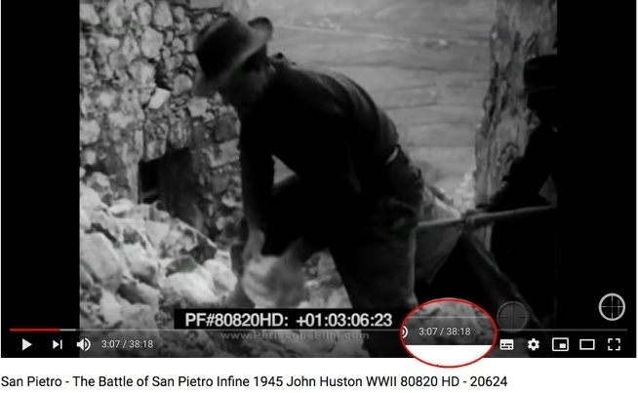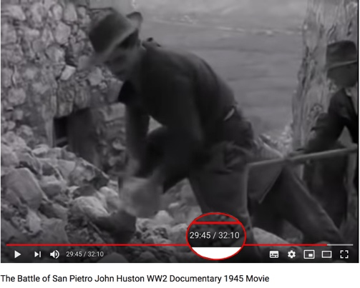

Fig.1 The same shot used at different points in various edits of Huston’s Battle of San Pietro

So why is a film like Eisentain’s Battleship Potemkin, 1925 not a documentary?

Comparing Ford’s Battle of Midway with Huston’s The Battle of San Pietro, while Ford’s film can be considered as a documentary, Huston film is a re-enactment and directed interpretation of the events of the battle. Thus, a serious ethical issue arises due to the events at San Pietro being presented as actual. Both films employ the same visual devices, transplanted from the fiction film, to convey the narrative to the audience. However, despite Huston’s use of the soldiers that took part in the battle, since they are participating in a staged re-enactment, they are fulfilling the role of ‘actors’.

Documentaries may utilise re-enactment while making it clear through a voice-over or some other device that the depicted events have been dramatized. In The Battle of San Pietro Huston makes no attempt to do so.

Thus according to this criteria, either Battleship Potemkin is also a documentary or The Battle of San Pietro is not.

A clear illustration of this continual reframing of history, by the prevailing dominant ideology, can be seen through the re-contextualisation of the footage from Riefenstah’s 1936 film Olympia, 1936, featuring the gold medal performance of the US Afro-Caribbean athlete Jesse Owens.

These sections of Riefenstah film have been repeatedly presented to support the narrative that Adolf Hitler refused to acknowledge Jesse Owens after his Olympic victories at the 1936 Munich Games because of his race and the contradiction his success posed to the validity of the white supremacist Nazi ideology. However, according to the Olympic historian Uyoe and Jesse Owens himself the reality was quite different;

“Surprisingly, Owens claims it was actually US President Franklin Roosevelt who failed to acknowledge his achievements, saying “Hitler didn’t snub me — it was our President who snubbed me. The President didn’t even send me a telegram. Hitler was the man of the hour.” Hearing this from Owens was shocking to say the least.”

Walter Benjamin’s concept; “History is written by the victors” certain rings true in this example.

Another consequence of the artistry of directors such as Boulting, Ophüls, Ford, the Maysles brothers & Zwerin, is that they have provided the prototypes for the news broadcasts to copy and so effectively carry out their function of social programming. These artist have been key architects in the manufacturers of Orwell’s ‘double think’; President’s Trump’s ‘fake news’ or as defined by the American Heritage Dictionary, 4thEdition; ‘brainwashing’.

“TV channel France3 has “fixed” a placard held by a Yellow Vest protester, which urged President Emmanuel Macron to resign. The broadcaster explained that the sign was broadcast reading just Macron, due to a “human error.” (Fig. 2)
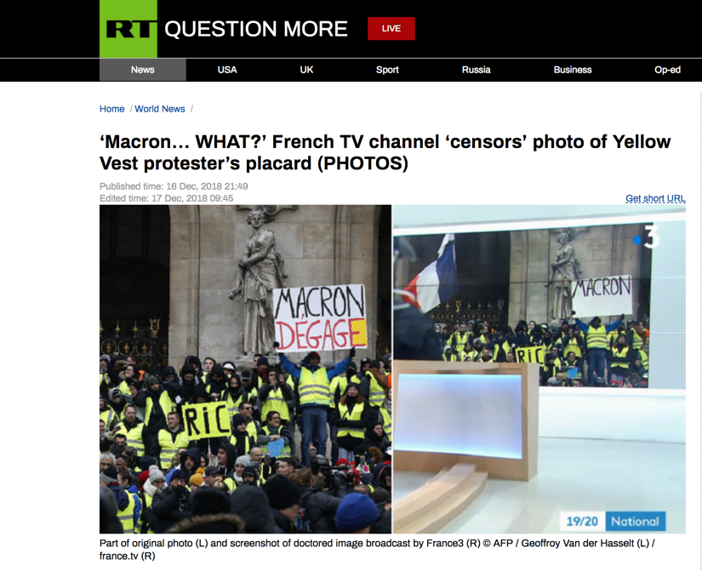
Fig. 2 RT.com reports on French TV France3 manipulation of an image, due to “human error” used during news reports of the 2018 ‘Yellow Vest’ anti-government protests in France

These documentary visualisations and editing templates are often drawn upon within movies and television fictional story telling where the director wishes to transmit the sense of ‘actual events’ taking place. Most notably in political dramas such as Wag the Dog, 1997, Snowden, 2016, The West Wing, 1999-2006, The Good Wife, 2009-2016 and the political and battle sequences in Battlestar Galactica, 2004-2009.

In recent years this form of cinematic social manipulation has become more subtle as can been seen in the work of Moore. Within his films he presents himself as an advocate of ‘the People’ presents various alleged social injustices, such as the unregulated sell of firearms to minors in Bowling for Columbine, 2002; or Fahrenheit 9/11, 2004 where he explores the apparent corruption, electoral rigging and manipulation of the events of Twin Tower attack on September 11th 2001 in New York that lead to the Bush/Cheney doctrine of ‘The Global War on Terrorism’ or ‘War on Terror’.

Released a few months before the 2004 US Presidential election, with the aim to discredit the Bush administration and prevent the securing of a second term, its objective failed. However, the Fahrenheit 9/11 was a box office success, critically acclaimed and remains widely promoted. It has also established Moore as a sought-after voice of opposition by the mainstream news companies; and so have the objectives of the film succeeded?

In the end it all depends on which objectives one is concerned with.

Even when the artist’s intention has been to expose the machinations of the established order, in the end, these efforts have merely served to allow the underlying agenda to continue undisturbed. In fact, these agendas are often strengthened through the embracing of the innovation provided by the creative expression of the artist.

Contemporary documentary film-makers, such as Moore, continue to draw on the techniques and styles of the past however increasingly place themselves more overtly forward and centre of their work. In doing so they become active participants in the creation of an ‘actual event’ rather than the documenter of them. This being so Moore’s work and that of other similar film-makers like Spurlock may be regarded not as documentaries but visual essays exploring their personal beliefs or perspectives.

Throughout Fahrenheit 9/11 Moore employs the narrative technique used by Resnais in Night and Fog, 1954, of interlacing contemporary footage with archive footage supported by emotive music to reinforce the voice over narration.

However, unlike the voice-over in Night and Fog, where it sets out the ideological position of the film’s premise, Moore’s narration in Fahrenheit 9/11 is presented in a personalised style more along the lines of self-reflection and entertainment than investigation.

This underlying strategy of Moore’s movie; to emotionally engage his audience through identifying with his apparent indignant internal monologue prevents his audience arriving at an independent conclusion based of presented evidence.

In this way his films are acting as a social safety valve for the prevailing geo-political system through the seemingly mainstream expression of an opposing viewpoint. However Moore’s films fail to actually offer an alternative option, controversial evidence or even proposing possible solutions to the issues he cites.

This is well articulated by Herman and Chomsky;

“The beauty of the system, however, is that such dissent and inconvenient information are kept within bounds and at the margins, so that while their presence shows that the system is not monolithic, they are not large enough to interfere unduly with the domination of the official agenda.”

In Fahrenheit 9/11 this is illustrated through Moore’s choice of interviewees and how he manages their stories. When interviewing decorated Marine Lance Corporal Abdul Henderson, Moore first introduces the Lance Corporal to the audience in a very tradition ‘talking head shot’ where his expresses his reasoning for his decision to disobey any future orders to return to Iraq.

Moore then cuts to archive footage of the then Governor of Texas, George W. Bush, [Fig. 3] making jokes during an after diner speech to the “haves and have mores” referring to them as those who “some refers to as the elite but I call my base”, inferring the president’s disconnection to the ordinary American people. The footage is presented without captions and so no context is provided. This gives the implication that the speech was given while Bush was president and not as a governor.

Moore has also cropped into the clip to remove the event’s name on the podium as well as the original screen captions from the Campaign 2000 CSPAN broadcast. To do this has taken significant effort since in the original shot the camera is slowly zooming into Bush as he is speaking while the footage that appears in the film is fixed and stable. [Fig. 4]

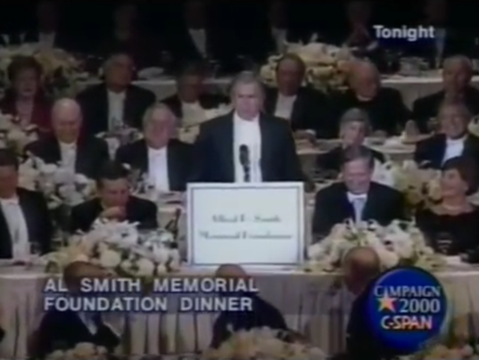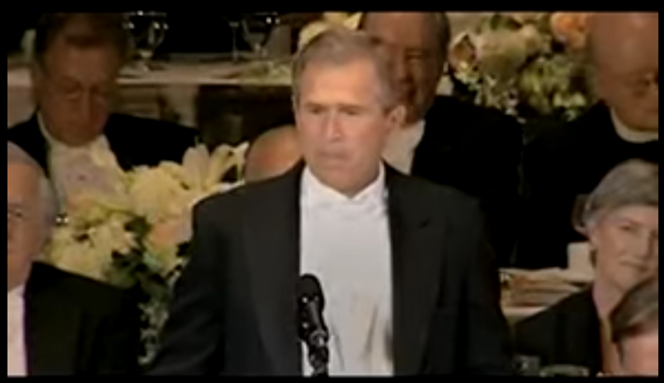
Fig. 4 George W. Bush speech; Fahrenheit 9/11, 2004
Fig. 3 Governor George W. Bush 55th Annual Al Smith Speech; original Campaign 2000 CSPAN broadcast, 2004

This sequence then cuts to Moore walking on the streets outside the United States Capital Building with the Lance Corporal. Again in the form of an internal dialogue his voice over explains that they are there to confront US Senators to encourage them to enlist their children in the US Military. However, except for the initial establishing shots of the sequence, the camera and so the point of focus remains on Moore himself. This remains the case for the rest of this sequence to the obvious exclusion of the Lance Corporal, the person Moore purportedly wants to advocate for.

By playing this role Moore fulfils the role of the permitted social rebel without ever challenging the status quo and fills any airtime that may have otherwise have been available to those actually investigating into the misinformation, abuse of power and corruption that surrounds the collapse of the Twin Towers and it subsequent use as justification for the US-led and NATO-backed War of Terror. In this way, more challenging and potentially damaging investigations and evidence remain relegated to to realms of ‘fridge media’ and tabloids.

Even when a filmmaker of high standing and reputation, such as Aaron Russo, the producer of films such Trading Places, 1983 and Wise Guys, 1986, makes a film of a challenging and inconvenient nature; such as his film America: Freedom to Fascism, 2006 they inevitably suffer the same fate.

While using a similar narrative and presentation style as Moore, Russo’s documentary is arguably better executed. Its focus is the investigation of the actual legal status of the US Internal Revenue Service, whether Americans citizens are actually required to pay an income tax and the apparent systematic erosion of civil liberties implemented by the banking elite of the early 19th century as well as those subsequently proliferated by the US government.

Interestingly, Moore’s Fahrenheit 9/11 has received enormous promotion and distribution support; Russo’s America: Freedom to Fascism did not.

Whose movie is more useful to the ‘system’? (Fig. 3)
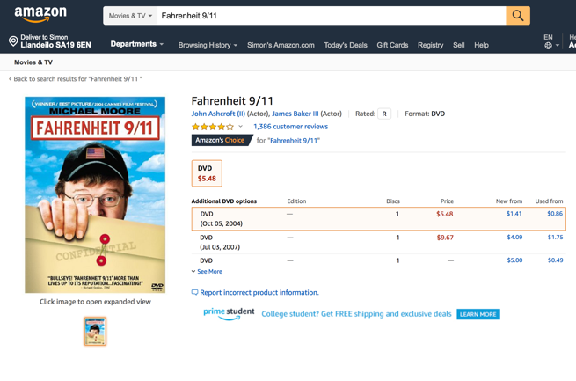
Fig. 3 Michael Moor’s is Fahrenheit 9/11 available on Amazon.com at $5.48 while Aaron Russo’s America: Freedom to Fascism is also available but priced $40.50

In the end, these ‘portraits of real life’ have always been but one cog in the machine of social manipulation however, now the line between documentary and fiction film-making is very blurred. It is now possible to apply Aufderheide’s definition of a documentary to news programming, feature films, television dramas or an internet vblog.

While the media jobbing artisans maintain the status quo by imitating the innovations of the social rebel artists, these are elevated to the role of celebrity and so neutralised.

Thus the most critical and rebellious artists eventually become another instrument of the mainstream media machine and so of the establishment they had often set out to critique, expose, confront or bring down.

Here are some examples for consideration and reflection; Artic Monkeys, Cold Play, Beatles, Rolling Stones, Lady Gaga, Beyoncé, Picasso, Banksy, Jean-Luc Godard, François Truffaut, Stanley Kubrick, Olive Stone, Greenpeace, Live Aid,…

Incidentally, the film was reshot using professional actors in 1948 under the name Shades of Gray, 1948 but without Huston’s involvement.
In 2004 only one of the then 100 sitting senators had a child serving in the armed forces.
Organisation such as Architects & Engineers for 9/11 Truth (https://www.ae911truth.org) have campaigned for many years for an official review of the available scientific evidence which points to the destruction of the Twin Tower not being due to impact of planes and the subsequent fires but ‘controlled demolition’ techniques. This along with the unacknowledged fact that even though the attack on the World Trade Centre was apparently carried out by two aircraft somehow three building collapse (the Twin Towers and the World Trade Centre Building 7 – (Architects and Engineers: Solving the Mystery of Building 7 - w/ Ed Asner. 2015 - https://www.youtube.com/watch?v=_nyogTsrsgI); or that, as reported at the time by CNN (CNN Breaking News Report with CNN correspondent Jamie McIntyre - https://www.youtube.com/watch?v=1y36S_W92XI [02:53]) from the site of the 9/11 attack on the Pentagon, no plane wreckage was recovered and that there is no evidence of damage to the building where the wings of the aircraft would have had to have entered. (September 11 9/11 No plane hit the Pentagon 9/11. Here is the proof. By HeshamTillawi https://www.youtube.com/watch?v=zdAgkr5HiMo [8:18]; ‘Huge MISSILE hit the Pentagon on September 11’ Army General’s EXPLOSIVE claim resurfaces, Daily Star, 9th January 2017 - https://www.dailystar.co.uk/news/latest-news/576464/september-11-attacks-missile-hit-pentagon-army-general-Albert-Stubblebine-conspiracy)
Documentary Film – A Very Short Induction; Aufderheide, Patricia. New York: Oxford University Press. 2007, p.2
ibid. p.3
ibid. p4
ibid. p.4
Documentary; a history of non-fiction film; Erik Barnouw. New York: Oxford University Press 1993 p.14
Documentary Film – A Very Short Induction; Aufderheide, Patricia. New York: Oxford University Press. 2007, p.10
Let There Be Light (1946) and Its Restoration; Scott Simmon; National Film Preservation Foundation, Programme Notes May 2012 - https://www.filmpreservation.org/userfiles/image/PDFs/LetThereBeLight_ProgramNote.pdf
ibid.p.1
Jesse Owens vs. Adolf Hitler: What Really Happened in Berlin, 1936 - IdyUyoehttps://medium.com/@idysports/jesse-owens-vs-adolf-hitler-what-really-happened-in-berlin-1936-f4f96f305947&https://www.youtube.com/watch?v=Kbc79rz1o5k
Theses on the Philosophy of History, 1940 - Walter Benjamin
“Brainwashing: n. Intensive, forcible indoctrination, usually political or religious, aimed at destroying a person's basic convictions and attitudes and replacing them with an alternative set of fixed beliefs. n. The application of a concentrated means of persuasion, such as an advertising campaign or repeated suggestion, in order to develop a specific belief or motivation.”; The American Heritage Dictionary, 4th EditionBoston: Houghton Mifflin Company 2006
‘Macron… WHAT?’ French TV channel ‘censors’ photo of Yellow Vest protester’s placard– RT.com - Published time: 16 Dec, 2018 21:49 Edited time: 17 Dec, 2018 09:45 - https://www.rt.com/news/446613-france3-macron-yellow-vests/
The Constitution of the United States - https://www.archives.gov/founding-docs/constitution
The Global War on Terrorism: The First 100 Days; 2001-2009 Archive for the U.S. Department of State - https://2001-2009.state.gov/s/ct/rls/wh/6947.htm
War on Terror; Wikipedia https://en.wikipedia.org/wiki/War_on_Terror
Manufacturing Consent; Herman, Edward S.; Chomsky, Noam. New York: Pantheon Books. 2002, p.xii
Governor George W. Bush - 55th Annual Al Smith Memorial Foundation Dinner Speech - Fahrenheit 9/11, 2004 - https://www.youtube.com/watch?v=Te5847t3CU0 [00:41]
Governor George W. Bush 55th Annual Al Smith Speech– Original Campaign 2000 CSPAN broadcast footage of 55th Annual Al Smith Memorial Foundation Dinner, 2000 – https://www.youtube.com/watch?v=Te5847t3CU0[02:36]
America: Freedom to Fascism, 2006 - Aaron Russo https://www.youtube.com/watch?v=O6ayb02bwp0
Documentary Film – A Very Short Induction; Aufderheide, Patricia. New York: Oxford University Press. 2007, p.2 Bibliography America: Freedom to Fascism, 2006 [Russo, Aaron] Battlestar Galactica, 2004-2009 [BSkyB) Blue Planet II, 2017–2018 [BBC] Camera Lucida : Reflections on Photography, Bartes, Roland. New York: Hill and Wang. 1980 Cave of Forgotten Dreams, 2017 [Herzog, Werner] Chronicle of a Summer (Chronique d'un été), 1961 [Morin, Edgar & Rouch, Jean] Department of State - https://2001-2009.state.gov/s/ct/rls/wh/6947.htm Desert Victory, 1943 [Boulting, Roy] Documentary Film – A Very Short Induction; Aufderheide, Patricia. New York: Oxford University Press. 2007 Documentary; a history of non-fiction film; Erik Barnouw. New York: Oxford University Press 1993 Fahrenheit 9/11, 2004 [Moore, Michael] Gimme Shelter, 1970 [Maysles, Albert; Maysles, David & Zwerin, Charlotte] Governor George W. Bush 55th Annual Al Smith Speech – Original Campaign 2000 CSPAN broadcast footage of 55th Annual Al Smith Memorial Foundation Dinner, 2000 – https://www.youtube.com/watch?v=Te5847t3CU0 Into the Abyss, 2011 [Herzog, Werner] Jesse Owens vs. Adolf Hitler: What Really Happened in Berlin, 1936 – Idy Uyoe https://medium.com/@idysports/jesse-owens-vs-adolf-hitler-what-really-happened-in-berlin-1936-f4f96f305947 & https://www.youtube.com/watch?v=Kbc79rz1o5k La Jetée, 1962 [Marker, Chris] Let There Be Light (1946) and Its Restoration; Scott Simmon; National Film Preservation Foundation, Programme Notes May 2012 https://www.filmpreservation.org/userfiles/image/PDFs/LetThereBeLight_ProgramNote.pdf ‘Macron… WHAT?’ French TV channel ‘censors’ photo of Yellow Vest protester’s placard – RT.com - Published time: 16 Dec, 2018 21:49 Edited time: 17 Dec, 2018 09:45 https://www.rt.com/news/446613-france3-macron-yellow-vests/ The Constitution of the United States - https://www.archives.gov/founding-docs/constitution Manufacturing Consent; Herman, Edward S.; Chomsky, Noam. New York: Pantheon Books. 2002 Man with a Movie Camera (Chelovek s kino-apparatom), 1929 [Vertov, Dziga] Nanook of the North, 1922 [Flaherty, Robert] Night and Fog, 1956 [Resnais, Alain] Night Mail, 1936 [Watt, Harry and Wright, Basil] RT.com - Published time: 16 Dec, 2018 21:49 Edited time: 17 Dec, 2018 09:45 https://www.rt.com/news/446613-france3-macron-yellow-vests/ Salesman, 1969 [Maysles, Albert; Maysles, David & Zwerin, Charlotte] Snowden, 2016, [Stone, Oliver] Super Size Me, 2004 [Spurlock, Morgan] The American Heritage Dictionary, 4th EditionBoston: Houghton Mifflin Company 2006 The Battle of Midway, 1942 [Ford, John] The Battle of San Pietro, 1945 [Huston, John] The Global War on Terrorism: The First 100 Days; 2001-2009 Archive for the U.S. The Good Wife, 2009–2016 [Scott Free Productions] Theses on the Philosophy of History, 1940 - Walter Benjamin The Plow That Broke the Plains, 1937 [Lorentz, Pare] The Sorrow and the Pity, 1969 [Ophüls, Marcel] The Spanish Earth, 1937 [Ivens, John] The West Wing, 1999–2006 [John Wells Productions] Triumph of the Will (Triumph des Willens), 1935 [Riefenstahl, Leni] War on Terror; Wikipedia https://en.wikipedia.org/wiki/War_on_Terror Wag the Dog, 1997 [Levinson, Barry]

