DEVELOPING EMOTIONAL INTELLIGENCE IN A WORK PLACE
Student Name : Syed Azizzur Rahman
Student ID: 1605376

TABLE OF CONTENTS
Introduction 3
What Are Emotions 4
What is Emotional Intelligence 5
Significance of Emotional Intelligence at a Workplace 5
Importance of Developing Emotional Intelligence in A Work Place 7
Utilizing Human Resource in the Workplace for Success 8
Absence of Emotional Intelligence 8
Recruitment and Selection 9
How Does Emotional Intelligence Operate/ Manifest At Nike 9
Benefits of Emotional Intelligence in Nike 11
Relationship between Emotional Intelligence, Effective Management Communication and Business Advantage 11
Critical evaluation of “Models of Emotional Intelligence” 13
Understanding Daniel Goldman Framework for Nike 13
Understanding How Daniel Goldman Framework will apply in Nike 16
Bar-On’s theory of EI and how it will Effects Nike EI 18
What is Mindfulness 21
Significance of Mindfulness in the Workplace 21
Critical appraisal of the importance of emotional intelligence and mindfulness in a workplace. 22
Conclusion 23
References 25

TABLE OF FIGURES
Figure 1: Nike, Inc. (Successstory.com, 2019) 4
Figure 2: domains and competencies of EI (positivepsychology.com, 2019) 7
Figure 3: Daniel Goldman Framework. (sonoma.edu, 2019.) 17

Introduction
The purpose of this report is to explain the importance of developing emotional intelligence within the organisation and also to explain the relationship between emotional intelligence, effective management; communication and it will help in the advantage of growing the business in the future, as globalization and competition are at its peak in this era. The growth and success of a business organisation depend on the external factors, internal factors and the effectiveness of the leadership and management of that organisation. For this purpose, emotional intelligence is used as it has increased the effectiveness and efficiency of leadership and management in organisations.
Moreover, it helps in simultaneously discovering individual and organisational objectives, which help the leaders and managers in motivating the employees to understand and explore the organisational objective by themselves to achieve the goals of an organisation. The report will focus on the concepts of emotional intelligence in the workplace by applying and understanding theories and models, and will briefly explain the importance of mindfulness in the workplace.
The company that has been selected is Nike in order to explore the objectives of leadership and management in the area of emotional intelligence, as Nike is an American Multinational Corporation and it creates, design, develop, manufacture and worldwide marketing and sales of footwear, clothing, equipment, accessories, and services. Nike has become the biggest supplier and manufacturer of sports goods throughout the world.

Company Background and History
Bill Bowerman and Phil Knight is the fellow benefactor of Nike, and it was propelled as Blue Ribbon Sports on 25th Jan 1964 and after some time it became Nike, Inc. on 30th May 1971 (Hofmann, Gold, and Curtin, 2019). Nike is an American Multinational Corporation and it creates, design, develop, manufacture and worldwide marketing and sales of footwear, clothing, equipment, accessories, and services (Dollard, 2019). Nike has become the biggest supplier and manufacturer of sports goods throughout the world.

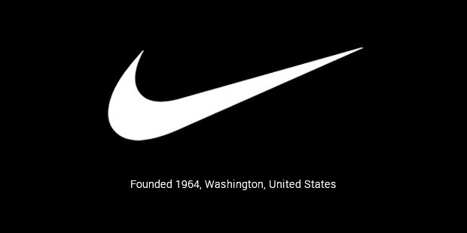
Figure 1: Nike, Inc. (Successstory.com, 2019)

The organisation has a market top of US$24.1 billion in its monetary year 2012 (Yao, 2019). The total employees in Nike were 44,000 in the year 2012 and they are increasing every month. In 2014, the brand worth was $19 billion and it has also become the most important brand in the sports industry and organisations. Starting in 2017, the Nike brand is esteemed at $29.6 billion.

What Are Emotions
Pert in her book “Molecule of Emotions” defines emotions as transformative connection between body and mind, refers to the mysterious mechanical interface turning information into matter that are synthesized by our bodies through chemical consciousness (Pert, 2012). Emotion is derived from a Latin word Emovere, means to move, stimulate or stirred up. Emotions results in sustainability in our struggles and guide us to crown of victories (Jhala, 2015). Emotions are defined as “what we touch”. It does not mean to only touch with our skin or fingers but it is what is touched by our eyes, nerves, ears or taste buds (Von Scheve, 2017). In addition to this, emotions are the reflection of our feelings touched by our imagination, for instance, from imagining fear of a loud noise frightening in the dark to imagining fame of those 15 minutes in which you are at the peak of your game and you know everyone in watching you. Hence, it can be said that emotions are the sentiments that motivate and move us (Pert, 2012).

What is Emotional Intelligence
The type of social intelligence that allows a person to understand and monitor the emotions of other people and himself in order to understand their behaviors and act in a different situation, to help and guide on them towards the right path is known as emotional intelligence (EI) (Salovey and Mayer, 1990). So EI is used to solve problems of people by using their emotional content and expressions of their emotions. Moreover, most of these emotional content contains information and different types of intellectual emotional problems that can only be processed and understood by using emotional intelligence (Salovey and Mayer, 1990).

Significance of Emotional Intelligence at a Workplace
Emotional intelligence in a workplace is also the same as above; it is the ability to know what is happening in the workplace and how to express and control emotions in the workplace. Moreover, how to handle the situation in the workplace and how well the interpersonal relationships are handled with other employees and it also allows us to understand the objectives and goals of the workplace, employee at the same time (Cherniss and Goleman, 2001).
The five key elements of emotional intelligence which were described by Daniel Goldman are as under:
- Self-awareness
- Self-regulation
- Social skill
- Empathy and
- Motivation
These components of emotional intelligence can allow leaders and managers to very efficient and effective in a business organisation. These components allow the leader to have a better understanding of the emotions of people in his surroundings in a workplace and allow him/her to take actions accordingly as the more control he has over these components the higher emotional intelligence a leader has and it will affect the performance of everyone positively. The below figure will help to understand the domains and competencies of EI more effectively:
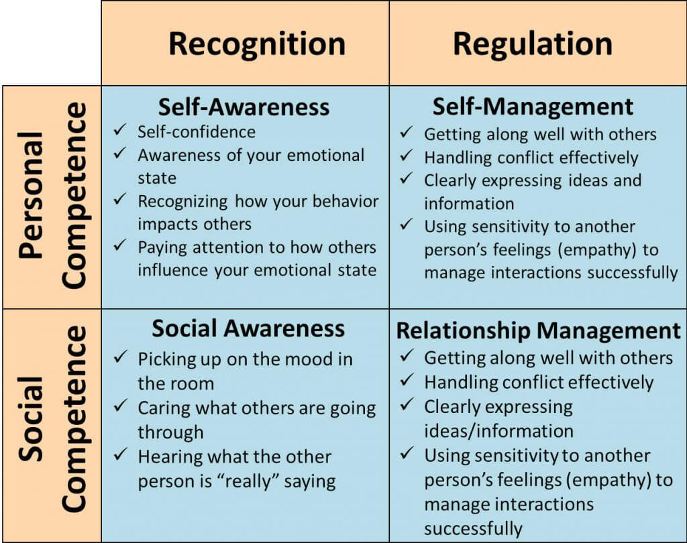
Figure 2: domains and competencies of EI

Importance of Developing Emotional Intelligence in A Work Place
Nowadays, leaders use different psychological concepts for creating self-awareness in the workplace and the best tactic for maximizing this effect is within the workplace is emotional intelligence as directly leads towards innovation and self-actualization of individuals and they become more task-oriented towards the organisational goals and objectives. Emotional intelligence allows the employees to work together as a team and allows the leaders and managers to use all the potential efforts for exploring new business opportunities to remain ahead of in the market place (Kotsou et al., 2019).

Utilizing Human Resource in the Workplace for Success
An organisation is a mixture of different resources, these resources rely and depend on each other for running the organisation among these resources the most important, and valuable resource is the human resource. The human resource consists of various skills and abilities and for utilizing the human resourcefully, they need to work together as a team to gain success. The leaders should use emotional intelligence to manage and control the teamwork and effective communication around the workplace for achieving the goals of the organisation. The EI allows the employees to create good relationships with others and educate them on how to maintain these relations with others; it also increases self-awareness and social skills, which leads towards organisational success (Kotsou et al., 2019). The fundamental aspect of leadership and management is EI and it creates effective leadership and management qualities. Therefore, it is clear that EI is an important part of effective leadership and if a leader has control over his emotions and feelings, he can be a good, manager and it will lead towards organisational success (Kotsou et al., 2019).

Absence of Emotional Intelligence
Positive sharing of hierarchical culture increases organisational achievement. Nike has confidence in collaboration and sharing of information and skills. Enthusiastic knowledge among the representatives has guaranteed it. Be that as it may, associations with an absence of sharing society experience the ill effects of various obstructions like the absence of effective communication, management and inability to investigate objectives. Leaders and supervisors inside these workplaces can feel the significance of emotional intelligence as the most important aspect of a positive working environment culture (Kotsou et al., 2019).

Recruitment and Selection

EI is not a part of the human being when he enters this world, but it increases day by day with the growth of human beings when he starts to analyze what is happening in his surroundings. Emotional intelligence and the ability of good human resources managers, allows them to recruit the best employee for the workplace on the basis of the emotional intelligence of that person which can be positive or negative (Davis, 2019). The process of recruitment and selection also uplifted by recruiting employees with good EI as they are hired to lead the organisation effectively for a long period of time. Emotional intelligence also helps in creating a successful career for employees.

How Does Emotional Intelligence Operate/ Manifest at Nike
Nike is the leading supplier and manufacturer of athletic footwear around the world and its slogan alone tells the importance of emotional intelligence which “Just Do It”. Simple, and yet, there is so much emotion behind these three words. What does it mean to “Just Do It?” does it mean to get out of your comfort zone and take a risk by just doing it? Does it mean you should get up, put on those Nike shoes and run out to shoot some hoops? It allows anyone and everyone to come up with their own interpretation of the phrase. So it clear that the workplace in Nike uses emotional intelligence for innovation and the leaders and managers need to work according to the present-day situation by following some exposed and hidden rules and standards of the company (Hubscher-Davidson, 2013). The major competitors of Nike are Adidas and Reebok as they are also in the sports and athletic footwear and apparel business, and to remain ahead of these competitors. Nike uses its effective leadership and management, as they believe that the emotional intelligence of leaders and managers are the most important thing for generating new ideas and is also considered as the key for sustaining their success in the present day (Hubscher-Davidson, 2013). The key purposes of emotional intelligence in Nike are as under:
- Emotional intelligence increases team performance and innovation in Nike by resolving the conflicts diplomatically.
- The employees will share their experience, knowledge, and skills with other individuals as emotional intelligence maximize collaboration among employees, which will lead to higher job satisfaction and lowering the level of turnover.
- Emotional intelligence eliminates the communication gap among the individuals by incorporating self-awareness, empathy, self-regulation, social skills and integrity among the performing groups.
- Emotional intelligence also helps in creating successful and effective leadership and management by building trust among the employees.
- The effectiveness of managers and leaders also ensures effective communication, helps in resolving conflicts among the employees and maximize team performance, which will lead to organisational growth and good customer relationship (Fosslien and Duffy, 2019).
It is clear that the emotional intelligence of leadership and management at Nike has increased the growth and innovation by creating effective management in the workplace. It also helps in resolving workplace conflicts efficiently, ensuring effective communication throughout the workplace that helps in working towards the objective of Nike and in motivating and increasing the morale of employees, which results in effective teamwork and innovation (Fosslien and Duffy, 2019). It allows Nike to remain ahead of its competitors and also to sustain its current market position for a long period of time.

Benefits of Emotional Intelligence in Nike
Nike is well known for its relationship with its customers and strong relationship within its employees and is also known for its innovative teamwork for the betterment of people and organisations (Davis, 2019). Emotional intelligence played a vital role in achieving this relationship. For building workplace relationships in Nike and also for managing it emotional intelligence focuses on how to gain self-awareness and self-management throughout the organisation and also how to gain social competence which includes social-awareness and relationship management as they are also a part of EI are derived from self-awareness and self- management (Davis, 2019). It allows the employees to focus on the work and react positively in every kind of situation, as it will allow the employee to effectively communicate and use humor to solve organisational conflicts. It also helps in increasing the ability to manage our emotions, which leads to managing stress and allows them to create good relationships with others. Therefore, it can be said that EI is the key factor for making organisational relationships in Nike, as all the above elements are the key factors for building are benefits of EI in an organisation (Davis, 2019).

Relationship between Emotional Intelligence, Effective Management Communication and Business Advantage
Powerful skills of communication support us to be efficient and more effective in our work, especially in such circumstances of daily life where even a minor difference can be made through better relationships. Emotional intelligence is a vital key to effective management communication and the fact cannot be denied that these two are strongly intertwined (Hendon, Powell, and Wimmer, 2017). In addition to this, today’s developing technical and digital environment are making employers to search for those people who can contribute effectively to the organisation, it not only means in terms of technical skills but also display their expertise using emotional intelligence for effective communication (Hendon, Powell, and Wimmer, 2017). Hassan Jofri in his study discussed that environment of communication has become complex nowadays, however, emotional intelligence, effective management communication strategic alignment is still the key concern among the employees and managers across the world. An organisations progress depends upon effective communication. Hence, the relation between, emotional intelligence, effective management communication and business advantage plays a key role in the success and growth of an organisation (Jorfi, et al., 2014).
According to a research, the performance of an employee is highly effected by emotional intelligence. In this research, it is discussed that the success and overall performance of a business does not only depend upon IQ level and professional knowledge of employees and management, but it also depends upon the emotional intelligence level of the employees and employers (Rexhepi, and Berisha, 2017). A study shows that companies are struggling to find rapid change in achieving competitive business advantages in global economy as well as finding difficulties in motivating their workforce, however, emotional intelligence has proved to be a critical factor in this environment for achieving sustainable high performance (Freedman, and Everett, 2010). Arora discussed in a study about a conflict that can rise in which a leader comprising of high emotional intelligence may deliver better by controlling their impulses and analyse the situation from every perspective and come up with a beneficial solution. However, the relationship between emotional intelligence, effective management communication and essential for the advantage of business.

Critical evaluation of “Models of Emotional Intelligence”
There are different theories that helped in the development and improvement of emotional intelligence in the workplace and helped us to understand the concepts of EI and how to implement them in different organisations. Every organisation has its own strategies for growing business, has different cultural values, beliefs and perceptions but the main objective of each every organisation is to increase its market cap and also to take of the well-being of all the people working in that organisation and these all things can easily be managed with the help of emotional intelligence (Laborde et al., 2019). For this purpose, there are different models of EI for exploring the different goals of an organisation in different ways.
The model of EI developed by Daniel Goldman focuses on five key areas of EI that are motivation, social skills, self-regulation, empathy, and self-awareness. Whereas the model of EI developed by Reuven Bar-On focuses on five components of EI, that are general mood, adaptability, intrapersonal skills, stress management, and interpersonal skills. In this report, I will apply and evaluate both of these models for Nike in order to understand and find which the best model for meeting the developmental needs of Nike.

Understanding Daniel Goldman Framework for Nike
This model is known as the most effective model for applying and understanding emotional intelligence in the workplace. For building strong leadership the model consists of five key components which are as under:

Self-Awareness
It is the most important element of emotional intelligence, the whole model based around this. The leaders and managers working in Nike need to find the areas where they are strong and weak, in order to increase their self-awareness. Because strong areas allow leaders to be self-confident whereas weakness will allow the leaders to find the areas, where they lack the most (Cherniss and Goleman, 2001). By finding these areas they can overcome their weaknesses and keep a record of their weaknesses by using self- evaluation tools. Moreover, they also need to control their emotions while making decisions at work as a key part of self-awareness.

Self-regulation
The leaders at Nike can easily increase their self-regulation by focusing on their moral values, ethics and by understanding their accountability as most of the leaders unknowingly make verbal attacks on other that creates a wrong image of their character in front of the employees and it will affect the culture and environment of the workplace (Cherniss and Goleman, 2001). As it is the definition of self-regulation to control the outcome in difficult situations by controlling personal behavior. The leaders at Nike can create self-regulation by practicing, by ensuring their calmness on a challenging situation and by understanding the difficulties of their employees when they face situational challenges (Cherniss and Goleman, 2001).

Empathy
Empathy is known as the act of putting oneself (leader or mangers) in the position of employees to known how they feel while working and facing difficulties in the workplace and moreover empathy also opens the gate for prompting teamwork as the leader how they are feeling and what to get the work done by using emotional intelligence (Boyatzis, Goleman, and Rhee, 2000). The leaders at Nike get feedback from employees in order to generate a strong sense of empathy by understanding their needs and they also focus on the body language of employees in order to understand their current condition or situation and decisions are made on the basis of employee’s current state of mind in order to achieve success.

Motivation
In the corporate world, resources are always limited in the organisation but the insight and awareness of employees are always unlimited, they always come with new ideas to gain success or to achieve organisational goals. So, in order to keep the employees motivated in unfavorable conditions, the leaders and managers at Nike use tactics to reward their employees on the basis of their willingness for doing their works. Emotional intelligence also allows the managers at Nike to focus on their leadership motivation assessment as they are successful or not in motivating the employees, what are their job objectives and last but not the least is thy showing optimistic behavior in difficult and challenging situations for keeping the employees motivated. Afterward, they also try to find the reason behind these difficult situations and try to solve all the problems to gain success in the future (Boyatzis, Goleman, and Rhee, 2000).

Social Skills
Nike is far ahead of its competitors in the athletic apparel and footwear manufacturing and supplying game because it believes in empowering its employees and customers by allowing them to provide new ideas for innovation. The effective communications of leaders and managers are very good because a leader with good communicational skills is also good at social skills. They also try to ensure effective communication among the employees throughout the workplace and they also coordinate with their employees to support them when they are working on new objectives and goals. They also try to resolve all the conflicts diplomatically so the feelings of employees don’t get hurt and it also increases the team performance (Holden et al., 2002). The leaders at Nike also believe that praising employees helps in keeping and building a loyal employee base, so they always try to appreciate the work on their team members when they have done something good or average to keep them motivated also. Most of the leaders know that how they are reaching their employees and how their social affect their employees, so they can easily make Nike a second home for their employees based on their social skills.

Understanding How Daniel Goldman Framework will apply in Nike
Now, it is clear that how the leaders and managers of Nike but there are using emotional intelligence are some areas which need to be explained in order to fully understand the work of this model and it is described by using the framework in the upcoming paragraph, which is as under:
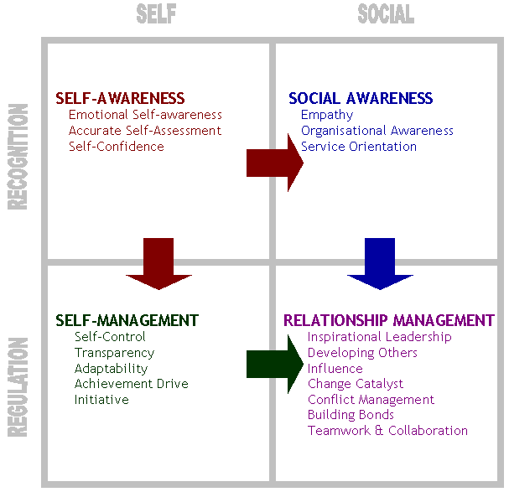
Figure 3: Daniel Goldman Framework

The leadership and management at Nike know the importance of emotional intelligence and they implement it by firstly understanding self-awareness, which is the combination of different morals of a person and his surroundings it includes self-understanding and personal awareness in the inner world (Cherniss et al., 2006). If a leader is self-aware of himself/herself emotional intelligence, it can easily be seen in their behavior and it will show their strong character through their action behavior. Moreover, it can also be called self-regulation as it based on action behavior. Whereas when a leader practices outer world self-awareness it becomes a part of empathy and try to put themselves on the place of employees to understand their feeling and difficulties when they work and find their actual situation when they work (Cherniss et al., 2006). Then social skills again raise self-regulation when self-regulation comes towards the outer world in the form of behavioral anger and emotions. Similarly, empathy also comes towards social skills which are shown by the behavior of leaders in the workplace. In the end, self-awareness also opens the gateway for social skills and it results in enhancing politeness, optimism, and discipline in a leader’s emotional intelligence (Cherniss et al., 2006). But all these activities are a part of personal motivation if you are not motivated you can apply any of these qualities and motivation allows the person to work for the development and implementation of emotional intelligence (Schmidt and Hayes, 2002).

Bar-On’s theory of EI and how it will Effects Nike EI
The Bar-On theory of emotion was developed in the year 1997. The BarOn theory was based five interrelated domains of the personal characteristics of a person whereas the traditional emotional intelligence focus on all aspects of a person. These domains are as under:
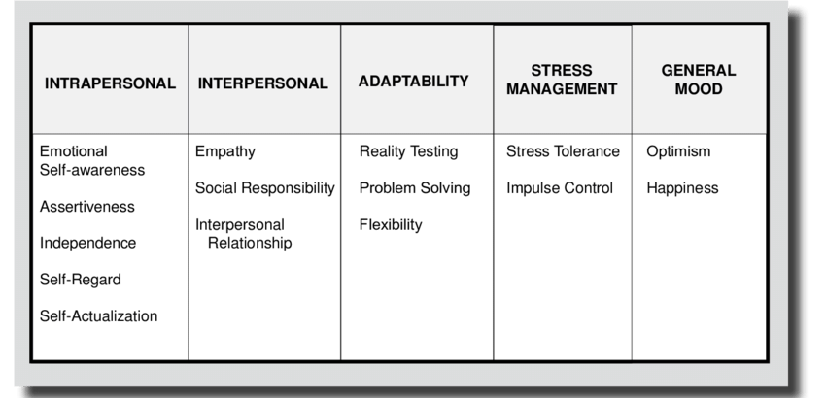

\
Interpersonal Skills
Interpersonal skills include self-regard, assertiveness, emotional self-awareness, self-actualization, and independence. The leaders and managers in Nike should understand their duty and should also work to understand themselves better for self- actualization as all this is part of a leader’s interpersonal skills. The managers can also easily improve their assertiveness by expressing their feelings with others but in such a manner that they do not hurt the feelings of others (Shapira-Lishchinsky, 2016).

Interpersonal Skills (Empathy)
As we have discussed earlier empathy is known as the act of putting oneself (leader or mangers) in the position of employees to known how they feel while working and facing difficulties in the workplace (Bar-On, 2006). Moreover, empathy also opens the gate for prompting teamwork as the leader how they are feeling and how to get the work done by using emotional intelligence. The leader should understand the feeling of their employees to enable a sense of empathy among their employees. In order to understand social responsibility, the leader should try to become a contributing and cooperative or constructive member of the social group and interpersonal skills can be improved by creating and maintaining a good work environment in the workplace (Bar-On, 2006).

Adaptability Skills
Leadership and management is a very hard job everyone cannot handle the stress and pressure of this job as it is a dynamic task. The person should be to mold himself according to any situation as adaptability depends on the behavior of human beings and situational factors that can be changed at any time, as they do not follow any pattern or sequence (Bar-On, 2006). The leaders and should be able to control their emotions, behavior, and actions when the situation is changing or is becoming difficult to control and the leader should be able to create reality testing skills which he /she should be able to compare the outcomes of the recent and experienced situation or scenarios. Moreover, these skills can also be used for drawing solutions in an unexpected situation by capering it with other experienced situations (Bar-On, 2006).

Stress Management
Stress is very important as it can be useful for motivating the employees for achieving their personal and organisational goals and it also makes managers and leaders a great motivator as they effective their employees by consulting with them regarding their problems and solving them (Bar-On, 2006). Stress management is the art of managing and ignoring the anger and negative vibes or feelings. The leaders and managers should practice stress management in order to keep themselves and their employees from negative feelings and trouble regarding their work (Bar-On, 2006).

General Mood
Motivated leaders and managers are always good for a workplace as they have positive minds and they can turn the workplace into a good workable place for al and also motivates the employees to work in the right direction and allows them to achieve individual and organisational goals. The leader or manager should be self-motivated and should have self-satisfaction in order to apply all the above positive things in the workplace (Goleman, 1995). As Nike is an innovative company, it always tries to motivate its employees in order to gain growth and they try to learn from their bad experiences in order to get a better result in the future.

What is Mindfulness
Mindfulness is the psychological process of analyzing and paying attention to the events happening in the current situation whiteout judging them. Mindfulness can be easily achieved and developed by doing meditation and training. Mindfulness is important for leadership and management in a workplace as it allows innovation and helps in completing challenging tasks by allowing the leaders and individuals to fully use all six senses together for achieving the goals and exploring the aims of a business organisation (Langer and Ngnoumen, 2017).

Significance of Mindfulness in the Workplace
The purpose of mindfulness is to create awareness of yourself and the surroundings around you, concisely it works around self-awareness and it enhances the ability of emotional intelligence, which allows individuals to manage their emotions externally and internally. Practicing mindfulness has psychological benefits such as improved memory, reduced depression and anxiety and moreover, mindfulness also has a positive impact on the workplace (Hunter and McCormick, 2008). Mindfulness drives many aspects of a healthy workplace, some of which are as under:
- Well-being
- Relationship
- Creativity

Critical appraisal of the importance of emotional intelligence and mindfulness in a workplace
In a study carried by Hoikka, it was discussed that if a person wishes to be successful in his working life then for him or her self-knowledge is the most essential aspect of any matter. Especially, talking about the position of leaders, it is important to adopt training of emotional intelligence and mindfulness to enhance interpersonal skills, self-awareness, creativity, self-regulations, focus, motivation, and empathy and learning skills (Hoikka, 2019). According to a study carried by Goleman and Lippincott, mindfulness has become a buzzword for the corporates highlighted as the practice that is widely hyped as fast way for achieving better leadership.
But it has been seen that the all the hyped benefits are not actually present, however, the research has revealed a complex relationship between emotional intelligence and mindfulness which shows that they are incomplete without each other and the leaders have to understand the importance if they look to excel in their careers (Goleman, and Lippincott, 2017). Stringer discussed in his report that before mindfulness emerged as the latest fix a workplace, it was emotional intelligence which was based on perception that those people become successful employees who adopt understanding, perceiving as well as managing emotions (Stringer, 2016). Stringer further discussed that mindfulness boost the emotional intelligence by enhancing our awareness for our own feelings and thoughts, hence, the more we increase awareness in our work, the more we enhance our emotional intelligence and mindfulness which will enable us to work more efficiently and effectively (Stringer, 2016).
However, it has been witnessed that everyone seems to be adopting mindfulness whether it is Google or NIKE. It is seen that Nike has adopted promotion of mindfulness within the workplace for improving the level of concentration of its staff as well as helped in enhancing the energy and focus that has significantly resulted in effective and efficient working of staff and making the workplace environment healthier and happier.

Conclusion
By evaluating the upper report, it is clear that emotional intelligence creates helps in building and creating strong leaders and a great management team in an organisation. Emotional intelligence in a workplace is also the same as above; it is the ability to know what is happening in the workplace and how to express and control emotions. Moreover, how to handle the situation in the workplace and who well the interpersonal relationships are handled with other employees and it allows understanding the objectives and goals of the workplace. Whereas the purpose of mindfulness is to create awareness of one and the surroundings around you, in a nutshell, it works around self-awareness and it also enhances the ability of emotional intelligence which allows individuals to manage their emotions externally and internally.
It is also clear that the absence of emotional intelligence in the leader and management of an organisation can lead the business organisation towards a poor organisational performance that will affect the employees also, they will not work for their goals, and it can affect the future of a company. The leadership and management at Nike know the importance of emotional intelligence and they implement it by firstly understanding self-awareness, which is the combination of different morals of a person and his surroundings it includes self-understanding and personal awareness in the inner world. If a leader is self-aware of himself/herself emotional intelligence, it can easily be seen in their behavior and it will show their strong character through their action behavior. Thus, organisations Nike has overcome this issue regarding emotional intelligence has overcome it in some areas by understanding and applying its framework. With the help of emotional intelligence, we can improve our leadership and management qualities so that it can help us in the future.

References
Arora, B. 2017, Importance Of Emotional Intelligence In The Workplace. International Journal of Engineering and Applied Sciences, 4(4).
Bar-On, R., 2006. The Bar-On model of emotional-social intelligence (ESI). Psicothema, 18, pp.13-25.
Boyatzis, R.E., Goleman, D. and Rhee, K., 2000. Clustering competence in emotional intelligence: Insights from the Emotional Competence Inventory (ECI). Handbook of emotional intelligence, 99(6), pp.343-362.
Cherniss, C. and Goleman, D., 2001. The emotionally intelligence workplace. How to select for measure and improve emotional intelligence in individuals, groups and organisations san Francisco: Jossey-Bass.
Cherniss, C. and Goleman, D., 2001. The emotionally intelligence workplace. How to select for measure and improve emotional intelligence in individuals, groups and organisations san Francisco: Jossey-Bass.
Cherniss, C., Extein, M., Goleman, D. and Weissberg, R.P., 2006. Emotional intelligence: what does the research really indicate?. Educational psychologist, 41(4), pp.239-245.
Davis, L., 2019. The Need for Emotional Intelligence in the Workplace.
Fosslien, L. and Duffy, M.W., 2019. No Hard Feelings: Emotions at Work and How They Help Us Succeed. Penguin UK.
Freedman, J. and Everett, T., 2010. The business case for emotional intelligence. White paper. Six Seconds.
Goleman, D. and Lippincott, M., 2017. Without emotional intelligence, mindfulness doesn’t work. Harvard Business Review. https://hbr. org/2017/09/sgc-what-really-makes-mindfulness-work,(09.10. 2017 tarihinde erişildi.).
Goleman, D., 1995. Emotional intelligence: Why it can matter more than IQ', New York: Bantam Harter, JK, Schmidt, FL, and Hayes, T. L 2002,'Business-unit-level relationship between employee satisfaction, employee engagement, and business outcomes: A meta-analysis'. Journal of Applied Psychology, 87(2), pp.268-279.
Hendon, M., Powell, L. and Wimmer, H., 2017. Emotional intelligence and communication levels in information technology professionals. Computers in Human Behavior, 71, pp.165-171.
Hofmann, A., Gold, N. and Curtin, C., 2019. Nike, Inc: Late Arrival to the'Athleisure-wear'Trend.
Hoikka, P., 2019. Why is Mindful Leadership with Emotional Intelligence Needed?.
Holden, G., Meenaghan, T., Anastas, J. and Metrey, G., 2002. Outcomes of social work education: The case for social work self-efficacy. Journal of Social Work Education, 38(1), pp.115-133.
Hubscher-Davidson, S., 2013. Emotional intelligence and Translation Studies: A new bridge. Meta: Journal des traducteurs/Meta: Translators’ Journal, 58(2), pp.324-346.
Hunter, J. and McCormick, D.W., 2008. Mindfulness in the workplace: An exploratory study. In SE Newell (Facilitator), Weickian Ideas. Symposium conducted at the annual meeting of the Academy of Management, Anaheim, CA.
Jhala, A. 2015. "Emotions" (Psychology). ResearchGate. [Online] Available from: https://www.researchgate.net/publication/320621079_Emotions_Psychology Accessed on [11 December 19]
Jorfi, H., Jorfi, S., Fauzy, H., Yaccob, B. and Nor, K.M., 2014. The impact of emotional intelligence on communication effectiveness: Focus on strategic alignment. African Journal of Marketing Management, 6(6), pp.82-87.
Kotsou, I., Mikolajczak, M., Heeren, A., Grégoire, J. and Leys, C., 2019. Improving emotional intelligence: a systematic review of existing work and future challenges. Emotion Review, 11(2), pp.151-165.
Laborde, Z.B., Burbano, K.B., Reinoso, V.G., Bangeppagari, M., Mulla, S.I. and Selvanayagam, M., 2019. Emotional Intelligence Models as Generators of Business Management Change in the Human Talent Area. Journal of Artificial Intelligence, 12, pp.1-10.
Langer, E.J. and Ngnoumen, C.T., 2017. Mindfulness. In Positive Psychology (pp. 95-111). Routledge
Mayer, J.D., DiPaolo, M. and Salovey, P., 1990. Perceiving affective content in ambiguous visual stimuli: A component of emotional intelligence. Journal of personality assessment, 54(3-4), pp.772-781.
Pert, C., 2012. Molecules Of Emotion: Why You Feel The Way You Feel. Simon and Schuster.
Positivepsychology, 2019. Emotional Intelligence Frameworks, Charts, Diagrams and Graphs. [Online] Available from: https://positivepsychology.com/emotional-intelligence-frameworks/ Accessed on [11 December 19]
Rexhepi, G. and Berisha, B., 2017. The effects of emotional intelligence in employees performance. International Journal of Business and Globalisation, 18(4), pp.467-479.
Sonoma, 2019. Daniel Goleman's five components of emotional intelligence. [Online] Available at: https://web.sonoma.edu/users/s/swijtink/teaching/philosophy_101/paper1/goleman.htm Accessed on [11 December 19]
Stringer, L., 2016. The Healthy Workplace: How to Improve the Well-Being of Your Employees---and Boost Your Company's Bottom Line. Amacom.
Successstory, 2019. Nike, Inc. SuccessStory. [Online] Available from: https://successstory.com/companies/nike-inc Accessed on [11 December 19]
Von Scheve, C., 2017. Collective emotions. The Wiley‐Blackwell Encyclopedia of Social Theory, pp.1-3.

