Vasile Pitirici
ID number 2213442
Lecturer name Chris Wilkin

MODULE: MARKETING ESSENTIALS
MODULE CODE: BMIH4005 REWORK
TOPIC: A COMPARISON OF THE MARKETING METHODS OF TWO MULTINATIONAL HOTEL CHAINS

TABLE OF CONTENTS

Introduction 3
Marketing Choices and Directions 4
Current Market Positions 5
Considerations within Marketing 6
Marketing Messages 7
Conclusion 8
References 9

Introduction
The two chosen multinational hotels for this essay Six Senses and Moxy have proved themselves as critical performers in the hospitality sector. Six Senses is a luxury resort and spa brand that was established in 1995, with an emphasis on sustainable tourism and wellness (www.sixsenses.com). Another hotel, Moxy, is a modern and trendy hotel brand that was established in 2014 that targets millennial tourists with its reasonable prices and social spaces (www.pilotplans.com). Both brands have taken specific marketing strategies to distinguish themselves in the market and draw their target audiences. In this essay the marketing approaches and strategies of Six Senses and Moxy would be explored along with the historical background, current market positions, considerations within marketing, and marketing messages would be analysed. By doing these analyses a deeper knowledge of the methods in which these brands have achieved success in the competitive hospitality sector and determine possible options for future development information can be gained.
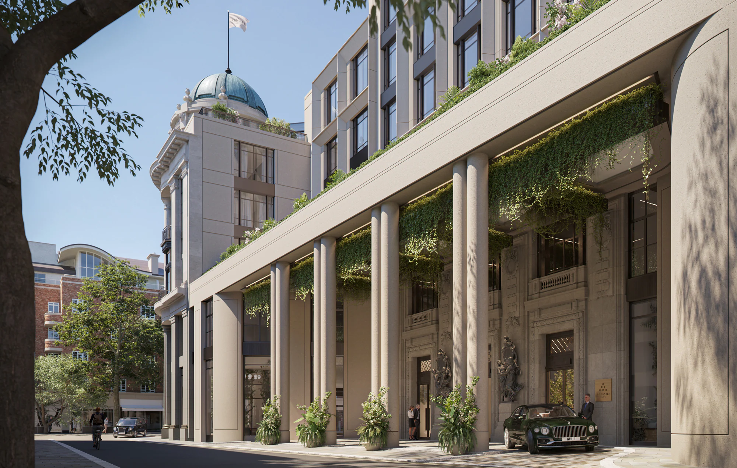
Six Senses Hotel and Spa, London. (Source: https://www.sixsenses.com)
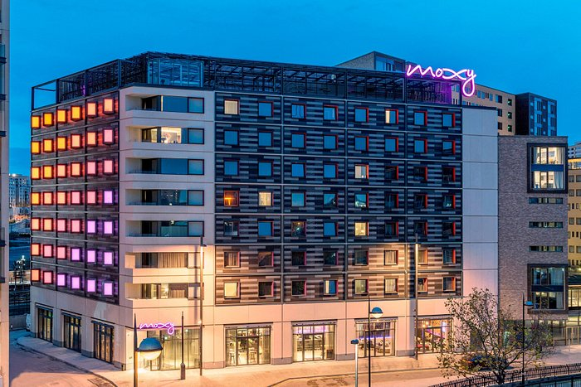
Moxy Hotels, London (Source: https://www.marriott.com)

Marketing Choices and Directions
Six Senses:
Six Senses has historically carried a remarkable approach to marketing by focusing on sustainable tourism and wellness. Their marketing strategy highlights the significance of environmental protection and the help of locally-sourced materials, which has reverberated with an increasing number of visitors who are concerned about sustainability (Sousa et al., 2021). Time by time, the hotel has extended its reach by establishing new properties in important locations around the globe, such as Thailand, Maldives and Portugal, and aiming at high-end clients who are ready to pay high for lavish and sustainable accommodations (Stombelli, 2020). Six Senses has also raised its focus on digital marketing, especially through social media such as Facebook and Instagram where it shares visually incredible images of its properties and advertise its sustainability initiatives regularly. This has enabled the company to achieve a broader audience and showcase its outstanding selling points to possible clients.

Moxy:
Another hotel named Moxy, takes a more active and irreverent strategy to marketing by targeting young visitors who value affordability and social experiences. Their marketing strategy highlights the hip and stylish image of the brand, with odd designs and bold colours that reflect the preferences of the target audiences (www.researchbank.swinburne.edu.au). Moxy has also taken substantial action to distinguish itself from conventional hotels by presenting collaborative spaces such as rooftop bars and game rooms, which appeal to millennial visitors who are seeking extraordinary experiences. Moxy has utilised digital marketing to outstanding effect, especially through social media platforms such as Facebook, Instagram, and Twitter (Tan and Wright, 2022). By using hashtags campaigns such as #moxytogether and #atthemoxy, the hotel has enabled guests to share their experiences in the properties which creates a sense of community about the brand. Moxy has also partnered with popular social media personalities and influencer marketing, to advertise its properties and engage with its new and regular customers.

Current Market Positions
Six Senses and Moxy occupy various components of the hospitality sector where Six Senses caters to high-end and premium customers seeking wellness-focused and sustainable experiences, while Moxy goes for younger customers and budget-conscious customers desiring social and amazing experiences.
Six Senses has specified itself as a high-end luxury brand, with a priority on wellness and sustainability (Andrijašević, 2021). The properties of this brand are generally situated in remote and unknown locations, such as mountain retreats and private islands, and deliver a set of healthiness-focused movements such as farm-to-table dining experiences, meditation and yoga classes, and spa treatments. Six Senses has distinguished itself from its rivals by highlighting its dedication to sustainable tourism by reducing waste through various initiatives such as plastic-free initiatives and water reservations and locally sourced equipment (Serradas, 2022).
On the other hand, Moxy has placed itself as a pleasure and stylish brand catering to youth audiences who are seeking exceptional and social experiences. The properties of Moxy usually feature collaborative spaces such as co-working spaces rooftop bars and game rooms where visitors can connect and socialize with others. Moxy has also distinguished itself from its rivals’ brands by delivering inexpensive yet fashionable and trendy accommodations, with an emphasis on building a dynamic and inclusive environment that targets its audiences (Fonseca, 2019).
Both Six Senses and Moxy have leveraged social media and digital marketing to great impact in terms of marketing. Six Senses has emphasised showing its distinctive selling points, such as wellness and sustainability through spectacular images and videos on social media platforms. On the other hand, Moxy has established the importance of community about its brand through influencer partnerships, user-generated content, and motivating visitors to share their feedback on social media and engage with others through hashtags such as #atthemoxy (Bojkov, 2023).
However, it is quite clear that both Six Senses and Moxy have designated substantial market positions by distinguishing themselves from rivals and targeting particular segments of the hospitality sector. Their marketing approaches have played an essential role in drawing the attention of the target audiences and establishing an influential brand identity.

Considerations within Marketing
Both Six Senses and Moxy have made concerns within their marketing approaches in reaction to several social, geopolitical and contemporary, and sustainability issues.
Social: Both brands have acknowledged the significance of social problems in their marketing approaches. Six Senses has executed an initiative named "Sustainability Fund" where a cut of the brand's returns are contributed to projects like community-based sectors such as healthcare, conservations, and education (Explored, 2020). Further, Six Senses has introduced several initiatives to help local society, such as job opportunities for its properties and offering vocational training to them. On the other hand, Moxy has also highlighted social problems in its marketing, with a focus on establishing a variousness and diversity environment in its properties. Moxy has also partnered with different organizations such as the Human Rights Campaign and the Trevor Project to help LGBTQ+ rights and establish secure spaces for visitors of all backgrounds.
Geopolitical and Contemporary Issues: Both Six Senses and Moxy have emphasised their marketing approaches to handle geopolitical and contemporary problems. Six Senses has executed several safety initiatives in reaction to the COVID-19 pandemic, such as improved hygiene protocols and making check-in procedures contactless (Kossecki et al., 2021). Further, Six Senses has focussed on its marketing to draw the attention of visitors who are seeking remote and personal travel experiences in response to Covid. Whereas, Moxy has acclimated its marketing to mirror the modern trends such as offering co-working spaces, the rise of digital wanderers and remote work, and high-speed internet in its properties. The brand has also reacted to current geopolitical problems, such as the Black Lives Matter campaign, by highlighting its dedication to diversity and its marketing strategies (Glenister, 2021).
Sustainability: Six Senses has focussed on sustainability in its marketing, highlighting its dedication to promoting sustainable tourism and decreasing its carbon footprint. The brand has executed several measures such as decreasing plastic usage and waste as well, through providing organic and locally-sourced food in its restaurants and increasing the use of reusable bottles. Besides, Six Senses has devised a program named "Earth Lab" where visitors can gather knowledge about sustainable living methods and confront environmental movements (www.sixsenses.com). However, Moxy has also constructed sustainability a preference with measures such as the use of eco-friendly cleaning products and LED lighting in its properties. Moxy also partnered with several organisations like “Clean the World”, to donate and recycle used soap and hygiene goods.

Marketing Messages
Six Senses and Moxy have both developed their marketing messages time by time to remain suitable in the “always changing” hospitality sector. Six Senses has placed itself as a premium and lavish wellness brand that highlight sustainability with a priority on delivering visitors with transformative experiences that provide them with a feel-good body, mind, and soul. The marketing messages also highlight its exceptional offers which include spectacular natural sites, holistic healthiness programs, and dedication to eco-friendly activities.
In distinction, Moxy has placed itself as a stylish, trendy, and reasonable brand that attracts young visitors who are seeking communal and social experiences (de Korte et al., 2019). The marketing messages of this brand are centred around pleasure, joy, and the idea of "play on," with movements such as "Nowhere but Moxy" emphasising the distinctive qualities and social offerings. Moxy's marketing messages have developed time by time to attract young audiences who are socially aware demographic, with drives such as "Activate the Future" highlighting the commitment of the brand to eco-friendliness and sustainability.

Conclusion
To conclude the essay, it can be said that the marketing strategies utilised by Six Senses and Moxy exhibit their unique placements within the hospitality sectors. Both companies have made strategic decisions in their marketing efforts, such as Six Senses' focus on luxury healthiness and sustainability whereas Moxy's emphasises affordability and social experiences. By regarding modern issues such as geopolitical and sustainability concerns, these brands have acclimated their marketing messages to stay pertinent and focus on changing customer preferences. While Six Senses and Moxy vary in their strategies, their success in the competitive hospitality sector underlines the significance of effective marketing approaches. As the industry continues to develop, it will be impressive to see how these brands and others will resume to innovate and grow their marketing approaches to fulfil the changing demands and tastes of customers.

References
Andrijašević, N., 2021. Personalization and Authenticity: Hospitality Strategies for a New Definition of Luxury (Doctoral dissertation, RIT Croatia).
Better than home - swinburne university of technology (2023). Available at: https://researchbank.swinburne.edu.au/file/10ab79fd-0a69-4457-8f14 2b522769203f/1/grace_lau_thesis.pdf
Bojkov, N. (2023) 20 user-generated content examples, EmbedSocial. Available at: https://embedsocial.com/blog/user-generated-content-examples/
de Korte, A., Bosman, J. and Blomme, R., 2019. The future of hospitality. In Hospitality Experience (pp. 122-152). Routledge.
Everything you need to know about moxy hotels: Are they worth it? (2023) RSS. Available at: https://www.pilotplans.com/blog/moxy-hotels-review#:~:text=Moxy%20Hotels%20is%20one%20of,worldwide%20on%20three%20different%20continents
Explored, S. (2020) Sustainable tourism with Jeff Smith, six senses hotels resorts spas, Medium. Available at: https://sustainabilityexplored.medium.com/sustainable-tourism-with-jeff-smith-six-senses-hotels-resorts-spas-18e077a91f8d
Fonseca, P.D.R.D., 2019. Impact of Instagrammers on consumers travel behaviour in the hospitality sector (Doctoral dissertation).
Glenister, G., 2021. Influencer Marketing Strategy: How to create successful influencer marketing. Kogan Page Publishers.
History (2023). Available at: https://www.sixsenses.com/en/about-us/history
Kossecki, P., Narożna, D., Steingartner, W., Płoneczka, K. and Smektała, A., 2021. Owning or Being? The Evolving Meaning of Luxury and COVID-19 Pandemic. Sociological Research of Polish Society. Sociological Research of Polish Society (November 23, 2021).
Serradas, M.M.M.R., 2022. Managing the tensions between luxury and sustainability: the case of the luxury hotels (Doctoral dissertation).
Sousa, B.B., Magalhães, F.C. and Soares, D.B., 2021. The role of relational marketing in specific contexts of tourism: A luxury hotel management perspective. In Building consumer-brand relationship in luxury brand management (pp. 223-243). IGI Global.
Stombelli, V.M., 2020. Corporate Social Responsibility in hospitality: are sustainability initiatives really sustainable? Case examples from CitizenM, Lefay and Six Senses. Worldwide Hospitality and Tourism Themes, 12(5), pp.525-545.
Sustainability and earth lab (2023) Luxury Resorts, Wellness Spas, and Five Star Hotels. Available at: https://www.sixsenses.com/en/experiences/sustainability-and-earth-lab
Tan, Y.S. and Wright, A.S., 2022. Exploring “Smart and Green” Concepts: A New Synergy for Irish Hospitality. Tourism and Hospitality, 3(1), pp.276-296.

