


Aida Luca Lamer
1706552

MSC Computing Portfolio
Computer Networks and Cyber Security
Network Security
ACCA7019

May 2022

Abstract
Using Cisco Packet Tracer, a topology is created and configured using laboratory skills. The Cisco routers are secured, AAA on the Cisco routers is implemented, and access control list is implemented for threat mitigation. The switch is securely configured to mitigate against LAN attacks and other common Layer 2 attacks. Cisco ISO Firewall and pre-shaped key authentication using CLI are implemented. With the aid of current research carried out, a secure network infrastructure is designed to be implemented by A2Z Technology LTD. Using Cisco Packet Tracer a blue print is designed, providing proposed choices and security measures to A2Z Technologies Ltd. A2Z Technologies Ltd are provided with a three-month project plan that demonstrates the planned time for implementation and the cost analysis of the proposed solutions. Three current attacks that propose current threat to organisations network infrastructure are explained to A2Z Technologies Ltd. A2Z Technologies Ltd are provided three recommended tests to be carried out following the completion of the implementation to ensure secure network infrastructure: black, grey and white box test. In the final part of the research, A2Z Technology Ltd are provided with an invoice for the professional services carried out by the network security engineer.

Table of Contents
Abstract 2
Table of Figures 4
Part 1-Packet Tracer 5
1.1 Introduction 5
1.2 Topology Set Up 7
1.3 Securing Cisco Routers 9
1.4 AAA Implementation 13
1.5 Using ACLs For Threat Mitigation 15
1.6 Layer 2 Attacks 16
1.7 Cisco IOS Firewall 18
1.8 Conclusion 19
Part 2-Secure Network Infrastructure Proposition 20
2.1 Introduction 20
2.2 Blueprint Design of Secure Network Infrastructure 20
2.3 Design Proposal 21
2.4 Cost Analysis 23
2.5 Project Plan 24
2.6 Attack Threats to Organisations 24
2.7 Secure Network Infrastructure Test 25
2.8 Invoice 25
2.9 Conclusion 26
References 27

Table of Figures
Figure 1-Topology set up using lab equipment 8
Figure 2-Topology set up using Cisco Packet Tracer 9
Figure 3-Basic security settings 9
Figure 4-Setting up interface IP address and OSPF 10
Figure 5-Privilege levels and role-based CLI Access 10
Figure 6-Monitoring network using SNMP 11
Figure 7-Automated features to enable security part 1 12
Figure 8-Automated features to enable security part 2 13
Figure 9-AAA authentication validating users against local database 14
Figure 10-Configuring router using Cisco ACS for AAA 14
Figure 11-AAA authentication using TACACS+ 15
Figure 12-AAA authentication using RADIOUS 15
Figure 13-Access control lists to filter traffic and mitigate network attacks R1 16
Figure 14-Access control lists to filter traffic and mitigate network attacks R2 16
Figure 15-Access control lists to filter traffic and mitigate network attacks R3 16
Figure 16-Switch security to mitigate LAN attacks SW1 17
Figure 17-Switch security to mitigate LAN attacks SW2 18
Figure 18-Switch security to mitigate LAN attacks SW3 18
Figure 19-ASA firewall configuration 19
Figure 20-A2Z Technology Ltd Blueprint Design 20
Figure 21-A2Z Technology Ltd Design Proposal 21
Figure 22-A2Z Technology Ltd Invoice 23
Figure 23-Gantt Chart 24
Figure 24-A2Z Technology Ltd invoice for professional work carried out 26

Part 1-Packet Tracer

1.1 Introduction
In the following chapter, research is carried out into security threats that modern network infrastructures are facing. Furthermore, with the use of Cisco Packet Tracer, a topology is set up using laboratory skills.

Network Security- Network infrastructure security is the installation of preventative measures to protect underlying network infrastructure. These measures are in place to deny unauthorised access, modification, deletion, and theft of resources and data. [1] The different approaches to network infrastructure security are access control, application security, firewalls, virtual private networks (VPN), behaviours analytics, and wireless security. [1] Access control is the prevention of unauthorised users and devices from being able to access the network. [1] Application security is used to lock down potential vulnerabilities by placing security measures on hardware and software. [1] Firewalls prevent or allow specific traffic from entering or leaving the network. [1] VPNs are used for endpoint encryption to create a secure tunnel of communication over the Internet. [1] Behaviour analytics are tools that detect activity is that differ from normal activities automatically. [1]

Types of threats and attacks- There are typically two common types of network delivered threats, which are passive network threats and active network threats. [3] Passive network threats are activities like wiretapping and scans that are designed to intercept traffic that is travelling through the network. [3] Active network threats include denial of service (DoS) attacks and SQL injection attacks with the aim to disrupt the network’s normal operations. [3] Overall, the most common types of threats that target network security are malware, advanced persistent threats, and distributed denial of service attacks. [4]

Tools to mitigate effects of common network security attacks- There are also several key tools to network security implementation controls that provides comprehensive access control and threat control. Firewalls create a barrier by performing access control and macro segmentation based on IP subnets. [2] Load balancers distribute load based on metrics and can also be used to absorb the effect of certain attacks including DDoS attacks. [2] IDS/IPS is deployed behind the firewall and provides protocol analysis and signature matching off data packets. This tool can prevent SQL injection attacks which are common security threats. [2] Sandbox is another method and is like IDS/IPS, without the requirement of signatures. Sandbox evaluates the end system environment to monitor weather threats such as malwares are targeting the network. [2] NTA/NDR is another key tool that monitors traffic directly and with the use of machine learning algorithms and statistical techniques, anomalies are monitored to determine the presence of threats. [2]

Fundamental principles of securing a network- The fundamental principles of securing a network include keeping patches and updates updated, using strong passwords, securing VPN, managing user access privileges, and removing inactive accounts. [5] When administrators become relaxed about applying patches and updates, cybercriminal's exploit vulnerabilities in the operating system, web browsers, browser plugins, and software applications. [5] To keep up to date with patches and updates, all computers in an inventory should have automatic updating enabled. The use of strong passwords that is difficult to detect by humans and computers is recommended to be minimum of 6 characters, combination of upper-case and lower-case letters, numbers, and symbols. [5] As recommended, passwords should be changed every 90 days, and the users should not be permitted to reuse their last 15 passwords. [5] After 8 failed login attempts within 45 minutes, the users are to be locked out for 1 hour 30 minutes. [5] Although measures are in place to secure passwords, social engineering techniques allow hackers to trick users into revealing their passwords. Secure VPN by encrypting data and authenticating identity. Open networks can be used by hackers to exploit onto the network. Managing employee access to critical data is important as inappropriate user access privileges pose significant security threats to organisations. [5] Inactive accounts should be deleted appropriately once an employee finished working for an organisation, as inactive accounts could be utilised by hackers to gain access and disguise their activity. [5]

How to mitigate effects of common network attack methodologies- Research found that reducing the exposure using essential security controls can reduce the exposure to common types of cyber attacks on systems that are exposed to the Internet. [6] One of the methods to mitigate common network attacks is boundary firewalls and Internet gateways as this method is used to establish network perimeter defences, web filtering, content checking, particularly web proxy, and firewall policies to detect and block executable downloads, block access to known malicious domains and to prevent users’ computers from communicating directly with the Internet. [6] Malware protection should be in place to establish and maintain malware defences to detect and respond to known attack code. [6] Patch management should patch all known vulnerabilities using the latest version of the software in aim to prevent attacks that exploit bugs in the software. [6] Allow listing and execution control should be implemented to prevent unknown software from running or installing itself. [6] Secure configuration should also be implemented to restrict the functionality of the devices, operating systems and applications to the appropriate abilities that the business needs to function. [6] Appropriate password policy must be in place and followed. [6] User access control should limit normal users’ permissions that they are able to execute, and least privilege principle should be enforced. [6]

How is Cisco Network Foundation Protection (NFP) framework used to secure networks- Cisco network foundation protection framework is the infrastructure protection that forms the foundation for continuous service delivery. [7] NFP consists of three functional areas: control plane, management plane, and data plane. The control plane provides the ability for the data to be routed correctly. The management plane enables to manage network elements. The data plane has the ability to forward the data. [7]

Mitigating effects of Viruses, Worms, Trojan Horse- There are several ways of mitigating vulnerabilities and patch management ensures appropriate patches are applied first instance to limit the exposure time the organisation is exposed to the known vulnerability. [6] Malware protection within the internet gateway is used to detect malicious code in imported items and the internal network and on the users computers where available malware protection measures should also be implemented. [6] unauthorised access is to be prevented by devices within the gateway to prevent unauthorised access to critical services and organisational assets. [6] Any unauthorised inbound and outbound connections should be detected by the gateway. [6] User access controls should be implemented to restrict the applications, privileges and data that the user can access and unnecessary software and the default user accounts can be removed with secure configuration. this ensures that features that would activate malware immediately are switched off and default passwords are changed. [6] Social engineering can also be reduced by training, educating, and promoting awareness content to users. [6] Network activity should be monitored and analysed to identify malicious and unusual activities as it is critical to detect a breach. [6]

Endpoint vulnerabilities and protection methods-Endpoint devices such as desktops, smart phones, tablets, printers, and servers have increasingly grown targets to threats. The two most persistent and biggest threats that target endpoints are ransomware attacks and phishing attacks. [8] There are ways organisations can mitigate endpoint vulnerabilities from becoming target to attacks. Endpoint threat protection utilises technologies such as antivirus and next generation antivirus which focuses on identifying, quarantining or blocking threats. [8] The tool operated by searching for known and unknown malware, potential threats and tools used by threat actors. [8] Signature based protection searches for known threats including trojans and viruses. [8] Behaviour based protection operated by searching for suspicious activity. [8] These types of technologies help reduce the threat organisations face, however an attacker could bypass these solutions even if there was only one gap. [8]

1.2 Topology Set Up
In the following section, the provided topology is set up on laboratory equipment and

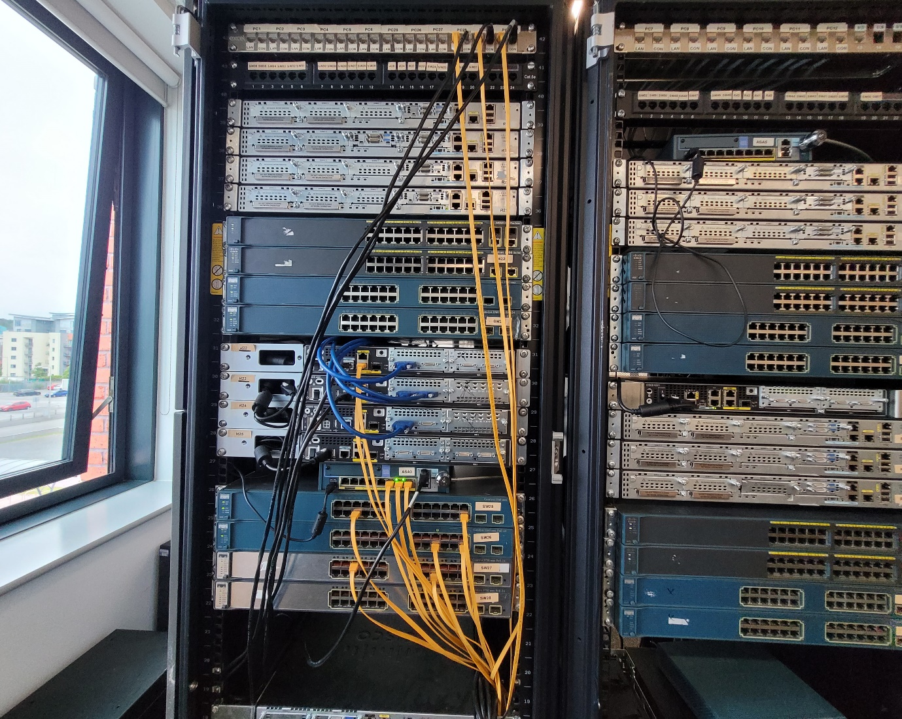
Figure 1-Topology set up using lab equipment
Figure 1 demonstrated the topology set up using laboratory equipment.

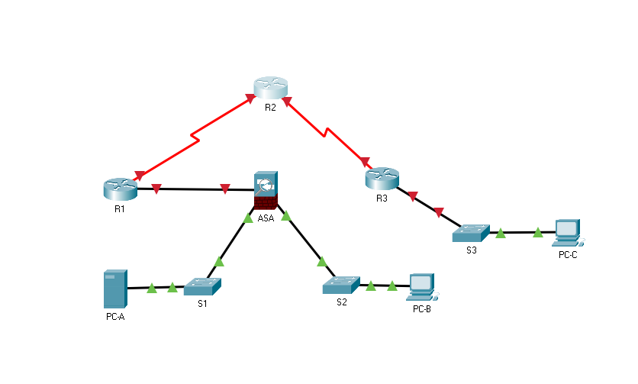
Figure 2-Topology set up using Cisco Packet Tracer
Figure 2 demonstrates the topology set up using Cisco Packet tracer.

1.3 Securing Cisco Routers
The following section configures and secures the Cisco routers.

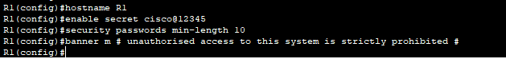
Figure 3-Basic security settings

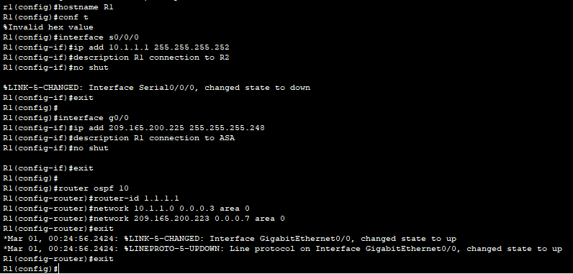
Figure 4-Setting up interface IP address and OSPF
Figure 3 and 4 demonstrates the basic settings and setting up the interface IP address and OSPF.

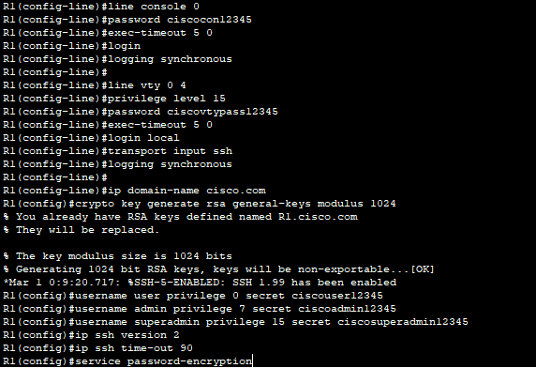
Figure 5-Privilege levels and role-based CLI Access
Figure 5 demonstrates the configuration command authorisation using privilege levels, role based CLI and secure administrative access configured.

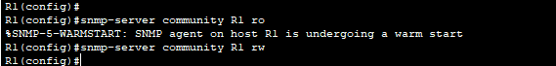
Figure 6-Monitoring network using SNMP
Figure 6 demonstrates the secure management and monitoring of network devices that have been implemented.

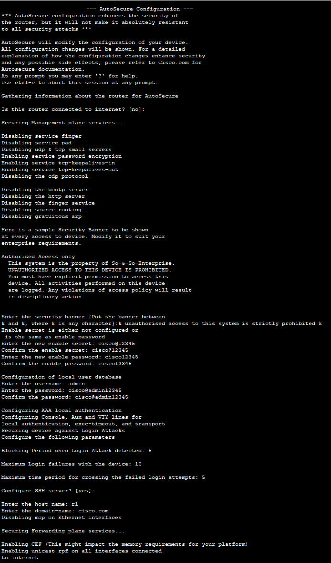
Figure 7-Automated features to enable security part 1

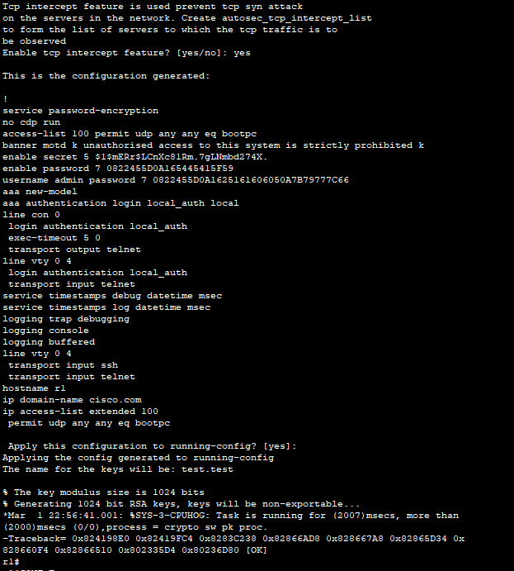
Figure 8-Automated features to enable security part 2
Figure 7 and 8 demonstrates using automated features to enable security on IOS-based routers.

1.4 AAA Implementation
AAA is implemented on Cisco routers with the use of local router database and external server.

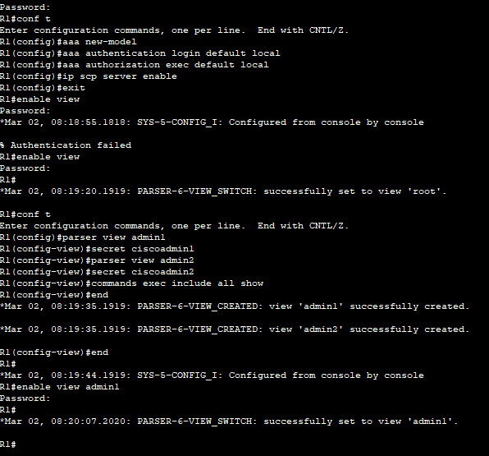
Figure 9-AAA authentication validating users against local database
Figure 9 demonstrates the implementation of AAA authentication that validates the user against local database.

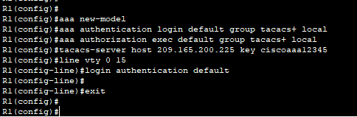
Figure 10-Configuring router using Cisco ACS for AAA
Figure 10 demonstrates the Cisco Secure ACS configured to support server-based AAA authentication.

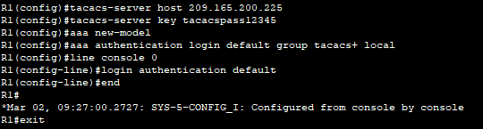
Figure 11-AAA authentication using TACACS+

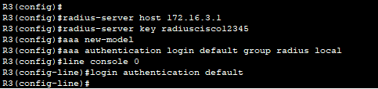
Figure 12-AAA authentication using RADIOUS
Figure 11 and 12 demonstrates the implementation of server-based AAA authentication with the use of TACACS+ and RADIUS protocols.

1.5 Using ACLs For Threat Mitigation
The following section is about mitigating threats to Cisco routers and networks using Access Control List, also known as ACLs.

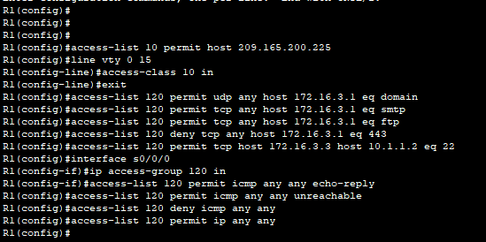
Figure 13-Access control lists to filter traffic and mitigate network attacks R1

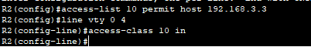
Figure 14-Access control lists to filter traffic and mitigate network attacks R2

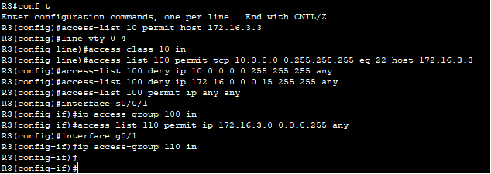
Figure 15-Access control lists to filter traffic and mitigate network attacks R3
Figure 13, 14, and 15 demonstrate the implementation of access control list, to filter traffic and to mitigate network attacks on a network. The figures also demonstrate the implementation of Zone-Based Policy Firewall using CLI

1.6 Layer 2 Attacks
The following section is about mitigating common Layer 2 attacks.

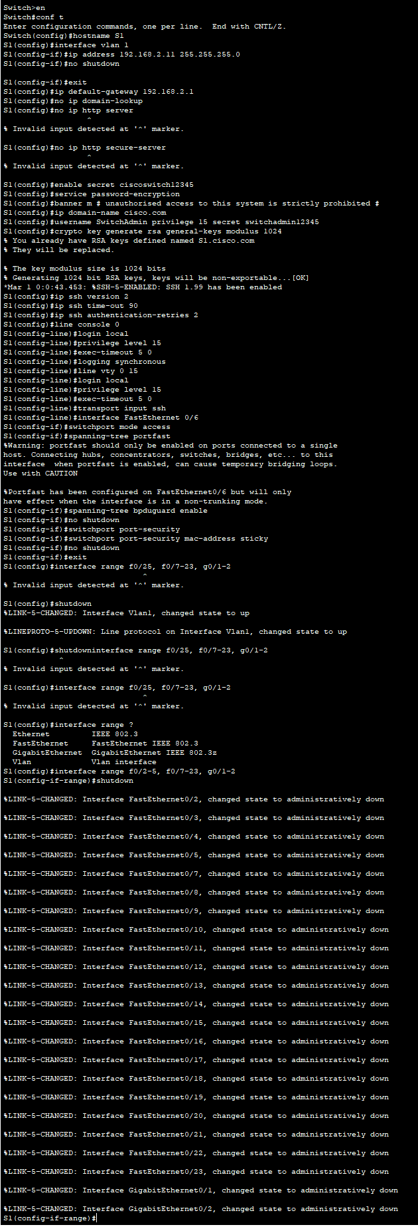
Figure 16-Switch security to mitigate LAN attacks SW1

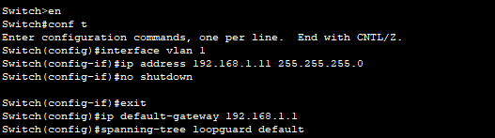
Figure 17-Switch security to mitigate LAN attacks SW2

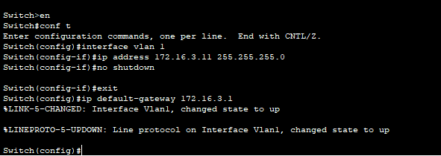
Figure 18-Switch security to mitigate LAN attacks SW3
Figure 16, 17, and 18 demonstrate the configuration of the switch security that is used to mitigate LAN attacks.

1.7 Cisco IOS Firewall
The following section demonstrates the implementation of the Cisco IOS firewall feature set.

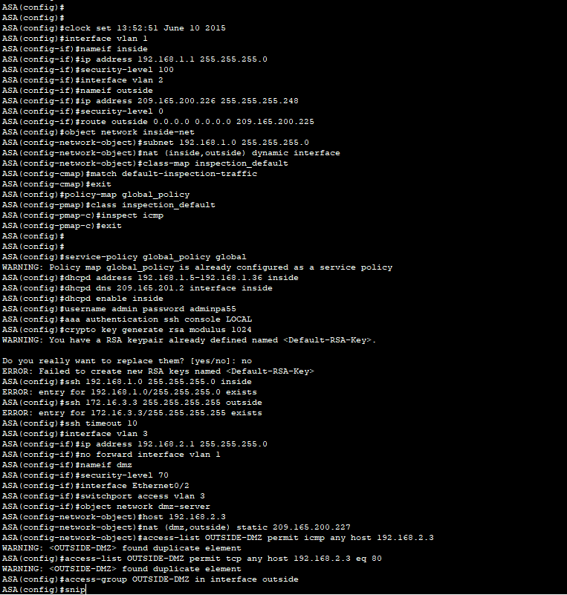
Figure 19-ASA firewall configuration
Figure 19 demonstrates a classic firewall configured to mitigate common network attacks and the implementation of Zone-Based Policy Firewall using CLI.

1.8 Conclusion
In conclusion, with the use of Cisco packet tracer, and current research carried out, the topology has been created and configured. The Cisco routers have been secured and AAA on Cisco routers is implemented. For threat mitigation, the access control list has been implemented and the switch has been securely configured to mitigate against LAN attacks, and other layer 2 attacks. Furthermore, the Cisco ISO firewall has been implemented and with the use of CLI the pre-shaped key authentication is implemented.

Part 2-Secure Network Infrastructure Proposition

2.1 Introduction
A2Z Technologies Ltd specialises in the design and manufacture of electronic equipment that are sold to companies in the UK and around the world. The head office of the company is based in Swansea and the manufacturing plant is based in Cardiff. There is no department that is based at the manufacturing plant, however the head office consists of various departments including sales, HR, R&D, finance, marketing, and customer relations. A number of employees are working from home, and some employees are using their personal devices to complete their work activities which requires the company to adopt cloud services. A2Z aim to be proactive and make their network infrastructure cybersecurity resilient.

2.2 Blueprint Design of Secure Network Infrastructure
Using the knowledge and understanding gained from part 1, Cisco Packet tracer is used to conduct a proposed blueprint design for A2Z Technology Ltd. The blueprint design is constructed and labelled.

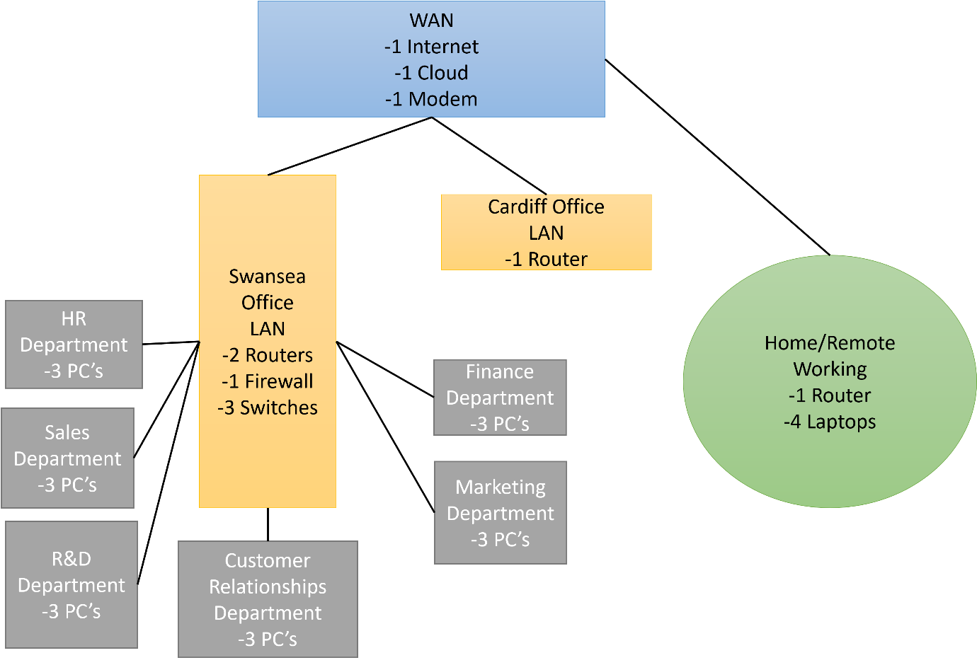
Figure 20-A2Z Technology Ltd Blueprint Design
Figure 20 demonstrates the proposed blueprint for A2Z Technology Ltd.
The blueprint design demonstrates a layout that meets A2Z Technology Ltd’s requirements. The blueprint shows that there are two offices, one is in Swansea, and another office is in Cardiff and they both operate on local area network (LAN). The Cardiff office does not have any onsite employees thus does not require any endpoint devices apart from one router. The Swansea Office does have onsite employees; thus it contains several endpoint devices, 2 routers, 1 firewall, and 3 switches. The Swansea office contains several different departments including HR, sales, R&D, customer relationships, finance, and marketing. All individual departments contain three PCs. The wide area network (WAN) contains the Internet, cloud, and a modern. The home working environment contains a wireless router and 4 laptops.

2.3 Design Proposal
A design to fit A2Z requirements is created using Packet tracer. This design proposal is explained to outline the proposed choices and security measures.

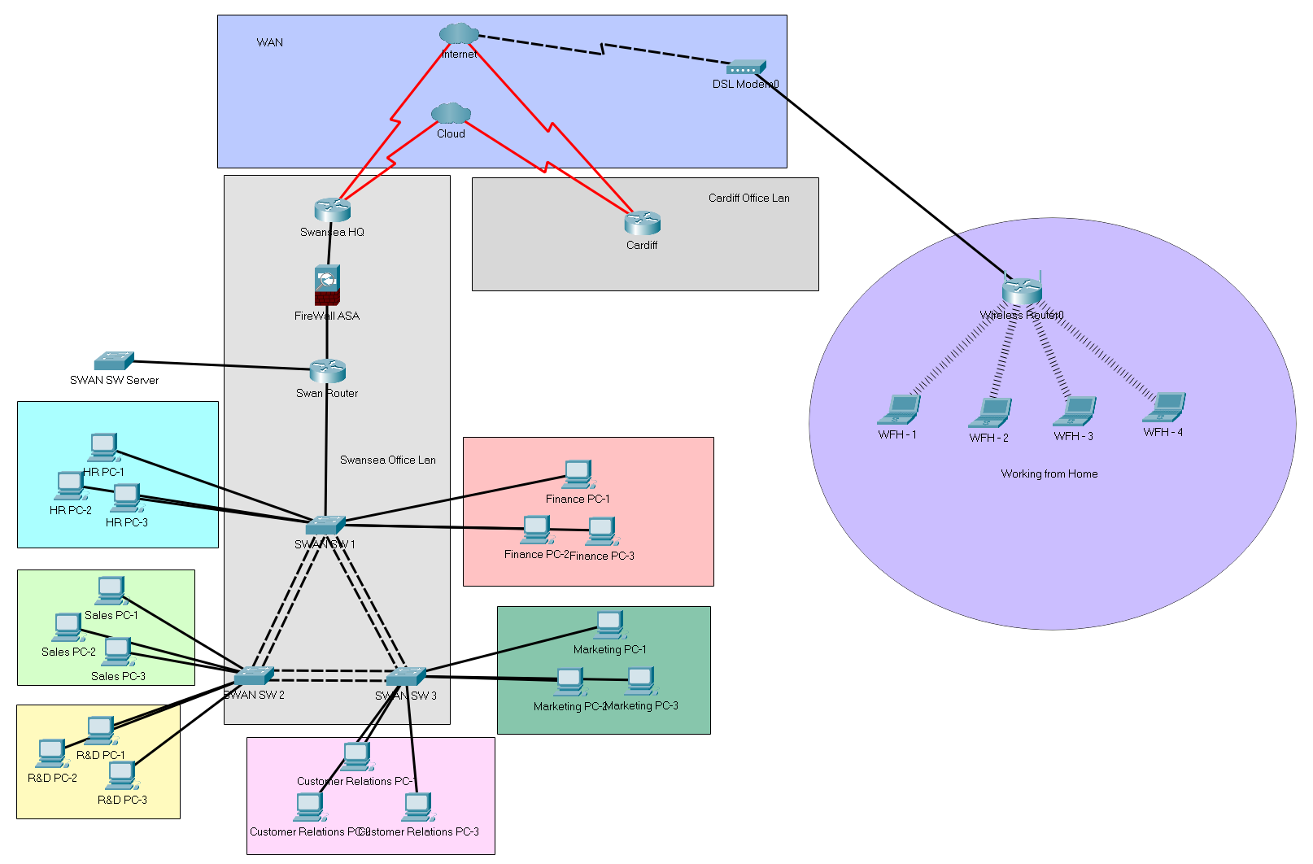
Figure 21-A2Z Technology Ltd Design Proposal
Figure 21 demonstrates the design proposal of a solution for A2Z Technology Ltd.
The creation of the design proposal must take into a consideration the practicability on the efficiency of the network but must not compromise the security in design. The requirements given out by A2Z required that the network typology design must incorporate security above all that allows for protection against modern security threats. This proposal will breakdown the different parts of the topology and explain why certain parts were used and given a reason to how they are operated and what layers of security they recommend. In the diagram provided by Cisco packet tracer it has been able to mock up a design and provide a quick configuration towards the setup this is to test and see how feasible it would be to set up the network in this state.
In the typology design 3 routers have been selected to keep simplicity and transparency going through. The three routers used are Cisco router 4321 which provide 2 Gigabit Ethernet ports, and two available NIM slots for further expansion on the router. Console connection and physical Kensington locks as are also provided. A compact 1u rack mountable router ensures that the router will not take up a lot of space and be very compact with the other routers, being able to stack 3 on top of each other. The routers are also built to have enough performance upgrades, includes a CPU offering four cores with two data plane calls; one control plane call and one dedicated for services and furthermore of up to 8 gigabytes of controlled and service memory till. The routers can be found inside the Swansea office as one of the routers will be used as in internal router on the other one will be used as an external router with a firewall placed in between them. The external router will have connections going to the Internet ISP and that will then be able to connect the cloud systems. From this, it will then be able to route its way to the Cardiff office where the 3rd and final router it will be found. In this design, the Cardiff router does not offer any form of connection as there is very little that happens in this area, and most of the security found inside is the access control lists.
The next step of the configuration of the typology is using switches. These are used to distribute multiple connections of devices across a network. Using three switches in a triangle formation with redundancy set up between them allows for continuous operation in case of downtime between the connections. This means that at any point the PCs should still be able to connect to the router. Furthermore, having a separate switch setup, the server connections allow for dedicated bandwidth and requires for them to be more secure in a segregated area. Having switch trunking enabled allows for the bandwidth to be higher between the switches giving them greater redundancy and speed and furthermore allowing for further growth and development with inside of the network. If the network expands, a fourth switch can be added to make a square shaped which would then create a need OnDemand for a layer three switch and a layer 2 switch.
In between the routers and switches is a firewall which is a Cisco ASA 505 and this particular device is used to filter incoming traffic and outgoing traffic for the security of the devices on the network. It can reduce an improved system performance and brings in a layer of defence against attackers that would try and take information and data from the company. Given the requirements and specifications, the router is placed in between the outside router and the inside router allowing it to process all incoming traffic and outgoing traffic making sure the Swansea office is secure as it is the head office. Cardiff office did not receive a firewall due to its size and lack of equipment required. Most of the activities can be covered internally on the router itself by using access control lists.
When it comes to the end users and the devices they are working on such as PCs and servers, they need to be kept more secure and have a layer security of their room place within them. The reason for this is an individual could have malicious intent and result in catastrophic damages towards the systems as they are very much inside the network. A solution to this is using vlans in each department as this will segregate and keep them separate from each other allowing only certain traffic that is wish to be allowed through to continue communicating. This will ensure cut communication and limit what type of network data is being transferred. Furthermore, using physical security all rooms will be locked at certain times and swipe key access is required to gain access mandatory security password changes will be required as well as maintenance on PCs as well and group policies to be placed on the physical device ports and connections. With the servers, limited access is required to be granted for people with selected permissions. Furthermore, a log and record, and physical security cameras are required to log the entry of the room being used to provide information of who enters and exits.
Lastly, the access to gain remote access to the network is provided by a simple diagram showing a home router and laptops connecting. These are all individually connected from different locations and homes. The diagram shows multiple users connecting over ADSL modem which would then go over the Internet and into either one of the offices. These devices are either a device provided by the organisation which has security already installed on it and a VPN, or this would be a bring your own device with VPN and a layer of security installed by the local administrator. This way the devices are secure and unpretentiously offer a threat or an opportunity for a hacker to take advantage.

2.4 Cost Analysis
The following section analyses the cost for implementing the solutions to fit A2Z Technology Ltd’s requirements.

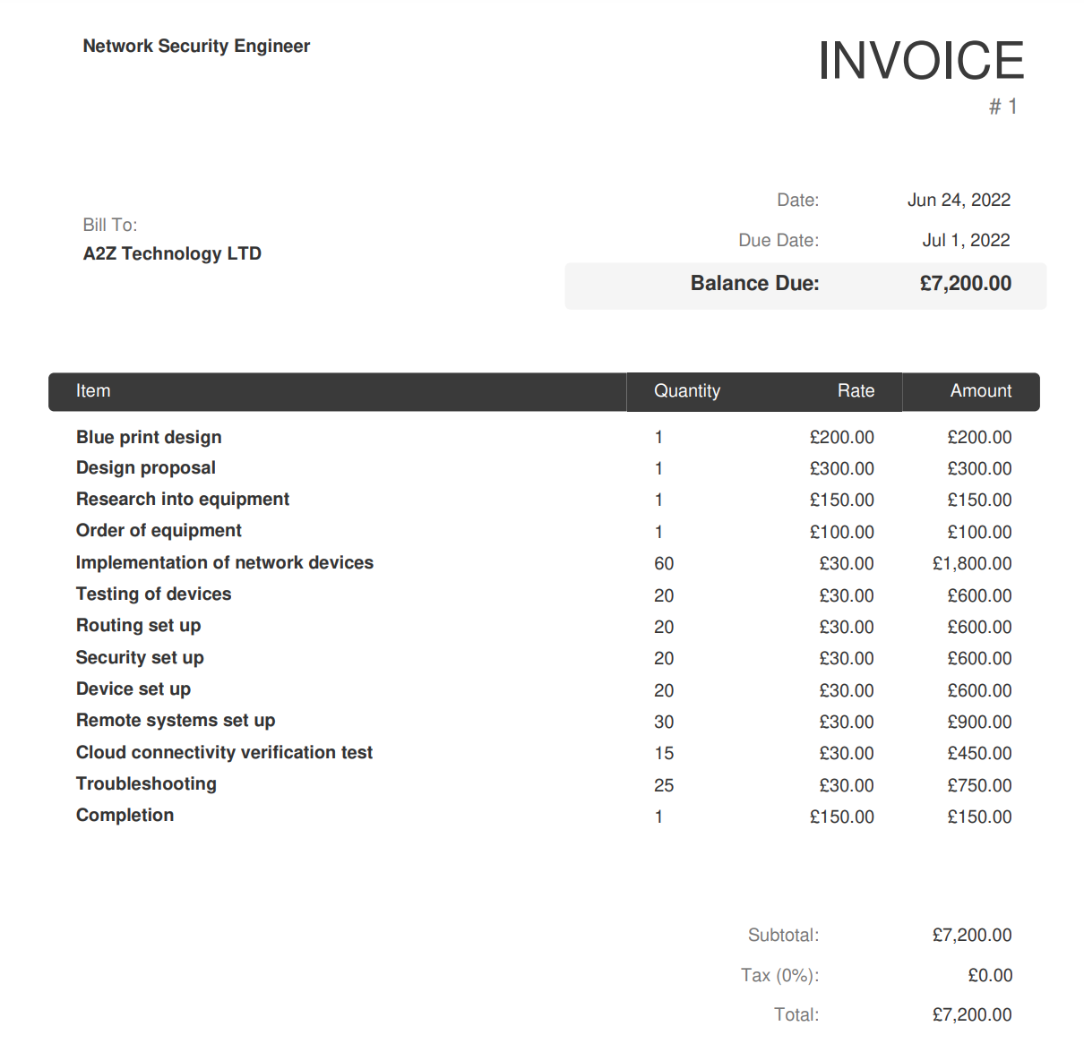
Figure 22-A2Z Technology Ltd Invoice
Figure 22 demonstrates the proposed invoice for A2Z Technology Ltd in the events that the organisation would choose the Network Security Engineer’s services.

2.5 Project Plan
Three-month project plan outlined of the conduction of the project. This shows the timeline of the implementation and the execution of solutions.

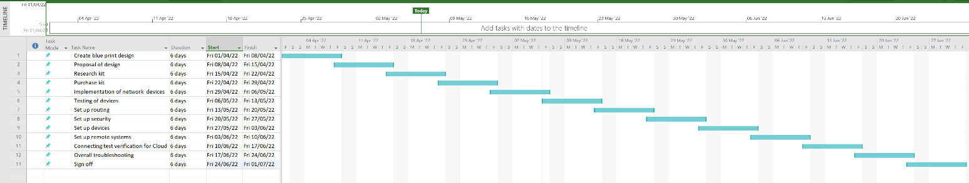
Figure 23-Gantt Chart
Figure 23 demonstrates the Gantt chart of the 3 months project plan to implement the solutions. The Gantt chart demonstrates the length off time each task has been allocated to complete.

2.6 Attack Threats to Organisations
Three different attacks are explained to A2Z that target organisations network infrastructure.
DDoS- One of the main attacks targeting organisations in recent years is the DDoS attack which is the most commonly performed type of cyber-attack with the aim of suspending the target and making them unavailable to the users. [9] One of the recent attacks that occurred on GitHub, demonstrated that the traffic was traced back to over a thousand different systems across millions of unique endpoints, this shows that DDoS attacks use various different protocols, and the attackers use botnets to execute the attacks. [9] DDoS attacks are extremely difficult to protects against, and large number of organisations turn to third party providers for such security protection against this threat. [9] However, research from Part 1 found that load balancers can also be used to absorb the effect of DDoS attacks. [2]

Structured Query Language- Another threat that organisations face is structured query language, also known as SQL attacks. [10] SQL is a programming language that is used to query a database, originally designed to manage data in relational database management system. [10] The most essential SQL commands are: INSERT, CREATE, UPDATE, DROP, SELECT and DELETE. [10] Attackers could potentially submit commands directly into the database, utilising vulnerabilities. [10] SQL injection and cross site scripting are two of the most commonly seen types of attacks. [10] Research in Part 1 found that IDS/IPS provides protocol analysis and signature matching off data packets which can prevent SQL injection attacks. [2]

Malwares- Malwares (malicious software) are posing a major threat to critical infrastructures. [11] Malicious software is designed to cause damage to the victim’s computer or network that provide services. [11] There’s several variations of different malwares including spyware, ransomware, and viruses. [11] Ransomware it's also malware that can cause sophisticated attacks and it effected many industries including transport, financial companies, telecommunications, health services, and low enforcement. [11] Research from Part 1 found that to mitigate such attack, Sandbox is a method and is similar to IDS/IPS. The system environment is monitored by the Sandbox to ensure threats such as malwares are not targeting the network. [2] Another key tool is found in Part 1 is NTA/NDR that monitors traffic directly. Using machine learning algorithms and statistical techniques, anomalies are monitored to determine the presence of threats. [2]

2.7 Secure Network Infrastructure Test
Three types of tests are recommended to be conducted to ensure the network infrastructure is secure following the implementation.
Black box test- Black box testing is also known as behavioural testing. This type of testing is a software testing method where the functionalities of the software application are tested without prior knowledge of internal code structure, internal path, and implementation details. [12] This type of testing focuses on inputs and outputs of software applications and is based on the software requirements and specifications. [12] There are several types of black box testing including functional testing, non-functional testing, and regression testing. [12] Functional testing is carried out by software testers and this type of testing relates to the functional requirements of the system. [12] Non-functional requirements include performance, scalability, and usability and this type of testing does not relate to testing specific functionalities, in fact it tests non-functional requirements. [12] Regression testing monitor that the new code is not affecting the existing code following system maintenance, upgrades, and code fixes. [12]
Grey box test- Grey box testing test software production or application with some prior knowledge of the internal structure of the application. [13] Grey box test is carried out for the purpose of identifying and searching the defects there are in result of incorrect code structure and inappropriate use of applications. [13] There are four techniques used for grey box testing, these are matrix testing, regression testing, pattern testing, and orthogonal array testing (OAT). [13] Matrix testing defines all variables that exist in the programmes. [13] Regression testing monitors if there's been any regression to the old program in result of the new version implemented. [13] OAT technique provides maximum code coverage with minimum test cases. [13] The 4th technique is pattern testing which performs tests on historical data where previous system had defects. [13]
White box test- White box testing is a software testing technique where internal structure, coding of the software, and the design are tested to monitor the flow of input and output and to improve usability, design, and security. [14] Analysis techniques that can be used when performing white box tests are statement coverage and branch coverage. Statement coverage requires every possible statement to be tested at least once in the code. [14] Branch coverage checks all possible paths of software applications. [14] There are many more coverage types, but the main white box testing technique is code coverage analysis. This technique identifies the areas of program that are not exercised by a set of test cases and once gaps have been identified, test cases can be created to verify the untested parts of the code, which in result improves the quality of the software product. [14]

2.8 Invoice
Invoice of professional consultation services carried out for A2Z as a network security engineer.

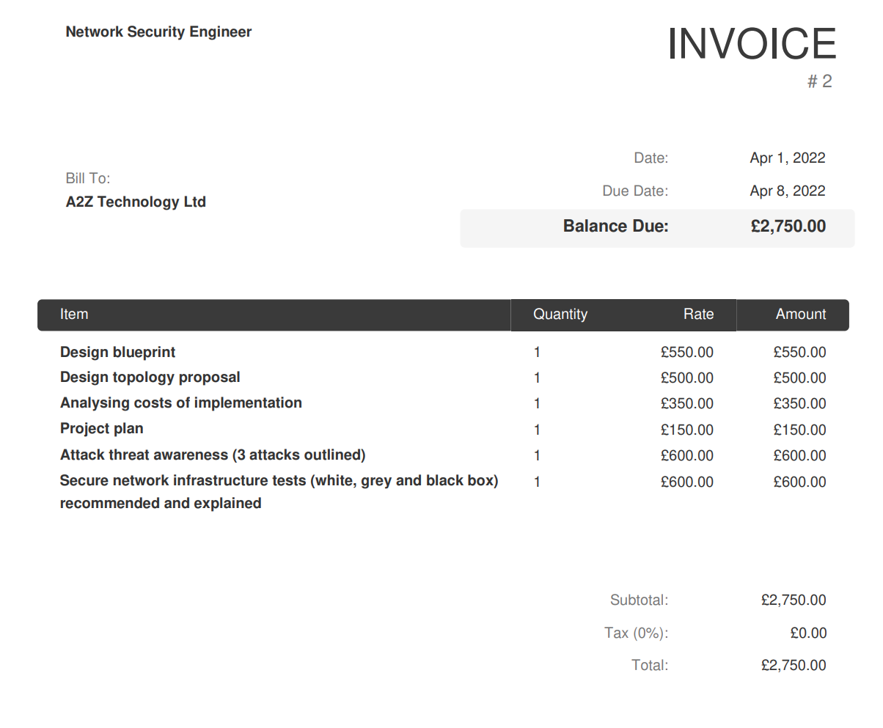
Figure 24-A2Z Technology Ltd invoice for professional work carried out
Figure 24 presents the invoice for A2Z Technology Ltd for the professional network security engineer’s services.

2.9 Conclusion
In conclusion, using the research carried out in part 1, a secure network infrastructure is designed to be implemented by A2Z Technology LTD. The software used to design the blueprint of the design is Cisco Packet tracer. The proposed choices and security measures provided to A2Z have been fully explained, and the cost analysis for the implementation of the solutions have been outlined. A three-month project plan timeline has been created to demonstrate the planned time for implementation. Three attacks have been explained to A2Z group to that propose current threat to organisations network infrastructure. Furthermore, three types of tests are recommended to be conducted once the implementation has been completed to ensure that the network infrastructure is secure. The tests recommended to A2Z are black, grey, and white box tests. An invoice for A2Z technology Ltd for the professional services carried out by the network security engineer is provided.

References
[1]"What is Network Infrastructure Security? | VMware Glossary", VMware, 2022. [Online]. Available: https://www.vmware.com/topics/glossary/content/network-infrastructure-security.html. [Accessed: 08- Mar- 2022].
[2]"What is Network Security? | VMware Glossary", VMware, 2022. [Online]. Available: https://www.vmware.com/topics/glossary/content/network-security.html. [Accessed: 08- Mar- 2022].
[3]"Network Threats - Types of Network Security Threats | Proofpoint UK", Proofpoint, 2022. [Online]. Available: https://www.proofpoint.com/uk/threat-reference/network-delivered-threats. [Accessed: 08- Mar- 2022].
[4]"Top 3 network security threats and how to protect against them", SearchNetworking, 2022. [Online]. Available: https://www.techtarget.com/searchnetworking/tip/Top-3-network-security-threats-and-how-to-protect-against-them. [Accessed: 08- Mar- 2022].
[5]"Network Security: Top 5 Fundamentals", IT Manager Daily, 2022. [Online]. Available: http://www.itmanagerdaily.com/network-security-fundamentals/. [Accessed: 08- Mar- 2022].
[6]2022. [Online]. Available: https://www.ncsc.gov.uk/information/reducing-your-exposure-to-cyber-attack. [Accessed: 08- Mar- 2022].
[7]C. Press, "Cisco Network Foundation Protection Framework > CCNA Security Portable Command Guide: Network Foundation Protection | Cisco Press", Ciscopress.com, 2022. [Online]. Available: https://www.ciscopress.com/articles/article.asp?p=1924983&seqNum=2. [Accessed: 08- Mar- 2022].
[8]"Endpoint Guide: Threats, Security, Visibility, and Protection", Secureworks.com, 2022. [Online]. Available: https://www.secureworks.com/blog/endpoint-security-guide-management-protection-detection. [Accessed: 08- Mar- 2022].
[9]D. Manikumar and B. Maheswari, "Blockchain Based DDoS Mitigation Using Machine Learning Techniques", 2020 Second International Conference on Inventive Research in Computing Applications (ICIRCA), 2020. Available: 10.1109/icirca48905.2020.9183092 [Accessed 9 March 2022].
[10]P. Tanakas, A. Ilias and N. Polemi, "A Novel System for Detecting and Preventing SQL Injection and Cross-Site-Script", 2021 International Conference on Electrical, Computer and Energy Technologies (ICECET), 2021. Available: 10.1109/icecet52533.2021.9698688 [Accessed 9 March 2022].
[11]T. Reshmi, "Information security breaches due to ransomware attacks - a systematic literature review", International Journal of Information Management Data Insights, vol. 1, no. 2, p. 100013, 2021. Available: 10.1016/j.jjimei.2021.100013 [Accessed 9 March 2022].
[12]"What is BLACK Box Testing? Techniques, Example & Types", Guru99, 2022. [Online]. Available: https://www.guru99.com/black-box-testing.html. [Accessed: 10- Mar- 2022].
[13]"What is Grey Box Testing? Techniques, Example", Guru99, 2022. [Online]. Available: https://www.guru99.com/grey-box-testing.html. [Accessed: 10- Mar- 2022].
[14]"What is WHITE Box Testing? Techniques, Example & Types", Guru99, 2022. [Online]. Available: https://www.guru99.com/white-box-testing.html. [Accessed: 10- Mar- 2022].

