Chapters and other information to include within the dissertation:



Heroes or Heretics?
An investigation into the public’s perception of vigilantism: Are the public supportive of Vigilantes and their acts?

Name of student: Abbey Luckwell
Student number: 2016623
Degree title: BSC Professional Policing Practice

Acknowledgements

First and foremost, I'd want to thank my dissertation tutor, Lewis Tandy, for all Their help and support throughout this process.
In addition, I would like to thank my Mum and Dad for being incredibly supportive whilst I was completing this study, my friends who helped me relax and take time to look after myself so I could become more resilient through this process.
Finally, I would like to give my sincere thanks to my boyfriend Jay who stuck with me and pushed me to do my very best even when I wanted to give up.

Declaration
This work has not previously been accepted in substance for any degree and is not being concurrently submitted in candidature for any degree.
Signed: A.L
Date: 03/07/2023

STATEMENT 1
This dissertation is being submitted in partial fulfilment of the requirements for the degree of BA.
Signed: A.L
Date: 03/07/2023

STATEMENT 2
This dissertation is the result of my own independent work/investigation, except where otherwise stated.
Other sources are acknowledged by footnotes giving explicit references. A bibliography is appended.
Signed: A.L
Date: 03/07/2023

STATEMENT 3
I hereby give consent for my dissertation, if accepted, to be available for photocopying and for interlibrary loan, and for the title and summary to be made available to outside organisations.
Signed: A.L
Date: 03/07/2023

STATEMENT 4
I hereby give consent for my dissertation, if accepted, to be available on the university’s IT system to those who have consent to use the system.
Signed: A.L
Date: 03/07/2023

Abstract

The Aim of this research was to investigate how the general public perceives vigilantism and analyse the rationales for and against it. Additionally, to also explores how technology advancements have influenced vigilante actions and how the dissemination of false information could encourage people to commit vigilante crimes.
To assist in understanding the publics perceptions of vigilantes and underlying reasoning to why the public may be supportive of their acts, primary research was then conducted in the form of a survey that was distributed online, to gather both qualitative and quantitative data, which was then compared to the secondary data.
The study's findings provided support for a sizable portion of the literature that was examined in chapter 2. The topics identified in this study regarding the publics perceptions of vigilantes are education, confidence in the police and criminal justice system, misinformation, and the type of crime committed to elicit a vigilante act. Each of these factors influences the possibility that the public will support vigilantism. However, the aim was achieved for the question: “Does the public support vigilantism?” as most of the participants were against vigilantism.

Contents
1. Chapter One: Introduction 8
1.1. Backround and rationale 8
1.2. Aim and Objectives 9
1.2.1. Aim 9
1.3. Objectives 9
1.3. Conclusion 9
2. Chapter Two: Literature review 10
2.1. Introduction 10
2.2. What is Vigilantism ? 10
2.2.1. Defining Vigilantism 10
2.3. Vigilantes and contemporary policing 11
2.3.1. Digital Vigilantes 11
2.3.2. Online “Paedophile Hunters” 11
2.4. Use of Media and the Spread of Misinformation 12
2.5. Public Perception 12
2.5.1. Confidence Hypothesis 13
2.5.2. Situational Hypothesis 13
2.6. Criminal justice system 13
2.7. Conclusion 14
3. Chapter Three: Methodology 15
3.1. Introduction 15
3.2. Primary v Secondary Research 15
3.3. Research Onion 15
3.3.1. Research Philosophy 16
3.3.2. Research Approach 16
3.4. Methodological choice 17
3.5. Strategy 17
3.6. Ethical consideration 17
3.7. Time Horizon 18
3.8. Conclusion 18
4. Chapter Four: Data Analysis 19
4.1. Introduction 19
4.2. Questionnaire findings 19
4.2.1 Question 3: Educational level 19
4.2.2. Question 4: In your own words, what is a vigilante? 20
4.2.3. Question 7: When do you believe vigilant acts are justified? 20
4.2.4. Question 8: Which incidents in your opinion, is the cause of most vigilante involvement? 21
4.2.5. Question 10: How much do you support vigilantism? 22
4.2.6. Question 14: Do you agree that misinformation inspires people to engage in vigilantism? 23
4.2.7. Question 15: What do you think could be done to end vigilante acts? 23
5. Chapter Five: Findings and Conclusion 25
5.1. Introduction 25
5.2. Publics definition of vigilantism 25
5.3. Support for vigilantism and the criminal justice system 25
5.4. Education 25
5.5. Offences that could prompt vigilante acts 26
5.6. Misinformation 26
5.7. Conclusion 26
6. Chapter Six: Recommendations 27
6.1. recommendation one: Larger Scale Survey 27
6.2. Recommendation two: providing the participants with a definition. 27
6.3. Recommendation Three: Accessible guides 27
6.4. Recommendation Four: Education programmes for children 27
6.5. More awareness of mis-information 27
7. Reference list 28
8. Appendices 37
8.1. Appendix 1 –Backlog of cases in the crown court Q2 210 to Q3 2022 37
8.2. Appendix 2 - The Research ‘Onion’ 37
8.3. Appendix 3 – Survey and results 39

- Chapter One: Introduction

This study seeks to understand how the general public views vigilantes, whether they support it, and the underlying reasons for their support. The context and background for this study are given in this chapter of the dissertation, along with an explanation of the significance of this field of study.

1.1. Backround and rationale
In the 19th century, the word "vigilante" made its way into the English language, having been derived from the Spanish word with the same spelling meaning “sentinel” or “watchman” (Safire, 1985). The term was first used in English to describe a member of a vigilance committee, a group set up to swiftly repress and punish crime when the legal system seemed to be failing (Safire, 1985). However, despite the implementation of more laws and technological advancements in the police and criminal justice systems over the past 200 years, vigilantism is still actively practised today by both lone individuals and groups (Trottier, 2016; Tippett, 2022).
Vigilantism is widespread throughout the world and is intimately related to crucial ideas like order (Bateson, 2020). However, for many years, the study of vigilantism has been largely abandoned by political science to historians (Abrahams, 1998, p.6), sociologists (Frampton, 2022),cultural studies experts (Tankebe, 2009). Only once or twice a year do the words "vigilantism" and "vigilante" normally occur in prestigious political science journals (Bateson, 2020). These references are frequently figurative in nature nevertheless, several political scientists—most notably Rosenbaum and Sederberg (1974), and Kirkpatrick (2008a)—have written more extensively about vigilantism (Bateson, 2020). There is clearly a lack of literature regarding vigilantes (Bateson, 2020) and with the backlog of cases for the crown court being at 62,800 and magistrates at a backlog of 347,820 (Institute for Government, 2023), the wait times for victims getting justice is rising, with 20% of victims waiting 1-2 years to have their day in court (Institute for Government, 2023). Criminal law committee co-chair Richard Atkinson has expressed concern that an increasing number of people will feel the delays are untenable and take the law into their own hands (Dearden, 2020). There is a genuine risk that individuals may start to feel there is no sense in reporting issues and they should handle them themselves by carrying out vigilante acts (Dearden, 2020).

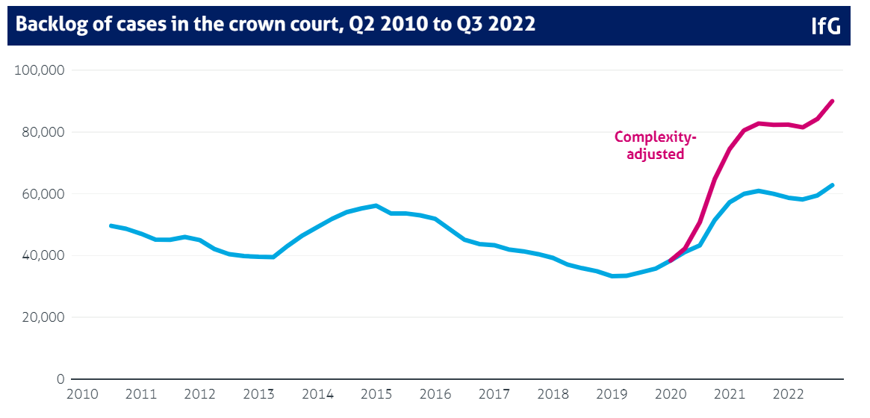
Figure 1. – Backlog of cases in the crown court, Q2 2010 to Q3 2023

Aim and Objectives

Aim
The aim of this research project is: To gain an understanding of the publics perspectives of vigilantism and to potentially identifying the underlying factors as to why the public support it.

Objectives

Objectives:
1. To conduct a critical review of existing and new academic literature on vigilantes and the public, as well as the role media plays in vigilantism.
2. To establish a suitable method to investigate public perceptions and understanding on the issue of vigilantes.
3. To analyse the information obtained to determine the public's perceptions towards vigilantism and whether they are in favour of it. Additionally, discover any underlying causes for their support, such as false information being circulated by the media and the criminal justice systems.
4. To provide recommendations associated with the key elements of vigilantism that have been identified.

1.3. Conclusion
This Chapter introduced the research study, detailed its aims and objectives, and discussed how and why it is significant to the ongoing studies on vigilantism and the public. A literature review will be presented in the following chapter, adding depth to the topics covered here.

2. Chapter Two: Literature review

2.1. Introduction
This chapter analyses significant, relevant, and academically acknowledged sources of literature in relation to the subject of vigilantes and their role within contemporary policing. This chapter will also highlight and explore the public’s perception of vigilantes and vigilantism and analyse the reasons for supporting such acts.
Additionally, to meet my objective I will discuss on how vigilante acts have been shaped by technological advances and how the spread of misinformation can cause individuals to carry out vigilante acts.

2.2. What is Vigilantism ?
There are numerous stories of vigilantism throughout history, whereby vigilantes are usually depicted as heroes and their actions deemed heroic regardless of whether this was the case (Lisa Arellano, 2012, p. 133–134).
Vigilantes and vigilantism have always existed as a form of social justice, from the San Francisco Committee of vigilance, which was founded in the 1850s in response to the widespread crime and corruption in the municipal government (Walker, 2000), to the more recent "Dark Justice" group in the United Kingdom, which was established in 2014 to catch online child predators (Tippett, 2022). According to Sederberg (1978), vigilantism stems from a need to protect social order in the face of behaviour that deviates from accepted social norms (Sederberg, 1978).

2.2.1. Defining Vigilantism
Defining the term “Vigilante” however, can be extremely difficult as everyone has a different opinion on what it is. According to Abrahams (1998), “vigilantism is not easy to define in rigorous, authoritative terms” (p. 6). The term "vigilantism" in scientific literature can be used to describe a wide range of actions, including terrorism, establishment violence, and uncivil disobedience (Rosenbaum & Sederberg, 1974, p. 542; Kirkpatrick, 2008a). Intuitively, "taking the law into one's own hands" is a common definition of vigilantism. However, because it is unclear what exactly "taking the law into one's own hands" implies, this informal interpretation is an inadequate basis for social scientific research on vigilantism (Rosenbaum & Sederberg, 1974, p. 542; Asif, 2022).
Even more constraints are placed on the idea by Johnston (1996), who defines vigilantism in terms of several requirements such as premeditation, voluntary action by private persons, group action, the use of force or threats of force, and security assurances.
This study will require a definition of vigilantism that is clear enough to avoid conceptual deliberation to the point of ineffectiveness, inclusive enough to allow comparison and for it to be operationalisable. For this study Regina Batesons (2020) definition will be used. Bateson defines Vigilantism as:
“the extralegal prevention, investigation, or punishment of offense” (Bateson, 2020, p.944)
Extra-legal being a term in this definition beyond or not regulated the law and not illegal (Bateson, 2020). The second part of Bateson’s definition is prevention, investigation, or punishment, these can be used separately or in a sequence (Bateson, 2020; Goldstein, 2012, pp.2–32). Bateson (2020) goes on to say that vigilantism necessitates action and that it is a behaviour that individuals engage in. Vigilantism may be used by both groups and individuals on a regular or irregular basis, frequently in conjunction with other strategies (Goldstein, 2012, pp.2–32). The third part of the definition is offence, Bateson establishes that vigilantism is a reaction to an offence (Bateson, 2020). However, an offence to vigilantes may not be a legal offence as outlined by the law, it could be a deviance from the local norm or social construct (Kirkpatrick, 2008b; Goode, 2015, p.99). Laws and standards can also change over time. For instance, when the coronavirus pandemic began to spread at the beginning of 2020, so-called "virus vigilantes" began acting extralegally to prevent, investigate, and punish actions that would not have been considered crimes just a few weeks earlier (Lashua, Johnson and Parry, 2022). Leaving one's house, mixing with others and visiting different places were examples of these behaviours that were now crimes (Harris et al., 2022; Bateson, 2020.)
Vigilantism is not always violent and can be non-violent (Bateson, 2020) as will be discussed throughout this review.

2.3. Vigilantes and contemporary policing

2.3.1. Digital Vigilantes
Due to the technological advances in the last two decades, there has been a rise in cyber vigilante groups and cyber vigilantes (Tippett, 2022). Digital vigilantism is the practice of orchestrating retribution via social media and mobile devices by individuals who are collectively offended by the actions of other individuals (Trottier, 2016; Dunsby and Howes, 2018). The offenses range from minor transgressions of social norms to acts of terrorism and involvement in riots (Dunsby and Howes, 2018). Digital vigilantes will often "DOX" an offender (Dunsby and Howes, 2018). To "Dox" or "Doxing" an individual or group is a form of "Naming and Shaming", whereby the targets personal details and even images are published for the public to see (Trottier, 2016).

2.3.2. Online “Paedophile Hunters”
In recent years, Self-Proclaimed, “Paedophile Hunters” have operating online to catch predators who are grooming children online (Frampton, 2022; Purshouse, 2020). They do this by employing a variety of techniques to convince groomers to be open and honest about their goals and interests (Frampton, 2022). Once these vigilantes have obtained enough information for them to reasonably believe that the other party believes they are speaking to an underage child they will arrange a meeting at a decoy house (Frampton, 2022). These “Hunters” will then look to film the encounter with the individual and dox them on social media, many of these “Stings” will be livestreamed for the public to watch and saved for others to watch later, usually the police are also called to attend and arrest the individuals 9Purshouse, 2020). Since 2013, 8 men who have been “Outed” and “Doxed” by these public stings have taken their own lives, with one male in August 2022 slicing his own throat while being filmed at a meet up (New York Post, 2022).
Paedophile hunters and the police have a complicated relationship. In 2019 the National Police Chiefs Council (NPCC) responded to Online Child Abuse Activists Groups (OCAG). It set out 4 types of groups of paedophile hunters that are currently operating in the UK (National Police Chiefs Council, 2019). Type 1 being Law Enforcement, Type 2 is Passive Partners, Type 3 are E- activists and type 4 are Real World Activists (National Police Chiefs Council, 2019). Type 3 and type 4 are vigilantes, however type 3 will only interact online while type 4 will go further and interact withing the real world (National Police Chiefs Council, 2019). This type of paedophile hunting poses no benefit to policing. The NPCC challenges these real-world activists by posing the question, why are these organisations still active when doing so puts prospective victims, suspects, and the efficiency and efficacy of the criminal justice system at risk? (National Police Chiefs Council, 2019; CPS, 2020; Frampton, 2022). Undoubtedly, the question of risk management and public protection, as well as who is responsible for these, is one of the main concerns surrounding paedophile hunters (CPS, 2020). For example, once a suspect leaves one of these “Stings” there is no safeguarding for the past victims (Frampton, 2022).

2.4. Use of Media and the Spread of Misinformation
Doxing, however, is not a new tool for modern vigilantes. On 1st July 2000 Sarah Payne, an 8-year-old girl was abducted and murdered by Roy Whiting (The Economist, 2001). Roy Whiting was a registered sex offender who had previously been convicted for abducting and sexually assaulting an 8-year-old girl in 1995 (Oliver, 2001). In response to the murder of Sarah Payne, a national newspaper, The News of the World, started a “Naming and shaming” campaign whereby they published images of sex offenders in the UK with their names and addresses (Liebling, Maruna and McAra, 2017, pp.272–274). Not only was this in response to the murder of Sarah Payne it was also a response to the government “Protecting” the details of registered sex offenders (Liebling, Maruna and McAra, 2017, pp.272–274). Within the article, it requested that readers do not engage in vigilante behaviour, however in Paulswood housing estate, a group of mothers turned vigilantes, organised marches and held vigils outside the homes of known paedophile’s, protesting against the housing of these individuals (Bell, 2002a). Elsewhere, there were accounts of convicted sexual offenders running away from their homes, facing irate mobs, having their property and loved ones attacked, and, around a fortnight after the News of the World campaign started, individuals had committed suicide (Bell, 2002b; Born, 2000). An innocent male, Ian Armstrongs home was also attacked due to mistake identity because of images that had been distributed by the newspaper (BBC News, 2000). Armstrong advised that a group of neighbours had gathered outside his home and were shouting “peadophile” at him (BBC News, 2000). Armstrong was so petrified that he brought his documents outside to show the group that he was not the person that they had identified him as (BBC News, 2000).

2.5. Public Perception
Lack of trust in the criminal justice system is still frequently cited as a cause of vigilantism (Haas, de Keijser and Bruinsma, 2012; Marsh et al., 2019; Tyler et al., 2012). Although vigilantism doesn't seem to be a common occurrence in many developed nations, there are signs that when it does, the public supports such extra-legal actions to a considerable degree (Rosenbaum and Sederberg, 1974). For example, Marianne Bachmeier, a single mother from Germany shot the male who was responsible for the death of her 7-year-old child six times while he was in court standing trial for the offence (Robson and Spina, 2022, pp.138–139). Due to her ruthless vigilante action, her trial attracted attention from all over the world. In a series of articles about the trial, the weekly German magazine Stern delved into Bachmeier's past as a working single mother who had a very difficult upbringing (Nahanara, 2021). The response from readers to the magazine was overwhelmingly positive. Had Marianne Bachmeier's act of vigilantism turned her into a cold-blooded killer or was she just a heartbroken mother seeking to exact revenge for the horrible death of her child (Ishak, 2021). After the trial of Marianne Bachmeier where she was sentenced to 6 years for the offences of premeditated manslaughter and unlawful possession of a firearm the Allensbach Institute conducted a study to find out what the public thought about her sentence (Nahanara, 2021). They found that 28% of Germans thought her six-year sentence was reasonable, 27% thought it was too harsh, and 25% thought it was too lenient (Nahanara, 2021).

2.5.1. Confidence Hypothesis
Nicole Haas (2010) hypothesises that there are 2 reasons for the public support of vigilantism. The first being the “Confidence Hypothesis.” The confidence hypothesis is the theory that vigilantism is supported when the public has low or even no confidence in the formal authorities (Haas, 2010; Robinson and Darley, 1995). This theory pertains to the general confidence in law enforcement and not in relation to a specific crime or offence (Hass, 2010). In a more recent study, Tyler et al. (2012), linked normative views toward three different types of violence to perceptions about the police and criminal justice system. With young men from diverse London ethnic minority communities serving as respondents, the study found that police perceptions are linked to responses to private violence is the study's most pertinent finding (Tyler et al., 2012). Retaliation and using violence to settle a conflict with neighbours in situations was viewed more adversely by respondents the more favourable they were of the police. These findings were also supported by a study done in Ghana in 2009 by Tankebe, which found that public support for vigilantism was substantially correlated with people's perceptions of how trustworthy the police were; those who thought the police were unreliable were more likely to support vigilantism than those who thought they were reliable, which again conforms to Haas' (2010) confidence hypothesis rather than the situational hypothesis. These two studies contribute significantly to the body of knowledge on public support for vigilantism and lend credence to the claim that distrust of the police may influence the public to support vigilante behaviour (Tyler et al., 2012; Haas, 2010; Tankebe, 2009).

2.5.2. Situational Hypothesis
The second hypothesis that Haas (2010) theorised was the “Situation Hypothesis.” According to this hypothesis, the elements of the act of vigilantism itself influence the support for it, support from the public may take the form of opinions on the crime itself, how serious they believe it to be, the identity of the victim and the perpetrator, and other factors (Rossi, Simpson and Miller, 1985). If the public does accept a vigilante act, it may not be because they no longer believe in the criminal justice system; rather, it may be due to the circumstances surrounding a particular instance of vigilantism (Stone, 2016; Haas, de Keijser and Bruinsma, 2012). Based on a study conducted by Haas (2010), it was shown that public support for vigilantism was not solely determined by confidence in the police, the situation's specific characteristics were also deemed to also be a factor. Additionally, it was discovered that a vigilante's use of violence and the police's response to it both affected respondents' reactions to the act of vigilantism that was taking place (Haas, de Keijser and Bruinsma, 2012). Another study conducted by Dow et al. (2023) on vigilantism in Guatemala found that when the public decide whether offences warrant the use of vigilante retribution, they consider the gender of the perpetrator and victim, their relationship to the police or a gang, and the seriousness of the crime (Dow et al., 2023). The findings indicated that respondents favoured vigilantism over traditional policing for male offenders, offenders who have targeted women, offenders who have committed serious crimes, and those connected to the police and gangs (Dow et al., 2023). These studies support the theory that when the public openly support acts of vigilantism, it does not necessarily indicate a lack of confidence in the criminal justice system. People may just respond to situational factors without their perception of the police necessarily having an impact (Hass, 2010; Haas, de Keijser and Bruinsma, 2012).

2.6. Criminal justice system
In 2019 the Sentencing council for England and Wales carried out a survey of 2000 adults to find out the public’s confidence in sentencing and the criminal justice system. According to the survey, there was a mixed level of confidence in the CJS's effectiveness and fairness overall. 52% of respondents said they were confident in the CJS's effectiveness, and 54% said they were confident in its fairness, while 44% and 42% of respondents said they were not confident in either. The report also showed that 77% of individual with a school level or below education thought that sentences were too lenient, this was quite a contrast with only 66% of individuals with an education of a degree stating the same (Marsh et al., 2019). This also links with Tankebe (2009) where the study’s findings appear to demonstrate that increasing literacy promotes the growth of greater awareness, comprehension, and tolerance of the rule of law. The positive impacts of more knowledge and awareness of the rule of law may work to reduce the current eagerness with which people turn to vigilante violence as academic education levels improve across Ghanaian society (Tankebe, 2009).

2.7. Conclusion
Overall, there is still very limited research on vigilantism and even less on vigilantes and the public’s perception towards them (Chen et al., 2022). Where previous research argues that confidence in the police and criminal justice system is key in the support from the public (Tyler et al., 2012; Haas, 2010; Tankebe, 2009) others argue that it is all situational and depends on several factors including the act of the vigilantism itself (Hass, 2010; Haas, de Keijser and Bruinsma, 2012; Dow et al., 2023). According to the arguments outlined in this review of the literature surrounding vigilantism and the UK's declining conviction rate (Home Office, 2022), there may be greater public support for vigilantism.

Chapter Three: Methodology

3.1. Introduction
This dissertation's previous chapter examined the literature already in existence on vigilante behaviour and how the public views their acts. It also discussed how vigilantism has been shaped by technological advances and how the spread of false information can influence vigilantism. This chapter will explain to the reader how the study will be carried out. This is referred to as the Methodology.

Creswell and Plano Clark (2011) define methodology as:

“The philosophical framework and the fundamental assumptions of research” (Creswell and Plano Clark, 2011)

This view is supported by Evans, Gruba and Zobel (2014) who argue that methodology provides a debate as to the philosophical basis of knowledge and how our perspective of knowing is informed (Evans, Gruba and Zobel, 2014). In relation to actual research methods it is agreed upon by most researchers that research methods are a range of methods that are employed for varying forms of inquiry (Evans, Gruba and Zobel, 2014; Walliman, 2011, pp.7–8).

Primary v Secondary Research

First-hand information obtained by the researcher themselves is referred to as primary data. It is often real-time information that may be gathered by a variety of techniques, such as surveys, observations, and interviews (Hox and Boeije, 2005). This method of gathering primary data is used since it will be tailored to the needs of the researcher (Bryman, 2016). Secondary data can originate from a variety of sources, such as journals, papers, and publications, and is information that has already been gathered and evaluated in the past. Although the material might not be specifically tailored to the researcher's needs, it might nonetheless relate to the topic of their study (Walliman, 2011).

As previously discussed in the literature review it was noted that there is a distinct dearth of recent academic studies and research on the public's perception of vigilante activities and the potential support of such acts. Due to the lack of current research available primary research will be conducted in order to bridge the gap in the existing literature that is already available and gain a further knowledge on the public’s perceptions of vigilantes.

Research Onion

The research onion framework, which Saunders et al. (2012) proposed (Figure 1), illustrates the numerous elements of research that must be considered and addressed in order to develop a strong research design, it assists researchers by acting as a step-by-step guide that is required to establish a research methodology.
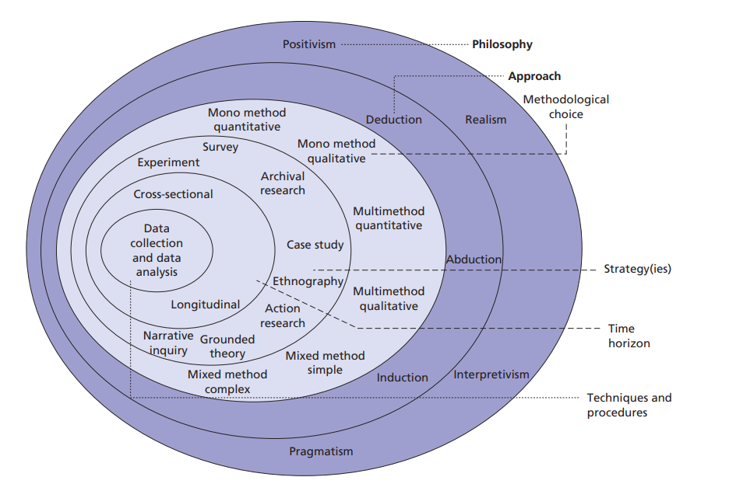
Figure 2. The research ‘onion’ (Saunders, Lewis and Thornhill, 2012)

Research Philosophy

The outer layer describes the approach or style a researcher may adopt when working on a topic and any preconceived notions the author of the research may have towards a certain topic of study (Saunders, Lewis and Thornhill, 2012).

Interpretivism focuses on the details of the problem and the underlying reality. It helps people understand their own thought processes and behaviour as well as those of others. (Saunders, Lewis and Thornhill, 2012). Using the interpretative method, according to Bryman (2016), may aid in acquiring a deeper knowledge of a culture and offer justifications for why things occur. This study will be using the interpretivism philosophy as a variety of answers could arise and the study requires the opinions of the general public and their perception of vigilantes and their acts.

Research Approach

The inductive method and the deductive approach are the two "Research Approaches" that are most frequently utilised in academic writing (Trochim, 2005). The deductive approach starts with developing a theory or hypothesis, research is then conducted to test this theory (Trochim, 2005). As opposed to induction, which starts with the collection of data and a theory is developed as a result of the data analysis (Bryman, 2016).

This study employs an "inductive" technique with the goal of gathering information to create a theory concerning the way the public view vigilante acts.

Methodological choice

Quantitative research is used to verify or examine hypotheses and beliefs. Through this form of research, generalised facts about a topic can be established. Common quantitative methods include experiments, quantifiable observations, and surveys with closed-ended questions (Walliman, 2008). Comparatively, qualitative research is used to understand concepts, perceptions, or experiences, according to Vishnevsky and Beanlands (2004). Through this sort of research, one can gain extensive knowledge on poorly understood subjects (Vishnevsky and Beanlands, 2004). Typical qualitative techniques include open-ended interview questions, verbal descriptions of observations, and literature studies that examine ideas and theories (Fossey et al., 2002).
Research using mixed methodologies involves gathering and analysing both quantitative and qualitative data for the same question (Bergman, 2009). This strategy makes an effort to ease the conflicts between quantitative and qualitative research and enables a researcher to be led by their own question without being constrained by it, as it allows for the employment of a number of strategies to address a single question (Teddie and Tashakkori, 2009).
A mixed method approach will be used for this study project. This will enable the research to take into account perspectives of the public on the subject of vigilantes acts as qualitative data while also gaining views on if the public are supportive of these acts as quantitative data. As a conclusion, the proposed research should offer a stronger foundation on which to address the stated goals and objectives.

Strategy
The selected approach is to use Survey Planet to produce a survey that will then be made available to members of the public online via links and through social media websites. By creating this survey, it allows participants to give a substantial amount of information describing their view (Akinci and Saunders, 2015) and by keeping it anonymous, respondents are able to provide a more honest and accurate answers to the questions which adds to the reliability validity of the data received (Murdoch et al., 2014; Rogelberg, 2007, p.41).
Due to the quantity of data needed for this study, this method is the most straightforward way to make sure there are enough participants because it is both cost-effective and efficient (Vaus, 2014).

Ethical consideration
All participants will be fully informed of the study's purpose and have the option to withdraw at any time. Participation is completely voluntary with the option to withdraw at any time, this ensures that the participants are protected from any harm the survey may have psychologically on the participant (Wolf et al., 2016, pp.185–500). Prior to conducting the questionnaire, consent must also be obtained. This will be done by providing the participant with an information sheet before the survey, allowing them to decide whether they want to participate in the study after receiving sufficient and pertinent information on what they survey is about and how their data will be analysed (UK Research and Innovation, 2023). To ensure that no personal information is gathered or stored and that no individuals or locations can be identified, all information submitted will be anonymised, with all personal data removed. All data will be kept on a password secure laptop with data encryption.

Time Horizon
Cross-sectional studies and longitudinal studies are two distinct categories of study design. A cross-sectional study gathers data from a population at a single moment in time; a longitudinal research gathers data over an extensive time frame from the same sample (Derriman et al., 2008).

The cross-sectional approach will be employed for this research project since it is the most effective model for carrying out population-based surveys (Institute for Health and Work, 2015). Due to the short span of the study and a number of variables, this approach is also the most suitable.

Conclusion
All the different components of this research approach have been identified and detailed in this chapter. The objective of the subsequent chapter is to gather, analyse, and present the results of the data collection techniques mentioned in this chapter.

4. Chapter Four: Data Analysis

4.1. Introduction

Following the gathering of primary research, this chapter of the dissertation will make attempt to set out the project's findings and analyse the data that has been obtained. Additionally, this chapter aims to answer the main objective of this study; To explore the public’s perception of vigilantes and their acts.
The survey was made available on a variety of social media platforms. 15 quantitative and qualitative questions were included in the survey. Due to research completed in the methodology chapter it was found that a combined approach to be the most successful (Teddie and Tashakkori, 2009) as makes it possible for a researcher to follow their own question without being limited by it. A definitive response was achieved by using closed questions, which required the participant to choose just one response. The open-ended questions on the questionnaire, however, permitted participants to express their opinions on the subject because the survey intended to gauge public perception. The findings will only focus on a subset of the questionnaire's questions; however, the appendix contains a complete list of all the questions.

4.2. Questionnaire findings

4.2.1 Question 3: Educational level

Question 3's objective once more was to gather more general information about the participants. Furthermore, it was shown in earlier studies conducted by Tankebe(2009) and Marsh et al (2019) that those with greater levels of education were more tolerant of the rule of law. The question was intended to see if this corroborated prior research and if participants with higher levels of education opposed vigilante conduct.
Although it was desired there would be at least one answer for each category, no participant had a PHD. 46% of participants had completed high school or an equivalent education, and 46% had earned a bachelor's degree. Six percent of participants had a master's degree, and one participant wanted to remain anonymous regarding this information.

4.2.2. Question 4: In your own words, what is a vigilante?

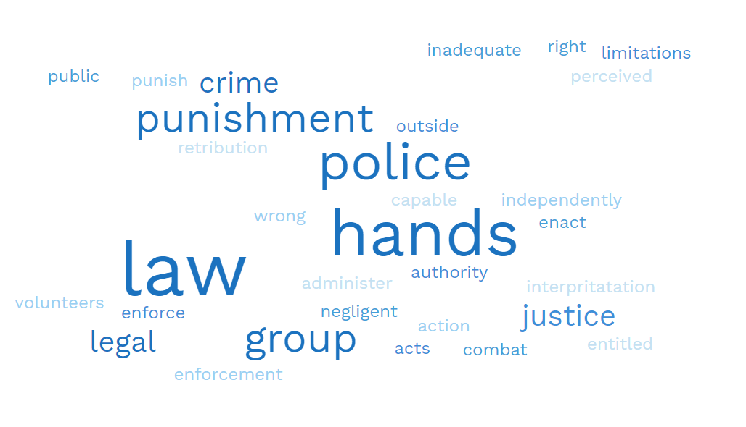
It was vital to pose this question and leave it free from constraints so that participants could explain what they considered a vigilante to be in their own words. Abrahams (1998) stated that the term vigilantism is incredibly challenging because many individuals have different ideas about what it is it was vital that this question was used to see if there was a unanimous agreement on what participants believed a vigilante was..
The phrase "takes the law into their own hands" was used by 68% of participants. 4% of participants that took the survey believed that a vigilante was someone who wanted to stop crime and enforce the law as they believed that the police were negligent and inadequate. While, 2% of participants stated that it was revenge. There were further answers including protecting the public and groups of people working outside of the law to bring others to justice.

4.2.3. Question 7: When do you believe vigilant acts are justified?

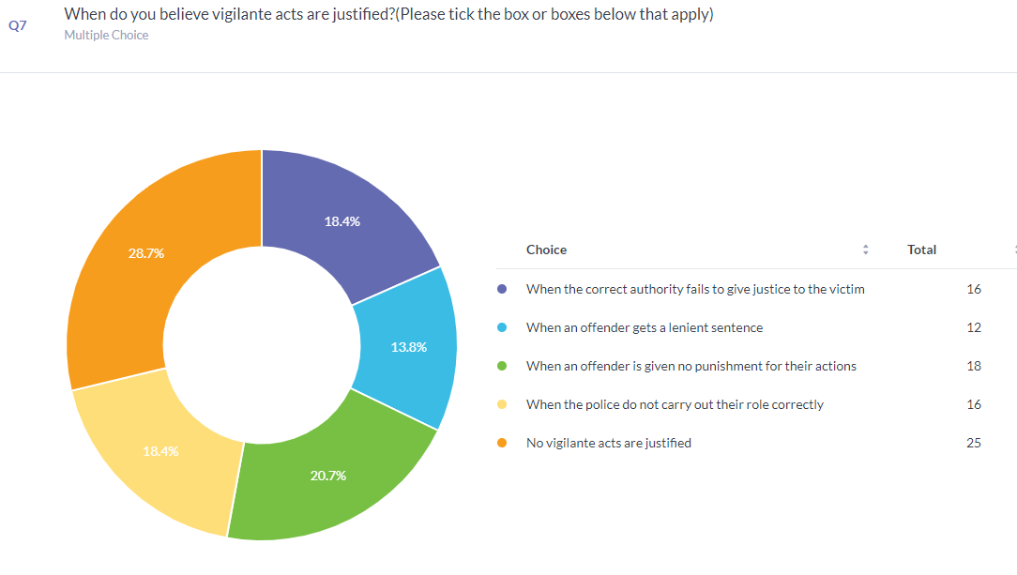

For this question the participants were able to choose multiple answers. The most selected answer by participants was that no vigilante acts are justified. This was the largest response with it being 8% higher than every other. The second highest response being vigilante acts are committed when an offender is given no punishment for their actions.
The third most selected answers were when the correct authority fails to give justice to the victim and when the police do not carry out their role correctly. This does corroborate the above question whereby participants stated that the police being the proper authority were negligent and inadequate. Furthermore it gives an argument for the “confidence hypothesis” by Haas 2010 and research carried out by Tyler et al (2012) where both theorise that when the public has no confidence in the correct authority then vigilantism will be supported and justified by the public.

4.2.4. Question 8: Which incidents in your opinion, is the cause of most vigilante involvement?

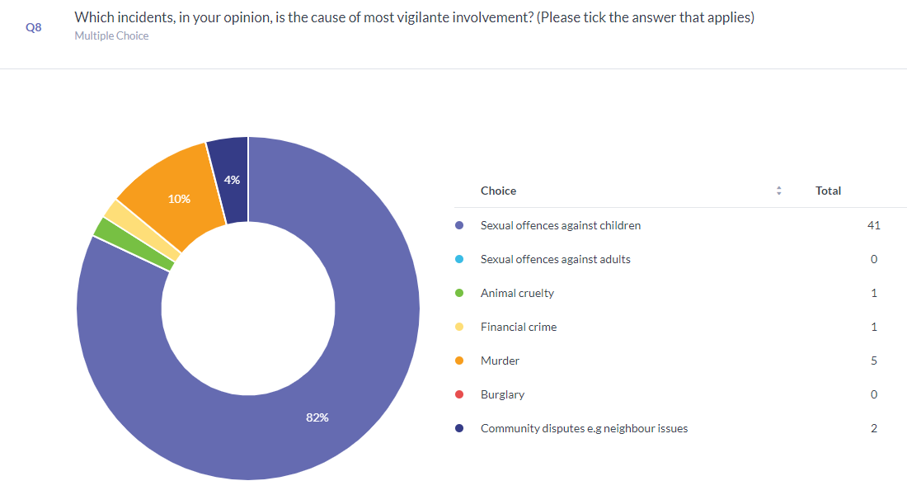

One question that received a majority result was question 8. The question related to which crime received the most vigilante involvement. This resulted in 41 participants choosing sexual offences against children, which equalled a staggering 81%. No other answer came close with only 5 participants choosing murder, 2 selecting community disputes, 1 selecting animal cruelty and 1 selecting financial crime.
Police forces in England and Wales saw a rise of 50.8% in incidents of sexual crimes against children between 2016 and 2018 where there was an online element to the crime (Jay et al., 2020), this is a massive increase compared to that of murders between these years where there was a decrease by 3.9% (Clark, 2022). Scandals involving high-profile individuals such as Jimmy Savile and football coach Barry Bennell have thrust the issue of sexual offences involving children into the limelight this added to the fact paedophile hunting groups have risen by 100% from 2018 to 2021 (Warrington, 2018; Rond, 2022) shows that the public views this crime to be the most serious crime that can be committed.

4.2.5. Question 10: How much do you support vigilantism?
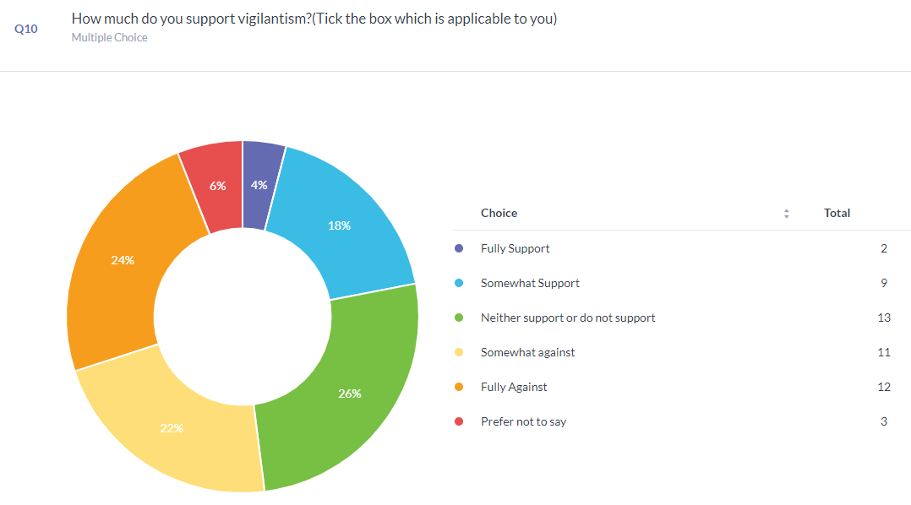
This question was vital as one of the aims for the research was to find out the public’s perception of vigilantism and it was imperative to find out if the public supported vigilantism or not. This question has an array of mixed answers from participants. Most participants, 26%, neither supported or did not support vigilantism. Out of those 7 participants were at high school or equivalent and 6 held a bachelor’s degree.
However, the results link in with Tankebe (2009) and Marsh at al (2019) who found in their study’s that those with a higher level of education understood the law more and were tolerant toward it as more participants who held a bachelors degree and master’s degrees were either somewhat against or fully against whereas those with a high school education level or equivalent were more likely to somewhat support or fully support vigilantism. Larmit (2020) also makes this argument and states because they are less knowledgeable with the rule of law, people with lower levels of education distrust democracy and feel alienated by it, which increases their support for vigilantism.

4.2.6. Question 14: Do you agree that misinformation inspires people to engage in vigilantism?
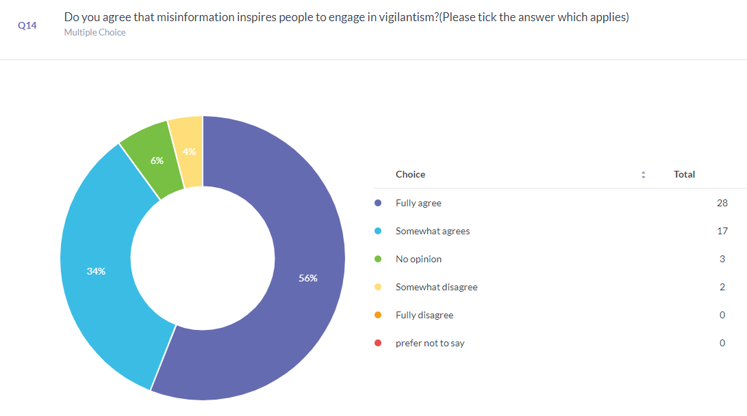
This question was asked by the researcher as part of their research was based around news outlets spreading information that may not always be correct. The outcome was very one sided whereby 56% of participants fully agreed that misinformation inspires people to engage in vigilantism and 34% somewhat agreed. 6% had no opinion on the matter and only 4% somewhat disagreed.
This shows that nearly all participants agreed on some level that misinformation can cause people to engage in vigilante acts. Banaji and Bhat (2019) found that more than 40 murders have been committed as a result of lynch mob mobilisations based on misinformation spread by WhatsApp about strangers claimed to be kidnappers of children or kidney thieves (Banaji and Bhat,2019). Another case of misinformation and vigilante involvement includes the National Butterfly Centre in South Texas, which was forced to close permanently after right-wing operatives threatened it for years before showing up and assaulting Executive Director Marianna Trio-Wright there. The threats came as a result of disinformation and damaging lies (Binkowski, 2022).

4.2.7. Question 15: What do you think could be done to end vigilante acts?

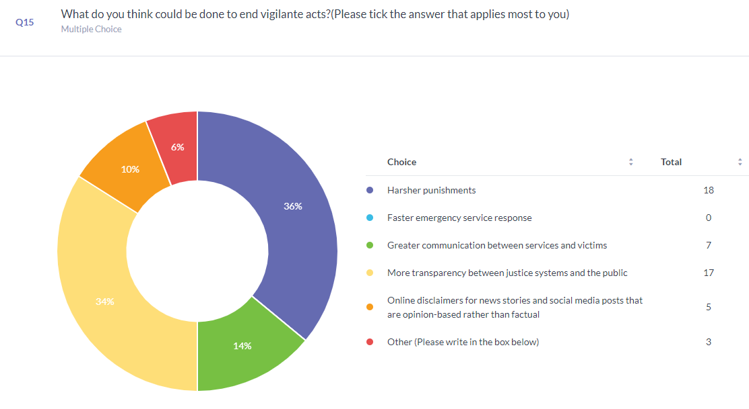
This question was imperative to the researcher as it is vital to show what the public think could be done to stop those taking the law into their own hands. The top answer from participants was that harsher punishments would be effective in stopping vigilantes, 36% of participants believed this. The second most selected answer that 34% of participants chose was more transparency between justice systems and the public. Thirdly 14% of participants thought that greater communication between services and victims would help end vigilante acts. Only 10% believed that online disclaimers for news stories would help.
This does relate to the sentencing council for England and Wales survey who found that 44% of participants were not confident in the CJS effectiveness and 42% believed they were not confidence in their fairness as it is clear to see the public believe that the punishments are too fair as participants in this study believed that harsher punishments would be needed to stop vigilant behaviour they also believed that more transparency between justice systems and the public would be good deterrent, with this information the public and potential vigilante may be deterred if they are educated on the law and what the criminal justice systems have the rights to do.

5. Chapter Five: Findings and Conclusion

5.1. Introduction
The purpose of this survey was to determine whether the general public views vigilantism positively or negatively. Furthermore, it was predicted, in line with earlier research (Rosenbaum and Sederberg, 1974), that the public does, in fact, embrace vigilantism to a significant extent. Additionally, this study explored the justifications for supporting vigilante actions as well as the ways in which false information can inspire someone to commit an act of vigilantism.

5.2. Publics definition of vigilantism

The difficulty of defining vigilantism was previously highlighted by Rosenbaum and Sederberg (1974). However, a sizable portion of survey respondents defined a vigilante as "Someone who takes the law into their own hands"; this is a very broad definition and demonstrates that the general public has a very direct view of vigilantism which lacks nuance. Participants may have responded to the following questions based on their own assumptions about what a vigilante and vigilantism are using this broad definition. Participants did, however, identify vigilantism as someone who wished to put an end to crime because they believed the police were inadequate and negligent. This in turn supports the study of Tyler et al (2012) that found that support for vigilantism can be a result of low confidence in the police. Additionally, Tankebe (2009) discovered that public confidence in the police can be utilised for predicting the likelihood of vigilantism. While fewer participants supported vigilantism, many of them said that vigilantism was justifiable when there was less trust in the police. When police fail to perform their function properly, public confidence in them falls (Tankebe 2009; Tyler et al, 2012). This is also consistent with the "Confidence hypothesis" put out by Haas (2010), which claims that when the public has little to no confidence in the CJS, vigilantism is supported.
  - Support for vigilantism and the criminal justice system.
According to a survey conducted by the Sentencing Council for England and Wales (2019), participants considered that the criminal justice system as a whole, not just the police, was lacking, which contributed to vigilante acts. According to Marsh et al. (2019), nearly half of their participants lacked faith in the authorities' justice or effectiveness, which led them to hypothesise that this may be one of the primary causes for certain members of the general public to support vigilantism. When participants in this survey were asked what could be done to stop vigilante acts, 70% of them said that more severe punishments and greater transparency between the justice system and the public was needed. This information could be used in order to demonstrate that the criminal justice system fails to educate the public of its rationale prior to making decisions. This also corroborates the results that Haas (2010) found in their research whereby less support for vigilantism was seen as a result of increased confidence in the courts and CJS; this finding was partially attributed to a lack of understanding of the judicial system by the public showing that greater transparency leads to more education and less support for vigilante acts as was found in this survey.

Education
This study observed that those who were fully in favour of vigilantism had a high school diploma or an equivalent education level, while eight of the participants who were fully opposed had a bachelor's degree. This finding is consistent with other studies, particularly those by Tankabe (2009) and Marsh et al. (2019), who claim that people with higher levels of education are more tolerant of the rule and therefore do not support vigilante behaviour.

Offences that could prompt vigilante acts
Whatever the motivation underlying a vigilante act, the public had a very strong and biased opinion regarding the crimes they believed vigilantes were most likely to commit their acts for. According to 81% of participants, vigilante activity was most prevalent in sexual offences against children. This comes as no surprise in research undertaken by Nicholls et al. (2012) they found that participants in their focus groups believed that in a scenario of an adult victim of sexual assault offenders deserved a jail sentence of between six and ten years. The sexual assault of a 12-year-old girl, on the other hand, prompted ideas for far longer prison terms, which could vary between 10 and 20 years (Nicholls et al. 2012). This was because it was believed there could never be any doubt as to whether the child had agreed, and because of the presumed greater "innocence" and "vulnerability" of children as well as the offender's guilt (Nicholls et al. 2012). The public also believed that sexual assault indicated a possible intention to commit rape, making it "almost as serious" as rape (Nicholls et al. 2012). The News of the World's "Naming and shaming" campaign also put a lot of pressure on local communities (Bell, 2002a). Individuals were then pressured and prompted by local mothers in the community who believed that they and other members of the community had to do something (Bell, 2002b) , which survey participants also corroborated this same sentiment and said that pressure to engage by the community was one reason they thought vigilante acts were committed. This also correlates with the personal involvement (Haas 2010) aspect as local communities discovered there were several registered sex offenders in their towns that they personally knew. This is consistent with Haas' situational hypothesis from 2010, since there were several factors involved and not solely because of confidence in the CJS. A recent child fatality involving a sexual offence, a possible child sex offender in the vicinity, and exceptionally high community emotions all contributed to the situation (Bell, 2002a). Haas (2010) situational hypothesis could predict how a member of the general public could change their mind from being fully against vigilantism to fully supporting it.

Misinformation
Misinformation was another element. Although most participants got their information through social media, the majority participants firmly agreed that this platform and news sources in general play a significant role in the dissemination of disinformation. The Paulswood riots and the ongoing mob attacks in India show how that plays out in real life, where innocent individuals were and continue to be persecuted due to a lack of research by the source and the readers (Franklin, 2008; Banaji and Bhat, 2019). 56% of participants stated that they totally agreed that misinformation drives others to execute vigilante activities, with social media being used as the main new source for 38% of adults in the UK (Watson, 2023) it is viewed by many that more could be done by social media companies to tackle the phenomenon (Van Gordon, n.d.).

Conclusion
In conclusion, the results of the exploratory study show that public opinion is divided between those who support vigilantism and those who do not; however, there are several underlying factors that can alter the public's perception, and each situation may have an alternative outcome depending on these factors which supports the wider literature found in Haas (2012) situational hypothesis. It’s not just a singular factor but usually a group of factors that influence the public to support vigilantism and to not support it.

6. Chapter Six: Recommendations

6.1. recommendation one: Larger Scale Survey
The recommendation would be to carry out this study on a larger scale. Since the data was based on a subset of the larger population, a significant portion of the public's opinion was not obtained due to time constraints of the study. An accessible sample was used in the study due to the short time frame; nevertheless, it would be interesting to disseminate the survey over a longer period of time so that data may be obtained from a greater number of the population.

6.2. Recommendation two: providing the participants with a definition.
'VIGILANTE' is a phrase that is connected to another recommendation for the purpose of the study. According to the study's findings, the public may misinterpret this phrase and have varied ideas about what it means. In this survey, the public was not given the precise meaning at the outset; instead, they were asked to respond to the questions using their own definition as a guide. The public does not accurately understand what is meant by the term "VIGILANTE," according to the responses that have been gathered. In order to determine whether the findings are impacted, it would be helpful to do more research where the public is given the definition before they complete the a survey.

6.3. Recommendation Three: Accessible guides
In the survey, it was discovered that the public thought vigilantism could potentially be stopped by using harsher punishments and more transparency between justice systems and the public. An additional recommendation would be for the police and criminal justice system to develop user-friendly, accessible guides that outline decisions for the public in order to better equip the public to comprehend the procedures the police and criminal justice service use to deal with particular crimes and outcomes that relate to sentencing. This would increase trust between the public and services by explaining why decisions are made to the public.

6.4. Recommendation Four: Education programmes for children
A fourth recommendation would be to include more education on the police and criminal justice system in the school curriculum, since it was shown that participants with lower levels of education—high school or equivalent—were more likely to support vigilantism than participants with higher levels of education. In order to give younger generations at high school level an awareness of the systems and how they operate as well as to teach children about the rule of law, the police and criminal justice systems should collaborate with the education sector.

6.5. More awareness of mis-information
The final recommendation relates to the dissemination of false information. Online news sources and social media platforms should impose additional restrictions on the news that is shared on their networks, and the public should be given greater guidance regarding the truth of the information which is shared online. When anything is not accurate, news organisations and social media platforms should employ more components like banners and disclaimers to alert the audience of the integrity of the information that they are viewing.

Reference list

- Abrahams, R.G. (1998). Vigilant citizens : vigilantism and the state. Cambridge: Polity Press In Association With Blackwell, p.6.
- Akinci, C. and Saunders, M.N. (2015). Using questionnaire surveys for within-organisation HRD research. [online] pp.217–230. doi:https://doi.org/10.4337/9781781009246.00024.
- Arellano, Lisa. (2012) Vigilantes and Lynch Mobs: Narratives of Community and Nation, Temple University Press, 2012, p. 133–134. JSTOR, http://www.jstor.org/stable/j.ctt14bsxf0.1. Accessed 23 Jan. 2023.
- Asif, M. (2022). Police legitimacy and approval of vigilante violence: The significance of anger. Theoretical Criminology, [online] p.136248062211013. doi:https://doi.org/10.1177/13624806221101369.
- Banaji, S. and Bhat, R. (2019). WhatsApp Vigilantes: An exploration of citizen reception and circulation of WhatsApp misinformation linked to mob violence in India. [online] Media@LSE. Available at: https://blogs.lse.ac.uk/medialse/2019/11/11/whatsapp-vigilantes-an-exploration-of-citizen-reception-and-circulation-of-whatsapp-misinformation-linked-to-mob-violence-in-india/ [Accessed 24 Jun. 2023].
- Bateson, R. (2020). The Politics of Vigilantism. Comparative Political Studies, [online] 54(6), pp.923–955. doi:https://doi.org/10.1177/0010414020957692.
- BBC News (2000). BBC News | UK | Vigilante attack on innocent man. [online] news.bbc.co.uk. Available at: http://news.bbc.co.uk/1/hi/uk/848737.stm#:~:text=An%20innocent%20man%20who%20was [Accessed 21 Jan. 2023].
- Bell, V. (2002a). The vigilant(e) parent and the paedophile: The News of the World campaign 2000 and the contemporary governmentality of child sexual abuse. Feminist Theory, [online] 3(1), pp.83–102. doi:https://doi.org/10.1177/1460012002003001068.
- Bell, V. (2002b). The vigilant(e) parent and the paedophile: The News of the World campaign 2000 and the contemporary governmentality of child sexual abuse. Feminist Theory, [online] 3(1), pp.83–102. doi:https://doi.org/10.1177/1460012002003001068.
- Bergman, M.M. (2009). Advances in mixed methods research : theories and applications. [online] Los Angeles, Calif.: Sage. Available at: https://edoc.unibas.ch/39229/ [Accessed 6 Mar. 2023].
- Binkowski, B. (2022). How Disinformation Powers Vigilantism. [online] Dame Magazine. Available at: https://www.damemagazine.com/2022/03/14/how-disinformation-powers-vigilantism/ [Accessed 24 Jun. 2023].
- Born, M. (2000). Paper drops paedophile campaign. [online] www.telegraph.co.uk. Available at: https://www.telegraph.co.uk/news/uknews/1351615/Paper-drops-paedophile-campaign.html [Accessed 29 Jun. 2023].
- Bryman, A. (2016). Social Research Methods. 5th ed. [online] Oxford: Oxford University Press. Available at: https://ktpu.kpi.ua/wp-content/uploads/2014/02/social-research-methods-alan-bryman.pdf [Accessed 5 Mar. 2023].
- Chen, F.X., Graso, M., Aquino, K., Lin, L., Cheng, J.T., DeCelles, K. and Vadera, A.K. (2022). The vigilante identity and organizations. Organizational Behavior and Human Decision Processes, [online] 170. doi:https://doi.org/10.1016/j.obhdp.2022.104136.
- clark, D. (2022). England, Wales: homicides 2002-2019. [online] Statista. Available at: https://www.statista.com/statistics/283093/homicides-in-england-and-wales/ [Accessed 23 Jun. 2023].
- CPS (2020). Online Child Abuse Activist Groups on the internet | The Crown Prosecution Service. [online] www.cps.gov.uk. Available at: https://www.cps.gov.uk/legal-guidance/online-child-abuse-activist-groups-internet [Accessed 29 Jun. 2023].
- Creswell, J.W. and Plano Clark, V.L. (2011). Designing and Conducting Mixed Methods Research. 3rd ed. [online] Thousand Oaks Sage Publications. Available at: https://www.google.co.uk/books/edition/Designing_and_Conducting_Mixed_Methods_R/YcdlPWPJRBcC?hl=en&gbpv=0 [Accessed 3 Mar. 2023].
- Dearden, L. (2020). Risk of vigilante attacks rising as victims wait for justice amid coronavirus delays. [online] The Independent. Available at: https://www.independent.co.uk/news/uk/home-news/coronavirus-court-backlogs-justice-delays-victims-vigilantes-covid-a9672896.html [Accessed 3 Jul. 2023].
- Derriman, L., Marshall, J., Moorman, C. and Downes, S.M. (2008). Cross-Sectional Versus Longitudinal Survey Research: Concepts, Findings, and Guidelines. Retina, [online] 28(6), p.910. doi:https://doi.org/10.1097/iae.0b013e31816d81d0.
- Dow, D.A., Levy, G., Romero, D. and Juan Fernando Tellez (2023). State Absence, Vengeance, and the Logic of Vigilantism in Guatemala. [online] p.001041402311690-001041402311690. doi:https://doi.org/10.1177/00104140231169026.
- Dunsby, R.M. and Howes, L.M. (2018). The NEW adventures of the digital vigilante! Facebook users’ views on online naming and shaming. Australian & New Zealand Journal of Criminology, [online] 52(1), pp.41–59. doi:https://doi.org/10.1177/0004865818778736.
- Evans, D., Gruba, P. and Zobel, J. (2014). How to Write a Better Thesis. Cham: Springer International Publishing.
- Fossey, E., Harvey, C., Mcdermott, F. and Davidson, L. (2002). Understanding and Evaluating Qualitative Research. Australian and New Zealand Journal of Psychiatry, [online] 36(6), pp.717–732. Available at: https://journals.sagepub.com/doi/pdf/10.1046/j.1440-1614.2002.01100.x [Accessed 28 Jun. 2023].
- Frampton, L. (2022). ‘Paedophile Hunters’: Practitioner Perspectives. Probation Journal, [online] 0(0). doi:https://doi.org/10.1177/02645505211070084.
- Franklin, B. (2008). Pulling Newspapers Apart: Analysing Print Journalism. [online] Google Books. Routledge. Available at: https://www.google.co.uk/books/edition/Pulling_Newspapers_Apart/mz7R9OocNVgC?hl=en&gbpv=1&dq=news+of+the+world+naming+and+shaming+campaign+innocent+people&pg=PA41&printsec=frontcover [Accessed 25 Jun. 2023].
- Goldstein, D.A. (2012). Outlawed: Between Security and Rights in a Bolivian City. [online] Duke University Press, pp.2–32. doi:https://doi.org/10.1215/9780822395607.
- Goode, E. (2015). Deviant Behavior. [online] Google Books, Routledge, p.99. Available at: https://www.google.co.uk/books/edition/Deviant_Behavior/ELhmCgAAQBAJ?hl=en&gbpv=1&dq=deviant+but+not+illegal+crimes&pg=PA99&printsec=frontcover [Accessed 28 Jun. 2023].
- Haas, N. (2010). Public support for vigilantism. [online] S.L.: Leiden: Netherlands Institute for the Study of Crime and Law Enforcement (NSCR). Available at: https://scholarlypublications.universiteitleiden.nl/handle/1887/16171 [Accessed 21 Jan. 2023].
- Haas, N.E., de Keijser, J.W. and Bruinsma, G.J.N. (2012). Public support for vigilantism: an experimental study. Journal of Experimental Criminology, [online] 8(4), pp.387–413. doi:https://doi.org/10.1007/s11292-012-9144-1.
- Harris, S., Joseph-Salisbury, R., Williams, P. and White, L. (2022). Notes on policing, racism and the Covid-19 pandemic in the UK. Race & Class, [online] 63(3), pp.92–102. doi:https://doi.org/10.1177/03063968211063436.
- Home Office (2022). Crime outcomes in England and Wales 2021 to 2022. [online] GOV.UK. Available at: https://www.gov.uk/government/statistics/crime-outcomes-in-england-and-wales-2021-to-2022/crime-outcomes-in-england-and-wales-2021-to-2022.
- Hox, J.J. and Boeije, H.R. (2005). Data Collection, Primary vs. Secondary. Encyclopedia of Social Measurement, [online] 1, pp.593–599. doi:https://doi.org/10.1016/B0-12-369398-5/00041-4.
- Institute for Government (2023). Performance Tracker 2022/23: Spring update - Criminal courts. [online] Institute for Government. Available at: https://www.instituteforgovernment.org.uk/performance-tracker-2022-23/criminal-courts [Accessed 3 Jul. 2023].
- Institute for Health and Work (2015). Cross-sectional vs. longitudinal studies. [online] www.iwh.on.ca. Available at: https://www.iwh.on.ca/what-researchers-mean-by/cross-sectional-vs-longitudinal-studies#:~:text=The%20benefit%20of%20a%20cross [Accessed 28 Jun. 2023].
- Ishak, N. (2021). Marianne Bachmeier: The ‘Revenge Mother’ Who Shot Her Child’s Killer. [online] All That’s Interesting. Available at: https://allthatsinteresting.com/marianne-bachmeier [Accessed 21 Jan. 2023].
- Jay, A., Evans, M., Frank, I. and Sharpling, D. (2020). The Internet Investigation Report March 2020. [online] webarchive.nationalarchives.gov.uk. Available at: https://www.iicsa.org.uk/document/internet-investigation-report-march-2020.html [Accessed 23 Jun. 2023].
- Johnston, L. (1996). WHAT IS VIGILANTISM? The British Journal of Criminology, [online] 36(2), pp.220–236. Available at: https://www.jstor.org/stable/23638013 [Accessed 21 Jan. 2023].
- Kirkpatrick, J. (2008a). Uncivil Disobedience. [online] Princeton University Press. Available at: https://www.jstor.org/stable/j.ctt7rw3s [Accessed 30 May 2023].
- Kirkpatrick, J. (2008b). Uncivil Disobedience: Studies in Violence and Democratic Politics. [online] Princeton University Press. Available at: https://www-jstor-org.ezproxy.uwtsd.ac.uk/stable/j.ctt7rw3s [Accessed 6 Apr. 2023].
- Larmit, S. (2020). Why are lower educated more in favor of vigilantism than higher educated? Investigating three possible explanations: distrust in institutions, distrust in democracy, and political alienation. [online] Available at: http://arno.uvt.nl/show.cgi?fid=153763 [Accessed 24 Jun. 2023].
- Lashua, B., Johnson, C.W. and Parry, D.C. (2022). Leisure in the Time of Coronavirus: A Rapid Response. [online] Google Books. Routledge. Available at: https://www.google.co.uk/books/edition/Leisure_in_the_Time_of_Coronavirus/6qRaEAAAQBAJ?hl=en&gbpv=1&dq=virus+vigilantes&pg=PT272&printsec=frontcover [Accessed 29 Jun. 2023].
- Liebling, A., Maruna, S. and McAra, L. (2017). The Oxford Handbook of Criminology. [online] Google Books, Oxford University Press, pp.272–274. Available at: https://www.google.co.uk/books/edition/The_Oxford_Handbook_of_Criminology/iJjJDgAAQBAJ?hl=en&gbpv=1&dq=naming+and+shaming+campaign+news+of+the+world&pg=PA272&printsec=frontcover [Accessed 29 Jun. 2023].
- Marsh, N., Mckay, E., Pelly, C. and Cereda, S. (2019). ComRes PUBLIC KNOWLEDGE OF AND CONFIDENCE IN THE CRIMINAL JUSTICE SYSTEM AND SENTENCING A REPORT FOR THE SENTENCING COUNCIL. [online] Available at: https://www.sentencingcouncil.org.uk/wp-content/uploads/Public-Knowledge-of-and-Confidence-in-the-Criminal-Justice-System-and-Sentencing.pdf [Accessed 22 Jan. 2023].
- Murdoch, M., Simon, A.B., Polusny, M.A., Bangerter, A.K., Grill, J.P., Noorbaloochi, S. and Partin, M.R. (2014). Impact of different privacy conditions and incentives on survey response rate, participant representativeness, and disclosure of sensitive information: a randomized controlled trial. BMC Medical Research Methodology, [online] 14(1). doi:https://doi.org/10.1186/1471-2288-14-90.
- Nahanara (2021). ‘Revenge Mother’ Shot Her Child’s Killer 8 Times. [online] Medium. Available at: https://nahanara.medium.com/revenge-mother-shot-her-childs-killer-8-times-649688123f77 [Accessed 21 Jan. 2023].
- National Police Chiefs Council (2019). Chief Constables’ Council Serious Error Reduction within the Acquisition and use of Communications Data. [online] pp.5–7. Available at: https://www.npcc.police.uk/2019%20FOI/NPCC%20Miscellaneous/015%2019%20NPCC%20FOI%20Response%20Part%203.pdf [Accessed 21 Jan. 2023].
- New York Post (2022). UK man slits throat after confronted by ‘pedophile hunters’ in Liverpool. [online] New York Post. Available at: https://nypost.com/2022/08/27/uk-man-slits-throat-after-confronted-by-pedophile-hunters-in-liverpool/ [Accessed 21 Jan. 2023].
- Nicholls, C.M., Mitchell, M., Simpson, I., Webster, S. and Hester, M. (2012). Attitudes to Sentencing Sexual Offences. [online] Available at: https://www.sentencingcouncil.org.uk/wp-content/uploads/Attitudes_to_Sentencing_Sexual_Offences_web1.pdf.
- Oliver, M. (2001). Whiting found guilty of Sarah Payne murder. The Guardian. [online] 12 Dec. Available at: https://www.theguardian.com/society/2001/dec/12/childprotection.markoliver [Accessed 21 Jan. 2023].
- Purshouse, J. (2020). ‘Paedophile Hunters’, Criminal Procedure, and Fundamental Human Rights. Journal of Law and Society, [online] 47(3), pp.384–411. doi:https://doi.org/10.1111/jols.12235.
- Robinson, P. and Darley, J. (1995). Justice, Liability, and Blame: Community Views and the Criminal Law. Faculty Scholarship at Penn Carey Law. [online] Available at: https://scholarship.law.upenn.edu/faculty_scholarship/1634/ [Accessed 30 Jun. 2023].
- Robson, P. and Spina, F. (2022). Vigilante Justice in Society and Popular Culture: A Global Perspective. [online] Google Books, Rowman & Littlefield, pp.138–139. Available at: https://www.google.co.uk/books/edition/Vigilante_Justice_in_Society_and_Popular/MMSVEAAAQBAJ?hl=en&gbpv=1&dq=Marianne+Bachmeier&pg=PA331&printsec=frontcover [Accessed 29 Jun. 2023].
- Rogelberg, S. (2007). Handbook of Research Methods in Industrial and Organizational Psychology. [online] Chichester: John Wiley & Sons, p.41. Available at: https://www.google.co.uk/books/edition/Handbook_of_Research_Methods_in_Industri/qOs36d2SXrAC?hl=en&gbpv=0 [Accessed 28 Jun. 2023].
- Rond, M.D. (2022). Opinion: I spent three years in a paedophile hunting team – here’s what I learned. [online] University of Cambridge. Available at: https://www.cam.ac.uk/research/news/opinion-i-spent-three-years-in-a-paedophile-hunting-team-heres-what-i-learned#:~:text=These%20stings%20take%20place%20in [Accessed 23 Jun. 2023].
- Rosenbaum, H.J. and Sederberg, P.C. (1974). Vigilantism: An Analysis of Establishment Violence. Comparative Politics, 6(4), pp.541–460. doi:https://doi.org/10.2307/421337.
- Rossi, P.H., Simpson, J.E. and Miller, J.L. (1985). Beyond Crime Seriousness: Fitting the Punishment to the Crime. Journal of Quantitative Criminology, [online] 1(1), pp.59–90. Available at: https://www.jstor.org/stable/23365653 [Accessed 30 Jun. 2023].
- Safire, W. (1985). ON LANGUAGE; VIGILANTE. The New York Times. [online] 10 Feb. Available at: https://www.nytimes.com/1985/02/10/magazine/on-language-vigilante.html#:~:text=Vigilante%20is%20a%20noun%20in [Accessed 3 Jul. 2023].
- Saunders, M., Lewis, P. and Thornhill, A. (2012). Research Methods for Business Students. 6th ed. [online] Harlow, Essex, England: Pearson Education Limited. Available at: https://gibsoncollege.edu.et/wp-content/uploads/2022/01/Research-Methods-for-Business-Students-by-Mark-Saunders-Philip-Lewis-Adrian-Thornhill-z-lib.org-1.pdf [Accessed 7 Mar. 2023].
- Stone, L.M. (2016). An eye for an eye: Examining public support for vigilante behaviour. [online] Available at: https://openrepository.aut.ac.nz/server/api/core/bitstreams/d4b19735-57e8-4156-a71e-8748e54f60fe/content [Accessed 30 Jun. 2023].
- Tankebe, J. (2009). Self-Help, Policing, and Procedural Justice: Ghanaian Vigilantism and the Rule of Law. Law & Society Review, [online] 43(2), pp.260–270. Available at: https://www.jstor.org/stable/29734190 [Accessed 22 Jan. 2023].
- Teddie, C. and Tashakkori, A. (2009). Foundations of mixed methods research : integrating quantitative and qualitative approaches in the social and behavioral sciences. Thousand Oaks: Sage Publications.
- The Economist (2001). Britain: Sarah’s law?; Paedophiles - ProQuest. [online] www.proquest.com. Available at: https://www.proquest.com/docview/224053447?accountid=130472&parentSessionId=%2Bfk%2B5xHkZVAsepHv8h2pcCyLgJalmnLAmUvsOqDHaJk%3D&pq-origsite=primo [Accessed 29 Jun. 2023].
- Tippett, A. (2022). The rise of paedophile hunters: To what extent are cyber-vigilante groups a productive form of policing, retribution and justice? Criminology & Criminal Justice. [online] doi:https://doi.org/10.1177/17488958221136845.
- Trochim, W. (2005). Research methods : the concise knowledge base. [online] London: Thomson. Available at: https://www.google.co.uk/books/edition/Research_Methods/cx9FPwAACAAJ?hl=en [Accessed 28 Jun. 2023].
- Trottier, D. (2016). Digital Vigilantism as Weaponisation of Visibility. Philosophy & Technology, [online] 30(1), pp.55–72. doi:https://doi.org/10.1007/s13347-016-0216-4.
- Tyler, T., Jackson, J., Huq, A. and Bradford, B. (2012). Going Outside the Law: The Role of the State in Shaping Attitudes Going Outside the Law: The Role of the State in Shaping Attitudes to Private Acts of Violence to Private Acts of Violence. [online] University of Chicago Public Law & Legal Theory . Available at: https://chicagounbound.uchicago.edu/cgi/viewcontent.cgi?referer=&httpsredir=1&article=1129&context=public_law_and_legal_theory [Accessed 22 Jan. 2023].
- UK Research and Innovation (2023). Consent. [online] www.ukri.org. Available at: https://www.ukri.org/councils/esrc/guidance-for-applicants/research-ethics-guidance/consent/ [Accessed 28 Jun. 2023].
- Van Gordon, W. (n.d.). True or False? How much is fake news influencing our lives? [online] www.derby.ac.uk. Available at: https://www.derby.ac.uk/magazine/issue-12/influence-of-fake-news/ [Accessed 25 Jun. 2023].
- Vaus, D.D. (2014). Surveys In Social Research. [online] Google Books. Routledge. Available at: https://books.google.co.uk/books?hl=en&lr=&id=rnxiAgAAQBAJ&oi=fnd&pg=PP1&dq=surveys+in+research&ots=6eVLKdqzIO&sig=F97rYTQfEnUthKtpnhpxAt97f-M#v=onepage&q&f=false [Accessed 8 Mar. 2023].
- Vishnevsky, T. and Beanlands, H. (2004). Qualitative Research . [online] www.proquest.com. Available at: https://www.proquest.com/openview/3198b68031c2bb4fd1191f5f3123c235/1?pq-origsite=gscholar&cbl=45638 [Accessed 28 Jun. 2023].
- Walker, J. (2000). The Intellectual Grounding of the San Francisco Committee of Vigilance of 1851. The Intellectual Grounding of the San Francisco Committee of Vigilance of 1851, pp.1–2. doi:https://doi.org/10.15760/etd.1276.
- Walliman, N. (2008). Social research methods. [online] r2.vlereader.com. Available at: https://r2.vlereader.com/Reader?ean=9781847878182 [Accessed 5 Mar. 2023].
- Walliman, N.S.R. (2011). Research methods: The Basics. [online] London: Routledge, pp.7–8. Available at: https://www.lsms.ac/public/uploads/sqkcstdKySSt9RrFhypN8RPjLMuHkPgZwlylmIwgbwkdUiidx41575401371vQXcGCdkUWCXO267edUDMcGByBfk7e2uUSnkIlMiJxdoXE0LLn.pdf [Accessed 28 Feb. 2023].
- Warrington, J. (2018). The Controversial Rise of Vigilante Paedophile Hunters. [online] www.vice.com. Available at: https://www.vice.com/en/article/bjpav4/vigilante-paedophile-hunters-are-doing-the-job-the-police-cant-do [Accessed 23 Jun. 2023].
- Watson, A. (2023). Usage of social media as a news source worldwide 2019 | Statista. [online] Statista. Available at: https://www.statista.com/statistics/718019/social-media-news-source/ [Accessed 25 Jun. 2023].
- Wolf, C., Joye, D., Smith, T.W. and Fu, Y.-C. (2016). The SAGE handbook of survey methodology. [online] London: Sage, pp.185–500. Available at: https://www.google.co.uk/books/edition/The_SAGE_Handbook_of_Survey_Methodology/g8OMDAAAQBAJ?hl=en&gbpv=1 [Accessed 28 Jun. 2023].

Appendices

Appendix 1 –Backlog of cases in the crown court Q2 210 to Q3 2022
Figure 1. – Backlog of cases in the crown court, Q2 2010 to Q3 2023

Appendix 2 - The Research ‘Onion’
Figure 2. The research ‘onion’ (Saunders, Lewis and Thornhill, 2012)

Appendix 3 – Survey and results
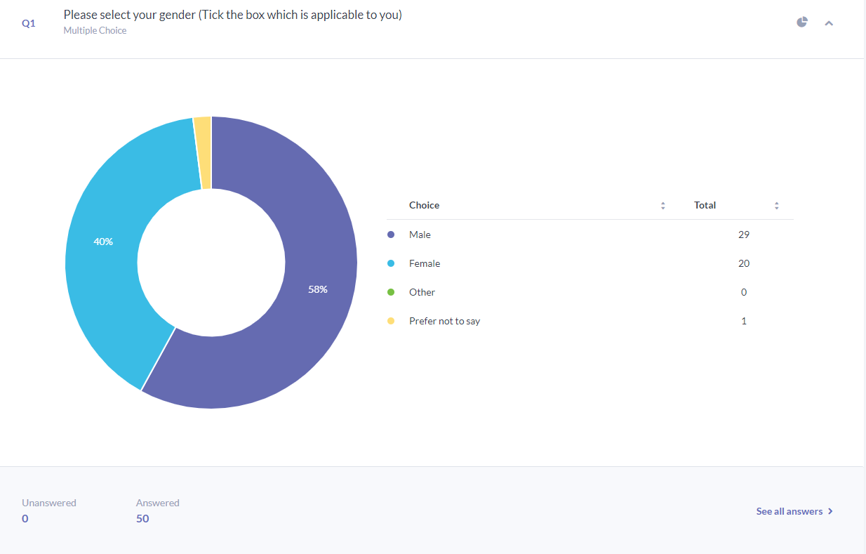
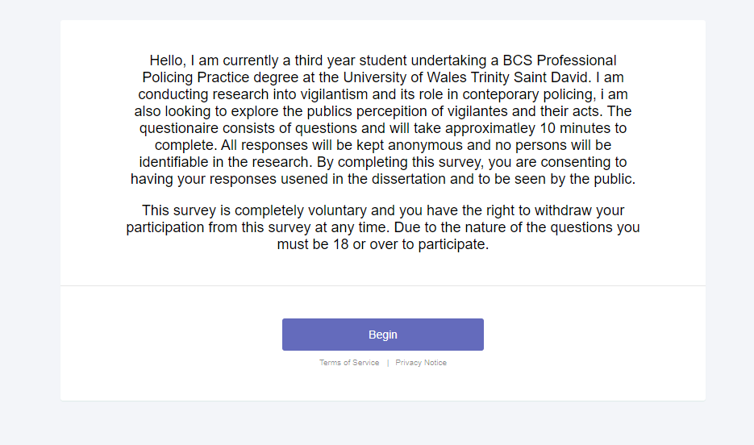

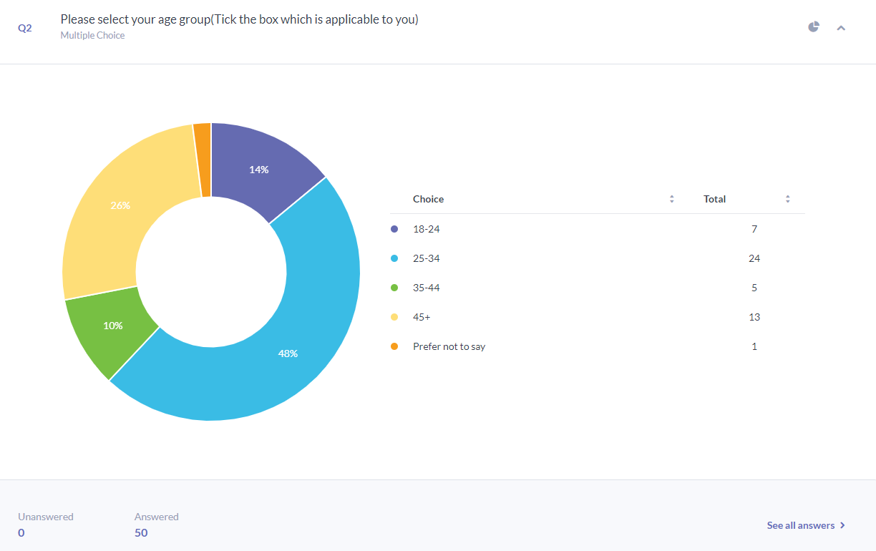

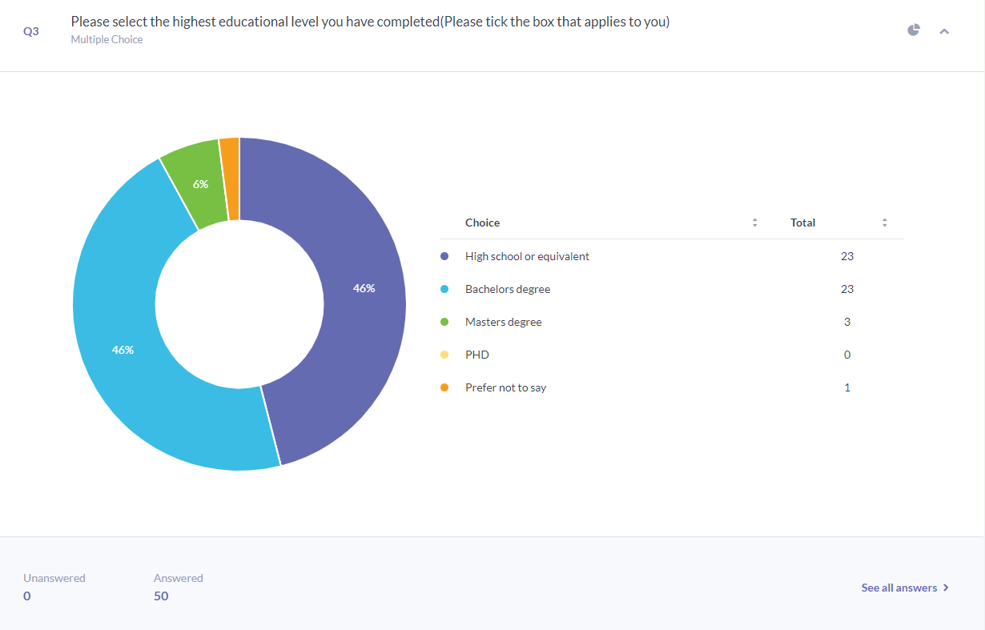

Taking personal revenge against others or a business.

Someone who takes the law into their own hands
Someone who takes the law into their own hands, with disregard for the law and/or due process.
Someone who tries to take the law into their own hands
undertakes public safety
A PERSON WHO TAKES THE LAW INTO THEIR OWN HANDS.
someone who takes the law into their own hands
a person who takes the law into their own hands
Someone who enforces law and order in their own way which can be in contradiction to traditional policing methods and even be construed as illegal acts.
A person who resolves criminal allegations with their own interpretation of justice outside of the legal system
A vigilante is someone who fights crime without lawful authority to do so. Someone that takes matters into their own hands.
Somebody who takes the law into their own hands
A person that believes that they are entitled to administer what they think is justice
A group of people who take matters into their own hands, as they feel police/ governments are not capable of dealing with matters.
Someone who takes the law into their own hands
a person who acts independently and of own volition outside of the law in order to seek retribution to right a perceived wrong
A person who takes action for a cause
someone who seeks to obtain justice in their own hands, typically outside of traditional law
Someone who takes the law into their own hands because they do not believe the police are doing enough to solve the problem.
A person who takes justice into their own hands
I would say that it is an act by an individual or individuals outside of Law Enforcement in response to such things as anti social behaviour or criminal activity that is becoming a problem in a certain area. They may feel that the person or persons responsible for this are not being held to account for their actions for various reasons and that the only punishment they will respond to is physical !
Somebody who takes the law in to their own hands
A member of a group of volunteers who decide on their own to stop crime and to punish criminals.
A group of people together that go after a criminal
Naughty man who does bad things but for good
Someone who takes law into their own hands and tracks and punishes people who have broken the law.
Somebody that takes the law into their own hands and acts as a sentence rather than leaving it to the law as in it I knew my friend had been robbed, and I took it upon myself to find out who did it and beat them up I’d be a vigilante instead of reporting what I knew to the police to deal
Somebody who takes the law into their own hands
Someone that takes the law into their own hands.
People who take matters into their own hands
Someone who tries to stop crime themselves without involving the police
A person who takes the law into their own hands but has no legal right to do so
Someone who takes action into their own hands to deliver justice
Someone who thinks they are doing right for the public.
Someone who does not work in law enforcement who attempts to combat crime
someone taking the law into their own hands
Someone who kind of takes the law into their own hands
A person who acts outside of lawfully authorised and sanctioned law enforcement to enact justice on those they perceived to have done wrong
Member of the public that takes the law into their own hands
When a person or persons choose to enforce the law without any legal authority, and often without cooperation with the police. I think vigilantism is mostly a reaction to inadequate and negligent policing in the community.
People who try to stop crime because the police are useless
Someone who takes the law into their own hands
Vigilante is a person who takes the law into their own hands due to limitations of law enforcement
Someone that feels that they're dishing out the correct punishment
Batman is a vigilante, as he fights crime. He is not a member of the police force.
Someone who takes the law into their own hands
Someone who commits acts of good outside of the law
Member of a group
Someone that takes the law into their own hands

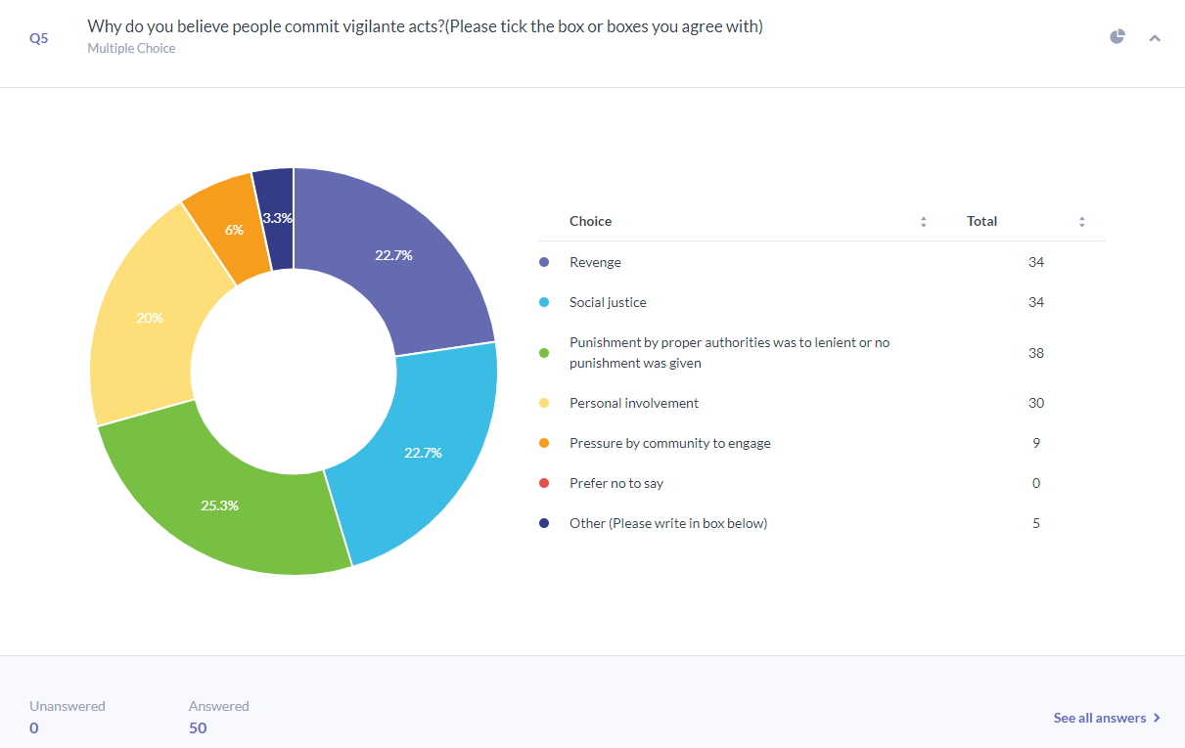

Appendix - to include

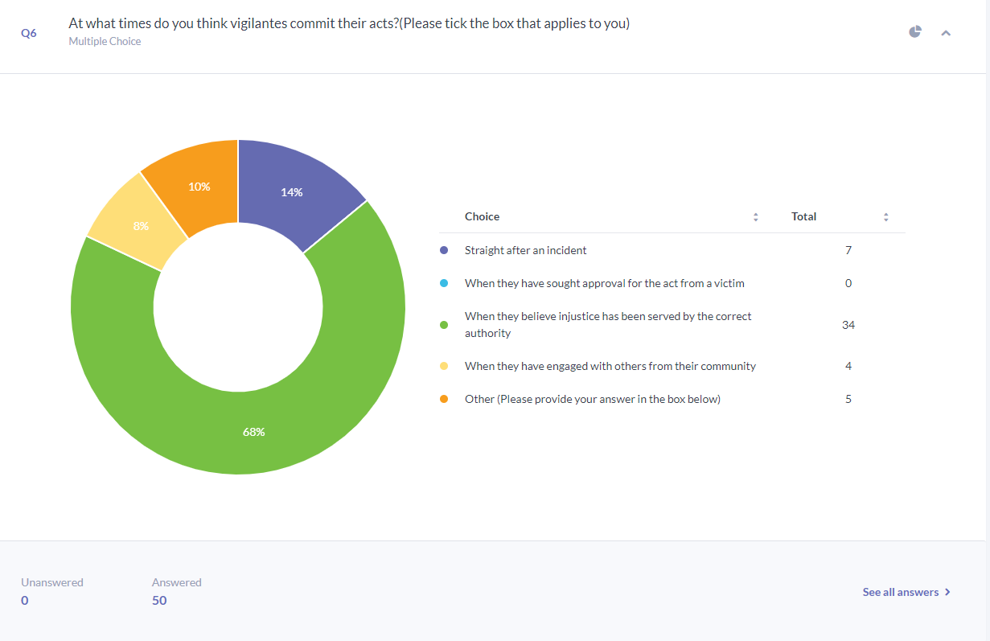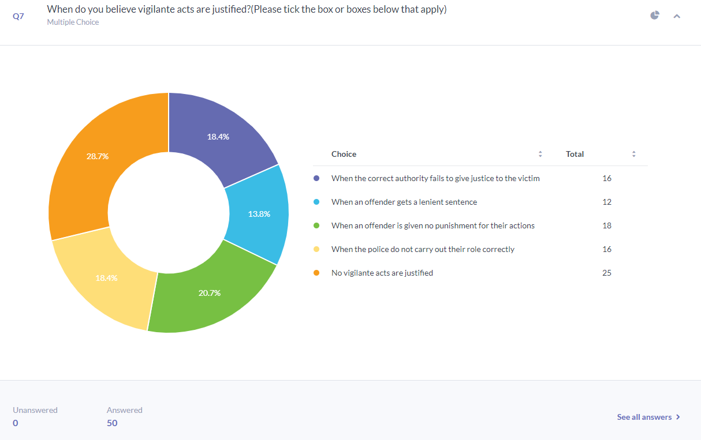
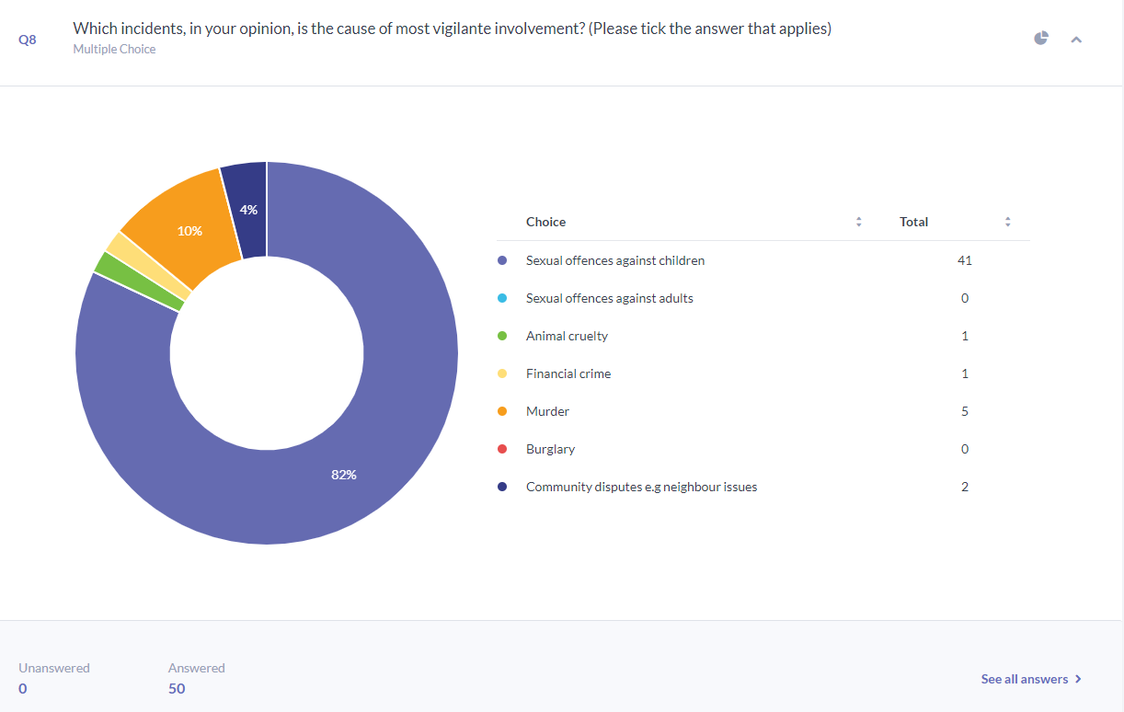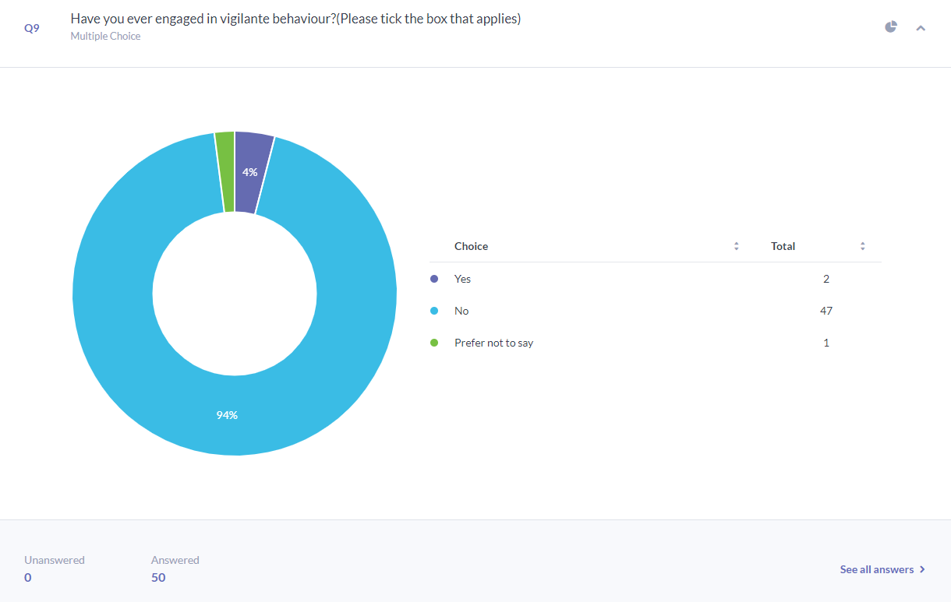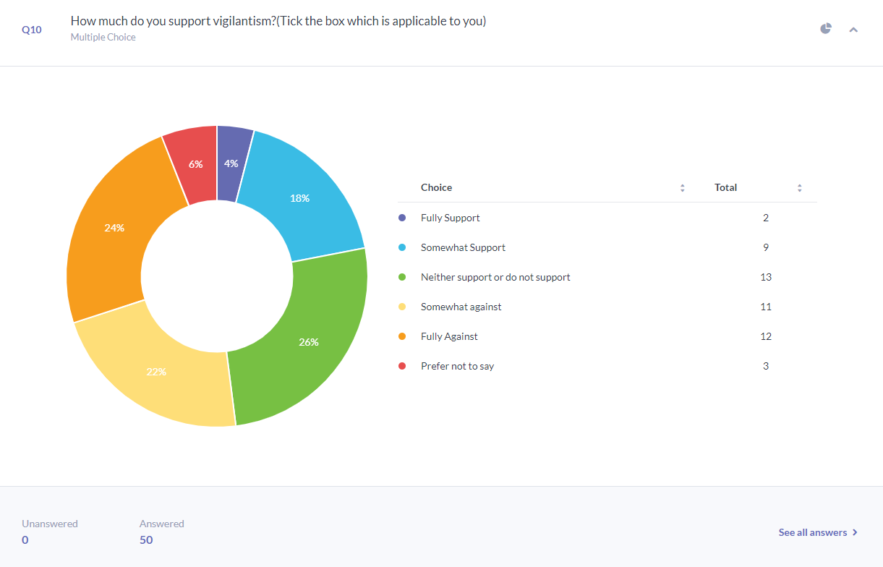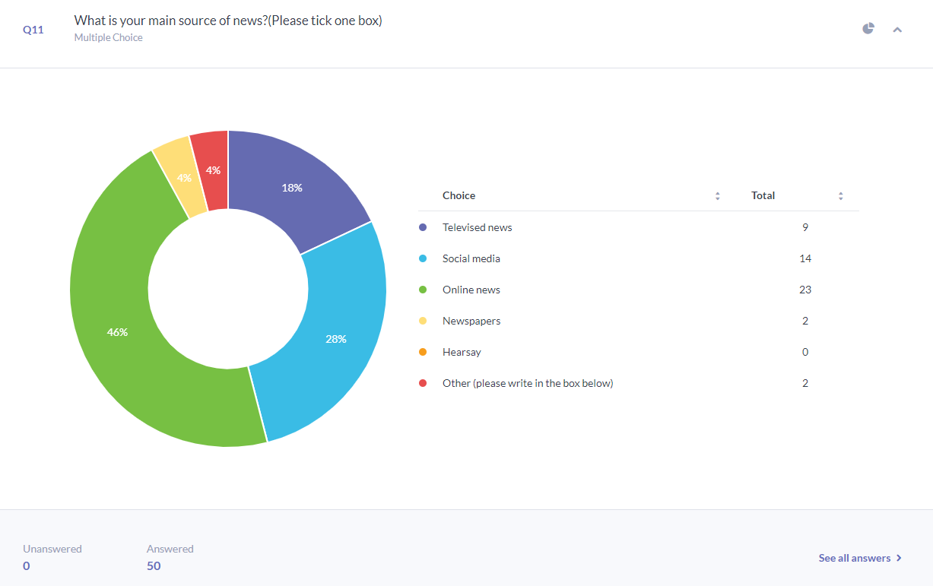
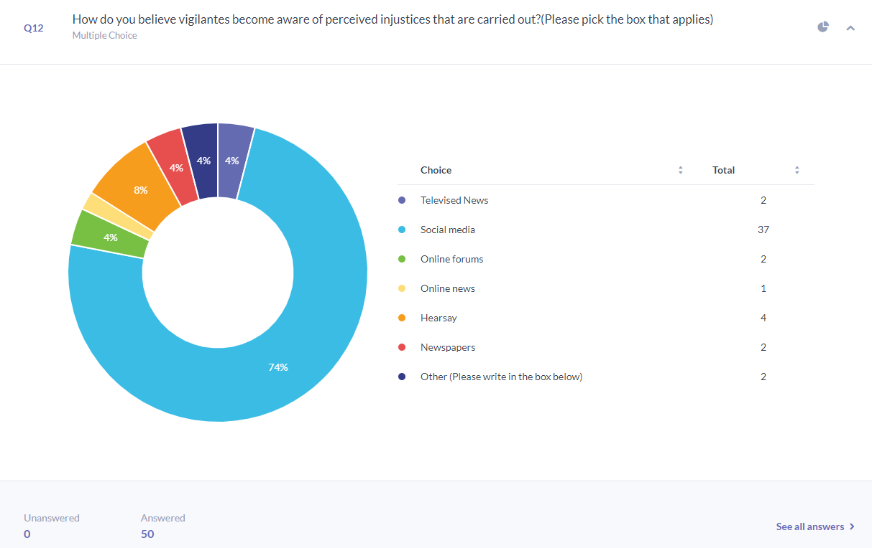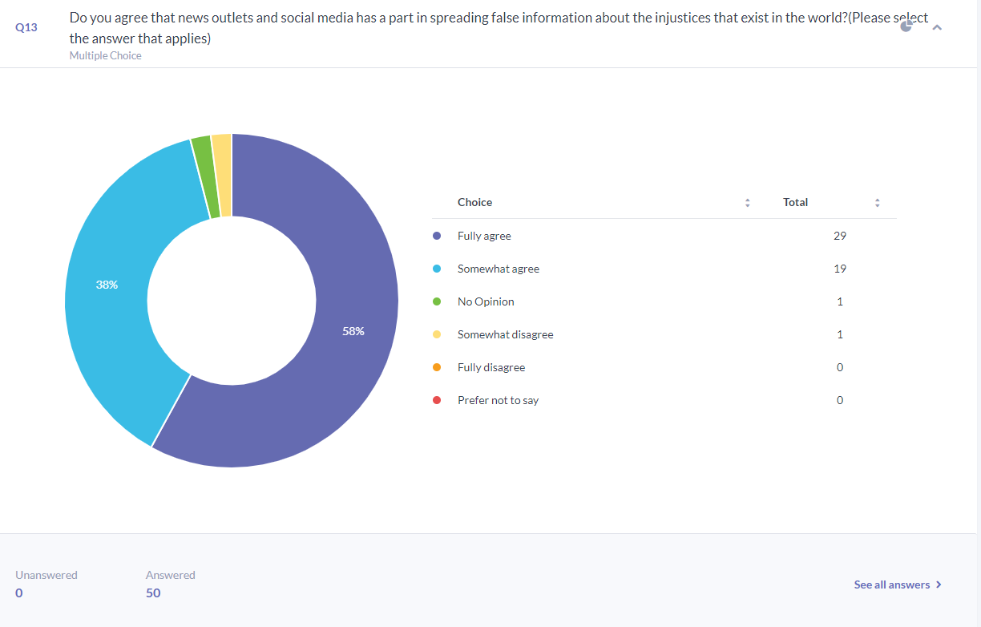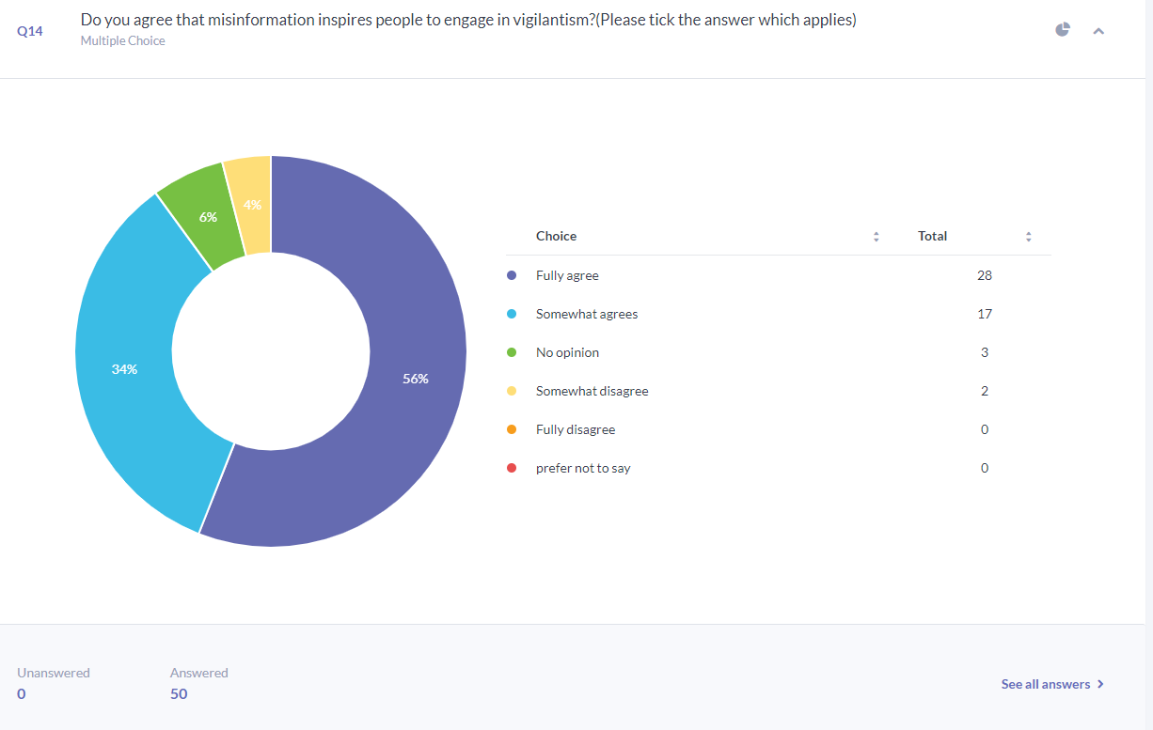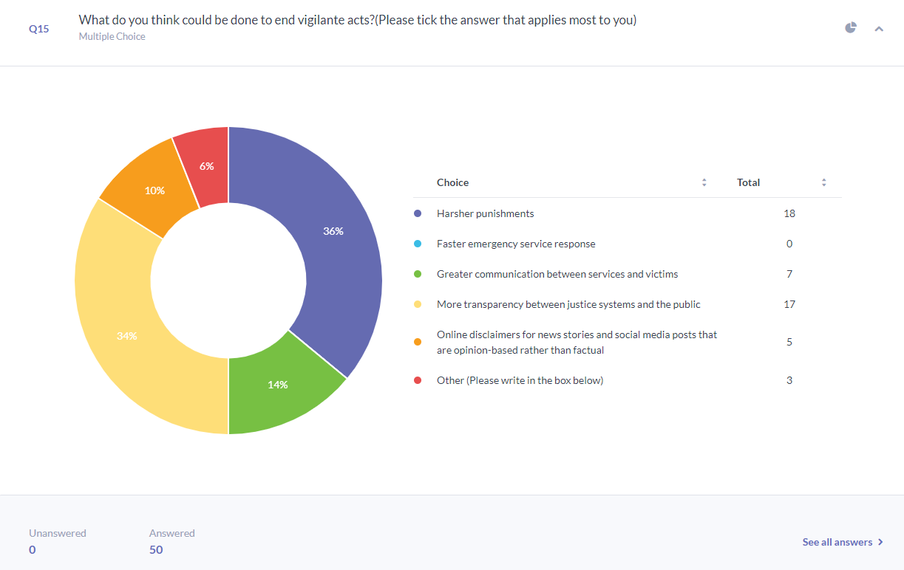questionnaires/all data results/charts etc.

