

Student name: Ndeye Rokheya Bop
Student ID: 2419596

Programme: BSc (Hons) Health and Social Care
Module name: Changemakers: Creativity and Value Creation
Assessment Title: Component 1: Online portfolio of set exercises
Module code: BMHP5014
Lecturer name: G1: Laila Surani

Contents
Introduction 3
Task 1: Defining Key Concepts in Practice 3
Task 2: Mind Map and Explanation 5
Task 3: Self Reflection on Group Activity 5
Task 4: Case Study Analysis of a UK Innovation 6
Task 5: Research Task 7
Task 6: Exploring Digital Innovation 8
6a. Wearable Health Technologies 8
6b. Electronic Health Records 9
6c. Digital Technology for Prevention 9
Task 7: NHS Leadership Framework 10
7a. Summary of the NHS Leadership Framework 10
7b. Leadership Behaviour Applied 10
7c. Reflective Journal Entry 10
Task 8: Self‑Reflection Journal Entry 11
List of Figures 12
References 13

Online portfolio of set exercises

Introduction
This portfolio brings together key ideas from the module on creativity, innovation, value creation and change in health and social care. Each task explores how these concepts apply in real practice settings and how they support better outcomes for individuals and communities. The work draws directly on learning from Weeks 1 to 8 using academic sources, theories and examples to demonstrate understanding. The final sections include a mind map, a reflective account of group activity and a short case study of a current innovation in the United Kingdom.

Task 1: Defining Key Concepts in Practice
Innovation refers to the introduction of new ideas, methods or technologies that improve existing practice. The Cambridge Dictionary describes innovation as the use of new ideas or methods to create something better. In health and social care, innovation is essential because services must constantly adapt to changing needs, rising demand and new clinical evidence. For example, telecare systems allow staff to monitor older adults remotely, improving safety and reducing unnecessary hospital admissions. Rogers’ Diffusion of Innovation Theory explains how new ideas spread gradually through organisations as staff recognise their usefulness and adopt them over time (Rogers, 2003). This helps to understand why some innovations are taken up quickly while others require more support.
Creativity involves generating new and useful ideas by combining imagination, knowledge, and experience. Amabile describes creativity as a process that produces something new and valuable. In health and social care, creativity matters because many problems require flexible thinking rather than routine solutions. Creative approaches can support wellbeing, especially for people with dementia or mental health needs. For instance, creative activities such as music or art therapy can reduce anxiety and improve mood. Amabile’s Componential Theory of Creativity highlights how creativity emerges from expertise, creative thinking skills and motivation (Amabile, 1996). This helps staff understand how to build environments that encourage new ideas.
Value Creation Value creation refers to improving outcomes for service users while making the best use of resources. Porter argues that value in healthcare is achieved when patient outcomes improve relative to the cost of delivering care (Porter, 2010). In practice, digital triage systems in general practice create value by reducing waiting times and helping clinicians prioritise urgent cases. This leads to better patient experiences and more efficient use of staff time. The five dimensions of value discussed in Week 4 show how value includes personal, technical, allocative, societal and environmental benefits.
Change involves moving from one way of working to another in order to improve services. Change is important in health and social care because organisations must respond to new challenges, policies and technologies. For example, introducing electronic care records requires staff training and adjustments to daily routines. Lewin’s Change Management Model explains that change happens through unfreezing current practice, implementing new behaviours and stabilising improvements (Burnes, 2017). This model helps staff understand how to manage transitions smoothly.
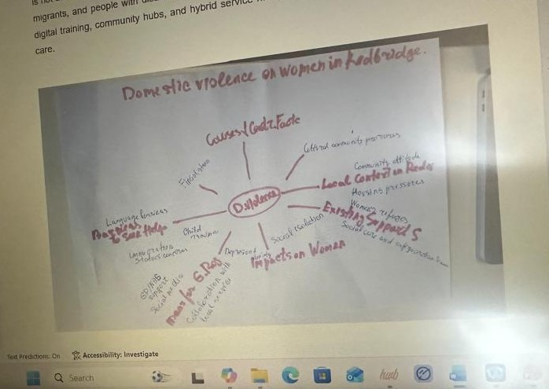
Appendix 1: Evidence of learning for Task 1

Task 2: Mind Map and Explanation
Problem: Digital Exclusion in Health and Social Care
Digital exclusion affects people who cannot access or use online health services. This problem matters because many NHS services now rely on digital tools such as online appointments, electronic prescriptions and remote monitoring. My mind map shows three main areas. The causes include limited digital skills, lack of internet access and low income. The impacts include missed appointments, reduced independence and poorer health outcomes. Possible solutions include digital training programmes, community support groups and providing devices for people on low incomes. Using the Social Determinants of Health framework helps to show how digital exclusion is linked to wider factors such as education, housing and income (Bibby and Lovell, 2018). If the problem is not addressed, inequalities will increase and vulnerable groups will continue to experience barriers to care.
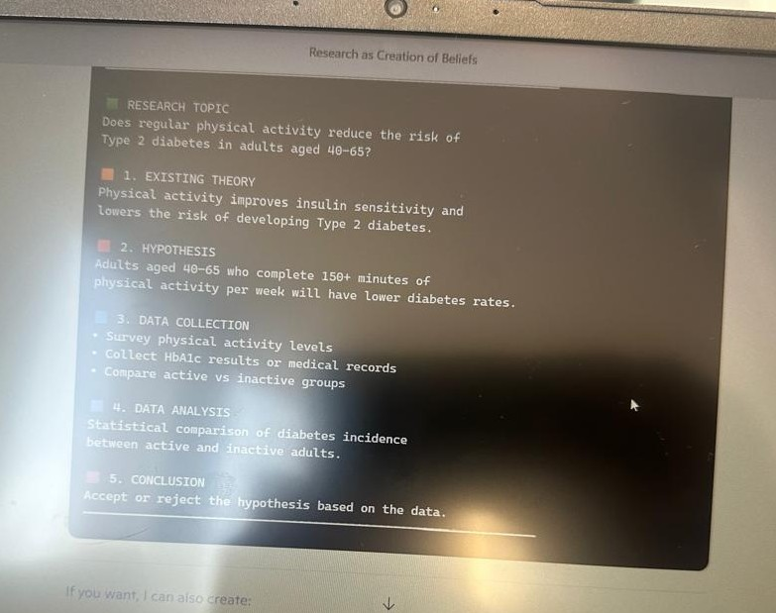
Appendix 2: Evidence of learning for Task 2

Task 3: Self Reflection on Group Activity
I used Gibbs’ Reflective Cycle to reflect on the convergent and divergent thinking activity. During the session, our group was asked to generate ideas using divergent thinking and then narrow them down using convergent thinking. Divergent thinking encouraged us to expand our ideas freely, while convergent thinking helped us select the most realistic option. At first, I felt more comfortable with convergent thinking because it is structured and focused. However, I realised that divergent thinking allowed me to contribute suggestions that are more creative. Jones and Estes explain that convergent thinking focuses on selecting the best solution, while divergent thinking encourages flexible and open exploration (Jones and Estes, 2015). When our group struggled to agree, I suggested listing the pros and cons of each idea, which helped us move forward. I learned that I rely on logical thinking but can also contribute creatively when given space. I also recognised the importance of listening to others and building on their ideas. Next time, I would try to use divergent thinking more confidently at the start of the task and encourage quieter group members to share their thoughts. Reflecting on this activity has helped me understand how both thinking styles support teamwork and problem solving.
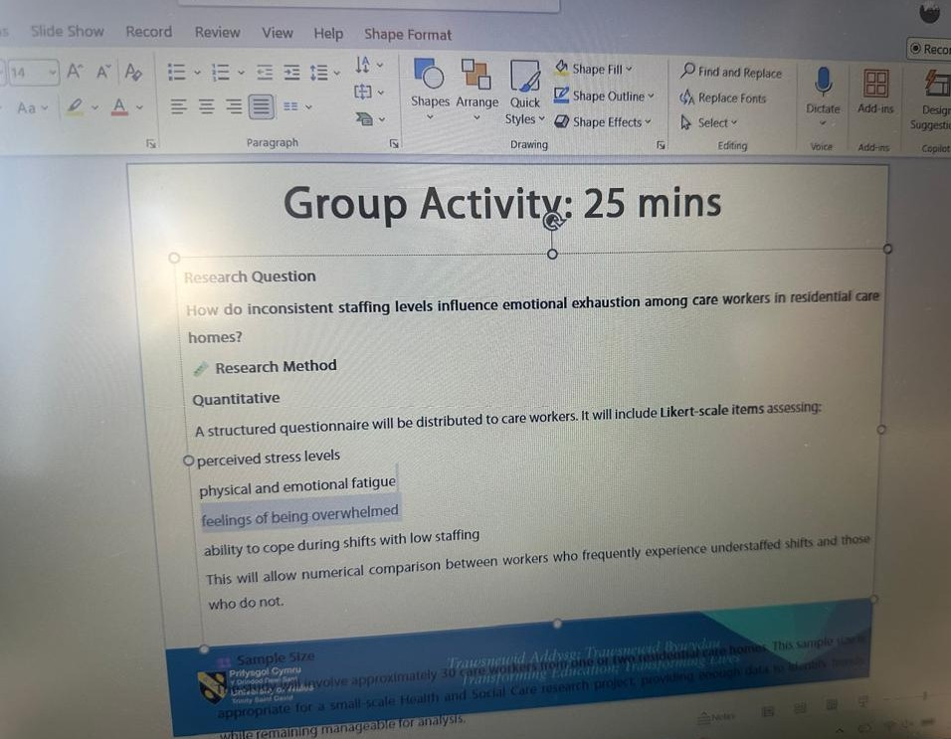
Appendix 3: Evidence of learning for Task 3

Task 4: Case Study Analysis of a UK Innovation
One recent innovation in the NHS is the development of virtual wards. These were introduced to address hospital overcrowding and long waiting times. Virtual wards allow patients with conditions such as respiratory illness or heart failure to be monitored at home using digital devices and regular contact with clinicians. Creativity played a role in designing a model that combines technology with personalised care. This approach created value by improving patient comfort, reducing hospital admissions and freeing up beds for those who need urgent care. NHS England reports that virtual wards have supported thousands of patients to recover safely at home while maintaining clinical oversight. The value created includes better patient experiences, reduced pressure on staff, and more efficient use of resources. Rogers’ Diffusion of Innovation Theory helps explain why virtual wards have been adopted widely, as staff recognised their usefulness and ease of use (Rogers, 2003). This innovation could be used in other areas such as mental health or long-term condition management, showing its potential for wider impact across the health system.
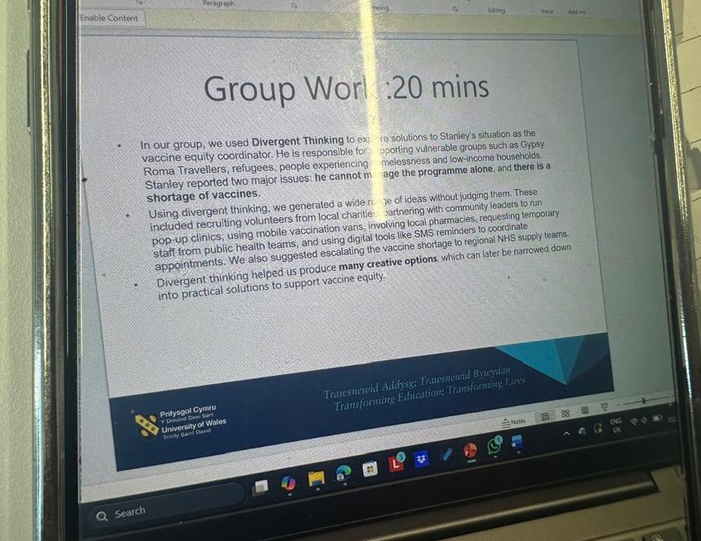
Appendix 4: Evidence of learning for Task 4

Task 5: Research Task
Staff stress is a common issue in health and social care, and two academic sources helped me understand why it develops. Maslach and Leiter (2016) explain burnout as something that builds up when pressure continues for a long time. They describe emotional exhaustion and feeling unable to meet expectations as key signs. They also highlight heavy workloads and limited support as major causes, which reflects what often happens in busy care environments. Johnson et al. (2018) focus more on organisational factors such as unclear communication, lack of resources and poor team structures. Their work shows that stress is shaped not only by personal feelings but also by the wider system. Both articles agree that workplace conditions strongly influence staff wellbeing, although they look at the problem from different angles. In real practice, these causes appear when staff face rising demand or struggle to manage complex cases without enough guidance. These studies helped me understand why stress develops and why improving organisational culture is important for supporting staff.
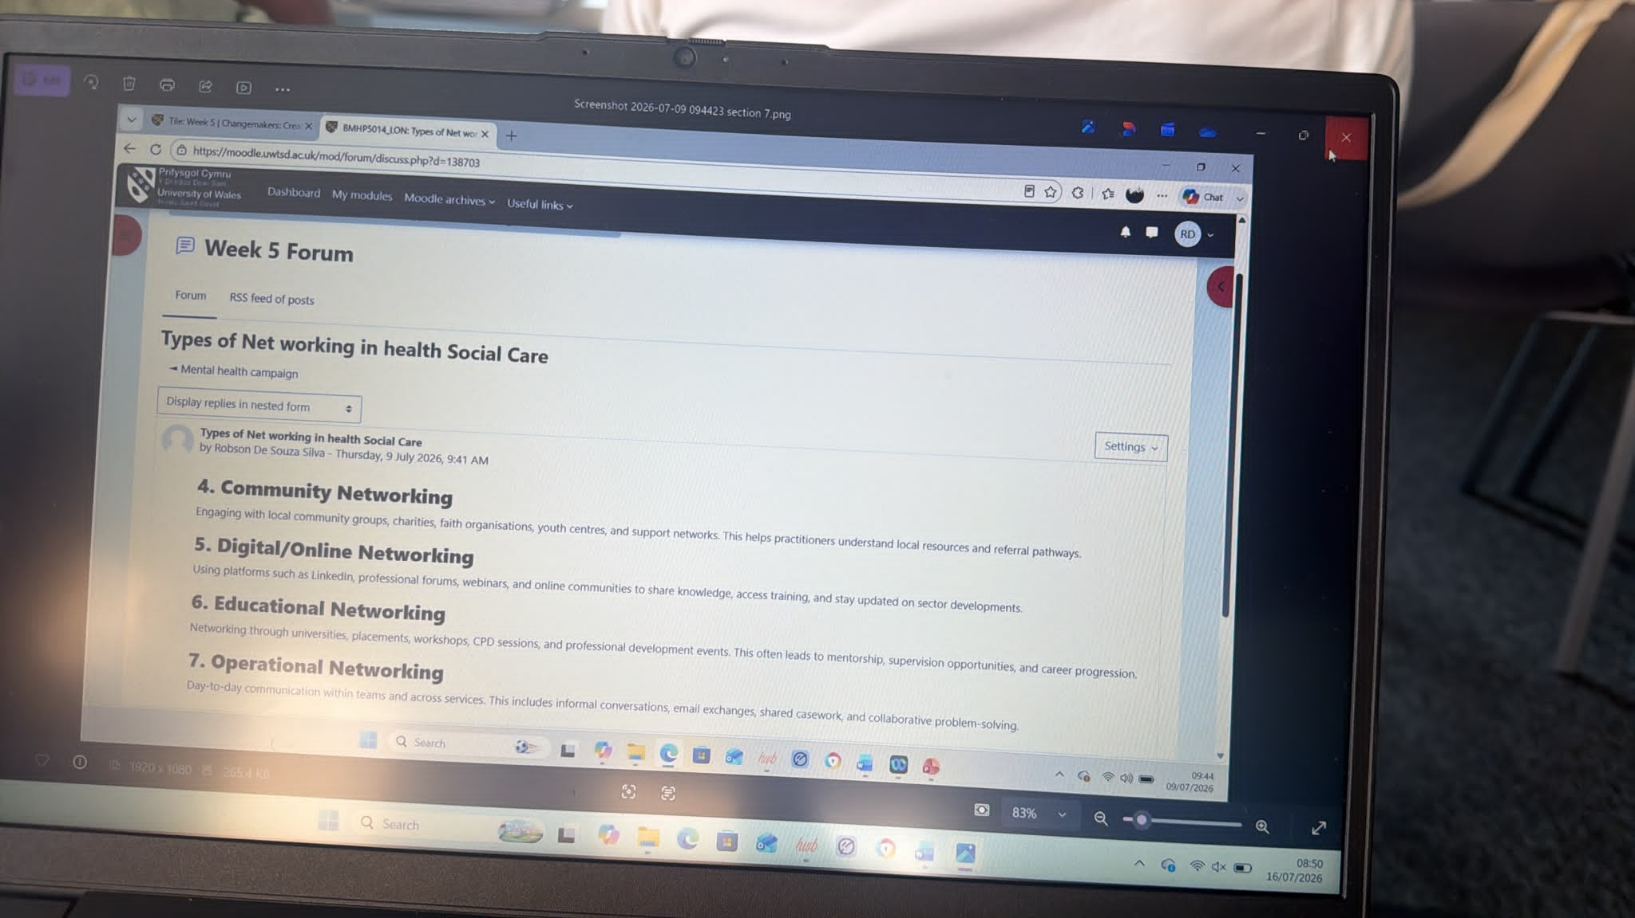
Appendix 5: Evidence of learning for Task 5

Task 6: Exploring Digital Innovation

6a. Wearable Health Technologies
Wearable devices like smartwatches help people manage long‑term health conditions by tracking information such as heart rate, sleep and activity levels. These tools give people a clearer picture of their health and can warn them when something changes. For example, some watches can detect irregular heart rhythms and alert both the user and their healthcare team. This helps people act early and avoid complications. Wearables also support clinicians by providing continuous data instead of relying only on appointments. The Technology Acceptance Model explains that people are more likely to use digital tools when they find them helpful and easy to use (Davis, 1989). This helps explain why wearables are becoming more common in managing chronic conditions.

6b. Electronic Health Records
Electronic Health Records help staff communicate better by giving everyone access to the same information. Instead of relying on paper notes, professionals can see test results, medication lists and care plans instantly. This reduces mistakes and saves time. EHRs also support continuity of care because information follows the patient across different services. For example, when someone moves from hospital to community care, staff can see the same records. This improves teamwork and reduces delays. The Technology Acceptance Model explains that people use digital tools more when they are easy to use and clearly helpful (Davis, 1989). EHRs improve teamwork and help ensure safe, coordinated care.

6c. Digital Technology for Prevention
Digital tools help people stay healthy by giving them easy access to advice and support. Apps that promote exercise, healthy eating or mental wellbeing encourage people to track their habits and set goals. A good example is the NHS Couch to 5K app, which guides beginners through a running plan. Digital tools also allow professionals to share information through videos or messages. These tools help prevent illness and reduce pressure on services. The Technology Acceptance Model explains that people use digital tools more when they find them useful and easy to use (Davis, 1989). This helps explain why simple apps can have a strong impact on public health.
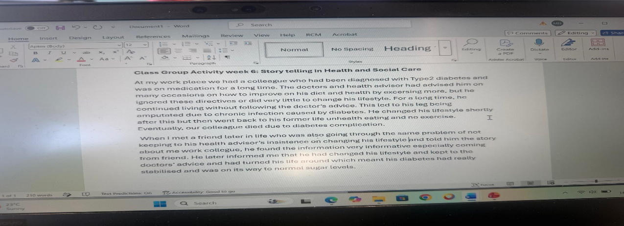
Appendix 6: Evidence of learning for Task 6

Task 7: NHS Leadership Framework

7a. Summary of the NHS Leadership Framework
The NHS Leadership Framework describes seven behaviours that show what good leadership looks like in health and social care. These behaviours include inspiring shared purpose, leading with care, evaluating information, connecting services, sharing the vision, engaging the team and holding people to account. The framework helps staff understand how leadership supports teamwork, communication and safe care. It is important because health and social care relies on collaboration, especially when services face high demand. By following these behaviours, leaders can create positive environments where staff feel valued and motivated. This supports creativity, innovation and better outcomes for service users. The framework also helps organisations develop consistent leadership standards across different roles and settings.

7b. Leadership Behaviour Applied
Inspiring shared purpose helps leaders show staff why their work matters. A leader can use this behaviour to support creativity by involving staff in planning new ideas. For example, a manager might ask the team to help design a wellbeing programme. This encourages staff to think creatively and feel ownership. Transformational Leadership Theory explains that leaders who inspire others can support innovation and positive change (Bass and Avolio, 1994). This behaviour can improve patient care by building a shared commitment to better outcomes.

7c. Reflective Journal Entry
This module helped me understand creativity and value creation more clearly. At first, I thought creativity was mainly about new ideas, but I learned that it also involves problem solving and teamwork. Activities like the convergent and divergent thinking task showed me how different thinking styles help groups work better. Learning about value creation helped me see how small changes can improve patient outcomes. The leadership content also showed me how supportive leaders encourage creativity. This learning will shape my future practice by helping me approach challenges with confidence and curiosity.
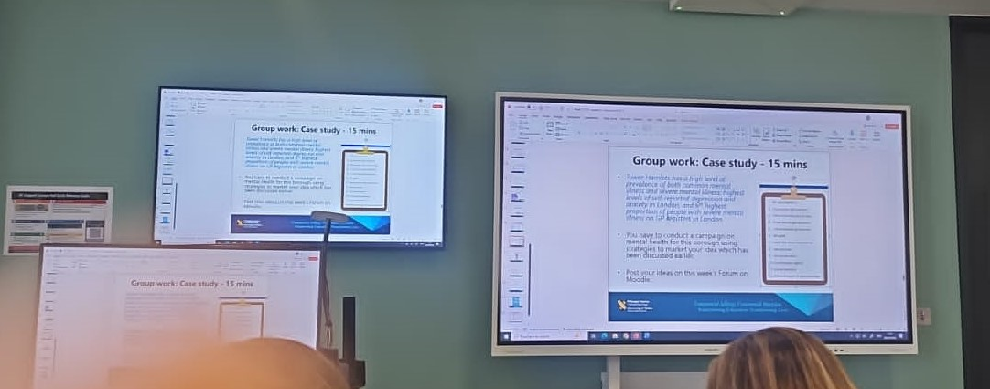
Appendix 7: Evidence of learning for Task 7

Task 8: Self‑Reflection Journal Entry
This module changed how I think about creativity, innovation and value creation. I learned that creativity is not only about new ideas but also about adapting to challenges and working with others. Activities like the divergent thinking task helped me explore ideas more freely. Learning about value creation showed me how important it is to focus on patient experience and long‑term outcomes. Using Gibbs’ reflective model helped me understand my strengths and areas to improve. In future practice, I want to apply these ideas by contributing suggestions, supporting colleagues and looking for ways to improve care.

References
Amabile, T. (1996) Creativity and Innovation in Organisations. Harvard Business School.
Bass, B.M. and Avolio, B.J. (1994) Improving Organisational Effectiveness through Transformational Leadership. Sage.
Bibby, J. and Lovell, N. (2018) What Makes Us Healthy? The Health Foundation.
Burnes, B. (2017) ‘Kurt Lewin and the Harwood Studies’, Journal of Change Management, 17(2), pp. 118–131.
Cambridge Dictionary (2023) Innovation. Cambridge University Press.
Care Quality Commission (2021) Enabling Innovation and Adoption in Health and Social Care. CQC.
Davis, F.D. (1989) ‘Perceived usefulness, perceived ease of use, and user acceptance of information technology’, MIS Quarterly, 13(3), pp. 319–340.
Gibbs, G. (1988) Learning by Doing. Oxford Polytechnic.
Johannessen, T., Storm, M. and Holm, A. (2019) ‘Safety for older adults using telecare’, Nursing Open, 6(3), pp. 1254–1261.
Johnson, J., Hall, L. and Berzins, K. (2018) ‘Mental health staff stress and organisational culture’, Journal of Mental Health, 27(1), pp. 1–8.
Jones, L.L. and Estes, Z. (2015) ‘Convergent and divergent thinking in verbal analogy’, Thinking and Reasoning, 21(4), pp. 473–500.
Maslach, C. and Leiter, M.P. (2016) ‘Understanding burnout’, World Psychiatry, 15(2), pp. 103–111.
NHS Leadership Academy (2022) NHS Leadership Framework. NHS England.
Porter, M.E. (2010) ‘What is value in health care?’, New England Journal of Medicine, 363(26), pp. 2477–2481.
Rogers, E.M. (2003) Diffusion of Innovations. 5th edn. Free Press.

