
Individual Presentation on

Talent Acquisition

Module: Managing People

Code: LCBB5004

Lecturer: Dr Laila Maazous

Name: Simona Vitelaru

Student ID: 2133624

Introduction

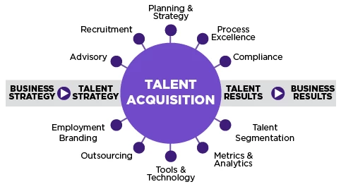
• Talent acquisition involves identifying potential candidates from the talent pool and recruiting them.

• It also involves employees to “employee turnover”.

retaining reduce

• The study focuses on providing effective strategies and incentive methods for talent acquisition and attracting potential candidates respectively.

Labour market overview: UK Hospitality scenario

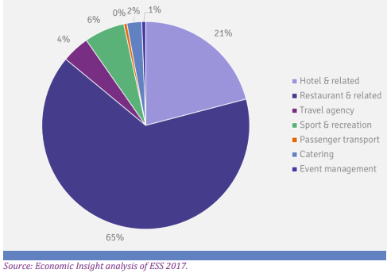
• The hospitality industry is a “labor-intensive industry”.

• Data shows that the vacancy in the "hospitality industry" has doubled (+102%) (Ukhospitality.org.uk. 2022).

• The government data shows that Hotel and related industry consists of around 21% of the total workforce of the "hospitality industry" in the UK (Assets.publishing.service.gov. uk. 2019).

Labor market overview (opportunity): UK Hospitality scenario (Contd.)

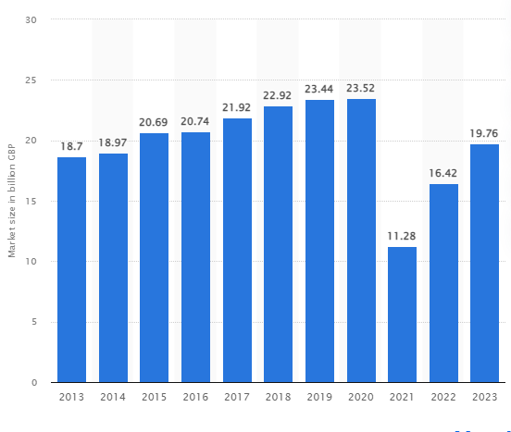
• The overall "hospitality industry" is expected to grow and reach 19.76 billion GBP in 2023 (Statista.com. 2023).

• Though the Restaurant industry in the UK has experienced a fall of 33%, the industry is expected to recover fully by 2024 (Statista.com. 2022).

• This also creates a high potential for new vacancies and also increases demands for new skills in the labor market.

Labour market overview (challenges): UK Hospitality scenario (Contd.)

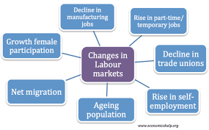
• The labour shortage is one of the major challenges in the labour market in the Uk (Theweek.co.uk. 2022).

• The “hospitality industry” is labour-intensive and gets negatively impacted due to a shortage of skilled labour.

• The employment rate in the UK is 75.9% in 2023 (Ons.gov.uk. 2023).

Talent acquisition strategies: Short-term

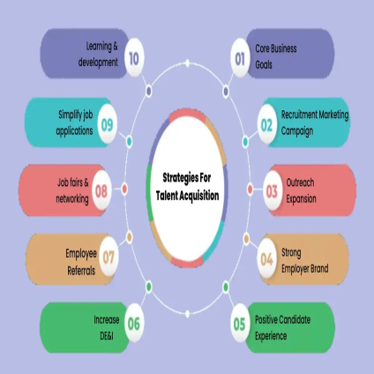
• The recent "future shock" focuses on "shaping the workforce of the future" (Ukhospitality.org.uk. 2022).

• Analysing the "demand gap", effective assessment of the skill demand is important as a short-term strategy of recruitment.

• Shortening the time for the recruitment procedure is effective for immediate hiring to support sudden demand.

Talent acquisition strategies: Short-term (Contd.)

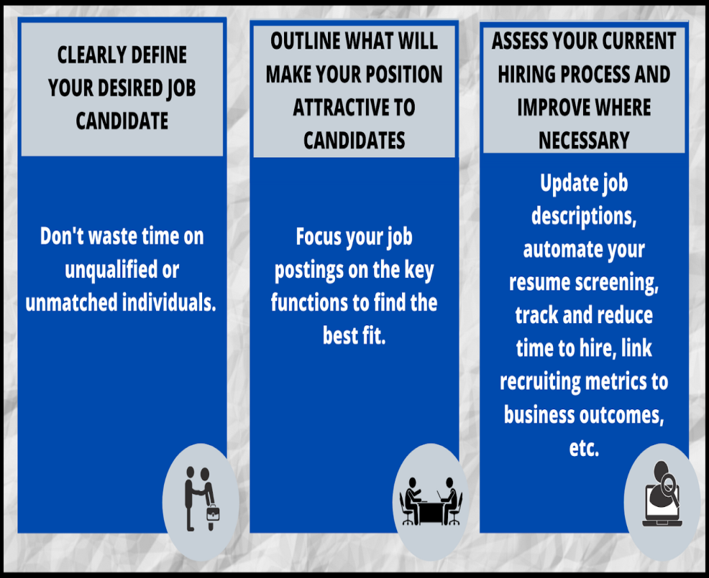
• Developing clearly defined and accurate job descriptions can be an effective strategy for short-term talent acquisition (Azizi et al. 2021).

• It is beneficial for diminishing the recruitment time and attracting only the relevant potential talents.

• It helps candidates to know whether their experience and qualifications are aligned with the vacancy or not.

Talent acquisition strategies: Short-term (Contd.)

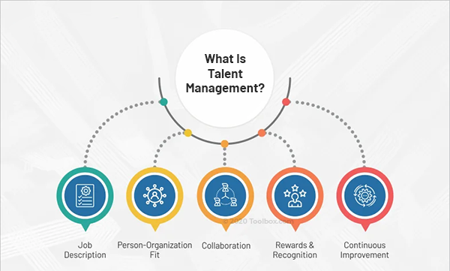
• Effective collaboration with third-party vendors can help to shorten the recruitment process.

• Vendors can help in sourcing, screening and shortlisting the appropriate candidates.

• Leveraging advanced technology for screening and shortlisting candidates can also be effective for short-term talent acquisition (Kulkarni and Che 2019).

Talent acquisition strategies: Long-term

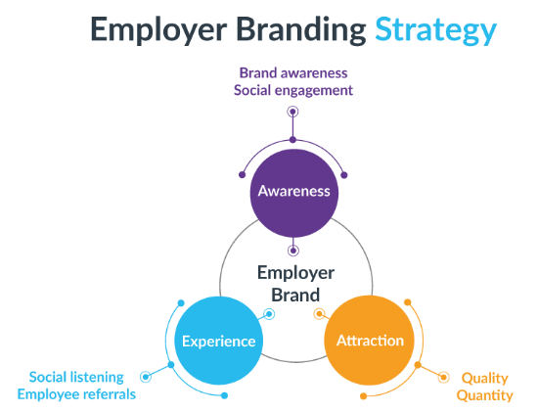
• One of the most effective strategies for long-term talent acquisition is to develop an "employer brand" to attract potential candidates (Itam, Misra and Anjum 2020).

• It helps the organisation to gain a competitive advantage in the job market.

• The work culture and the reputation of the organisation significantly help in attracting highly skilled talents from the talent pool.

Talent acquisition strategies: Long-term (Contd.)


• Utilising online platforms and social media can help to scale the recruitment process in the long term (Ali et al. 2020).

• It enhances the online presence of the organizations and helps to attract global talents through these portals.

• It also helps in comparatively easy communication and provides faster responses along with reducing recruitment costs.

Talent acquisition strategies: Long-term (Contd.)

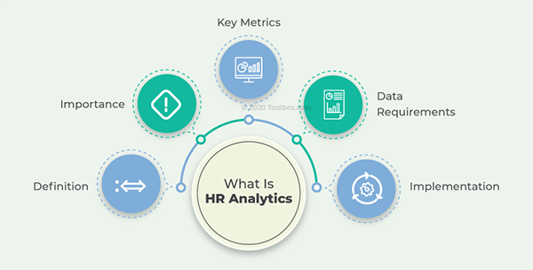
• Analysing trends and evaluating data is another strategy for long-term talent acquisition (Abdeldayem and Aldulaimi 2020).

• It helps recruiters to create and develop better "acquisition material" in the long run.

• evaluating data also helps to get valuable insights that help recruiters to identify top skills required for specific jobs.

Incentives methods for attracting potential candidates (Monetary)


• Profit sharing and providing a share of the profits to the employees can be effective monetary incentives for attracting employees (Ngwa et al. 2019).

• This can be in the form of “retiral fund contribution” or “business stock” etc.

• These are offered in addition to regular pay, bonuses and other benefits.

Incentives methods for attracting potential candidates (Monetary) (Contd.)

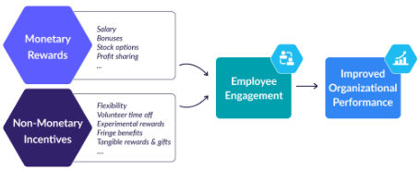
• Providing "cash rewards" can be highly effective for attracting top talents from the global talent pool (Forbes.com. 2023).

• For many people, extra money and paying rewards for good work is always a motivator.

• It not only attracts talented and skilled employees but also helps them to enhance their performance.

Incentives methods for attracting potential candidates (Non-Monetary)

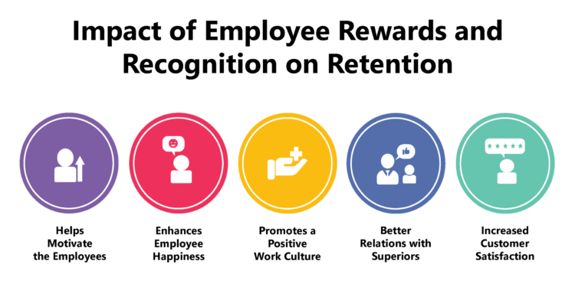
• Recognition in public is one of the most effective “non-monetary incentive methods” to attract potential candidates (Mwila and Kulwa 2022).

• It also helps to enhance the motivation level of the employees to further work better.

• Recognising the employees for their good work helps to enhance the overall “work culture” and motivates the employees.

Incentives methods for attracting potential candidates (Non-Monetary) (Contd.)

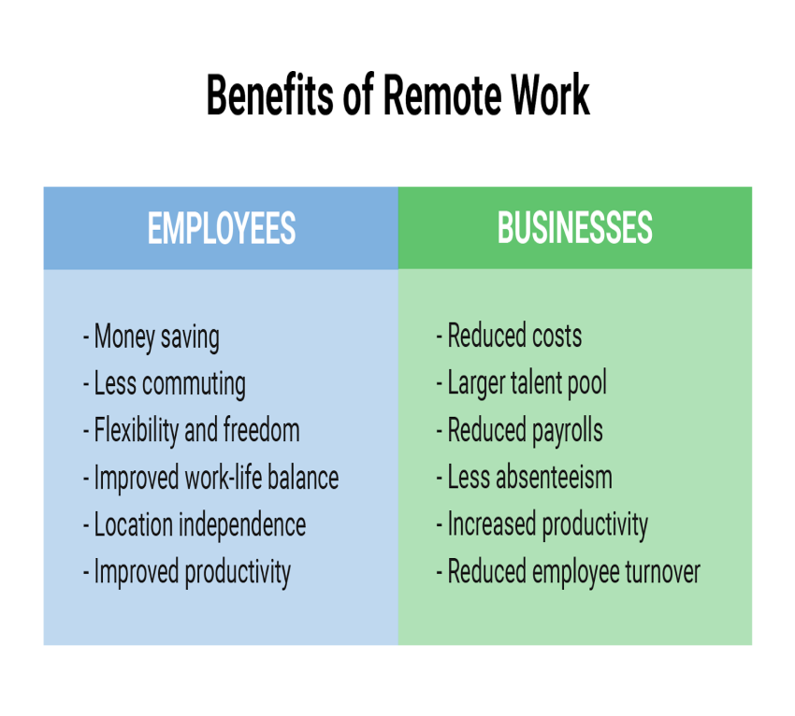
• In the current scenario, the option for flexible working or remote working is another effective “non-monetary method” to attract employees (Moroa et al. 2023).

• Many potential candidates are preferring for remote work-setting and flexible work modes.

• The trend has increased after the outbreak of the “global pandemic”.

Conclusion

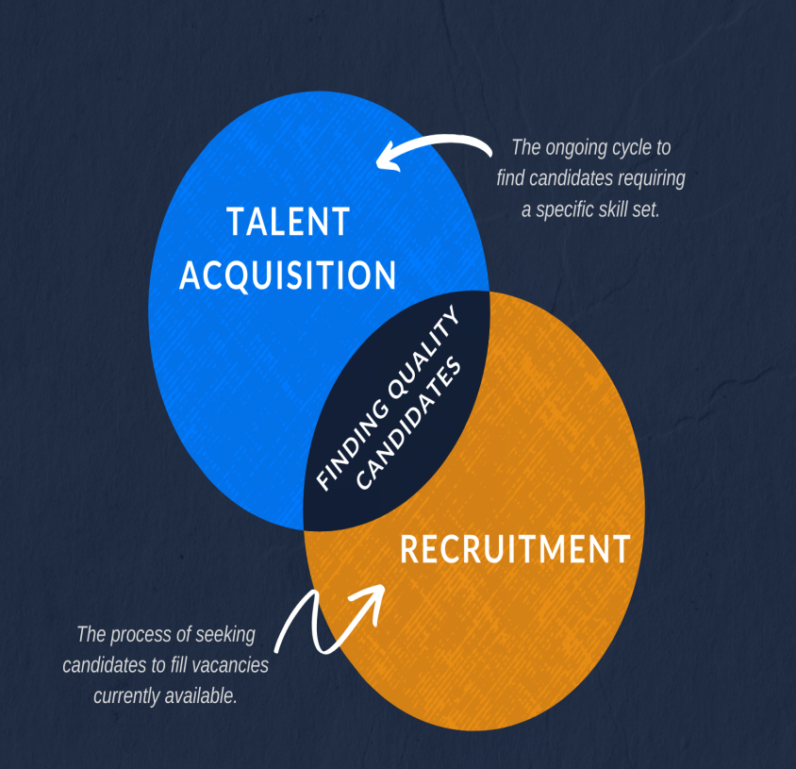
• The shortage of skilled labour along with the high demand for effective manpower in the hospitality industry are creating challenging situations in the UK labour market.

• The effective short-term and long-term strategies for talent acquisition have been discussed.

• Both monetary and non-monetary incentive methods for attracting top talents are also addressed.

Reference list

1. Abdeldayem, M.M. and Aldulaimi, S.H., 2020. Trends and opportunities of artificial intelligence in human resource management: Aspirations for public sector in Bahrain.
International Journal of Scientific and Technology Research, 9(1), pp.3867-3871. [Available at: https://www.researchgate.net/profile/Saeed-
Aldulaimi/publication/340460650_Trends_And_Opportunities_Of_Artificial_Intelligence_In_Human_Resource_Management_Aspirations_For_Public_Sector_In_Bahrain/links/5e8f
07cc299bf1307989f7b0/Trends-And-Opportunities-Of-Artificial-Intelligence-In-Human-Resource-Management-Aspirations-For-Public-Sector-In-Bahrain.pdf]
2. Ali, S.H., Foreman, J., Capasso, A., Jones, A.M., Tozan, Y. and DiClemente, R.J., 2020. Social media as a recruitment platform for a nationwide online survey of COVID-19
knowledge, beliefs, and practices in the United States: methodology and feasibility analysis. BMC medical research methodology, 20(1), pp.1-11. [Available at:
https://bmcmedresmethodol.biomedcentral.com/articles/10.1186/s12874-020-01011-0]
3. Assets.publishing.service.gov.uk. 2019. Hospitality and Tourism workforce landscape. [Online] Available at:
<https://assets.publishing.service.gov.uk/government/uploads/system/uploads/attachment_data/file/827952/Hospitality_and_Tourism_Workforce_Landscape.pdf> [Accessed 5 July
2023].
4. Azizi, M.R., Atlasi, R., Ziapour, A., Abbas, J. and Naemi, R., 2021. Innovative human resource management strategies during the COVID-19 pandemic: A systematic narrative review
approach. Heliyon, 7(6). [Available at:
https://scholar.google.com/scholar?output=instlink&q=info:5tL2Ck6JZUoJ:scholar.google.com/&hl=en&as_sdt=0,5&as_ylo=2019&scillfp=2914603433756212673&oi=lle]
5. Forbes.com. 2023. Monetary Incentives In The Workplace (2023 Guide). [Online] Available at: <https://www.forbes.com/advisor/business/monetary-incentives/> [Accessed 5 July
2023].
6. Itam, U., Misra, S. and Anjum, H., 2020. HRD indicators and branding practices: A viewpoint on the employer brand building process. European Journal of Training and
Development, 44(6/7), pp.675-694. [Available at: https://www.researchgate.net/profile/Urmila-Itam-
2/publication/341122588_HRD_indicators_and_branding_practices_a_viewpoint_on_the_employer_brand_building_process/links/5ee84f4e458515814a628c6c/HRD-indicators-and-
branding-practices-a-viewpoint-on-the-employer-brand-building-process.pdf]
7. Kulkarni, S.B. and Che, X., 2019. Intelligent software tools for recruiting. Journal of International Technology and Information Management, 28(2), pp.2-16. [Available at:
https://scholarworks.lib.csusb.edu/cgi/viewcontent.cgi?article=1398&context=jitim]
8. Moroa, S.R., Cauchick-Miguela, P.A., de Sousa-Zomerb, T.T. and de Sousa Mendesc, G.H., 2023. Design of a sustainable electric vehicle sharing business model in the Brazilian
context. International Journal of Industrial Engineering & Management (IJIEM), 14(2). [Available at: https://www.researchgate.net/profile/Suzana-
Moro/publication/370943686_Design_of_a_sustainable_electric_vehicle_sharing_business_model_in_the_Brazilian_context/links/646b68e3ce39a956fbcff37e/Design-of-a-
sustainable-electric-vehicle-sharing-business-model-in-the-Brazilian-context.pdf]
9. Mwila, P.M. and Kulwa, B., 2022. Non-monetary Incentives: It’s Role in Enhancing Job Performance among Secondary School Teachers in Kinondoni Municipality, Tanzania. Asian
Journal of Education and Social Studies, pp.15-30. [Available at: http://libraryeprints.uk/id/eprint/52/1/730-Article%20Text-1224-1-10-20221101.pdf]
10. Ngwa, W.T., Adeleke, B.S., Agbaeze, E.K., Ghasi, N.C. and Imhanrenialena, B.O., 2019. Effect of reward system on employee performance among selected manufacturing firms in
the Litoral region of Cameroon. Academy of Strategic Management Journal, 18(3), pp.1-16. [Available at: https://www.researchgate.net/profile/



