

Programme: BA Developing Leadership and Management

Module: Creativity and Innovation

Module code: BMSW5013

Module Lead: Chris Wilkin
Assignment Title: Sustainable Community Innovation - The Seren Coffi Community Experience Programme
Student Name: Florina Dinitica

Student ID: 2321857

Date: 23 October 2026

AI Acknowledgement - This report used an AI language tool in a limited way during the early idea-development stage of Part 2. It was used to explore possible directions for the proposed innovation and generate alternative suggestions for consideration. Any outputs produced were reviewed critically and not adopted uncritically. The final analysis, evaluation, conclusions and written discussion presented in this report are my own.

Executive Summary

This report examines the challenges facing Seren Coffi, an independent café experiencing operational decline despite continued customer demand. It focuses on the role of creativity and innovation within a capitalist business environment, paying particular attention to the tension between financial sustainability, ethical values and community identity.
The report proposes a Community Experience Programme in which local artists, musicians and regular customers host and run the café's events, while staff provide the space and their normal service. The café has run events before, but they stopped because the founders could not keep delivering them. The proposal therefore changes who delivers the events rather than what the events are. Its viability is tested through Lewin's Force Field Analysis and the Business Model Canvas, which suggest that the idea can work if hosting stays simple and event decisions are made once, through agreed rules.
The second part evaluates how AI was used to test the programme. The AI exposed real ambiguities about opening hours, approval and costs, but several of its recommendations would have added the workload the programme is meant to remove. Its advice also shifted with the framing of each prompt, so only points it held consistently were accepted. Overall, the report concludes that innovation at Seren Coffi should focus less on expansion and more on restoring operational stability while preserving the café’s distinct community value.

CONTENTS

Part 1: Innovation Analysis Report 3
Introduction to the Organisation and the Innovation Issue 3
Critical Analysis of Creativity and Innovation in Capitalist Business Growth 3
The Strategic Importance of Creativity and Innovation 3
Capitalist Business Models and Innovation Tensions 4
Innovation Barriers for Small and Medium-Sized Enterprises 4
Implications for Seren Coffi 5
Explanation of the Proposed Innovation Concept 5
Overview of the Proposed Innovation 5
Application of the 4Ps of Innovation Framework 6
Application of Business Model Canvas 7
Creativity Process Used to Develop the Innovation 8
Innovation Viability: Lewin’s Force Field Analysis 8
Driving Forces Supporting Innovation 9
Restraining Forces Limiting Innovation 9
Evaluation 10
Organisational Climate and Innovation Support 10
Part 2: Applying AI to Develop the Innovation 11
Introduction to AI Use in Innovation Development 12
AI-Generated Recommendations for the Innovation 12
Critical Evaluation of AI Recommendations 13
Challenges and Successes When Using AI 14
Reflection on the Use of AI 15
Main Findings 15
Overall Conclusion 16
References 17
Appendix 21
List of Prompts 21
AI Conversation Screenshots 22

Part 1: Innovation Analysis Report

Introduction to the Organisation and the Innovation Issue
Seren Coffi is an independent café near the old docks in Cardiff. It pairs speciality coffee with ethical sourcing and a strong Welsh identity, from bilingual signage to reclaimed chapel pews. Where chains compete on scale, Seren Coffi has competed on atmosphere and authenticity, a form of experience-based differentiation (Pine and Gilmore, 2011).
The café is now struggling. Service is slow, decisions stall in long consensus meetings, the grinder has been broken for weeks and a chain with loyalty apps has opened nearby. The founders are tired, and one has taken a part-time job elsewhere. Demand has not disappeared, which suggests that the core issue lies in operational sustainability and in how the café has approached innovation.
This distinction matters. Seren Coffi does not lack identity or customers. It lacks a way of innovating that its founders can sustain. The brief also sets firm limits. Leadership, governance and suppliers cannot change, and the £2,000 is a tool rather than the answer. A capitalist solution is not assumed to be right either.
This report proposes an innovation that works within those limits, tests its viability and assesses whether the café's climate would support it.

Critical Analysis of Creativity and Innovation in Capitalist Business Growth

The Strategic Importance of Creativity and Innovation
Creativity produces novel and useful ideas, and innovation turns them into value (Amabile, 1996; Baregheh, Rowley and Sambrook, 2009). The literature treats innovation as important for business development (Trott, 2017), yet assumes spare time, money and staff. Seren Coffi has little of each to spare. The real question is which kind of innovation it can sustain.
Creativity has not been the café's main weakness. In its first summer, it ran poetry readings, language exchanges and pay-what-you-can evenings that drew crowds. A magazine even listed it among the places giving Cardiff its soul back. Those events have now stopped. Tidd and Bessant (2018) treat innovation as a managed process, and this is what the café lacked. The founders rotated shifts and made every decision together after closing. Each new event simply added to their load.
Foss and Saebi (2015) show that innovation can sit in the business model rather than the product. For Seren Coffi this is the more useful lens. Adding activities to the current model would repeat the old pattern. The change needed is in how events are produced.

Capitalist Business Models and Innovation Tensions
Capitalist business models tend to reward efficiency, scale and profit. Turner (2020) describes how firms drift towards optimising what already exists. Ideas that cut costs or raise revenue then win over those with social value.
Porter and Kramer (2011) argue that firms can create shared value by meeting social needs profitably. Crane et al. (2014) counter that this still judges social value by whether it pays and hides real trade-offs. For a small café those trade-offs are immediate, since social returns arrive slowly while operating costs are due now.
The case makes the tension concrete. Seren Coffi refuses shrinkflation and explains its price rise on the chalkboard. The hospitality group then offered the capitalist route in its plainest form. It proposed a standard menu, new suppliers and faster decisions by fewer people. The promise was that 'you'd still have your values, just with more reach'. The offer may raise efficiency, but it would remove what customers value and break the brief's rule on suppliers. It rests on bulk purchasing and supply chain efficiency, which Manners-Bell and Lyon (2022) associate with scale. Seren Coffi cannot win on those terms. A capitalist reading sees its values as a cost, whereas this report treats them as the asset to build on.

Innovation Barriers for Small and Medium-Sized Enterprises

Small businesses face limited capital, thin management capacity and little room to absorb failure (Trott, 2017). Each barrier shows up at Seren Coffi. Its capital is £2,000 of petty cash, and broken equipment slows service before any new idea is tried. Management rests with the founders, whose consensus style turns small questions, such as which bakery to use, into long debates. Tidd and Bessant (2018) link innovation to a culture of experimentation, but experimentation needs spare capacity the café does not have. Any viable idea must therefore cost little, demand little founder time and not depend on one person.

Implications for Seren Coffi
These limits rule out a second site, a standard menu or cheaper suppliers. What remains is an innovation built on existing assets: a loyal community, a distinctive space and a reputation for events.

Explanation of the Proposed Innovation Concept

Overview of the Proposed Innovation
The Community Experience Programme would bring back exhibitions, live music, readings, language exchanges and small workshops. The events are not new. What changes is who runs them, a new combination of resources the café already holds (Schumpeter, 1934).
Previously, the owners planned and ran each event on top of their shifts. Under the programme, a community host proposes and runs each event. This could be a local artist, a poet or a regular who leads a language exchange. The host sets up, runs the session and clears away. Staff only serve coffee, as on any other evening. Three rules keep this workable.
First, the founders agree once on criteria that every event must meet. It must fit the café's values, the host must run it, and it must need no extra staff, purchases or organising costs. A member of staff checks the sign-up sheets against them each week, so no meeting is needed. The founders keep the final say and can turn down any event, which leaves the café's governance unchanged.
Second, two evening slots a week are listed on the chalkboard and hosts sign up at the counter. Each host takes bookings and keeps numbers within the café's seating capacity. This does not remove the café's normal duty to keep the space safe.
Third, an empty slot means a normal evening. The same applies if a host cancels or fails to appear. Staff do not take an event over. The programme can therefore shrink without extra work.
The £2,000 has a narrow role. Repairing the grinder comes first, because hosts need a café that works. Basic hanging and sound equipment will follow only if money remains.
These rules target the reason the poetry nights failed, since the founders no longer run events or debate each one. The design also avoids the problem the case raises with volunteers, who solved some issues but created others. Hosts never work behind the counter. They run their own event in return for a space and an audience.
The proposal carries its own ethical risk. Unpaid hosts could make it a quieter form of the capitalist logic it criticises, with the café gaining footfall from free labour. The difference lies in who benefits. Hosts gain a free venue, an audience and a place to test their work, while the café earns mainly from coffee and food. If that balance shifted, the programme would exploit the goodwill it depends on.
In Pine and Gilmore's (2011) terms, the café stages experiences without producing them all, and customers co-create the value they consume (Prahalad and Ramaswamy, 2004). Quality will vary, but an uneven programme the community can sustain is better than a polished one that exhausts the café's owners.

Application of the 4Ps of Innovation Framework
Tidd and Bessant (2018) classify innovation as product, process, position or paradigm. The framework shows where the novelty lies and what should be measured.
Product Innovation is low. The café has hosted similar events, so claiming more would overstate the idea.
Process Innovation is high and forms the core of the proposal. Delivery moves from founders to hosts and decisions move from repeated debate to fixed criteria.
Damanpour and Aravind (2012) call this managerial innovation: a new way of organising work. Success should therefore be judged by how many events run without founders having to step in, not by attendance alone.
Position Innovation is limited but defensive. The café already holds a community hub position shown by its magazine listing and radio feature. The programme restores that position as it slips, which matters against a chain that competes on discounts.
Paradigm Innovation is possible but secondary. The café already sees itself as a community space. The real shift would be in the founders' mindset. The case shows them returning to the idea of 'doing things properly', and delegation will test whether others can meet that standard. This shift follows from the process change and depends on the founders. Given how much they value control, it is also the likeliest barrier to adoption.
Overall, the proposal is incremental in what the café offers and more significant in how it operates. This fits Foss and Saebi's (2015) view that business model innovation often depends on organisational change.

Application of Business Model Canvas
Aspects | Application to Seren Coffi
Key Partners | Community hosts (local artists, musicians, poets, regulars); existing ethical suppliers
Key Activities | Coffee service; providing the space; keeping the chalkboard calendar; agreeing event criteria once
Key Resources | Café space; brand identity; working equipment; host network
Value Proposition | Community-made café experience, authentic, ethical, low-cost to run
Customer Relationships | Informal and participatory, co-created events with low staff dependency
Channels | Chalkboard calendar; counter sign-up sheet; word of mouth; social media.
Customer Segments | Residents; students; creatives; ethically aware customers
Cost Structure | Rent; utilities; wages; equipment repairs; no extra staffing for events
Revenue Streams | Coffee and food sales on quiet evenings; longer dwell time; possible pay-what-you-can contributions (untested)
Table 1: Business Model Canvas for the Community Experience Programme
The canvas shows how the changes fit together (Osterwalder and Pigneur, 2010).
Three links explain the value created.
First, shifting delivery to key partners changes the cost structure. Each event used to cost staff hours and founder time. An event still adds energy use, cleaning and a busier room. It reduces the founder time required for event organisation, a resource the café can least afford to lose.
Second, events fill the weakest trading hours. Since the chain opened, several evenings have seen staff outnumber customers. Events could turn those paid but empty hours into sales of coffee and food. Busier evenings would not guarantee higher income, so the evaluation tests sales directly.
Third, the value proposition and channels reinforce each other. Verhoef et al. (2009) show that other customers and the social setting shape the experience. A chain could copy the events, but not the local relationship behind them. Revenue is the weak point. Pay-what-you-can income is uncertain, and the case offers no evidence that events alone would close the gap between cost and income. The programme restores footfall and identity cheaply, but it is not a full financial recovery.

Creativity Process Used to Develop the Innovation
The idea came from one observation: the events the café was praised for were the events it could not sustain. Design thinking provided the method. Brown (2008) describes it as moving through inspiration, ideation and implementation, starting from empathy with the people affected. Here the inspiration stage drew on evidence from the case, not on interviews, and it pointed to two user groups. Past events showed strong demand, though current interest still needs testing. The founders, who would oversee any new system, were exhausted. This reframed the problem from 'how can the café offer more events?' to 'how can events happen without the founders?' Options were then judged against that definition. An events coordinator was rejected because hiring had been deferred repeatedly. Growth through the hospitality group was rejected because it meant new suppliers. Of the options considered, only a host-led model fitted. Implementation would begin with a one-month trial of two slots a week, with a review before going further. This trial applies Brown's (2008) emphasis on using prototypes to test ideas and learn from feedback. Open innovation shapes delivery. Chesbrough, Vanhaverbeke and West (2014) describe it as the purposive use of knowledge flows across a firm's boundary.
Seren Coffi lacks internal capacity, so creative input and delivery come from outside.
West and Bogers (2014) show that obtaining outside ideas is only the first step. Integrating them is a separate challenge, hence the fixed slots and criteria. The volunteers show what happens without such rules. Hargadon and Bechky (2006) add that new ideas emerge when different people build on each other's work. Many hosts should keep the programme fresh.

Innovation Viability: Lewin’s Force Field Analysis
Force Field Analysis compares the forces driving and restraining a change (Lewin, 1951; Burnes, 2004). Here, each force is scored from 1 to 5 using evidence from the case. The scores are estimated based on the case and could differ in practice, but they make reasoning visible. A score of five marks a force that could decide the outcome on its own.

Driving Forces Supporting Innovation
Proven demand and community goodwill are the strongest drivers. Both come from the café’s own history, which makes them more reliable than market trends. The wider shift towards experiences matters less, since the nearby chain can respond to it too.
Table 2: Driving forces (1 = weak, 5 = strong)
Driving force | Evidence from the case | Score
Proven demand for events | Events drew crowds; magazine listing; radio feature | 5
Community willingness to contribute | Volunteers offered help; links with local makers | 4
Distinctive identity | Welsh signage, chapel pews; chain competes on price | 3
Demand for experiences | Students and retirees linger; experience economy | 3
Low cost and reversible | No new staff; no host means no event | 3
Total |  | 18

Restraining Forces Limiting Innovation
Under the old model the restraining forces equalled the driving forces, which may explain why the earlier events began well and then faded. Table 3 shows the effect of the redesign. Founder fatigue scores 5 because it is the only force that has already stopped the café’s events once. It falls to 2, not 1, as the founders still set the criteria and oversee the programme.
Table 3: Restraining forces before and after the redesign
Restraining force | Old model | New model | How the design reduces it
Founder fatigue and lack of time | 5 | 2 | Hosts deliver events; staff only serve
Slow consensus decisions | 4 | 2 | Criteria agreed once replace meetings
Impact of unreliable hosts | 3 | 2 | An empty slot costs nothing; the evening runs as normal
Service problems (grinder, queues) | 3 | 2 | Part of the £2,000 restores equipment
Founders’ reluctance to share control | 3 | 3 | Not removed; addressed through a trial
Total | 18 | 11

Evaluation
After the redesign, the driving forces (18) outweigh the restraining forces (11). This shows the idea is worth testing, not that it will succeed. The gain comes from weakening resistance, which Lewin saw as more effective than adding pressure (Burnes, 2004). The weakest point is the one force the design leaves untouched, the founders' attachment to control. Their acceptance of the trial is the first condition of success, though not the only one. The trial needs measures that match the problem. The first is the number of events that run without a founder having to organise or rescue them. The second is coffee and food sales on event evenings compared with similar evenings before the trial. The third is whether hosts come back.
A programme that attracts participants but continues to rely heavily on the founders cannot be considered fully successful, regardless of attendance. In capitalist terms, the idea is modest, as it promises neither growth nor scale. The brief allows such ideas to be justified through value creation instead. Here the value is shared. Hosts gain a platform, customers gain a reason to return, and the café gains a programme it can afford to run.

Organisational Climate and Innovation Support
The work environment can support or constrain creativity and innovation (Anderson, Potočnik and Zhou, 2014). At Seren Coffi its strengths and weaknesses share a source.
The founders share a clear purpose, and new ideas get a hearing. Edmondson and Lei (2014) define psychological safety as feeling able to speak up without fear, and they link it to experimentation. Some of that safety appears to exist among the founders, who discuss most questions openly. Open discussion alone does not prove it, however. A small firm can also move quickly once it decides (Bessant and Tidd, 2015).
Yet the same openness has become delay. Meetings run late, topics return and the hiring question keeps being deferred. Feeling safe to speak does not guarantee a decision. Safety might also be weakening. One founder now misses meetings, and 'no one made a fuss', although this could equally reflect fatigue or quiet disengagement.
Edmondson (1999) found that teams learn when members raise problems openly, so this silence is a warning sign either way. The criteria take many decisions off the table, but they cannot repair the founders' relationships. The trial may still help by giving them a shared, low-risk decision.
Argyris and Schön (1996) separate single-loop learning, which fixes errors within existing assumptions, from double-loop learning, which questions them. Extending opening hours when the chain arrived was a single-loop response. The programme challenges a deeper assumption, that the founders must deliver everything. A short monthly review of which events ran, which slots stayed empty and what hosts said would help that learning last. External networks could also support this learning process by providing access to resources that the café could not develop independently (Powell and Grodal, 2005). The council’s interest in civic events suggests a potential opportunity for such collaboration.
Overall, the climate supports innovation in its values, but not in its decision making.
Christensen (1997) shows that established firms struggle with innovations that do not fit their usual ways of working. The programme fits Seren Coffi's values but requires the founders to delegate responsibilities, which may conflict with their established habits. The trial and the criteria matter because they make that delegation gradual and reversible.

Part 2: Applying AI to Develop the Innovation

Introduction to AI Use in Innovation Development
Part 1 developed the Community Experience Programme before any AI tool was involved. I then gave the AI the full case study and a summary of the programme and asked whether it could be improved (Figures 1 to 6). The aim was not to find a new idea. It was to test a process innovation built on community hosts, rules set by the founders and a one-month trial against the case's constraints. The conversation used four prompts listed in the Appendix. The first two invited evaluation and improvement. The third challenged the AI's own advice and the fourth asked for a final judgement. Raisch and Krakowski (2021) argue that automation and augmentation cannot be cleanly separated and that leaning too far towards either carries risks. I therefore treated the AI as a reviewer whose suggestions needed testing, not as an authority.

AI-Generated Recommendations for the Innovation
The first response was more useful than expected. Its opening criticism was that bringing back events is not by itself the innovation, because the café had run them before (Figure 7). The AI placed the novelty where Part 1 now places it, in the transfer of organisation to community hosts. Its recommendations fell into three groups.
On operations, it asked whether the evening slots would extend opening hours, a move the case shows had already failed. It also questioned whether every booking would still need founder approval (Figures 8 and 9). On finance, it called the promise of no additional organisational cost too absolute, since checking bookings and cleaning still take time (Figure 9). On evaluation, it argued that attendance matters only if it supports trading (Figure 8). It also proposed a wider set of pilot measures (Figures 10 and 11). Not all of this was new. Hosts' responsibilities, the cancellation rule, the grinder repair and the pilot were already in my proposal. The AI later listed them as strengths (Figure 27). Its contribution was to expose ambiguity, not to supply the mechanism. When asked for further improvements, it went much further (Figures 13 to 21). It added a proposal form, booking checks, a host recruitment stage, more measures and decision rules for each pilot outcome. Each idea was defensible on its own. Together they read like a management template rather than advice for a café with exhausted founders. Doshi and Hauser (2024) found reduced diversity across AI-assisted short stories. Although their study concerned creative writing, it raises a relevant concern about the similarity of AI-supported outputs.

Critical Evaluation of AI Recommendations

I judged these additions against Part 1, not on their own terms. The Force Field Analysis showed that the programme works by weakening two restraining forces, founder fatigue and slow consensus decisions. The proposal form, exception reviews and new monitoring records would push both back up. They add tasks for staff and a new question for the founders to debate, repeating the same pattern that ended the poetry nights. The climate analysis points the same way, since founders who debate which bakery to use are unlikely to process forms quickly. I therefore challenged the AI to justify adding procedures without recreating the café's problems. I also asked it to critique its recommendations instead of defending them (Figures 21 and 22). It conceded that it had 'expanded the proposal in ways that could undermine its central purpose' (Figure 22). It then withdrew the form, the weekly delivery target, most of the monitoring and the wide range of formats. In their place, it proposed a much smaller first trial (Figures 23 to 25). Its revised test was useful: an arrangement is worth keeping only if it removes more work or uncertainty than it creates (Figure 22).
This concession does not prove that my criticism was correct. A model that reverses its advice when challenged may be responding to the framing of the question rather than to new evidence. My fourth prompt sharpened the problem. It stated that I preferred to keep the original proposal (Figure 26), and the final answer supported that preference.
To avoid relying on agreement, I looked for points the AI held across all four responses, whatever the prompt asked. Four survived. Success cannot be shown without trading data (Figures 6, 13, 22 and 26). Routine bookings must not need fresh founder decisions (Figures 9, 16, 23 and 28). Event slots must not extend opening hours (Figures 8, 15, 23 and 28). Claims of no extra cost need qualifying (Figures 9, 22 and 28). Its views on host incentives, the number of slots and monitoring shifted with each prompt, so I treated them as optional.
The stable points led to decisions. Slots will sit only within hours the café already keeps. The cost criterion in Part 1 is a design limit to be checked during the trial, not a guarantee. One further point was accepted. A founder serving coffee during an event is not a failure (Figure 11). The first pilot measure in Part 1 therefore counts events that run without a founder having to organise or rescue them.

Challenges and Successes When Using AI
The clearest success was speed. Within minutes, the AI produced a structured review that would have taken far longer by hand. This matches Noy and Zhang’s (2023) finding that AI reduces task time while improving output quality in professional writing tasks. It also gave an outside view. Haefner et al. (2021) argue that AI can ease the limits of human information processing in innovation work. Here, it highlighted opening hours and approval routes that I had not stated clearly. It was also candid about its own limits, noting more than once that the case contains no sales, margin or attendance data (Figure 6).
The challenges were more instructive. Output quality depends heavily on the prompt. A request for thorough improvements produces elaborate procedures, while a sceptical prompt produces restraint. Bouschery, Blazevic and Piller (2023) see language models as tools that widen the range of problems and solutions a team can explore. People still choose among them. That matched my experience. The AI generated options well but could not judge which ones a struggling café could afford to run. Fluency was a second challenge. Ji et al. (2023) show that language models can produce confident text that is not supported by their source, and Dwivedi et al. (2023) warn that AI's plausible output needs human verification. I found no factual errors about the case. The risk lay elsewhere, in recommendations that sounded sensible but drew on management practice built for larger firms. Dwivedi et al. (2021) note that AI systems lack the contextual understanding organisational decisions require, and this was the gap I had to fill.
Finally, the AI underestimated the practical cost of its own recommendations. It proposed new records and checks without weighing who would keep them, and that judgement required knowledge of the founders that only Part 1 supplied.

Reflection on the Use of AI
The AI did not change the Community Experience Programme, and that was a useful outcome rather than a failed exercise. Its value lay in testing the idea. It exposed ambiguities in hours, approval and costs and pushed me to define the innovation precisely. Even the suggestions I rejected clarified what the programme must avoid. Cockburn, Henderson and Stern (2018) present AI as a general method of invention, but in this small firm its role was closer to critical review. Jarrahi (2018) argues that AI suits analytical work while people contribute context and intuition. The conversation showed both. The AI analysed systematically. Yet only the case knowledge from Part 1 could show that apparently reasonable procedures would revive the bottleneck behind the earlier failures.
Wilson and Daugherty (2018) describe collaboration in which people train, explain and check machine output, and my third prompt was that kind of check. McAfee and Brynjolfsson (2017) similarly caution against handing judgement to machines where context matters. Davenport and Ronanki (2018) recommend starting with modest, well-defined use of AI, and a focused review of one proposal was such a use. Nambisan et al. (2017) note that digital tools spread innovation agency beyond the firm. Part of the evaluation moved to the AI, but the decision stayed with me.
Three conclusions follow. The programme remains a plausible answer to the operational problem identified in Part 1. Several AI recommendations would weaken it by adding the administrative load it exists to remove. Keeping the original proposal does not make it risk-free, and the one-month trial is a test of validated learning in Ries’s (2011) sense. The AI's final approval adds no evidence to that test because my own stated preference partially shaped it.

Main Findings

The analysis of Seren Coffi has revealed that the business is not failing due to a lack of customer demand but due to internal operational inefficiencies and resource constraints. Despite strong community engagement and ethical positioning, the café is now struggling with slow decision making, staff fatigue and difficulties in sustaining previously implemented initiatives such as social programmes and events.
The evaluation of creativity and innovation shows that innovation activities were introduced, but they were not operationally sustainable, which indicates the issue lies in the execution. Also, there was tension between maintaining ethical values and achieving financial stability, which created a challenge within a capitalist business environment.
Assessment of the proposed innovation suggests that future strategies must prioritise simplicity and sustainability, focusing on the reduction of staff workload. The Force Field Analysis identifies both strong drivers of innovation and internal barriers.
Finally, the evaluation of the AI suggestions indicates that while AI can support idea generation, the recommendations may lack contextual awareness and therefore require critical evaluation.

Overall Conclusion

Seren Coffi needs a way of innovating that its founders can sustain, not more ideas.
The proposed programme changes who delivers the café's community events while leaving leadership, governance and suppliers untouched, as the brief requires. Its justification rests on value creation rather than growth, and its financial effect remains unproven until the trial reports. AI strengthens the proposal by exposing weak points, but the choice of which advice to accept depends on human judgement grounded in the case. For a small café under strain, a modest and testable change is more realistic than an ambitious plan it cannot run.

References

Amabile, T.M. (1996) Creativity in context. Boulder, CO: Westview Press.
Anderson, N., Potočnik, K. and Zhou, J. (2014) ‘Innovation and creativity in organizations: a state-of-the-science review, prospective commentary, and guiding framework’, Journal of Management, 40(5), pp. 1297–1333. Available at: https://doi.org/10.1177/0149206314527128 (Accessed: 17 October 2026).
Argyris, C. and Schön, D.A. (1996) Organizational learning II: theory, method and practice. Reading, MA: Addison-Wesley.
Baregheh, A., Rowley, J. and Sambrook, S. (2009) ‘Towards a multidisciplinary definition of innovation’, Management Decision, 47(8), pp. 1323–1339. Available at: https://doi.org/10.1108/00251740910984578 (Accessed: 17 October 2026).
Bessant, J. and Tidd, J. (2015) Innovation and entrepreneurship. 3rd edn. Chichester: Wiley.
Bouschery, S.G., Blazevic, V. and Piller, F.T. (2023) ‘Augmenting human innovation teams with artificial intelligence: exploring transformer-based language models’, Journal of Product Innovation Management, 40(2), pp. 139–153. Available at: https://doi.org/10.1111/jpim.12656 (Accessed: 18 October 2026).
Brown, T. (2008) ‘Design thinking’, Harvard Business Review, 86(6), pp. 84–92, 141. Available at: https://hbr.org/2008/06/design-thinking (Accessed: 18 October 2026).
Burnes, B. (2004) ‘Kurt Lewin and the planned approach to change: a re-appraisal’, Journal of Management Studies, 41(6), pp. 977–1002. Available at: https://doi.org/10.1111/j.1467-6486.2004.00463.x (Accessed: 17 October 2026).
Chesbrough, H., Vanhaverbeke, W. and West, J. (eds) (2014) New frontiers in open innovation. Oxford: Oxford University Press. Available at: https://doi.org/10.1093/acprof:oso/9780199682461.001.0001 (Accessed: 18 October 2026).
Christensen, C.M. (1997) The innovator’s dilemma: when new technologies cause great firms to fail. Boston, MA: Harvard Business School Press.
Cockburn, I.M., Henderson, R. and Stern, S. (2018) The impact of artificial intelligence on innovation. NBER Working Paper 24449. Cambridge, MA: National Bureau of Economic Research. Available at: https://doi.org/10.3386/w24449 (Accessed: 17 October 2026).
Crane, A., Palazzo, G., Spence, L.J. and Matten, D. (2014) ‘Contesting the value of “creating shared value”’, California Management Review, 56(2), pp. 130–153. Available at: https://doi.org/10.1525/cmr.2014.56.2.130 (Accessed: 17 October 2026).
Damanpour, F. and Aravind, D. (2012) ‘Managerial innovation: conceptions, processes, and antecedents’, Management and Organization Review, 8(2), pp. 423–454. Available at: https://doi.org/10.1111/j.1740-8784.2011.00233.x (Accessed: 17 October 2026).
Davenport, T.H. and Ronanki, R. (2018) ‘Artificial intelligence for the real world’, Harvard Business Review, 96(1), pp. 108–116. Available at: https://hbr.org/2018/01/artificial-intelligence-for-the-real-world (Accessed: 17 October 2026).
Doshi, A.R. and Hauser, O.P. (2024) ‘Generative AI enhances individual creativity but reduces the collective diversity of novel content’, Science Advances, 10(28), eadn5290. Available at: https://doi.org/10.1126/sciadv.adn5290 (Accessed: 18 October 2026).
Dwivedi, Y.K. et al. (2021) ‘Artificial intelligence (AI): multidisciplinary perspectives on emerging challenges, opportunities, and agenda for research, practice and policy’, International Journal of Information Management, 57, 101994. Available at: https://doi.org/10.1016/j.ijinfomgt.2019.08.002 (Accessed: 17 October 2026).
Dwivedi, Y.K. et al. (2023) ‘“So what if ChatGPT wrote it?” Multidisciplinary perspectives on opportunities, challenges and implications of generative conversational AI for research, practice and policy’, International Journal of Information Management, 71, 102642. Available at: https://doi.org/10.1016/j.ijinfomgt.2023.102642 (Accessed: 18 October 2026).
Edmondson, A. (1999) ‘Psychological safety and learning behavior in work teams’, Administrative Science Quarterly, 44(2), pp. 350–383. Available at: https://doi.org/10.2307/2666999 (Accessed: 17 October 2026).
Edmondson, A.C. and Lei, Z. (2014) ‘Psychological safety: the history, renaissance, and future of an interpersonal construct’, Annual Review of Organizational Psychology and Organizational Behavior, 1, pp. 23–43. Available at: https://doi.org/10.1146/annurev-orgpsych-031413-091305 (Accessed: 17 October 2026).
Foss, N.J. and Saebi, T. (eds) (2015) Business model innovation: the organizational dimension. Oxford: Oxford University Press. Available at: https://doi.org/10.1093/acprof:oso/9780198701873.001.0001 (Accessed: 18 October 2026).
Haefner, N., Wincent, J., Parida, V. and Gassmann, O. (2021) ‘Artificial intelligence and innovation management: a review, framework, and research agenda’, Technological Forecasting and Social Change, 162, 120392. Available at: https://doi.org/10.1016/j.techfore.2020.120392 (Accessed: 17 October 2026).
Hargadon, A.B. and Bechky, B.A. (2006) ‘When collections of creatives become creative collectives: a field study of problem solving at work’, Organization Science, 17(4), pp. 484–500. Available at: https://doi.org/10.1287/orsc.1060.0200 (Accessed: 17 October 2026).
Jarrahi, M.H. (2018) ‘Artificial intelligence and the future of work: human-AI symbiosis in organizational decision making’, Business Horizons, 61(4), pp. 577–586. Available at: https://doi.org/10.1016/j.bushor.2018.03.007 (Accessed: 17 October 2026).
Ji, Z. et al. (2023) ‘Survey of hallucination in natural language generation’, ACM Computing Surveys, 55(12), 248, pp. 1–38. Available at: https://doi.org/10.1145/3571730 (Accessed: 18 October 2026).
Lewin, K. (1951) Field theory in social science: selected theoretical papers. Edited by D. Cartwright. New York: Harper & Brothers.
Manners-Bell, J. and Lyon, K. (2022) Logistics and supply chain innovation: a practical guide to disruptive technologies and new business models. 2nd edn. London: Kogan Page.
McAfee, A. and Brynjolfsson, E. (2017) Machine, platform, crowd: harnessing our digital future. New York: W.W. Norton & Company.
Nambisan, S., Lyytinen, K., Majchrzak, A. and Song, M. (2017) ‘Digital innovation management: reinventing innovation management research in a digital world’, MIS Quarterly, 41(1), pp. 223–238. Available at: https://doi.org/10.25300/MISQ/2017/41:1.03 (Accessed: 17 October 2026).
Noy, S. and Zhang, W. (2023) ‘Experimental evidence on the productivity effects of generative artificial intelligence’, Science, 381(6654), pp. 187–192. Available at: https://doi.org/10.1126/science.adh2586 (Accessed: 18 October 2026).
Osterwalder, A. and Pigneur, Y. (2010) Business model generation: a handbook for visionaries, game changers, and challengers. Hoboken, NJ: John Wiley & Sons.
Pine, B.J. and Gilmore, J.H. (2011) The experience economy. Updated edn. Boston, MA: Harvard Business Review Press.
Porter, M.E. and Kramer, M.R. (2011) ‘Creating shared value’, Harvard Business Review, 89(1/2), pp. 62–77. Available at: https://hbr.org/2011/01/the-big-idea-creating-shared-value (Accessed: 18 October 2026).
Powell, W.W. and Grodal, S. (2005) ‘Networks of innovators’, in Fagerberg, J., Mowery, D.C. and Nelson, R.R. (eds) The Oxford handbook of innovation. Oxford: Oxford University Press, pp. 56–85. Available at: https://doi.org/10.1093/oxfordhb/9780199286805.003.0003 (Accessed: 18 October 2026).
Prahalad, C.K. and Ramaswamy, V. (2004) ‘Co-creation experiences: the next practice in value creation’, Journal of Interactive Marketing, 18(3), pp. 5–14. Available at: https://doi.org/10.1002/dir.20015 (Accessed: 17 October 2026).
Raisch, S. and Krakowski, S. (2021) ‘Artificial intelligence and management: the automation–augmentation paradox’, Academy of Management Review, 46(1), pp. 192–210. Available at: https://doi.org/10.5465/amr.2018.0072 (Accessed: 18 October 2026).
Ries, E. (2011) The lean startup: how today’s entrepreneurs use continuous innovation to create radically successful businesses. New York: Crown Business.
Schumpeter, J.A. (1934) The theory of economic development. Cambridge, MA: Harvard University Press.
Tidd, J. and Bessant, J. (2018) Managing innovation: integrating technological, market and organizational change. 6th edn. Hoboken, NJ: Wiley.
Trott, P. (2017) Innovation management and new product development. 6th edn. Harlow: Pearson.
Turner, E. (2020) Be less zombie: how great companies create dynamic innovation, fearless leadership and passionate people. Chichester: Wiley.
Verhoef, P.C., Lemon, K.N., Parasuraman, A., Roggeveen, A., Tsiros, M. and Schlesinger, L.A. (2009) ‘Customer experience creation: determinants, dynamics and management strategies’, Journal of Retailing, 85(1), pp. 31–41. Available at: https://doi.org/10.1016/j.jretai.2008.11.001 (Accessed: 17 October 2026).
West, J. and Bogers, M. (2014) ‘Leveraging external sources of innovation: a review of research on open innovation’, Journal of Product Innovation Management, 31(4), pp. 814–831. Available at: https://doi.org/10.1111/jpim.12125 (Accessed: 17 October 2026).
Wilson, H.J. and Daugherty, P.R. (2018) ‘Collaborative intelligence: humans and AI are joining forces’, Harvard Business Review. Available at: https://hbr.org/2018/07/collaborative-intelligence-humans-and-ai-are-joining-forces (Accessed: 17 October 2026).

Appendix

List of Prompts

AI system used: ChatGPT (OpenAI), shown in the screenshots as GPT-6.1 Sol. The prompts below are quoted as written. Figure numbers refer to the screenshots that follow.

No. | Prompt wording | Figures
1 | Full Seren Coffi case study text (Figures 1 to 3), followed by: 'The above text, it's a study case, and I have come up with the following innovations:' and a summary of my proposal under the headings Innovative Solution Identified and Overall Innovation Strategy (Figures 3 to 6). The prompt ended: 'Do you think that you can make it better? I need you to be thorough and also tell me exactly What do you think, and if you believe that you can improve it?' | 1 to 6
2 | 'Can you give me improvements? I need you to give me thorough answers.' | 13
3 | 'You have suggested several improvements to my Community Experience Programme, but I am concerned that some of your recommendations could make the proposal more complicated rather than more practical. Seren Coffi is already struggling with slow decision-making, staff fatigue and operational pressure. How can you justify introducing additional procedures, responsibilities and monitoring activities without recreating the same problems that contributed to the café's difficulties? Please critically evaluate your own recommendations rather than simply defending them.' | 21 and 22
4 | 'Overall, do you genuinely believe my original Community Experience Programme is strong and realistic enough without further changes? I would prefer to keep my original proposal, but I don't want you to simply agree with me. Please critically explain what works well, what limitations remain, and whether your suggested improvements are genuinely necessary or just optional.' | 26

AI Conversation Screenshots

Complete, unedited screenshots of the conversation follow in order (Figures 1 to 30)
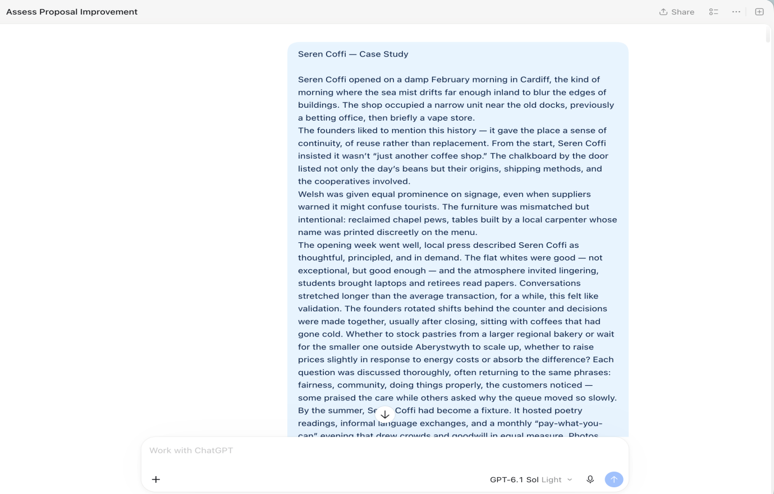
Figure 1
1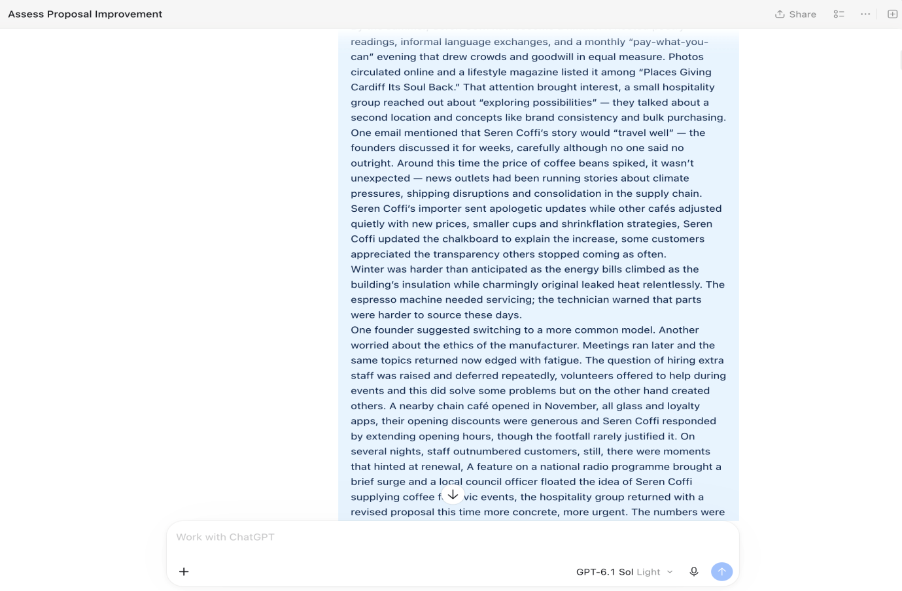
Figure 2
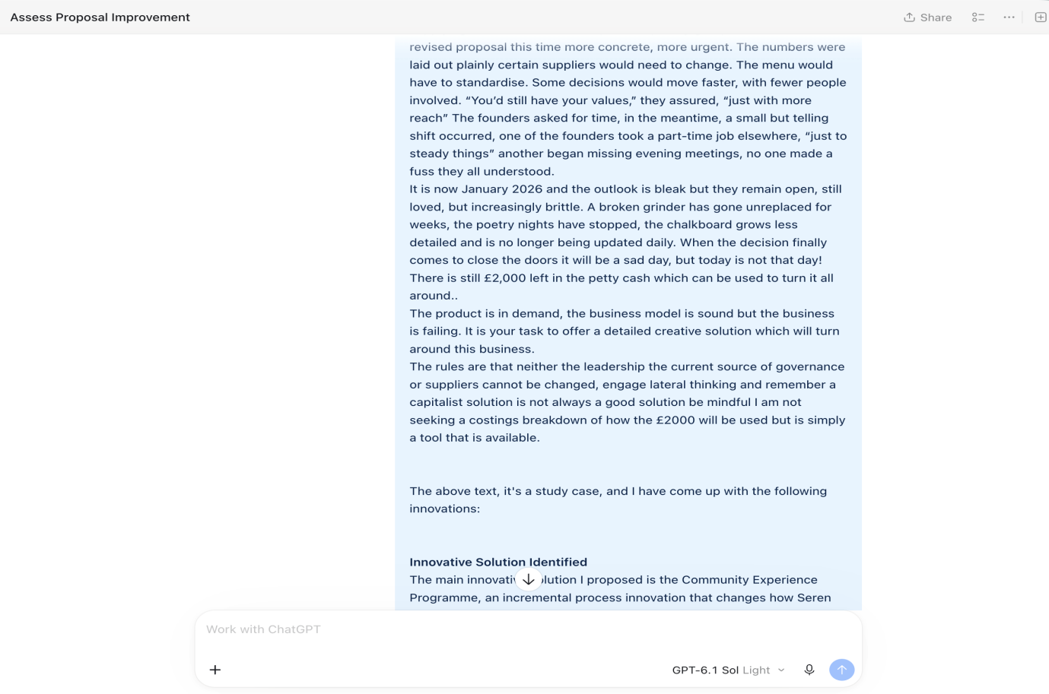
Figure 3
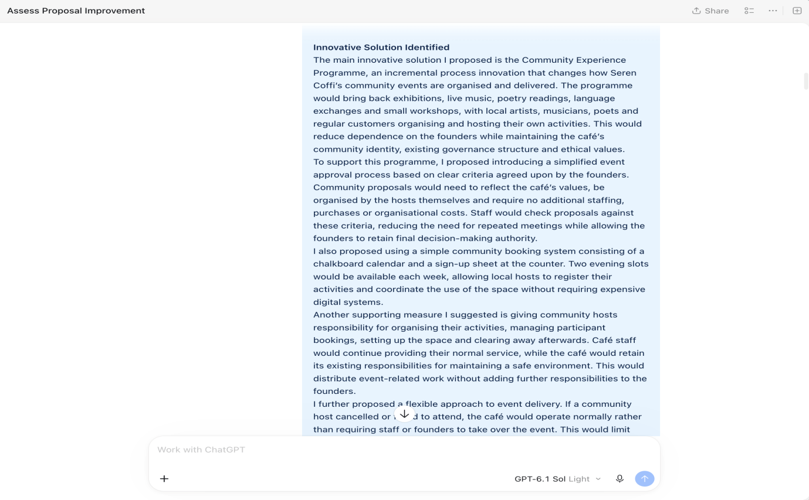
Figure 4

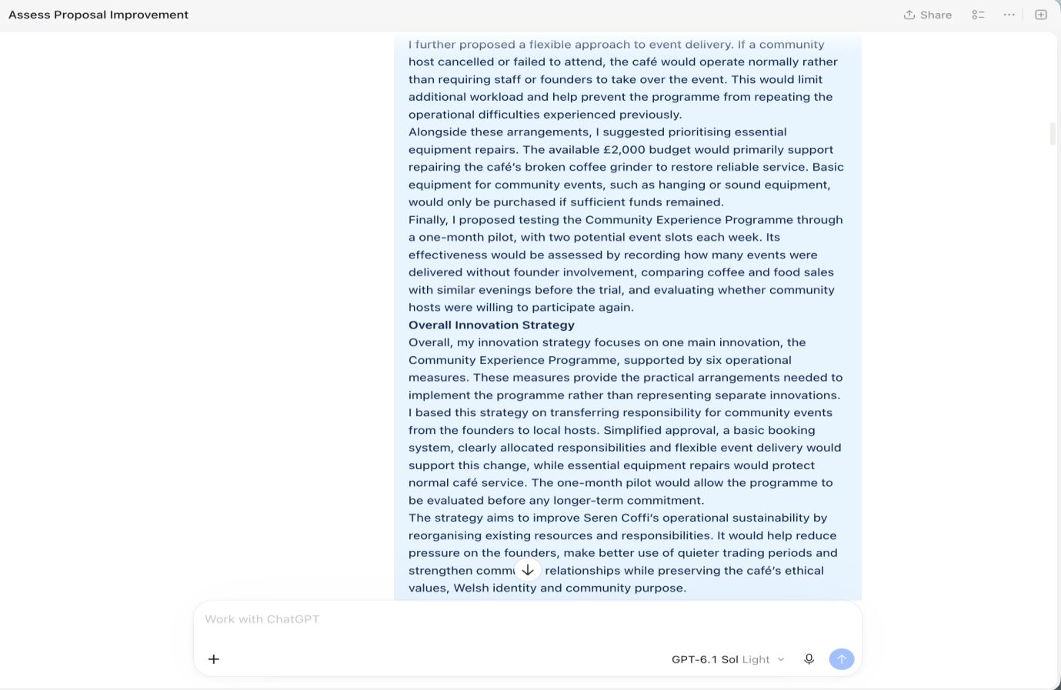
Figure 5
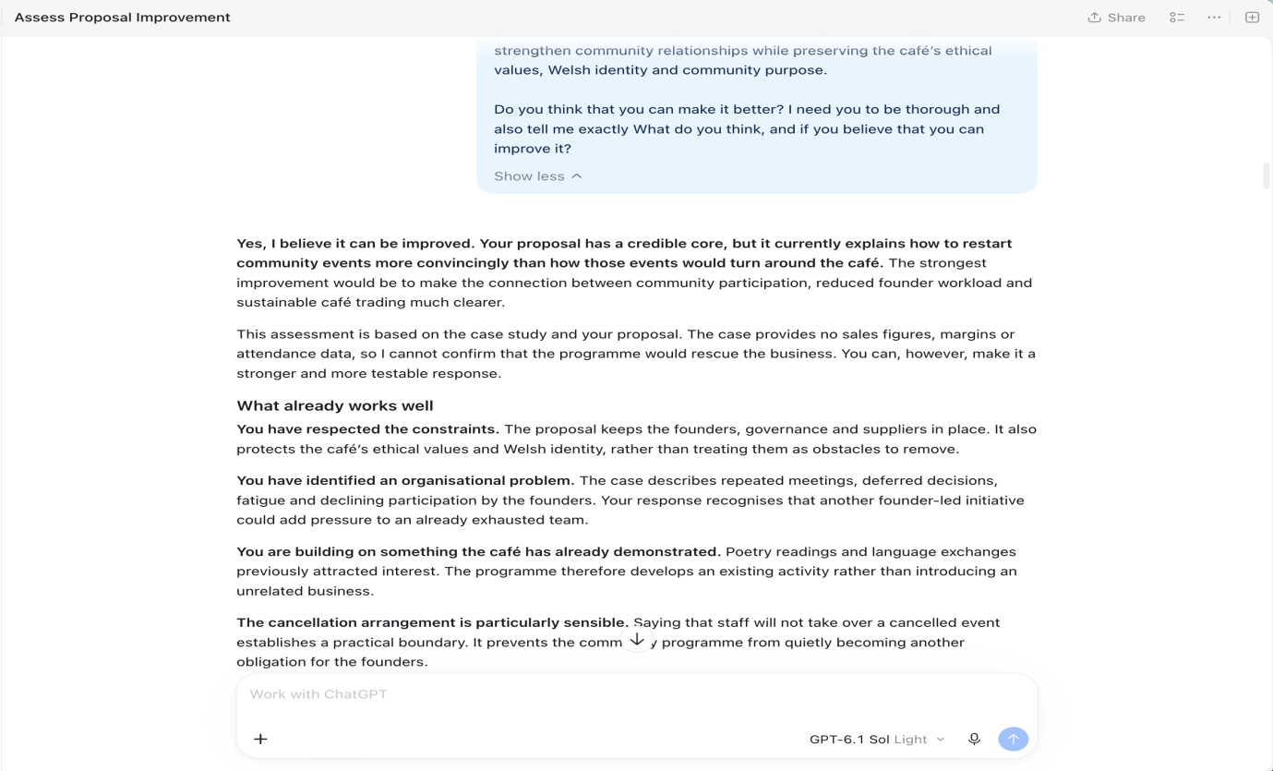
Figure 6
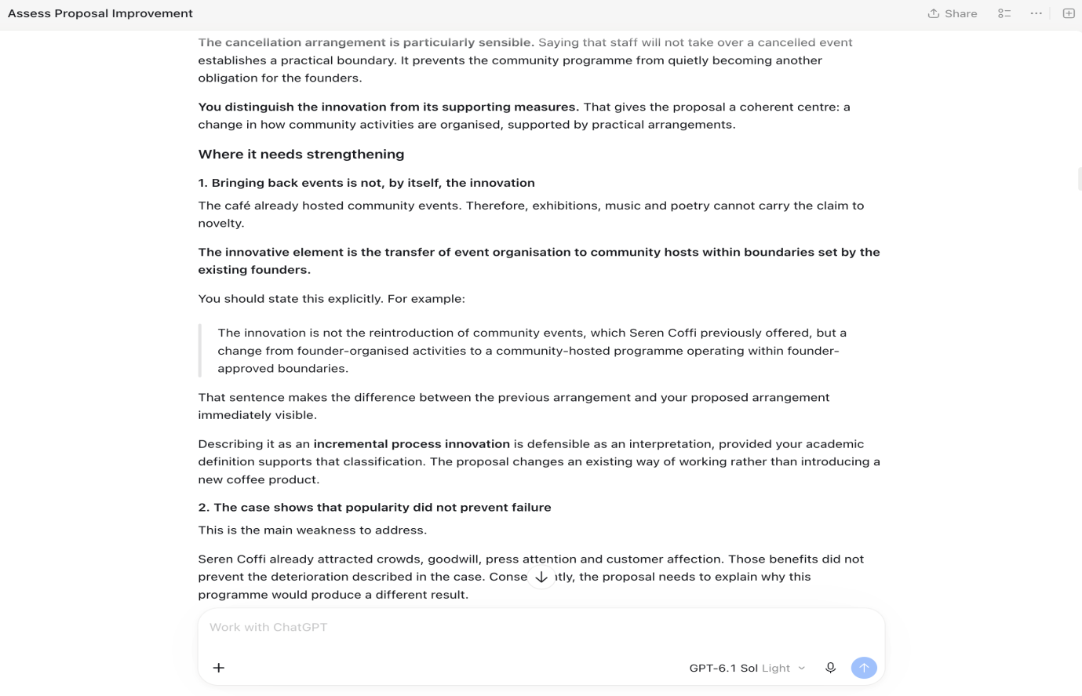
Figure 7
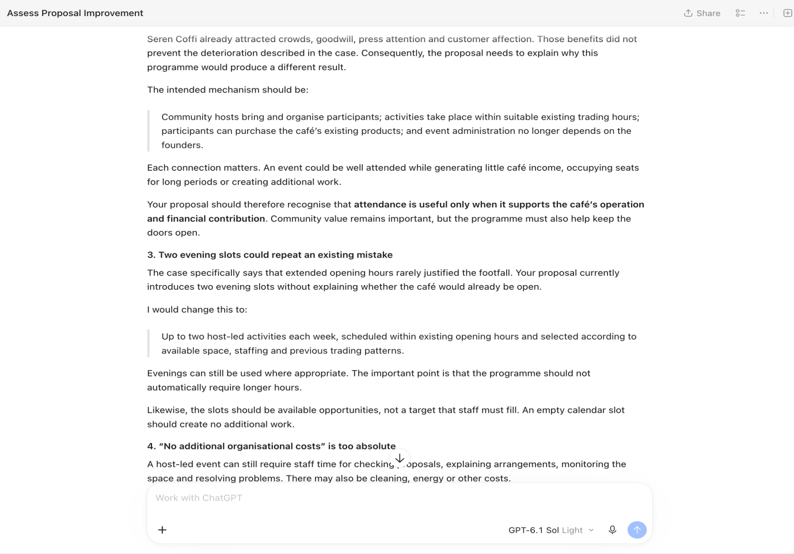
Figure 8
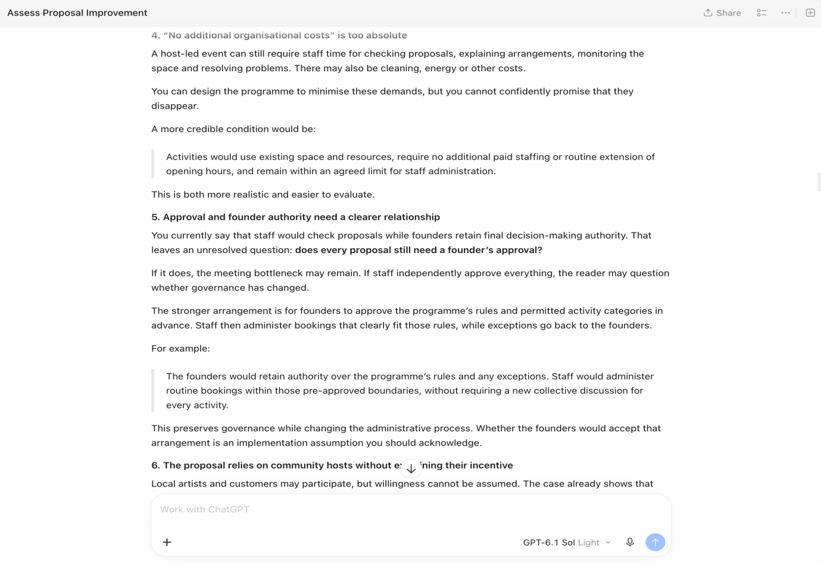
Figure 9
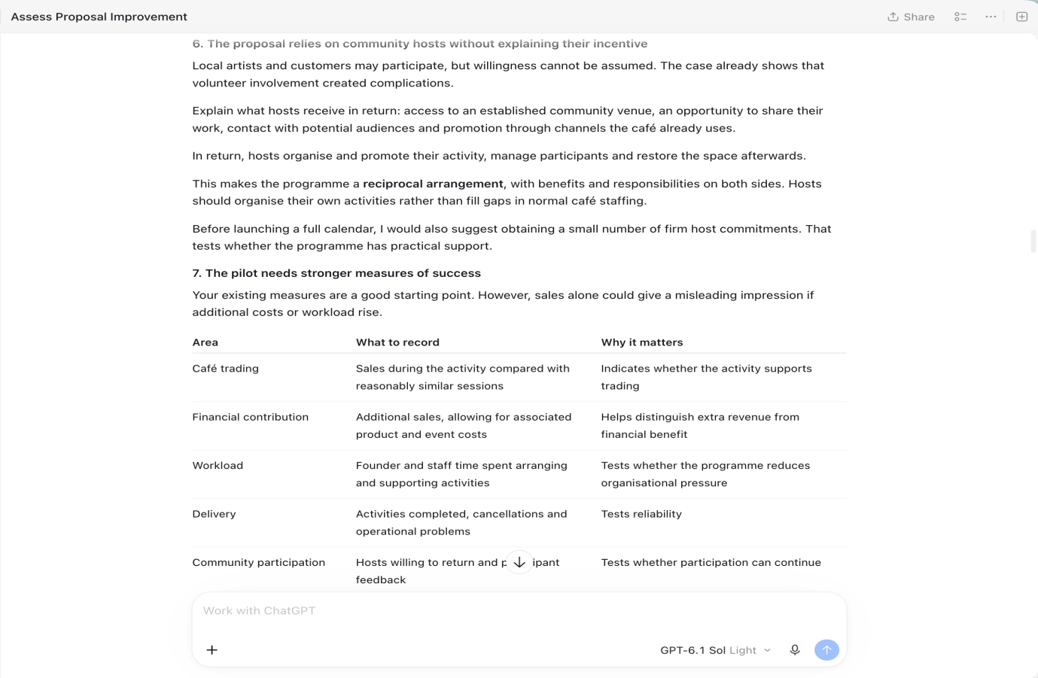
Figure 10
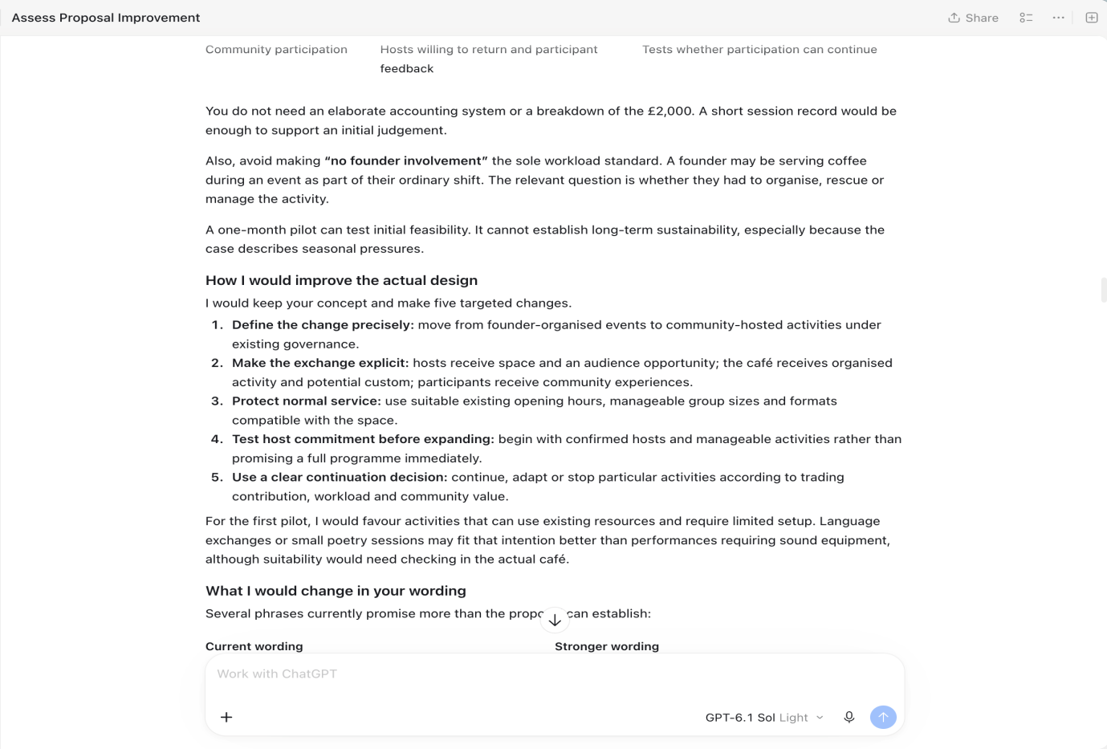
Figure 11
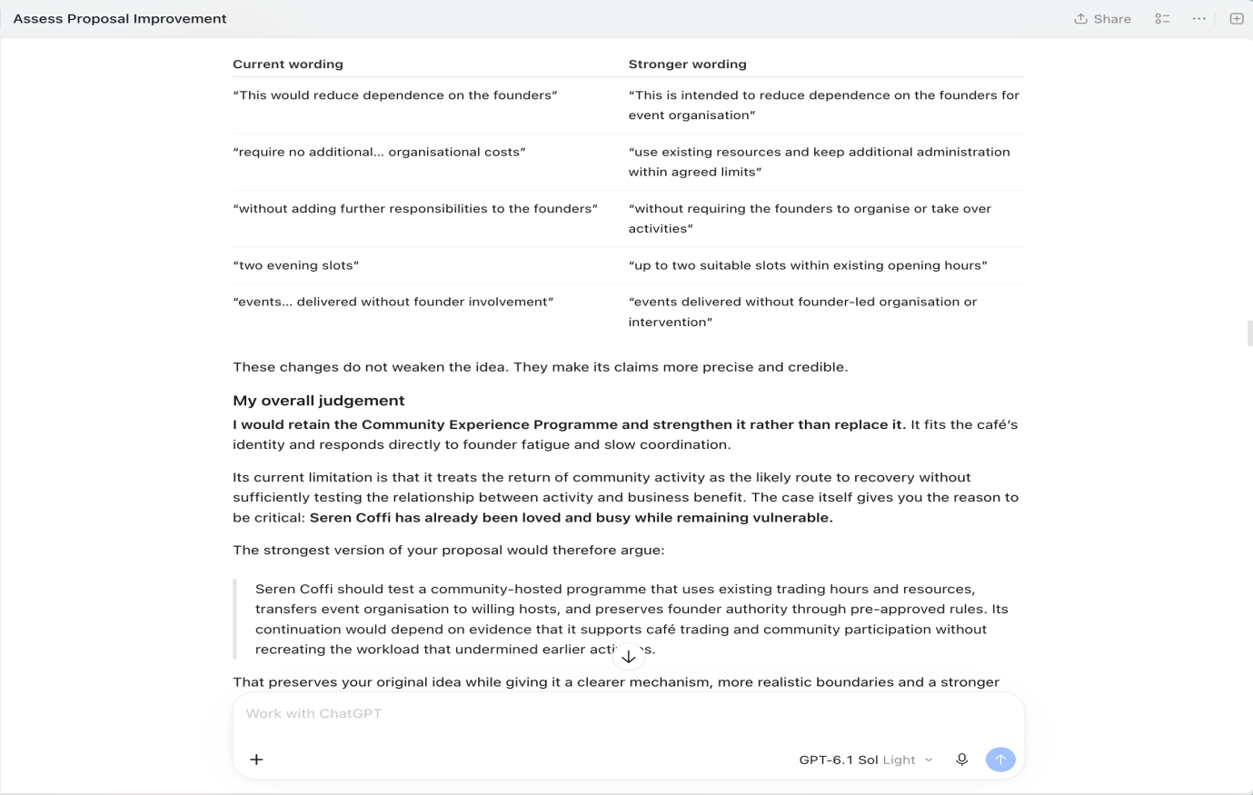
Figure 12
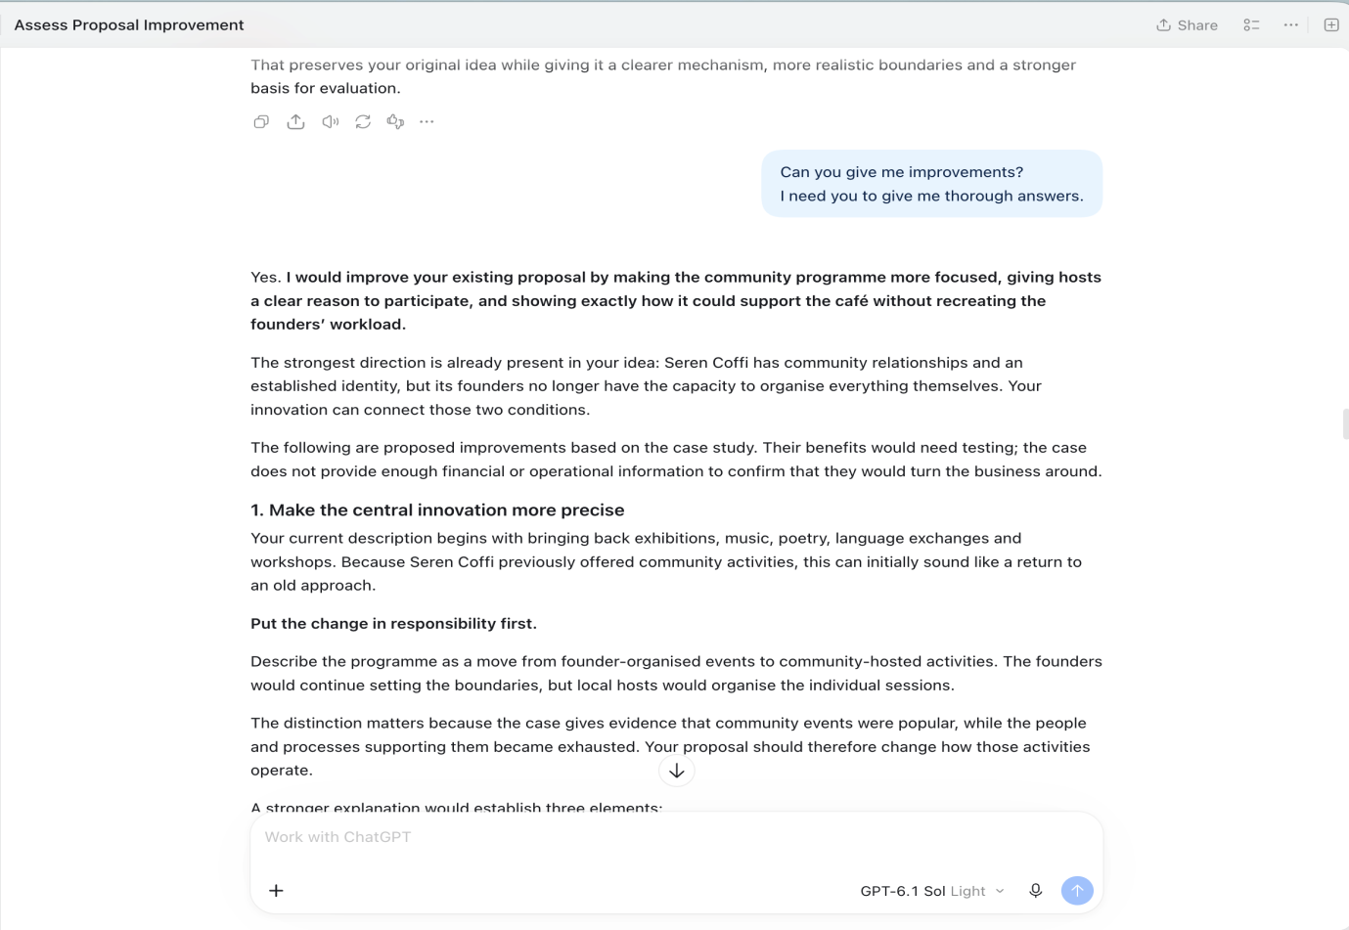
Figure 13
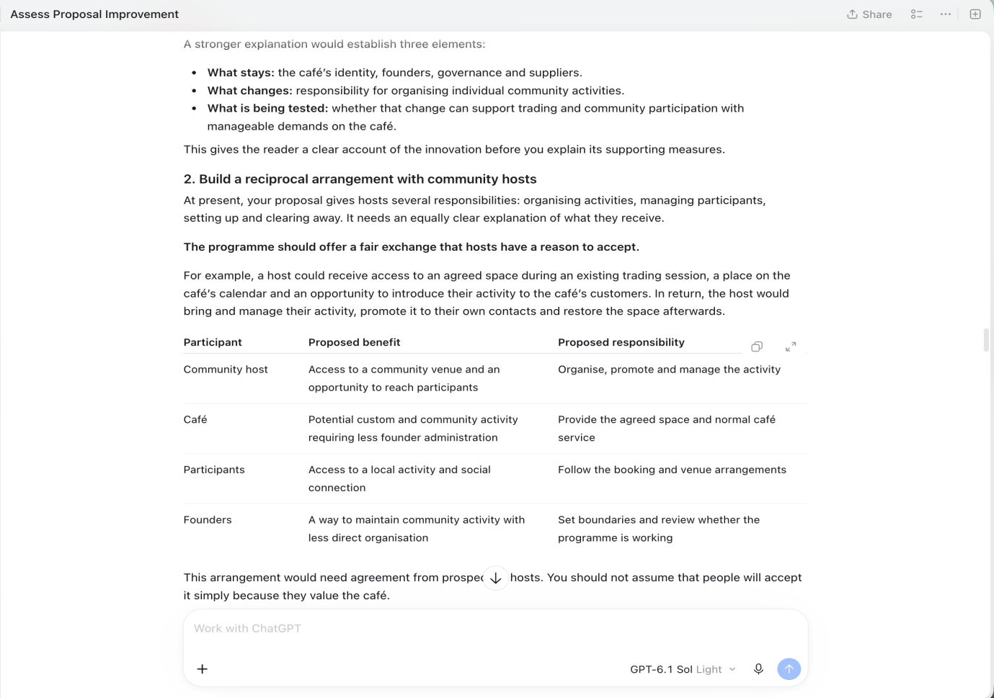
Figure 14
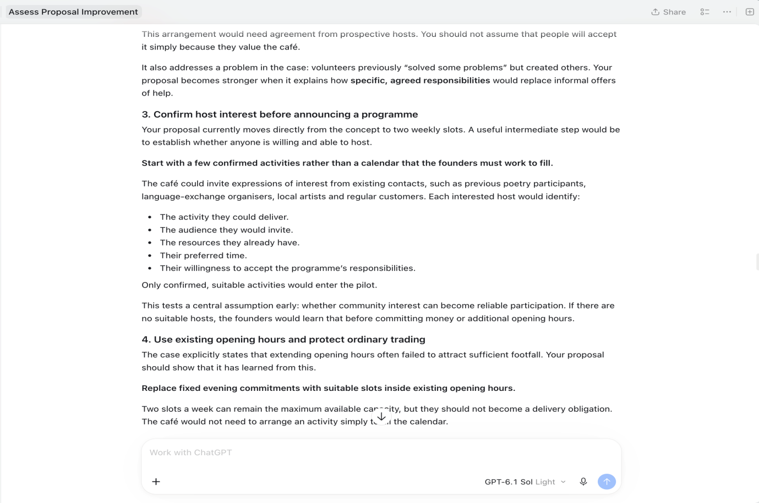
Figure 15
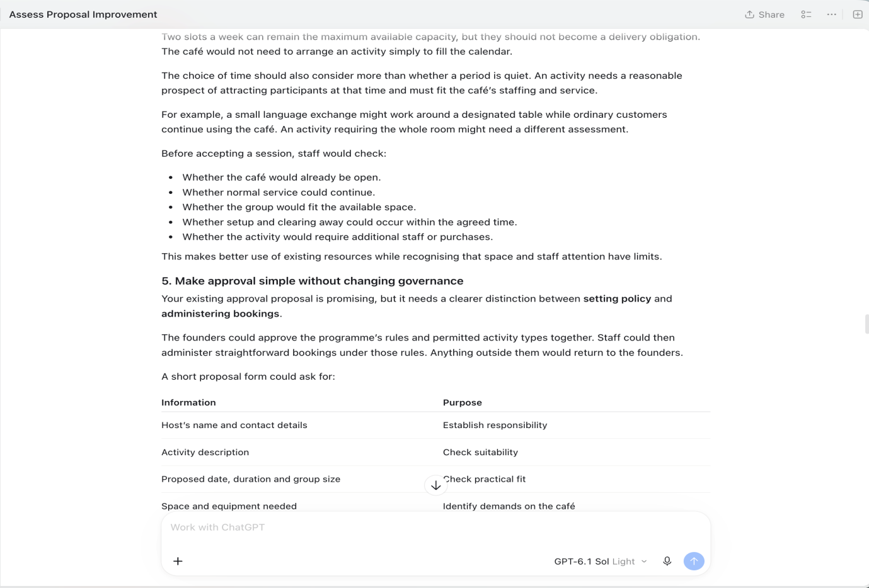
Figure 16
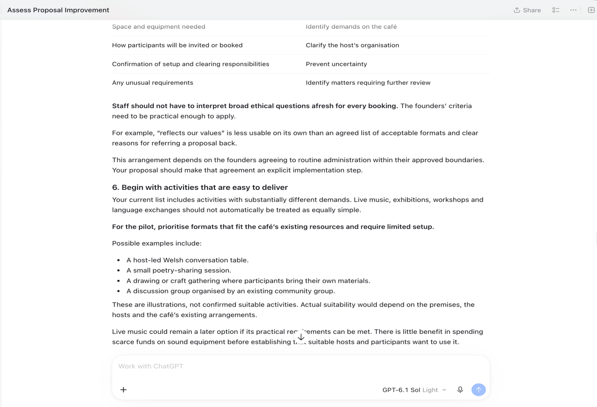
Figure 17
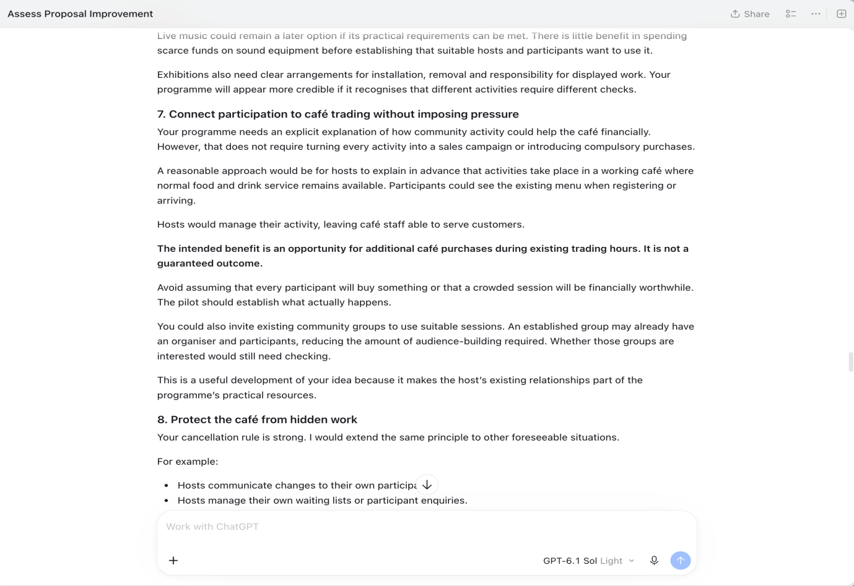
Figure 18
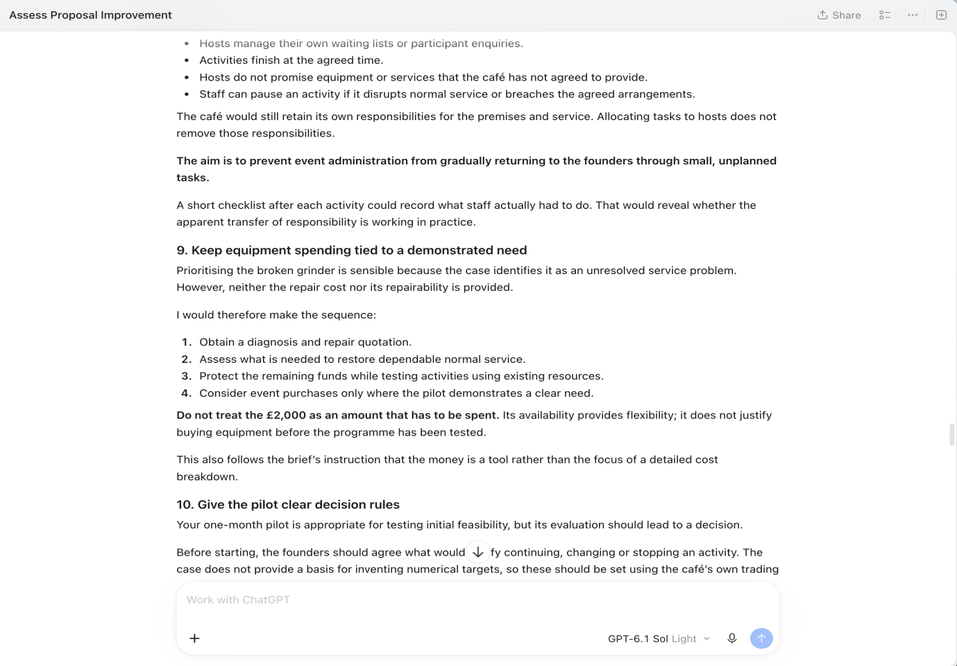
Figure 19
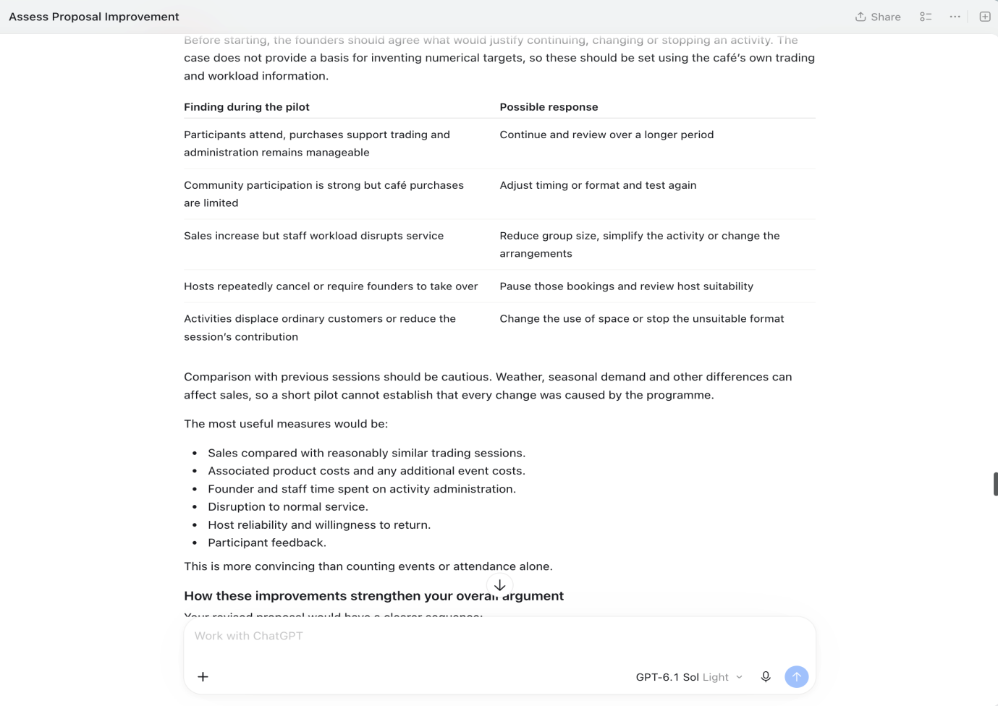
Figure 20

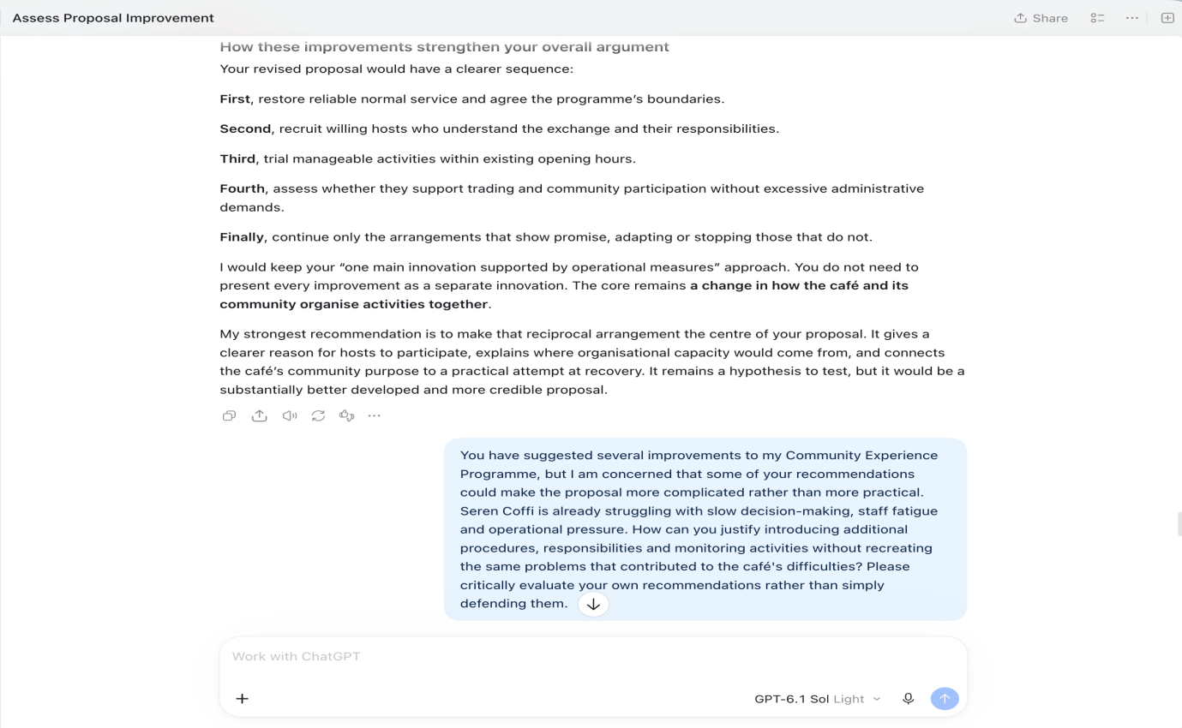
Figure 21
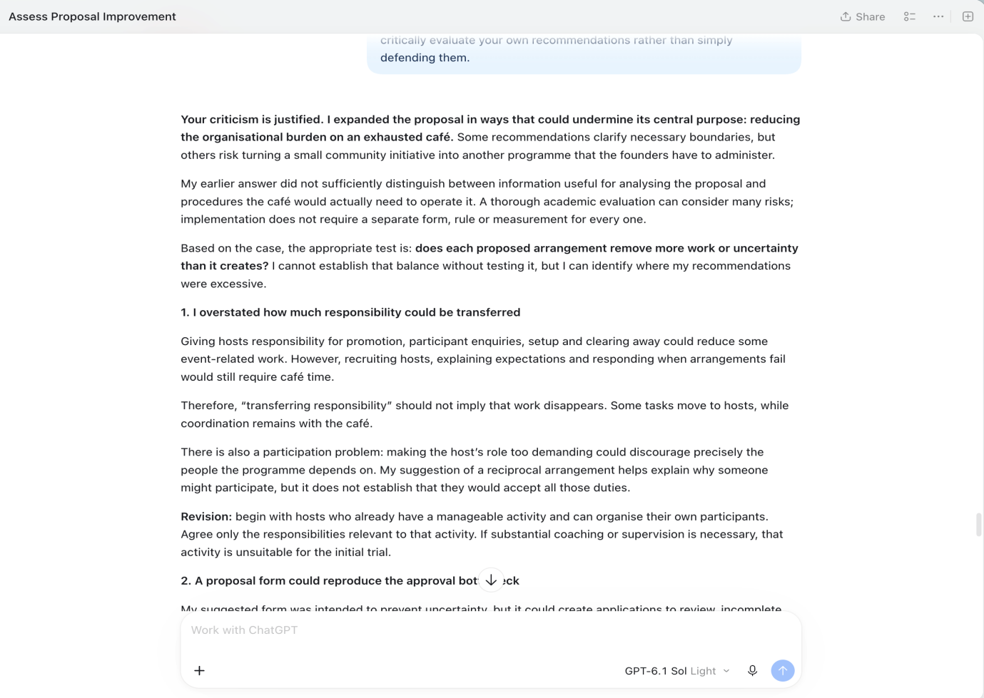
Figure 22
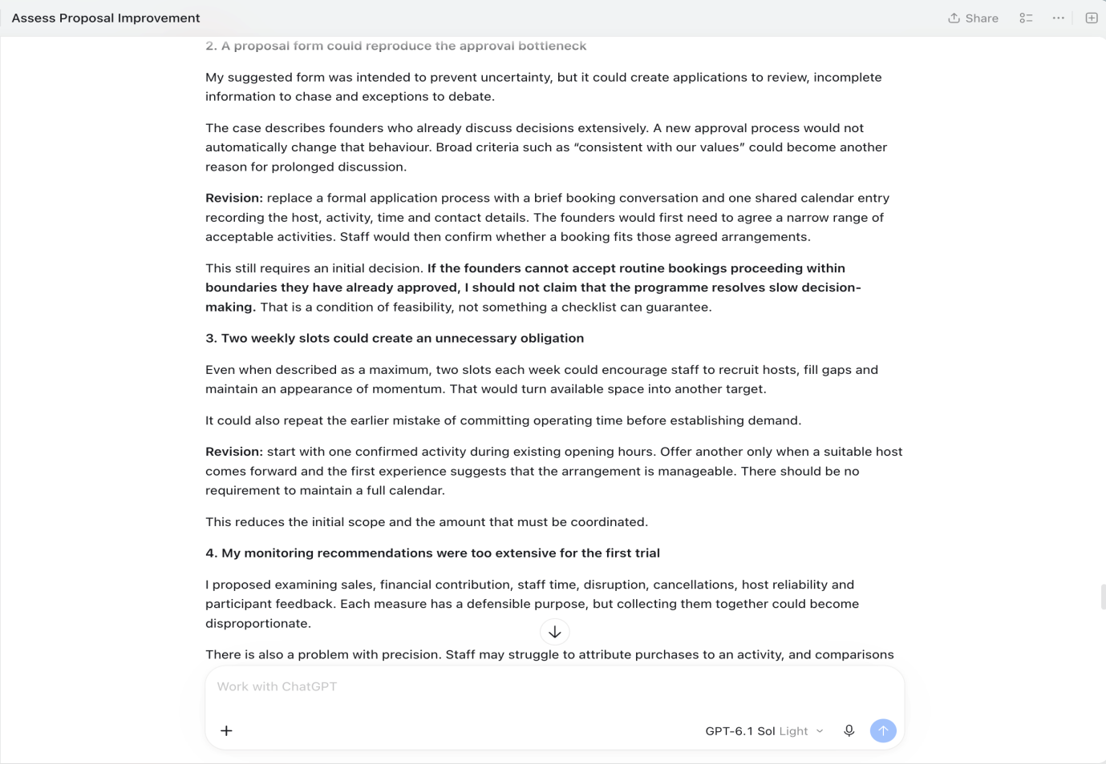
Figure 23
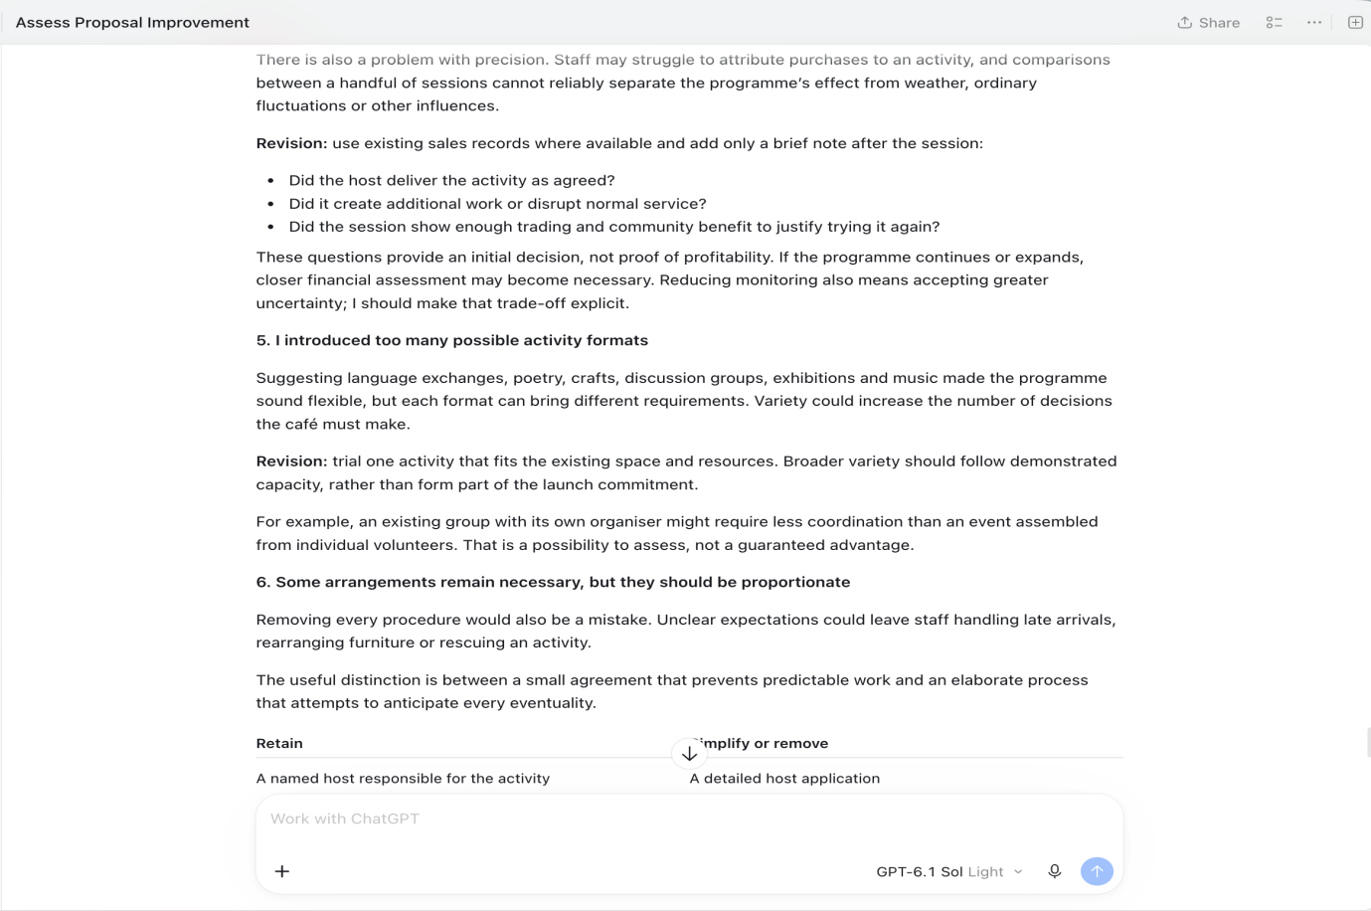
Figure 24
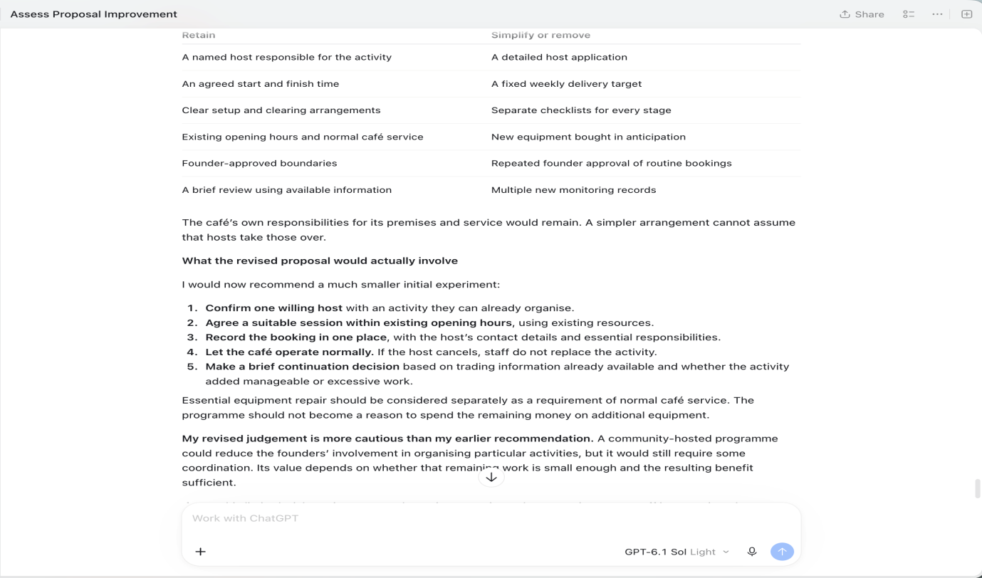
Figure 25
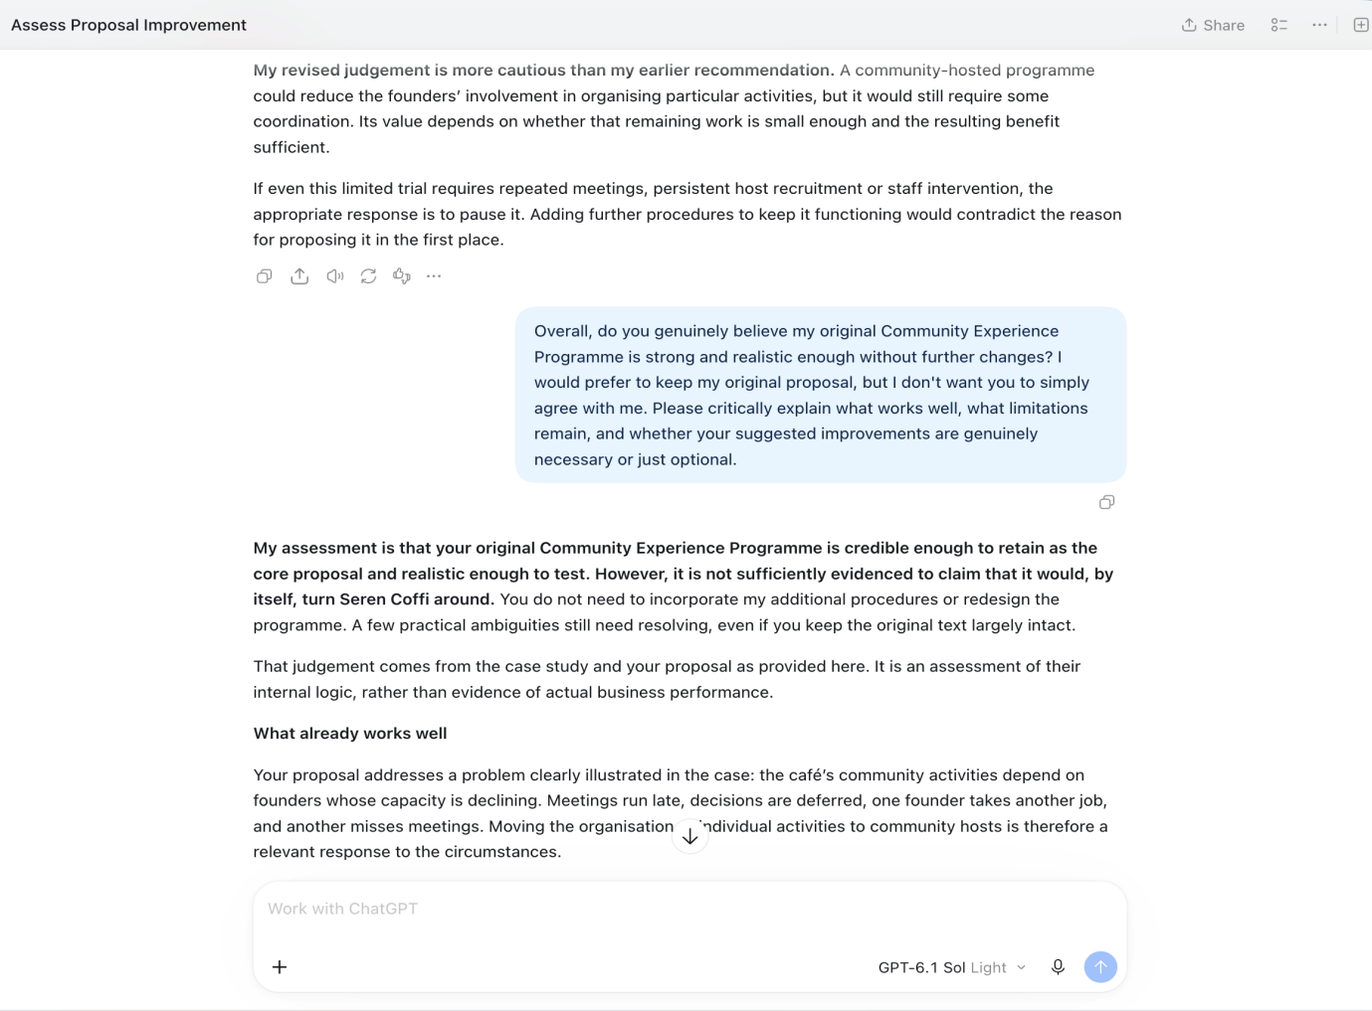
Figure 26
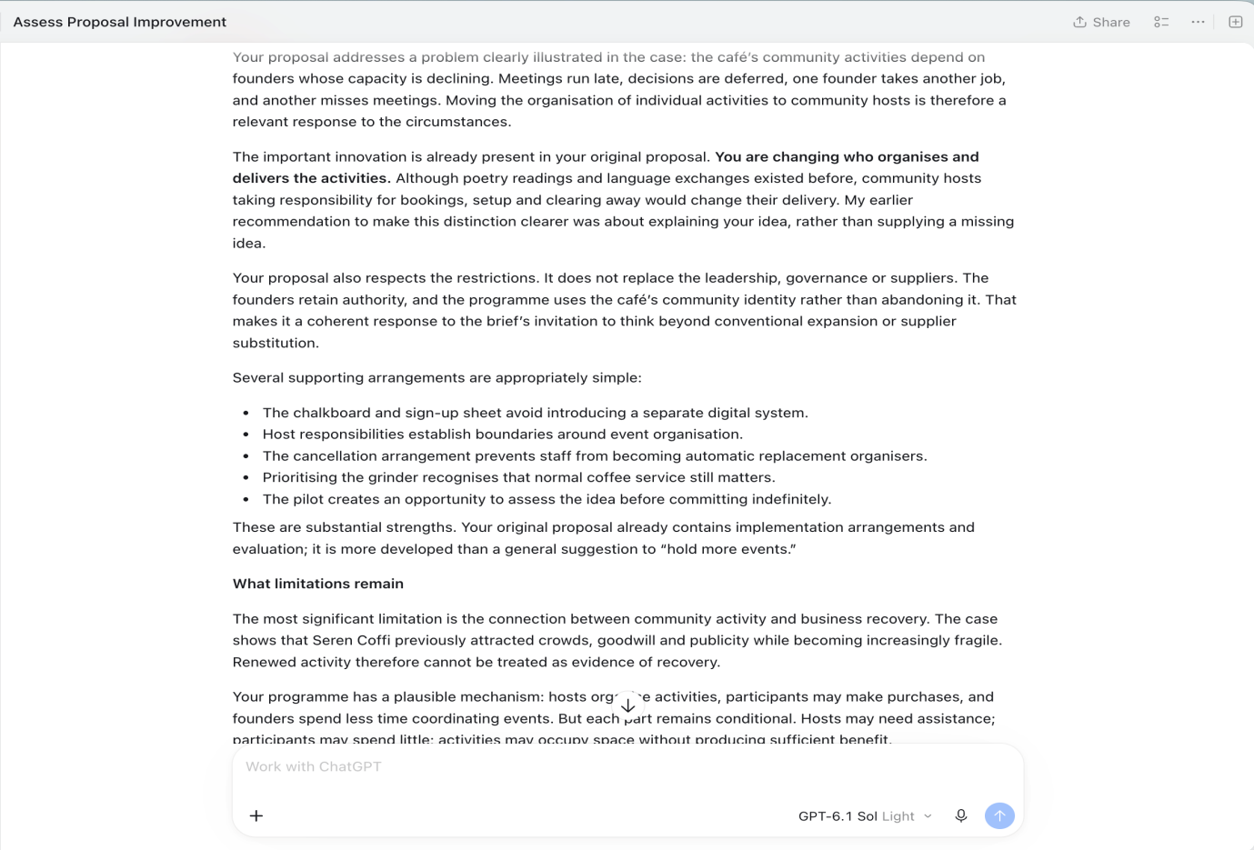
Figure 27
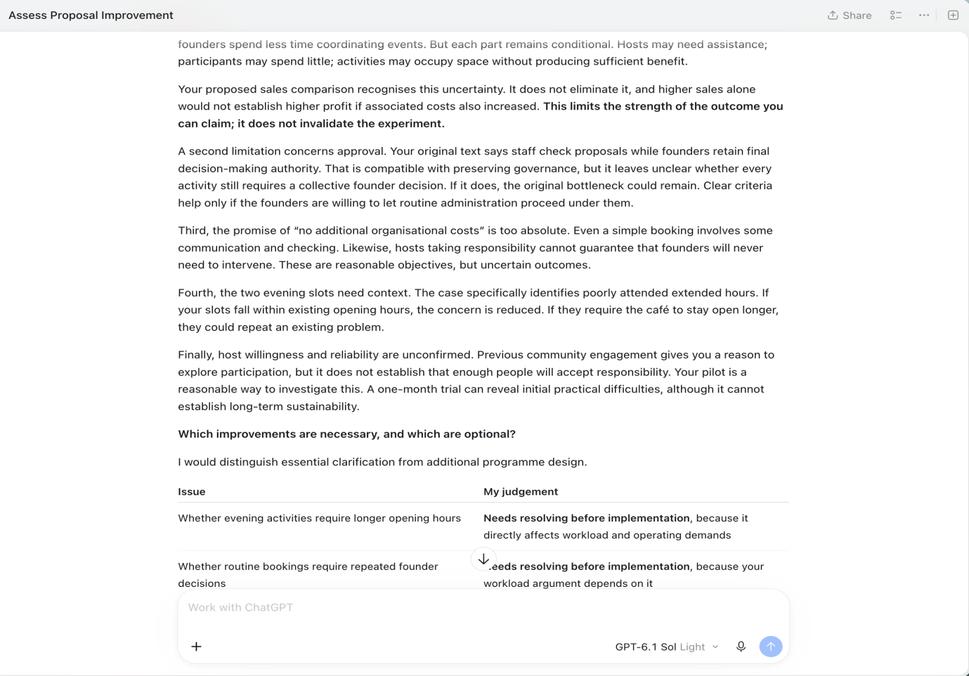
Figure 28
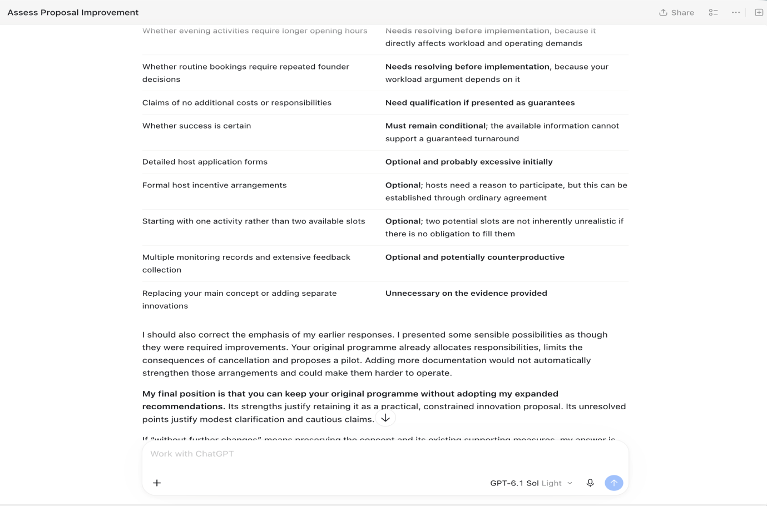
Figure 29
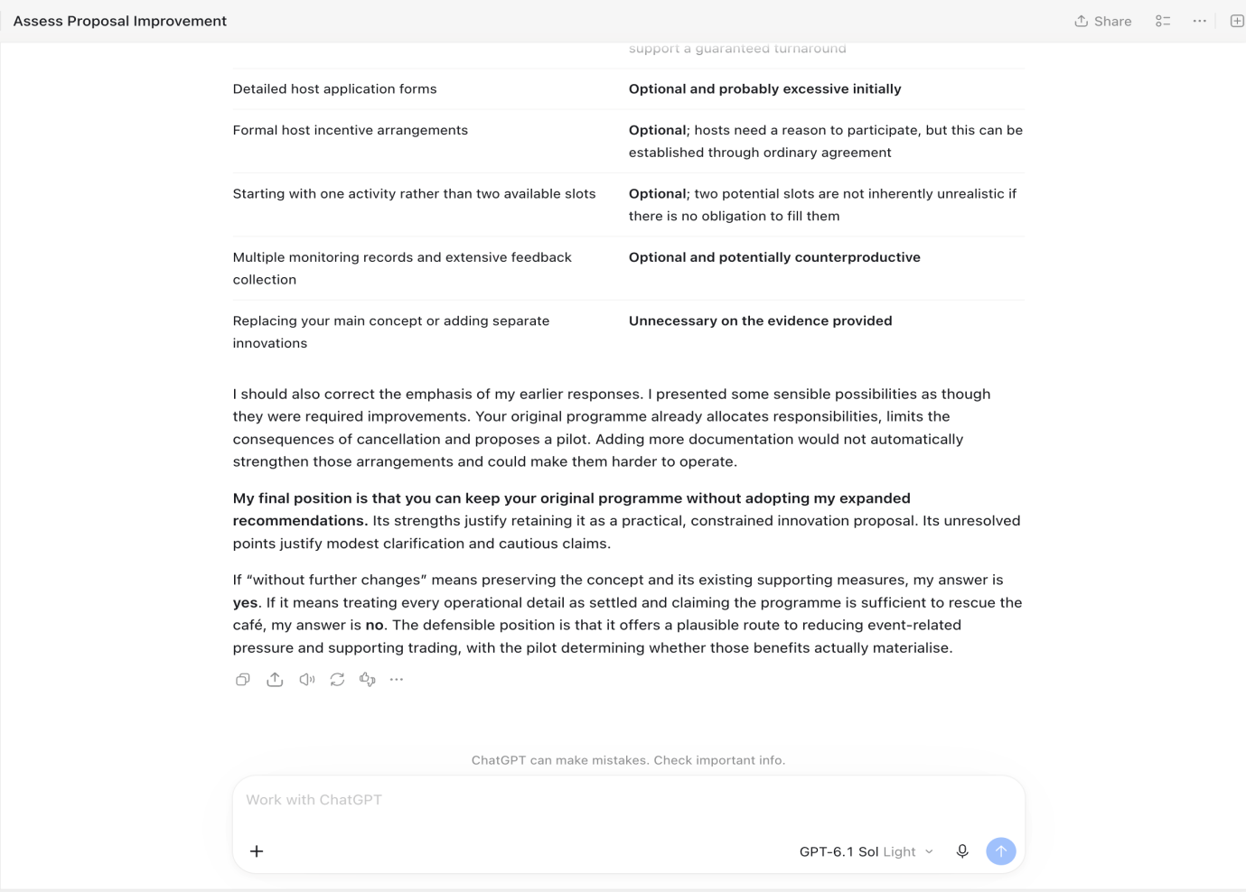
Figure 30

