Amy Morgan (2319574)

Responsible Marketing

Contents
Introduction 1
Behavioural change 1
Segmentation and Targeting 1
Positioning 2
Market research 3
References 4

Introduction
This portfolio will examine how individuals perceive food banks, how they approach the problem of food poverty in Llanelli, what resources are currently available to assist those in need, and what we can do to improve the situation.

Rational
The rational for choosing this topic is due to the fact that
14.4 million people in the UK lived in poverty in 2021-2022 this consisted of 8.1 million adults of working age, 4.2 million adolescents and 2.1 million pensioners. With the increase in the middle-income household income and the removal of various short term coronavirus related assistance, poverty rates have reverted roughly to their pre pandemic levels (Joseph Rowntree Foundation, 2024). 655,00 people across the UK used a food bank for the first time between April 2023 to March 2024. The use of food banks has increased by 94% within the last five years. 1.1 million of the 3.1 million emergency food parcels were provided to children (Trussell, 2024).
Of the 112 lower super output areas (LSOA’s) in Carmarthenshire 25 are considered to be among Wales’ 30% most impoverished places. The Llanelli region contains the majority of these areas (60%). Those residing in the most impoverished communities like Llanelli are showing a stronger impact from the current cost of living crisis and the aftermath of the Covid 19 pandemic (Carmarthenshire County Council, 2023). In 2022 Llanelli food bank distributed 6099 food parcels to local people in crisis (Llanelli Foodbank, 2022).
9.5 million tonnes of food is wasted annually in the UK, food waste is a result of inadequate infrastructure and cooperation for transferring excess food. Another cause for food waste is the confusion over the date labels consumers may discard safe to eat foods because they do not understand our ‘best before’ and ‘use by’ are about food quality not food safty resulting in food waste (Waste Managed, 2024).
In 2021 – 2022 Wales produced 309,000 tonnes of household food waste (edible and inedible) this equates to 230kg per household. 75% of all food waste in households were categorized as edible food that is meant for human consumption (Wrap Cymru,2024).

Behavioural change

Less than 2 million of the over 10 million people in the UK who are at risk of not having enough food use food banks, meaning that over 8 million people must skip meals because they cannot afford to eat. Half of which don't think they're eligible for assistance, and half of them don't want to deny assistance to those who could be more in need. More than two-thirds have acknowledged that they avoid food banks out of embarrassment and humiliation (Shaw, N. 2024).
As previously said, most individuals experiencing food poverty are too ashamed to use a food bank. We may address this by establishing more programs and faculties in addition to the food bank. A pay-as-you-go plan and an inexpensive food pantry are two examples of these that would allow more people to utilize the facilities without feeling ashamed or stigmatized. A cooking class with the items included in the food parcels could be an additional program ( Birmingham City Council, 2024).
The United Kingdom could learn a lot from other countries around the world when it comes to solutions to combat food waste Denmark has more food waste programs than any other state in Europe, ranging from government subsidies for food waste projects to collaborations and awareness campaigns. The lobby organization Stop Spild Af Mad - Stop Wasting Food, founded by graphic artist Selina Juul, is primarily responsible for this (Russell,2016).

Segmentation and Targeting

Within this section we will be looking at the two segments that we will be targeting and why. The first segmentation we will be looking at is Geographic. After speaking to a representative of Llanelli Food Bank their geographic limit is the Llanelli region of Carmarthenshire. The only evidence they require is proof of address i.e. letter or driver's licence. (C, Thomas, Llanelli Foodbank, 2024).

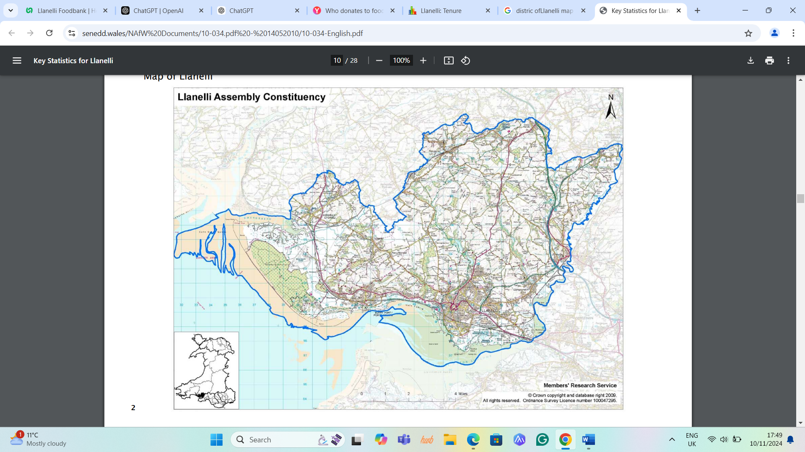
Image from (National Assembly for Wales, 2010).

The second segment is psychographic within this section we will be looking at two psychographics' one aimed at the people in food poverty and the other aimed at two income households.
According to (Salary Expert) the average salary for people that work in Llanelli is £33,576.so a two-person family income equals to £67,152 a year. According to (Gov.UK, 2024) the national living wage is £23,795.20. Out of the 11,096 homes in Llanelli 6,385 households are owned, leaving 4,811 households renting their homes through the local authority and the private rent sector (Census, 2024).
The channels i will be using to address my audience will be as follows, to get more people facing food poverty to attended foodbanks without feeling embarrassed. And getting more people to donate to the local foodbank. One way to tackle this is by social media campaigns reducing the stigma. Platforms such as TikTok, facebook etc. Putting an article in Wales Online and the local newspaper, handing out leaflets and putting up posters in the local area.

Positioning

People who reside in towns and their immediate surroundings are the most likely to donate to foodbanks, according to (YouGov UK,2021). They most likely have middle-class backgrounds, are over 55, are retired, or work part-time jobs. Of those who have donated to the foodbank, 44% said they have done so directly, and 26% are currently members of a nonprofit organization. According to (Census Data, 2024) 8173 of the 25,083 residents of Llanelli are aged 55 years or older. Thats 8,173 potential donors for the foodbank to target
By appalling to local businesses like Marks and Spencers and emphasizing how donating to the local food bank can strengthen their community ties and boost their reputation. They could set up a donation hub in store emphasising how donating directly impacts people within your local community and that every donation helps feed a local family.

Market research

By doing some research in to the local food bank in Llanelli (Llanelli Foodbank) the process seems long overdue for an update they have not updated their website since 2022 and what information that is on there is very minimal. They have only posted six times in their news collum between 2018 to 2022.

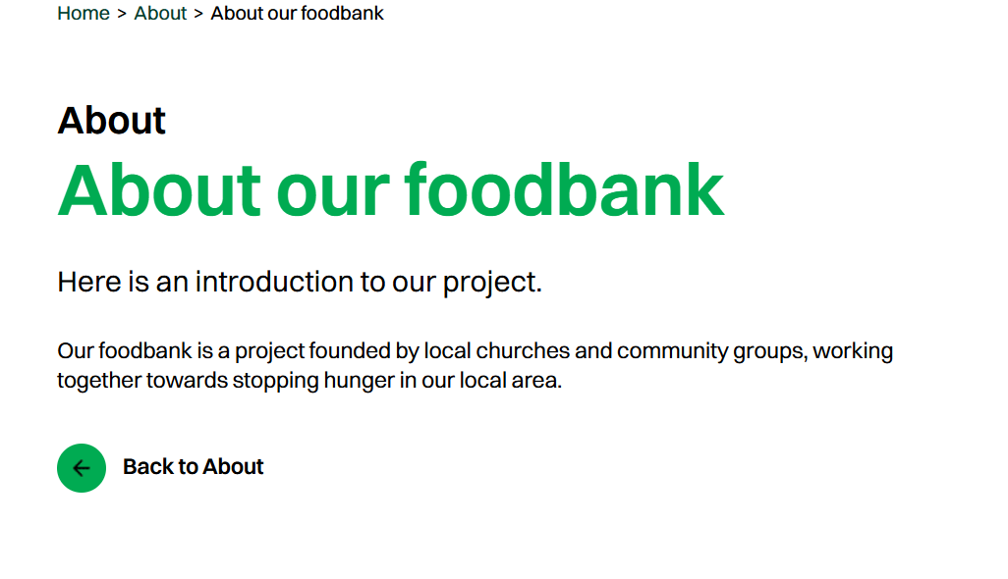
There are no foodbanks in and around Llanelli that you can go to without a refural the nearest program available is a food pantry in Merthyr (Your Local Pantry).
as shown above many people in food crisis do not use food banks because they feel embarrassed, and it takes a lot of courage to overcome that fear and ask for help. , but the possess seems long-winded people of Llanelli can't just turn up to the foodbank and ask for assistance no they first have to be referred by a local authority like the Council, Citizens Advice Burrow, or child services. This means if you inn need of help you need to go through several loopholes repeating your situation over and over so you can get a food voucher that entitles you to a 3-day emergency package with the maxium of 4 uses. Can you imagine how tiring and embarrassing that would feel to have to go through that process over and over again.
With better advertising like posters, leaflets, newspaper articles and a more active social media presence collaborating with local social media influencers like (The_tradie_wife) she has 412.4 k followers and dose loads of work helping local charities. Her most recent was a haul of over £1000 for the local woman's refuge.

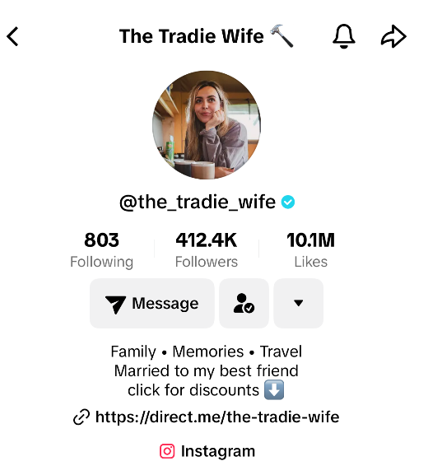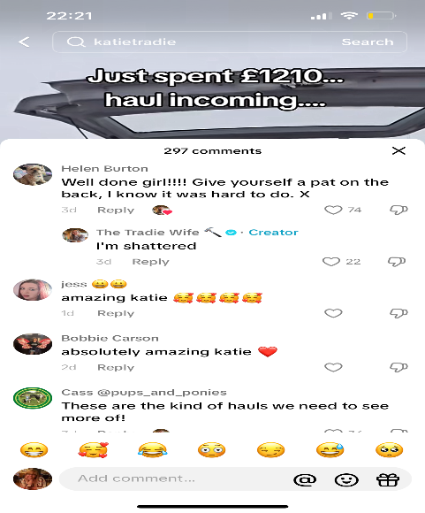

and by combining what is already in Llanelli (Llanelli Foodbank) with a food pantry like (Your Local Pantry) we could have a service that reaches more people in the community.
The food pantry would not need a referral and there would be no limit to the number of times you could use it Similar to a store, a pantry allows you to select the food you desire from the shelves. Members can choose groceries worth several times more in exchange for a tiny weekly subscription fee of a few pounds, frequently saving up to £1,000 annually on shopping expenses. Every pantry has a treasured function as a community centre, frequently acting as a launching pad for additional projects and concepts like cooking courses, volunteer opportunities, and training.

Advertisement

References

Birmingham City Council. (2024). Increasing Dignity and Reducing Shame and Stigma; Toolkit for food projects. file:///C:/Users/Amy/Downloads/Shame_and_Stigma_Toolkit_CF%20(2).pdf

Carmarthenshire County Council. (2023). Tackling Poverty Plan. https://www.carmarthenshire.gov.wales/media/my0nz53o/tackling-poverty-plan-2023.pdf

Census Data. (2024). Llanelli: Age by Grouped Years. https://www.censusdata.uk/w04000519-llanelli/ts007a-age-by-grouped-years

Census Data. (2024). Llanelli: Tenure. https://censusdata.uk/w04000519-llanelli/ts054-tenure

Gov.UK. (2024). National Minimum Wage and National Living Wage Rates. https://www.gov.uk/national-minimum-wage-rates

Llanelli Food Bank. (2022). Helping local people in crisis. https://llanelli.foodbank.org.uk/

National Assembly for Wales. (2010). Key Statistics for Llanelli. https://senedd.wales/NAfW%20Documents/10-034.pdf%20-%2014052010/10-034-English.pdf

Russell, H. (2016). How did Denmark become a Leader in the Food Waste Revolution?. https://www.theguardian.com/environment/2016/jul/13/how-did-denmark-become-a-leader-in-the-food-waste-revolution#:~:text=Denmark%20has%20more%20initiatives%20against,by%20graphic%20designer%20Selina%20Juul.

Salary Expert. (2024). Average Salary in Llanelli, United Kingdom. https://www.salaryexpert.com/salary/area/united-kingdom/llanelli

Shaw, N. (2024). Millions not using food banks they need because of embarrassment. https://www.walesonline.co.uk/news/cost-of-living/millions-not-using-food-banks-28888448

Trussell. (2024). End of Year Stats. https://www.trussell.org.uk/news-and-research/latest-stats/end-of-year-stats

Waste Managed. (2024). Food Waste – 2024 Facts & Statistics. https://www.wastemanaged.co.uk/our-news/food-waste/food-waste-facts-statistics/#:~:text=food%20waste%20guide.-,How%20much%20food%20waste%20does%20the%20UK%20have%3F,distribution%2C%20retail%2C%20and%20households.

Wrap Cymru. (2024). Household Food and Drink Waste in Wales 2021-2022. https://wrapcymru.org.uk/resources/report/household-food-and-drink-waste-wales-2021-22#:~:text=How%20much%20household%20food%20waste,or%20230%20kg%20per%20household.

YouGov UK. (2021). Who donates to food banks?. https://yougov.co.uk/society/articles/33681-who-donates-food-banks

Your Local Pantry. (2024). Pantry Listings. https://www.yourlocalpantry.co.uk/pantry-listings/

