

An experiment of Serverless technology and the effect it has on DevOps metrics

by
Jamie Ellis

Supervisor: Tim Bashford
Second Marker: Michael Dacey

Project submitted as part of the requirements for the award of MSC Software Engineering and Web Development

January 2020

Copyright Acknowledgement Form
University of Wales Trinity Saint David

I, Jamie Lee Ellis, understand that I am solely responsible for the content of this dissertation and its use of copyrighted materials. All copyright infringements and issues are solely the responsibly of myself as the author of this dissertation and not University of Wales Trinity Saint David, its programs, or libraries.

______________________________ _______________________
Signature of Author J.Ellis Date 20/12/2019
______________________________ _______________________

Abstract

Serverless technology is the latest paradigm that is being used by cloud providers in the deployment of applications. While it’s said to bring many benefits, it is new technology and research is needed. Being able to view research out there exploring this technology and if it is beneficial would be valuable information for a business to make a more informed decisions about adopting this technology.

This project aimed to tackle the answer that can a Serverless approach to a web application have significant differences to the DevOps metrics of an application. Research was conducted where the result was a recommendation framework of the DevOps metrics you would want to monitor for a web application. Following an agile approach, two applications were designed, a Non-Serverless and a Serverless to highlight the differences in design. An experiment was then conducted using the framework to record samples of DevOps Metrics from the applications to identify any differences.

The results of the experiment showed a significant difference to the memory usage where the Serverless application was using approximately 50% less memory. There were smaller, less significant difference too where it took on average less time to build despite being 220 MB bigger. There was a quicker response time for the database requests made so there’s absolutely no reason why there shouldn’t be more research on the subject made in the future, adding to the experiment from this project. The final conclusion from the project is that despite having a restricted timeline of completion for this project, an interesting result was still achieved and with more time to build more scaled, real live systems that could give actual real results with more metrics to monitor from more research and more samples of data used.

Acknowledgements

I would like to express my special thanks of gratitude to my lecturers in the University of Wales Trinity Saint David for the amount of effort they have put into my development while completing my MSC. In particular, I would like to give thanks to Dr Tim Bashford, who not only being one of the lecturers in the university, has been the supervisor for this project. He has supported me throughout the duration of the project, offering me support, advice which has helped me point in the right direction in regard to my research.
Secondly, I would also like to thank my parents, my girlfriend and friends who have been a huge support throughout this busy time in my life. I could not have done it without your support.

Table of Contents

Table of Contents
Copyright Acknowledgement Form 1
Abstract 2
Acknowledgements 4
Table of Contents 5
Table of Figures 8
Table of tables 9
1. Introduction 10
1.1 Definition of Terms 13
1.2 Aims and Objectives 14
1.2.1 Aims 14
1.2.2 Objectives 14
2. Research and Software Methodology 16
2.1 Research Methodology 16
2.1.1 Philosophy 16
2.1.2 Approach 16
2.1.3 Strategy 17
2.2.1 Planning 18
2.2.2 Requirements 18
2.2.3 Design 19
2.2.4 Coding/Testing 19
2.2.5 Deployment 20
2.4 Resources 23
3. Background Research 24
3.1 History 24
3.2 Cloud Computing 26
3.2.1 Bare metal 26
3.2.2 Virtual Machines 27
3.2.3 Containerisation 28
28
3.3 Serverless 30
3.3.1 Serverless Model ( FaaS) 31
3.3.2 Serverless benefits and drawbacks 32
3.4 AWS 33
3.4.1 API Gateway 34
3.4.2 Lambda 34
3.4.3 DynamoDB 35
3.4.4 S3 35
3.4.5 Comparison of S3 Storage Classes 38
3.5 DevOps 39
3.5.1 DevOps Metrics 39
3.5.3 The metrics framework for web applications 43
3.5.4 Metrics Provider – AWS 44
3.5.5. AWS CloudWatch 44
3.6 DVLA 46
3.6.1 History 46
3.6.2 Drivers Vehicles Licensing Agency 47
3.6.3 The DVLA’s IT Strategy 48
3.6.4 Systems 49
3.7 React 51
4. Design and Implementation 53
4.1 User requirements 53
4.1.1 Non-Serverless requirements 53
4.1.2 Serverless Application 55
4.2 UML Diagrams 56
4.3 Implementation 58
4.3.1 Setting up React-app 58
4.3.2 App.js 59
4.3.3 Blending Bootstrap with React 60
4.3.4 Utilising Reacts state method to store form data 61
4.3.5 Configuring Mongo dB to React application 62
4.3.6 CloudFormation 62
4.3.7 Serverless 64
4.3.8 Form Validation 64
5. Testing 66
6. Experiment 67
6.1 Hypothesis 68
6.1.1 Null Hypothesis 68
6.1.2 Alternative Hypothesis 68
6.2 Results 68
6.3 Data Analysis 69
6.3.1 Average Memory Usage 69
6.3.2 Average Response Time to submit database 71
6.3.3 Average Time to Build 74
6.3.4 Average Error Rates 75
6.3.5 Availability 75
6.3.6 Build Size 76
6.3.7 Application Size 76
6.3.8 Average Size Per Request 77
7 Conclusion and Evaluation 78
8 Reflection 80
9 References 83
10. Appendix 86

Table of Figures

Figure 1- Research Gantt chart 21
Figure 2- Testing Gantt chart 21
Figure 3- Development Gantt chart 22
Figure 4 - Results Gantt chart 22
Figure 5- Percentage of household internet users in U.K. 1998 25
Figure 6- Percentage of household internet users in U.K. 2019 25
Figure 7 - Virtual Machine traditional design 27
Figure 8- Containerisation traditional design 28
Figure 9- AWS Serverless model 34
Figure 10 - JSX example 52
Figure 11- process flowchart for application 57
Figure 12 - Serverless DB configuration 58
Figure 13- Non-Serverless configuration 58
Figure 14 - Install react-app command 59
Figure 15 - creating react app named non-serverless app command 59
Figure 16 - App.js 60
Figure 17- React change state value function 61
Figure 18- React state values example 61
Figure 19- CloudFormation file first part Figure 20 - CloudFormation file second part 64
Figure 21- App.js 65
Figure 22 - Non-Serverless average memory usage results 68
Figure 23 - Results for Serverless average memory usage 69
Figure 24 - Results of Non-Serverless average response time to submit to database 71
Figure 25 - Results for Serverless average response time to submit to database 72
Figure 26 - Results for Serverless average time to build 74

Table of tables

Table 1 - Table showing the results of a recent survey on company’s IT budgets 10
Table 2- Table of number of drivers in the U.K 1921-1973 47
Table 3- Table of metrics to be used for experiment 67
Table 4- Results of the experiment 68
Table 5 - Statistics for non-Serverless average memory usage 70
Table 6 - Statistics for Serverless average memory usage 71
Table 7 - Statistics for Non-Serverless average response time to submit to database 72
Table 8 - Statistics for Serverless average response time to submit to database 73
Table 9- Statistics for Non-Serverless average time to build 74
Table 10 - Statistics for Serverless average time to build 75
Table 11- Results for application size 76
Table 12- Results average size per request 77

Introduction

A recent study mapping how companies are spending technology budgets conducted by Spiceworks where over 1000 companies across Europe and North America show how important they value investing further into their IT budget. Below is a table which shows the results of the study, more information relating to the study can be found at https://www.spiceworks.com/marketing/state-of-it/report/ [1]

Number of Companies planning to increase IT budget | Number of enterprises (over 1000 employees) increasing 2020 IT expenditure.
44% | 25%

Table 1 - Table showing the results of a recent survey on company’s IT budgets
As companies plan to grow, they realise the importance that technology has on this. There are many factors that can really affect how a company grows for example social media in today’s world is considered a very easy way to reach a wider audience and broaden a company’s base. Having a web presence is seen as a must have for a company, especially a company that is selling a product.

With this web presence comes the need to keep up with the demands of the business and depending on the size of the company, could result in investing a considerable amount of money every month. This has made companies consider ways they can save money on their IT budget from the technology to build their applications to the Infrastructure in place to maintain them. Over the years have seen many different ways to build Infrastructure from physical Servers, virtualization and now Serverless.

Third party companies have taken advantage of this and offer Infrastructure services to other companies for a competitive price meaning companies can decide what’s best for them when it comes to maintaining their own Infrastructure or using a 3rd party providers- weighing up factors like price and security.

Serverless is the latest paradigm in the computer architectural world, the use of a cloud provider to manage the servers for you or your company. With providers like AWS offering a variety of Serverless products, there is a belief that this is a going to be a big player in the future of the infrastructure of businesses. As it’s quite new technology, there is more research around it required for companies to be able to make an informed decision on whether to move to a Serverless environment. Through the use of DevOps Metrics, it is possible to check many aspects of an application to see if there is a significant difference between using a Serverless environment or not, which could be useful for companies to be able to make a more informed decision about what would be best for their company.

The use of DevOps Metrics can be very useful to a company by giving them the opportunity to:

- Analyse the performance of their services
- Work out the cost of their services
- Further enhance testing of their services
- Identify vulnerabilities and problem solve with more ease

The aim of this project will be to build and test two applications (one using serverless technology and one not) using DevOps Metrics to see if the use of Serverless technology can improve the metrics of the application and to see if it has any value to a company, while also providing research into important DevOps Metrics that companies should be looking to use. This will be provided through the use of a framework provided by the results of the research.

Definition of Terms

AWS – Amazon Web services

S3 – Simple Storage Service

Npm – Node Package Manager

JS – JavaScript

CSS- Cascade Stylesheet

Aims and Objectives

1.2.1 Aims

- To critically evaluate the history of sharing information leading up to Serverless technology, DevOps and their importance to an organisation.
- Identify if a Serverless approach can improve the DevOps metrics of an application.
- Identify if any improvement is significant to make a difference to the organisation.
- To build a framework for the testing of applications to form the experiment.

1.2.2 Objectives

To critically evaluate the history of sharing information leading up to Serverless technology, DevOps and their importance to an organisation
- Gain access to the UWTSD research facilities online.
- Critically evaluate the history of the sharing of information, the creation of the internet and its growth in the modern world.
- Critically evaluate how businesses adapted to the growth of the internet leading up to the use of Serverless Technology, in general looking at a description of what Serverless is, the Serverless Model and how it works, cloud providers offering serverless features and also the Benefits and Drawbacks etc.
- Critically evaluate DevOps in general, the features of DevOps, DevOps metrics, Benefits and Drawbacks etc.
- Research into how DevOps Works with alongside Serverless.
- Research into the most important DevOps metrics that a business should be monitoring.

To build a framework for the testing of applications to form the experiment.
- Identify key areas of the application to be tested by researching.
- Build a framework of the key areas.
Identify if a Serverless approach can improve the DevOps metrics of an application

- Build an application that is not using a Serverless environment.
- Build an application that is using a Serverless environment.
- Use the framework to test the applications.
- Test DevOps metrics of an application not using a Serverless environment.
- Test DevOps metrics of an application using a Serverless environment.
- Compare the results of both tests.
Identify if any improvement is significant to make a difference to the organisation

- Examine results of the tests.
- Evaluate the results of the tests.
- Identify whether the results show a difference to DevOps metrics or not.
- Conclude on the experiment.
- Reflect on the experiment.

Research and Software Methodology

2.1 Research Methodology

In this section of the project, the key will be identifying the methods that will be used to gather the data for the experiment and explaining the reasons behind these decisions. This will be split into 3 areas – Philosophy, Approach and Strategies

2.1.1 Philosophy

There are 2 main philosophies that are widely regarded when working on a project, these are mentioned in the research onion written by Saunders et al. They are Positivism and Phenomenology. For more information on the philosophies discussed, please see the link provided https://research-methodology.net/research-philosophy/ [2].

A factual research would be required for this experiment due to the nature of the data needed. Human senses would not need to be considered in the gathering of data. Scientific data provided by the DevOps Metrics for the applications will provide the data to be analysed. A hypothesis would be more appropriate and given the resources and time allocated to the experiment, A Positivism philosophy will be utilised.

2.1.2 Approach

There are 3 types of approaches that can be chosen – Deductive, Inductive and Abductive. A comparison of Inductive and Deductive will be conducted before an approach can be chosen.

For this project, the approach will need to set out to prove the theory that already exists – Serverless can provide a company with business value. A hypothesis will need to be chosen and then an experiment to test the hypothesis. Data will need to be gathered before the experiment can be tested. This will be accomplished through the use of two software applications and the DevOps Metrics recorded for the applications. It’s quite clear that this experiment requires the use of a Deductive approach.

2.1.3 Strategy

To ensure that the results are credible and valid, it’s important that the results are triangulated and to do this, 3 strategies are to be chosen.

- Experiment – An experiment will be conducted using the data gathered from 2 applications using the DevOps Metrics of both. Using this data, it will be clear to see if there is a difference between the two services.
- Software Development – A development of a 2 web services, one service being run Serverlessly and the other service being run without the use of Serverless technology. DevOps Metrics will be used for both services, recording key data that will be analysed and compared against each other.
- Document Review – Analyse of the results from the experiment will need to be conducted to be able to test the hypothesis. After analysing the data, a critical write up of the results will proceed with a conclusion of the test. A review of the test itself will also take place, discussing the ways in which the test could have been improved and future tests that could follow on from these results.

2.2 Software Methodology

Choosing an appropriate software methodology will be an important step in the design of the application that will be part of the experiment. However, for this particular project, there would not be a suitable methodology. Due to this identification a variety of methods taken from different methodologies will be chosen to suit the needs of the project.

2.2.1 Planning

The first stage involves the development of a plan for the project, this involves developing a plan for the project, considering the resources required and the time allocated to the project. An identification of the systems being developed will be conducted first, consideration of the resources and time will be undertaken to ensure the project can be achieved within the given deadline of the project. Lastly a project plan will be created. A Kanban board will be created to manage the project due to the benefits of the virtualisation which is provided via a Kanban board.

To clarify more clearly, 2 tasks are required to complete the planning stage:

- Resource and time planning
- Project plan (Gantt chart)

2.2.2 Requirements

Moving along to the next stage, the application being made will be designed off the creation of a requirements list. The purpose of this stage is to identify what the software is required to do, which will allow the additional stages to be achieved effectively. This stage is considered by many resources to be an important part in software development projects as it wouldn’t be possible to design, test and implement software without knowing what exactly the software is required to do. [3][4]
The requirements will be split into two lists:

Functional – The features and functions that the software must have. For example – This system must be able to store user data when the submit button is clicked.
Non- Functional – These requirements take into consideration the attributes that the system must have. These would include attributes like usability, performance, scalability etc.

2.2.3 Design

Once the requirements have been established, the next stage of the process is the design stage. With the use of UML diagrams, the design stage will be split into two design areas.
- High level design
- Low level design
[5]

The Low-level design will bring all the components together and show they will be connecting together in the system. For the high-level design or architectural design as it’s also known, a more detailed diagram will be designed adding onto the low-level design. [6]

2.2.4 Coding/Testing

Following the low level and High-level designs from the following stage, the building process of the system can begin. In some Agile Methodologies the coding and testing stages would be separated however, for this stage a feature driven development will be implemented where each feature will be designed and then tested to ensure it meets its requirement before moving onto the next feature. A variety of different types of testing will be utilised for certain aspects of the applications.

2.2.5 Deployment

The final stage for this project will come after the coding/testing stage has been completed. This will be the releasing of the system into a live environment on AWS so the experiment can be conducted. Maintenance of the system may be required for the duration of the experiments however; this will not be added as part of the deployment stage instead of adding it into its own stage. If the system was to be used long term, then a maintenance stage would be added.

2.3 Gannt Charts

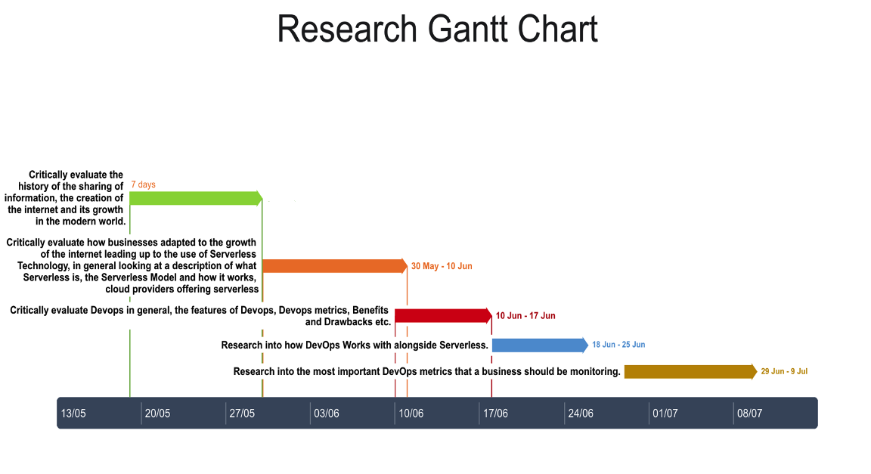

Figure 1- Research Gantt chart

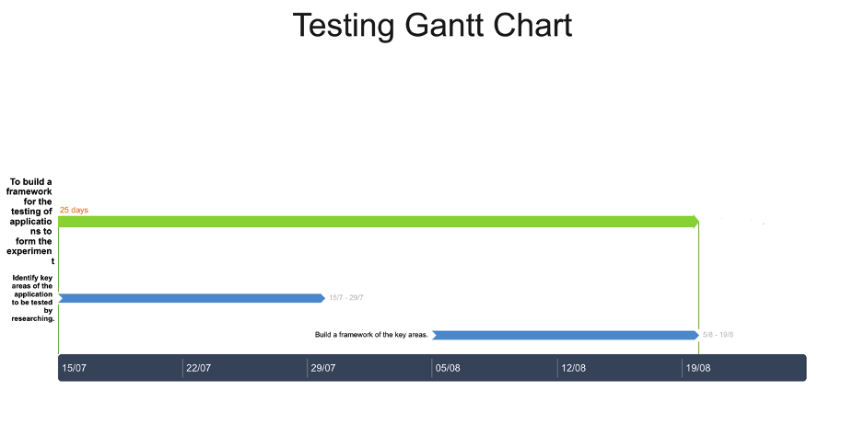

Figure 2- Testing Gantt chart
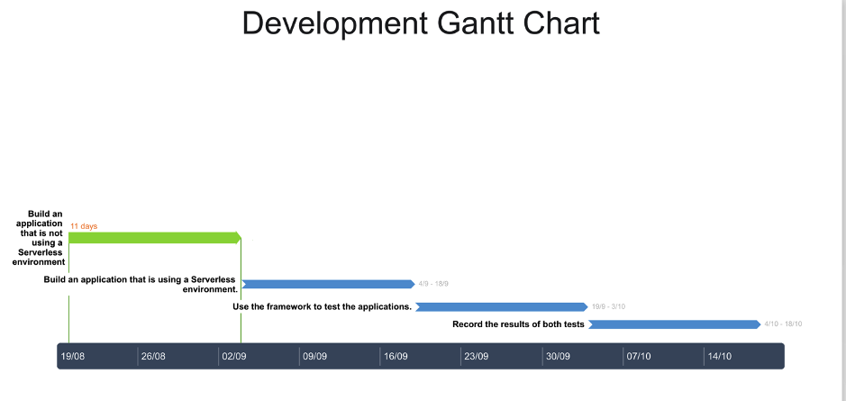
Figure 3- Development Gantt chart
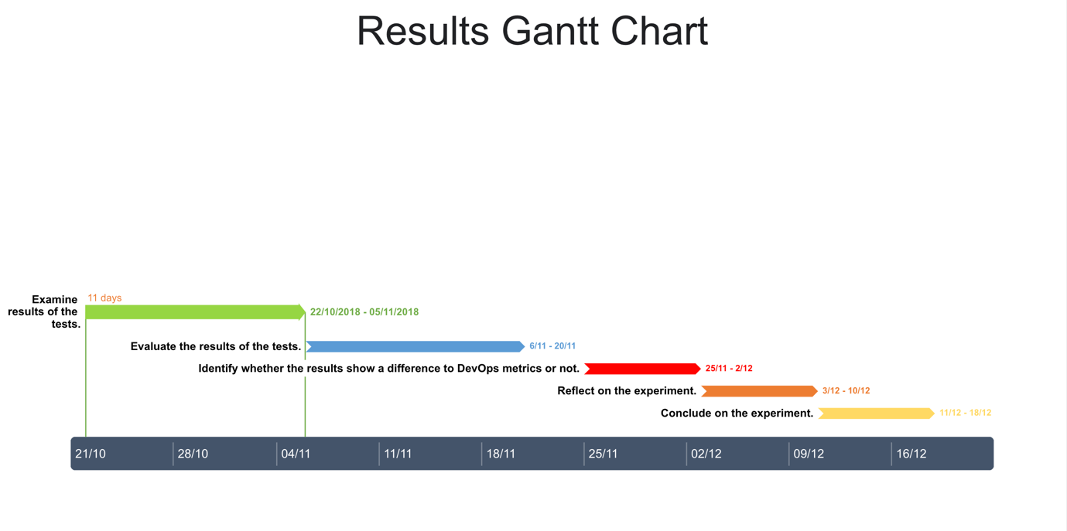
Figure 4 - Results Gantt chart

Resources

The following resources will be required in the research area of the project.

- Access to a DVLA laptop – To be able to complete the research
- Access to the internet – For all areas of the project
- Microsoft Word Software – To write up results of research
- Microsoft Excel Software – To analysis the results of the experiment
- Access to UWTSD Online library – To access the universities research facilities
- Access to UWTSD Library- To lend books for research
The following resources will be required in the implementation area of the project.

- Access to a DVLA laptop- To build the software and test the experiment
- Access to the internet – As part of the development of the project, downloading of software required.
- Access to Amazon Web Services – To use their services to host the applications and analysis the applications metrics.
- Source code editor Software e.g. Microsoft Visual Studio Code
- Additional Software – For use of UML diagrams, Gantt Charts etc

At the current stage of the project, these highlighted requirements are believed to be a concise identification to enable the successful completion of the project, although it is observed that through the evolution and progression of the project the requirements identified do have the potential to be changed or enhanced.

Background Research

3.1 History

Before the phenomenon that is “Serverless”, there’s a rich history behind the evolution of information sharing that has been influenced by the evolution and enhancement in technology. It is observed that it began back in 1969 with the development of Arpanet, designed by the U.S. Advanced Research Projects Agency (ARPA) with the idea of connecting 4 computers at a university together so the computers were able to not just communicate with each other but share resources between each other. This goal was achieved through the idea that is commonly known today networking but was very new at the time, using packets to package up information and send to another device on the network to be unpackaged. Twenty years later another important step was being taken. [7]

It was 1989, at a time where the internet was not yet born but the idea was being thought of by a familiar face to many in the IT community, Tim Berners-Lee. Tim was a researcher for an organisation known as CERN and it was during his research that he developed the idea of worldwide set of protocols that would achieve the goal of building a distributed server that users on the network to access a variety of different files anywhere in the world. This proposal would a few years down the line become the information superhighway which is what is known as the internet these days. Speeds were initially slow to begin with but over time and with the evolution and enhancements, internet connections and servers had improved considerably and still today, new ways to improve speeds are being investigated. [7] [8]

Throughout the 90’s and 00’s there was a big boost in the number of Internet users in the U.K. As the internet increased in popularity, computers became a normal part of many homes across the U.K. Below shows the huge increase in internet users over the last 20 years– first 1998 and then 2019. Statistics provided by Statista. [9]

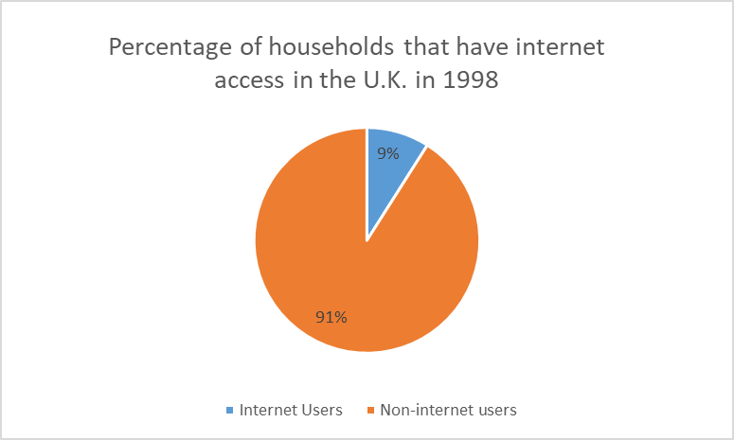

Figure 5- Percentage of household internet users in U.K. 1998

Figure 6- Percentage of household internet users in U.K. 2019
A staggering 93% of internet users in households by 2019 compared to just 7% in 1998. With the internet came browsers capable of be displaying information, this was the beginning of human beings being able to share information across the world in a much quicker fashion.

The need for companies to keep up with the demand of the internet and the sharing of information on the internet created an opportunity for companies to offer server hosting services with the goal of offering 24/7 availability of information via the web. This was the start of a new level of service that would eventually lead to where we are now – Serverless. There are a variety of different server designs used by companies throughout the years and a thorough look at them will be required before we move onto Serverless. But before that, an understanding of cloud computing is required.

3.2 Cloud Computing

Cloud computing is a popular, modern and growing paradigm. With the use of datacentres, resources from hardware to applications are stored and then offered to the companies as services. It’s grown from a need for companies to have resources provided for them to offer a quick, powerful service to keep up with demand from their users. [10]

3.2.1 Bare metal

Bare metal servicing is the design of a server that sits directly on a computer with physical components. This means that there is no virtualization at all in this design, instead relying on dedicated components. The key feature of a bare metal design that separates it from other designs is its single tenant design. This feature means that it does not shared resources with other “tenants” unlike a cloud design that would be multi- tenant. By not being a multi-tenant environment, it is said to increase the level of stability and predictability. [11]

3.2.2 Virtual Machines

Later down the line after bare metal servers were introduced, a new platform was designed to keep up with the growing demand in companies requiring servers. Where the bare metal designed was based on running one environment on one server host (single tenant), the idea of running multiple environments on a server was investigated. Running applications on a server that emulates a hardware System. This piece of software is known as a Hypervisor and it’s the key to Virtual Machines. Its job is to sit in the middle of the infrastructure and the VM allowing the creation and the running’s of the server. [12]

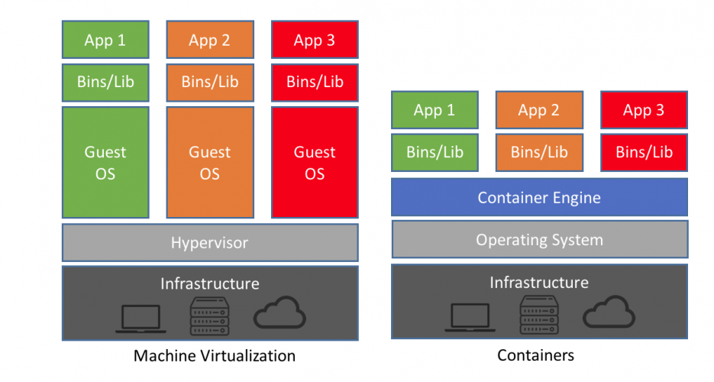

Figure 7 - Virtual Machine traditional design

What’s quite clear from the image above is the opportunity to have multiples Operating Systems on the same infrastructure while not having to be reliant on each other. They also have their own library, binaries and applications which make them unique but also there is possibility of sharing files over between VM’s, but files would need to be copied over. Consideration is needed when creating a VM as they need to be sized appropriately due to the VM’s usage of the memory coming from the computer it’s being built on. However, this approach is said to have brought in cost savings and sped up provisioning of servers for companies which made keeping up with the demand easier. [12]

The internet continued to flourish and now it has become a part of everyday life, but also new ways of building servers kept being investigated. Along came Docker with the idea of using containers and making them popular. Now it’s moved onto using containers to deploy servers and applications.

3.2.3 Containerisation

The latest craze, containers take a different approach to Virtual Machines as instead of running multiple Operating Systems on a piece of hardware, the containers make a virtual OS that can run multiple systems. [12]

Figure 8- Containerisation traditional design

The diagram above shows the one Operating System that sits on top of the physical servers allowing for just maintenance of one Operating System instead of multiple Operating Systems in a Virtual Machine design. Containers are made which contain the Binaries, Libraries and Applications and this can be shared between each other but when shared they become read-only. The key feature of the containers is that they are considerably lighter than running a Virtual Machine. Where a Virtual Machine would take up a size in the gigabytes, a container will take up a smaller size in Megabytes. This size difference allows the containers to start up in very little time. [12]

More and more, researchers into this technology have been finding ways to decrease the times of running up a server, where and along came the Serverless approach. We are right now of an approach that would give the developer the time and focus on their applications without the worry and considerations about the infrastructure side of things. [12]

3.3 Serverless

The term “Serverless” is said to be the latest new technology out there that deals with the deployment of applications and services. [13] It’s known as the next step away from the past ways of using physical servers to implement deployment. [14]

However, “Serverless” is a bit of an oxymoron as it doesn’t actually mean it is functioning without the use of a server. This is due to the way of how Serverless operates. Normally, a Serverless run application would be running on a cloud platform using a cloud service provider AWS, Microsoft Azure for example. These cloud providers would then charge the users for using their service using millisecond granularity to ensure accurate payments are taken. However, physical servers are being used by the cloud service providers to provide this support so the term Serverless isn’t fully true to its word.[15]

This approach allows the architects to worry less about the maintenance and management of the physical server, enabling the architects to apply their time in a more efficient way. [16] Hence, they are able to then focus more on many different aspects on their system such as:

- Coding
- Testing
- Deploying
[17]

3.3.1 Serverless Model ( FaaS)

Then engine used to efficiently implement the required functions to ensure the successful implementation of Serverless is known as FaaS. [18]. Following this model enables the developer to use a Serverless infrastructure. This engine allows a developer to run functions without the worry about how the functions operate.[19] It is said to be “a computing engine, that allows us to write a simple, self-contained, single-purposed function to process or compute a task”.[18]

The Serverless model is a framework that is described as being “typically implemented as distributed systems with multiple components working together to abstract the system and its configuration from the end-user”, this kind of framework does a lot of work for the user and that gives the idea of it being Serverless. [20]

An important aspect of the Serverless model is the functions and methods used. From a software engineering perspective, functions are designed to take in parameters and return values back. [21] They are important because designing an application in Serverless is to make the components of the system all stateless functions containing a trigger which activates them at a time that can be decided by the developer. [22]

3.3.2 Serverless benefits and drawbacks

The following research section researches into the benefits that are believed to be true when it comes to the Serverless infrastructure. The investigation section of the thesis will look to compare the results with the opinions below taking into account from the DVLA’s point of view.

The biggest issue that seems to be said of Serverless technology is that it’s notorious for cold starts of which are functions spinning up new containers where there aren’t any ready to use. This is a common issue in the fundamentals of the technology, where it is viewed that the larger the functions being implemented can be viewed to cause an increase and be more of a dramatic consequence of cold starts. There are ways around this by keeping functions warm but no way to completely remove the cold starts. [23]

One of the biggest advantages that Serverless offers is that it’s said to offer to a developer that is the cloud providers offer their Serverless features as a pay as you go service. This is enticing to many companies especially a company who are just setting up as it reduces the costs of the business to run its operations. [24]

However, this is argued against where it is claimed that Serverless is more expensive than running a server yourself by up to 80% more. [26]

The costs of using Serverless technologies doesn’t just have benefits for the customers, the cloud providers who offer this service are said to benefit too. Infrastructure used to build Serverless features are shared by everyone and repeated saving on costs. This saving in money allows them to offer an affordable and cheaper service to their customers. The end game is a service that allows both the customer and the supplier the opportunity to benefit from. [25]

Another well-known benefit of utilising a Serverless design is the zero-maintenance needed for a developer and organisation to worry about when using a cloud provider like AWS. There’s no need to worry about the server – provisioning, scaling, maintenance etc. The architecture of a Serverless approach allows code to be deployed with ease, enabling developers to save time for example making improvements to their applications. [24]

Despite this, it is said to be harder to hire people with Serverless skills due to it being new technology and it can become an issue to attract people to apply. [23]

3.4 AWS

Throughout this project Amazon Web Services (AWS) will be utilised for the Serverless services that are available. The DVLA run many of their applications and services on AWS and using these services it is believed that via the implementation of the services provided by AWS, these will provide a more accurate and concise set of results towards the testing of the project. The AWS Serverless Application Model or SAM as it’s commonly referred to, is a framework designed by Amazon Web Services which has tools in place to implement the architecture for the creation of a Serverless application. [27]

Amazon Web services is said to be “The world’s most comprehensive and broadly adopted cloud platform, offering over 165 fully features services from data centres globally.” [28] Using cloud technology, it offers a service that looks after the infrastructure of a system for the company. That means that the important stuff that make up a computer e.g. CPU, memory, storage, operating system etc are all offered and managed by AWS. [29]
Let’s take a look at the way AWS implements Serverless.

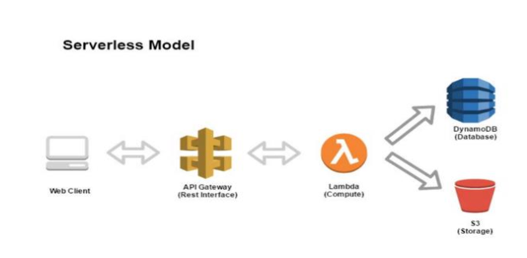

Figure 9- AWS Serverless model

3.4.1 API Gateway

The API gateway acts as a management service for API services and uses REST to apply standards to its service. This service is completely managed by AWS and it provides a simpler approach to creating, maintaining, monitoring and securing APIs. As you guessed, the API Gateway is the process of API calls and can process a high amount of call – hundreds of thousands. Alongside this, management of traffic has been included and control over who can access the API. [30]

3.4.2 Lambda

The Lambda section is simply where the code for the application is sent and executed. [31] This is backed up by Youngbin Kim and Jimmy Lin who agree with the definition of Lambda while adding that “Typically, these blocks of code are stateless, reading from and writing to various “state as a service” offerings (databases, message queues, persistent stores, etc)” [32]. If successful, then the data can go into two different storage types.

3.4.3 DynamoDB

DynamoDB is a Non-SQL database service that stores the data into a database while S3(provided by AWS) is a storage unit of which data can be stored in various formats e.g. JSON, XML. [31]

3.4.4 S3

Amazon Simple Storage Service (S3) is a service that provides the ability to store objects and protect all sizes of data while gaining the benefit from having exceptional scalability, data availability, security and performance.[33] There are numerous reasons why a developer would want to use Amazon S3 as shown below:

- Website hosting
- Backing up and restoring
- Application building
- Big data analytics
- Archiving of data using Glacier
[33]

To meet the requirements of the user, Amazon offer a variety of different storage classes. They are:

- Amazon S3 standard – Described by Amazon as offering high durability, availability and performance for frequently accessed data as well delivering low latency and high throughput. This class can be used for many reasons like the ones highlighted earlier.
- Amazon S3 Standard-Infrequent Access (S3 Standard – IA) – Compared to standard s3 standard, this class suits cases where the object isn’t needed to be used frequently but must be available to be accessed immediately. This class shares the same need for high durability, availability and the same low latency and high throughput. Considered ideal for long-term storage, backups and disaster recovery.
- Amazon S3 One Zone-Infrequent Access (S3 One Zone-IA) – This class is also used for data that needs to be accessed less frequently and requires fast access like the Standard-IA. The difference between this class to the other classes is that it does not store data into multiple availability zones lie the other classes, it stores data into one AZ. It is considerably cheaper than the Standard-IA (Amazon stating it’s 20% cheaper) and said to be a good option for budget projects with no need for frequent data.

- Amazon S3 Glacier – Glacier specialises in the archival of data at a low-costing price. Glacier offers three options for the retrieval of data to suit the needs of the customers. These options depend on the retrieval time required of the customer e.g. minutes or hours. This class is well suited when long-term storage of data is required and there is no urgent retrieval of data needed.
- Amazon S3 Glacier Deep Archive – S3’s lowest costing storage class, ideal for retaining data for long periods of time and very little retrieval of data per year. This can be said to be an extreme version of the Glacier where data can be retrieved in minutes and regularly accessed as the retrieval times for this class take up to 12 hours and infrequent access of data.
- Amazon S3 Intelligent-Tiering - This class works as an intelligent tool that monitors the access patterns and decides where to put your objects. It achieves this by storing objects into frequent access and an infrequent access class, monthly monitoring of the object allows it to see how frequently your objects are being accessed and move into the best option for your objects to save money. This does come with a small price for using the tool.
[33]

3.4.5 Comparison of S3 Storage Classes

This section of the thesis shows a detailed comparison of the S3 Storage Classes provided by Amazon Web Services. A good understanding of the differences in Storage Classes can help to make a more informed decision for a project.

 | Availability | Durability | Availability Zones | Minimum Capacity charge per object | Minimum storage duration charge | Retrieval fee | First byte latency | Lifecycle Transitions
S3 Standard | 99.99% | 99.99% | ≥3 | N/A | N/A | N/A | milliseconds | Yes
S3 Standard-IA | 99.99% | 99.99% | ≥3 | 128KB | 30 days | per GB retrieved | milliseconds | Yes
S3 One Zone-IA | 99.95% | 99.99% | 1 | 128KB | 30 days | per GB retrieved | milliseconds | Yes
S3 Glacier | 99.99% | 99.99% | ≥3 | 40KB | 90 days | per GB retrieved | select minutes or hours | Yes
S3 Glacier Deep | 99.99% | 99.99% | ≥3 | 40KB | 180 days | per GB retrieved | select hours | Yes
S3 Intelligent-Tiering | 99.99% | 99.99% | ≥3 | N/A | 30 days | N/A | milliseconds | Yes

[33]

3.5 DevOps

To fully understand what the term “DevOps” is, a critical evaluation into the area is required. Further detail into the DevOps Metrics and what is considered essential to measure is necessary to successfully achieve the best results from this experiment.

So what is DevOps? , unfortunately it doesn’t have an exact definition but it’s agreed by many as being a number of best practices , standards, methods and concepts that helps to make a software delivery process more efficient.[25][34][35] It takes a lot of different areas into consideration from the development side and also the operational side of things too. Communication and collaboration in the workplace are considered to be important factors in the implementation of a DevOps environment.

There are a few beliefs that are said to make up the DevOps structure:

- Automation is a big part of DevOps; this can improve the speeds in which projects are implemented and updated.
- Culture – There’s a sharing culture within this community and a real feel of that people make the software and also or that software is designed for people.
- Measuring is also a critical part of the DevOps beliefs. These measurements are to ensure quality is at its highest through the use of metrics.
[25]

3.5.1 DevOps Metrics

It’s important at this stage of the experiment to gain an understanding of DevOps metrics as they will be a key element that will show the differences in the applications. So, what exactly is meant by the meaning DevOps Metrics? Basically, metrics are a variety of different aspects that allow the developer to track their services and monitor them. Without being able to monitor the metrics of their services, it would be impossible to find out which areas would need improvement and which areas that were performing better than others. [36]

With a substantial amount of metrics that can be used, research will be required into what are considered to be important metrics to measure so the experiment can be successful while taking into consideration business value for a company like the DVLA.

3.5.2 What to measure?
For this experiment to provide the best results, it’s very important that the right metrics are measured. Research will be taken and the opinion of respectable individuals in the Cloud community will be used to achieve this.

Research has shown that these metrics need to be considered for the monitoring of a web application. [37] [38] [39]

Metric | Description
CPU Usage | The amount of work the processor is doing to run the application. Usually measured as a percentage.
Error Rates | The frequency of the number of errors that will occur on the application.
Average Response time | The average time that it takes for the application to respond to a request.
Origin Latency | The time it takes for the application to receive the request in its hosted environment to responding to the request.
Time to build | The time it takes for the application to be built.
Availability | The availability of the application (available to the user).
Request rate | The rate in which your application is receiving requests (measured in RPS).

It’s clear after researching into metrics to measure that there are metrics that will not be used for this experiment but are important in the monitoring of software. The four key metrics published in the book Accelerate – Building and Scaling High Performing Technology Organizations written by Forsgen et al and also including foreword by Martin Fowler (a respectable name in the software engineering community) that these are the metrics that are endorsed and used by many developers. [40] [41] [42]

The Metrics are stated below:

Deployment Frequency – Measuring the frequency in which software is deployed to a live production. Measured to tell the developer exactly how often they are providing users with a product.

Lead Time for changes – “The time it takes to go from code committed to code successfully running in production”.

MTTR – Mean time to recover (MTTR) is the mean time that a service needs to be restored.

Change Failure Rate – The measure of the number of times a failure occurs in a service that requires attention.
[40]

Monitoring the user satisfaction is also an important metric to consider. However, for this experiment the only user of the application will be the developer so there would not be a need to add this metric into the experiment.

Cost is also to be considered in this experiment as this has significant business value but with the time given for this project, there would not be an appropriate experiment to make which could tackle this issue but would be one that should be measured in a future experiment with the question being can the metrics being monitored contribute to a saving of money for a business when switching to a serverless environment?

Metric | Value
CPU Usage

Application Size

Average Response time

Latency

Time to build

Error rates

User satisfaction

Request rate

Availability

Deployment Frequency

Lead Time for changes

Mean time to recover (MTTR)

Change Failure Rate

3.5.3 The metrics framework for web applications

Now that it’s clear which metrics will be used; a metrics provider will need to be chosen for this experiment. Many providers support DevOps but the DVLA utilise Amazon Web Services on their services so AWS has been chosen as the metric provider for this experiment and their DevOps supported services researched in the following section.

3.5.4 Metrics Provider – AWS

The next section will briefly identify how DevOps works within AWS as the experiment will be utilising AWS to get the correct metrics measured. Amazon Web Services fully endorses DevOps as part of their product and offer a range of services to support it. These services include:

- AWS CodePipeline – Used for continuous integration and service.
- AWS CodeDeploy – Automation of code deployments to speed up the process for example releasing new features.
- AWS CloudFormation – Administrative management system for AWS resources
- AWS CloudWatch – A monitoring service for AWS resources, used to collect and monitor metrics. Log files etc.
[30]

3.5.5. AWS CloudWatch

In order to measure the metrics required in the experiment, a monitoring service is required to be utilised. Amazon CloudWatch offers a service for monitoring and managing applications, infrastructure and resources. It achieves this by collecting data to enable a more detailed or enhanced look into the performance and operations which are taken and presented to the user in a structured, understandable manner via the implementation of logs and dashboards. [28]

The wonderful thing about CloudWatch is that it has metrics embedded into the service that monitor up to 70 different services within AWS for example S3, EC2 etc. These are automatically monitored and all they require is the implementation of a service, the developer will not need to do anything else but there is the option for the user to set up custom metrics if they wish to do so. A key feature to CloudWatch is the ability to set up actions/triggers. CloudWatch constantly monitors the services and also allows the user to set alarms on areas of their services when certain criteria are met which can be utilised to set off actions when the alarms recognise that the threshold have been met. An action can be a variety of different commands from stopping a service, sending out notifications or to simply just tell the service to do nothing. [43]

3.6 DVLA

3.6.1 History

According to the gov.uk website “Driver licences were first introduced in Britain by the Motor Car Act, 1903, purely as a means of identifying vehicles and their drivers.”. [44]
Once a person bought a car, they had to register that vehicle and display the licence plate for that vehicle for an annual fee just like you still see today. [44]

Over the years the popularity of driving vehicles as shown below.

Year | Number of Drivers (Approximately)
1921 | 1 million
1939 | 3 Million
1973 | 20 Million

Table 2- Table of number of drivers in the U.K 1921-1973
[44]

As you can see from table 2 above, the number of drivers was rising slowly throughout the decades, but it is observed that it wasn’t until the 1960’s that the prices on cars became affordable for everyone and that the number of drivers on the road increased. After the number of drivers on the road increased, it became apparent that there was a need for a new way of managing driving licences in the form of a licencing system making use of computer technology. This system would need to be managed in one centralised building of which the Drivers, Vehicles and Drivers Agency started to form. [44]

3.6.2 Drivers Vehicles Licensing Agency

This section will give an overview of the evolution that has occurred since the opening of the DVLA.

When it was decided that a centralised computer system was going to be new way of managing driving licences, a location was needed for this to take place. Swansea was chosen as this location after many other places were considered also. By 1973, the Drivers and Vehicle Licensing Centre (DVLC) as it was known as originally began the new process of registering and issuing licences to the drivers and their vehicles throughout the U.K. [44]

As the years went by, the DVLC kept growing and became more centralised, through the use of the post office for customers to pick up forms instead of needing local offices. This is shown as in 1973 81 offices were open for customers but by 1985 only 53 were open and eventually by 2012 there were no remaining local offices and it was then that Swansea become a fully centralised centre, of which support is still offered in post offices. [44]
As business began to grow, The DVLC formed a partnership with the Department of Transport in 1990 when they became an Executive Agency. This partnership caused a name change from the DVLC to what we all know as the Driver and Vehicle Licensing Agency (DVLA) today.
To really highlight the growth of the DVLA, here is a list of some of the services that the DVLA offer with some statistics as of 2012/2013:

- Provides Driver registry information for 45 million drivers and carried out 15 million driver transactions for that year.

- Provides Vehicle registry information for 37 million vehicles that has been licensed with a plate while carrying out over 97 million vehicle transactions for that year.

- A contact Centre that directly deals with enquires from customers. They deal with an estimated 12 million calls and emails for the financial year and was voted the ‘Best Overall Contact Centre of the year’ in 2012 by the Customer Contact Association.

- Manages a Driver Medical Team that assesses the medical fitness of drivers in the U.K. This is part of the DVLA’s goals to improve road safety. Drivers are obliged to inform the DVLA when they have been diagnosed with certain illnesses for example vision problems, diabetes, heart conditions etc. The DVLA will investigate the driver’s condition and make a decision on whether they are fit enough to drive. For the year 2012/13, 750,000 drivers were investigated for medical conditions by the Drivers Medical Team.

[44]

3.6.3 The DVLA’s IT Strategy

This section describes the current IT strategy developed by the DVLA to move forward the department in the next few years. An IT strategy plan was developed for the years 2017-2020 and look to find solutions to the following issues:

- Moving away from legacy systems due cost and complexity factors.
- Reducing costs by 40% across the ITS department while delivering efficiency.
- Rebalancing of costs across the whole department to meet the reduction cost targets.
- Protection of data by using top level security methods.
- Contributing to the motoring community i.e. producing software to improve motoring services for customers.
[45]

To achieve these goals, there are 3 main areas that the DVLA will be looking to utilise correctly.
- Systems
- People
- Process
[45]

3.6.4 Systems

The DVLA feel they can improve their systems by following certain rules in the way they build their architecture. By making the systems loosely coupled and component based, this will reduce the complexity and potentially the costs of fixing them as the quicker it can be fixed, the less time is needed, and efficiency levels don’t get affected significantly. The use of automation is considered to be a useful tool that the DVLA can take advantage to save costs and time as it allows the opportunity to use repeatable builds of environments using templates. Automation can be used in many other different forms to be beneficial to costs e.g. for allowing environments to self-heal themselves and for scaling up and down due to demand. [45]

3.6.4.1 People

This area of the plan focuses in on the civil servants working for the DVLA. The first topic mentioned is the working environment, an environment that runs with the civil service values and behaviours. This is seen as an environment where a civil servant can be proud to work for the IT department in the organisation, feel like a valued member of staff and dedicated to providing an excellent service to the people in the U.K. using the services provided by the DVLA. The skillset of their staff is a topic mentioned in this area too. It’s considered particularly important that the potential of the staff is utilised and investment in the staff to reach their potentials to achieve the goal of having an internally growing department. The plans of the agency are not just to develop staff but also attract skilled workers to fit into the way of working. [45]

3.6.4.2 Process

The DVLA recognises that flexibility is required with the processes and that a structure known as a tri-modal structure needs to be put in place to allow them to provide a better service overall and in this structure are 3 key points. Innovation by exploring new technologies and using agile techniques with the idea of learning constantly. The use of tools to gain leverage is another point. This is achieved using Agile and DevOps to design and improve the products. Another focus point here is processes. Making them stable which allows for a better service. [45]

3.7 React


A popular tool that is used by a variety of huge companies like Atlassian, E-Bay, Instagram and Facebook. React takes a collection of JavaScript tools that can be used to design UI interface components with the goal of making it “painless to create interactive UIs”.[46] A great tool for the creation of interactive UI designs, there are a few key features that React has that sets it apart from other JavaScript libraries like Angular.js for example.

Virtual DOM – To familiarise yourself with DOM, you can find out more about DOM here https://developer.mozilla.org/en-US/docs/Web/API/Document_Object_Model/Introduction
.[47] The use of virtual DOM’s is said to have great benefits to the performance of an application. Instead of working with the browser DOM as a regular framework would do, which causes changes to the entire DOM when an event is triggered, React uses what it is known as a virtual DOM. It acts exactly like a normal DOM, React updates the virtual DOMs through the render () method with the creation of node trees, where changes to the data cause a new virtual DOM to be designed. [48]

JSX – A syntax language that utilises the full power of JavaScript, it is said to be a popular feature for developers who use react although it is not mandatory. It allows the ability for XML/HTML code to exist within the react environment. [48] The example given from reacts website which can be viewed in figure 10 of a variable being put into JSX and rendered using the DOM. [46]

const name = Jamie Ellis;
const element = <h1>My name is, {name}</h1>;

ReactDOM.render(
element,
document.getElementById('root')
);

Figure 10 - JSX example
So why would you use JSX? well it is believed that using JSX enables developing to be easier due to the short code nature of it whilst also providing the simplicity of the way it works, contributing to the popularity of developers. [48]

Design and Implementation

4.1 User requirements

The following section breaks down the user requirements of the applications into two sections, being the Functional and Non-Functional requirements.

Non-Serverless requirements

4.1.1.1 Functional requirements

- User form - The application will be able to allow a user to fill out a form. The form will consist of textboxes and radio buttons with a submit button at the end of the form. The form will also include String and Number input when appropriate.

- Form Validation – The user must not be able to submit the form without filling out all the required data from the form. The missed data will be highlighted to the user on the front-end and will not allow the user to submit the form until the validation is completed.

- Form submission to database - The form must be able to successfully post the data from the form into a database when the user uses the submit button to submit the form. The user will be prompted when the post has been successful, and the form will be cleared so a new form can be created.

- Database properties – The application will store away the database properties in the backend to allow connectivity to the front-end.

4.1.1.2 Non-Functional requirements

- User friendly – The application should be designed for a user to be easy to understand, the user should not have much learnability when using the application. The application should be reliable, so the user does not unnecessary confusion when using the application. The form should be simple in design and should resemble a form design that the user can identify with to make the process simpler and less time consuming.
- Static website hosting – The application must be hosted onto AWS as a static website. The application will sit inside a S3 bucket as object storage.
- Metrics monitored – The application’s metrics for example Performance, CPU usage, speed etc be monitored through AWS. The application must be available on AWS for the duration of the experiment for the metrics to be analysed.

4.1.2 Serverless Application

4.1.2.1 Functional Requirements

- User form - The application will be able to allow a user to fill out a form. The form will consist of textboxes and radio buttons with a submit button at the end of the form. The form will also include String and Number input when appropriate.

- Form Validation – The user must not be able to submit the form without filling out all the required data from the form. The missed data will be highlighted to the user on the front-end and will not allow the user to submit the form until the validation is completed.

- Form submission to database - The form must be able to successfully post the data from the form into a database when the user uses the submit button to submit the form. The user will be prompted when the post has been successful, and the form will be cleared so a new form can be created.

- Database properties – The application will connect to the database with the use of a serverless Lambda function. The lambda function must hold the code pointing to the database and the data being submitted into the database. The lambda function must be given permission to post into the database through the creation of ay IAM policy.

4.1.2.2 Non-Functional requirements

- User friendly – The application should be designed for a user to be easy to understand, the user should not have much learnability when using the application. The application should be reliable, so the user does not unnecessary confusion when using the application. The form should be simple in design and should resemble a form design that the user can identify with to make the process simpler and less time consuming.
- Static website hosting – The application must be hosted onto AWS as a static website. The application will sit inside a S3 bucket as object storage.
- Metrics monitored – The application’s metrics for example Performance, CPU usage, speed etc be monitored through AWS. The application must be available on AWS for the duration of the experiment for the metrics to be analysed.

4.2 UML Diagrams

The flowchart of which can be viewed within figure 11 describes the processes of the application. The application does not require complexity for this project as the results of the experiment are viewed to be more of an importance. Via the implementation of a simple form, an end user will fill out the form while having to pass validation by entering data into all of the form parameters. Once the form validation has been completed, the application will then push the form data into the database set up, if not successful then an error message will be displayed to the end user. If successful then the data will be pushed to the database and stored, a message displayed to the end user informing them and the form data cleared for a new form to be created.

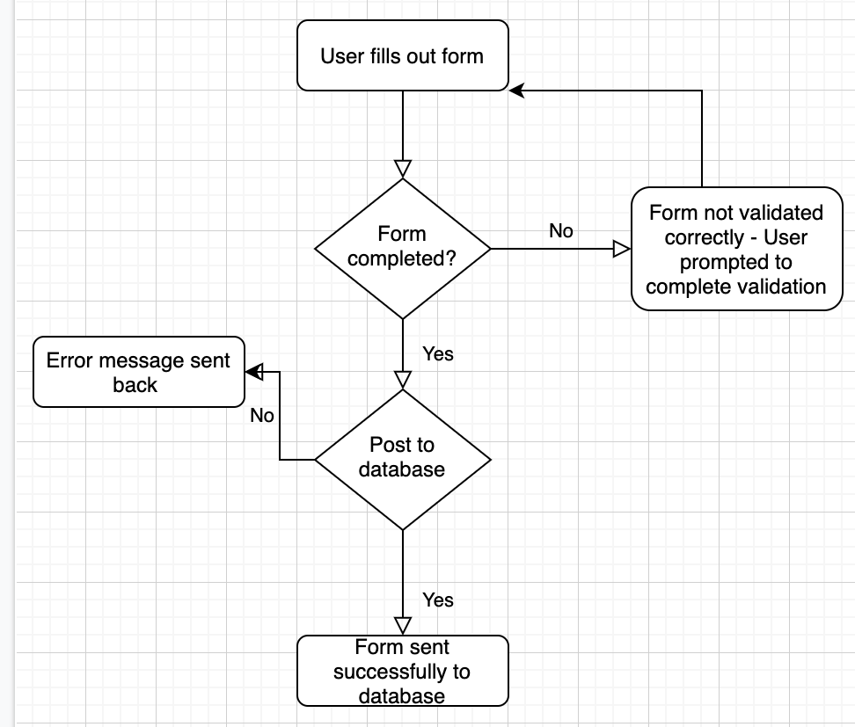

Figure 11- process flowchart for application
A more in-depth look at the application processes is required through the use of a flowchart. The diagram below goes through the process of sending data to the database in the Serverless application. A lambda function will be created but will need to be triggered by the API gateway that will be waiting for the post request to occur. The lambda function will then divert the post request to the specified DynamoDB table.

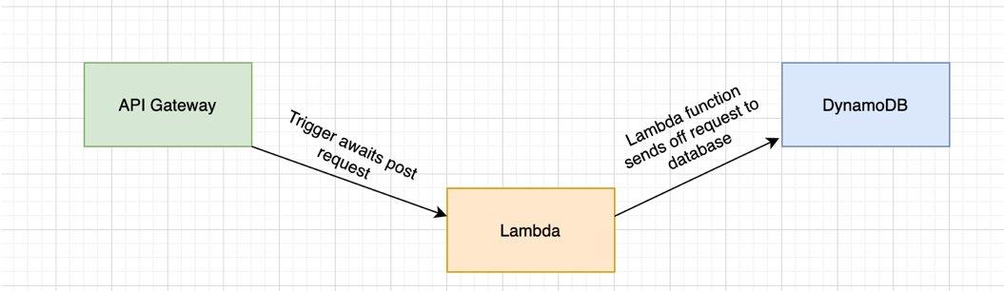

Figure 12 - Serverless DB configuration
The Non-Serverless process differs and shares some similarities from the serverless application in the way the database is handled. In both designs, the application will use Axios to create the request which will point at the DynamoDB table. The Non-Serverless design will need to a server to handle the requests where Serverlessly AWS will handle this for the end user.
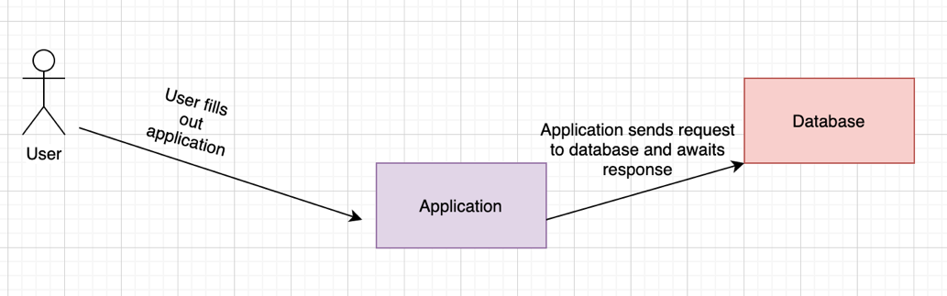

Figure 13- Non-Serverless configuration

Implementation

This section of the report delves into the challenges that we’re faced during the implementation of the applications and gives advice of how to get around these issues.

4.3.1 Setting up React-app

Before React can be used, there is a little work needed to set it up. The first thing to do is create yourself a folder for the application and in a terminal cd into the folder. It’s important to know that you must have Node installed to be able to use the npm command. Next you need to run the following command “npm init” which will create you a package.json file into your folder. This package.json file is important to the structure of using React.js as it holds metadata about the project.

Installation of react is the next step to take. This can be achieved by installing pieces of React separately but there is a much easier way to do both the initializing of the package.json and installing of React. This way will create for you a boilerplate React application with everything you need to start working with React. This was designed by Facebook as a way to quickly throw up a template for implementing React applications and only requires one line of code.

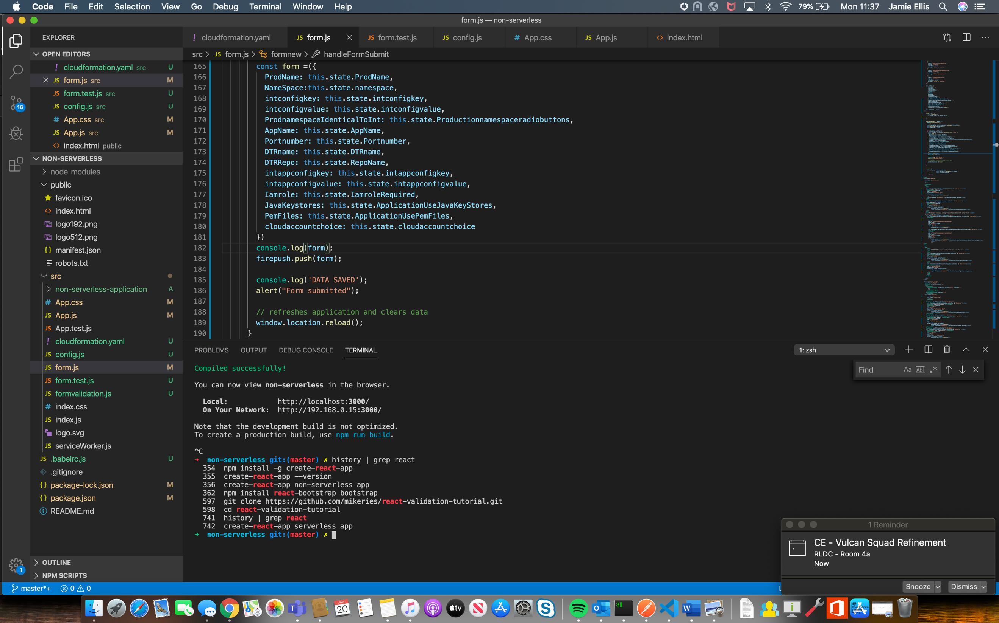

Figure 14 - Install react-app command
Now that React is up and running in your folder, all that is left to do is create yourself an application. Facebook has done a wonderful job of simplifying this task with their creation of the create-react-app. By entering create-react-app and the name of the project into the command terminal, the creation of your application will occur.
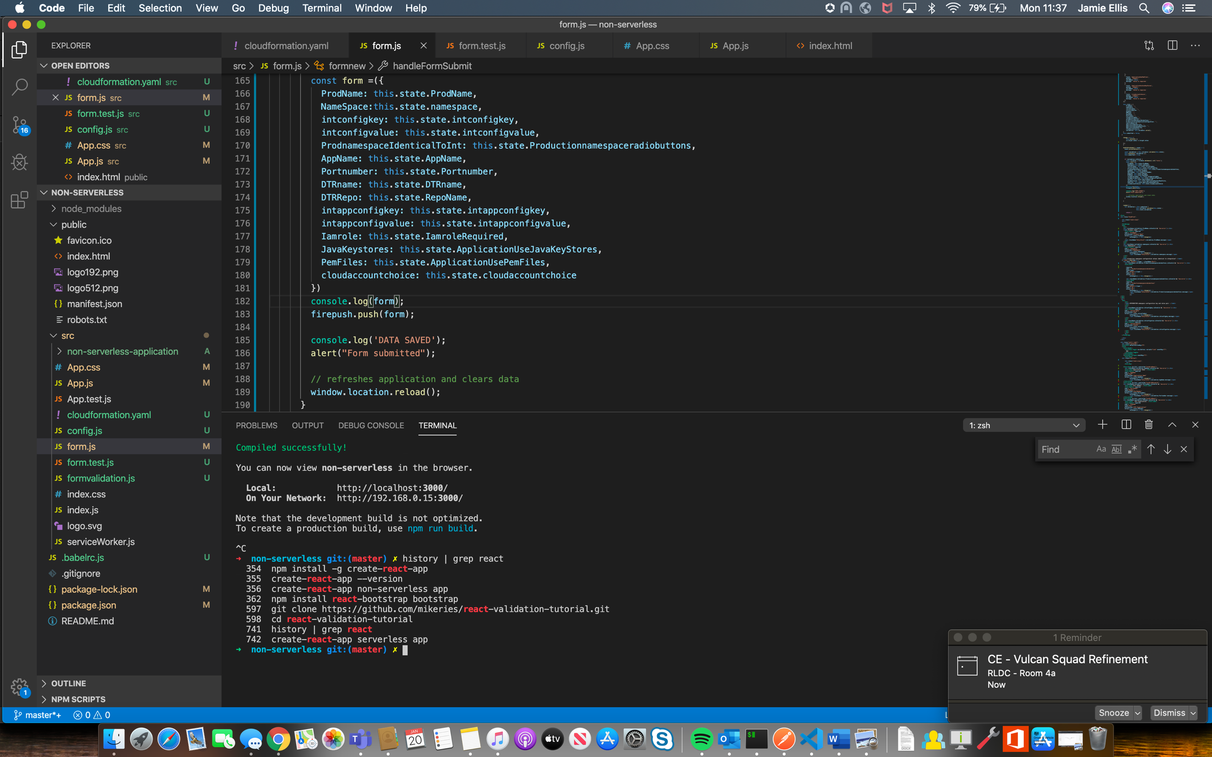

Figure 15 - creating react app named non-serverless app command
Running the command npm start will start-up your application locally on localhost:3000 unless configured to load up on another port.

4.3.2 App.js

The setup for the React app is fairly simple to understand once you dive into how the code is interacting with each other. The index.js works as the homepage but all it is really doing is calling in the function App from the App.js file by importing it and then rendering the function to appear through the index.js. The results from Index.js will appear first when opening up localhost. The import can only be achieved by App.js having the export default App line which is allowing it to be exported as a function.
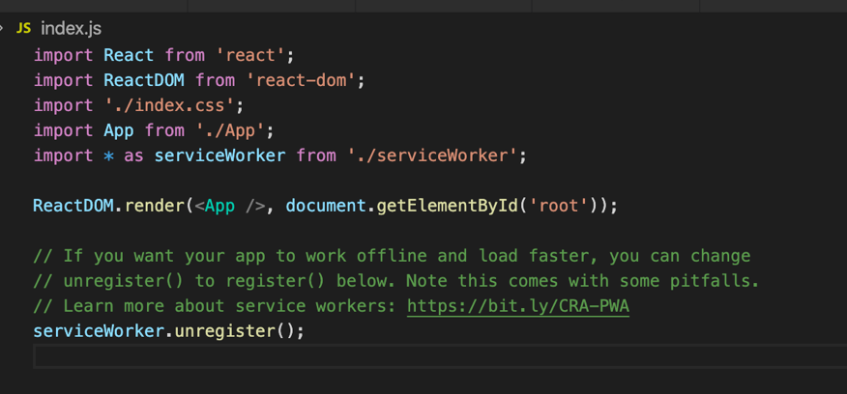

Figure 16 - App.js
The App.js file is set up to be the page where most of the HTML and CSS work will take place. It is obvious as it is templated with a header and a main with a div class labelled “starter-template”. There is also an App.css file in the directory that has been connected up to the App.js file, everything you need to get started is there for you.

4.3.3 Blending Bootstrap with React

Arguably considered the most popular CSS framework used by developers, Bootstrap is an open source, very useful tool for adding components and styling into your project in a simple and efficient way.[49] It has also been designed to work alongside React for the creation of various components from buttons, forms, navbars etc.

Bootstrap-React can be installed into your project by running the command “npm install react-bootstrap bootstrap” into your terminal within your project folder. This will plug in the Bootstrap files into your project and allow you to call in components etc. However, CSS files are not all added to the install so some can be imported in, but others will need to be linked in. More information on how Bootstrap-React works and the components that are available can be found here. [50]

4.3.4 Utilising Reacts state method to store form data

Creating a React-App to design a form can be pretty useful. React has the benefit of allowing a developer to store data that belongs to a component, this is known as the state. Not only storing the data but re-rendering the component when the state values change allows the app to constantly react to changes.

When designing a form, Form data can be stored in the state like the image shown below in figure 18 on the left side of the page and the state can be changed by the user when they enter the form data so it’s up to date for when the form is ready to be submitted through the use of a function as shown in the image below in figure 17 on the right side of the page.
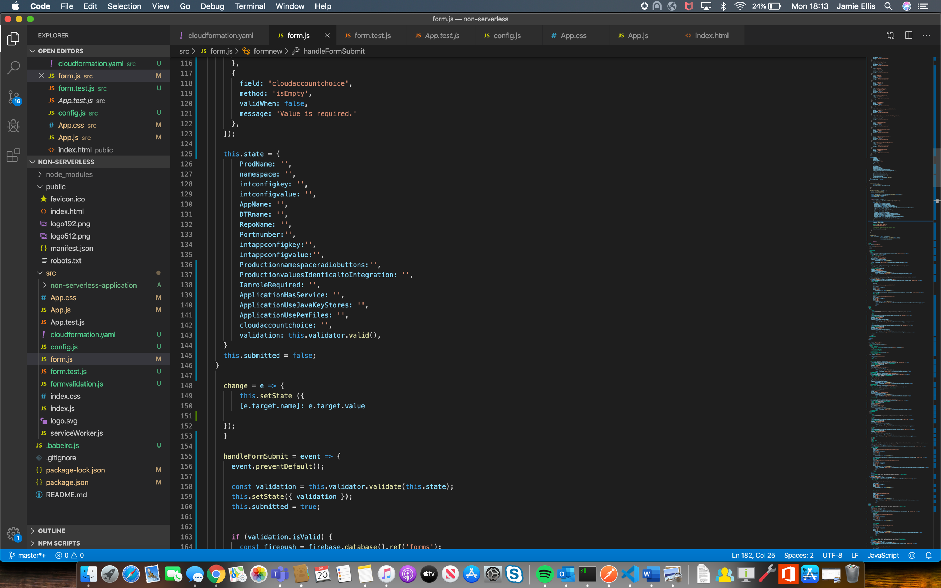
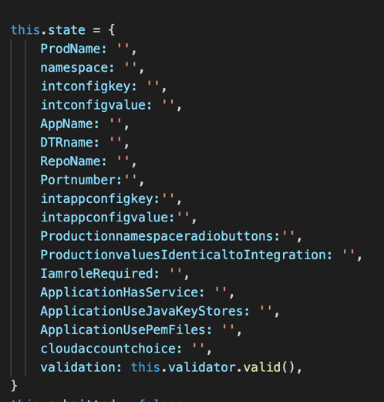

Figure 17- React change state value function

Figure 18- React state values example

4.3.5 Configuring Mongo dB to React application

Connecting a local database was the biggest challenge faced in the creation of the Non-Serverless application. To be able to successfully import the database into the project, an understanding of how the database works with the frontend and backend was needed.

The database represents the backend and of course was required before connecting it to the frontend. Also required was a server for the purpose of handling requests from the web app. Node js have a variety of different frameworks but, express seems to be the most popular of server frameworks for node js.

In the frontend, the application needed to send off a POST request to the backend which would go straight to the database. A http request client called Axios had been created that works wonderfully with web applications and is capable of doing what is needed. Once the request has been made, the server will handle the request and send it off to the database.

4.3.6 CloudFormation

There are many ways to store an application into AWS, the most basic way would be logging into your AWS account from the console and creating a S3 bucket, filling out the details of the bucket and then uploading your project folder into the bucket. This will be fine but once you start adding more features, it can be hard to maintain all of your services. There is a way that you can manage your AWS infrastructure all in one place using AWS CloudFormation.

CloudFormation is a great way to provision your cloud resources through the use of language files such as JSON or YAML, when uploaded they act as an automation tool to build your infrastructure. The infrastructure will be built into a stack where you are easily able to build or tear down the stack as you wish in a more simplified manner than choosing to implement your services separately.

For this project, a CloudFormation file is perfect for the creation of a S3 bucket that will be used as a static website for the applications. To improve the performance and speeds of your application, AWS offer a service known as CloudFront which is a CDN that will not charge you extra for transferring data from an AWS resource like S3. CloudFront is fully integrated with the AWS monitoring service CloudWatch, providing default metrics and also the option to add extra metrics for extra costs [51]. The YAML file shown below within figures 19 and 20 are an example of using a S3 bucket known as the “Non-Serverless application” and the “CloudFront distribution” to host the contents of the S3 bucket.

CloudFormation files can be uploaded through the AWS console or uploaded locally using the AWS CLI.

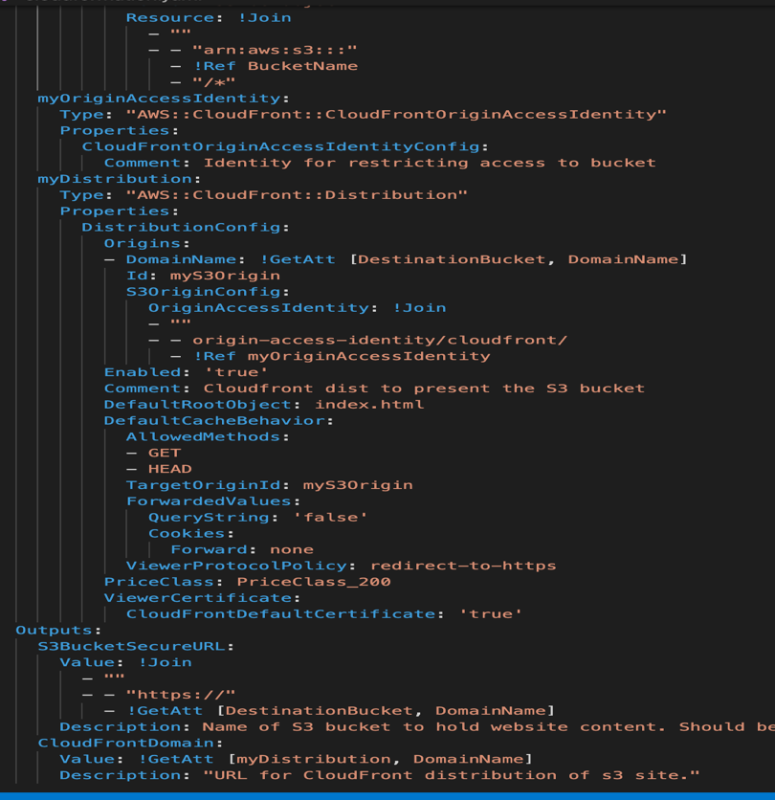
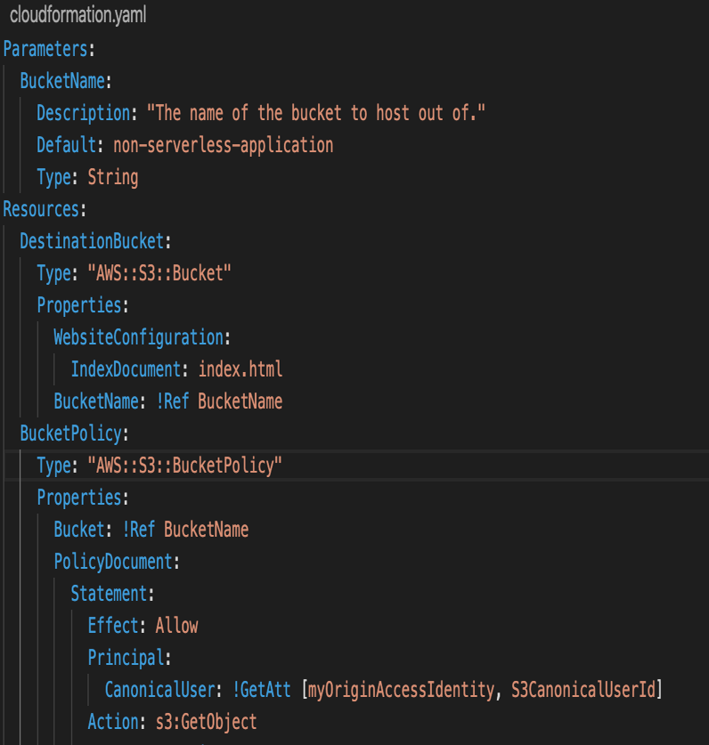

Figure 19- CloudFormation file first part Figure 20 - CloudFormation file second part

4.3.7 Serverless

Restructuring the database code is the major challenge that was faced when implementing the Serverless application. AWS has a variety of Serverless services but all that was required for the database post was DynamoDB, AWS Lambda and API Gateway. In the same way that the Non-Serverless application worked, the frontend was going to make the http request, the request was going to have to be handled and then a connection to a database was also required to store the given request.

Once the database was created, a Lambda function was next to be designed, this function’s role is to sit and wait to be triggered by the API Gateway and then handle the request targeting the DynamoDB table. Connecting it to the API gateway caused a challenge as it will not directly allow requests to the database unless an inline policy has been made that allows the gateway certain rules to deal with requests with the DynamoDB.

4.3.8 Form Validation

This tutorial was followed on how to implement validation to the form and code was taken from this site. [52].

Testing

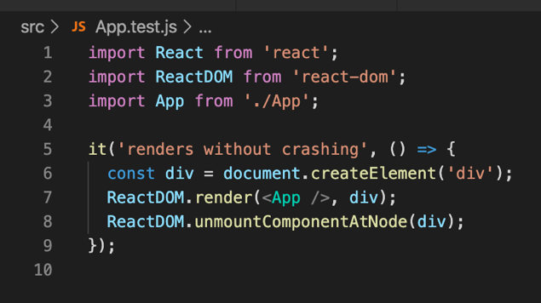
The Create-React-App boilerplate that was used for the creation of the applications come with a test that will check if the function App will run without crashing when being rendered to the Index.js. This test can be altered to suit your project.

Figure 21- App.js
Testing the data being sent through the form was tested using console logs. By storing the values of the form into a variable, the values were then tested by adding the console.log line of code as shown below in the textbox.
const DBValues= {
ProdName: this.state.ProdName,
namespace: this.state.namespace,
intconfigkey: this.state.intconfigkey,
intconfigvalue: this.state.intconfigvalue,
AppName: this.state.AppName,
DTRname: this.state.DTRname,
RepoName: this.state.RepoName,
Portnumber: this.state.Portnumber,
intappconfigkey: this.state.intappconfigkey,
intappconfigvalue: this.state.intappconfigvalue,
Productionnamespaceradiobuttons: this.state.Productionnamespaceradiobuttons,
ProductionvaluesIdenticaltoIntegration: this.state.ProductionvaluesIdenticaltoIntegration,
IamroleRequired: this.state.IamroleRequired,
ApplicationHasService: this.state.ApplicationHasService,
ApplicationUseJavaKeyStores: this.state.ApplicationUseJavaKeyStores,
ApplicationUsePemFiles: this.state.ApplicationUsePemFiles,
cloudaccountchoice: this.state.cloudaccountchoice
};

console.log(DBValues);

Postman was identified as the software required to test the connection of the databases. By creating post requests aimed at the database URLs, Postman will send the request and give you a response if it can connect to the address.

Experiment

After the implementation and testing of the applications had been thoroughly conducted, the applications will be hosted on AWS where there will be an experiment to test the DevOps Metrics framework as discovered through the research section of this project, with the goal of identifying if there is a significant difference between the applications or not.

 | Non-Serverless | Serverless
Average Memory usage

Average Response time to submit to database

Average Size Per Request

Average Time to build

Average Error Rates

Availability

Build Size

Application Size

Table 3- Table of metrics to be used for experiment

6.1 Hypothesis

6.1.1 Null Hypothesis

There will not be any significant differences to any of the DevOps Metrics between the Non-Serverless application and the Serverless application.

6.1.2 Alternative Hypothesis

There will be a significant difference to the DevOps Metrics between the Non-Serverless application and the Serverless application.

6.2 Results

 | Non-Serverless | Serverless
Average Memory Usage | 15.96 MB | 8.06 MB
Average Response Time to submit database | 19.6ms | 15.42ms
Average Size Per Request | 301 Bytes | 301 Bytes
Average Time to Build | 16.16 s | 16.72s
Average Error Rates | 0% | 0%
Availability | 100% | 100%
Build Size | 2 MB | 1.8 MB
Application Size | 162 MB | 382 MB

Table 4- Results of the experiment

Data Analysis

6.3.1 Average Memory Usage

The results for the Average Memory Usage were gathered by taking 5 measures of the JS heap size that measures the amount of memory that JavaScript is needing for the applications after the code has been read– known as JS heap size. A high JS heap size can slow down an application’s performance, so it’s considered important to detect and remove leaks of memory [51]. The results were taken throughout different periods of the day – 10am, 12pm, 2pm,4pm, 6pm and an average score was taken from the 5 samples.

Non-Serverless samples show a fairly consistent average memory usage score in the 14Mb range but then the final result showed a spike in memory of 21.6 MB. An average of the samples shows a result of 15.96 MB Memory Usage.

Figure 22 - Non-Serverless average memory usage results

Checking the standard deviation of the samples back up the suggestion that the data is fairly consistent with the mean. Four of the samples show a low standard deviation with scores very close to the average. One of the results show a higher deviation score which suggests that that sample was further away from the average than the other samples. This suggests that it was a spike in memory. More research with more samples could be completed to further examine if this is true.

value | Result | std dev
1 | 14.4 | 1.10308658
2 | 14.9 | 0.74953319
3 | 14 | 1.38592929
4 | 14.9 | 0.74953319
5 | 21.6 | 3.98808225
avg | 15.96

Table 5 - Statistics for non-Serverless average memory usage
The serverless samples show a less Memory Usage from the samples. The samples show a clearly consistent result throughout all of the 5 samples of between 8.0 and 8.1 MB. The average result of the samples was 8.06.

Figure 23 - Results for Serverless average memory usage
Working out the standard deviation backed up the claim that the samples were producing a strong level of consistency. All 5 samples taken show a very low standard deviation score which indicates that the scores are consistent with the mean score.

value | Result | std dev
1 | 8.1 | 0.02828427
2 | 8 | 0.04242641
3 | 8.1 | 0.02828427
4 | 8 | 0.04242641
5 | 8.1 | 0.02828427
avg | 8.06

Table 6 - Statistics for Serverless average memory usage
Comparing the results of both applications show that the Serverless application is using approximately 50% less memory than the Non-Serverless application which is a significant difference.

6.3.2 Average Response Time to submit database

This metric was measured in the Non-Serverless application through postman where 5 requests were sent off at different times of the day. Postman provided a detailed breakdown of the time and tasks for the requests sent. The serverless application required to look through the CloudWatch logs of the DynamoDB table where the put latency of the requests were recorded and once again 5 samples were taken throughout the day.

The Non-Serverless application samples show a very sporadic spread of results. The first two samples give a much higher response time than the other 3 results. This indicates that maybe the Non-Serverless with the MongoDB connection maybe offers less consistency with its erratic behaviour however, it could also mean that it just needs some time to offer once the server is running to offer consistent results. It would be a good idea to experiment further on this subject to get a better answer to that question.

Figure 24 - Results of Non-Serverless average response time to submit to database

To be clearer about the consistency of the samples, standard deviation tests were made from the samples. The results highlight the same issue that there is inconsistency with the data samples as there is a high standard deviation meaning the data is spread out. This does not however give a reason for why the data was so erratic and would need further experiments over a longer period of time.

value | Result | std dev
1 | 33 | 9.47523087
2 | 40 | 14.4249783
3 | 9 | 7.49533188
4 | 9 | 7.49533188
5 | 7 | 8.90954544
avg | 19.6

Table 7 - Statistics for Non-Serverless average response time to submit to database
The Serverless application samples showed a good consistency level, all the samples shown in figure 25 were between 14 and 15ms and this resulted in a mean of 15.42ms.

Figure 25 - Results for Serverless average response time to submit to database
Standard deviation results from table 8 came back very low to indicate there was a close spread of numbers to the mean and that the samples were consistent.
value | result | std dev
1 | 14.51 | 0.6462956
2 | 15.01 | 0.29274221
3 | 16.16 | 0.52043059
4 | 15.92 | 0.35072496
5 | 15.52 | 0.06788225
avg | 15.424

Table 8 - Statistics for Serverless average response time to submit to database
Comparing the results for the metric show that although the Non-Serverless application recorded some lower times than the Serverless application, it was more erratic and resulted in a higher average score overall. Serverless application was more consistent throughout and scored a lower average. The difference between the averages is not enough to be considered significant and the some would argue that even if it was, the difference in microseconds would not make much of a difference to the application.

6.3.3 Average Time to Build

This DevOps metric was measured when using node JS to build the applications with the command “time npm run build”. By putting “time” in front of the command, Node JS was able to record the time it took for the applications to build onto the command line to be used for this experiment.

value | Result | Std Dev
1 | 8.23 | 0.24748737
2 | 7.83 | 0.03535534
3 | 7.75 | 0.09192388
4 | 7.9 | 0.01414214
5 | 7.69 | 0.13435029
avg | 7.88
Consideration was taken on whether an average of 5 builds each would be taken or just the one build. It was decided that by taking an average of 5 builds that there could be an opportunity to gain some interesting data.

Table 9- Statistics for Non-Serverless average time to build
With a low standard deviation score shown in table 9 indicating that the samples are spread close to the mean, it suggests that the Non-Serverless application showed a consistent time of builds from the samples with a relatively fast build time in the 8ms.

Interestingly, the Serverless application also indicates a consistent build time while offering a slightly faster build time, a mean score of 7.88ms was recorded compared to the 8.3ms from the Non-Serverless application while standard deviation scores back up this evidence. While there is a difference in the build time, the difference is very little and would not be considered significant.

Value | Result | std dev
1 | 8.73 | 0.32809755
2 | 8.32 | 0.03818377
3 | 8.07 | 0.13859293
4 | 8.11 | 0.11030866
5 | 8.1 | 0.11737973
avg | 8.266

Table 10 - Statistics for Serverless average time to build
Figure 26 - Results for Serverless average time to build

6.3.4 Average Error Rates

Through the experiment, the average error rates proved to be of a challenge to provide an accurate metric. The applications were built not to error during the experiment. For this reason, the applications were given results of 0%. While it was not an appropriate metric to use for this experiment, the metric would be a useful metric to monitor for experiments that are given more time to conduct, of which was not possible for this project due to the time restraints apposed on it. Future experiments should also be aimed at using a project that is being used regularly and has a consistent level of requests being made.

6.3.5 Availability

Availability was a difficult metric to measure in this experiment, the applications were always available for the time of the experiment. For this reason, the applications were given results of 100%. While it was not an appropriate metric to use for this experiment, the metric would be a useful one to monitor for experiments that are given more time to conduct.

6.3.6 Build Size

To get the build size, the applications had to be built using the command “npm run build”. This built a folder for the build which could then be measured for the size. There was no requirement to take more than one sample for the build size due to the results would always be the same, the build size will not change.

There was very little difference between the two applications in terms of build size. The Non-serverless application showed a build size of 2 MB exactly while the Serverless application had a slightly lower build size of 1.8 MB. From this information, it’s fair to say that there was a small difference in the results but not a significant difference in this DevOps Metric. It would be interesting to see if the difference becomes more significant when using bigger projects in future experiments.

6.3.7 Application Size

The application size was measured by taking the size of the whole application folder once the applications were finished. Only one measurement was taken for this metric to see if there was much of a difference in the sizes of each application. This test shows that there is a significant difference in the size of the both applications, Serverless has a 220 MB increase over the size of the Non-Serverless application as can be seen in table 11 below.

Non-Serverless | Serverless
162 MB | 382 MB

Table 11- Results for application size
Despite the higher size in application, the Serverless application is capable of offering a slightly lower build size than the Non-serverless application which highlights the capabilities of the technology.

6.3.8 Average Size Per Request

Average Size Per Request was a metric that needed to have the suffer data for both the applications to ensure that the experiment was completed consistently and fairly. The same data would be added to both the applications so there wouldn’t be any unfair advantages for either of the applications.

Five Samples of the same data were inserted into both of the applications where the size of each requests was recorded and a mean score of 301 MB was taken from the samples.

Value | Result
1 | 278
2 | 325
3 | 299
4 | 346
5 | 256
avg | 300.8

Table 12- Results average size per request
From the results of the experiment, it is clear that the null hypothesis has to be rejected due to the significant difference in the memory of a Serverless design. Therefore, it can be said with confidence that the Alternative hypothesis cannot be rejected.

Conclusion and Evaluation
The growth of companies investing in their IT budgets is increasing steadily and with no signs of it slowing down, companies are in need of branching out more and more online to reach a wider audience, to successfully sustain the company’s growth requirements. It’s important companies adapt with the new technologies out there which can help them provide a better service, save money and simplify their future development processes. As part of this need, companies are looking into the latest phase out there to help them with their applications – Serverless. The idea of not needing to maintain their own servers while improving applications is very appealing to companies but there is research needed to see if there is truth to it and if so when would it be appropriate to implement Serverless technology and when it wouldn’t be appropriate to implement serverless technologies.

Research into the DevOps metrics that turned into the creation of the DevOps metrics framework had a positive effect on the project. This framework was used to pick metrics for the experiment and helped to contributing towards the results of the experiment. Another important aspect of the framework is that it offers different metrics not included in the experiment which could be used by companies but also could be used by anyone wanting to take this work and improve upon it.

Applications were made with the theory of highlighting the difference between a Non-Serverless and a Serverless design. With this in mind, it was important to design applications that were able to be show the difference between the two. This is why it was necessary to make use of UML diagrams to design two different systems that would do this. The requirements gathering for the applications were reached successfully so the experiment could deliver an answer to the question of if a Serverless approach could bring a Significant difference to DevOps metrics of an application.

The experiment that was undertaken has provided many benefits to the IT community. The results show that there is a significant difference in the aspect of memory and also some slight differences in the build time and response time for the requests to a database. This information is interesting and offers an opportunity to expand upon it by using applications that are dealing with high level of requests, constant flow of users throughout the day to add more stress on the systems. That way some metrics that were not useful in this experiment such as error rates, availability etc. could add more value to the experiment.

Cost is an issue that businesses take seriously, the reason companies are investing further into their IT budget is due to the investment to make more money. The idea of using Serverless technology is not just to improve metrics but to also reduce costs. The experiment was not able to tackle this issue due to the time restraints allocated to the completion of this project. A company would benefit from running a similar experiment with the goal of evaluating the cost difference between a Non-serverless system and a Serverless system over a long period of time. This could then lead onto more experiments where it could be investigated if different types of applications would be more suited to a Serverless approach than others. All these kinds of experiments could be beneficial to the business as they could potentially save them money.

Reflection
Overall, I would describe the duration of this project as an interesting learning experience. I wanted the opportunity to learn more about Serverless technology while also being able to design a piece of software in a language I had little knowledge of. I was able to achieve this goal and learn more than I expected to learn.

From the beginning of the project I was expecting to learn about Serverless technology while learning to design a React web application however, the project took me on a journey where I learned how to implement Serverless technology into the web application, the many features that AWS has that can be utilised in the creation and maintaining of a web application and how they interact with each other while also learning how to use CloudFormation to simplify the development of infrastructure.

I felt that given the time restraints imposed on the nature of the project, being an academic project and the level of skills I currently possess in the given subject, the applications that were developed to an acceptable standard. They were built appropriately for the experiment as they were able to demonstrate the difference between Non-Serverless features and Serverless features which enabled the completion of the project I would have liked to have been able to add more to the applications, being able to expand the size of the applications which may have offered a more realistic experiment to the type of applications that are being developed in real life companies like the DVLA. This I feel, could well have given me different results in the experiment and been more beneficial to the DVLA.

I do feel that the applications will benefit the developers like myself that are new to their careers and the technologies used in the project because they will give them a nice introduction into the technologies. Developers with more skill and experience will be able to take the project and expand upon it, adding to the DevOps Metrics framework as I do want the framework to be useful for companies in the future.

Given the timescale that was allocated for the project, I would say that I am relatively happy with the results of the experiment. I set out with the goal of seeing if the idea of implementing Serverless technology into a project could had make a significant difference to a project and I’m happy to say that I was able to get an answer to this from the project. I wasn’t confident that I would see a difference, so it was surprisingly to see that even on a small project like this one, there was an area where it greatly improved the metrics. Although I feel the experiment went fine, I do feel that it could have been better and there would have been ways I could have improved it. The experiment could have been improved by researching more into the DevOps metrics so there wouldn’t have been metrics included in the experiment that were not useful or provided any information to help prove the hypothesis.

Additionally, the experiment could have been improved via the inclusion of additional data. Thus, increasing the given data samples, which could have provided the possibility of providing different results. It is believed that this would then have provided the application to be provided a more beneficial time frame to identify if there would have been a consistency in any of the metrics involved. This would then enable the opportunity for the experiment to be improved upon in the future development/evolution of the experiment by either myself or via another developer.

References
- 2020 State of IT: Industry Trends on Tech Spend, Adoption & Jobs - Spiceworks. (n.d.). Retrieved January 4, 2020, from https://www.spiceworks.com/marketing/state-of-it/report/
- Research Philosophy - Research Methodology. (n.d.). Retrieved October 25, 2019, from https://research-methodology.net/research-philosophy/
- “Functional and Non-functional Requirements: Specification and Types | AltexSoft.” [Online]. Available: https://www.altexsoft.com/blog/business/functional-and-non-functional-requirements-specification-and-types/. [Accessed: 25-Oct-2019].
- The Importance of Requirements - TestLodge Blog. (n.d.). Retrieved October 25, 2019, from https://blog.testlodge.com/importance-of-requirements/
- A. Rongala, "Software Development Life Cycle and its Phases", IT, 2019.
- R. Kumar, “Software Development Life Cycle – SDLC | Software Testing Material,” 2018. [Online]. Available: https://www.softwaretestingmaterial.com/sdlc-software-development-life-cycle/.
- Hauben, M. (n.d.). History of ARPANET Behind the Net-The untold history of the ARPANET. Retrieved August 28, 2019, from http://www.dei.isep.ipp.pt/docs/arpa.htmlhttp://www.dei.isep.ipp.pt/docs/arpa--1.html
- Cohen-Almagor, R. (2011). Internet History. International Journal of Technoethics, 2(2), 45–64. https://doi.org/10.4018/jte.2011040104
- Internet usage in the United Kingdom (UK) - Statistics & Facts | Statista. (n.d.). Retrieved January 28, 2020, from https://www.statista.com/topics/3246/internet usage-in-the-uk/
- Zhang, Q., Cheng, L., & Boutaba, R. (2010). Cloud computing: State-of-the-art and research challenges. Journal of Internet Services and Applications, 1(1), 7–18. https://doi.org/10.1007/s13174-010-0007-6
- “What is a Bare Metal Server? Definition & Guide.” [Online]. Available: https://phoenixnap.com/blog/what-is-bare-metal-server. [Accessed: 27-Sep-2019].
- “Containers vs. Virtual Machines (VMs): What’s the Difference? | NetApp Blog.” [Online]. Available: https://blog.netapp.com/blogs/containers-vs-vms/. [Accessed: 27-Sep-2019].
- I. Baldini et al., “Serverless Computing: Current Trends and Open Problems,” in Research Advances in Cloud Computing, Singapore: Springer Singapore, 2017, pp. 1–20.
- S. Burns, “SERVERLESS COMPUTING: WHAT IT IS AND WHY IT MATTERS: Enterprises might be f...: EBSCOhost,” Comput. Wkly., 2018.
- S. Hyvämäki, “Data processing pipeline automation on cloud platform,” 2019.
- K. Chowhan, Hands-On Serverless Computing: Build, run and orchestrate serverless applications using AWS Lambda, Microsoft Azure Functions, and Google Cloud Functions. Packt Publishing, 2018.
- D. Zanon, Building Serverless Web Applications. Packt Publishing, 2017.
- C. Kaewkasi, Docker for Serverless Applications: Containerize and orchestrate functions using OpenFaas, OpenWhisk, and Fn. Packt Publishing, 2018.
- E. van Eyk, C. L. Abad, and J. Grohmann, “A SPEC RG Cloud Group’s Vision on the performance challenges of Faas Cloud Architectures,” 2018.
- Ali Kanso and Alaa Youssef, “Serverless: Beyond the Cloud,” 2017.
- J. Spillner, “Practical Tooling for Serverless Computing,” Zurich Univ. Appl. Sci., 2017.
- I. Baldini et al., “The Serverless Trilemma: Function Composition for Server-less Computing,” vol. 17.
- When (and why) not to go serverless. (n.d.). Retrieved January 21, 202s0, from https://serverless.com/blog/when-why-not-use-serverless/
- M. Sewak and S. Singh, "Winning in the era of Serverless Computing and Function as a Service", 2019. Available: https://ieeexplore.ieee.org/stamp/stamp.jsp?tp=&arnumber=8529465. [Accessed 7 June 2019].
- K. Chowhan, Hands-On Serverless Computing: Build, run and orchestrate serverless applications using AWS Lambda, Microsoft Azure Functions, and Google Cloud Functions. Packt Publishing, 2018.
- Cons of Serverless Architectures - By Gary Arora. (n.d.). Retrieved January 28, 2020, from https://hackernoon.com/cons-of-serverless-architectures-7b8b570c19da
- Amazon Web Services, “AWS Serverless Application Model - Amazon Web Services,” 2019. [Online]. Available: https://aws.amazon.com/serverless/sam/. [Accessed: 26-May-2019].
- Amazon Web Services, “What is AWS.” [Online]. Available: https://aws.amazon.com/what-is-aws/. [Accessed: 31-May-2019].
- V. A. Fusaro, P. Patil, E. Gafni, D. P. Wall, and P. J. Tonellato, “Biomedical Cloud Computing With Amazon Web Services,” PLoS Comput. Biol., vol. 7, no. 8, p. e1002147, Aug. 2011.
- AWS, “Serverless Computing – Amazon Web Services,” 2019. [Online]. Available: https://aws.amazon.com/serverless/. [Accessed: 19-Jun-2019].
- M. Gupta, Serverless Architectures with AWS: Discover how you can migrate from traditional deployments to serverless architectures with AWS. Packt Publishing, 2018.
- Y. Kim, J. Lin, and D. R. Cheriton, “Serverless Data Analytics with Flint.”
- “Cloud Object Storage | Store & Retrieve Data Anywhere | Amazon Simple Storage Service.” [Online]. Available: https://aws.amazon.com/s3/. [Accessed: 27-Sep-2019].
- J. Smeds, K. Nybom, and I. Porres, “DevOps: A definition and Perceived Adoption Impediments,” in Lecture Notes in Business Information Processing, 2015, vol. 212, pp. 166–177.
- M. Azoff, “DevOps: Advances in Release Management and Automation (OI00127-072) DevOps: Advances in Release Management and Automation The Ovum Rainbow Map for DevOps solutions comparing 11 vendors,” 2011.
- “draft-unify-nfvrg-devops-02 - DevOps for Software-Defined Telecom Infrastructures,” 2015.
- Elliot, S. (2014). Insight DevOps and the Cost of Downtime: Fortune 1000 Best Practice Metrics Quantified.
- 8 Key Application Performance Metrics and How to Measure Them - DZone Performance. (n.d.). Retrieved January 28, 2020, from https://dzone.com/articles/8 key-application-performance-metrics-and-how-to-m
- Application Performance Monitoring: What and Why? | Chromatic. (n.d.). Retrieved January 28, 2020, from https://chromatichq.com/blog/application-performance-monitoring-what-and-why
- N. Forsgren, J. Humble, and G. Kim, Accelerate: building and scaling high performing technology organizations.
- “Measuring DevOps Success with Four Key Metrics | Stelligent.” [Online]. Available: https://stelligent.com/2018/12/21/measuring-devops-success-with-four-key-metrics/. [Accessed: 27-Sep-2019].
- “Learning from the Accelerate ‘Four Key Metrics’ - Redgate Software.” [Online]. Available: https://www.red-gate.com/blog/software-development/learning-from-the-accelerate-four-key-metrics. [Accessed: 27-Sep-2019].
- ] “Amazon CloudWatch - Application and Infrastructure Monitoring.” [Online]. Available: https://aws.amazon.com/cloudwatch/. [Accessed: 27-Sep-2019].
- “History of road safety, The Highway Code and the driving test - GOV.UK.” [Online]. Available: https://www.gov.uk/government/publications/history-of-road-safety-and-the-driving-test/history-of-road-safety-the-highway-code-and-the-driving-test. [Accessed: 27-Sep-2019].
- “DVLA IT Strategy 2017-20 - GOV.UK.” [Online]. Available: https://www.gov.uk/government/publications/dvla-it-strategy-2017-20. [Accessed: 27-Sep-2019].
- React – A JavaScript library for building user interfaces. (n.d.). Retrieved January 2, 2020, from https://reactjs.org/
- Introduction to the DOM - Web APIs | MDN. (n.d.). Retrieved January 29, 2020, from https://developer.mozilla.org/enUS/docs/Web/API/Document_Object_Model/Introduction
- Aggarwal, S. (2018). Modern Web-Development using ReactJS. In International Journal of Recent Research Aspects (Vol. 5).
- 15 Best CSS Frameworks for Developers in 2020. (n.d.). Retrieved January 29, 2020, from https://www.mockplus.com/blog/post/css-framework
- React-Bootstrap. (n.d.). Retrieved January 29, 2020, from https://react bootstrap.github.io/
- Monitoring CloudFront with Amazon CloudWatch - Amazon CloudFront. (n.d.). Retrieved January 29, 2020, from https://docs.aws.amazon.com/AmazonCloudFront/latest/DeveloperGuide/monitoring-using-cloudwatch.html
- Form Validation in React - Code Monkey - Medium. (n.d.). Retrieved January 31, 2020, from https://medium.com/code-monkey/client-side-form-validation-in-react-40e367de47ba

Appendix

Lambda Handler code

'use strict';

const AWS = require('aws-sdk');
const docClient = new AWS.DynamoDB.DocumentClient({region: "us-east-1"});
module.exports.serverlessLambda = async event => {
console.log("Processing...");
const tablename = process.env.tablename
const params = {
Item: {
date: Date.now(),
message: JSON.parse(event.body).key1
},
TableName: tablename
};

const response = await docClient.put(params).promise()

return {
statusCode: 200,
headers: {
'Access-Control-Allow-Origin': '*',
'Access-Control-Allow-Credentials': true,
},
body: JSON.stringify(
{
message: response,
},
null,
2
),
};

// Use this code if you don't use the http event with the LAMBDA-PROXY integration
// return { message: 'Go Serverless v1.0! Your function executed successfully!', event };
};

Serverless YAML code

service: serverlessproject

plugins:
- serverless-iam-roles-per-function

provider:
name: aws
runtime: nodejs12.x

functions:
serverlessLambda:
handler: handler.serverlessLambda
# The following are a few example events you can configure
# NOTE: Please make sure to change your handler code to work with those events
# Check the event documentation for details
environment:
tablename: !Ref serverlessTable
events:
- http:
path: app
method: post
cors: true
iamRoleStatements:
- Effect: "Allow"
Action:
- dynamodb:PutItem
Resource: !GetAtt serverlessTable.Arn

resources:
Resources:
serverlessTable:
Type: AWS::DynamoDB::Table
Properties:
BillingMode: PAY_PER_REQUEST
KeySchema:
- AttributeName: "date"
KeyType: "HASH"
AttributeDefinitions:
- AttributeName: "date"
AttributeType: "N"

Formvalidation.js

import validator from 'validator';

class FormValidator {
constructor(validations) {
// validations is an array of validation rules specific to a form
this.validations = validations;
}

validate(state) {
// start out assuming valid
let validation = this.valid();

// for each validation rule
this.validations.forEach(rule => {

// if the field hasn't already been marked invalid by an earlier rule
if (!validation[rule.field].isInvalid) {
// determine the field value, the method to invoke and optional args from
// the rule definition
const field_value = state[rule.field].toString();
const args = rule.args || [];
const validation_method =
typeof rule.method === 'string' ?
validator[rule.method] :
rule.method

// call the validation_method with the current field value as the first
// argument, any additional arguments, and the whole state as a final
// argument. If the result doesn't match the rule.validWhen property,
// then modify the validation object for the field and set the isValid
// field to false
if(validation_method(field_value, ...args, state) !== rule.validWhen) {
validation[rule.field] = { isInvalid: true, message: rule.message }
validation.isValid = false;
}
}
});

return validation;
}

valid() {
const validation = {}

this.validations.map(rule => (
validation[rule.field] = { isInvalid: false, message: '' }
));

return { isValid: true, ...validation };
}
}

export default FormValidator;

Serverless form code

// imports

import React from 'react';
import FormValidator from './formvalidation';
import Form from 'react-bootstrap/Form';
import Row from 'react-bootstrap/Row';
import Col from 'react-bootstrap/Col';
import Button from 'react-bootstrap/Button'
import ButtonToolbar from 'react-bootstrap/ButtonToolbar';
import FormGroup from 'react-bootstrap/FormGroup';
import Accordion from 'react-bootstrap/Accordion';
import Card from 'react-bootstrap/Card';
import axios from 'axios';

export default class formnew extends React.Component {
constructor() {
super();

// validator constructor
this.validator = new FormValidator([
{
field: 'ProdName',
method: 'isEmpty',
validWhen: false,
message: 'Value is required.'
},
{
field: 'namespace',
method: 'isEmpty',
validWhen: false,
message: 'Value is required.'
},
{
field: 'intconfigkey',
method: 'isEmpty',
validWhen: false,
message: 'Value is required.'
},
{
field: 'intconfigvalue',
method: 'isEmpty',
validWhen: false,
message: 'Value is required.'
},
{
field: 'AppName',
method: 'isEmpty',
validWhen: false,
message: 'Value is required.'
},
{
field: 'DTRname',
method: 'isEmpty',
validWhen: false,
message: 'Value is required.'
},
{
field: 'RepoName',
method: 'isEmpty',
validWhen: false,
message: 'Value is required.'
},
{
field: 'intappconfigkey',
method: 'isEmpty',
validWhen: false,
message: 'Value is required.'
},
{
field: 'intappconfigvalue',
method: 'isEmpty',
validWhen: false,
message: 'Value is required.'
},
{
field: 'Portnumber',
method: 'isEmpty',
validWhen: false,
message: 'Value is required.'
},
{
field: 'Productionnamespaceradiobuttons',
method: 'isEmpty',
validWhen: false,
message: 'Value is required.'
},
{
field: 'ProductionvaluesIdenticaltoIntegration',
method: 'isEmpty',
validWhen: false,
message: 'Value is required.'
},
{
field: 'IamroleRequired',
method: 'isEmpty',
validWhen: false,
message: 'Value is required.'
},
{
field: 'ApplicationHasService',
method: 'isEmpty',
validWhen: false,
message: 'Value is required.'
},
{
field: 'ApplicationUsePemFiles',
method: 'isEmpty',
validWhen: false,
message: 'Value is required.'
},
{
field: 'ApplicationUseJavaKeyStores',
method: 'isEmpty',
validWhen: false,
message: 'Value is required.'
},
{
field: 'cloudaccountchoice',
method: 'isEmpty',
validWhen: false,
message: 'Value is required.'
},
]);

// declaring of form values
this.state = {
ProdName: '',
namespace: '',
intconfigkey: '',
intconfigvalue: '',
AppName: '',
DTRname: '',
RepoName: '',
Portnumber:'',
intappconfigkey:'',
intappconfigvalue:'',
Productionnamespaceradiobuttons:'',
ProductionvaluesIdenticaltoIntegration: '',
IamroleRequired: '',
ApplicationHasService: '',
ApplicationUseJavaKeyStores: '',
ApplicationUsePemFiles: '',
cloudaccountchoice: '',
validation: this.validator.valid(),
}
this.submitted = false;
}

// function to change state values when form changes
change = e => {
this.setState ({
[e.target.name]: e.target.value

});
}

// submit button ensures validation is okay before submitting to database
async handleFormSubmit (event) {
event.preventDefault();

const validation = this.validator.validate(this.state);
this.setState({ validation });
this.submitted = true;
const startime = new Date();
console.log(startime);
const endtime = new Date() - startime;
console.log(endtime);

if (validation.isValid) {

const DBValues= "Prodname: " + this.state.ProdName + " " + "namespace " + this.state.namespace + " " + "intconfigkey: " + this.state.intconfigkey + " " + "intconfigvalues: " + this.state.intconfigvalue + " "
+ "Appname: " + this.state.AppName + " " + "DTRname: " + this.state.DTRname + " " + "Reponame: " + this.state.DTRname + " " + "Portnumber: " + this.state.Portnumber + " " + "intappconfigkey: " + this.state.intappconfigkey + " "
+ "intappconfigvalue: " + this.state.intappconfigvalue + " " + "Productionnamespaceradiobuttons: " + this.state.Productionnamespaceradiobuttons + " " + "ProductionvaluesIdenticaltoIntegration: "
+ this.state.ProductionvaluesIdenticaltoIntegration + " " + "Iamrolerrequired: " + this.state.IamroleRequired + " " + "AppService: " + this.state.ApplicationHasService + " "
+ "JavaKeyStores: " + this.state.ApplicationUseJavaKeyStores + " " + "Pemfiles: " + this.state.ApplicationUsePemFiles + " " + "Cloudaccount: " + this.state.cloudaccountchoice + " " ;

await axios.post(
//
' https://skcukx7a1a.execute-api.us-east-1.amazonaws.com/dev/app',
{ key1: `${DBValues}`}
);
console.log(endtime);
console.log('DATA SAVED');
alert("Form submitted");

// refreshes application and clears data
window.location.reload();
}

}
render() {
let validation = this.submitted ?
this.validator.validate(this.state) :
this.state.validation

return (

<Form>
<div class="SeedFrom">

<div class="inner-wrap">
<br/>

<FormGroup>
<Row>
<Col>
<div className={validation.ProdName.isInvalid && 'has-error'}></div>
<label>Product name? </label>
<Form.Control required
name = 'ProdName'
placeholder="Product Name"
value={this.state.ProdName}
onChange={e => this.change(e)}
/>
<span className="help-block">{validation.ProdName.message}</span>
</Col>
<Col>
<div className={validation.namespace.isInvalid && 'has-error'}></div>
<label>Namespace? </label>
<Form.Control required
name = 'namespace'
laceholder="NameSpace"
value={this.state.namespace}
onChange={e => this.change(e)} />
<span className="help-block">{validation.namespace.message}</span>
</Col>
<Col>
<label>Production namespace configuration values identical to integration? </label>
{['radio'].map(type => (
<div key={`default-${type}`} className="mb-3">
<div className={validation.Productionnamespaceradiobuttons.isInvalid && 'has-error'}></div>
<Form.Check

required
name = "Productionnamespaceradiobuttons"
type={type}
id={`default-${type}`}
label={`Yes`}
value={"Yes"}
onChange={e => this.change(e)}/>

<div className={validation.Productionnamespaceradiobuttons.isInvalid && 'has-error'}></div>
<Form.Check
required
name = "Productionnamespaceradiobuttons"
type={type}
id={`default-${type}`}
label={`No`}
value={"No"}
onChange={e => this.change(e)} />
<span className="help-block">{validation.Productionnamespaceradiobuttons.message}</span>
</div>
))}
</Col>
</Row>
<br/>
<Row>
<Col>
<label>INTEGRATION namespace configuration key and value pair: </label>
</Col>
<Col>
<div className={validation.intconfigkey.isInvalid && 'has-error'}></div>
<Form.Control required
name = 'intconfigkey'
placeholder="Key"
value={this.state.intconfigkey}
onChange={e => this.change(e)}/>
<span className="help-block">{validation.intconfigkey.message}</span>
</Col>
<Col>
<div className={validation.intconfigvalue.isInvalid && 'has-error'}></div>
<Form.Control required
name = 'intconfigvalue'
placeholder="Value"
value={this.state.intconfigvalue}
onChange={e => this.change(e)}/>
<span className="help-block">{validation.intconfigvalue.message}</span>
</Col>
</Row>
<br/>
</FormGroup>

</div>
</div>

<div class="split right">
<div class="centered">
<Accordion defaultActiveKey="0">
<Card>
<Card.Header>
<Accordion.Toggle as={Button} variant="link" eventKey="1">
App
</Accordion.Toggle>
</Card.Header>
<Accordion.Collapse eventKey="1">
<Card.Body>
<div class="section">

<div class="inner-wrap">
<br/>
<Form.Row>

<Form.Group as={Col} controlId="formGridEmail">
<div className={validation.AppName.isInvalid && 'has-error'}></div>
<Form.Label>Application Name: </Form.Label>
<Form.Control required
name = 'AppName'
type="Text"
placeholder="Application Name"
value={this.state.AppName}
onChange={e => this.change(e)} />
<span className="help-block">{validation.AppName.message}</span>
</Form.Group>
<Form.Group as={Col} controlId="formGridPassword">
<div className={validation.Portnumber.isInvalid && 'has-error'}></div>
<Form.Label>Port Number: </Form.Label>
<Form.Control required
name = 'Portnumber'
type="Number"
placeholder="PortNumber"
value={this.state.Portnumber}
onChange={e => this.change(e)} />
<span className="help-block">{validation.Portnumber.message}</span>
</Form.Group>
<Form.Group as={Col} controlId="formGridEmail">
<div className={validation.DTRname.isInvalid && 'has-error'}></div>
<Form.Label> DTR organization: </Form.Label>
<Form.Control required
name = 'DTRname'
type="Text"
placeholder="DTR Organization"
value={this.state.DTRname}
onChange={e => this.change(e)}/>
<span className="help-block">{validation.DTRname.message}</span>
</Form.Group>

<Form.Group as={Col} controlId="formGridPassword">
<div className={validation.RepoName.isInvalid && 'has-error'}></div>
<Form.Label>DTR repo:</Form.Label>
<Form.Control required
name = 'RepoName'
type="Text"
placeholder="DTR repo"
value={this.state.RepoName}
onChange={e => this.change(e)} />
<span className="help-block">{validation.RepoName.message}</span>
</Form.Group>
</Form.Row>
<br/>
<Row>
<Col>
<label>INTEGRATION application configuration key and value pair: </label>
</Col>
<Col>
<div className={validation.intappconfigkey.isInvalid && 'has-error'}></div>
<Form.Control required
name = 'intappconfigkey'
placeholder="Key"
value={this.state.intappconfigkey}
onChange={e => this.change(e)}/>
<span className="help-block">{validation.intappconfigkey.message}</span>
</Col>
<Col>
<div className={validation.intappconfigvalue.isInvalid && 'has-error'}></div>
<Form.Control required
name = 'intappconfigvalue'
placeholder="Value"
value={this.state.intappconfigvalue}
onChange={e => this.change(e)} />
<span className="help-block">{validation.intappconfigvalue.message}</span>
</Col>
</Row>
<br/>
<Form.Row>
<Col>
<Form.Label>Are the production namespace configuration values identical to integration? </Form.Label>
{['radio'].map(type => (
<div key={`default-${type}`} className="mb-3">
<div className={validation.ProductionvaluesIdenticaltoIntegration.isInvalid && 'has-error'}></div>
<Form.Check
required
name = "ProductionvaluesIdenticaltoIntegration"
type={type}
id={`default-${type}`}
label={`Yes`}
value={"Yes"}
onChange={e => this.change(e)}/>

<div className={validation.ProductionvaluesIdenticaltoIntegration.isInvalid && 'has-error'}></div>
<Form.Check
required
name = "ProductionvaluesIdenticaltoIntegration"
type={type}
id={`default-${type}`}
label={`No`}
value={"No"}
onChange={e => this.change(e)} />
<span className="help-block">{validation.ProductionvaluesIdenticaltoIntegration.message}</span>
</div>
))}
</Col>
<Col>
&nbsp;
<Form.Label>Does this application have a service? </Form.Label>
&nbsp;
{['radio'].map(type => (
<div key={`default-${type}`} className="mb-3">
<div className={validation.ApplicationHasService.isInvalid && 'has-error'}></div>
<Form.Check
required
name = "ApplicationHasService"
type={type}
id={`default-${type}`}
label={`Yes`}
value={"Yes"}
onChange={e => this.change(e)}/>

<Form.Check
required
name = "ApplicationHasService"
type={type}
id={`default-${type}`}
label={`No`}
value={"No"}
onChange={e => this.change(e)} />
<span className="help-block">{validation.ApplicationHasService.message}</span>
</div>
))}
</Col>
&nbsp;
<Col>
<Form.Label>Does application use Java Keystores? </Form.Label>
&nbsp;
{['radio'].map(type => (
<div key={`default-${type}`} className="mb-3">
<div className={validation.ApplicationUseJavaKeyStores.isInvalid && 'has-error'}></div>
<Form.Check
required
name = "ApplicationUseJavaKeyStores"
type={type}
id={`default-${type}`}
label={`Yes`}
value={"Yes"}
onChange={e => this.change(e)}/>

<Form.Check
required
name = "ApplicationUseJavaKeyStores"
type={type}
id={`default-${type}`}
label={`No`}
value={"No"}
onChange={e => this.change(e)} />
<span className="help-block">{validation.ApplicationUseJavaKeyStores.message}</span>
</div>
))}
</Col>
&nbsp;
<Col>
<Form.Label>Does this application use pem files?</Form.Label>
&nbsp;
{['radio'].map(type => (
<div key={`default-${type}`} className="mb-3">
<div className={validation.ApplicationUsePemFiles.isInvalid && 'has-error'}></div>
<Form.Check
required
name = "ApplicationUsePemFiles"
type={type}
id={`default-${type}`}
label={`Yes`}
value={"Yes"}
onChange={e => this.change(e)}/>

<Form.Check
required
name = "ApplicationUsePemFiles"
type={type}
id={`default-${type}`}
label={`No`}
value={"No"}
onChange={e => this.change(e)} />
<span className="help-block">{validation.ApplicationUsePemFiles.message}</span>
</div>
))}
</Col>
<Col>
<Form.Label>Is an iam role required?</Form.Label>
{['radio'].map(type => (
<div key={`default-${type}`} className="mb-3">
<div className={validation.IamroleRequired.isInvalid && 'has-error'}></div>
<Form.Check
required
name = "IamroleRequired"
type={type}
id={`default-${type}`}
label={`Yes`}
value={"Yes"}
onChange={e => this.change(e)}/>

<Form.Check
required
name = "IamroleRequired"
type={type}
id={`default-${type}`}
label={`No`}
value={"No"}
onChange={e => this.change(e)} />
<span className="help-block">{validation.IamroleRequired.message}</span>
</div>
))}
</Col>

</Form.Row>
<Form.Row>

<Col>
<Form.Label>Which cloud account will this run? </Form.Label>
{['radio'].map(type => (
<div key={`default-${type}`} className="mb-3">
<div className={validation.cloudaccountchoice.isInvalid && 'has-error'}></div>
<Form.Check
required
name = "cloudaccountchoice"
type={type}
id={`default-${type}`}
label={`AC`}
value={"AC"}
onChange={e => this.change(e)}/>

<Form.Check
required
name = "cloudaccountchoice"
type={type}
id={`default-${type}`}
label={`MC`}
value={"MC"}
onChange={e => this.change(e)} />
<span className="help-block">{validation.cloudaccountchoice.message}</span>
</div>
))}

</Col>
<Col>
<ButtonToolbar>
<Button onClick ={(event) => {this.handleFormSubmit(event)}} as="input" type="submit" value="Submit" />
</ButtonToolbar>
</Col>
</Form.Row>
</div>
</div>
</Card.Body>
</Accordion.Collapse>
</Card>
<br/>
</Accordion>
</div>
</div>
</Form>
);
}
}

Non-Serverless code

import React from 'react';

import './App.css';
import "bootstrap/dist/css/bootstrap.min.css";
import { BrowserRouter as Router, Route, Link } from "react-router-dom";
import FormValidator from './formvalidation';
import Postform from './components/post.component';

import Form from 'react-bootstrap/Form';
import Row from 'react-bootstrap/Row';
import Col from 'react-bootstrap/Col';
import Button from 'react-bootstrap/Button'
import ButtonToolbar from 'react-bootstrap/ButtonToolbar';
import FormGroup from 'react-bootstrap/FormGroup';
import Accordion from 'react-bootstrap/Accordion';
import Card from 'react-bootstrap/Card';

import axios from 'axios';

export default class formnew extends React.Component {
constructor() {
super();

this.validator = new FormValidator([
{
field: 'ProdName',
method: 'isEmpty',
validWhen: false,
message: 'Value is required.'
},
{
field: 'namespace',
method: 'isEmpty',
validWhen: false,
message: 'Value is required.'
},
{
field: 'intconfigkey',
method: 'isEmpty',
validWhen: false,
message: 'Value is required.'
},
{
field: 'intconfigvalue',
method: 'isEmpty',
validWhen: false,
message: 'Value is required.'
},
{
field: 'AppName',
method: 'isEmpty',
validWhen: false,
message: 'Value is required.'
},
{
field: 'DTRname',
method: 'isEmpty',
validWhen: false,
message: 'Value is required.'
},
{
field: 'RepoName',
method: 'isEmpty',
validWhen: false,
message: 'Value is required.'
},
{
field: 'intappconfigkey',
method: 'isEmpty',
validWhen: false,
message: 'Value is required.'
},
{
field: 'intappconfigvalue',
method: 'isEmpty',
validWhen: false,
message: 'Value is required.'
},
{
field: 'Portnumber',
method: 'isEmpty',
validWhen: false,
message: 'Value is required.'
},
{
field: 'Productionnamespaceradiobuttons',
method: 'isEmpty',
validWhen: false,
message: 'Value is required.'
},
{
field: 'ProductionvaluesIdenticaltoIntegration',
method: 'isEmpty',
validWhen: false,
message: 'Value is required.'
},
{
field: 'IamroleRequired',
method: 'isEmpty',
validWhen: false,
message: 'Value is required.'
},
{
field: 'ApplicationHasService',
method: 'isEmpty',
validWhen: false,
message: 'Value is required.'
},
{
field: 'ApplicationUsePemFiles',
method: 'isEmpty',
validWhen: false,
message: 'Value is required.'
},
{
field: 'ApplicationUseJavaKeyStores',
method: 'isEmpty',
validWhen: false,
message: 'Value is required.'
},
{
field: 'cloudaccountchoice',
method: 'isEmpty',
validWhen: false,
message: 'Value is required.'
},
]);

this.state = {
ProdName: '',
namespace: '',
intconfigkey: '',
intconfigvalue: '',
AppName: '',
DTRname: '',
RepoName: '',
Portnumber:'',
intappconfigkey:'',
intappconfigvalue:'',
Productionnamespaceradiobuttons:'',
ProductionvaluesIdenticaltoIntegration: '',
IamroleRequired: '',
ApplicationHasService: '',
ApplicationUseJavaKeyStores: '',
ApplicationUsePemFiles: '',
cloudaccountchoice: '',
validation: this.validator.valid(),
}
this.submitted = false;
}

change = e => {
this.setState ({
[e.target.name]: e.target.value

});
}

handleFormSubmit = event => {
event.preventDefault();

const validation = this.validator.validate(this.state);
this.setState({ validation });
this.submitted = true;

const DBValues= {
ProdName: this.state.ProdName,
namespace: this.state.namespace,
intconfigkey: this.state.intconfigkey,
intconfigvalue: this.state.intconfigvalue,
AppName: this.state.AppName,
DTRname: this.state.DTRname,
RepoName: this.state.RepoName,
Portnumber: this.state.Portnumber,
intappconfigkey: this.state.intappconfigkey,
intappconfigvalue: this.state.intappconfigvalue,
Productionnamespaceradiobuttons: this.state.Productionnamespaceradiobuttons,
ProductionvaluesIdenticaltoIntegration: this.state.ProductionvaluesIdenticaltoIntegration,
IamroleRequired: this.state.IamroleRequired,
ApplicationHasService: this.state.ApplicationHasService,
ApplicationUseJavaKeyStores: this.state.ApplicationUseJavaKeyStores,
ApplicationUsePemFiles: this.state.ApplicationUsePemFiles,
cloudaccountchoice: this.state.cloudaccountchoice
};

console.log(DBValues);

if (validation.isValid) {
axios.post('http://localhost:4000/form/add', DBValues)
.then(res => console.log(res.data));

console.log('DATA SAVED');
alert("Form submitted");

// refreshes application and clears data
window.location.reload();
}

}

render() {
let validation = this.submitted ?
this.validator.validate(this.state) :
this.state.validation

return (
<Router>
<Form>

<header className="App-header">
<br></br>

<h1>Seed Form</h1>

</header>

<div className ="SeedFrom">

<div className ="inner-wrap">
<br/>

<FormGroup>
<Row>
<Col>
<div className={validation.ProdName.isInvalid && 'has-error'}></div>
<label>Product name? </label>
<Form.Control required
name = 'ProdName'
placeholder="Product Name"
value={this.state.ProdName}
onChange={e => this.change(e)}
/>
<span className="help-block">{validation.ProdName.message}</span>
</Col>
<Col>
<div className={validation.namespace.isInvalid && 'has-error'}></div>
<label>Namespace? </label>
<Form.Control required
name = 'namespace'
laceholder="NameSpace"
value={this.state.namespace}
onChange={e => this.change(e)} />
<span className="help-block">{validation.namespace.message}</span>
</Col>
<Col>
<label>Production namespace configuration values identical to integration? </label>
{['radio'].map(type => (
<div key={`default-${type}`} className="mb-3">
<div className={validation.Productionnamespaceradiobuttons.isInvalid && 'has-error'}></div>
<Form.Check

required
name = "Productionnamespaceradiobuttons"
type={type}
id={`default-${type}`}
label={`Yes`}
value={"Yes"}
onChange={e => this.change(e)}/>

<div className={validation.Productionnamespaceradiobuttons.isInvalid && 'has-error'}></div>
<Form.Check
required
name = "Productionnamespaceradiobuttons"
type={type}
id={`default-${type}`}
label={`No`}
value={"No"}
onChange={e => this.change(e)} />
<span className="help-block">{validation.Productionnamespaceradiobuttons.message}</span>
</div>
))}
</Col>
</Row>
<br/>
<Row>
<Col>
<label>INTEGRATION namespace configuration key and value pair: </label>
</Col>
<Col>
<div className={validation.intconfigkey.isInvalid && 'has-error'}></div>
<Form.Control required
name = 'intconfigkey'
placeholder="Key"
value={this.state.intconfigkey}
onChange={e => this.change(e)}/>
<span className="help-block">{validation.intconfigkey.message}</span>
</Col>
<Col>
<div className={validation.intconfigvalue.isInvalid && 'has-error'}></div>
<Form.Control required
name = 'intconfigvalue'
placeholder="Value"
value={this.state.intconfigvalue}
onChange={e => this.change(e)}/>
<span className="help-block">{validation.intconfigvalue.message}</span>
</Col>
</Row>
<br/>
</FormGroup>

</div>
</div>

<div className="split right">
<div className="centered">
<Accordion defaultActiveKey="0">
<Card>
<Card.Header>
<Accordion.Toggle as={Button} variant="link" eventKey="1">
App
</Accordion.Toggle>
</Card.Header>
<Accordion.Collapse eventKey="1">
<Card.Body>
<div className ="section">

<div className ="inner-wrap">
<br/>
<Form.Row>

<Form.Group as={Col} controlId="formGridEmail">
<div className={validation.AppName.isInvalid && 'has-error'}></div>
<Form.Label>Application Name: </Form.Label>
<Form.Control required
name = 'AppName'
type="Text"
placeholder="Application Name"
value={this.state.AppName}
onChange={e => this.change(e)} />
<span className="help-block">{validation.AppName.message}</span>
</Form.Group>
<Form.Group as={Col} controlId="formGridPassword">
<div className={validation.Portnumber.isInvalid && 'has-error'}></div>
<Form.Label>Port Number: </Form.Label>
<Form.Control required
name = 'Portnumber'
type="Number"
placeholder="PortNumber"
value={this.state.Portnumber}
onChange={e => this.change(e)} />
<span className="help-block">{validation.Portnumber.message}</span>
</Form.Group>
<Form.Group as={Col} controlId="formGridEmail">
<div className={validation.DTRname.isInvalid && 'has-error'}></div>
<Form.Label> DTR organization: </Form.Label>
<Form.Control required
name = 'DTRname'
type="Text"
placeholder="DTR Organization"
value={this.state.DTRname}
onChange={e => this.change(e)}/>
<span className="help-block">{validation.DTRname.message}</span>
</Form.Group>

<Form.Group as={Col} controlId="formGridPassword">
<div className={validation.RepoName.isInvalid && 'has-error'}></div>
<Form.Label>DTR repo:</Form.Label>
<Form.Control required
name = 'RepoName'
type="Text"
placeholder="DTR repo"
value={this.state.RepoName}
onChange={e => this.change(e)} />
<span className="help-block">{validation.RepoName.message}</span>
</Form.Group>
</Form.Row>
<br/>
<Row>
<Col>
<label>INTEGRATION application configuration key and value pair: </label>
</Col>
<Col>
<div className={validation.intappconfigkey.isInvalid && 'has-error'}></div>
<Form.Control required
name = 'intappconfigkey'
placeholder="Key"
value={this.state.intappconfigkey}
onChange={e => this.change(e)}/>
<span className="help-block">{validation.intappconfigkey.message}</span>
</Col>
<Col>
<div className={validation.intappconfigvalue.isInvalid && 'has-error'}></div>
<Form.Control required
name = 'intappconfigvalue'
placeholder="Value"
value={this.state.intappconfigvalue}
onChange={e => this.change(e)} />
<span className="help-block">{validation.intappconfigvalue.message}</span>
</Col>
</Row>
<br/>
<Form.Row>
<Col>
<Form.Label>Are the production namespace configuration values identical to integration? </Form.Label>
{['radio'].map(type => (
<div key={`default-${type}`} className="mb-3">
<div className={validation.ProductionvaluesIdenticaltoIntegration.isInvalid && 'has-error'}></div>
<Form.Check
required
name = "ProductionvaluesIdenticaltoIntegration"
type={type}
id={`default-${type}`}
label={`Yes`}
value={"Yes"}
onChange={e => this.change(e)}/>

<div className={validation.ProductionvaluesIdenticaltoIntegration.isInvalid && 'has-error'}></div>
<Form.Check
required
name = "ProductionvaluesIdenticaltoIntegration"
type={type}
id={`default-${type}`}
label={`No`}
value={"No"}
onChange={e => this.change(e)} />
<span className="help-block">{validation.ProductionvaluesIdenticaltoIntegration.message}</span>
</div>
))}
</Col>
<Col>
&nbsp;
<Form.Label>Does this application have a service? </Form.Label>
&nbsp;
{['radio'].map(type => (
<div key={`default-${type}`} className="mb-3">
<div className={validation.ApplicationHasService.isInvalid && 'has-error'}></div>
<Form.Check
required
name = "ApplicationHasService"
type={type}
id={`default-${type}`}
label={`Yes`}
value={"Yes"}
onChange={e => this.change(e)}/>

<Form.Check
required
name = "ApplicationHasService"
type={type}
id={`default-${type}`}
label={`No`}
value={"No"}
onChange={e => this.change(e)} />
<span className="help-block">{validation.ApplicationHasService.message}</span>
</div>
))}
</Col>
&nbsp;
<Col>
<Form.Label>Does application use Java Keystores? </Form.Label>
&nbsp;
{['radio'].map(type => (
<div key={`default-${type}`} className="mb-3">
<div className={validation.ApplicationUseJavaKeyStores.isInvalid && 'has-error'}></div>
<Form.Check
required
name = "ApplicationUseJavaKeyStores"
type={type}
id={`default-${type}`}
label={`Yes`}
value={"Yes"}
onChange={e => this.change(e)}/>

<Form.Check
required
name = "ApplicationUseJavaKeyStores"
type={type}
id={`default-${type}`}
label={`No`}
value={"No"}
onChange={e => this.change(e)} />
<span className="help-block">{validation.ApplicationUseJavaKeyStores.message}</span>
</div>
))}
</Col>
&nbsp;
<Col>
<Form.Label>Does this application use pem files?</Form.Label>
&nbsp;
{['radio'].map(type => (
<div key={`default-${type}`} className="mb-3">
<div className={validation.ApplicationUsePemFiles.isInvalid && 'has-error'}></div>
<Form.Check
required
name = "ApplicationUsePemFiles"
type={type}
id={`default-${type}`}
label={`Yes`}
value={"Yes"}
onChange={e => this.change(e)}/>

<Form.Check
required
name = "ApplicationUsePemFiles"
type={type}
id={`default-${type}`}
label={`No`}
value={"No"}
onChange={e => this.change(e)} />
<span className="help-block">{validation.ApplicationUsePemFiles.message}</span>
</div>
))}
</Col>
<Col>
<Form.Label>Is an iam role required?</Form.Label>
{['radio'].map(type => (
<div key={`default-${type}`} className="mb-3">
<div className={validation.IamroleRequired.isInvalid && 'has-error'}></div>
<Form.Check
required
name = "IamroleRequired"
type={type}
id={`default-${type}`}
label={`Yes`}
value={"Yes"}
onChange={e => this.change(e)}/>

<Form.Check
required
name = "IamroleRequired"
type={type}
id={`default-${type}`}
label={`No`}
value={"No"}
onChange={e => this.change(e)} />
<span className="help-block">{validation.IamroleRequired.message}</span>
</div>
))}
</Col>

</Form.Row>
<Form.Row>

<Col>
<Form.Label>Which cloud account will this run? </Form.Label>
{['radio'].map(type => (
<div key={`default-${type}`} className="mb-3">
<div className={validation.cloudaccountchoice.isInvalid && 'has-error'}></div>
<Form.Check
required
name = "cloudaccountchoice"
type={type}
id={`default-${type}`}
label={`AC`}
value={"AC"}
onChange={e => this.change(e)}/>

<Form.Check
required
name = "cloudaccountchoice"
type={type}
id={`default-${type}`}
label={`MC`}
value={"MC"}
onChange={e => this.change(e)} />
<span className="help-block">{validation.cloudaccountchoice.message}</span>
</div>
))}

</Col>
<Col>
<ButtonToolbar>
<Button onClick={this.handleFormSubmit} type="submit">Submit</Button>
</ButtonToolbar>
</Col>
</Form.Row>
</div>
</div>

</Card.Body>
</Accordion.Collapse>
</Card>
<br/>
</Accordion>
</div>
</div>
<Route path="/post" component={Postform} />
</Form>
</Router>
);
}
}

Server.js

const express = require('express');
const app = express();
const bodyParser = require('body-parser');
const cors = require('cors');
const mongoose = require('mongoose');
const PORT = 4000;

let form = require('./form.model.js');

app.use(cors());
app.use(bodyParser.json());

mongoose.connect('mongodb://127.0.0.1:27020/form', { useNewUrlParser: true });
const connection = mongoose.connection;

connection.once('open', function() {
console.log("MongoDB database connection established successfully");
})

const formRoutes = express.Router();
app.use('/form', formRoutes);

formRoutes.route('/add').post(function(req, res) {
let Post = new form(req.body);
Post.save()
.then(Post => {
res.status(200).json({'form': 'form added successfully'});
})
.catch(err => {
res.status(400).send('adding new form failed');
});
});

app.listen(PORT, function() {
console.log("Server is running on Port: " + PORT);
});

Form database model code

const mongoose = require('mongoose');
const Schema = mongoose.Schema;

let form = new Schema({

ProdName: {
type: String
},
namespace: {
type: String
},
intconfigkey:{
type: String
} ,
intconfigvalue:{
type: String
},
AppName: {
type: String
},
DTRname:{
type: String
},
RepoName:{
type: String
},
Portnumber:{
type: String
},
intappconfigkey:{
type: String
},
intappconfigvalue:{
type: String
},
Productionnamespaceradiobuttons: {
type: String
},
ProductionvaluesIdenticaltoIntegration: {
type: String
},
IamroleRequired: {
type: String
},
ApplicationHasService: {
type: String
},
ApplicationUseJavaKeyStores: {
type: String
},
ApplicationUsePemFiles: {
type: String
},
cloudaccountchoice: {
type: String
}

});

module.exports = mongoose.model('form', form);

