Management and Organisational Behaviour

International Hotel Management

Module Code: BMIH5004

Lecturer’s name: Julia Ault

Student Name:Zoltan Mathe

Student ID: 2110539

Table of Contents
Introduction 3
Discussion 4
Conclusion 9
References 10

Figure 1: Blake and Mouton Managerial Grid 3
Figure 2: Adair’s model of Action Centred Leadership (ACL) 6

Introduction
Craig Poole, the General Manager of Doubletree by Hilton has been evaluated in this analysis using two well-established leadership models: Blake and Mouton Managerial Grid and Adair's Action Centred Leadership model. Through these models, his preferred management style, task completion efficiency, team building and maintenance, and individual development has been evaluated. These results provide valuable insights into Craig Poole's leadership approach's strengths and weaknesses and emphasize areas where he can improve to promote the hotel's long-term success.

Discussion
Management theorists Robert Blake and Jane Mouton developed the Managerial Grid in the early 1960s. When it comes to a manager or leader's degree of task-centeredness versus their person-centeredness, the Blake Mouton Grid can be useful. It identifies five different combinations of the two and the resulting leadership styles (Todăriţă, 2021). The Leadership Grid is another name for it. Managers can use the Managerial or Leadership Grid to assess their leadership style through grid training. Managers can determine their level of concern for production and people.
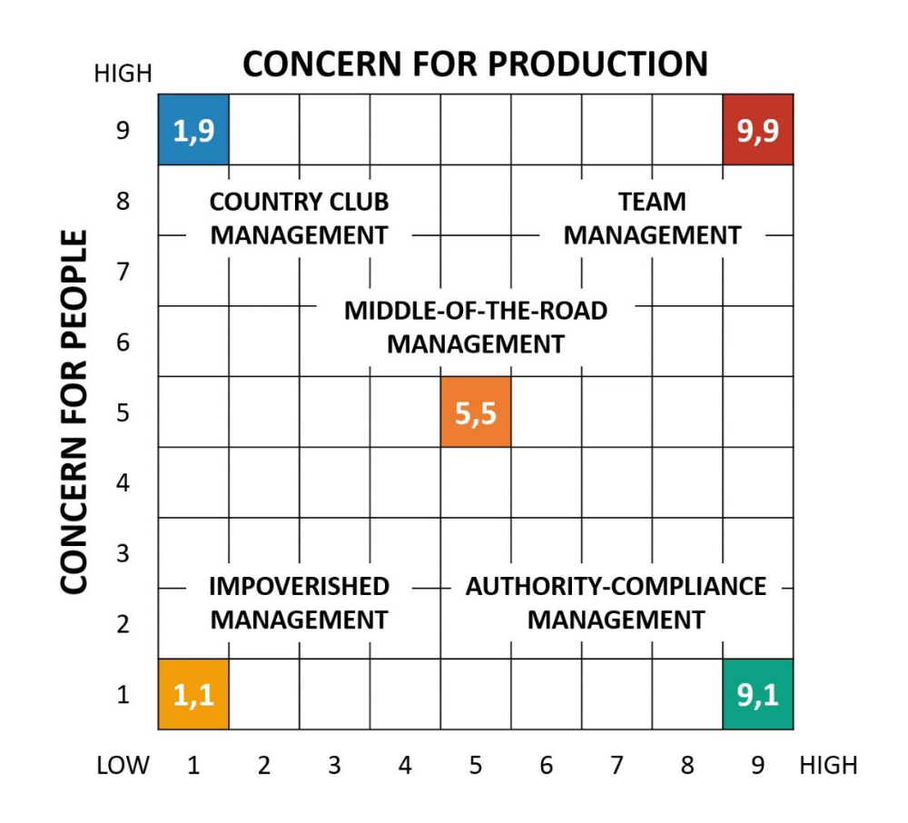
In the grid, concern for people (accommodating people's needs and giving them priority) was depicted on the y-axis of the grid, while concern for production (keeping tight schedules) was depicted on the x-axis. Each dimension ranged from low (1) to high (8), which resulted in 81 possible positions for a leader's style (Vidyakala, 2020).
Figure 1: Blake and Mouton Managerial Grid
Source: (Todăriţă, 2021)
The following is a list of the five types of leadership that are a result:
1. Country Club Management (1,9): It is a style of leadership in which the leader cares more about the social needs of the people in the group than the job at hand (Burke, 2021).
2. Authority-Compliance Management (9,1): In this type of leadership, the leader cares more about getting things done than how the members feel.
3. Impoverished Management (1,1): This is a style of leadership in which the leader tells people what to do and how to do it, but doesn't follow through on the plans they make.
4. Middle-of-the-road management (5,5): This is a style of leadership in which the leader is not too ambitious about the workers or their productivity.
5. Team management (9,9): This is a style of leadership in which the leader cares a lot about the needs of the workers and how well they do their jobs.
Craig Poole has been in charge of the Doubletree by Hilton for a long time. Craig has more than 20 years of experience in the hospitality business and is known as a leader who gets things done.
Concern for production: Craig Poole is highly intent on achieving his objectives and providing his clients with services of the highest possible calibre. In the hospitality industry, all of these factors—revenue, occupancy rates and guest satisfaction ratings—play a vital role in determining how successful a business is (Adele Gutman Milne, 2021). He is particularly focused on boosting all three of these metrics at the hotel. For instance, he has implemented a number of measures to minimise expenses and bring in more money, such as cutting the costs of staff, increasing room rates and letting people know about the hotel's offerings. This has allowed him to bring in more money while also reducing costs. In addition to that, he has invested money in the training and development of his personnel in order to increase their abilities as well as their performance (Adair, 2018). This might result in more work being completed and satisfied clients.
Concern for people: Craig Poole is more concerned with the amount of work that his employees are able to produce rather than how their needs and feelings are being met. He has worked to improve their performance by providing them with training and development, but as a manager, he has been condemned for being too demanding and rigid (Gadomska-Lila, 2019). Despite this, he has sought to train and develop them. He is notorious for holding his employees to extremely high standards and imposing severe punishments on them whenever they fail to reach those requirements or act inappropriately. This can make the workplace uncomfortable and tense, which can have a negative impact on both the workers' morale and their level of job satisfaction.
According to the Blake and Mouton Managerial Grid, Craig Poole belongs in the task management quadrant because he fits the description of someone who prioritises getting things done at the price of caring for his staff. Because of this, the grid places him in this quadrant (Roy, 2019). This demonstrates that Craig Poole is extremely focused on achieving his goals and improving the operation of his hotel, but it also suggests that he may not pay as much attention to the wants and sentiments of his employees. This strategy may be successful in the short term since it may result in increased output and more income; however, in the long run, it may cause employees to become worn out and force them to leave the company.
The Blake and Mouton Managerial Grid has received criticism for oversimplifying the complexity of leadership styles and for disregarding the situational circumstances that might impact a manager's behaviour (Ross and Dixon, 2016). Both of these issues have been cited as reasons for the criticism. A manager's leadership style may differ depending on the circumstances, the culture of the company, the requirements and goals of the staff, the manager's own personality and experience, and so on. As a result, the Blake and Mouton Managerial Grid ought not to be utilised on its own to evaluate Craig Poole's management capabilities; rather, it ought to serve as a jumping off point for an investigation that is more in-depth.
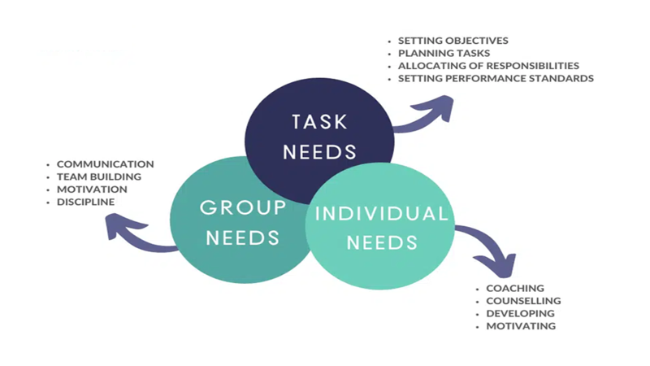
Action-centered leadership is a form of business leadership model that managers, supervisors, and other employees in leadership positions can use to more effectively manage and lead teams. It enables managers to apply different principles to various work situations and to respond more effectively to changing information. The method can help business leaders manage any situation more effectively. Action-oriented leadership involves getting things done, managing people and monitoring groups and teams (Zuhroh, Damayanti and Purnomo, 2017). This form of leadership can assist an organization in boosting morale, increasing productivity, and achieving greater success. Leaders and managers can utilize action-centered leadership in situations where they must manage multiple tasks, individual responsibilities, and team responsibilities. This model can help them accomplish their daily responsibilities more efficiently and swiftly.
Figure 2: Adair’s model of Action Centred Leadership (ACL)
Source: Rickards, 2015
Achieving the Task: The fact that Craig Poole is dedicated to increasing the hotel's income, occupancy rates and levels of happiness among customers demonstrates that he is capable of achieving the aim. He has made measures to minimize costs and raise income, such as cutting the costs of labor, increasing room rates and letting guests know about the hotel's attractions. These are only some of the initiatives he has taken. In addition to that, he has invested money in the training and development of his personnel in order to increase their abilities as well as their performance (Charles, 2016). This might result in more work being completed and satisfied clients.
According to Adair's ACL model, in order for a strong leader to successfully complete a task, they must first establish extremely clear goals, then develop plans and methods, monitor progress and then make any required adjustments (Low and Low, 2018). Craig Poole appears to be adhering to these principles, as evidenced by the fact that he has developed strategies and procedures with the intention of achieving the objectives he has set regarding revenue, occupancy and guest happiness. In addition, he performs frequent checks on the progress being made and makes any necessary adjustments to ensure that the hotel is on the right track to achieve its objectives.
Building and Maintaining the Team: People have expressed their skepticism regarding Craig Poole's capacity to construct and maintain a cohesive team due to their perception of his leadership style as being overly stringent and demanding. He is known to have high standards for his employees and to be quite harsh with them if they make mistakes or don't do their tasks effectively (Cook, 2016). He has sought to improve the performance of his workers through training and development, but he is also known to have high standards for them. This can make the workplace uncomfortable and tense, which can have a negative impact on both the workers' morale and their level of job satisfaction.
According to Adair's ACL model, effective leaders must construct and maintain a team that is both motivated and capable of cooperating effectively. They accomplish this through defining everyone's duties and responsibilities, fostering open dialogue and trust, resolving issues and recognizing and rewarding those who perform well. It has been reported that Craig Poole does not care for or support his staff, so it is possible that he needs to concentrate on these aspects of his leadership. The establishment of and maintenance of a strong team is critical to the long-term success of the hotel since it has the potential to result in more contented workers, lower rates of employee turnover and increased levels of work (Morphet, 2015).
Developing the Individual: Since Craig Poole has been accused of not caring about or supporting his employees, it is difficult to evaluate how well he helps each person develop their potential because of this. He has invested money in the training and development of his employees, yet it is well known that he has a reputation for being tough with people when they make mistakes or don't perform their tasks correctly (Bouchon, Daya and Ragavan, 2016). People may find it more difficult to learn as a result of this.
According to Adair's ACL model, effective leaders must facilitate the growth and development of their followers by instructing, mentoring, providing feedback and providing support. Additionally, they need to provide opportunities for employees to develop both emotionally and professionally, as well as recognize and reward excellent performance (Rickards, 2015). It's possible that Craig Poole has to improve in these areas so that he can provide his staff with the knowledge and abilities they require to perform their jobs effectively and advance in their careers.
Craig Poole scores high on Adair's ACL model for getting things done but he may use some improvement in the areas of teamwork and self-development. He has been criticized for his demanding management style, which can make the workplace unpleasant and make it hard for the team to stay motivated, despite the fact that he has clear goals and has established plans and processes to achieve them (Gadomska-Lila, 2019). To ensure his staff has the knowledge and abilities to accomplish their tasks effectively, he may also need to provide them with greater guidance, mentoring and development opportunities. He can aid the hotel's long-term performance by strengthening these areas and developing a more steady and effective leadership style.

Conclusion
Using the Blake and Mouton Managerial Grid and Adair's Action Centred Leadership model, it can be concluded that Craig Poole is effective at accomplishing the work, but may need to improve in building and maintaining the team and growing the individual. Even though he has clear goals and has made plans and systems to reach them, he has been criticized for being a demanding and strict boss, which can hurt morale and job happiness among his workers. Craig Poole can help the hotel and its employees succeed in the long run by building a team that is motivated and works well together, giving teaching and mentoring to help employees grow and develop and working on his leadership style. This report gives a good framework for figuring out how effective leadership is and where it could be better.

References
Adair, J., 2018. Lessons in Leadership: 12 Key Concepts. Bloomsbury Publishing.
Adele Gutman Milne, C. (2021) Craig Poole, GM of the Year, shares a case study of hospitality leadership, culture, and profit., Adele Gutman. Available at: https://www.adelegutman.com/post/craig-poole-hotel-leadership-culture (Accessed: 13 May 2023).
Bouchon, F., Daya, P. and Ragavan, N.A., 2016. Hospitality Higher Education Talent Management Programme, STEP: A Stepping-Stone to Develop Future Hospitality Leaders. TEAM Journal of Hospitality and Tourism, 13(1), pp.41-53.
Burke, W.W., 2021. Blake, Robert R., and Jane S. Mouton: Concern for People and Production. The Palgrave Handbook of Organizational Change Thinkers, pp.213-222.
Charles, G., 2016. Leadership resilience: Lessons for leaders from the policing frontline. Routledge.
Cook, S., 2016. Leading the customer experience: inspirational service leadership. Routledge.
Gadomska-Lila, K., 2019. Impact of Generational Diversity on Leadership. Przedsiębiorczość i Zarządzanie, 20(6.3), pp.285-297.
Low, K.C.P. and Low, K.C.P., 2018. Leadership in Japan. Leading Successfully in Asia, pp.193-237.
Morphet, J., 2015. Applying Leadership and Management in Planning: theory and practice. Policy Press.
Rickards, T., 2015. Dilemmas of leadership. Routledge.
Ross, J. and Dixon, G., 2016. THEORETICAL RELATIONSHIP BETWEEN CHALEFF'S FOLLOWER BEHAVIORS AND BLAKE AND MOUTON'S MANAGERIAL GRID: A DISCUSSION. In Proceedings of the International Annual Conference of the American Society for Engineering Management. (pp. 1-10). American Society for Engineering Management (ASEM).
Roy, D., 2019. Managerial grid in macroeconomic perspective: An empirical study (2008–2017). Journal of Transnational Management, 24(3), pp.165-184.
Todăriţă, E.T., 2021. Leadership Style Determination according to Robert Blake and Jane Mouton’s Managerial Grid. In International conference KNOWLEDGE-BASED ORGANIZATION (Vol. 27, No. 1, pp. 241-246).
Vidyakala, K., 2020. A Conceptual Study on Managerial Grid Approach. Aut Aut Research Journal, 11, pp.117-122.
Zuhroh, D.F., Damayanti, N.A. and Purnomo, W., 2017. Action-Centered Leadership (ACL) Model pada Kinerja Program Imunisasi di PUSKESMAS Wilayah Sidoarjo. INFOKES (INFORMASI KESEHATAN), 9(1), pp.42-50.

