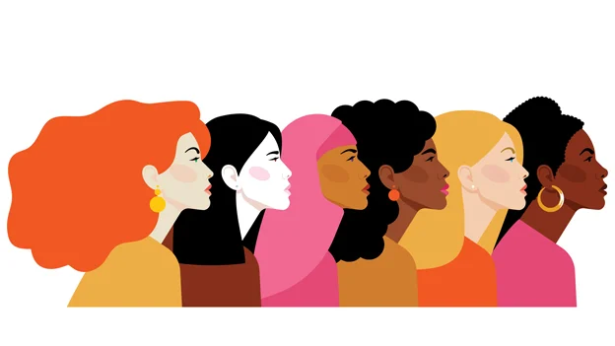  WOMEN’S EQUAL RIGHTS  How women’s equal rights have changed since the early 1990’s? | 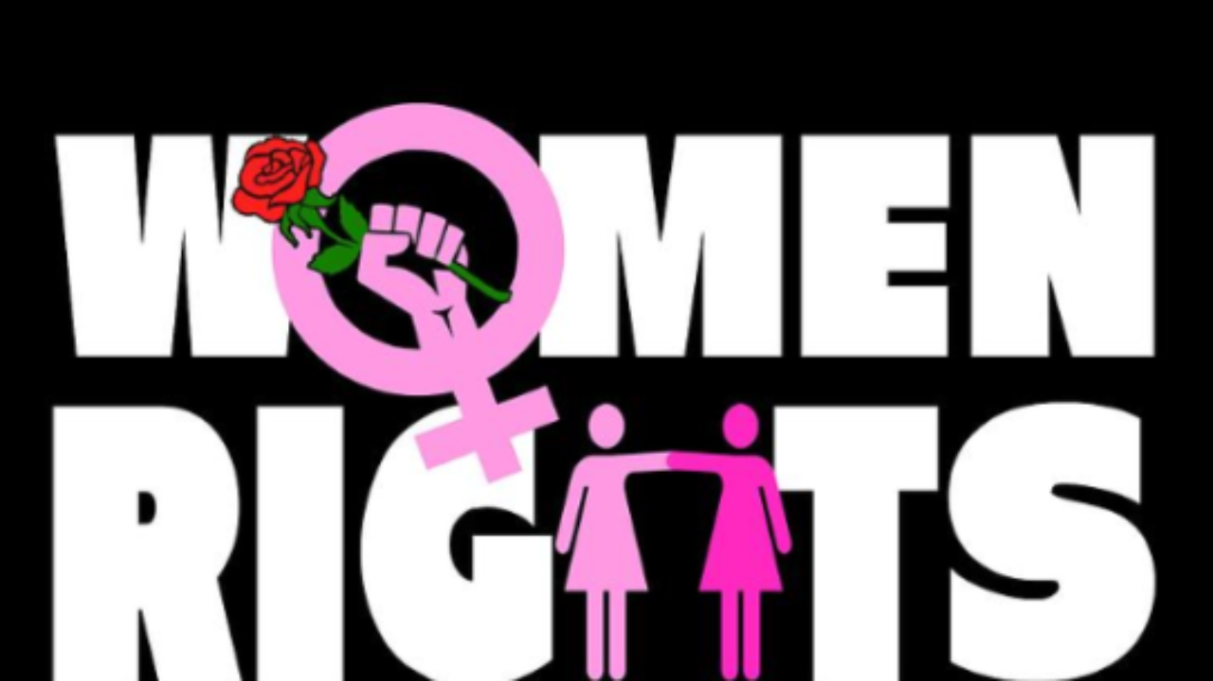  Sara John – Davies Business Inquiry & Research (BMSP5007) BA Business Management – Year 2

Introduction
This report presents the study of how women’s equal rights have changed since the early 1990’s? The reason the researcher has chosen to discuss this subject because they personally feel effected by this chosen topic as they work in a very heavy male dominated work environment. This was one of the main reasons that made the researcher want to make sure that they explored and investigated more into this topic of women’s rights. Before this research project the researcher had very limited knowledge on the topic and many lives have changed this being in the workplace, the new and old laws and also the social lives on women.
According to the Women for Women International charity who help women all over the world, the believe that ‘2020 was set to be a critical moment for women’s rights and gender equality, with an unprecedented number of political milestones, bringing much needed focus on bolder actions that challenge the status quo and deliver on commitments for all women.’ (Agenda for Action, 2020)In relation to the workplace, Sheryl Sandberg who is the COO and a member of the board of Facebook once said ‘ Next time you are about to call a little girl ‘Bossy’ say instead: she has executive leadership skills’ (Sheryl Sandburg, 2020)
During collecting the evidence for this report. The researcher decided that the best to do this was to conduct three 20-minute interviews. This being with 3 strong independent women and ask their views on how they feel women’s rights have changed since 1990’s? The second way to collect a broader collection of opinion was to collect a 10 question, questionnaire and send this out to staff at work, university students and also post the link to the survey on the researchers social media accounts.
Interviews – Qualitative
The first part of the report is going to be focussing on the three interviews which I conducted.
Participant A
Participant A – During the 20-minute interview with A the researcher found out a lot about A and how they have felt about Women’s rights and how it has all changed. At the beginning of the interview A said that she was just graduating from university, with a degree in Catering management. When participant A got a job being a manager in a hotel, she remembers very clearly that in the early 1990’s – all of the chefs would be men, all receptionists would be women, housekeeping would be girls, head waiters would be men, certain roles were very gender specific, but A only realised this once she had looked back on this time in her life, it all seemed very normal back then. A expressed how in her life in the 1990’s she left this role for a new job, but didn’t enjoy the new role so got her old job back and on her first shift back she as very annoyed by the gossip that she had slept her way back again. Which in those days was common, a woman only got in a high position or got her job back if she has sex with the boss. But this was not the case women who worked hard got certain positions, but it was sexist and jealousy from the other male members of staff. Hence why they would say that they slept to the top. From Catering then A moved into HR, to work in Debenhams at the age of 25. This was a very female dominated role as people call it the soft roles all of the people who worked here would be women. If you worked on the shop floor you would have to be a man to sell a suit, or a woman to sell lingerie. If you worked on a till you were female. This was just how it was; people were mainly pigeonholed into these roles even though they were all encouraged to go to university it was near impossible to get the job they went to university to get. It was very important for Unions to do their roles in the 90’s they were very big – everyone was encouraged to join the unions. A remembers when all of the new acts/laws came in,
- Equality Act 2010
- Human Rights act in 1998
- Disability Discrimination 1995.
A felt that when she has children everything changed. She felt that her husband turned into the caveman that went out to work and she was the mum who stayed at home and didn’t work even though she worked so hard for the job and the management level, when she had children people expected her to give up the jobs and just play mum. A felt that she feels strange now seeing it and looking back now, but she wasn’t unhappy in her role she just felt that whenever a new law came in every woman was excited as something good is changing for them. But it’s not until they look back now A realised how bad it was to work as a women manager. The last part that participant A touched on when discussing this is that she used to be slapped or pinched on the bum while she worked in the hospitality industry and that it was just accepted but she didn’t feel that this was wrong it was only when she moved out of London, she felt that she realised that this was not acceptable behaviour.
Participant B
Straight away into the interview after being asked the question about ‘How do you feel that Women’s equal rights have changed since the early 1990’s?’ B expressed that she felt that equal rights have changed for the better she doesn’t feel that anything is close to being completely equal, but she does feel that everything has improved since the 1990’s. B felt that when she was growing up through school in the 1990’s she felt that certain things such as girls don’t tend to continue with education their main roles will be finish education at 16. Go and find a husband who will be the bread winner and then from there the girl will cook, clean, shopping and eventually have children and be a mum. When B was graduating from university, she went into three very heavy male dominated work environment. All of three of these she entered as junior management level. She felt there was a lot of sexism in all of these workplaces and that she can count on two hands the number of women have been in these factory’s but also, they haven’t been a typical male role, all women have been in female admin and HR departments. Not really finance or on the shop floor. While entering the business world participant B has felt that they were discriminated against in the early years of being a junior manager as they feel that they were told that they needed to make tea/coffee for everyone and not just attend a meeting for the work meeting it was called being the mum of the group which is not good enough. Work environments should be purely independent on the tea level. B felt that when a relative of hers had a baby she felt that it was looked that the women would stay at home with the baby but in their modern way of life it believed that the man will stay at home and not work and the women will take some maternity but not the full time space. But then she will return to work when she feels well enough too. B believes that she when she has children is not going to take breaks from business/worklife she feels that her husband will have to step up and do a lot more housework and not thinking that B can do everything.

Participant C
Participant C took different approach to the interviews. They decided to take a more personal level to the interview as they have had less jobs than the other two participants.
When C was growing up it was very much that their Mother raised them and did all of the household chores as their Father was either working or in the pub. To the point which C didn’t really know who their Father was when she was younger. This is what she believed what Men did at the end of the working day men would just go to the pub, as there was many a day when C’s Mother had to take C’s Fathers dinner over to the pub as he was there that late after work. C didn’t have much of a relationship with her Father growing up as even on weekends he was either in the Bookies or the pub. But C’s Mother did have a little weekend job so she could go out and socialise while working their and to have some money of her own. C admitted that she didn’t really listen to her Mother, but when her Father was home that’s what mattered, and she always listened to him. When C took her boyfriend home who she wanted to buy a house within the near future, her Father was very much like oh no, you must get married first. C went to college to do Hair and Beauty – this was an all-female course there was no men there but only one male lecturer, but he did treat everyone equal. C didn’t feel threatened by any males. C went to work on at a sewing factory then, which was run by a female. One of the men working there run the cutting room so anytime they needed work they send C to him, as he had a crush on C. C used her sexuality and flirting to get work fast, In regard to pay here the women were on a lot lower pay than all of the men there. C then left here to have her first born, she ran the house, she then Then got a job with Celtic SMR and as C was going through a divorce this man run business was very flexible and happy for C to bring her son in. C expressed how she has never felt out of place there and has been the longest serving staff member there.
Trends
Two of the participants have been through very similar situations A and B, this being the workplace and the amount lack of women in management roles and also the amount of pay issues as well as the amount of lack of gender quality. The trend the researcher gives for these two recognitions. But, with participant C this was a more home-work life balance and what they have gone through as a woman has majority has been good the trend which I give this one is Personal Understanding.
Quantitative – Questionnaire
Quantitative data is data expressing a certain quantity, amount, or range. Usually, there are measurement units associated with the data. (OECD Glossary of Statistical Terms - Quantitative Data Definition, 2003) The researcher decided to do a questionnaire for this part of the report. They decided this because this was one of the best ways to be able to get the highest amount of reviews fast and efficiently but also get results from all different types of people and from all different age ranges so the researcher decided this was going to be perfect for making the change and noticing the difference in womens rights and how fast is has changed.

Questionnaire
The first question which the researcher has asked was;
How old are you?
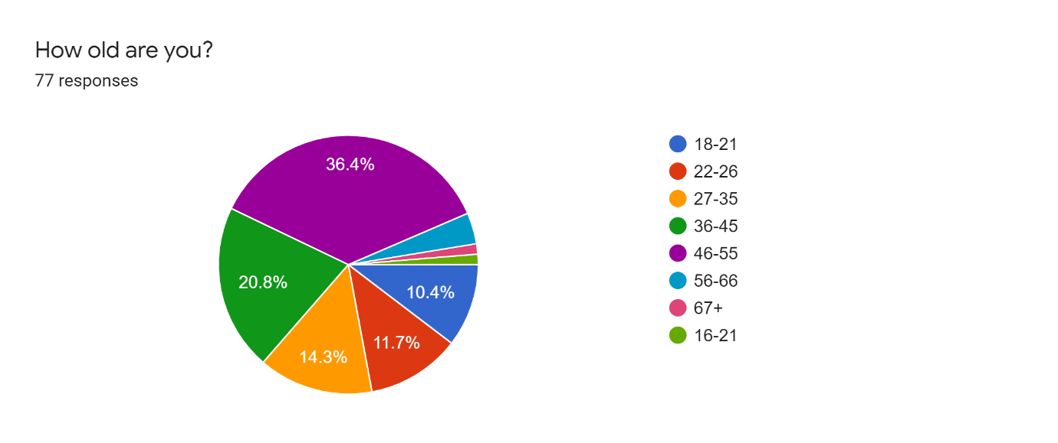
The researcher managed to have 77 responses and the fast majority of this was aged 46-55 this was then followed up by 36-45 and then all of the other age groups were massive close. The researcher feels that this is going to be big impact on the other questions results and what the ages would say and what women’s rights mean to them.

What is your Gender?
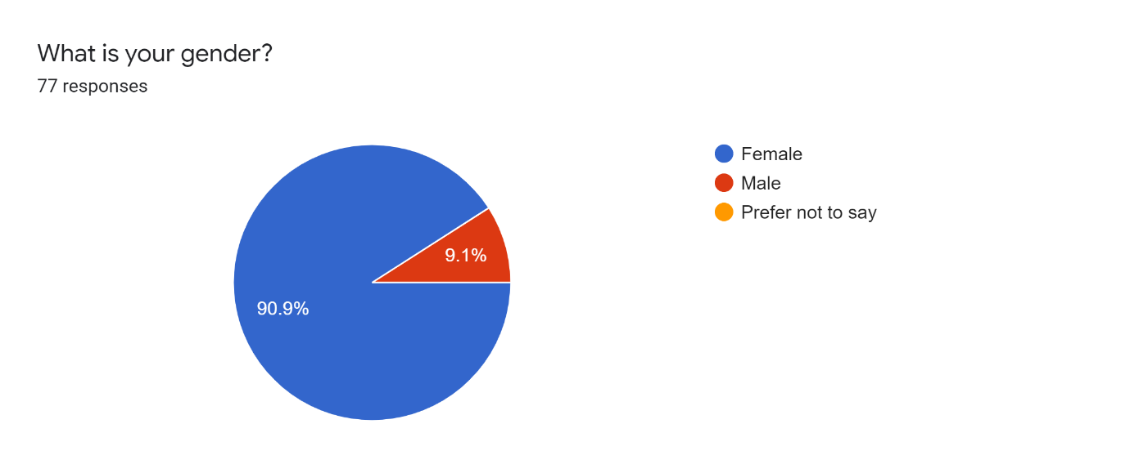
The researcher thought that this was a good question to ask because this way they were able to work out the majority of the genders that have answered the questionnaire. There was only 9.1% males that answered this questionnaire, so it means that this was a heavy female dominated questionnaire. Which is on one hand good because it means that it is possible to get truthful answers off women who made have experienced bad or good experiences on women’s rights.

Are you currently employed or a student?
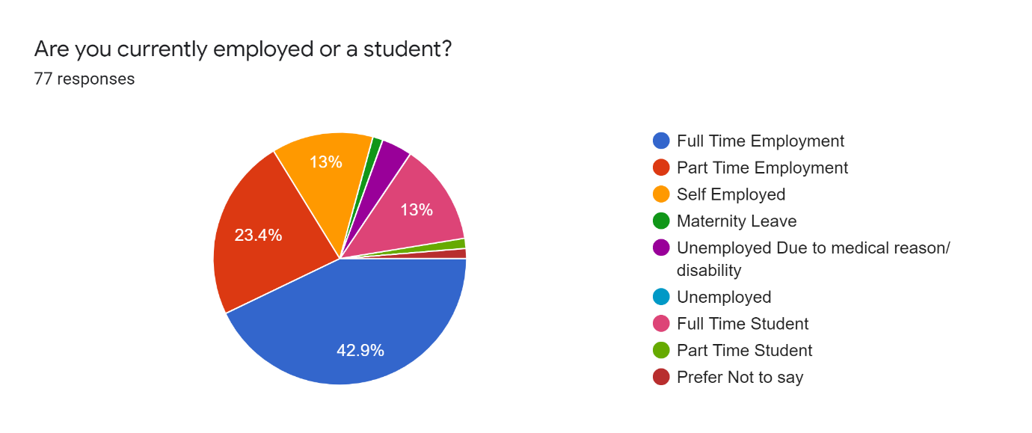

The third question which the researcher asked was the person answering either in;
- Full time employment
- Part time employment
- Self employed
- Maternity Leave
- Unemployed due to medical reason/disability
- Unemployed
- Full time student
- Part time student
- Prefer not to say.
The majority of the people who answered this questionnaire were full time employment or part time employment. This meant that the majority of people who answered this questionnaire are in the workplace so they may have experienced good or bad with women’s rights.

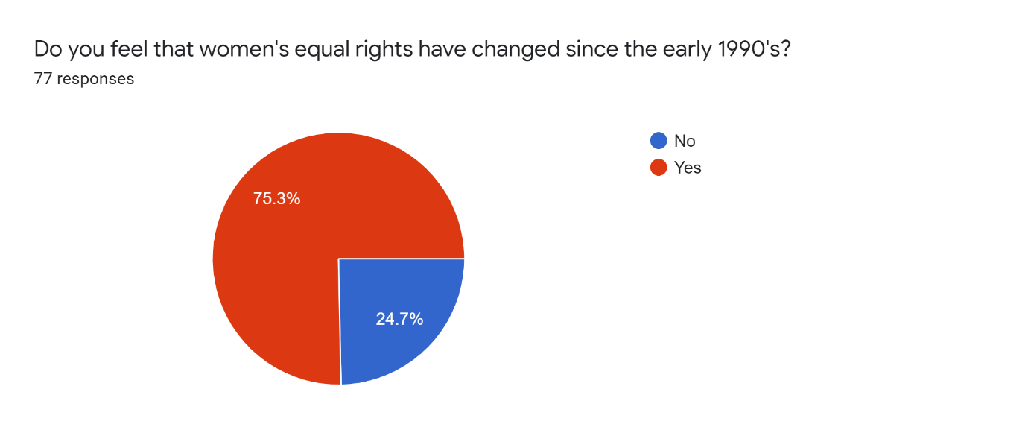
The fourth question which the researcher asked was ‘Do you feel that women’s equal rights have changed since the early 1990’s? The answer options to this is a simple yes or no…. the researcher decided to keep this question simple because this way the people answering the questions couldn’t get agitated or political about the topic.
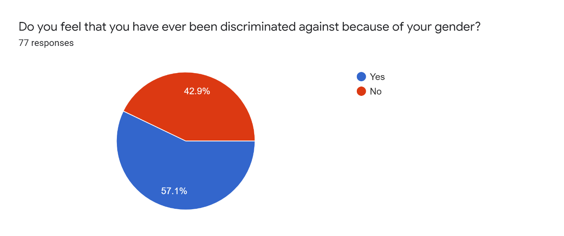
The next question which was asked in the questionnaire was ‘Do you feel that you have ever been discriminated against because of your gender?’ This was a very close one the answer Yes was 57.1% and the answer No was 42.9%. This is very close, so this means that some people mainly women have felt discriminated by their gender.
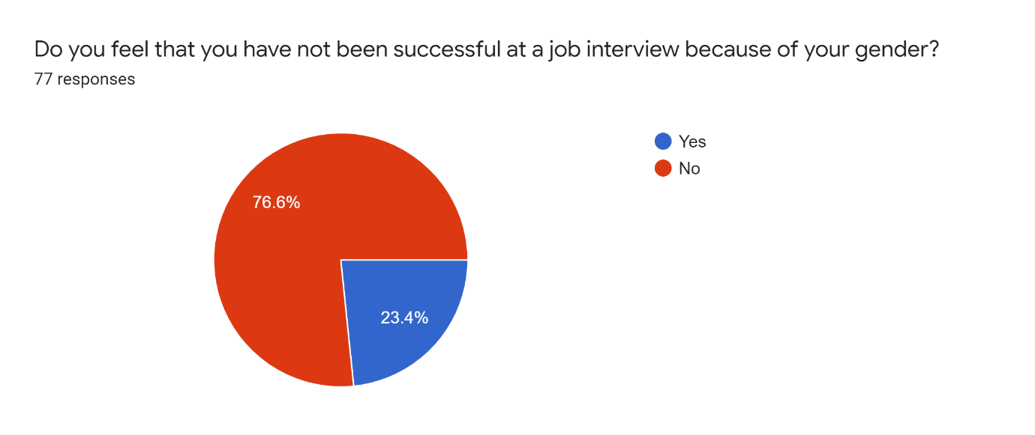
The next question which the researcher asked was ‘Do you feel that you have note been successful at a job interview because of your gender?’ This was not very spilt at all, 76.6% responded no. This is good news as this means many people out of the 77 people who answered don’t feel that they haven’t been successful at a job interview because of their gender which is good news.
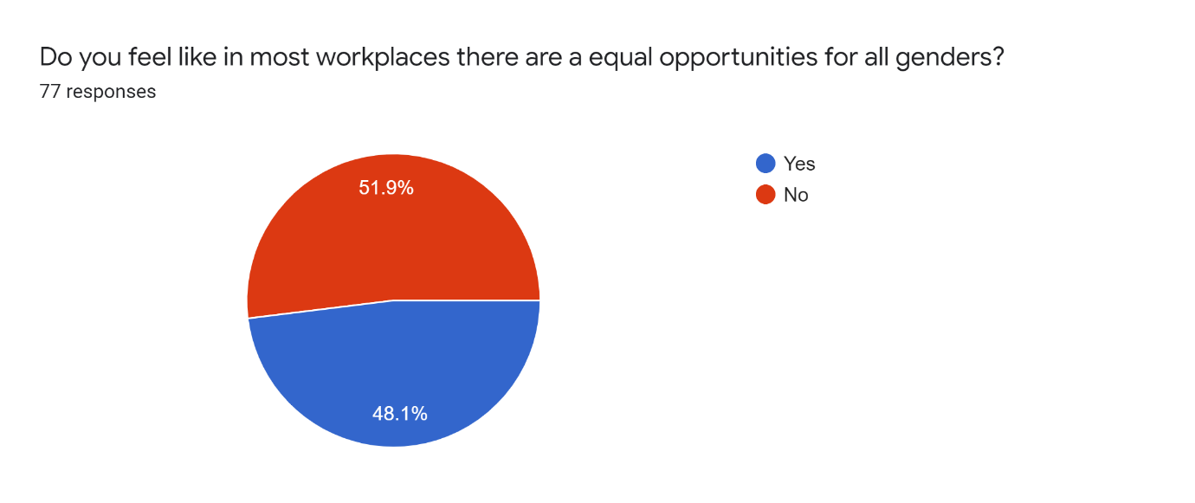
This question was ‘Do you feel like in most workplaces there are a equal opportunities for all genders?’ This was a very split question; this is a very hard one for the researcher to analysis as it is all down to personal opinion there is no business research because there is no writing to say what is equal and what isn’t equal.
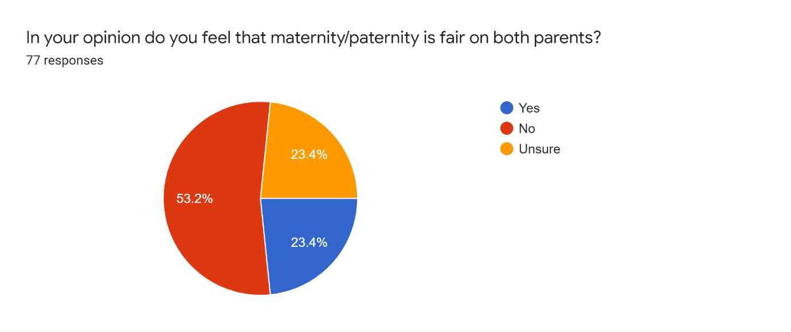
One of the last questions which the researcher asked in the questionnaire was – ‘In your opinion do you feel that maternity/paternity is fair on both parents?’ This was once again very spilt again, 53.2% said No, 23.4% Yes and 23.4% unsure…. This unsure could be because people are currently not aware of the amount of time of mums/dads get off. The No is definitely because of people who have had children and understand how unfair the system is on parents.
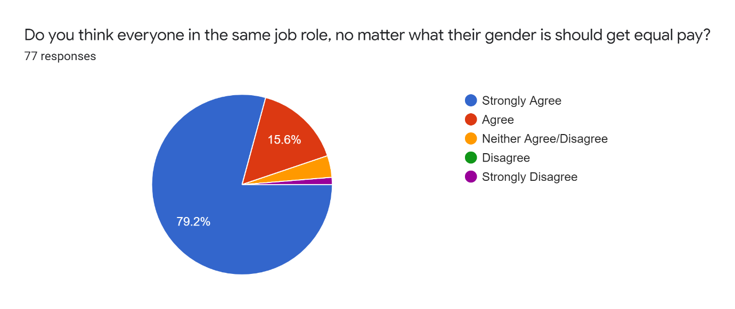
This question was ‘Do you think everyone in the same job role, no matter what their gender is should get equal pay?’ this is a very political one, but the majority of the answers to this was Strongly Agree. This is something which the researcher hoped they would see. But this is something which has going through parliament time and time again and this is normally just left up to the business.
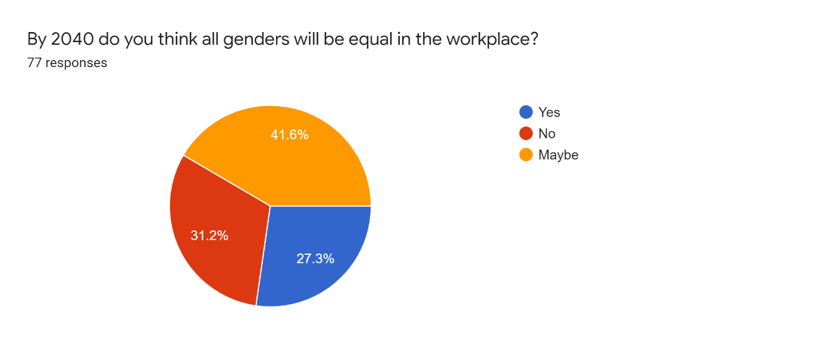
The last question of this questionnaire is ‘By 2040 do you think all genders will be equal in the workplace?’ This is something the researcher wanted to people to answer because they were interested in peoples thoughts on the future of women’s human rights. This was not as positive results as the researcher had hope with the majority of the answers being maybe or no.
Conclusion
To conclude this report the researcher hoped that they were going to learn a lot about the early 1990’s all the way through to 2020! This was what the researcher has learned, and she is very shocked on what she has learned on the interviews and how they are able to get away with what they did in the 1990’s. But, also from the questionnaire results the researcher now has hope that this is going to be getting better and better and more positive as 2040 does approach the researcher would love to prove people wrong and do as much as they can to move women’s rights in the correct way and not go back to sexism and discrimination

.

References
Agenda for Action. (2020, December). Women for Women International. https://womenforwomen.org.uk/agendaforaction
OECD Glossary of Statistical Terms—Quantitative data Definition. (2003, January 3). https://stats.oecd.org/glossary/detail.asp?ID=2219
Sheryl Sandburg. (2020, September). 13 quotes on women and work. World Economic Forum. https://www.weforum.org/agenda/2016/03/quotes-on-women-at-work/

