Programme: BSc Health and Social Care

Module Name: Introduction to Physiology
Module code: BMHP5023

Assignment Title: Component 1: Written Assignment (Case Study Report)
Student Name: Farah Deeba
Student Number: 2325143

Submitted To: Robert Nartowski
Date: 23rd February 2026

Table of Content
1. Introduction 3
2. Description 4
2.1. Maintenance of Healthy Blood Sugar Levels 4
2.1.1. Pancreas – Anatomic Structure 4
2.1.2. The Physiological Process of Glucose Homeostasis 4
2.2. Cell Metabolism – Energy Production 5
2.2.1. Transfer of Oxygen 5
2.2.2. Transfer of Glucose 5
2.2.3. Cell Respiration 5
2.3. Health Regulation for Patients with Type 2 Diabetes 6
2.3.1. CBG 6
2.3.2. Blood Plasma Venous Test and CGM 6
2.4. Lifestyle Habits to Improve Health 7
2.4.1. Diet 7
2.4.2. Exercise 7
2.4.3. Medication 7
3. Conclusion 8
4. References 8

Introduction
Diabetes is a disease that involves either lack of insulin production by pancreas in sufficient amounts or its ineffective utilisation by the body (WHO, 2024). Glucose is needed by the body for energy. It can be produced by the body and is also obtained through breaking down of food that humans intake (CDC, 2026). It is released into the bloodstream and upon an unusual increase of its content, body signals pancreas for release of the insulin. Insulin is a hormone responsible for regulating blood sugar and its absence or body’s resistance to it does not allow glucose to reach the cells (NIH, 2023). Consequently, high levels of glucose retain within the blood stream which may damage body organs including eyes, kidneys, nerves and the heart (CDC, 2026).
There are three most common types of diabetes including 1) Type 1 diabetes where the body does not produce insulin, 2) Type 2 diabetes where the pancreas does produce insulin however, the body resists its utilisation, and 3) Gestational diabetes which occurs during pregnancy usually goes away after the child birth (NIH, 2024). Type 1 diabetes result from an autoimmune condition (NHS, 2025) where the insulin producing cells within pancreas are destroyed by the immune system. Symptoms are not diagnosed in early stages, they appear suddenly, and may rapidly escalate to create severe condition. The autoimmune condition can be triggered by genetic or environmental factors (CDC, 2026). The risk factors for the type 2 and the gestational diabetes include increased weight, ethnicity, age, family history, and individual medical history of diabetic condition (NHS, 2025; NIH, 2024). Type 2 diabetes risk factors also include insufficient amount of physical activity, and smoking.
This report serves the purpose of creating awareness and providing medical assistance to diabetic patients concerning their condition and the lifestyle habits that influence their health. It acknowledges the need for the patients to comprehend their condition and implement personal health care strategies by tracking their blood sugar levels and addressing the areas of their lifestyle that may assist in management of condition. The report includes information concerning natural maintenance of healthy blood sugar levels within body, conversion of glucose and oxygen into energy during cell metabolism, significance and means for monitoring blood glucose levels for patients with type 2 diabetes, and healthy lifestyle habits recommended for regulating health condition.

Description

Maintenance of Healthy Blood Sugar Levels
The maintenance of blood sugar levels also termed as glucose homeostasis is crucial for meeting the bodily demands. It involves regulatory mechanisms of hormonal and neural nature and depends on the coordinated function of endocrine system, circulatory system, digestive system and cellular functions (Suh et al., 2007; Häusl et al., 2019). The central function within this process is the secretion of insulin and glucagon hormones from pancreas (Rodriguez-Diaz and Caicedo, 2014). these hormones prevent hyperglycaemia (raise in glucose levels) and hypoglycaemia (drops in glucose levels).

Pancreas – Anatomic Structure
Pancreas is found in upper abdomen and secrets digestive juices for exocrine functions in addition to the release of hormones for endocrine function. The endocrine cells within the pancreas are clustered together to form islets of Langerhans (structures within exocrine pancreatic tissue).
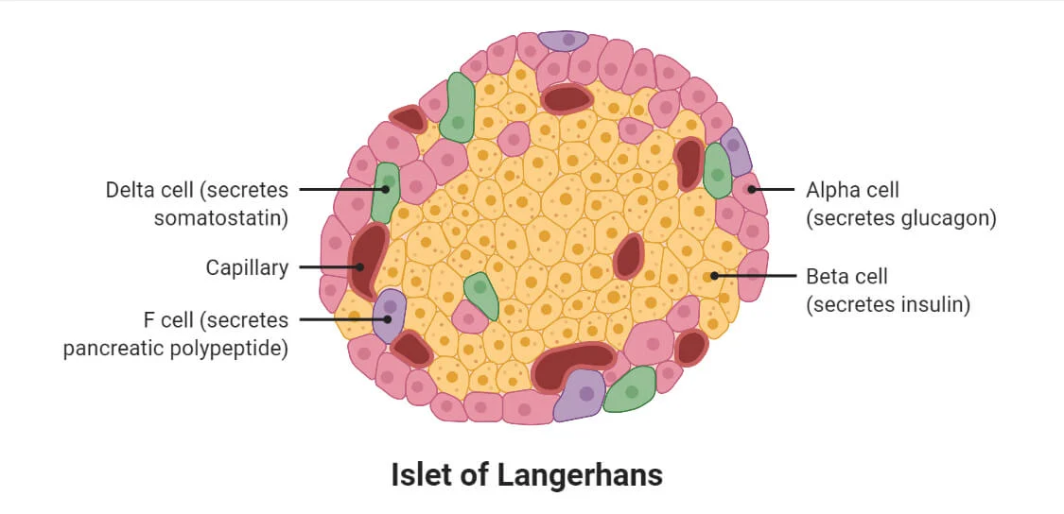
Figure 1. (Source: Sapkota, 2024)
The cluster contains five different types of cells among which the alpha and beta cells are responsible for releasing glucagon and insulin respectively (Röder et al., 2016).

The Physiological Process of Glucose Homeostasis
When the food rich in carbohydrates gets digested and broken down into glucose and absorbable monosaccharides, glucose is absorbed by the villi within the small intestine and is transferred to the capillaries and into the blood stream. It causes rise in blood sugar level which is detected by pancreas and the beta cells within it are stimulated to release insulin by exocytosis process (an active transport process enabling movement of glucose from the cytoplasm to outside) (Peate and Nair, 2011). Insulin regulates blood sugar by enabling glucose absorption within muscles and fat cells, stimulates glycogenesis (conversion of glucose into glycogen) by the liver, and reduces glucose production of the liver.
Similarly, the alpha cells within the pancreas are stimulated upon the falling of blood sugar levels which release glucagon by exocytosis (Wendt and Eliasson, 2022; Peate and Nair, 2011). Glucagon stimulates the process of glycogenolysis where glycogen within the liver is converted into glucose and released into the bloodstream. The flow of glucose between the bloodstream and the above-mentioned body organs (muscles and liver) occurs through exocytosis where insulin binds over the stated organs (Peate and Nair, 2011).

Cell Metabolism – Energy Production
At cellular level the nutrients are absorbed and converted into energy through cell metabolism which involves consumption of glucose and oxygen within the cells (Rigoulet et al., 2020).

Transfer of Oxygen
The supply of oxygen to the cells is facilitated by the respiratory and cardiovascular systems. The deoxygenated blood received by heart from the body through the superior and inferior into the right atrium and then to the right ventricle is pumped into the pulmonary artery that caries it into the lungs for release of carbon dioxide and acquirement of oxygen (Cleveland Clinic, 2024). The pulmonary veins from lungs carry the oxygenated blood from the lungs into the heart which is then pumped further into the body after successively passing through left atrium, left ventricle, and aorta (NHLBI, 2025).
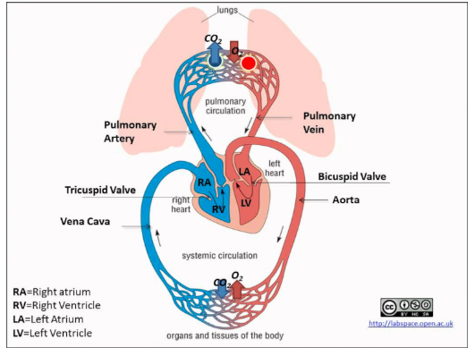
Figure 2. (Source: University of Guelph, 2026)
Majority (98%) of this oxygen is carried through haemoglobin which is a metalloprotein consisting of four subunits (Rhodes et al., 2022). Each of the units is composed of a heme group that contains iron and is attached to a globin polypeptide chain. Oxygen is carried by binding of one oxygen molecule with each of the subunits thereby enabling each haemoglobin to transport a quadruple of oxygen molecules. The remaining two percent of oxygen is present within the blood plasma which is a yellow-coloured liquid dissolved with nutrients. The oxygen from blood then diffuses into the tissues through passive means and the process is accelerated by lipids as argued by Pias (2021).

Transfer of Glucose
Meanwhile, Glucose (from the bloodstream) passes the hydrophobic cell membrane through facilitated diffusion by proteins since it cannot pass directly due to its molecular weight (Peate and Nair, 2011; Carbó and Rodríguez, 2023). This absorption is considerably increased by insulin (Nakrani et al., 2023). The absorbed glucose is either converted into energy (ATP) or stored as glycogen (a polysaccharide). This conversion is a part of cellular respiration.

Cell Respiration
Cell respiration occurs in Mitochondria and involves three stages namely glycolysis, citric acid cycle, and electron transport. Glycolysis may occur in the presence of oxygen (aerobic respiration) and in the absence of it (anaerobic respiration). The latter condition produces small amount of ATP only. Similarly, electron transport involves aerobic respiration where glucose is burned (combusted) in the presence of oxygen to release ATP carbon dioxide and water (Sturgeon, 2018).
C₆H₁₂O₆ + 6O₂ ATP + 6CO₂ + 6H₂O
Figure 3. (Source: Britannica, 2026)
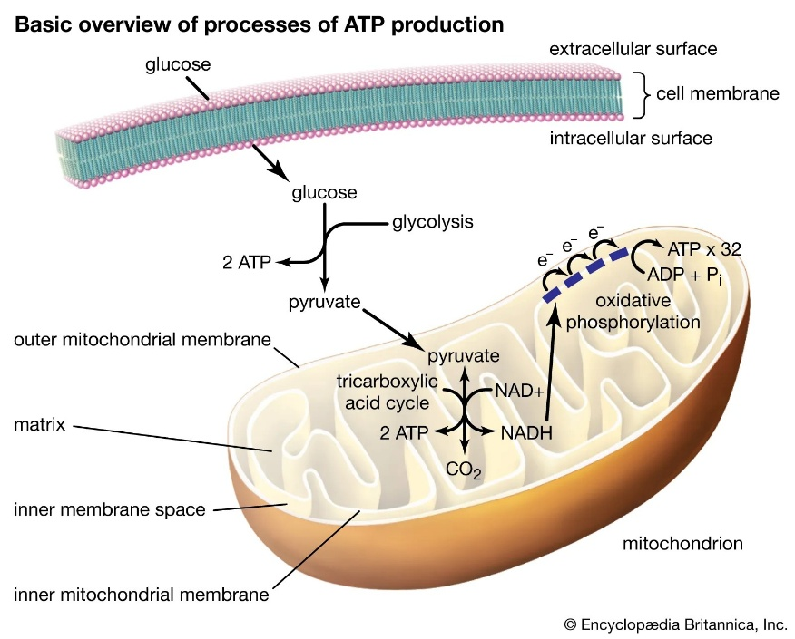
All the stages of cell respiration yield ATP production which is the energy needed for the body and tissues to function. More specifically, ATP is needed for muscle contractions, hormone producing synthesis, functions of cell membrane, mechanism of nerve impulse transfer, cell division, and molecular transportation across cell membranes (Nakrani et al., 2023).

Health Regulation for Patients with Type 2 Diabetes
Monitoring blood sugar enables the identification of fluctuating patterns of sugar levels within the bloodstream that occur due to diet, medications, exercise, and other pathological processes associated with body functions. It is crucial to monitor and manage blood sugar levels because unusual rise or drops may lead to acute and chronic health conditions that may be life-threatening (Mathew et al., 2023). The outcomes of monitoring blood glucose include improved glycaemic control, enhanced quality of life, and reduced hypoglycaemia (Pleus et al., 2022). The blood sugar tests can be conducted both within and outside of clinical lab spaces. The former methods include capillary blood glucose (CBG) and venous blood tests involving monitoring glucose levels in blood plasma while the latter monitoring method mainly involve CBG and can be conducted anywhere such as within homes (Mathew et al., 2023).

CBG
The current systems for monitoring blood sugar levels outside clinical facilities (and involve self-monitoring) involve an easy process of acquiring a small blood sample from capillary used for measuring sugar levels within the sample. This is the CBG method and is technology enabled facilitated through medical devices that give quick results within seconds of time (Pleus et al., 2022; Mathew et al., 2023). Modern devices are integrated with features such as those enabling connectivity, diabetes management tools, and digital diaries. These tools are mostly relevant for monitoring type 2 diabetes since the results have been found to be nearly accurate as professional in-lab monitoring methods (Pleus et al., 2022).

Blood Plasma Venous Test and CGM
The venous blood tests involve collecting blood plasma through venipuncture and testing the sample within the lab. There is also a continuous glucose monitoring (CGM) method which involves applying a hydro resistant sensor on either abdomen or the back of upper arm which is usually removed after 13-14 days and can be scanned to provide reading of glucose measurement over the duration. Through this method, blood sugar levels can be measured even during the sleep and is suitable for patients that require intensive insulin therapy (Mathew et al., 2023). However, a professional lab-based test is required for appropriate and most accurate diagnosis of the condition. Nevertheless, self-monitoring enables effective management by allowing the patients to comprehend their condition and maintain their health in accordance.

Lifestyle Habits to Improve Health
People with type 2 diabetes can control their health condition through maintaining a healthy lifestyle and it is necessary to manage blood sugar levels to prevent complications (Chen and Lin, 2025). Lifestyle habits for controlling blood sugar levels include abstaining from smoking, exercising on daily basis, maintaining a healthy diet, and maintaining body mass index between 18.5 kg/m², and 24.9 kg/m². Maintaining the stated lifestyle habits is significant for reducing the risk of chronic diseases which include diabetes, cardiovascular complications, and cancer. Furthermore, glycaemic control can be significantly regulated by stress management and good sleep quality maintenance. Lifestyle habits are beneficial for prevention of diabetes (thereby managing prediabetic conditions) and also for regulating health during the type 2 diabetes.

Diet
Studies find that taking plant-based diets and food that is low in carbohydrates, calories, and glycaemic index allow improvements in insulin sensitivity, beta-cell function, glycaemic control, and weight management (Papamichou et al., 2019; Lewgood et al., 2021; Papakonstantinou et al., 2022). Amerkamp et al. (2025) conducted a literature review by examining the outcomes of multiple studies investigating the influence of lifestyle habits such as diet and exercise upon outcomes for diabetic patients and discovered that low calorie diet combined with exercise significantly benefits the health conditions.

Exercise
Exercise is beneficial for managing body weight and blood glucose levels which also includes improvement in skeletal muscle since it plays a significant role on blood glucose regulation. Exercise also yields other multiple health benefits including enhanced blood circulation and reduced risks of heart issues and stroke (Reddy, 2018).

Medication
Proper medication is also a necessary precaution for preventing health complications within diabetic patients. Insulin and other medicines for diabetes assist in lowering blood glucose levels and need to be taken in doses as recommended by health specialists. Moreover, new medicines other than the ones prescribed must not be taken unless consulted with health professionals (Mayo Clinic Staff, 2024).

Conclusion
This report has provided significant details related to the condition of diabetes, natural blood sugar control within a healthy body, the role of glucose and oxygen within cell metabolism, importance and methods for blood sugar monitoring for patients with type 2 diabetes, and lifestyle habits that may improve their condition. It has been discussed that diabetes occurs due to lack of insulin production (type 1) within the body or due to insulin resistance (type 2) which results in excessive glucose levels within bloodstream which damages the body organs. Under normal conditions beta cells within pancreas are triggered to release insulin within the body to reduce glucose within blood by enabling its absorption into muscles and fat cells. The insulin also stimulates glycogenesis within liver and reduces its glucose production.
Body cells utilise glucose with oxygen for cell respiration, a process of cell metabolism, the end product of which is the ATP (energy needed by the body to function). For patients having type 2 diabetes monitoring their blood sugar levels is crucial for maintaining health and preventing complications. Different methods for measuring blood sugar exist that can be performed inside or outside the clinical facilities and include tests such as CBG, blood plasma venous tests, and CGM. Furthermore, maintaining healthy lifestyle (through habits such as maintaining diet, exercising, and taking proper medications) helps regulate diabetic condition by preventing it at the pre-diabetic stage and regulating health during diabetic conditions thereby avoiding further complications.

References
Amerkamp, J., Benli, S., Isenmann, E. and Brinkmann, C., (2025). ‘Optimizing the lifestyle of patients with type 2 diabetes mellitus-Systematic review on the effects of combined diet-and-exercise interventions’. Nutrition, Metabolism and Cardiovascular Diseases, 35(5), p.103746. Available at: https://doi.org/10.1016/j.numecd.2024.09.016
Britannica, (2026). ‘Cellular Respiration.’ Available at: https://www.britannica.com/science/cellular-respiration [Accessed: 22 February 2026]
Carbó, R. and Rodríguez, E., (2023). ‘Relevance of sugar transport across the cell membrane’. International journal of molecular sciences, 24(7), p.6085. Available at: https://doi.org/10.3390/ijms24076085
CDC, (2026). Diabetes Basics. Available at: https://www.cdc.gov/diabetes/about/index.html [Accessed: 18 February 2026]
Chen, W.J. and Lin, L.Y., (2025). The impact of diabetes self-care, healthy lifestyle, social support, and demographic variables on outcomes HbA1c in patients with type 2 diabetes. Clinical medicine insights: Endocrinology and Diabetes, 18, p.11795514251331907. Available at: https://doi.org/10.1177/11795514251331907
Cleveland Clinic, (2024). Circulatory System. Available at: https://my.clevelandclinic.org/health/body/circulatory-and-cardiovascular-system [Accessed: 20 February 2026]
Häusl, A.S., Balsevich, G., Gassen, N.C. and Schmidt, M.V., (2019). Focus on FKBP51: A molecular link between stress and metabolic disorders. Molecular metabolism, 29, pp.170-181. Available at: https://doi.org/10.1016/j.molmet.2019.09.003
Lewgood, J., Oliveira, B., Korzepa, M., Forbes, S.C., Little, J.P., Breen, L., Bailie, R. and Candow, D.G., (2021). Efficacy of dietary and supplementation interventions for individuals with type 2 diabetes. Nutrients, 13(7), p.2378. Available at: https://doi.org/10.3390/nu13072378
Mathew, T.K., Zubair, M. and Tadi, P., (2023). Blood glucose monitoring. In: StatPearls. StatPearls Publishing, Treasure Island (FL)
Mayo Clinic Staff, (2024). Diabetes management: How lifestyle, daily routine affect blood sugar. Available at: https://www.mayoclinic.org/diseases-conditions/diabetes/in-depth/diabetes-management/art-20047963 [Accessed: 21 February 2026]
Nakrani, M.N., Wineland, R.H. and Anjum, F., (2023). Physiology, glucose metabolism. Available at: https://www.ncbi.nlm.nih.gov/books/NBK560599/ [Accessed: 19 February 2026]
NHLBI, (2025). How the Heart Works, How Blood Flows through the Heart. Available at: https://www.nhlbi.nih.gov/health/heart/blood-flow [Accessed: 19 February 2026]
NHS, (2025). Diabetes. Available at: https://www.nhs.uk/conditions/diabetes/ [Accessed: 19 February 2026]
NIH, (2024). Symptoms & Causes of Diabetes. Available at: https://www.niddk.nih.gov/health-information/diabetes/overview/symptoms-causes [Accessed: 19 February 2026]
Papakonstantinou, E., Oikonomou, C., Nychas, G. and Dimitriadis, G.D., (2022). Effects of diet, lifestyle, chrononutrition and alternative dietary interventions on postprandial glycemia and insulin resistance. Nutrients, 14(4), p.823. Available at: https://doi.org/10.3390/nu14040823
Papamichou, D., Panagiotakos, D.B. and Itsiopoulos, C., (2019). Dietary patterns and management of type 2 diabetes: A systematic review of randomised clinical trials. Nutrition, Metabolism and Cardiovascular Diseases, 29(6), pp.531-543. Available at: https://doi.org/10.1016/j.numecd.2019.02.004
Peate, I. and Nair, M. eds., (2011). Fundamentals of anatomy and physiology for student nurses. John Wiley & Sons.,
Pias, S.C., (2021). Pathways of oxygen diffusion in cells and tissues: hydrophobic channeling via networked lipids. Oxygen Transport to Tissue XLI, pp.183-190. Available at: https://doi.org/10.1007/978-3-030-34461-0_23
Pleus, S., Freckmann, G., Schauer, S., Heinemann, L., Ziegler, R., Ji, L., Mohan, V., Calliari, L.E. and Hinzmann, R., (2022). Self-monitoring of blood glucose as an integral part in the management of people with type 2 diabetes mellitus. Diabetes Therapy, 13(5), pp.829-846. Available at https://doi.org/10.1007/s13300-022-01254-8
Reddy, P.H., (2018). Can diabetes be controlled by lifestyle activities?. Current research in diabetes & obesity journal, 1(4), p.555568. Available at https://pmc.ncbi.nlm.nih.gov/articles/PMC5792082/
Rhodes, C.E., Denault, D. and Varacallo, M.A., (2022). Physiology, oxygen transport. In StatPearls [Internet]. StatPearls Publishing. Available at https://www.ncbi.nlm.nih.gov/sites/books/NBK538336/
Rigoulet, M., Bouchez, C.L., Paumard, P., Ransac, S., Cuvellier, S., Duvezin-Caubet, S., Mazat, J.P. and Devin, A., (2020). Cell energy metabolism: An update. Biochimica et Biophysica Acta (BBA)-Bioenergetics, 1861(11), p.148276. Available at https://doi.org/10.1016/j.bbabio.2020.148276
Röder, P.V., Wu, B., Liu, Y. and Han, W., (2016). Pancreatic regulation of glucose homeostasis. Experimental & molecular medicine, 48(3), pp.e219-e219. Available at https://doi.org/10.1038/emm.2016.6
Rodriguez-Diaz, R. and Caicedo, A., (2014). Neural control of the endocrine pancreas. Best practice & research Clinical endocrinology & metabolism, 28(5), pp.745-756. Available at https://doi.org/10.1016/j.beem.2014.05.002
Sapkota, A., (2024). Pancreas: Structure, Hormones, Functions & Disorders. Available at https://microbenotes.com/pancreas/ [Accessed: 22 February 2026]
Sturgeon, D., (2018). Introduction to Anatomy and Physiology for Healthcare Students, Taylor & Francis Group, ProQuest Ebook Central, Available at http://ebookcentral.proquest.com/lib/trinity/detail.action?docID=5323306.
Suh, S.H., Paik, I.Y. and Jacobs, K.A., (2007). ‘Regulation of blood glucose homeostasis during prolonged exercise’. Molecules and cells, 23(3), pp.272-279. Available at https://doi.org/10.1016/S1016-8478(23)10717-5
University of Guelph, (2026). ‘Heart Anatomy & Circulatory System Blood Flow’ Available at https://books.lib.uoguelph.ca/human-physiology/chapter/anatomy-of-heart/ [Accessed: 22 February 2026]
Wendt, A. and Eliasson, L., (2022). ‘Pancreatic alpha cells and glucagon secretion: Novel functions and targets in glucose homeostasis’. Current opinion in pharmacology, 63, p.102199. Available at https://doi.org/10.1016/j.coph.2022.102199
WHO, (2024). Diabetes. Available at https://www.who.int/news-room/fact-sheets/detail/diabetes [Accessed: 21 February 2026]

