SARANNN ELIZABETH STRANGE
1701763
12/01/21

QUESTION 4

4a)
Weights are used to let the neurons learn from examples. Each connection is weighted.
- Inhibitory connections have negative weights (WK2)
- Excitatory connections have positive weights (WK1 & WK3)
- Activity of the neuron is calculated with the weighted summation of the input signals
The weights can be changed through gradient decent this allows the neuron to learn.

4b) i
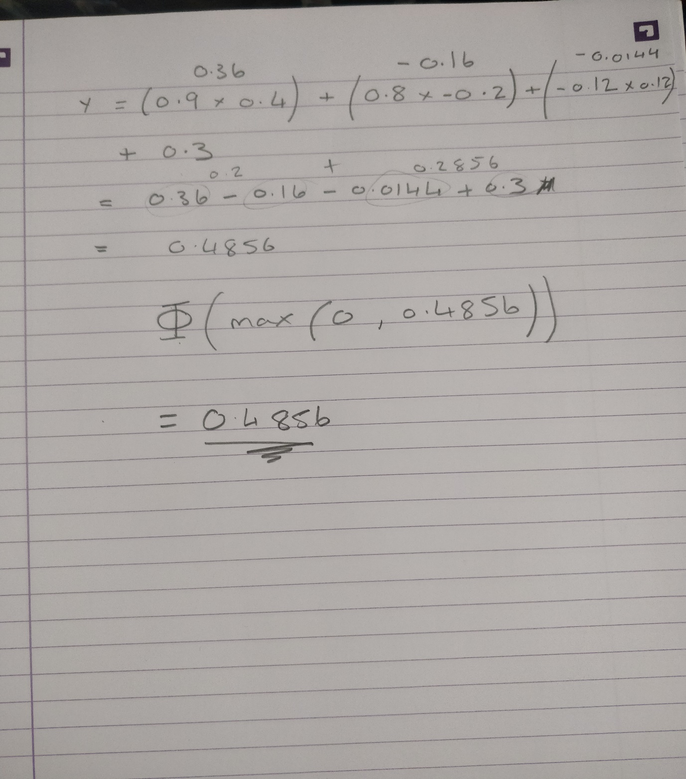

4b) ii



4c)
The dying relus problem is caused by the gradient being 0 when x is less than 0 this is bad because there is no gradient to learn from through gradient decent

This can be fixed by adding a slight gradient when x is less than 0

