Adriana Roman
Student ID: 2007914

Data Analysis and Visualisation (ACCB4002)
Assessment 2

Lecturer: Dr Anupam Mazumdar
UWTSD (London)

Table of contents:

Introduction………………………………………………….…………………….……………………3
Description of Dataset…………………………….………………………………….…………………4
Visualisation……………………………………………………………………………………………4
Appropriate hypotheses for the analysis………………………….…………………………………….4
Selection of T-test: two-sample assuming unequal variances…...………….………………………….5
Techniques and process for presenting the results………………………….………….……………….5
Testing of hypotheses to various significance level…………………………………….………………5
Outliners in the Dataset…………………………………………………………………………………8
Factors Affecting Hypotheses Testing………………………………………………………………….9
Results…………………………………………………………………………………………………10
Conclusion…………………………………………………………………………………………….11
References………………………………………………….………………………………………….12

List of Figures:

Figure 1. Ages Visualisation……………………………………….………………………….…..…...4
Figure 2. Test for p=0.10………………………………………………………………………………6
Figure 3. Test for p=0.01………………………………………………………………………………6
Figure 4. Test for p=0.02………………………………………………………………………………7

Introduction
In this report the data found in BBC (UK) News, it identified that the infection rate of Covid-19 is varied in White and BAME patients. 50 people from both the community are selected and find out the truthfulness of the data using T-test: two-sample assuming unequal variances hypothesis test and find out the truthfulness.
The factors affecting the power of hypothesis is been discussed, various factors which can affect the hypothesis, the methods and recommendation for better hypothesis testing is being discussed. Outliers in the Datasets is being discussed and their impacts as well, removing outliers can help in better hypothesis testing. The ways by which the Outliers can be detected and this can be removed from the Datasets.

Description of Dataset
The dataset generated after it is found that the infection rate of Covid-19 is varied between the White people and BAME, which is black and minority ethnic people of United Kingdom. The dataset contains the 50 people from both the community. The age of the people of which the data is analysed varied between 20 to 50. The data of these people is analysed to find out the truthfulness. Hypotheses are made on several data set. To test the hypothesis which was made that the infection rate in both kind of citizens is varying, the test for the hypothesis is done on both types.

Visualization

Figure 1. Ages Visualization
This is the visualization of the ages of the patients of white and BAME community, the ages can be seen varying. The line chart shows the variations of the age in which it can be seen that for various ages, there would be different rate of infection.

Appropriate hypotheses for the analysis
T-test: two-sample assuming unequal variances:
This hypothesis is done on the two independent populations which are having unequal variances. The test can be of two types first one is two-tailed and another one is one-tailed. So, the dataset is having two populations from different communities and the operation is performed on them for finding out the truthfulness of the data. The variances of both the data are different so this test is performed (Theopeneducator n.d.).

Selection of T-test: two-sample assuming unequal variances
This test is selected because the variance of both White and BAME is different and having the sample which is distributed. To compare the age of both the people to find out the infection ratio and their truthfulness of the findings and this is suited appropriate for the analysis. The data analysis is done in MS-excel where the sample data is selected for both the sample and then calculate the hypothesis and tested.

Techniques and process for presenting the result

Null Hypotheses (Ho): It is a type of hypotheses which shows that there is no difference between the characteristics of two categories (Hayes 2020).
Mean1- mean2 = 0
The Alternative Hypotheses (HA): States that the characteristics of a population do not match with another one. If the sample contains some evidence, the null hypotheses can be rejected, and an alternative hypotheses can be favoured (Frost n.d.).
Mean1-mean2 is not equal to zero.
So, from taking the ideas from these hypotheses, they can be calculated.

Testing of hypotheses to various significance level
a) p = 0.10
The hypotheses is calculated for various significance levels, as the significance level is 0.10.
1) If the t Stat is smaller than the critical two-tail, and here it is true as the -0.2988 is smaller than 1.6605, the value of null hypotheses cannot be rejected, and that data must support the null hypotheses, and infections in white and BAME patients can be considered equal.
2) From the result which is got from the table, if the p-value of two-tail is larger than the value of alpha, we cannot reject the null hypotheses. In this case, alpha is p = 0.10, so that it can be seen that 0.765 is larger than 0.10 so it can be understood that the null hypotheses cannot be rejected (Zaiontz n.d.).
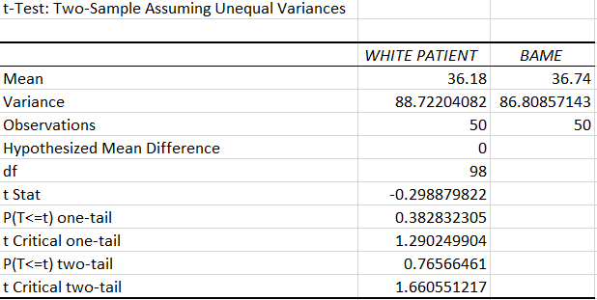
Figure 2. Test for p = 0.10
b) p = 0.01
For the value of significance 0.01, the same technique is used. The value which is evaluated from the result is:
1) That if the t stat value is smaller than the critical two-tail value, the null hypotheses cannot be rejected. Here the value of t stat is -0.2988 which is smaller than the two-tail value which is 2.626 so that the null hypotheses cannot be rejected and the null hypotheses is performed.
2) It is seen that if the p two-tail value is larger than the value of the significance, the null value cannot be rejected. Here the p two-tail value which is 0.765 which is greater than the value of alpha which is 0.10, then the null hypotheses cannot be rejected (Zaiontz n.d.).
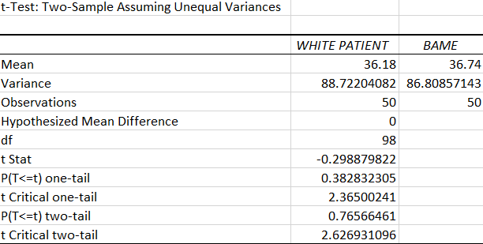
Figure 3. Test for p = 0.01

c) p = 0.02
For the significance value p = 0.02, the two-sample assuming unequal variances is done, where the ages of the white patient and BAME people are compared. It is found after the hypotheses that:
1) If the value of t stat is less than the value of t critical two-tail value, then the null hypotheses cannot be rejected. So, from the result, it can be observed that -0.2988 is less than 2.365 so the null hypothesis is not avoided.
2) Also, it is also stated that, if the value of the probability of two-tail is greater than the significance value, from the observations it is seen that the 0.765 is greater than 0.02 then it can be seen that null hypotheses will not be rejected (Zaiontz n.d.).
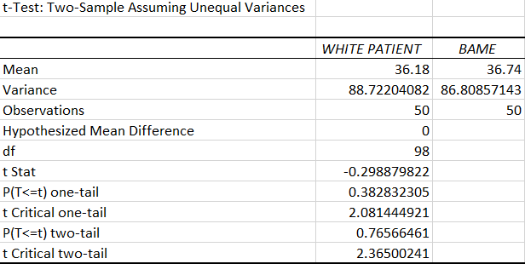
Figure 4 Test for p = 0.02
(Sakai 2018)

Outliers in the Dataset

Outliers and their impact:
It is the data value which is very different from other value, either it is too high or too low. They are also some unusual or different value in the Dataset. They interrupt the test and leads to unsatisfied findings. They can lead to unsignificant results if the value of statistical analyses differs in mean and the standard deviation. It should be done before performing any test.

In the test which is being done, t-test there is no outliers as all the values are under 20-50 and no unusual value, the mean and the standard deviation are also of significant changes, they don’t have any high difference between the means and the standard deviations. So, the presence of outliers is already detected and found no outliers.

If in case any outliers found they can be dealt with some methods:

1.Sorting the Data: Data can be sorted to find out the outliers in the given Set of the Data. The Ascending and Descending order of the Dataset will give the exceptionally low or high values of the Data.

2. Make graphs of the Given Data: The graph like scatter plots, histogram or boxplots can easily highlight the Data which is different and puts it in the different location.

3. Calculating the Z-score: Calculation of Z-score can identify the unusualness of the Data in the normal distribution of the Data. Z score of any observation can be calculated by taking the raw measurement and subtracting the mean from that value and dividing it by the standard deviation. The Z-score would be high for the higher values and low for lower values and the outlier can be identified.

4. Using the hypotheses test: This test was been used in this report for testing the variation of infection rates in between BAME and WHITE patients. If the p-value is less than the significance values, then it can be seen that the null values are rejected and conclude that there is a value which is Outlier. In our case p-value is greater than the significance value that means there is no Outlier (Frost n.d.).

Factors Affecting Hypotheses Testing

They are affected by these factors:
- Size of the sample (n): The power of the test will be greater if the sample size will be larger, for smaller sample the value and trend of the data is not that known. There must be big size of the sample. In the case which is been analysed there is only 50 samples which is less and the test is not that effective because the less data cannot clarify the trend and pattern the particular dataset is following and that results in bad hypotheses testing and the null values are not rejected for the further in the testing process.

- Level of Significance: This means that as lower the significance value, the power of the significance will be low. So, for lower values the acceptance region becomes bigger and then there will be less probability of rejecting the null hypotheses. If the values are false and hypotheses is false, even then the null hypotheses will be hard to reject for lower values of significance.

- True value parameter: It tells that if the difference between true value of the parameter and the specified value in the null hypotheses, there will be more power in the hypotheses testing. The true value is being compared with the null values. This should be maximized for better testing of the power of hypotheses testing (StatTrek n.d.).

Results
From the three observations, it can be seen that both cases of t-stat and probability are tested and they have given the results that, the null hypothesis cannot be rejected. So, as a result, it can be found that the values of infection in both the communities in between various age groups, cannot be considered equal, the hypothesis which was made earlier that the infection rate is varying from the data it can be shown that that was right and based on the null hypotheses, it can be assumed that the rate of infection in both the communities is varying and this proves the perception made earlier right which can be shown by the null hypotheses.
There is no outlier detected as all values related to the age is in between 20-50, only thing which can affect the hypotheses test is the size of the Dataset.
The result shows the truthfulness is there in each significance level and better for the highest significance level p=0.10.

Conclusion
The T-test: two sample assuming unequal variances is made on the data of BAME and White patients of United Kingdom in order to find out the infection rate whether it is varying or not, for various significance values it was calculated and observed that the null hypotheses cannot be rejected and the infection rate for both the community is varying.
It can be concluded that for better hypotheses testing there must be large Data regarding the population and they must be tested for high significance value, so that the analysis should be efficient and true.

References
- Frost, J. n.d. Alternative Hypothesis. Statisticsbyjim, [online], Available at: https://statisticsbyjim.com/glossary/alternative-hypothesis/. [Accessed on 11 December 2020]
- Frost, J. n.d. 5 ways to find outliers in your data. Statisticsbyjim, [online], Available at: https://statisticsbyjim.com/basics/outliers/. [Accessed on 19 December 2020]
- Hayes, A. 2020. Null Hypothesis. Investopedia, [online], Available at: https://www.investopedia.com/terms/n/null_hypothesis.asp. [Accessed on 11 December 2020]
- Sakai, T., 2018. t-Tests. In Laboratory Experiments in Information Retrieval (pp. 27-41). Springer, Singapore.
- StatTrek. N.d. Power of Hypothesis test. Stattrek, [online], Available at: https://stattrek.com/hypothesis-test/power-of-test.aspx. [Accessed on 19 December 2020]
- Theopeneducator. N.d. Two sample T-test unequal variance. Theopeneducator, [online], Available at: https://www.theopeneducator.com/doe/hypothesis-Testing-Inferential-Statistics-Analysis-of-Variance-ANOVA/Two-Sample-T-Test-Unequal-Variance. [Accessed on 11 December 2020]
- Zaiontz, C. n.d. Real statistics using excel. Real-statistics, [online], Available at: https://www.real-statistics.com/students-t-distribution/two-sample-t-test-uequal-variances/. [Accessed on 11 December 2020]

