

Van Diemen Formula Ford Assembly, Motion Simulation & Push Rod FEA Analysis.

John Michael Hughes
P146322
BEng Motorsport Engineering: Year 3
Advanced Computational Methods: CAE & FEA
M6X00408
Andrew Harrison
05/05/2019

Contents
List of Figures, Graphs & Tables 2
1.0.0 Introduction 4
1.1.0 Aims 4
2.0.0 Methodology & Analysis 5
2.1.0 Model Assembly 6
2.1.1 Equations 8
2.1.2 Materials 8
2.2.0 Motion Simulation 9
2.2.1 Motion Analysis 11
2.3.0 Push Rod FEA Analysis & Modification 11
2.3.1 Push Rod (Initial Geometry) 11
2.3.2 Push Rod (Iteration 4) 12
3.0.0 Conclusion 14
4.0.0 References 15
5.0.0 Appendix 17
5.1.0 Push Rod Iterations 17

List of Figures, Graphs & Tables
Figure 1 - 1996 Van Diemen Formula Ford Chassis 4
Figure 2 - Formula Ford CAD Assembly 6
Figure 3 - Mechanical Mate (Hinge Mate) 7
Figure 4 - Angle Limit Mate 7
Figure 5 - Master Dimension Equation Relationship 8
Figure 6 - Diameter Dimension Relationship 8
Figure 7 - Serrated "Road" Section 9
Figure 8 - Damper & Spring Components 10
Figure 9 - Formula Ford Assembly Mass Properties 10
Figure 10 - Reaction Force on the Lower Push Rod Joint 11
Figure 11 – Push Rod Displacement Contours (Left) & Stress Contours (Right) 11
Figure 12 - Push Rod (Evolution 4) Displacement Contours (Left) & Stress Contours (Right) 12
Figure 13 - Inner & Outer Dimensions (mm) (Initial Design - Left, Iteration 4 - Right) 13
Figure 14 - Cut Plane of Push Rod (Evolution 4) 13
Figure 15 - Push Rod Iteration 4 Ribbing 14
Figure 16 - Push Rod Iteration 1 19
Figure 17 - Push Rod Iteration 2 19
Figure 18 - Push Rod Iteration 3 19

Graph 1 - Mass & Displacement per Push Rod Iteration 17
Graph 2 - Stress & Strain per Push Rod Iteration 17
Graph 3 - Safety Factor per Push Rod Iteration 18

Table 1 - Push Rod Iteration Figures 17

1.0.0 Introduction
The Formula Ford race series consists of minimalistic design cars to reduce part costs and allow affordable racing. As a race car navigates a circuit, numerous components are subjected to forces produced from lateral, longitudinal and vertical forces, therefore it is essential that the intended parts are designed to be suitable for the intended purpose. Present day design techniques involve the extensive use of CAE and FEA modelling to thoroughly analyse new components and to reduce costs in the manufacturing of prototype configurations (Colsoul, et al., 2012), thus reducing costs for such racing series as Formula Ford.
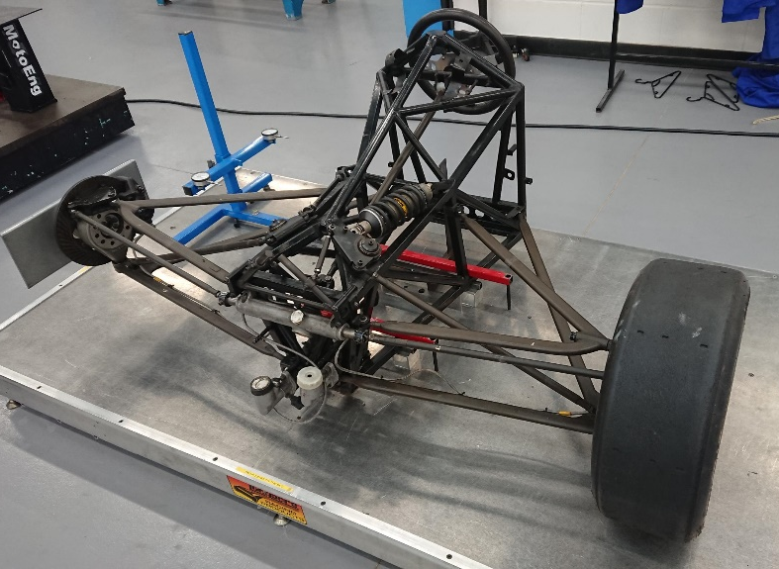
Figure 1 - 1996 Van Diemen Formula Ford Chassis
The components of interest comprise of a 1996 Van Diemen Formula Ford Chassis and its associated front suspension geometry. Many forces are transmitted through the suspension geometry to allow the car to maintain its traction and thus grip, however due to such forces, the components are liable to failures, therefore thorough FEA analysis needs to be conducted to predict the applied stresses that the components will be subjected to, so that safety factors are maintained.
For the purposes of this case, each individual component shall be created using Solidworks CAD software and assembled to produce a fully motion simulated model. A selected part shall then be subjected to FEA analysis based on the calculated loads predicted within the motion simulation process.

1.1.0 Aims
This investigation involves the creation of a Van Diemen chassis and front suspension CAD models. A full model shall then be assembled comprising the use of correct mechanical mates within Solidworks.
Once the assembly has been produced, motion analysis on the entire model will be completed, generating forces that the suspension will be subjected to.
Using these generated forces, an FEA study can be completed on a selected component. Once an initial FEA case has been completed, the results shall then be studied, and potential design improvements made to the selected part.
CAE and FEA areas of interest include:
- Model assembly
- Motion production
- Stress
- Strain
- Displacement
With each area being discussed, a concise design case can be performed and critically analysed.

2.0.0 Methodology & Analysis
The creation of the Formula Ford model was completed in Solidworks CAD software. Each component constructed individually.
The components include:
- Chassis
- Upper and lower wishbones
- Wheel upright
- Stub axle
- Wheel hub
- Steering rack case
- Steering rack
- Push rod
- Track rod
- Wheel
- Tyre
- Spherical bearings
- Anti-roll bar spades
- Drop links
- Bell crank
- Damper
- Spacers
Nuts and bolts used were selected from the Solidworks library.

2.1.0 Model Assembly
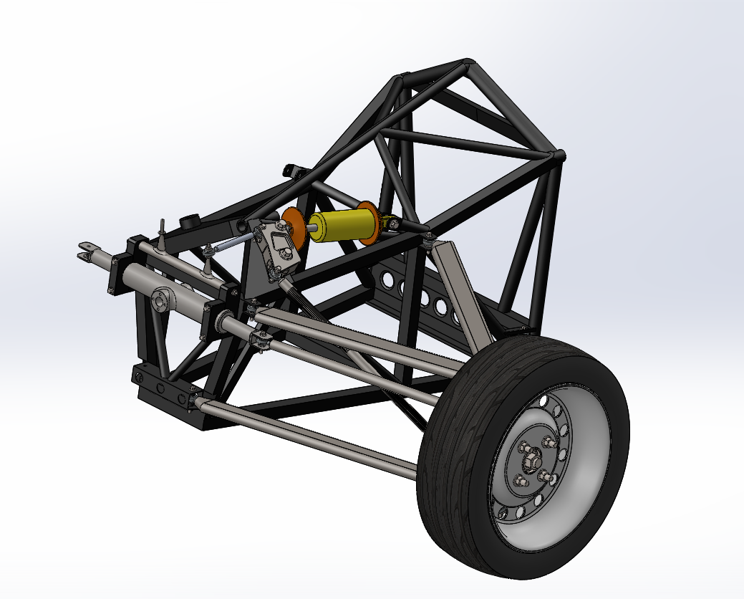
Figure 2 - Formula Ford CAD Assembly
Many parts created for manufacture often consist of numerous individual components assembled together with established constraints to allow proper manoeuvrability. This allows further dynamic studies to be performed to give the proper resultant operational values. This provides the operator with a greater understanding of how the created model will perform in certain situations, and analysis of critical parts can be produced. Greater understanding of a developing model holds the potential to provide better project planning, reduced costs and allows superior manufacturing processes. (Franciosa, et al., 2013)
Figure 2 displays the created Formula Ford assembly for use within this investigation. When creating an assembly, thought has to be given to future analysis of the created model. This means extra consideration has to be offered when constraining components within the assembly. If the model is over constrained, this could reduce the needed tolerances and diminish the overall operation parameters of the assembly, which will then alter downstream analysis results. (goengineer.com, 2008)
The current assembly involves the use of component mates and limiting factors. Mates create relationships between separate parts and define the degrees of freedom available. If a body were floating in space, it would have six degrees of freedom, three rotational and three translational (Chang, 2009). If the created mates over constrain the assembly, the allowable degrees of freedom reduce too far, thus creating redundancies within the mates. (http://help.solidworks.com, 2019)

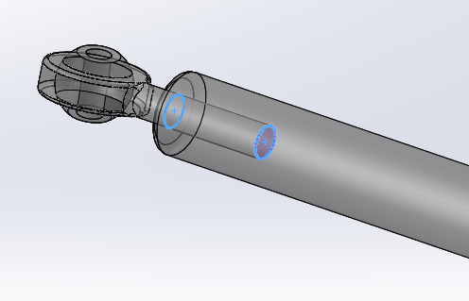
Figure 3 - Mechanical Mate (Hinge Mate)
As well as providing proper component constraining, the correct mate needs to be used within the assembly itself. The above figure shows a spherical bearing joint mated to a push rod using a mechanical mate, known as a hinge mate. A hinge mate provides one degree of rotational freedom. The same effect can be created by using a standard single concentric mate along with a face coincident mate, however, the use of a mechanical mate provides the operating syntax with further information, allowing it to recognise that only one degree of freedom is allowed for the selected components.
Due to the nature of the assembly model, the majority of the relationships between components required the use of a hinge mate to allow rotation, however a number of lock relationships were provided. Locking components removes all degrees of freedom, which was utilised within the steering geometry as this was not a necessity when commencing the motion analysis.
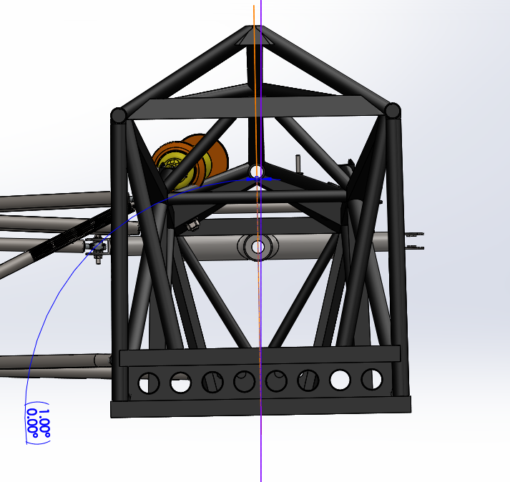
Figure 4 - Angle Limit Mate
A limitation mate was used to allow a maximum of 1° of body roll. As Figure 4 illustrates, the angle limit was set between the central vertical plane of the chassis geometry and a vertical plane created within the assembly.

2.1.1 Equations
The use of equations allow the derivation of numerous values by only changing a single variable (www.lynda.com, 2014). A simple use of this could be to control dimensional relations between created features within a geometry. The operation of equations permits the economic use of the CAD package, saving time and the need to search through endless sketch entities.
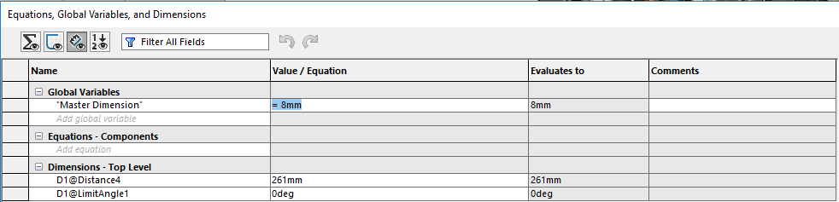
Figure 5 - Master Dimension Equation Relationship
The model in this case utilised a Global Variable equation within the relationship between the suspension component ends and the shank of the spherical bearing (Figure 5). For example, this would mean that if the diameter of the hole located at each end of the push rod were to be increased, the diameter of the spherical bearing shank would also increase by the same value. This would then provide a constant relation between both components without the need for them to be edited individually. Figure 6 displays the generated diameter dimension relationship with the ∑.
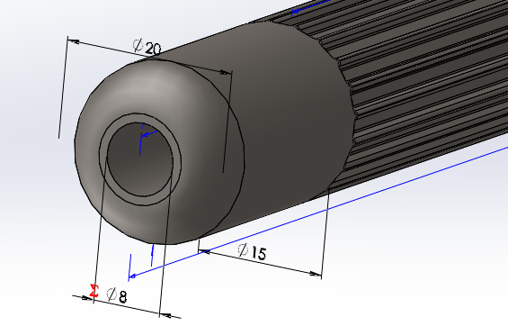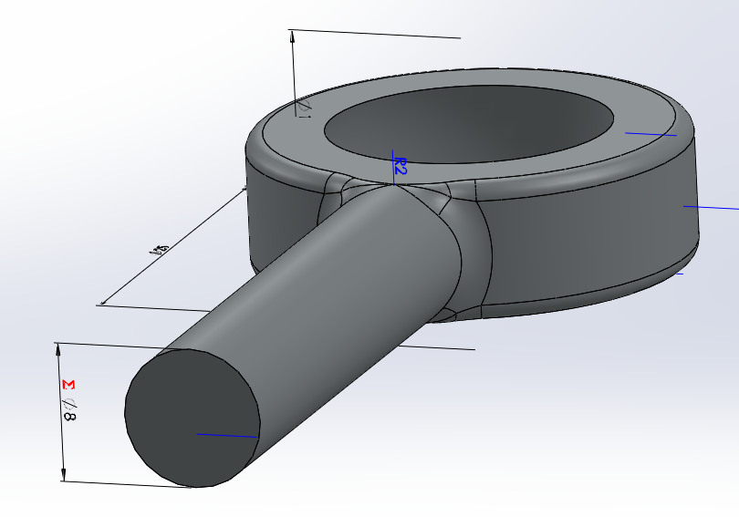
Figure 6 - Diameter Dimension Relationship

2.1.2 Materials
Materials had to be selected for the individual parts. The Solidworks materials library includes the property characteristics of each contained material. Due to this, mass properties of individual components are available, and thus sprung and unsprung mass can be accurately represented within the simulation process.
For example, within the Formula Ford regulations, the chassis must be manufactured using tubular steel (Formula Ford Kent, 2017). The most common grade of Steel used for this purpose is 4340 (Elleray, 2013), therefore these properties were assigned to the chassis geometry.

2.2.0 Motion Simulation
Once the assembly has been created and the correct component constraints applied, a motion simulation can be conducted.
For the sake of computational time, only half of the front suspension geometry was assembled.
The idea of motion simulation is that the user provides values to required characteristics on which the simulation model shall be based upon (Brach , 2009). For this case, a “road” section was created that provided a number of vertical serrations, which would simulate uneven track conditions or even a circuit curb as displayed in the figure below.
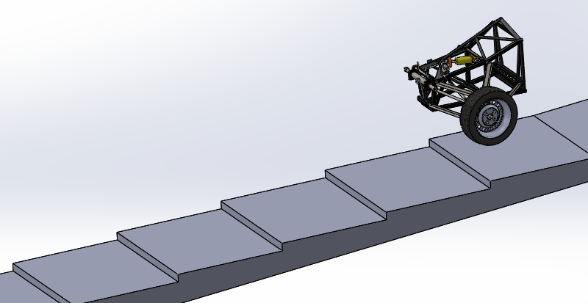
Figure 7 - Serrated "Road" Section
A liner motor was applied to the Formula Ford assembly, providing it a direction in the – X axis and also a velocity of 3m/s.
A contact mate was generated between the tyre and the road surface. Within this mate, certain contact characteristics can be applied, such as a coefficient of friction, or even the nature of surfaces that are contacting. Creating this constraint allows the tyre to remain upon the surface of the road, without it, the syntax would not recognise that two surfaces are interacting with each other, and the serrations would be ignored.
(Salaani, et al., 2006) suggests that an average friction coefficient for a tyre in dry conditions is between 0.5 and 1, therefore a coefficient of 0.7 was used, however, this value is an estimation based on generic figures as the actual characteristics of the tyre are unknown. This should have little effect on the vertical loadings induced by the suspension geometry and as no lateral acceleration is applied, only longitudinal forces are affected.
In most cases, motion simulation is used to generate a virtual dynamic phenomenon of a potential “real world” scenario, therefore, environmental characteristics also need to be applied. For the purposes of simplicity, this only involved the creation of a downward acceleration in the form of gravity (9.81m/s²).
As the basic premise of this simulation is to analyse the forces acting upon a component within the suspension geometry, so damper and spring features would need to be used. This is because when the car encounters the uneven road surface, it is the spring that absorbs the forces produced from the uneven surface and the damper reacts against them (Harris, 2019). This then generates opposing forces which need to be created for an accurate simulation.
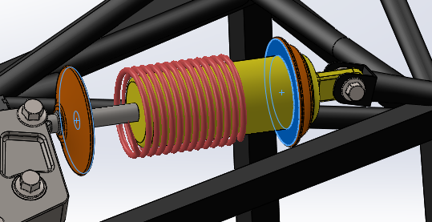
Figure 8 - Damper & Spring Components
A virtual spring component was assigned between both spring hats mounted on the damper body. A spring rate of 70N/mm was given as this figure is an actual representation of the real spring. A damping constant of 10N/(mm/s) was used between the damper rod end face and the bottom of the damper body. However, this value is an approximation and was adjusted purely based on the oscillations produced from the spring.
To accurately calculate the damping constant, a damper dynamometer could have been employed to evaluate the force produced per velocity assigned. From this, further evaluations could be made on the sprung mass damping to denote whether the car is critically damped or under damped. This would then allow comparisons of the sprung mass produced in the simulation model and the sprung mass of the real car. (Kasprzak, 2014)
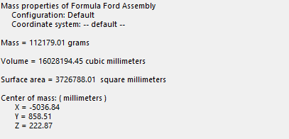
Figure 9 - Formula Ford Assembly Mass Properties
As can be seen in Figure 9, the total mass of the assembly equates to 112.17Kg. The minimum weight allowed for a Formula Ford car is 498Kg (with driver) (www.formulafordbc.com, 2019), concluding that with an assumption of a 40% forward bias of mass (without driver – assuming a weight of 75Kg), a total corner mass of 84.6Kg was calculated for a real car. This differs by 27.57Kg with the mass of the assembly, however, without creating an entire model assembly, it is unknown whether the two masses would become more comparable. This fact could have an impact on the forces calculated within the motion simulation, thus the FEA results could be skewed.

2.2.1 Motion Analysis
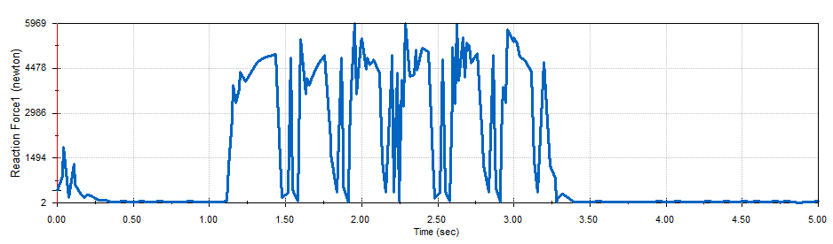
Figure 10 - Reaction Force on the Lower Push Rod Joint
Figure 10 displays the reaction forces generated in the lower joint of the push rod. It can be clearly seen that the trace follows the vertical wheel travel across each of the bumps on the road surface. A peak force of 5969N was produced on the push rod.
A force of 1100.38N was calculated for the car when static, so the reaction force equates to 5.4 times the static force when travelling at a velocity of 3m/s.

2.3.0 Push Rod FEA Analysis & Modification
With a completed motion simulation, the software has the ability to analyse dynamic loadings on selected components within a time step period. The loadings within the time step are then segregated into multiple scenarios, where the user can analyse the stresses, displacement and strains per scenario that the studied component has induced.
For the purposes of this case, an FEA analysis took place on the push rod, then improvements made to the component based on the initial FEA study.
The time step selected is 0.9s to 1.7s. Referring to Figure 10, this period includes an entire suspension motion over a bump on the road surface.
Within this section, only the initial and final iteration push rods shall be analysed. Further details of all the iterations can be found in chapter 5.0.0.

2.3.1 Push Rod (Initial Geometry)
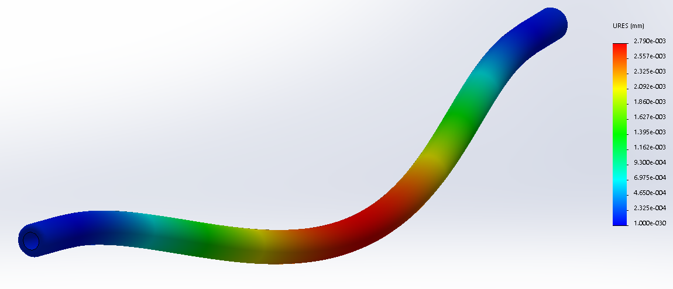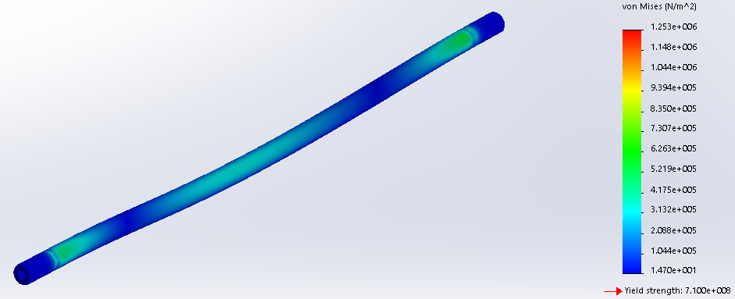
Figure 11 – Push Rod Displacement Contours (Left) & Stress Contours (Right)
The initial geometry of the push rod, comprising of a solid body, two 8mm x 30mm holes and 2mm fillets on each outer diameter edge, produced a total mass of 0.67Kg.
The above figures display the areas of maximum displacement and stress concentrations. From further studying, it is noticed that within the area of maximum displacement, an area of high stress exists.
The maximum induced stress equates as 3.67x10⁰⁰⁶N/m² with a maximum displacement of 0.0093mm. The yield strength of the used material (4340 Steel) is shown as 7.1x10⁰⁰⁸N/m².
This produces an excessive yield safety factor of 193.5.
$$Yield Safety Factor=\frac{Yield Strength}{Stress}$$
However, this high safety factor is directly associated with the low velocity used within the simulation, resulting in the production of low forces, thus low stresses. This could be rectified by running a simulation using a realistic average velocity of 30m/s (67mph), however, as the minimum simulation time allowed is 5 seconds, this would result in a road of considerable length, thus increasing computational time for very little benefit.
Looking directly at the produced results, it was concluded that areas of improvement could be made in regard to component mass and displacement.

2.3.2 Push Rod (Iteration 4)
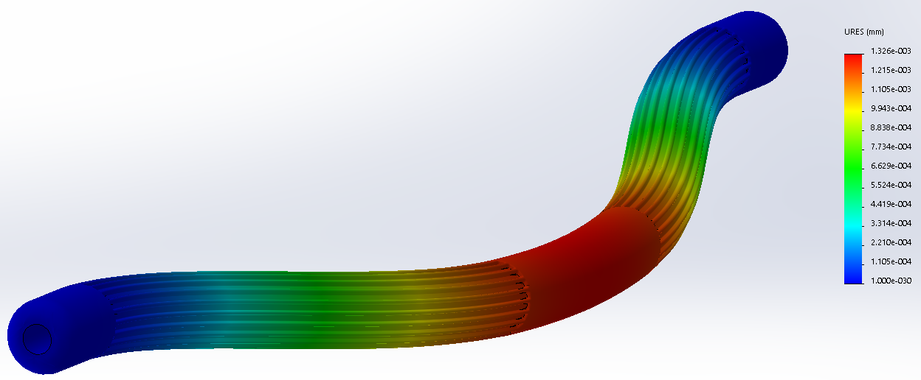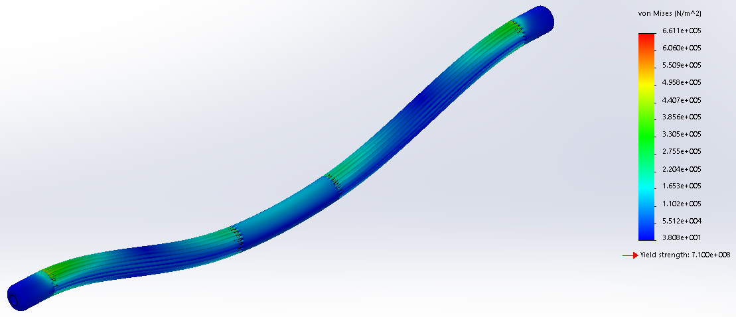

Figure 12 - Push Rod (Evolution 4) Displacement Contours (Left) & Stress Contours (Right)
The above figure displays the areas of maximum displacement and stress induced on the modified push rod. These areas remain comparable to the initial design; however, the numeric values have differed.
Due to the modifications made, the resultant maximum stress has a value of 2.004x10⁶N/m² and a maximum displacement of 0.0041mm (reduction of 0.0052mm). The same material has been used, therefore the yield strength of the material remains the same.
The reduction in stress results in a superior safety factor of 354.3. This is an increase of 161, meaning the modified rod remains firmly below the materials plastic deformation point.

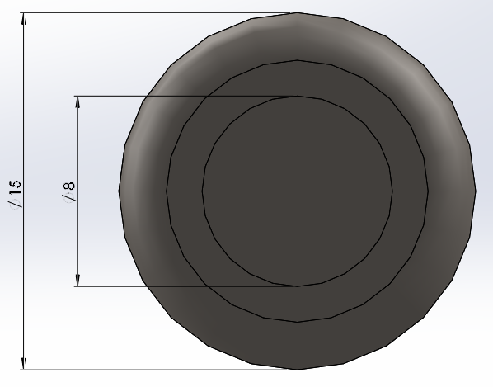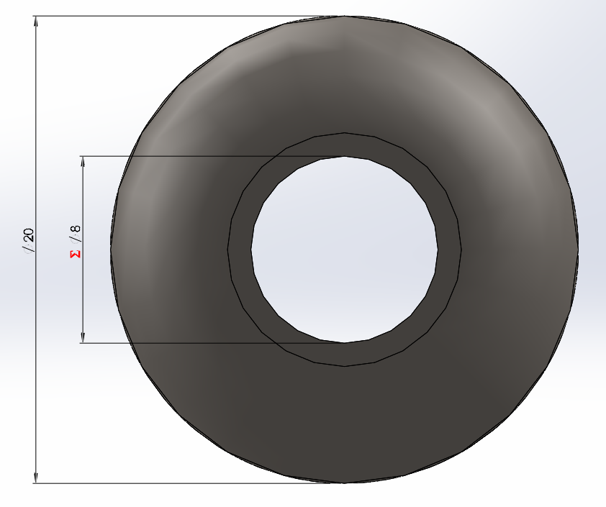
Figure 13 - Inner & Outer Dimensions (mm) (Initial Design - Left, Iteration 4 - Right)
The calculation of stress is described as:
$$σ=\frac{F}{A}$$
- $σ$ = Direct Stress (N/m²)
- $F$ = Force (N)
- $A$ = Cross Sectional Area (m²)
With an increase in outer diameter for the modified push rod, results in a larger cross sectional area, however, to reduce the produced mass, the rod was consequently hollowed, reducing the cross sectional area.
Figure 14 - Cut Plane of Push Rod (Evolution 4)
The reduction in mass (from 0.67Kg to 0.507Kg) also results in a lessened inertial force ($F=Ma$), therefore the overall force seen on the push rod has decreased (considering the reaction forces have remained the same), producing an average lower stress throughout the studied time step (O’Rourke , 2014).
$$ε=\frac{σ}{E}$$
- $ε$ = Strain
- $E$ = Youngs Modulus (205N/m²)
The decreased stress then results in a reduced strain as the Youngs Modulus has not been altered (due consistent material usage), thus an overall reduced deflection is generated.

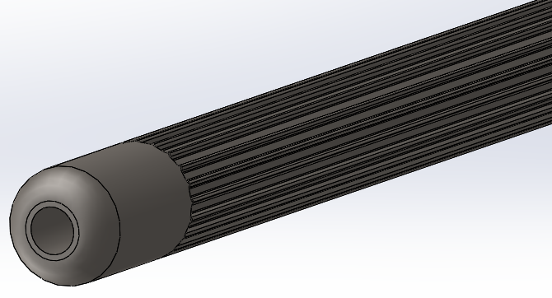
Figure 15 - Push Rod Iteration 4 Ribbing
A further reduction in mass was made by “ribbing” the outer area of the push rod (Figure 15). This technique maintains cross sectional area, however the amount of material used is reduced, thus a lesser mass is generated. To control the potential of stress concentrations between the ribs, fillets have been introduced to reduce sharp angles. Using this technique spreads the stresses across a greater surface area. (Mattheck, et al., 2008)

3.0.0 Conclusion
Considering a number of assumptions have been made throughout this investigation, the resultant values for forces and stresses are assumed as skewed, however, as individual cases remain relative to each other, valid comparisons can be made.
Further accuracy within the CAD components could be made. For example, the chassis tubular frame remains as solid “bars”, thus when a material is applied, masses are comparatively greater than the actual cars chassis (as studied in 2.2.0). This then increases the static mass and reaction forces.
As previously stated, the applied linear motor within the motion simulation should use a velocity and damping characteristics of greater realism. This would then produce forces of greater relativity compared to measured values if a comparison were to occur between virtual and reality.
The entire validity of this investigation can be questioned as no validation study was conducted to generate confidence in the user with the software. Therefore, though the cases within this report have had comparisons made along with researched methods, the calculated dynamic forces and FEA studies remain inconclusive.
However, it is seen that with a reduction in mass, thus inertia force, a reduction in induced stress becomes apparent and therefore smaller displacement values are generated.

4.0.0 References
Brach , R. M., 2009. Tire Models for Vehicle Dynamic Simulation and Accident Reconstruction, Michigan: SAE International.
Chang, K.-H. C., 2009. Motion Simulation and Mechanism Design with SolidWorks Motion 2009 , Oklahoma: The University of Oklahoma .
Colsoul, F., Voss, B. & Wissart, T., 2012. “Motion in FEA”: An Innovative Approach for More Physical and More Accurate Vehicle Dynamics Simulation, Michigan: SAE International.
Elleray, P., 2013. METHODS OF CHASSIS CONSTRUCTION (PART 2). [Online]
Available at: http://www.radonsport.com/RaceTech150-Radon.pdf
[Accessed 9 1 2019].
Formula Ford Kent, 2017. www.britishformulaford.co.uk. [Online]
Available at: http://www.brsccff1600.co.uk/Files/2017__FF1600_Published_Copy.pdf
[Accessed 9 1 2019].
Franciosa, P., Gerbino, . S. & Patalano, S., 2013. A sequential constraint solver to simulate assembling operations for tolerance analysis, Naples: Elsevier.
goengineer.com, 2008. SolidWorks Optimization. [Online]
Available at: http://files.goengineer.com/docs/whitepapers/Design%20Validation/Simulation%20Professional/Optimization.pdf
[Accessed 2019 1 8].
Harris, W., 2019. How Car Suspensions Work. [Online]
Available at: auto.howstuffworks.com/car-suspension2.htm
[Accessed 9 1 2019].
http://help.solidworks.com, 2019. Mates. [Online]
Available at: http://help.solidworks.com/2017/english/solidworks/sldworks/c_mates_overview_assemblies.htm
[Accessed 8 1 2019].
Kasprzak, J., 2014. Understanding your Dampers: A guide from Jim Kasprzak, Mooresville: Kaz Technologies.
Mattheck, C. et al., 2008. A simple graphic way to reduce stress concentrations by growth, Eggenstein-Leopoldshafen: WITpress.
O’Rourke , L., 2014. The Mathematics of Simple Beam Deflection, London: The Royal Academy of Engineering.
Salaani, M. K., Heydinger, G. J. & Grygier, P. A., 2006. Measurement and Modeling of Tire Forces on a Low Coefficient Surface, Michigan: SAE International.
www.formulafordbc.com, 2019. Tech Info. [Online]
Available at: www.formulafordbc.com/technical-info/
[Accessed 9 1 2019].
www.lynda.com, 2014. Using equations to drive a sketch. [Online]
Available at: www.lynda.com/SOLIDWORKS-tutorials/Using-equations-drive-sketch/143606/157803-4.html
[Accessed 8 1 2019].

5.0.0 Appendix

5.1.0 Push Rod Iterations
Table 1 - Push Rod Iteration Figures
The above table displays the results considered for each push rod modification.

Graph 1 - Mass & Displacement per Push Rod Iteration
Throughout the design optimisation, it can be viewed that both mass and displacement have reduced considerably.

Graph 2 - Stress & Strain per Push Rod Iteration
As can be seen in the above graph, iteration 1 produced the least amount of stress, however, iteration 4 produced the least combined stress and strain.

Graph 3 - Safety Factor per Push Rod Iteration
Even though iteration 4 did not produce the greatest safety factor, its average results through every considered area has been consistent. Design optimisation studies can still be carried out to further improve the component, however, for the sake of this study, it can be seen that improvements can be made with the use of CAE and FEA techniques.

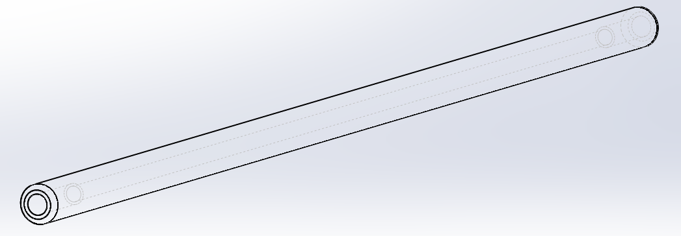
Figure 16 - Push Rod Iteration 1
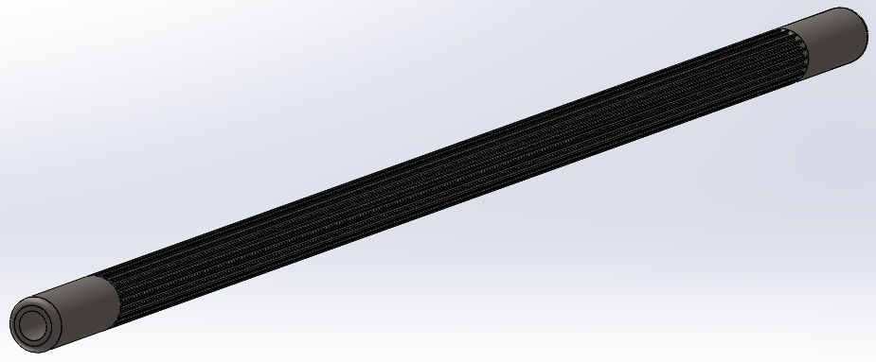
Figure 17 - Push Rod Iteration 2
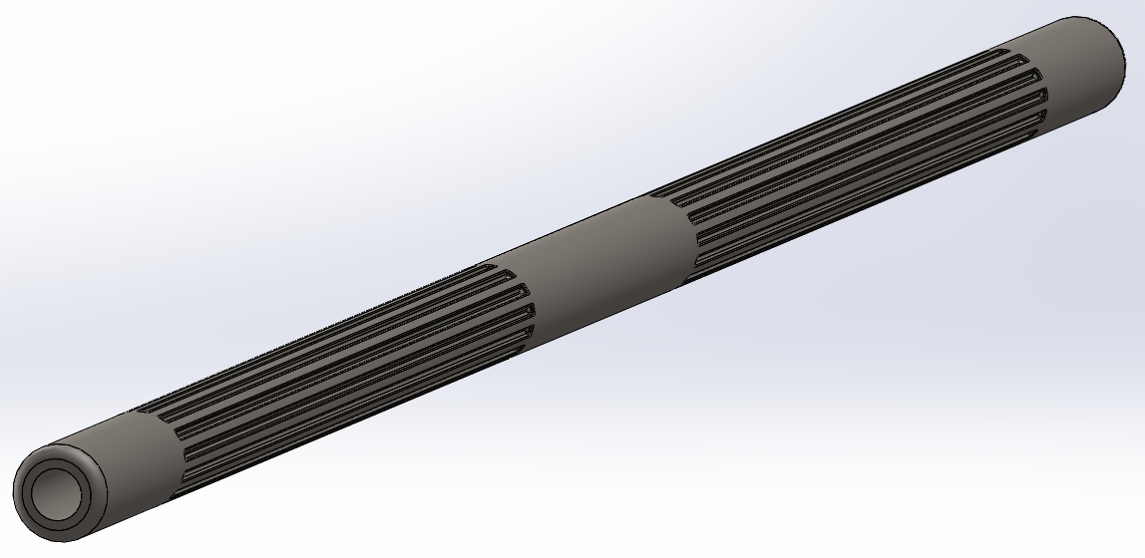
Figure 18 - Push Rod Iteration 3

https://uowtsd-my.sharepoint.com/:f:/g/personal/jhughes_146322_student_uwtsd_ac_uk/EnmeVdarA-ZJmgD6a7JpoAwB0SjZFFmosZWRtbbFcPTGpA?e=VYezoR

