Starbucks competitive strategy analysis report

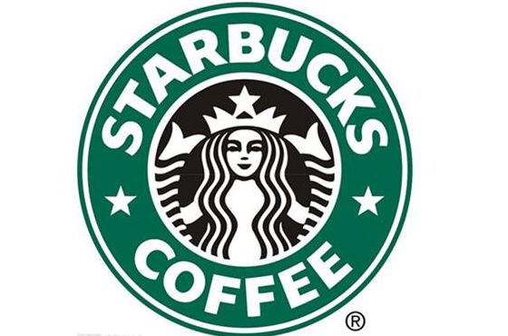

Reported to: Gareth Hughes

Submitted by: Chen Wei

Deadline time: 16/11/17

Contents
Executive Summary - 3 -
1.0 Introduction - 4 -
1.1 Starbucks - 4 -
1.2 Objective - 4 -
1.3 business level strategy - 4 -
1.4 competitive advantage - 5 -
1.5 Porter’s Generic Strategy - 5 -
2.0 Main body - 7 -
2.1Differentiation strategy - 7 -
2.2 Starbuck’s Differentiation strategy - 7 -
2.2.1 Strong branding effect. - 8 -
2.2.2 The Corporate Social Responsibility - 8 -
2.2.3 Research and Development - 9 -
2.3 The advantage of Starbucks Differentiation strategy - 9 -
2.4 The disadvantage of Starbucks Differentiation strategy. - 10 -
3.0 Conclusion - 12 -
4.0 Recommendation - 13 -
Reference - 14 -

Executive Summary
The aim of the report is to:
- Identify the competitive strategy of Starbucks
- Analysis the relevant methods’ implications of achieving this strategy.
- Being critical evaluation of Starbucks strategy which them used.
- Provide the relevant recommendation could be provide to improve the future performance in terms of Starbucks.

This study takes a qualitative approach, and sources are secondary, mainly from peer-reviewed articles, textbooks, professional and official websites.

The framework for this study is based on Porter's generic strategies, and it was observed that Starbucks takes Differentiation strategy.

Starbucks has used of those key approaches to achieve this strategy:
- Product Differentiation project
- Strong branding effect
- The Corporate Social Responsibility
- Investing in research ＆development.

According to Differentiation strategy, Starbucks has gain those strengths:
- Adding market share
- Building a positive brand effect
- Increase the ability to bargaining

The limitation of Starbucks’ Differentiation strategy:
- Starbucks service quality reduce
2. Competitive imitation

It is recommended that:
- Continue building a good relationship with their stakeholder according to corporate social responsibility.
- Slow down the pace of expansion and to ensure that each store service is similar with strategic slogan.

1.0 Introduction

1.1 Starbucks
Starbucks is the premier roaster, marketer and retailer of specialty coffee in the world, operating in 68 countries. (Starbucks company report, 2015). And Starbucks have still focus on new product. In 1996, Starbucks introduced bottled Starbucks Frappuccino coffee drinks, this product sales accounted for 10% of Starbucks. In 1992, Starbucks successful listed as a professional coffee company. And then, between 1992 to 2008, Starbucks has rapidly open branch. Until 2017, there are more than 24000 store in the world.

1.2 Objective
This report will:
1.Identify the competitive strategy of Starbucks, then analysis what competitive position Starbucks got from this strategy.
2.Analysis the relevant methods’ implications of achieving this strategy. And why those methods can help Starbucks gain those competitive advantage.
3.Being critical evaluation of Starbucks strategy which them used. Talking about those strategy whether bring some lack for Starbucks.
4.Provide the relevant recommendation could be provide to improve the future performance in terms of Starbucks.

1.3 business level strategy
According to Dr. Vladimir Kvint define to strategy is that: a system of finding, formulating, and developing a doctrine that will ensure long-term success if followed faithfully.

For the organization, they have three levels strategies respectively as:
- Corporate-level Strategy
- Business- level strategy
- Operation Strategy

In this study we focus on Starbuck's business-level strategy. Business- level strategy is concerned with questions of how to compete within a particular business. (BEARD, D.W. and DESS, G.G., 1981)

1.4 competitive advantage
For Charles Doyle，（2011）competitive advantage can be define as“the factor
which enables a firm to compete successfully with competitors on a sustained basis particularly to satisfy consumer needs and wants.” The results indicate that the Sustainable Competitive Advantage construct is an important antecedent of organizational performance because it highlights fundamental attributes for organizations to achieve positive economic consequences. (DE GUIMARÃES, et al., 2017)

1.5 Porter’s Generic Strategy
According to Michael Porter’s analysis, there are three ways to help company to gain competitive advantage, Cost Leadership strategy, Differentiation strategy and Focus strategy. This is Porter's generic strategies. （Porter 2004）

The Cost Leadership strategy is service for customer who is sensitive for price. This strategy includes two parts, Low Cost strategy and best value strategy. Low Cost strategy is used to provide the lowest price in the market to service for customer. Best value strategy is used to compare products with competitor similar products, and then, setting a lower price than their competitor.
Differentiation strategy is provided some individual product or service for their customer who is not sensitive for price. This strategy should company have enough power to research and develop their product or service.
Focus strategy is use to find their niche group, and then provide the special service for them. This strategy includes Focus Cost Leadership strategy and Focus Differentiation strategy. The Focus Cost Leadership strategy is used provide the most basic service with the cheapest price on the market. The Focus Differentiation strategy is means that give the better service than their competitor for their niche group. But, when their niche group achieve this service, they should achieve the higher primum price. (Fred. R. David 2008) This study finds that Starbucks adopts Differentiation Strategy, which will be discussed in the following parts.

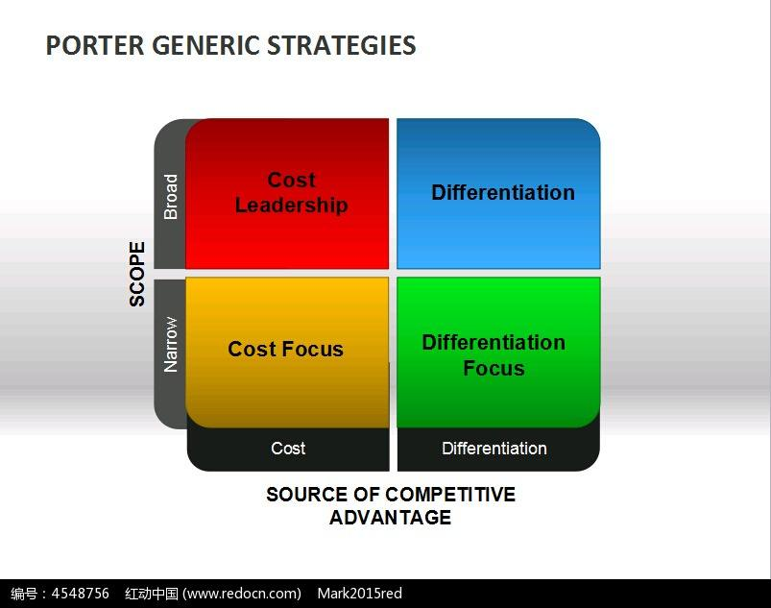

2.0 Main body
For Starbucks, this company use business-level strategy to help themselves to be different from their competitors, and then, to enlarge those Differentiation to attract customer and add their loyalty. In this process, Starbucks choose Differentiation strategy from Porter’s Generic Strategy to achieve their purpose. The first, Starbucks choice different product to attract customer to shopping, then, using the considerate service and comfortable leisure environment to help Starbucks enhance customer’s loyalty. The next step is that train their staffs and build a suitable environment to set a strong and positive brand. In the last, Starbucks use the premium price to ensure their profit.

2.1Differentiation strategy
The Differentiation strategy as part of business level strategy is resourcefully executed when the businesses gives exclusive or better significance to the buyer with the direction of product quality, features, or follow up support (Allen & Helms, 2006) The Differentiation strategy appeals to complex or well familiar customer that are concerned with uniqueness or quality of product and willing to give benefit cost (Nandakumar et al., 2011).

Differentiation strategy can be achieved through the following approaches: product Differentiation project, brand image, technology, customer service and cooperate social responsibility. According to porter strategy, he thinks that If a company can effectively implement the strategy, then the company can have a higher profit than competitors, and can occupy the dominant position in the five forces model. (Porter, 2008)

2.2 Starbuck’s Differentiation strategy
For Starbucks, they imply a different set of Differentiation strategy by strong branding, and corporate social responsibility. The following is an evaluation of Starbucks's strategy:

2.2.1 Strong branding effect.
Creating your brand identity, voice, and overall messaging becomes much easier to articulate and execute once you've defined your brand Differentiation. (BOYLE, L., 2007)
For Starbucks, the green circle and black and white figure is Starbucks brand. When Starbucks want to have a more positive’s brand, they have use those ways.

In the first, they aim to create a romance, atmosphere, sophistication and sense of community brand. (Schultz and Yang, 1997) This is their operating slogan. Then, they have set a lot of rules to their partners and managers to carry out this slogan. It includes all staffs should accept 13 weeks of training. It is used to learn how to make a coffee and to understand the nuances of the Starbucks brand. (Karolefski, 2002). According to those details to help staffs to understand how to deliver on its promise of a service expensive. Next, Starbucks created a 'third place' in people's lives - somewhere between home and work where they could sit and relax. (Paul, et al., 2010 Page 41-47) In the next step, Starbucks choice set a higher price for their product (help their brand located). In the end, Starbucks choice rapidly developing branches to rapidly improve their popularity. And Starbucks do not do any advertisement, they think their service and product is the best advertisement for their customer. This confidence also helps Starbuck building a positive brand. According to those way, Starbucks wish make customer believe that they are not only buy a coffee, they also buy a complete set of services. In the end, customers achieve their brand culture and willing to pay for the brand premium behind this culture.

2.2.2 The Corporate Social Responsibility
Corporate Social responsibility is concerned with the ways in which an organization exceeds its minimum obligations to stakeholder specified through regulation. (Gerry. J et al. 2015 Page 146) For Starbucks, this company continue to improve their service for their stakeholders (customer, supplier, and local government)

For customers, Starbucks choose the best coffee beans to cook. They think the best coffee bean can cook the best coffee for their customers. For their supplier, they purchase their coffee bean use the primum price, and provide the business loans to reduce their risk in the future (Starbucks 2017). And Starbucks have invested in many coffee plantations. Because many coffee plantations are not rich. So, When Starbucks invested in those place, there are more job opportunity for local people and can improve their living environment.

These measures help the coffee industry develop steadily, and for suppliers, they will undertake smaller business risks, and be more focused on the production of coffee beans. And because Starbucks helped them, then suppliers would give Starbucks feedback, such as providing Starbucks's best coffee beans. For coffee plantation government, they are also happy with Starbucks's involvement in the local business system - one that drives the local economy and provides more jobs. These measures are a win-win solution for Starbucks and its stakeholders.
In the next section, this study will evaluate the chosen strategy by Starbucks..

2.2.3 Research and Development
The standard of new product for Starbucks is that “A new product has to be relevant to coffee, absolutely best of class in its category, and it has to broaden the reach of Starbucks.” (KIM, N.J., 1997.)
Starbucks spends a lot of time in developing new product. In 2003, Starbucks invented a simple, refreshingly drinkable cold coffee beverage which will appeal to Starbucks coffee lovers, Frappuccino coffee. And Starbucks Corp. give their customers a power, to design their own Frappuccino. (HELLIKER, K., 2010) And in order to develop Japanese market, Starbucks have developed a green tea Frappuccino, this product help Starbucks open the new market very quickly. In the China market, because Chinese think tea is their main drinks, Starbuck has invented some tea coffee, for example Honey grapefruit tea and oolong tea. (Starbucks, 2017) Those development help Starbuck quickly join in the local culture, and help Starbucks add the market share quickly.

2.3 The advantage of Starbucks Differentiation strategy
- Building brand loyalty: Customer loyalty is a response how a business presents its product and service. (Lawfer 2004 Page 11) Starbucks support more excellent service than competitors to customer, and give the more perfect product to their customer. When customer compare Starbucks and his competitor, customer will find that Starbucks will give them the better consumption experience. In this process, customer will be loyalty for Starbucks.

And experience can be a key source of cost efficiency and there is evidence it may provide competitive advantage. (A.C. Hax and N.S. Majluf 1990) When Starbucks give customer a perfect experience of coffee, if the other competitor wants to steal Starbucks customer, they should pay the more cost to be better than Starbucks. It would virtually reduce the risk for the new competitive enter the market.

- Increase the ability to bargaining: With Starbucks Differentiation strategy, there are many customers would be loyalty for this company. Because Starbucks has many loyalty customers, appropriate price increases will not affect Starbucks's passenger flow. It means that Starbucks can have the higher profit than their competitors. Looking for the history with Starbucks coffee price, there is not be reduced. But the customer is increased very quick, and with the stores quickly expending, the selling is always increased. (Xu Ying 2017) [online]

2.4 The disadvantage of Starbucks Differentiation strategy.
- Starbucks service quality reduce: With the rapid development of Starbucks in the world, Starbucks has more than 24000 stores in the world, but the number of barista cannot guarantee that every shop will have excellent barista, which will lead to Starbucks's service cannot be as excellent as before. Although Starbucks would train every staff with 13 weeks, but because staff lack the When there is a difference between the quality of service and the original brand slogan, the brand effect of Starbucks will be rapidly weakened. And with the development of the network, Starbucks's high profits and services compared with the original difference will soon appear. Customers will lose loyalty to Starbucks, too. The advantage that Starbucks built before the powerful brand effect will disappear. While the rapid development in order to establish a strong brand, strategy will play a negative role.

- Competitive imitation: when Starbucks has enough profit, competitor would choice imitation them, whatever the product or service style, it means that Starbucks would lose their customer. Because Starbucks’ main problems is how to keep their Differentiation strategy to does it continue to justify a price premium. Starbucks’ competitor can be very easy to imitate Starbucks Differentiation-the additional service, for example, coffee club (Costa has built coffee club to attract customer), good shopping atmosphere and high-quality customer service. (Paul, et al., 2010 Page 41-47)

- According to strategy clock model, we can find that Porter Generical strategy is lacking hybrid strategy. This strategy depends on company whether have this ability to make customer fell the product of service addition value and keep a low price. So, for Starbucks, this company also have other choice for strategy. Cut down the primum.

Conclusion
This report talks about Starbucks business-level strategy, Differentiation strategy. With the Differentiation strategy, Starbucks being the biggest winner in the coffee market. They can sell their product with higher primum price, and their customer also happier to pay for them.

Starbucks have used the Differentiation strategy by:

- according to research and development to develop new market and appeal more customer.
- With the CSR to building a good relationship with their stakeholder.
- Using the positive brand effect to appeal customer and make them be loyalty for Starbucks.

With Starbucks Differentiation strategy, Starbucks has gain those advantage:

- Having the strong customer loyalty.
- Having the enough ability to set a primum price for their customer to ensure profit

The disadvantage of Starbucks Differentiation strategy:
- Competitor would cope Starbucks operate model to steal Starbucks customer
- Starbucks would be lack of barista result in service quality reduce, then lose customer’s loyalty.

In the next part, we would give Starbucks some accommodation.

4.0Recommendation
- Continue building a good relationship with their stakeholder according to corporate social responsibility. Because when Starbucks has a good relationship with their stakeholders, Starbucks can continue maintain their branding effect and still attract their customer.
- Slow down the pace of expansion and to ensure that every store service is similar with strategic slogan. Because Starbucks expanding too quickly, in order to meet all customer’s demand, Starbucks switch traditional coffee beans to vacuum packaged coffee, the traditional coffee machines has been turned to automated expresso machine (which can make coffees 40% faster and move customers through the lines more quickly), it also result in coffee beans loss their original taste. (Grove et al., 2000) This situation also results in that Starbucks’ customer loss their loyalty for this brand. So, in order to continue attract their customer and let them believe Starbucks, company should slow down their step to exploding, and spend more time and many on their customer’s interesting.
- Keep research and development. This method could help Starbucks still invent new product, and can attract more customer and be Differentiation from their competitor.

Reference
A.C.Hax and N.S. Majluf, in R.G. Dyson (1990) 1st ed Strategy Planning： Models and analytical techniques,

Allen, R.S. & Helms, M.M. (2006), “Linking strategic practices and organizational performance to Porter’s generic strategies”, Business Process Management Journal, 12(4), 433-454.

BEARD, D.W. and DESS, G.G., 1981. Corporate-Level Strategy, Business-Level Strategy, and firm performance. Academy of Management Journal (pre-1986), 24(4), pp. 663.

BOYLE, L., 2007. The brand experiences. Multichannel Merchant, 3(3), pp. 40-41.

Charles, D., 2011, A Dictionary of Marketing. 3 ed Publisher: Oxford University Press

DE GUIMARÃES, J., CESAR FERRO, SEVERO, E.A. and DE VASCONCELOS, C., RICARDO MAIA, 2017. Sustainable Competitive Advantage: A Survey of Companies in Southern Brazil. Brazilian Business Review, 14(3), pp. 352-367.

Fred. R. David. 2008 11th ed Strategy management

Grove, S. J., Fisk, R. P., & John, J. (2000). "Services as Theater", in Handbook of Service Marketing and Management. Ed. T. A. Swartz, and D. Iacobucci . Thousand Oaks, CA: Sage Publications, 21-35.

HOLCOMBE, R.G., 2009. PRODUCT DIFFERENTIATION AND ECONOMIC PROGRESS. Quarterly Journal of Austrian Economics, 12(1), pp. 17-35.

HELLIKER, K., 2010, Mar 17. At Long Last, Customized Frappuccino. Wall Street Journal. ISSN 00999660.

H．Schultz, D.J. Yang Pour Your Heart into It: How Starbucks build a Company One Cup at a Time Hyperia Publishing, New York. (1997)

Karolefski, J., 2002. Conquering new grounds. Brand Channel, 11 February. <http://www.brandchannel.com/features_effect.asp?pf_id=78> (accessed 29.08.08.).
Johnson, G, Scholes, K and Whittington, R (2015) Exploring Corporate Strategy: Text and Cases, 8th edition London: Prentice hall

KIM, N.J., 1997. Starbucks' strategy: full steam into Asia. Puget Sound Business Journal, 18(23), pp. 1.

Lawfer, M., R. (2004). Why Customers Come back: How to create Lasting Customer Loyalty. Franlin Lakes, Career Press.

Nandakumar, M. K., Ghobadian, A., & Regan, N.O. (2011). Business-level strategy and performance: The moderating effect of environment and structure. Management Decision, 48(6), 907-939.

Porter, M.E., 2004.Comoetitive Advantage. New York: Free Press

Porter. M.E., 2008. Competitive Strategy: Techniques for Analyzing Industries and Competitors. New York: Simon&Schuster

Paul. G. Patterson, Jane Scott, Mark D. Uncles, 2010, How the local competition defeated a global brand: The case of Starbucks, Australasian Marketing Journal, volume 18, issue 1, February 2010, Page 41-47

Starbucks, 2017.【online】
Available at: < https://www.starbucks.com.cn/cn/about/responsibility/store-products-sourcing>
[ Accessed 13 November, 2017]

Starbucks company annual report，2015【online】
<https://s22.q4cdn.com/869488222/files/doc_financials/annual/2015/Starbucks-Fiscal-2015-Form-10-K.pdf >
[Accessed 10 November 15, 2017]

Ying, X, 2017, Starbucks's price hike is just to expel low consumption, love placeholder? 【online】
Available at: < http://www.sohu.com/a/128232137_188668>
【Accessed 13 November 2017】

