
Institute of Inner-City Learning London Campus

Master of Business Administration
Business Development Proposal Outline Structure

Name: Shaunakkumar Patel
Student ID: 2504923
Module Name: Business Development Proposal
Module Code: LCMB7037

Table Of Contents
AI Use Acknowledgement 3
1. Introduction 3
(Figure 1.1. - The Pulse Corner Café) 4
(Figure 1.2. – The Pulse Corner Café interior) 5
1.1. Aim, Objectives and Questions 5
2. Literature Review 6
2.1. Job To Be Done (JTBD) 7
2.2. PESTLE Analysis 7
2.3. Porter’s Five Forces 8
2.4. Value Proposition Canvas 8
2.5. Business Model Canvas 8
(Figure 2.5.1. - Business Model Canvas) 9
3. Methodology 10
3.1. Research Approach 10
3.2. Data collection 10
3.3. Data analysis 10
3.4. Ethical Considerations 11
4. Initial Market Opportunity Analysis 12
4.1. Market Overview 12
4.2. Market Size and Demand Estimation 13
4.3. Customer segmentation 13
4.4. Job-To-Be-Done (JTBD) Analysis 14
4.5. PESTLE Analysis 14
4.6. Porter’s Five Forces Analysis 15
4.7. Value proposition canvas 17
4.8. Business model opportunity 17
(Table 4.8.1.: - Business Revenue Streams Assumption) 18
5. Limitations 19
6. Time frame 20
(Figure 6.1. – The Gantt Chart) 20
7. Conclusion 20
8. References 21

AI Use Acknowledgement

I acknowledge the use of ChatGPT (OpenAI) and Gemini (Google) as support tools during the preparation of this Business Development Project (BDP). ChatGPT was used to support research, proofread drafts, and suggest improvements to grammar and clarity. Gemini was used to generate visual concepts to help illustrate the proposed venture.
The final structure, analysis, arguments and written content of this submission are my own work. All information, analysis, evaluations, conclusions, and recommendations presented in this report have been critically reviewed, verified, and edited by me. I consulted academic sources, industry reports, and other reference materials independently and used them where appropriate. AI-generated content has not been used to replace my own research, analysis, or my own thinking.
This submission reflects my own work and understanding of the business venture, The Pulse Corner. I take full responsibility for everything in it.

Introduction
Hybrid and remote work have changed the way people connect with workplaces and professional settings. After the COVID-19 pandemic, more organisations started using flexible work options. This shift pushed more people to look for workspace options outside the usual office or their own home (McKinsey Global Institute, 2021).
The Office for National Statistics (ONS) says about 28% of UK employees worked in a hybrid setup during 2025, showing that people still want flexible working environments. (ONS, 2025). JLL (2025) also reported that flexible office space made up around 800,000 square feet of office take-up in London, which points to the growing importance of who is working and flexible workspace solutions.
The proposed Business Development Project (BDP) features a new venture called “The Pulse Corner", which is a family-friendly café and co-working community space based in Richmond, London. Richmond upon Thames has a population of approximately 198,000 residents and is recognized for its high concentration of professional occupations, families and remote workers, making it a suitable location for a flexible workspace concept (Office for National Statistics, 2024). The concept is meant to bring together the idea of a professional co-working space with good café service and a children's discovery zone. The concept provides a flexible workspace that supports professionals, freelancers, entrepreneurs and working parents.

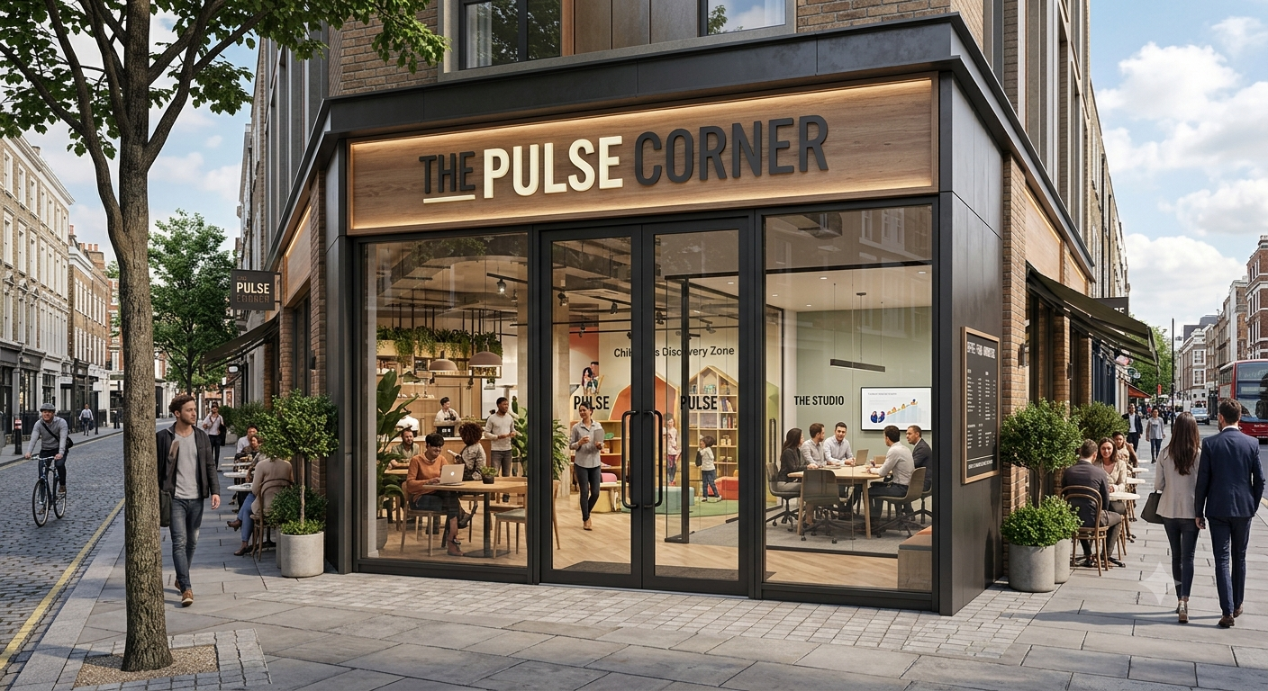

(Figure 1.1. - The Pulse Corner Café)
  - (Source: Self-Created using Google Gemini AI, 2026)
London’s growing flexible workspace market, increasing hybrid working practices, and rising demand for affordable work environments create favorable conditions for The Pulse Corner (JLL, 2023).
A dedicated Children’s Discovery Zone will provide supervised educational activities, allowing parents to work productively while remaining close to their children.

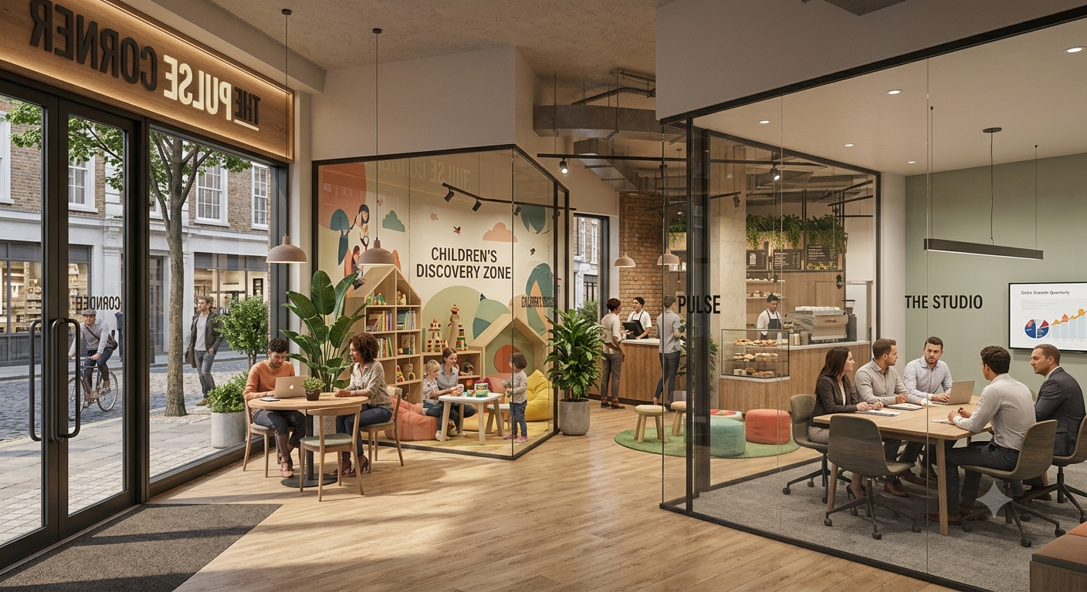

(Figure 1.2. – The Pulse Corner Café interior)
  - (Source: Self-Created using Google Gemini AI, 2026)
Recent labour market data shows that flexible work environments are still in high demand. The Office for National Statistics (2024) reports that 28% of working people in the UK use a hybrid work arrangement, and millions still split their time between home and other work locations. Looking at 2025, the UK had around 4.4 million people who were self-employed, which points to a large market for independent workspace (Office for National Statistics, 2025). The UK café industry adds to this picture, bringing in more than £11 billion each year and highlighting strong demand for cafés as social and workspaces (IBISWorld, 2025).

Aim, Objectives and Questions
Aim:
This Business Development Proposal aims to evaluate the feasibility of The Pulse Corner, a family-friendly café and co-working space, in Richmond, London. The study will look at market demand, customer needs, the external business environment, and preliminary financial viability using secondary research.
Objectives:
- To analyses the demand for flexible co-working cafés in Richmond, London.
- To identify the needs and preferences of remote workers, freelancers and working parents in relation to workspace and family-friendly services.
- To evaluate the external business environment affecting The Pulse Corner using PESTLE analysis.
- To assess industry competitiveness using Porter’s Five Forces.
- To estimate the potential customer base, occupancy levels and revenue streams and cost structure to assess commercial viability and break-even requirements.
Questions:
- Is The Pulse Corner a feasible business opportunity within Richmond, London?
- What are the key needs and preferences of remote workers, freelancers and working parents in relation to workspace and family-friendly services?
- What market opportunities exist for a family-friendly co-working café in Richmond?
- What external factors could influence the business performance of The Pulse Corner?
- What occupancy, revenue and cost levels are required to achieve commercial viability and break-even for The Pulse Corner?

Literature Review
This literature review outlines the theoretical frameworks that will guide the analysis and development of The Pulse Corner. Developing a new business requires a structured approach to understand customers' needs, analyze market conditions and evaluate competitive forces. To achieve this, the proposal employs five established frameworks: jobs to be done, PESTLE, Porter’s five forces, the value proposition canvas, and the business model canvas. Each framework offers distinct strengths and limitations, and together they provide a comprehensive basis for identifying market opportunities and shaping a viable business model for The Pulse Corner.

Job To Be Done (JTBD)
The Jobs to Be Done (JTBD) framework focuses on underlying goals that customers seek to achieve when they adopt a product or services, rather than on the product or services itself (Christensen et al., 2016). Its strength lies in shifting the analysis from product features to the functional, social and emotional jobs that customers want to accomplish.
For The Pulse Corner, JTBD is relevant because the venture is designed to help remote workers, freelancers and working parents accomplish specific jobs, such as finding a professional environment to focus, accessing affordable meeting spaces and balancing work with childcare responsibilities. The framework will be applied to identify the core jobs, pains and gains of target customers and to ensure that the value proposition is aligned with these needs.

PESTLE Analysis
PESTLE analysis provides a structured method for examining the external macro-environment factors that may influence an organization’s performance: political, economic, social, technological, legal and environmental factors (Johnson et al., 2020). Its strength lies in offering a broad overview of opportunities and risks arising from the external environment.
For The Pulse Corner, PESTLE will be used to identify external conditions that could affect demand for flexible workspaces and café services in Richmond. The analysis will highlight both enablers and constraints that may influence the venture’s strategic options.

Porter’s Five Forces
Porter’s Five Forces framework evaluates industry Attractiveness by analysing 5 competitive forces: Competitive rivalry, the threat of new entrants, the threat of substitutes, the bargaining power of buyers and the bargaining power of suppliers. (Porter, 1980). Its strength is that it provides a clear structure for understanding the source of competitive pressure and long-term profitability within an industry.
The Pulse Corner, Porter’s Five Forces, will be applied to assess the competitive intensity of both the cafe and flexible workspace in London and Richmond.

Value Proposition Canvas
The value proposition canvas helps organisations articulate how their products and services create value for specific customer segments (Osterwalder et al., 2014). It consists of two main elements: The customer profile, which identifies customer jobs, pains and gains, and the value map, which describes how the offering alleviates pains and creates gains. Its strength lies in linking customers inside directly to the design of the value proposition.
For The Pulse Corner, the value proposition canvas will be used to clarify the jobs, pains and gains of remote workers, freelancers and working parents and to ensure that the combination of Co working space, cafe services and a Children Discovery Zone is aligned with these needs. This will support the development of a compelling and customer centered value proposition.

Business Model Canvas
The Business Model Canvas (BMC) outlines nine building blocks that describe how an organization creates, delivers, and captures value: customer segment, value proposition, channels, customer relationships, revenue stream, key resources, key activities, key partnerships, and cost structure (Osterwalder and Pigneur, 2010). Its strength is that it provides a holistic view of business models on the single page, facilitating strategic discussion and interactions.
For The Pulse Corner, the BMC will be used to map the key components of the proposed business model, including target customer segments, value propositions, revenue streams, and cost drivers. This will help assess whether the idea is internally coherent and identify resources and activities required to deliver the concept.

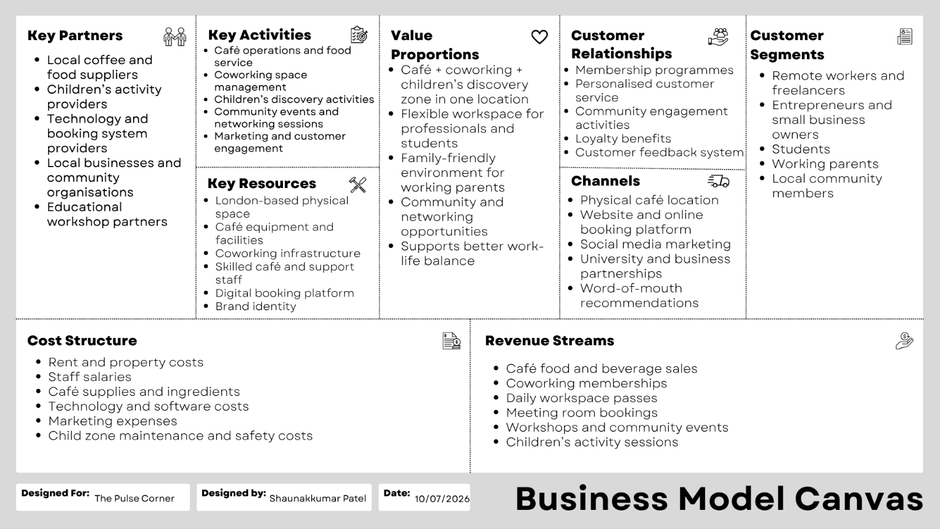
(Figure 2.5.1. - Business Model Canvas)
  - (Source: Self-Created using Canva, 2026)
Altogether. These frameworks provide a solid foundation for analysing the feasibility of The Pulse Corner. JTBD clarifies what customers are trying to achieve. PESTLE examines external influences. Porter’s Five Forces maps competitive dynamics, the value proposition Canvas links customer insights to offering, and the BMC integrates those elements into a coherent business model. Collectively, they will guide the research design, the market opportunity assessment and the development of strategic recommendations.

Methodology

Research Approach
This proposal adopts a qualitative secondary research approach to evaluate the potential and feasibility of The Pulse Corner. A family-friendly Café and Co working community space in Richmond, London. Secondary research is appropriate because it provides access to existing academic, government and industry data, enabling an assessment of customer needs, market demand, the competitive landscape and external influences without primary data collection.
The focus is on published information from academic journals, government statistics and reputable industry reports.

Data collection
Secondary data will be collected from academic journals, industry reports, government publications, and professional industry sources, accessed via databases such as Google Scholar, The Office for National Statistics (ONS), IBISWorld, Mintel, JLL, Deloitte, PwC, and McKinsey. Sources will be selected based on the following criteria:
Credibility: Preference for peer-reviewed academic journals, official government statistics and reports from established industry analysts.
Recency: Sources published within the last five to seven years were possible to reflect current market conditions and working patterns.
Relevance: Data and analysis that directly relate to flexible workspaces, cafe markets in Richmond, OR compatible London boroughs and family-friendly services.
Transparency: Sources that clearly explain their methodology and data foundations.

Data analysis
The collected secondary data will be analyzed using the frameworks outlined in the literature review. Each framework will be applied systematically to ensure consistency and depth of analysis.
The Job-To-Be-Done (JTBD) Framework will be used to identify the functional, social, and emotional jobs that target customers seek to accomplish, along with associated pains and gains.
PESTLE analysis will be used to examine political, economic, social, technological, legal, and environmental factors that may influence the external environment for The Pulse Corner.
Porter’s Five Forces will be applied to assess the competitive intensity and overall attractiveness of the café and flexible workspace sectors.
The Value Propositions Canvas will be used to allow for customer jobs, claims and gains with the proposed features and services of The Pulse Corner.
The Business Model Canvas will be used to map the key components of the business model, including customer segments, value propositions, value streams, and cost structure.

Ethical Considerations
As this study relies solely on secondary data, there is no direct interaction with human participants, which minimizes risks related to privacy, consent and confidentiality. All data used in the proposal are obtained from legally and publicly available sources. Academic integrity will be maintained by accurately referencing all sources in accordance with UWTSD Harvard (Cite Them Right) guidelines to avoid plagiarism and uphold academic integrity standards.
Reliability and Validity
To enhance the reliability and validity of the findings, multiple credible sources will be triangulated for each key assertion. For example, data on hybrid working patterns, flexible workspace demand and local dynamics will be cross-checked between government statistics (e.g., ONS), industry reports (e.g., JLL, IBISWorld) and academic literature.
Sources' credibility will be prioritized by favorite peer-reviewed journals, official statistics and reports from established consultancies. Residency will be empathized with by using the most up-to-date data available, typically within the last five to seven years, to reflect current market conditions and working practices.
Limitations of secondary data are acknowledged, including potential gaps in Richmond-specific information, differences in methodologies across sources, and the inability to capture very recent changes in the local demand. Those limitations will be addressed by clearly stating assumptions, highlighting data gaps and interpreting findings cautiously.

Initial Market Opportunity Analysis

Market Overview
- About 28% of UK workers had hybrid working arrangements, which keeps demand for flexible workspaces (ONS, 2025).
- Richmond upon Thames had an estimated population of 197,749 residents in 2025.
- Around 102,000 residents aged 16 and over were employed in Richmond in 2023, representing a significant market for coworking facilities (ONS, 2024).
- London’s flexible office market recorded approximately 800,000 square feet of flexible office take-up in 2025 (JLL, 2026).
- Growth in freelancing, self-employment and entrepreneurship continues to support demand for flexible workspace solutions.
More specific local indicators support the potential demand for flexible workspace. Recent labour market data suggests that the significant share of Richmond's working-age population is employed in professional, managerial or creative occupations and that the number of self-employed residents and freelancers in the borough has grown steadily over the last five years (Office for National Statistics, 2024; Richmond Council, 2024).
Within a 10-to-15-minute walk of the proposed site in Richmond Town Center, there are numerous independent and chain cafes, but only a small number of dedicated co-working operators, and most are positioned at a premium price point. Local commercial rent on secondary High Street locations is typically lower than in central London, although exit levels vary by frontage and floor level. The primary customer catchment for the Pulse Corner is therefore defined as residents and workers within a 15–20-minute walk or short public transportation journey encompassing Richmond Town Centre, adjacent residential neighborhoods and nearby business parks.

Market Size and Demand Estimation
For financial planning purposes, The Pulse Corner assumes an initial utilization target based on a combination of local population, estimated footfall and benchmark data from comparable cafe and coworking operations.
Co-working users: An initial target of 40-60 co-working users per day is based on capturing a small population of local remote workers, freelancers and small business owners within the primary catchment area. If a fraction of employed and self-the employed population in Richmond regularly seeks external workspaces, this range represents a conservative estimate of a single new entrant.
Café customers: A target of 120-180 café customers per day is aligned with typical throughput UH for a mid-sized independent café in a busy suburban high street location, adjusted for additional draw from coworking and family users.
Children’s Discovery Zone: An assumption of 10 to 20 children using the Discovery Zone daily reflects a pilot scale offering concentrated by space, staffing and safeguarding requirements and aimed primarily at working parents using the coworking and cafe facilities.
Occupancy: An average co-working occupancy of 45 to 55% during the first year is assumed, reflected in a ramp-up period as the business builds awareness and membership.

Customer segmentation
Remote workers and freelancers
- Require flexible, professional workspace outside the home and traditional office. (McKinsey Global Institute, 2021).
- Value reliable connectivity, professional amenities, and opportunities for informal networking. (Deloitte, 2023).
Entrepreneurs and small business owners
- Seek affordable, scalable workspace solutions that minimize fixed overheads.
- Require cost-effective meeting facilities and a professional environment for client interactions (ONS, 2025).
Working Parents
- Need to balance productivity with childcare responsibilities.
- Require child-friendly workspaces that allow them to remain close to their children while working (ONS, 2025).

Job-To-Be-Done (JTBD) Analysis
Applying to JTBD highlights core customer needs.
- “When I work remotely, I want a professional environment so I can focus and get things done.”
- “When I meet clients, I want a place that is affordable and presents a professional image.”
- “When I balance work and parenting, I need a space that supports simultaneously.”

PESTLE Analysis
Political
National and local policies support small business creation, entrepreneurship, and flexible working arrangements.
Economical
Rising living costs and inflation increase demands for affordable alternatives to traditional office leases, while independent professionals and small businesses seek lower-cost flexible workspace options (Bank of England, 2025).
Social
Hybrid working has become a mainstream employment pattern, with 28% of UK employees working in a hybrid arrangement (ONS, 2024). In family-orientated boroughs such as Richmond, there is additional demand for workspaces that accommodate the needs of working parents and support work-life balance.
Technological
More than 95% of UK businesses use cloud-based digital tools, making high-speed internet and reliable connectivity essential for coworking environments (Microsoft UK, 2024).
Legal
The venture must comply with food safety legislation, health and safety regulations, employment law and specific requirements relating to children's activities. Basis. These include safeguarding, staff suitability checks, risk assessments and potentially registration or inspection requirements for supervised childcare provision.
Environment
Consumers increasingly prefer businesses that demonstrate environmental responsibility, such as reducing waste, sourcing through sustainability and improving energy efficiency. Incorporating green practices may enhance the appeal for The Pulse Corner to environmentally conscious customers in Richmond.

Porter’s Five Forces Analysis
Competitive Rivalry
Competitive rivalry is high because London contains thousands of cafés and a large concentration of flexible workspace operators competing for similar professional customers (IBISWorld, 2025; JLL, 2024). In Richmond, competition includes independent cafes, national chains and a limited but growing number of Co working providers. The Pulse Corner will need to differentiate itself through its family-friendly offering, combined cafe and co-working model and community focus.

Threat of New Entrants
Barriers to entry are moderate. Setting up a cafe or small coworking space requires capital investment, compliance with regulation and a suitable location, but these barriers are not prohibitive. The key challenge for new entrants is differentiation and building a loyal customer base in a crowded market. The Pulse Corner’s integrated concept and focus on working parents may create a niche that is raised easily.

Threat of substitutes
Substitutes include homeworking, libraries, university study spaces, traditional cafes and other informal work environments (JLL, 2024). Many of these options are low cost or free, increasing the threat of substitution. The first corner must therefore offer clear added value in terms of professionalism, amenities, community and childcare support to justify paid usage.

Bargaining power of buyers
The bargaining power of buyers is high, as customers can choose from a wide range of cafes and working space options across Richmond and London. Price sensitivity and availability of alternatives mean that the Pulse Corner must offer competitive pricing and a compelling value proposition to attract and retain users.

Bargaining power of suppliers
The bargaining power of suppliers is moderate. There are many suppliers serving the hospitality and office equipment sectors, which reduces dependency on any single provider. However, costs for key inputs such as food and beverages, technology and materials can still affect profitability, requiring careful supplier selection and negotiation.

Value proposition canvas
Customer jobs
- Complete work tasks efficiently in a professional environment.
- Study your work in a comfortable, well-equipped space.
- Expand professional networks and access informal collaboration opportunities.
- Balance work responsibilities with parenting and family commitments.

Customer pains
- Distraction and isolation when working from home.
- Lack of affordable, suitable workspace outside the home and traditional offices.
- Limited availability of family-friendly work environments that accommodate children.

Customer gains
- Access to a flexible, reliable and professional workspace.
- A sense of community and opportunities for informal networking.
- Dedicated children's discovery zone

Business model opportunity

Revenue streams | Indicative assumption
Café sales | 120-180 customers/day * £9 average spend
Daily co-working fees | 20-30 users/day * £18
Monthly memberships | 40-60 members * £220/month
Meeting room bookings | 2-4 bookings/day * £25-£40/hour
Workshop and community events | 2-4 events/month

(Table 4.8.1.: - Business Revenue Streams Assumption)
(Source: Self-Created)
Based on these assumptions, a mature operating model could generate approximately £45,000 to £65,000 in monthly revenue, with cafe sales expected to contribute a large share of income. The figures are intended as preliminary feasibility estimates rather than final financial forecasts and will require further validation through detailed financial modelling.

Competitive advantages
The Pulse Corner stands out by bundling three services. Professional Coworking. A Quality Café. And a children's discovery zone. This combination. Fills the gap left by other providers. And carves out a niche in London's workspace market.

Preliminary Cost Estimates and Break-Even

- Rent: Estimated at £6,000 per month for ground-floor premises of approximately 1,300 sq ft in Richmond town centre.
- Refurbishment and fit-out: One-off investment of approximately £90,000 for interior design, partitioning, lighting, plumbing and electrical works to create distinct café, co-working and children’s zone areas.
- Café equipment: Initial outlay of approximately £30,000 for espresso machines, grinders, refrigeration, dishwashing and food preparation equipment.
- Co-working furniture and IT: Estimated £25,000 for desks, chairs, meeting room furniture, high-speed internet, Wi-Fi infrastructure and booking systems.
- Staffing: A core team comprising a manager, two baristas, one co-working host and part-time children’s zone assistants, with an estimated annual staffing cost of £130,000, including wages, pensions and payroll taxes.
- Food and beverage costs: Variable cost of goods sold (COGS) estimated at approximately 30–35% of café revenue.
- Insurance: Annual premium of approximately £4,500 for public liability, product liability, employer’s liability and specialized cover for children’s activities.
- Technology and utilities: Ongoing monthly costs of approximately £2,200 for POS systems, software subscriptions, electricity, gas, water and waste services.
- Marketing: Initial and ongoing marketing budget of approximately £800 per month for digital advertising, local promotions and community events.
- Children’s Discovery Zone operation: Additional costs for dedicated staff, materials, activities, cleaning and compliance with safeguarding and health and safety requirements, estimated at £2,500 per month

Operational, legal and safeguarding considerations for the Children's Discovery Zone.
The proposed Supervised Children Discovery Zone presents significant operational, legal and safeguarding issues that need to be addressed before the service can be delivered. Depending on the exact nature, duration and age group of the provision The activity may be regulated by rules for early years or out-of-school care and may require registration or formal approval with relevant authorities.
Key requirements that are likely to apply include robustness regarding policies and procedures, DBS checks and sustainability assessment for all staff working with children; staff training in children's protection fostered and health and safety clear policies on ratio of staff to children, drop-off and collection procedures and parental concerns; and appropriate insurance covers that explicitly include supervised children's activity. The design and operation of the space must also ensure that there is physical separation between the children's zone and the food preparation area. Compliance with fire safety and accessibility regulations and risk assessment for all activities and equipment.

Limitations
This study relies solely on secondary data, which may not fully reflect current customer preferences in Richmond. Some industry reports contain estimates rather than primary evidence. To improve reliability, multiple credible academic, government and industry sources will be compared.

Time frame

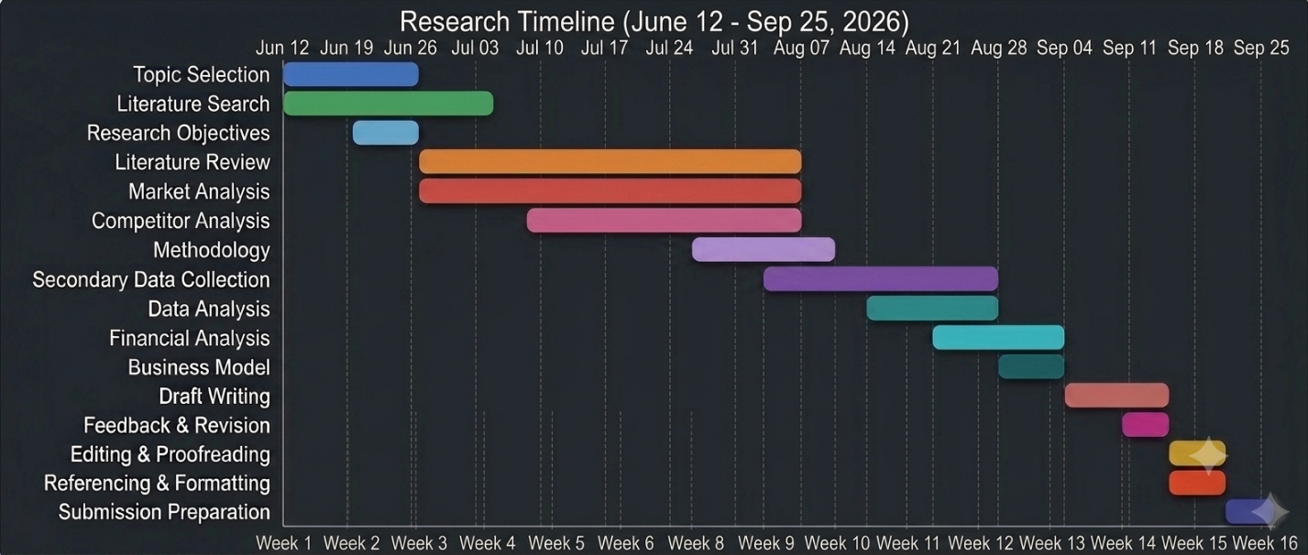

(Figure 6.1. – The Gantt Chart)
  - (Source: Self-Created using Google Gemini AI, 2026)
The Gantt chart shows project activities from the start of the murder up to the BDP suggestion deadline. The timeline is designed to ensure that all stages, including research; analysis; routine; and revision, are completed before the final subscription date.

Conclusion
This business development proposal evaluates The Pulse Corner’s feasibility as a family-friendly Café and co-working community hub in Richmond, London. Using respected business frameworks like JTBD, PESTLE, Porter’s Five Forces, Value Proposition Canvas, and The Business Model Canvas, I will check customer needs, market fit and commercial viability.

Preliminary findings suggest growing demand for flexible workspaces and family-friendly services, supporting the feasibility of The Pulse Corner.

References
Bank of England (2025) Inflation and household spending trends. Available at: https://www.bankofengland.co.uk (Accessed: 22 July 2026).
Canva: Visual suite for everyone. Available at: https://www.canva.com/ (Accessed: 11 July 2026).
Christensen, C.M., Hall, T., Dillon, K., and Duncan, D.S. (2016) Competing against luck: the story of innovation and customer choice. New York: Harper Business.
Deloitte (2023) The future of work: flexible working and workforce transformation. Available at: https://www.deloitte.com/ (Accessed: 09 July 2026).
Google (2026). Gemini AI. Available at: https://gemini.google.com/ (Accessed: 11 July 2026).
Grundy, T. (2006) ‘Rethinking and reinventing Michael Porter’s five forces model’, Strategic Change, 15(5), pp. 213–229.
IBISWorld (2025) Cafés and coffee shops in the UK. Available at: https://www.ibisworld.com (Accessed: 22 July 2026).
JLL (2023) Global flexible office and workspace trends. Available at: https://www.jll.com/ (Accessed: 09 July 2026).
JLL (2025) The flexible office space imperative. Available at: https://www.jll.com/ (Accessed: 22 July 2026).
Johnson, G., Whittington, R., Scholes, K., Angwin, D. and Regnér, P. (2020) Exploring strategy: text and cases. 12th edn. Harlow: Pearson.
Joyce, A. and Paquin, R.L. (2016) ‘The triple-layered business model canvas: a tool to design more sustainable business models’, Journal of Cleaner Production, 135, pp. 1474–1486.
Klement, A. (2018) When coffee and kale compete: become great at making products people will buy. CreateSpace Independent Publishing Platform.
McKinsey Global Institute (2021) The future of work after COVID-19. Available at: https://www.mckinsey.com/featured-insights/future-of-work/the-future-of-work-after-covid-19 (Accessed: 09 July 2026).
Office for National Statistics (2023) Homeworking and hybrid working in the UK. Available at: https://www.ons.gov.uk/ (Accessed: 09 July 2026).
Office for National Statistics (2024) Hybrid working in Great Britain. Available at: https://www.ons.gov.uk (Accessed: 22 July 2026).
Office for National Statistics (2025) Self-employment statistics, UK. Available at: https://www.ons.gov.uk (Accessed: 22 July 2026).
OpenAI (2026) ChatGPT (ChatGPT 4o) [Large language model]. Available at: https://chatgpt.com (Accessed: 11 July 2026).
Osterwalder, A. and Pigneur, Y. (2010) Business model generation. Hoboken: Wiley.
Osterwalder, A., Pigneur, Y., Bernarda, G., and Smith, A. (2014) Value proposition design: how to create products and services customers want. Hoboken: Wiley.
Porter, M.E. (1980) Competitive strategy: techniques for analysing industries and competitors. New York: Free Press.
Richmond Council (2024). Borough demographic and economic profile. Available at: https://www.richmond.gov.uk (Accessed: 22 July 2026).
Ulwick, A.W. (2016) Jobs to be done: theory to practice. Austin: Idea Bite Press.
Yüksel, İ. (2012) 'Developing a multi-criteria decision-making model for PESTEL analysis', International Journal of Business and Management, 7(24), pp. 52–66.

