An enquiry into the perceptions and attitudes of the importance of climate change education in the context of curriculum design.

Stephen Hadley
ECEG7002Q
31st March 2023
Yr Athrofa: Education and Humanities

DECLARATION FORM


Name of the Programme of Study: MA EDUCATION

Name of Student (Capital Letters): STEPHEN HADLEY

DECLARATION

I certify that the whole of this work is the result of my individual effort, and that all sources have been acknowledged.

Signed ............................................................... (Student)

Date ...............................................................

DECLARATION

I am satisfied that this work is the result of the Student’s effort.

Signed .............................................................. (Lecturer)

Date ..............................................................

Acknowledgments
Abstract
The existential threat of climate change has dominated public discourse following a succession of extreme weather events and a growing awareness of projected changes to future global weather patterns. The current rate of climate change will lead to a transformation of future social and economic models. This in turn will demand changes to individual and collective behaviour, thus placing focus on how to prepare young people for this through school-based climate change education. Debate exists over the position of climate change education in the school curriculum given the challenges facing future generations. This has led to discussion over which curriculum model could provide the best platform for the delivery of purposeful climate change education.
This study explores the perceptions and attitudes of CCE in the context of curriculum design. It engages with debates over the priorities in curriculum design and content and what is deemed to be ‘essential knowledge’. Furthermore, it examines how a school curriculum can deliver CCE more effectively in the future. In addition, it looks at the delivery of CCE within a curriculum, assessing the interdisciplinary, multidisciplinary, and disciplinary approaches in building awareness and understanding of climate change.
Two research methods were be used for this study. Questionnaires investigated respondents’ experiences with CCE in the context of curriculum design. This determined the prior experience of the respondent and explored attitudes to CCE within the Curriculum for Wales. It also asked how a curriculum design can best facilitate awareness and understanding of climate change. The questionnaire used mixed methods to produce quantitative and qualitative responses. Questionnaires were offered to the full range of professionals within seven schools. In addition, four semi structured interviews were conducted to elicit qualitative data from senior professionals in schools responsible for the decision making around curriculum design and content.
This enquiry was considered in the context of the new Curriculum for Wales. This has provoked focus on curriculum reform and discussion over what key knowledge, skills and understanding are important today and in the future. An additional context to note is the Well-being of Future Generations Act (2015,) which places a legal responsibility on policy makers to improve the social, economic, environmental, and cultural well-being of Wales. No other country in the world has made this commitment.
Findings suggest there is a strong awareness of the importance of CCE and an appreciation of its overall importance in the school curriculum. Responses stated that is addressed by all teachers in a range of settings within school. There was little resistance or complacency with the idea of further development of CCE. This is combined with a willingness to make progress in the development of CCE the schools. The context of education reform in Wales has contributed to a greater awareness of different curriculum designs. Links were made with progress in the implementation of the new curriculum with the evolution of CCE in schools. Furthermore, there is an awareness of a multidisciplinary mode of delivery and aspiration to progress to a more embedded interdisciplinary approach, which recognised by previous research the most effective method in delivering CCE. This research identified that there is strong knowledge and understanding of climate change from a global perspective in schools However, that more focus is needed on actions and responses on a local level and looking at CCE through more authentic contexts.

Acronym
CONTENTS
- Introduction

- Literature review
Themes –
- Curriculum design in relation to effective CCE.
- Approaches to delivering CCE in a school curriculum - the relative value of disciplinary, multidisciplinary, and interdisciplinary approaches in teaching CCE.
- The role of knowledge in CCE.

- Methodology
- Research design – case study, use of constructivist paradigm.
- Sample/Population
- Data gathering, procedure and analysis – questionnaire and interviews.
- Ethics
- Trustworthiness

- Results
- Questionnaires
- Interviews

- Evaluation of results

- Conclusions and Recommendations
- Summary of main findings
- Conclusions
- Positioning and developing the research.
- Recommendations.
7. References
8. Appendices
- Ethics Forms
- Participant info

Introduction
My interest in this area of study is both professional and personal. As a Lecturer of Education, with a responsibility for PGCE Geography students, my teaching covers the topic of climate change. I aim to develop the student teacher’s knowledge and understanding in these areas. This also involves considering the use of effective pedagogy in the delivery of this element of the curriculum. Furthermore, my involvement in the Welsh government funded CAMAU project, designed to support education strategy in building a new curriculum, pedagogy and assessment arrangements, has directly led to work with curriculum design. This enquiry can inform my work at UWTSD for the students, schools, and colleagues that I support.
From wider perspective, interest and motivation comes from the appreciation of the importance of the climate change issue. There is a growing acknowledgement of the magnitude and speed of climate change and discussion has evolved on the actions needed to mitigate and adapt to its impact. With future generations facing dramatic change to climatic, societal, and economic models, focus has fallen on how to educate and prepare for response and adaptation in the short-, medium- and long-term contexts. The importance of this is clear in a statement released by UNESCO (2017)
‘Education plays a paramount role in raising awareness and promoting behavioural change for climate change mitigation and adaption. It helps increase the climate change mitigation and adaptation capacity of communities by enabling individuals to make informed decisions.’
In addition, from a global perspective, the prominence given to this issue is evident in the ‘UN Agenda 2030 Sustainable Development Goal (SDG) 13 “Take urgent action to combat climate change and its impacts”. This document includes a specific target to improve climate change education.
However, recent observations of the education system have led me to consider the importance and profile of climate change education in the current curriculum in Wales. I have noted increased focus and professional dialogue around issues such as the impact of Covid 19, decolonising the curriculum and social inclusion. This is evident in the professional learning offered, module design or eve agenda items in meetings. Clearly, these are all important issues that require action, but I have questioned why climate change education has not received the prominence and attention other educational issues/initiatives have had.
This point needs to be considered in the context of Wales being the first country in the world to place a legal responsibility on policy makers to create holistic solutions to improve environmental well-being, through the Well-being of Future Generations Act (2015). This legislation also outlines an ambition for a healthier and environmentally resilient society. Therefore, it is important to stress the necessity of addressing climate change as part of education policy in Wales as clear a legal position for all involved in the design and delivery of the curriculum.
These observations concerning the profile of climate change education are reflected in the position taken by the UK Student Climate Network (2021) over the current state of education in preparing the young people of today to cope with the challenges of tomorrow.
‘Our education system is failing us. We're not being adequately taught about the climate crisis in our classrooms. Schools are not preparing us for the world we're about to enter, yet still prepare us for jobs and a society based on the system that caused the crisis. We must urgently reform the national curriculum and learn to address the ecological crisis as an educational priority.’
Although this would be an expected position for an activist group with a sole focus, the points are nonetheless pertinent. Similarly, concerns over the place of climate change education in the curriculum were explicit in the ‘Teaching the Future’ (2021) survey which involved 4,680 secondary school teachers from England. In the survey, 41% of respondents claimed that climate change is rarely or never mentioned in their schools and only 5% of teachers stated that climate change is integral to many aspects of the curriculum. In addition, 65% of respondents felt climate change was not taught in a meaningful way within their subject, even though 90% said the climate was relevant to their subject area. Finally, 40% of respondents said they would like more time and capacity to devote to climate issues, as well as more cross-subject collaboration.
These concerns were identified earlier by Cantell et al. (2019) who stated that key questions needed to be addressed concerning the adequacies of models, structures, programs, and communications for capacity building effective CCE. Earlier influential research on the delivery of climate change education by Kagawa & Selby (2010) stressed that confronted by increasing climate change, nothing short of a paradigm shift in education is needed.
Overall, personal and professional experience, and an awareness of a growing debate over the place of climate change education in the school curriculum has created the desire to understand more about the teacher’s perceptions and attitudes around this. This will allow those involved in the research to evaluate their own, or their school’s approach. Dialogue around this topic can be a starting point for developing climate change education and its impact or reinforce and support approaches already developed. I propose that this research can aid my own practice in assisting teachers and schools to evaluate their own practice and support the aim of delivering effective climate change education in secondary schools. It also links to the overall process of curriculum design which has been prominent because of current educational reform. Redesigning and implementing a new curriculum in Wales has been the key focus since Professor Graham Donaldson’s Successful Futures report (2015), a seminal curriculum blueprint based on distinctive purposes delivered by six Areas of Learning and Experiences. This national focus of curriculum evaluation and design provides an ideal opportunity to examine specific features of the curriculum, such as CCE, and consider the relationship between CCE and the overall purpose of the curriculum.
Chapter 2 – LITERATURE REVIEW.
This review focuses on several major themes which emerge repeatedly throughout the literature reviewed and are particularly relevant to education in Wales. These themes are:
  - Curriculum design in relation to effective CCE
  - Approaches to delivering CCE in a school curriculum - the relative value of disciplinary, multidisciplinary, and interdisciplinary approaches in teaching CCE,
  - The role of knowledge in CCE.
With the research focus on education in Wales, literature that related the specific context around curriculum design, and CCE’s place in that played an important role. However, it was crucial to use a full range of literature from all over the world, looking at a range of education systems. It can be argued that it would be problematic to focus on literature from countries with more acute climate change issues, or potential climate issues, as every country is experiencing climate change in some form. Furthermore, was important to engage with research spanning the last 30 years as the debate around climate change has evolved, with climate change denial subsiding in the face the increasing range of data provided and the reality of increased extreme climate events. This is a potential influence on the research on CCE.
i. Curriculum design in relation to CCE
In discussing the position of climate change education in curriculum design it is necessary to consider a range of desired outcomes from a curriculum. Curriculum design can be defined as the deliberate, purposeful and systematic organisation of a curriculum with the goal of improving learning (Schweitzer, 2019). It is also important to explore which type of curriculum design would foster the most effective delivery of climate change education that would allow young people that understand climate change and respond effectively to the social, economic and environmental challenges presented. Irwin (2020) stresses the crucial role education can play in combating climate change and moving to a post-carbon world. For this to happen effectively, curriculum designers need to have a clear grasp of the problems, and a plan for remedial action that will make necessary changes to what is taught in schools. However, Whitehouse (2006) identify that a major issue with a majority of formal curriculum is that they are constructed from previous experiences and tends to reproduce what has occurred before. This provides an obvious problem when considering climate change as previous decades have been characterised by greater climate stability and climate change was not commonly viewed as an existential threat. This perspective was reasserted by Irwin (2020) that curriculum in most areas is unchanged by climate awareness. If it is to be acknowledged that our curriculum should reflect the needs of society in the present and in the future as noted by Enser (2021) then is important to acknowledge CCE’s position in the curriculum as society will need to adapt to the impact of climate change.
The following section explores a range of factors that can drive curriculum design and what approach might best accommodate effective climate change. Enser (2021) identified that curriculum should be designed to equip children with the skills for life whilst looking after mental health and wellbeing. In addition, a curriculum can be designed to develop character, making pupils resilient and in turn developing moral character leading to empathetic and socially responsible adults. In a more general sense, a curriculum can be designed to be broad and balanced leading to range of academic activities. In earlier research, a different perspective was offered by Kilpatrick (1926) who stated that schools should be places of experience. If the experience is to be relevant and personal to the pupils, then surveying pupils can be important to discover their precise interests so that we can tailor the curriculum to them. However, this approach can be problematic. Enser (2021) argues that the fundamental flaw is by basing a curriculum on the experiences that pupils can readily access, or have already had, we don’t add anything new; they are denied access to knowledge from beyond their own narrow range of experiences. This point is evident in research by Kagwa & Selby (2010) who stress the necessity for teachers to reconsider the impact of the invisibility and uncertainty of climate change and the new experiences that will arise from that. Because of this, they suggested that teachers need to respond with urgency and be radical in their curriculum and lesson planning.
Stenhouse (1975) identifies three starting points for school level curriculum design. Firstly, a content curriculum, where specification of content is taught as a starting point. it can be argued that a content curriculum can provide essential knowledge that can empower young people. A knowledge-driven curriculum is evident in England, driven through government policy and OFSTED. Furthermore, this approach is evident in the social realism advocated by Young (2010) which stresses that school study should be based on academic disciplines creating a powerful knowledge. This was a perspective is further developed by Dewey (2011) who advocates decisions on curriculum should be centred on the criterion of social worth. It is possible to see how a content driven curriculum design could lead to exposure to powerful knowledge (Young, 2010). Enser (2021) understood this knowledge is created in academic disciplines which are engaged in their own search for truth. The sense of clarity and truth in knowledge is crucial in an impactful delivery of climate change education.
However, it can be argued that there are limitations with a content curriculum. It can allow scope for gaps to form in curricula, particularly if it is built around the traditional subject disciplines. This approach runs the risk of neglecting the sociological, political, economic knowledge required for action in the face of climate change. There is also potential for a content driven curriculum to become too focused the transmission of facts and information at the expense of knowledge and understanding. This point is taken further by Whitehouse (2006) who stressed that the traditionally discipline-based curriculum, while providing a framework for learning about climate change, does not lend itself to the creation of more integrated approaches to the delivery of climate change education.
Stenhouse’s (1975) second design focus identifies the specification of outcomes to be achieved. As with a content driven curriculum, an outcomes-based curriculum is subject articulated. However, the learning outcomes drive design and as a result accountability on a pupil, teacher and school become inevitable features. This has been a key feature of curriculum design in England and Wales since the introduction of the National Curriculum and the subsequent use of levels in assessing pupils. The recent and deliberate shift away from this approach in Wales, following the Successful Future’s report (2015), highlights the issues that can arise with basing curriculum design around outcomes. It can lead to a focus on strategic compliance and performativity combined with a sense of losing focus on the big picture (Enser, 2021). This is supported by Whitson (2008) who identifies a tendency to view education as a matter of production, rather than formation if curriculum design is outcomes based. This reinforces the work of Britzman et al. 1997 who notes that across the age range, classrooms had become essentially places to practice techniques, particularly from an assessment perspective, without addressing the complexities of the pupil’s life in the present and the future.
With that in mind, it is possible to understand why education systems might consider a process driven curriculum as vehicle for effective CCE. Stenhouse (1975) identifies this as a third starting point, which has the specification of long-term goals and educational purposes acting as a key driver for content and methods are then selected which are deemed to be fit for purpose. This involves the foundation for curriculum design being based on concern regarding the nature of the child and its development as a human being, rather than being based around the idea of knowledge, the transmission of culture, or a statement of the outcome to be achieved (Kelly, 2009). Biesta (2013) addresses this perspective, concluding that that schools should be providing an education that meets the needs of society, largely by training children ready for employment and possibly developing their character in such a way as to be useful to wider society.
However, it is important to note that Biesta (2013) argues beyond this one perspective in curriculum design, arguing that education is multidimensional and that schools should balance the competing demands of qualification, socialisation and subjectification. This suggests that it is problematic to solely focus on one of the three approaches to curriculum design offered by Stenhouse (1975). Qualification without exposing pupils to subject traditions or affecting their awareness of themselves in relation to that knowledge. Biesta’s perspective on curriculum design offers a way to incorporate the delivery of effective climate change education. Reid (2019) identifies this as viewing the qualification context as concerning the acquisition of knowledge, skills, and dispositions and seeing this in the context of climate change education. This might involve allowing students to understanding why climate change is important to address in their lives, and those of others. Biesta’s socialisation domain is about the ways in which, via education, we become part of established traditions and ways of being and doing. Again, Reid (2019) indicates that could be demonstrated through learning to work with others to advance solutions to climate change problems in the local to wider communities they are a member of. Finally, Reid (2019) argues that that Biesta’ subjectification domain offers the most relevant view on delivering effective CCE education within a curriculum. This is because subjectification centres on the personal, responsible actions within a context. Therefore, the process of subjectification in a classroom can be a vehicle for introducing new ideas to address the unprecedented challenges of climate change.
Marsden (1997) agrees with the stance taken by Biesta (2013) and believes that all three of multidimensional educational purposes co-exist. However, he suggests that it is difficult to deny that there are shifts in which a purpose dominates at any one time in the curriculum and that there is a great deal of overlap between them. Marsden (1997) argues that the shifts between subject knowledge transmission, wider educational orientation and social dimensions of education are part of a constant flux in schools. This idea is also seen in Lambert and Hopkin’s (2014) approach to curriculum construction. This is based on the idea that the curriculum will ultimately be an outcome of the dynamic interaction between three domains: the student, the way a subject is taught, plus the broader social purposes of education.
The idea of process-based curriculum is central to education reform in Wales. The Curriculum for Wales displays many elements of a process/purpose curriculum and through the Successful Futures report (2015) has outlined has set out a clear direction for the future of Wales. The Welsh government (2020) states that this curriculum will contribute national and global policy initiative in the shape of the Well-being of Future Generations Act and with the United Nations Sustainable Development Goals. This shift in curriculum design is has given opportunities for teachers to be empowered and creative, and to provide a relevant vehicle for learners through four clearly designed purposes placed in a local context. This links to Kenis & Mathijs (2012) findings that identified great value in encouraging students to be agents of wider change within their communities and as a result becoming more effective in terms of addressing climate change.
In contrast, direct reference to climate change in the English National Curriculum is found in the disciplines of Science and Geography. Howard- Jones et al (2021) identifies that despite this and unrelated to their subject discipline, teachers favoured a cross-curricular approach with a majority already communicating to their students about it. In addition, this research also noted that the National Curriculum in England does not currently require students to understand the broader impacts of climate change on the environment, society, and economy, or to consider issues of social justice in relation to climate change. This position offers an alternative to Wales and the Well-being of Future Generations Act, as there is no compulsory requirement for students in England to understand or engage with the forms of social action most likely to bring about societal change.
- Approaches to delivering CCE in a school curriculum.
Within a curriculum there are three approaches evident in delivering CCE, disciplinary, multidisciplinary, and interdisciplinary. Traditionally, CCE been delivered via the subject disciplines of Geography and to a lesser extent, Science. This point is reinforced by Thornton et al (2022) who notes that the curricular focus of a discipline-centred model mirrors the interests of scholars in the academic disciplines, and this leads to teachers in this model, consequently viewing themselves as "geography” teachers alone.
From a disciplinary approach, Geography as a subject provides the knowledge and skills necessary to engage this position and engage critically in the discussion on climate change (Chang, 2012). This point helps explain the traditional position of climate change education in curricula. Furthermore, the use of a disciplinary approach to teach about climate change is intrinsically linked to the ability of geography teachers to provide significantly more knowledge and understanding about the issue, especially the scientific aspects of climate change (Ho, Li-Ching, Seow, 2017). This dynamic was also identified by Anyanwu et al (2017) who researched climate change education in South Africa, Canada, Greece, and Turkey. They identified a statistical difference between teachers of different specialisations, which indicates that specialisation impacts on teachers' understanding and knowledge about climate change. This supports the widely accepted premise that experience was found to have a significant bearing on teachers' knowledge and understanding of climate change. (Anyanwu et al 2017)
Chang (2016) argued that the subject of Geography is the best place to teach about climate change using a range of geographical concepts such as human–environment interaction. This is supported by Chalkey et al. (2015), who stated that geography is suitable for learning about complex environmental issues and problems because it is characterised by an integrated and multi layered approach towards relationships between people the environment. This is further developed by Reid (2019) who observed that Geography taught in schools is characterised by specific pedagogies based around text and media resources, place-based fieldwork, and inquiry. These are particularly relevant to teaching and learning about climate change issues. With this in mind, there is greater responsibility for geography and environmental teachers to provide careful attention to the positioning and framing of climate change education within schools (Ho, Li-Ching, Seow, 2017)
However, the use of the single discipline of Geography as a vehicle for CCE, has been questioned for its traditional approach, such as limiting the range of content taught and focusing more on physical processes. These findings have been supported by Gaudelli and Heilman (2011) have also criticised the traditional discipline-centred approach to climate change education that perceives students as geographers who attempt to build knowledge of a subject discipline. This theme is reinforced by Aarnio-Linnanvuori (2013) who concludes that where schools are organised around subject specific structures the wider human perspective and societal understanding of environmental studies can be missing. As a result, the holistic understanding of climate change and its impact has thus been lacking. In addition, the focus on subject based, disciplinary model identified by Gaudelli & Heilman (2011) provides challenges in using a process curriculum domain and the subjectification domain which are both identified as important drivers in constructing effective CCE. (Biesta, 2013)
Yet, is important to note that research suggests that Geography teachers, despite the obvious connection to climate change education, are not resistant to the multidisciplinary or interdisciplinary approaches. Hinde et al (2011) found that geography educators explicitly believed the subject facilitated effective material for reading and comprehension exercises. Furthermore, it complimented the sciences, because earth science and human-environment interaction are two major traditions of study in geography.
Ho, Li-Ching, Seow, (2017) also identified in their research that the delivery of climate change studies is often placed in the hands of geography teachers. However, this can have a negative impact as many geographers that take it for granted that their discipline is particularly best suited for the teaching and learning of all environmental issues above all other disciplines. This mindset can produce a lack of appreciation of alternatives, including a multi-disciplinary approach. In contrast to the disciplinary approach, climate change education can be delivered, and arguably more effectively, through a multi-disciplinary approach. Lawrence (2012) suggested that teachers could consider alternative subjects and consider combining them in a in disciplinary manner, rather than just viewing climate change solely as a geography topic. This point is developed in research conducted by Schreiner, Henriksen, and Hansen (2010) who noted that the climate issue is extremely complex and encompasses a range of traditional academic disciplines such as natural, social and political sciences as well as history, geography, economics psychology, philosophy and ethics. In most educational systems, these disciplines are delivered independently of one another and not conducive in providing effective climate change education.
In stressing the benefits of a multidisciplinary approach to CCE, Klosterman & Sadle (2010) observed that students had improved their content knowledge through the integration of socioscientific issues such as climate change, into the science curriculum. This approach asked pupils to use higher order thinking skills to evaluate, analyse and synthesise information as they learn, triggering discussion of the climate change issue with peers, thus further facilitating their knowledge, and understanding.
This multidisciplinary approach is evident in the new Curriculum for Wales. The ‘Inclusion of sustainability and climate change in the national curriculum’ research briefing (2021) made specific reference to how climate change might be addressed areas of learning and experience. It suggests that the Geography aspect of the Humanities area in a school’s curriculum should provide a rich context for exploring the issues of sustainability, climate change and energy choices, whilst the Humanities in general could examine the context of the climate emergency through exploring the industrial revolution, the distinct geography and topography of Wales, and international relations. It also identifies Science and Technology as an area that can addressed the climate emergency.
Further support for the multidisciplinary approach can be found with in research conducted by Dupigny-Giroux (2010) who note an effective way to facilitate climate literacy, an understanding of the influence of climate on yourself and society and your influence on climate, was through a multi-disciplinary approach that covers both the social and natural sciences. This study stresses that delivering the climate change topics needed teaching and learning that encompassed a critical investigation of human interaction with the environment. Linking to this theme, Ho, Li-Ching & Seow’s, (2017) study of education system in Singapore and the Philippines noted the importance of different areas of the curriculum delivering CCE. However, they identified another dynamic which the necessity to build connections and collaboration across subject disciplines to address the links that exist across various socio-economic and ecological systems. This acknowledges an interdisciplinary approach as being more effective in delivering CCE. This also supports Kagawa & Selby’s (2010) assertion that wherever it is delivered, CCE will be most effective if it is a holistic and social learning process stressing the importance of an interdisciplinary response. More recently, Hawkey, James, & Tidmarsh (2019) support this position stating that climate change must be addressed in the curriculum by interdisciplinary frameworks of understanding that includes its ethical dimensions.
The importance of an interdisciplinary approach was furthered by Oldakowski & Johnson’s (2018) research into the use of interdisciplinary curriculums has indicated improved delivery of climate change education. They highlighted a range of studies that demonstrated that by embedding geographic principles such as basic place familiarisation, physical geography and earth science, and local culture and identity into literacy, mathematics, and science lessons impacts student-learning outcomes in a positive fashion (Gehlhar & Duffield 2015). Furthermore, the interaction effect of combining geography with literacy, Maths, and Science has been positively received by educators (Jo & Bednarz 2014). However, despite the evidence that interdisciplinary formats have real benefits in delivering climate change education Schreiner, Henriksen, & Hansen (2010) highlight that the structure of most schools do not support such interdisciplinary collaborations.
- The role of knowledge in CCE.
Discussion around curriculum design can lead to questions around what knowledge students need. As a result, in examining perceptions and attitudes to CCE, it is appropriate to consider climate change knowledge and its relationship with curriculum design and content. From a climate change education perspective, this idea of knowledge has been examined by Monroe et al (2019) whose literature review on assessing the degree of effectiveness of CCE strategies identifies that making climate change information personally relevant and meaningful for learners as key. Monroe et al (2019) also found that for learners there was great value in engagement in designing and implementing school/community projects to target some element of climate change. It is important to avoid climate change knowledge remaining to be largely made of inaccurate and incomplete conceptualisations, despite its acknowledged importance and relevance (Chang, 2016). Earlier research from McCaffrey & Buhr (2008) notes a similar theme where a great disconnect was observed between actual climate science knowledge and perceived knowledge. These findings provoke questions regarding what knowledge is the most appropriate to teach when we are considering CCE.
Henderson (2019) identifies that educators and researchers have attempted to shift CCE away from earlier and simplistic versions of information transmission and toward a more socially complex approach. This links to the work Dijkstra & Goodhart (2012) who note that more environmental knowledge by itself, does not lead to changes in attitudes or behaviour. In contrast, Bassy (2020) argues beyond the transmission of knowledge that young people need to know about what is causing the climate to change for the worse as the Earth heats up, but also need to develop the personal skills to tackle the challenges that they may face in the future. This is position supported by Kenis & Mathijs (2012) who state the knowledge of root causes of climate change, visions on alternatives and especially strategies to reach these is needed for progress. However, any attempts at transformative change will have to challenge the entrenched conservative understanding of school knowledge identified by Dewey (2011).
This theme is further developed by Enser (2021) who noted the importance of those with knowledge being best placed to deal with society’s problems. If climate change is to be successfully address, then we need people who possess the powerful knowledge to solve them. A commonly covered topic used to illustrate that point, the challenges around single-use plastics are not going to be addressed by those who can design an engaging leaflet, but by people with excellent disciplinary knowledge on environmental geography and resource management. As a result, it is important to acknowledge the importance knowledge has on the curriculum. This theme is also evident in the work of Munroe (2019) who identifies when learners are given the opportunity to interact with specialist knowledge and experience the relevant processes for themselves, they gained a greater understanding.

Chapter 3 – METHODOLOGY
a. Design
The research paradigm of constructivism has been used for this enquiry. This paradigm assumes that the meaning of experiences and events are formed by individuals, and consequently individuals construct the realities in which they are involved. Furthermore, the researcher must understand that the broad assumption underpinning the constructivist paradigm is that knowledge is socially constructed by all participants active in the research. As a result, that the researcher should try to understand the complex reality that the participants are experiencing (Schwandt, 2000). This is reinforced by Charmaz (2006) who noted in using this paradigm a researcher must be aware that his/her interpretation of the area of study is itself a construction. In developing this position, it is useful to appreciate that the acknowledged co-construction of the researcher’s interpretation in constructivist research demands that the enquiry is both transparent and reflective in its nature. (Mills, Bonner, & Francis, 2006).
Within this paradigm, the school context plays an active role alongside the researcher’s values in shaping the perceptions of interviewees and respondents. Consequently, there needs to be consideration of ethics around researcher responsibility. Safeguards were needed to mitigate any challenges to the validity and reliability of the findings. These safeguards involved the use of two research methods and the provision of a clear rationale for the enquiry for all participants. The constructivist paradigm emphasises that research is a product of the values of researchers and therefore they cannot be independent of them. With my own career in education spanning 28 years with direct experience of the implementing the new curriculum for Wales in a pioneer school, combined with my work with curriculum and pedagogy at UWTSD, it is inevitable that I will have constructed my own reality. It would be unwise to approach this research believing that I could be independent from this focus.
The constructivist paradigm is generally related to qualitative methods of such as interviews, and questionnaires. Both methods were used in this enquiry with the understanding of the social construction of reality, emphasising that research is best conducted through the interaction between researcher and respondents. This was apparent in the use of four semi structured interviews. The level of interaction seen with the interviews was not visible with the questionnaires, but was still placed comfortably in this paradigm, where interaction is a feature.
A case study approach has provided the design frame for this research. Yin (2009) noted that case studies offer an in-depth study of current phenomenon as part of a real-life context. This is based on a range of evidence sourced from information, both qualitative and quantitative. This highlights the suitability of a case study approach for this enquiry. According to Hamilton and Corbet (2013), there are eight forms of case study. Within this enquiry, there are four types that arguably fit best. This case study can be viewed through an exploratory lens, with the collection of data trying to identify patterns in attitudes and perceptions relating to CCE in the context of curriculum design. Also, it is credible to view this enquiry as a reflective case study, where the research methods allowed the interviewees/respondents to reflect on the status of curriculum design and CCE in their own school. Arguably, a descriptive element can be identified, looking theories around curriculum design and the link to purposeful CCE. Finally, the explanatory lens that attempts to explain why attitudes and perceptions have evolved, could also be evident. There was scope for the active use of these four types of case study in this enquiry, thus reinforcing the overall suitability of the design frame.

b. Sample/Population
The research interviews focused on four secondary schools in South Wales. The targeted participants for interviews were decision makers in schools, including a head teacher, a deputy head, an assistant head teacher. By inviting those in leadership roles it allowed questioning of educators who are involved in curriculum design and have the capacity to provide an overview of different elements of the curriculum within their school. However, this did not ignore that the 4 participants had a unique professional background and range of experiences which would potentially lead to differences in their responses. The selection of the four schools resulted from my professional relationships arising from my roles in Welsh education as a PGCE tutor, CAMAU researcher and ERW External Consultant. These roles have involved collaboration with a range of secondary school across South Wales. This made it easier to approach schools to invite participation in interviews and questionnaires. Furthermore, there was a conscious decision to target a diverse range of schools for this research. This led to the sample including schools of different sizes, dealing with a range of catchment areas, in different regions of South Wales. Also, the context of curriculum reform in Wales and an understanding of the four schools’ engagement with this provided another factor in the identification of participants for interviews.
The questionnaire was issued to the four schools in which the interviewees were based, along with 4 additional schools. The interviewees completed the questionnaire before the interview. All teaching staff were invited to complete the questionnaire. Convenience sampling was used as non-probability sampling method due to ease of accessibility of the school and teachers linked to the university. The level of response was dependent on individuals were the most willing and able to participate. The advantages for using this approach lie in its practical criteria relating to availability and proximity of respondents (Musa et al, 2016). In addition, the data was available for use quickly. However, it is important to acknowledge that convenience sampling should not be seen as fully representative of all teachers and can be vulnerable to respondent’s hidden biases. (Mackey & Gass, 2005)
With regards to the questionnaire, the sample for was self-selected and it reflected the range of teachers within a school. This was based on a range of experience, subject specialism and positions held within school. A total of 47 teachers (10% cohort) responded to the request. They were spread across a range of disciplines and roles in school. The issue of response rates was a potential threat to the validity of the findings. This concern is supported by Drever (2006) who identified the problems of low response rates as well a lack of control and questions not being misunderstood with questionnaires as a threat to the validity of this method. Although the 47 responses fell short of the initial target of 50 identified in the ethics form, it still provided a viable number to ensure the validity of the research.

c. Data gathering, procedure and analysis – questionnaire and interviews.
The approach to researching the perceptions and attitudes of CCE were predominately qualitative as it is based on experiences and understanding of climate change education in the context of curriculum design in Wales. The use of semi structure interviews and questionnaires are qualitative in nature, however there were quantitative features arising from the responses and analysis of the range of questions used. The aim was for the interviews to take place after the questionnaire had been issued and completed. The questions in the interview would look to develop themes from the questionnaire.
Questionnaire
A questionnaire was designed to determine prior experience of the respondent and explore attitudes to curriculum design and CCE within Wales. It also asked about the importance of climate change, and how a curriculum can evolve to facilitate awareness and understanding of this particular focus. The questionnaire used mixed methods to produce quantitative and qualitative responses. However, there was more weighting of questions that produced quantitative responses, this balanced the rich qualitive data that the interviews provided. Numeric and measurable data which identified previous and current experiences with curriculum design and CCE were complemented by more in-depth qualitative responses at the end of the questionnaire, where richer thought and opinion were gained.
In the constructing the questionnaire, attention was given to Youngman’s (1982) list of 7 question types including scale-based questions and open/closed questions would be used in combination to investigate attitudes to CCE in the context of curriculum design. The Microsoft ‘Forms’ programme was used as a research tool to deliver the questionnaires as it is recognised and authorised by UWTSD. Also, the ‘Forms’ questionnaire format offered familiarity and simplicity in use for researcher and respondents. This range of questions provided both qualitative and quantitative responses that required statistical analysis, aided by the facility of transferring data into MS Excel for further scrutiny.
A questionnaire pilot was employed using a small group of educational professionals who had experience in teaching and research within a school context. According to Bell (2010) data gathering instruments greatly benefit from being piloted. This allows testing the length of time it takes respondents to finish the questionnaire, and to check the clarity of all instructions and questions Furthermore, a pilot can be used to improve the reliability, validity and practicability of the questionnaire (Oppenheim 1992). Direct consultation with the respondents from pilot did highlight minor issues with the clarity of two questions. As a result, amendments were made with the wording of questions. Bell (2010) suggests that care is required with wording and position of the questions, when asking for sensitive information about learning experiences. In addition, pilot feedback was also used to develop the scale of responses for the questionnaire. It led to the addition of a neutral option on the list of responses, avoiding a dichotomy in the respondent’s position to a series of statements relating to CCE. Finally, feedback provoked the redesign of the final question to facilitate more qualitive responses. Comments from the pilot noted with the emotive nature of climate change any respondent should have an option to explain their opinions and position in all issues raised across the questionnaire. By developing the questionnaire this way, it reinforced the use of the constructivist paradigm as any qualitative responses given will be socially constructed by the participants active in the research.
Interviews
Cohen et al, (2009) noted that questionnaires do not provide the best method in investigating complex issues. This was reinforced by Burns (2000) who questioned this method if additional probing is required. Therefore, to strengthen the validity and reliability of the research, semi structured interviews would be used as a second research method. These interviews targeted a range of senior leaders and developed themes used in the questionnaire. The semi structured interviews differed from the questionnaires as they focused on one groups of educators, senior leaders in school. This sample included a head teacher, a deputy head and two assistant head teachers, as opposed to the full spectrum of teaching staff targeted by the questionnaires. The interviews were planned around a semi structured format and lasted approximately 25 minutes in length. The questions looked to develop themes present in the questionnaire with the semi structured approach allowing flexibility for both the interviewer and the respondents. The semi structured approach was also necessary to allow a degree consistency between the four interviews. The use of an unstructured format would not have facilitated consistency. The responses arising from the interviews were analysed using the themes drawn from the literature.
A range open and closed questions were be included in the interview to elicit qualitative data. The interviews were conducted via the online platform of Microsoft Teams. Archibald et al. (2019) identified the viability of online platforms as a tool for collection of qualitative data because of its ease of use, cost-effectiveness, data management features, and security options. This research emphasised how this tool is useful in building and maintaining rapport with the researcher. It also identified the possibility of greater flexibility in where and when interviews can be conducted. This was evident with the 4 interviewees as the use of Teams facilitated greater cooperation with the participants as it was easier to schedule and allowed greater flexibility. All interviewees were familiar with the platform since the pandemic, were used to this form of meeting and dialogue. The platform allowed for the recording and transcribing of the interview. In addition to this, notes were taken to record key points and themes arising from the interviews. It might be suggested that the absence of a face to face interview could have impacted on the semi structured format with the, with the online method creating barriers in eliciting the rich data associated with this research method. It is possible the researcher would be unable to respond fully to some of the more nuanced signals from the interviewee, that may lead to further questioning. However, this potential weakness was mitigated through the professional relationship and rapport that already existed between the researcher and the participants. Also, the findings of Archibald et al (2019) did not identify the online format as a hindrance in the outcomes of research interviews.
The sample selection of 4 interviews attempted to minimise the subjective nature of response that can arise from interpersonal variables. However, with the research based in a constructivist paradigm, it was accepted and welcomed that biases were a constructed in any participants’ experience, and therefore valid in this research. The semi structured interview allowed questioning to develop themes from the in the questionnaire. However, the difference in the questioning reflected the difference in the perspective presented.
In the planning and use of the research methods it was acknowledged that potential weaknesses could exist. For example, researcher bias could impact the use of semi structured interviews, as interviewers are human and their manner can influence their participants (Selltiz et al, 1962) Also, with all interviews been led by one researcher there could be concerns with the interpretations of an individual’s point of view (Bell & Opie, 2002) As a result, awareness regarding this, and criticality over the interpretation of the data was deemed crucial to the validity and reliability of the inquiry (Bell, 2009). This reinforced the selection of two research methods to offer triangulation and balance the possible impact of researcher bias. Researcher bias could also manifest itself in the semi structured nature of the questioning in the interviews with the perception of questions being guided by the position of a university tutor, rather than a researcher. Similarly, there was recognition of further issues surrounding the use of semi structured interviews. The interviewer could be exposed to the inconsistencies of the participants interpretation and presentation of reality (Burns, 2000). Again, this was mitigated using questionnaires as another research method to strengthen the overall methodology.
Another potential weakness related to the ‘halo effect’. It was conceivable that my own position as researcher, and my previous work and collaboration with the schools in question of part of the partnership network could influence the process. With the questionnaire being issued by a UWTSD lecturer of Education, and the interviews being conducted by the same UWTSD lecturer, answers could be influenced by the status of the researcher and the institution. This could lead to responses that aimed to please or fit with the expected position on CCE and curriculum design. Furthermore, it was necessary to consider prestige bias on behalf of the respondent. This could provoke responses designed to not look bad or deflect issues that may have arisen within the school, particularly given the recent educational reform in Wales and the ongoing process of redesigning the curriculum. These points were mitigated through clear guidance regarding anonymity. In addition, it can be argued that the halo effect and prestige bias would be mitigated by the existing relationship between the researcher and the interviewee and by the experiences that the interviewees would have had in working directly with other researchers and external agencies.
The analysis of the transcripts from the semi structured interviews provided a complex task. A thematic approach based on Braun & Clarke’s framework (2006) was used for this. Within this framework, the coding of the transcripts to was used to highlight key themes and allowed the best use of the rich data formed by the four interviews. Codes were used to identity comments around curriculum design or climate change, positive or negative perspectives, current or future positions. This allowed the development of themes. Richards & Morse, (2007) noted that coding is the initial step towards in-depth interpretation and analysis. However, it can be argued there are some issues around coding that need considering. This is related to coding not being a precise science, and some elements of the transcripts could be unclear and do not work with the codes and themes established for the process. In addition, the use of multiple quotations from both methods needed careful attention as the meaning may have been lost in the interpretation of the data. The quotes used needed to typify the data. In conjunction with the use of Braun and Clarke’s framework, the constant comparative method was use in analysing the four transcriptions. This involved the comparison of different elements of the interview including sentences, phrases and paragraphs (Thomas, 2017).
d. Ethics
The BERA ethical guidelines for educational research provided the basis for the ethical scrutiny of this enquiry. The first ethical guideline of the responsibilities to participants required the most attention. It was important to be aware that the two research methods identified for this project were an intrusion into the professional life of the respondent (Bell, 2010). With this research being centred on examining the perceptions and attitudes towards the importance of climate change education in the context of curriculum design potential ethical issues around health and well-being needed consideration. The questioning process in both the questionnaire and the semi structured interviews probed significant questions around an existential threat and the response of the education system to this. Consequently, it was necessary to be sensitive to causing anxiety and alarm in the interviewee/respondent that could be related to teaching, or life outside teaching. As a result, an explanation of the rationale of research, and why that school leaders had been invited to participate in the interview process, or complete a questionnaire was provided (Bell, 2010). This process ensured that there was no doubt over whether an informed decision had been made to engage with the interview/questionnaire. Another health and wellbeing factor considered was the workload pressure associated with the senior roles asked to be interviewed, attempting to avoid a situation where participation in this project created stress. The use of online interviews was a means of negating the time pressure that comes with engaging with a research process.
According to Cohen et al (2009) the voluntary aspect of the questionnaire and the agency to withdraw at any point has to clear. The online questionnaire was designed with an initial page to read before the survey. It included a summary of the project, the information from the participant information sheet and the researcher’s contact details. A covering email accompanied the link to the questionnaire, explaining the nature of the research and stressed the optional nature of the questionnaire and the confidential nature of it. The final page of the questionnaire contained a ‘Submit’ button, combined with a statement reminding the participant that clicking the final ‘Submit’ button of the survey at the end would constitute the participant providing consent to participate, in full knowledge of the information contained in the participant information sheet. It was essential that the respondents were aware that the questionnaire would be anonymous and, therefore, it would not be possible to identify individuals in any publication or report. The questionnaire allowed respondents to state their subject specialism, position, and years of experience. Any identifying features of the school were removed from raw data, if this became a feature of qualitive data the school would be referred to as school X in any notes or data analysis.
These principles were applied to the semi structured interviews. The interviews offered anonymity to protect the interviewee and allow the opportunity to speak openly. Interviewees were provided with a prepared consent form to sign prior the interview. This was issued alongside a detailed information sheet about the research. This was designed to inform the participants what they were required to do and highlighted their rights regarding participation and withdrawal at any point of the interview. This was repeated at the beginning of each interview. The interview notes/transcripts used pseudonyms to prevent identification. As with the questionnaire, it was also stressed to the four interviewees that that the research adhered to the policy of the University of Wales, Trinity St David’s Ethics Committee.
Along with the ethics policies of UWTSD, the other 4 BERA guidelines for educational research were also applied to this enquiry. With respect to responsibilities to sponsors, clients and stakeholders in research, it was clearly communicated that the data collection, and analysis techniques, and the inferences drawn from their findings were conducted in a rigorous and robust manner. This occurred within the context and boundaries of the chosen paradigm of constructivism and the design framework of case study. In considering the responsibilities to the community of educational researchers, the research was conducted to the highest possible standards with an awareness of the importance of protecting the integrity and reputation of educational research in dealing with all respondents and participants.
In addressing the responsibilities for publication and dissemination it was acknowledged that this research on the relevant and immediate issue of CCE and curriculum design would provoke interest. Therefore, communicating the findings and highlighting the practical significance of the research would require clarity in language deemed appropriate for the intended audience. Discussion with participants during the research led to future plans to share of the findings within their school community to address their needs in developing purposeful CCE, all within the confidentiality parameters set out in the ethics process. Finally, the responsibilities for researchers’ wellbeing and development were also considered in the ethics process. It was recognised that safety is a concern in qualitative research, as it can be conducted in situations that carry risk. However, these risks were mitigated using online questionnaires and interviews.
e. Trustworthiness
The issues of validity and reliability were constantly addressed by the methodology of the enquiry. Validity was addressed through the construction of the questionnaire and interview question framework relating to the key points and themes arising from the literature. The use of a pilot further reinforced the validity of this research method. Prior knowledge of the participants and their role in school offered reassurance of their engagement in the research. The validity of sample was addressed using four schools for the interview and seven in total for the questionnaire. The validity of sample was enhanced by covering a range of schools according to size and catchment area. successfully targeting educational professionals from different element of senior management for the interview. In addition, all teachers were targeted in school and the results indicated that the full range of teaching staff, spread across all disciplines and all levels of responsibility responded.
Awareness of reliability focused on the consistency in the application of the research methods. Following the use of a pilot, the same questionnaire combined with the same process of issuing the questionnaire was used with the seven schools. Similarly, the semi structured interviews were also constructed around the same framework of questions. Overall, the use of mixed methods provided the basis of reliability and validity and helped mitigate issues such as researcher and prestige bias.

Chapter 4. -PRESENTATION OF THE DATA
- Research results - questionnaire
The questionnaire received 47 responses. It was sent to 7 secondary schools in South Wales.
1. What is your subject specialism?
The 47 responses covered the full range of subjects in the secondary school context. The highest number of responses came from Geography (9) and Science (8), these subjects would be the most comfortable with the focus of this research. The other subjects covered were Maths (6), English (5), History (4), ICT (5), RE (3), Welsh (1), Art (1), Drama (1), Law (1), Design & Technology (1) Vocational (1), ALN (1).
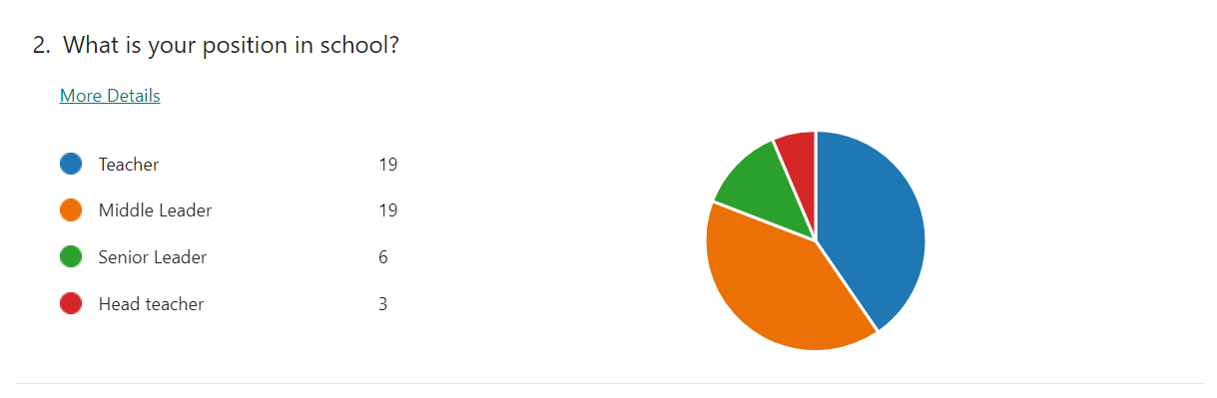
The questionnaire was issued with the aim that all teaching staff in school would be covered in the responses. This was achieved. The responses covered the full range positions in school, 40% of respondents were teachers, 40% middle leaders, 13% senior leaders and 6% headteachers.

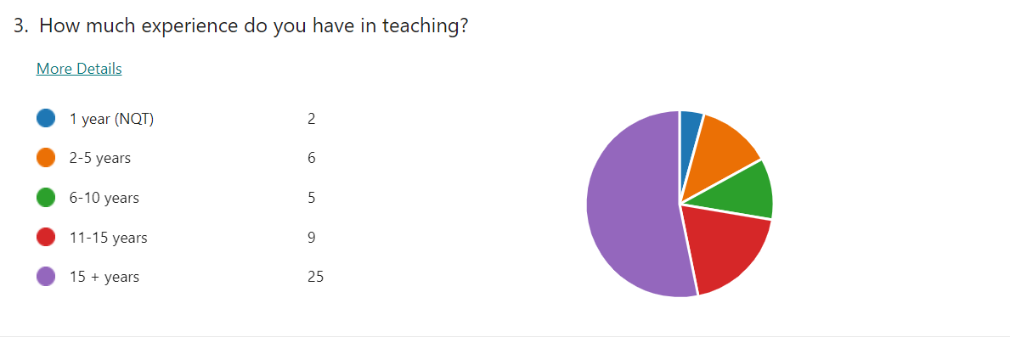
Most respondents had considerable experience in teaching, 53% had over 15 years, 19% had 11-15 years’ experience, 11% had 6 to 10 years, 13% had 2-5 years’ experience and only 4% were NQTs.

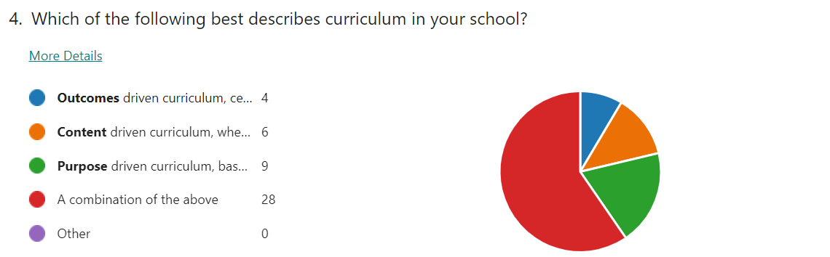
Most respondents, (60%) identified a combination of drivers to the curriculum in their school, 19% identified a purpose driven curriculum, 13% content, and 8% outcome. What is interesting here is the low % on outcomes driven curriculum given the accountability factor secondary schools experience with GCSE and A Level exam results.

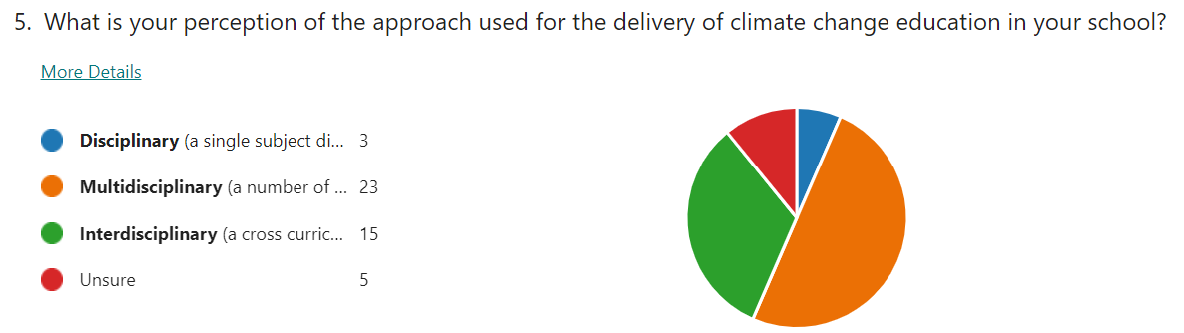
Most respondents, (49%) acknowledged a multidisciplinary approach to CCE in their school, 30% believed an interdisciplinary approach was used, 6% a disciplinary approach and 11% were unsure.

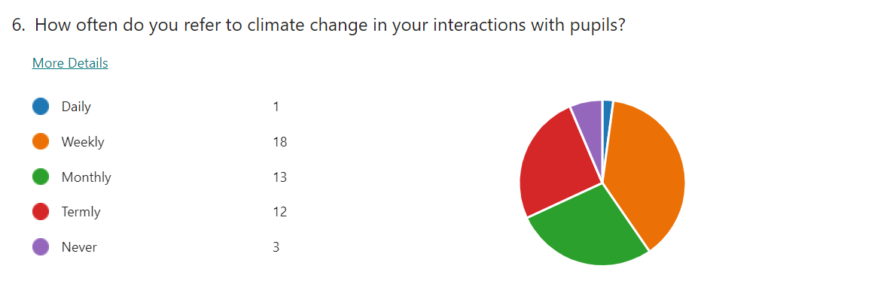
The greatest frequency identified by respondents was weekly (18%), 28% referred to climate change monthly and 26% termly. Daily reference to climate change was noted by 2% of respondents and 6% stated that they never referred to it at all.

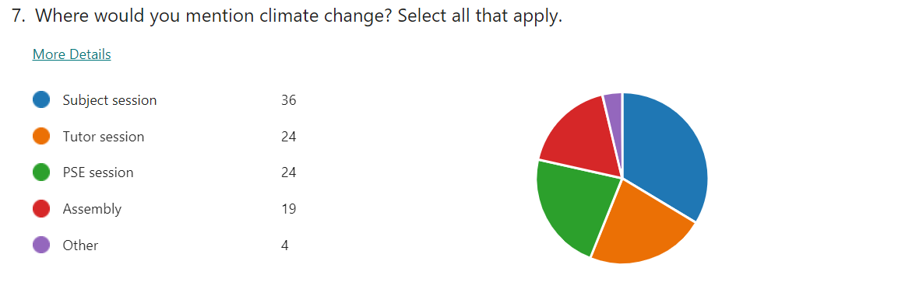
This question allowed participants to select all that apply from the list. The subject session was identified as the most likely setting to focus on climate change, at 34%. There was little difference between tutor session (24%), PSE session (24%) and assembly (19%).

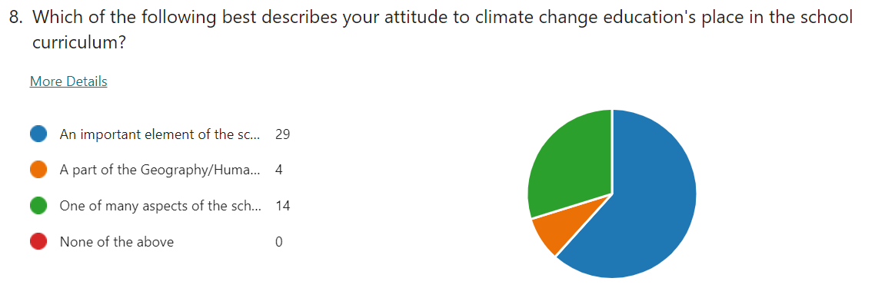
A majority of respondents (62%) believed that CCE was an important element of the school curriculum, 30 % believed it was one of many aspects of the school curriculum, and only 8% felt that it was part of the Geography/Humanities curriculum.

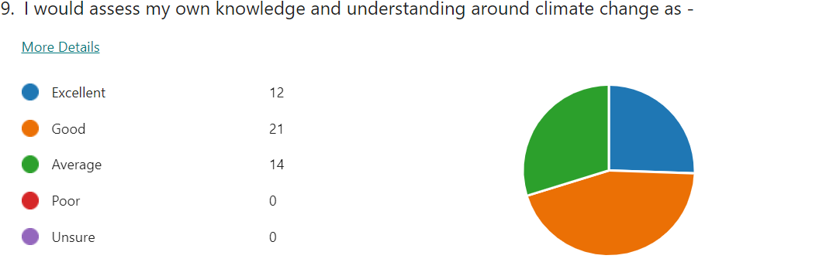
Respondents were asked to self asses their own understanding of CCE. All respondents felt their knowledge and understanding was average or above, 30% at average, 45% good and 26% excellent.

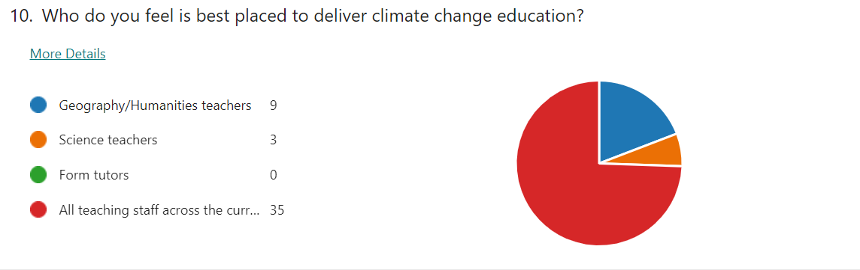
There was a strong reaction to the final ‘All teaching staff across the curriculum’ with 74% of respondents selecting this, 19% identified the disciplinary focus of Geography/Humanities teachers, 6% Science teachers. No respondents felt that form tutors were best placed to deliver CCE.

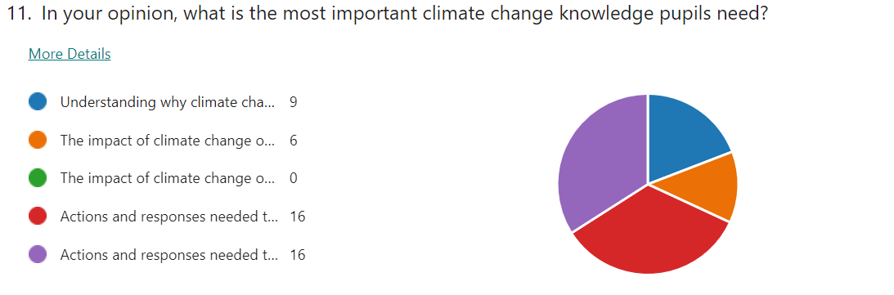
The actions and responses options, at global level and local level was selected by 34% for each one. The impact option on a global level was seen as the most important by 13% and interestingly no one believed that impact at a local level was the most important. Understanding why climate change happens was selected by 19% of the respondents.

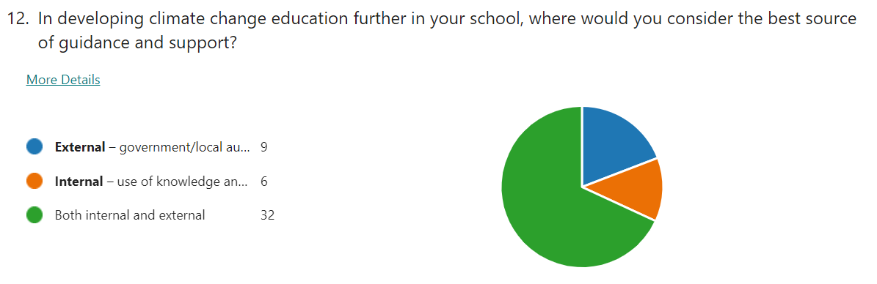
Both internal and external support was deemed to be the best source of guidance and support with the development of CCE (69%), whilst 19% believed that solely external support and guidance would help develop CCE, and 13% believed expertise existed in the school to develop it further.

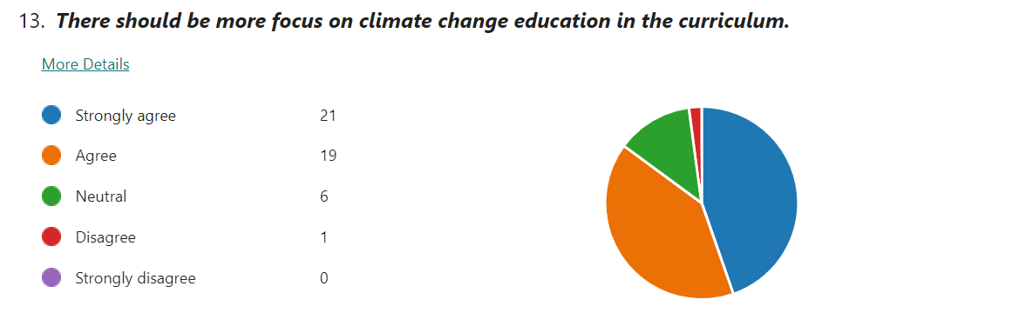
This stage of the questionnaire, Q13- 17, offered a series of statements to respond to. Regarding more focus on CCE in the curriculum 45% strongly agreed and 40% agreed. Only 2% disagreed and 13% took a neutral stance.

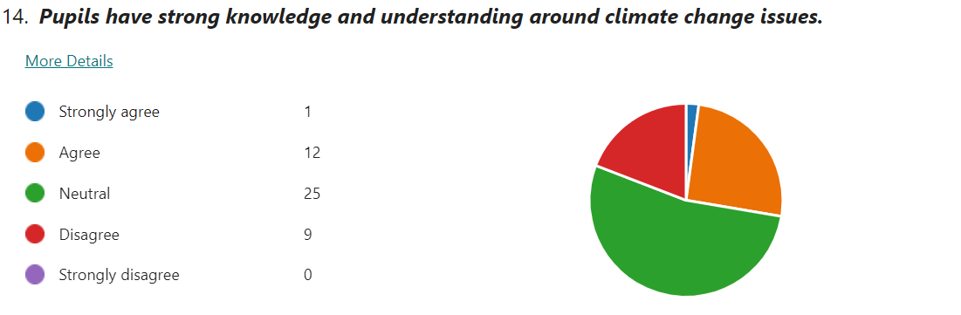
53 % of respondents remained neutral in considering pupils knowledge and understanding around CCE. This statement had the greatest range of responses, with 26% agreeing and 19% disagreeing. Only 2% strongly disagreed with the statement.

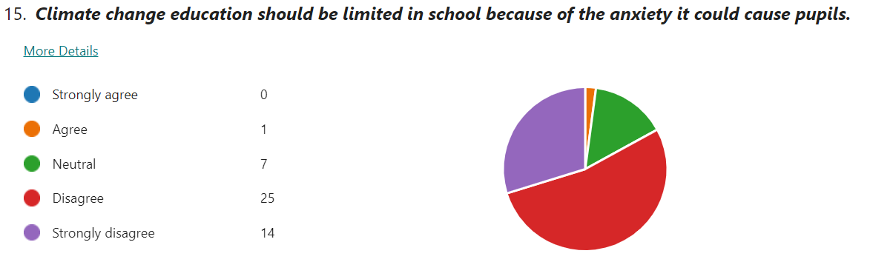
There was strong response against this with 53% pf respondents disagreeing and 30% strongly disagreeing. A neutral stance was taken by 15% and only 2% agreed.

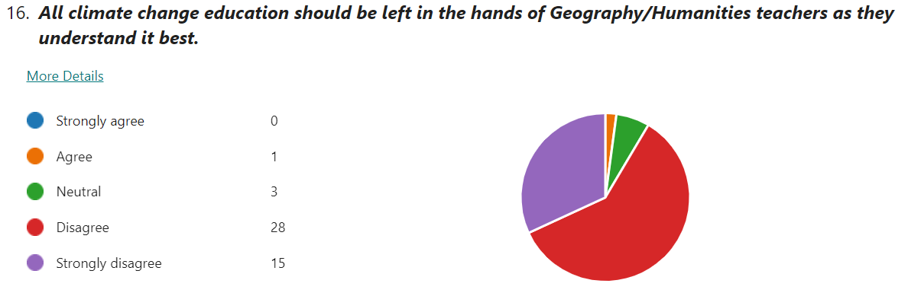
There was strong response against this with 68% of respondents disagreeing and 32% strongly disagreeing. A neutrals stance was taken by 15% and only 2% agreed. A neutral position was taken by 6% and only 2% agreed.

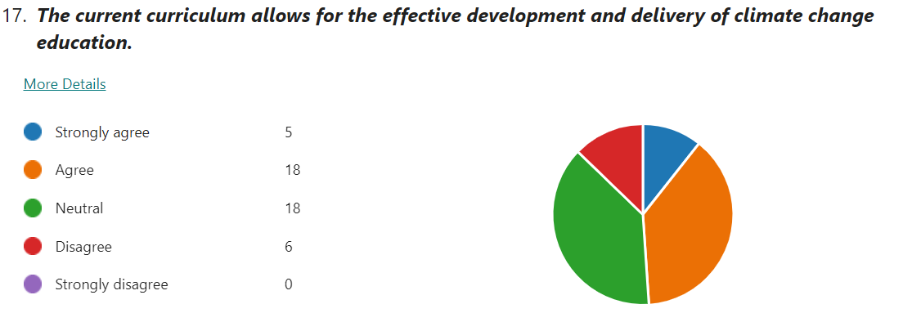
The response to this statement was less clear cut with 38% of respondents remaining neutral, 38% agreeing and 11% strongly agreeing. Only 13% of respondents disagreed with the statement.

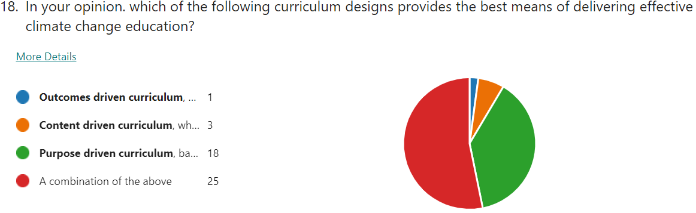
The final 2 questions acted as a conclusion, and an opportunity for respondents to connect CCE with the wider context of curriculum design. There was a high degree of similarity with the response to Q4. Once again, the combination of curriculum designs was that most popular opinion held (53%), purpose 37%, content 8% and just 2% believing that an outcomes curriculum is best placed to deliver effective CCE.

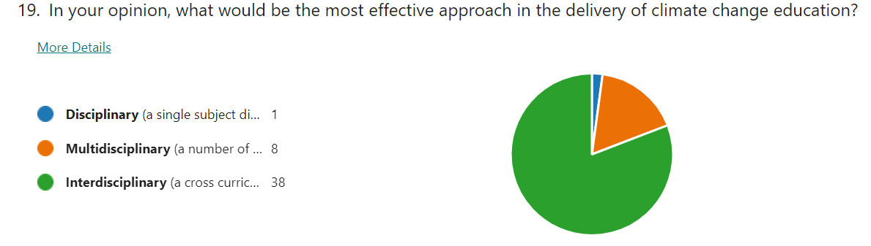
These categories were used in Q5. Most respondents (81%) identified the Interdisciplinary approach as being the most effective, 17% selected the multidisciplinary approach and just 2% selected the disciplinary approach.
20. Please use the box below if there are any points from the previous questions that you wish to expand on.
An opportunity was given to respondents to expand on any of the questions in the questionnaire, creating more qualitive data. The one main theme to arise from the 8 responses was the sense of all areas of the curriculum having a responsibility to deliver CCE.
‘we are able to incorporate climate change information and topics into many of our subjects or our registration classes’
‘I really hope this questionnaire sparks conversation in school about where climate education fits in multiple subjects.’
‘all subject areas can introduce elements into their curriculum that discuss directly or touch upon the causes, effects and response to current climactic changes’.
‘…with every subject incorporating some aspects of CC into their curriculum where appropriate’.

- Semi Structured interviews – results

1. What is its overall purpose of your curriculum, what do you want it to do for your pupils?
This opening question was designed to engage with the context curriculum design before moving into the more specific focus of climate change education. There was a degree of commonality in the responses, with two main strands arising. Firstly, both p1, p2 and p3 focused on the curriculum being designed to there to provide skills and knowledge which allows students to make informed decisions in the future. Secondly, all interviewees referred to the type of individual that they want the curriculum to produce. p4 and p1 referred to producing ‘resilient learners’, P3 identified healthy, confident, and ethical individuals p2 and p3 made explicit links to the four purposes that underpin the curriculum for Wales. Alongside this, p1 and p4 noted that it was not about all about GCSE grades, there was a bigger picture in looking at curriculum, whilst p3 made a distinction between the focus of content to the process of how learning happens.
‘It is about giving our children the skills and knowledge and experiences to enable them to be the best they can be’p1
‘Give them the breadth and depth of skills and knowledge to be informed and be able to critique what is around them.’p2
‘Not all about results… its not be all and end all, because it is about the individual’p4
2. Which one of these headings best describes the curriculum in your school? -Outcomes/ Content /Process driven curriculum / A combination of all.
Relating directly to the questionnaire, this question provided an opportunity to explain any curriculum design that the interviewees worked with. Responses shared an acknowledgement that it was difficult to use one design and that a combination of outcomes, content and process was evident, with the balance of these different in different places. Both p1 and p3 referred to this being holistic.
‘It’s a blend, it’s about knowledge, it’s about content…and being able to apply those skills to other situations ’p4
However, unsurprisingly given the secondary school focus, the outcome dimension was noted strongly
‘I might be inclined to say outcomes, because of the GSCE focus. However, I say that with a heavy heart as life in education is more than that. I want the next generation to love learning and continue learning and the only way to do that is not teaching to the exams…. ‘p3
This sentiment was reinforced by p4 in relation to the over purpose of the curriculum
3. How does the Well Being of Future Generations Act impact on the curriculum design within the school?
All interviewees recognised the mandatory nature of this legislation and its impact on the Welsh curriculum with regards to CCE. Differences were found in how much attention it was given and how it is used, P2 stated it would not be explicit in curriculum design for, this was apparent in the response from p4. Both p1 and p2 identified that only some although some senior members of staff would have a clear grasp of this specific piece of legislation and its impact on curriculum design.
‘We make reference as a leadership team to the national priorities, we discuss some of the documents and make reference to them when sharing with staff, I don’t think teachers on the ground, on an operational level have the time to do everything’p1
4. How is climate change delivered in your school & who do you think is best placed to deliver CCE?
All interviewees identified the disciplines Geography and Science as the main drivers. p3 directly referred to Humanities, as that is where the subject specialism lies and noted dialogue with the Science ALOE avoid repeating what is covered in CCE. Other areas of the curriculum were also identified, p1 stressed the Welsh Baccalaureate and highlighted how Design & Technology look at the sustainability of materials. p2 identified the Health and Wellbeing ALOE and a genuine consideration of how learning is sequenced and the purpose of what is being taught. p4 noted its presence in RVE, with Hinduism, and environmental strands that work across the LNF, happening ‘informally in pockets’ with the authentic contexts element, stressed in the new curriculum, allows this to happen if used properly. P4 also noted the pastoral system as a vehicle, through PSE lessons and the use of the house system, with one house focusing on an environmental project of creating greener classrooms and applying for funding, being successful – for greener classrooms.
With the above answers, it was noted identified that Geography and Science teachers would be best placed, they have the best subject discipline knowledge. P3 offered a different angle on this, explaining that it was not as simple as identifying a particular group of teachers, about the quality of the work that is planned. This was also advocated by P2, who highlighted the importance of planning over the subject knowledge of one or a group of teachers.
5. How would you label the approach to climate change education in your school - Disciplinary, Multi-disciplinary or Interdisciplinary?
This question to allowed interviewees to explain the approach to climate change in their school.
The overall picture from the 4 participants was that there was a degree of a multidisciplinary approach, with more than one subject was delivering some form of CCE. However, all identified the disciplines of Geography and Science as the key drivers of CCE. CCE was evident in other parts of the curriculum, such a RE, across the LNF
However, p1, p2 and p4 acknowledged that this multidisciplinary approach with CCE happens informally across the curriculum but not in a planned way. P4 referred to it as ‘incidental’ and p2 the current approach had evolved ‘organically’ and needed to be more purposeful in its development.
All interviewees expressed an appreciation of what a more interdisciplinary approach could bring, p1 and that teachers would open to greater links, a move to something that resembled a more interdisciplinary approach. P3 described the transition to an interdisciplinary approach, based on the collaborative work of middle leaders. P4 explained the aspiration to move to an interdisciplinary approach, noting this has potentially the greatest impact as an approach.
‘I think specifically for climate change education I don’t see how else we do it, otherwise it becomes compartmentalised and responsibility of Geography and Science’
The interview itself initiated ideas about how different areas of the school could come together. Like p3, p2 acknowledged the value of specialists from different areas coming together to look at things like that (CCE) and how that joined up thinking works and ‘changing the culture of how you plan’
6. What are you trying to achieve with the current forms of climate change education?
The common link between the interviewees was the idea of looking at impact of climate change.
‘Looking at potential impacts on different levels of awareness, looking at the evidence, evaluating that evidence and looking at what can be done to reduce the impacts of climate change on and at different scales, local, national and international’p3
All interviewees referred to an understanding of the global perspective and case studies from across the world. These responses were more frequent and detailed than those that referred to an understanding of a local context.
p2 also noted impact of climate change, raise awareness and to think about their role. p3 developed that further so that students can differentiate between what governments can do and what individuals can do in response. p4 highlighted the importance of developed well-reasoned opinions that prepare them for the future. p2 raised an interesting point, trying to achieve progress not telling students what to do, but by being more subtle, providing a rationale for why we have do what we need to do, thus giving a big picture. Also, p2 identified the role schools should play in challenging climate change denial that may originate from home. - ‘you can have the best education in school, but they come in with their own preconceived ideas, often from home’
7. What can be done to move climate change education forward?
Responses to this question revealed several themes. p1 saw the value in to moving to an interdisciplinary approach, all interviewees looked at linking curriculum areas together. p1 identified the benefits in combining the STEM subjects with Geography and Science on a theme of sustainability.
Al interviewees acknowledged the need of developing the use of local examples to support climate change education.
‘Schools can be very good at looking at things across the world, as opposed to the impact of things locally’p2
According to p3, this would allow greater emphasis on what individuals can do in their locality –
‘They were becoming more aware of how of how to care for the environment, in that sense they find it easier, less abstract’ p3
All interviewees stressed the importance of using experiences away from the classroom.
‘I think climate change education just delivered from a textbook or just a paper exercise is not enough, you really need to get out there’ p2
P2 also noted that ‘the answer doesn’t just lie in school’ and that there were benefits for getting CCE experts in school to talk to students and teachers.
The idea of improved planning and collaboration was highlighted by p2 and p3 as key factor in improving CCE. p2 believed that a change in the culture of planning was needed, creating the time for teachers to talk, promoting collaboration in school and between schools. p3 believed that planning CCE needed to start with the end in mind, focusing on what do we actually want to learn and what skills will we need.
8. What are the obstacles in pursuing CCE in school?
Three interviewees identified time as an obstacle. p1 offered concerns about the limited space in a congested curriculum for more time on CCE.
‘Something has to give somewhere, what do you take out to put that in?’ p1
This theme was noted by p2, pressures on the curriculum meant that there isn’t enough time for CCE and there are other priorities, which suggests that CCE is not valued in the way it should be. p4 stated that current approaches to the curriculum not sufficient.
‘Time is squeezed in so many ways and until education is properly funded, we are robbing Peter to pay Paul ’p4
The idea of teachers not having enough time to plan and deliver effective CCE was seen as an obstacle by p2. p4 offered a different angle on this, observing that teachers new to the profession may not have the ‘goodwill’ to invest the time that is needed to make this sort of change, as it tends to happen after school or at lunchtime or at the weekend. ‘Goodwill’ is needed to respond to good ideas around CCE and this may have to happen out of the confines of the accepted working day in the current model.
The lack of funding was also seen as an obstacle. p2 noted that funding for curriculum development has been scaled back. Funding the experiences outside of the classroom, identified by all as part of effective CCE, also needs funding.
‘You need to take those pupils on field trips to really experience that, and the resource, in terms of paying you have to fund it or know someone who can get you something’p2.
Other obstacles were noted. p1 identified a potential issue around forming a consensus amongst staff, forming a decision that it is a school priority, although it was suggested that this should not be the problem though given the profile of the issue. p1 also noted the potential risk of tokensim and avoiding the delivery of CCE becoming a box ticking exercise. p2 highlighted obstacles from outside school, the students having preconceived ideas, from home, ones that may challenge the legitimacy of the climate change argument.
9. Is there any additional support that the school could use in pursuing climate change education at school?
Ali interviewees identified external help, CCE experts, additional funding and time. p1 and p2 strongly believed that staff and students would benefit from experts, although acknowledged that expertise available in school.
‘ you could have experts in the room because I think they hear the same teacher voice, and I think other voices are critical’p2
‘External help, the sort that can come and work with teachers… developing their knowledge’
Interestingly, p1’s school had secured external input from a globally respected university. p3 acknowledged that expertise from local universities was useful, but it had to be at an appropriate level, describing a previous unsuccessful experience where input had been pitched at the wrong level for the students involved.
Funding was a common theme with this question.
‘Climate change education is going to require investment along with clear, easy to follow, accessible guidance form government’p1
p4 and p3 identified that additional money allows the time for a school to make the most of the innovation and creativity that exists with staff and students. p3 developed this by describing the professional learning time given to staff every other Friday pm when the students go home early. This is valuable time to collaborate and design and write curriculum.
p4 identified that support, perhaps from Welsh Government, would be useful around Careers, looking at what opportunities could arise, not just now, but the jobs in the future that don’t currently exist.
10. Do you see the links between overall goals for your curriculum and climate change education?
All interviewees believed that links did exist between the principles that guided the curriculum and CCE. Differences existed between the extent of the relationship at this point. Both p2 and p3 saw links, primarily due to the 4 purposes that underpins the new Curriculum for Wales.
‘Yes, definitely, because you are keeping the 4 purposes in mind.’p3
‘Yes, I think the curriculum for Wales is a good thing and that’s what is aspires to…that’s what the 4 purposes are all about’p2
p1 and p4 acknowledge links, but in a more cautiously. p1 felt there were not enough and that CCE needs to be more explicit in the curriculum. p4 also believed more could be done to link CCE to the overall principles of the curriculum,
‘I think people would say so, I don’t think it does, but if we looked at it could work…we need to exploit the expertise in the subjects that we have talked about, we have done it with the LNF and the DCF, but it’s critical, because where are we going to end up if we don’t?’p4

Chapter 5 - DISCUSSION, & INTERPRETATION OF THE DATA
A clear theme arising from the research is the high level of importance that CCE is viewed, important as a focus in the current curriculum and important to develop it further. These positive attitudes were identifiable across all groups of teachers, and was not dependent on position, subject specialism, or level of experience. All interviewees, and 85% of questionnaire respondents agree, or strongly agree that there should be more focus on CCE in the curriculum. Only 2% of respondents felt that CCE should be limited because of the anxiety that it could cause for pupils. This research suggests climate change is mentioned on a regular basis in a range of school settings. Whilst all respondents and interviewees identified that improvements could be made, there was knowledge and understanding of how progress could happen in the bigger picture of curriculum design and approaches within the curriculum, which supported previous research. Most of the respondents and interviewees displayed an understanding of the next steps needed for this to happen, with a greater focus on an interdisciplinary approach within a process driven curriculum. All interviewees and qualitative responses from the questionnaire stressed that greater collaboration over planning and sharing of good practice, supported by expertise within school and outside of schools, will aid progress. Overall, this research suggests that the concerns regarding the adequacies of models, structures, programs, and communications for capacity building effective CCE outlined by Cantell et al (2019) are being addressed.
Both questionnaire and interviews highlighted a perception of a combination of curriculum designs working at the same time in school. All interviewees and 60% of respondents perceived that it was possible to see an outcomes, content and purpose driven curriculum across their secondary school. The acknowledgment of these 3 drivers reflect to the work of Stenhouse (1975) However, there is a greater connection to Biesta (2013) and his assertion that education is multidimensional and that schools should balance the competing demands of qualification, socialisation, and subjectification, thus suggesting that it is problematic to solely focus on one of the three approaches to curriculum design. In addition, theses finding support Marsden (2007) that all three of multidimensional educational purposes co-exist and that moves between subject knowledge transmission, wider educational orientation and social dimensions of education are part of a continuous flux in schools.
All interviewees noted outcomes as a driver of curriculum design, and 8% of respondents noted it as the sole driver. Stenhouse (1975) stated that when learning outcomes drive design accountability on a pupil, teacher and school become inevitable features. This is particularly relevant when it comes to accountability for GSCE results. This has been a key feature of the previous curriculum design in Wales which centred on the National Curriculum and the subsequent use of levels in assessing pupils. However, the recent curriculum reform in Wales, underpinned by the 4 purposes, has delivered a clear move away from the National Curriculum. Reference to the new curriculum and its principles was clear throughout the 4 interviews yet only 13% of respondents identified it as the only driver. This low figure might be explained by the fact that are different curriculum designs used in schools secondary as reforms to Key Stage 4 are yet to be implemented.
When asked about the curriculum design that provides the best means of effective climate change, 53% saw a combination of designs as key, interestingly, the second most popular choice was process/purpose curriculum (37%), which is the basis of the new curriculum in Wales. Two of the interviews made positive and explicit links to the new curriculum and the 4 purposes as integral to the development of purposeful CCE. This indicates that there are evolving positive attitudes towards the new curriculum and a perception that it will provide the best platform for effective CCE. This challenges Irwin (2020) that curriculum in most areas is unchanged by climate awareness.
The literature review identified that within a curriculum the multidisciplinary approach will deliver more effective CCE than a disciplinary approach. The 4 interviews and 49% of questionnaire responses identified that a multidisciplinary approach was currently used in all school in the delivery of CCE, with multiple disciplines involved beyond the most frequent point of delivery, Geography. The qualitive aspect of the questionnaire produced further support for this, with the most common response referring CCE being delivered by multiple subjects.
However, when asked about the most effective way would be to deliver CCE, 81% of respondent selected the interdisciplinary model. This corresponded with the data from the interviews, where all interviewees aspired to move to an interdisciplinary model, although the stage of implementation varied. This perception that an interdisciplinary will be the most effective is supported by the research. Kagawa and Selby’s (2010) asserted that wherever it is delivered, climate change education will be most effective if it is a holistic and highlighting the importance of an interdisciplinary model. This is reinforced by Oldakowski & Johnson’s (2018) research into interdisciplinary curriculums which indicated improved delivery of CCE. This raises the question of how teachers and school can make the successful transition to an interdisciplinary format and how would CCE evolve in that process. This point has some relationship with the finding of Schreiner, Henriksen, & Hansen (2010) who noted that despite the evidence that interdisciplinary formats have genuine benefits in delivering climate change education discovered that the structure of most schools is not conducive to such interdisciplinary collaborations. It can be argued that as the new curriculum in Wales evolves that curriculum design in schools will allow this. This is supported by most of the respondents who believed the new curriculum could allow for the effective development of climate change.
Most respondents believed that CCE was an important element of the school curriculum, or one of the many aspects noting its whole school presence, supporting the perceived multidisciplinary approach. Only 8% saw it as part of Geography and Science. This was supported by the interviewees who all stressed the importance of it and were able to identify its place in across the school curriculum, particularly at KS3. Two of the interviews highlighted that effective planning and collaboration was more important than the subject specialism of the teachers delivering it. This supports research by Howard- Jones et al (2021) that teachers favoured a cross-curricular approach with a majority already communicating to their students about it, and this position was unrelated to subject discipline. This theme is further reinforced by the questionnaire where the presence CCE was identified across the school timetable, in subject, tutor and PSE sessions, assemblies and 66% respondents mentioning climate change at least monthly.
However, this was not mirrored in terms of responses to the questionnaire, where the largest number of responses in the sample came from Geography and Science teachers. Arguably, these are the teachers most familiar with the content and more likely to deliver it. Also, the interviews highlighted that the starting point for CCE was in these subject areas, and that these disciplines would dominate the delivery of CCE, despite the aspiration for a more interdisciplinary approach. This links to Chang (2012) who highlighted that preference of Geography as a subject to deliver the knowledge and skills necessary to engage critically in the discussion on climate change. This could also relate to Reid’s (2019) observations that that Geography delivered in schools is characterised by specific pedagogies centred on text and media resources, place-based fieldwork, and inquiry. These are particularly relevant to teaching and learning about climate change issues. In addition, the high number of respondents with a science specialism and the identification of the discipline by interviewees as a key part of CCE knowledge and delivery is reflected in the ‘Inclusion of sustainability and climate change in the national curriculum’ research briefing (2021) which explicitly mentions identifies Science and Technology as an Area of Learning and Experience that can addressed the climate change.
These results provide a contrast to the ‘Teaching the Future’ (2021) survey. In the survey, 41% of respondents claimed that climate change is rarely or never mentioned in their schools and only 5% of teachers stated that climate change is integral to many aspects of the curriculum. In addition, 65% of respondents felt climate change was not taught in a meaningful way within their subject. One explanation for this is survey was conducted in England and the difference in responses could be attributed to the direction that curriculum design has evolved in Wales. The curriculum in England has not undergone this extent of reform. Dewey (2011) identified the entrenched conservative understanding of school knowledge provide obstacles to at transformative change and this could explain the differences between the English and Welsh education systems.
Monroe et al (2019) in their literature review assessing the effectiveness of CCE strategies identify that making climate change information personally relevant and meaningful for learners was key. They also found there was great value for learners with engagement in designing and implementing school/community projects that targets some element of climate change. This theme is developed by Bassy (2020) who stresses the need for students to develop the personal skills to face future challenges. This theme, of the local and personal focus, was only partially seen in the research conducted. Only 17 % of respondents identified that actions and responses on a local level was the most important climate change knowledge needed, and no respondents selected the impact of climate change at a local level. This was replicated in the interviews were only one participant focused on the local perspective. The other 3 interviews had more references to global impacts and global actions, mirroring the weighting of the responses to the questionnaire. A possible reason for this could be the media presentation of climate change, which focuses on the extreme global events such as wildfires in Australia or recent floods in Pakistan, and less on the local perspective.
These findings indicate that action is needed in thinking about climate change through the lens of locality and agency. This would respond to Kenis & Mathijs (2012) focus on the value in encouraging students to be agents of wider change within their communities and as a result becoming more effective in terms of addressing climate change. These findings challenged my own presumptions, I expected this local context to be more apparent in the responses. There is strong focus in the literature on the importance of a local focus and placing CCE in authentic contexts in the findings of this research suggest that this needs to be built into present and future CCE for it to be more purposeful.
The research identified that additional support in pursuing climate change education at school would be desirable. All interviews noted the benefits that external input could have in developing CCE and 88% of respondents highlighted the importance for external support. There is a link here to the authentic experiences based around CCE mentioned by all interviewees. This connects to the importance of local perspectives in ensuring that CCE is relevant to students highlighted by Monroe et al (2019). Another angle in examining external input is support for teachers in their pursuit of designing more effective CCE through developing knowledge around CCE and implementation of a fully interdisciplinary approach.
All interviews shared the same perceived obstacles in developing CCE in schools, more time needed for CCE in a crowded curriculum and more funding to develop it. With regards to the curriculum, more than half of the respondents were either neutral or disagreed with the notion that the current curriculum allowed for the effective development of CCE. This suggests that more progress is needed with curriculum design. The need for additional financial support links to desire to have greater external input on this topic. All interviews noted the importance of teachers collaborating and planning together in school and between schools. Again, this comes with a cost impact in creating the space and time for teachers to do this.
Chapter 6. - CONCLUSIONS and RECOMMENDATIONS
(a) Summary of main findings.
All respondents and interviewees displayed an understanding of the importance of CCE in school. It is addressed by all teachers in a range of school settings and there was little resistance or complacency with the idea of the further development of CCE. It is acknowledged that the current delivery of CCE is not enough, although there is a perception that CCE is evolving. Both research methods revealed a clear intention to move forward with CCE, combined with a positive outlook on what can be achieved in the future. This research identified an understanding of the legal responsibility based in the Future of Wellbeing Act (2015); however, it also suggests that it referred to by senior leaders in school, but rarely beyond that, and sometimes not even explicitly within senior leadership teams.
There is an awareness of multiple curriculum designs operating in schools. The recognition of a content, outcome and process curriculum operating alongside each other is a point noted by Biesta (2013) and Marsden (1997). This would seem to be attributable to the engagement by teachers and schools with the process of curriculum reform. It is also related to the transition period in curriculum design since the publication of Successful Futures (2015) with significant changes at KS3 and no change with KS4. Most responses from the interviews and the questionnaire were consistent with the findings of Reid (2019) that a identifies the process curriculum centred on Biesta’s (2010) subjectification domain as the basis for the most effective CCE and that the new curriculum in Wales has process/purpose elements that will aid progress towards more effective climate change.
The most common approach identified in delivering CCE is the multidisciplinary approach, some identified an interdisciplinary approach and with most schools aspiring to build an interdisciplinary model. This is supported by Kagawa & Selby’s (2010) and Ho, Li-Ching & Seow’s, (2017) findings that CCE will be most effective if it is a holistic, interdisciplinary learning process. This can be is related to recent curriculum reform in Wales which has driven a cross curricular approach, particularly in establishing Areas of Learning and Experience, rather than single subject specialisms. This contrasts with the work of Chang (2016) and Chalkey et al. (2015) who asserted that Geography is the most suitable vehicle for learning about complex environmental issues. Both research methods produced an acknowledgement that collaboration between teachers and between schools will aid future development of effective CCE.
In terms of appropriate knowledge and content supporting CCE, this research noted a tendency for teachers to be drawn towards global perspectives on CCE, only a small number appreciating the importance of local perspectives. Henderson (2019) observed that this was a position that many educators have tried to move away from. This contrasted with the research of Monroe et al (2019) which strongly identifies the value of placing most focus on a local and personal perspectives set in authentic contexts. The findings of this research identified this was happening in a limited way in some schools. Obstacles were identified the further development of CEE, these are a congested curriculum and pressures on time and money, both needed to give the necessary attention to building an interdisciplinary curriculum and improving CCE knowledge within the profession.
(b) Conclusions and directions for further research.
It can be concluded that there is an acute awareness of the importance of CCE and an appreciation of its overall importance in the whole school curriculum. This is combined with a willingness to make progress in the development of CCE in the school curriculum.
Recent education reform in Wales has led to a greater awareness of different curriculum design. Progress in the implementation of the new curriculum, with a predominately process approach curriculum, will be conducive to the improvement of CCE in schools. In addition, there is an awareness of the current mode of delivery and aspiration to move to a more embedded interdisciplinary approach, which again is recognised by research as the most impactful way to deliver CCE.
There is knowledge and understanding of climate change from a global perspective, However, the research indicates that more focus is needed regarding actions and responses on a local level more in tune with Bassy’s (2020) findings the importance of moving beyond the transmission of knowledge around the reasons for climate change to the development the personal skills to tackle the challenges that lie ahead.

Positioning and developing the research.
In critiquing the enquiry, the small size of the sample raises issues over validity. The research was valid within the context established for this enquiry, using standardised questionnaire and a semi structured interview format based on existing research. However, the validity of the enquiry would be increased with a larger sample, targeting more schools and more teachers, including the primary sector. The sample could be further strengthened by engaging with policy makers as well as teachers. The location of the study also needs to be addressed, with schools only in South Wales providing the sample for this enquiry. To improve the validity of the research the sample would include schools from all over Wales. Moving beyond Wales and engaging with other education systems in the UK would also increase the validity and reliability of the results. Arguably, increasing the sample size to include schools in countries that are acutely threatened by climate change, such as schools in the Netherlands at risk from rising sea levels or schools in Southern Spain dealing faced with extreme heat and drought, would add more validity and reliability to a study on CCE. Addressing the validity of the sample size and location reliability also would improve reliability. Reliability also needs to be critiqued when examining the position of the researcher. My own background in the teaching of the Humanities, Geography and CCE is a factor. Reliability can be found in the possession of knowledge and understanding relating to the enquiry, however, there are potential drawbacks, with biases that form as a consequence of working closely with CCE which then impact the research.
In further research on curriculum design, there is scope to examine the advantages and disadvantages of a process driven curriculum and the functionality of other parts of the outcomes and content approaches alongside this. From a CCE perspective, there is value in further research into how to convey the local impact of climate change in conjunction with developing ideas around individual actions and responses on a local level.
Finally, there are potential benefits to investigating contrasts in this research to CCE in England. This would also need to consider the context of curriculum design as there has been divergence in curriculum models used in the two education systems. There was an original intention of gathering data across several schools in England and Wales changed in the planning process. Following advice from other researchers it was identified that the scale of the data gathering would become too large for this the parameters of this research and the inquiry would also become comparative in its nature. However, it the future, this comparative enquiry could develop a greater understanding of the current and future position of CCE in the Welsh curriculum.
(d) Recommendations.
It is recommended that there a continued development of CCE across the curriculum with external support drawn from all stakeholders, including government, local consortia, and universities.
Support and guidance for schools is recommended in both curriculum design and CCE, this research has highlighted the intrinsic link between key elements of this enquiry. The new Curriculum for Wales has process elements underpinning its design and research suggests that this provides the best means of delivering CCE. Therefore, supporting curriculum design in schools will provide the framework in which more purposeful CCE can exist. This would also involve support for schools moving from the multidisciplinary model to the interdisciplinary model. Defining and sharing this process of this transition, combined with offering a case study of how CCE can be delivered purposefully over all Areas of Learning and Experience could offer a possible approach.
However, recent education reforms in Wales are based on schools and teachers having agency to design and implement their own curriculum. Consequently, using a top-down approach, where models of effective CCE are issued externally, could be detrimental and confusing. This is pertinent given the findings from CCE research that a focus on the local and personal perspective is the most impactful which suggests that schools planning around their locality for their students would be the most impactful approach. It can be argued that in terms of external support, assisting with the process, rather than simply offering a model that can be implemented would be the most effective route forward. It would also align with how schools have addressed the new Curriculum for Wales. Future developments in CCE could include greater emphasis on the Future of Well-being Act (2015). There much to gain from this unique position of having a legal commitment to addressing climate change in Welsh educational policies. The fact that Wales is the only country in the world to embed this in law should be a source of pride and celebrated, whilst at the same time implemented in a rigorous and robust manner.
The importance of planning and teacher collaboration featured in this enquiry. Further discussion is needed over the use of funding to support teachers in developing CCE in a new curriculum design model and accessing external support. The research identified the belief that there was a large source of expertise in schools to harness. It also identified that some schools have arranged timetables to facilitate team planning and collaboration school wide. The sharing of good practice across schools could facilitate changes and adaptations to how teachers are given time and space to plan.
Finally, it is also recommended that assistance is given to schools in identifying appropriate external support, both in curriculum design and CCE. An obvious source of support can be found in sharing the outcomes of this enquiry. All interviews finished on the note of future collaboration, with an interest in the results and a desire for future consultation and intervention. This will be the next step.

Reference list.
Aarnio-Linnanvuori, E., 2013. Environmental issues in Finnish school textbooks on religious education and ethics. Nordidactica: Journal of Humanities and Social Science Education, (2013: 1), pp.131-157.
Archibald, M. M., Ambagtsheer, R. C., Casey, M. G., & Lawless, M., 2019. Using Zoom Videoconferencing for Qualitative Data Collection: Perceptions and Experiences of Researchers and Participants. International Journal of Qualitative Methods, 18.
Anyanwu, R., Le Grange, L., & Beets, P., 2015. Climate change science: The literacy of Geography teachers in the Western Cape Province, South Africa. South African Journal of Education, 35(3), 1–9.
Bassey, M. (2020) Forum for promoting 3-19 comprehensive education, Vol. 62 Issue 2, p227-234, 8p; DOI: 10.15730/forum.2020.62.2.227
Bell, J. (2010) Doing Your Research Project. 5th Edition. OU Press: Maidenhead
Bell, J. and Opie, C., 2002 Learning from research: getting more from your data. OU Press: Maidenhead
Berkowitz, A. R., Ford, M. E., & Brewer, C. A., 2005. A framework for integrating ecological literacy, civics literacy, and environmental citizenship in environmental education. In E. Johnson & M. Mappin (Eds.), Environmental education and advocacy: Changing perspectives of ecology and education (pp. 227–266). Cambridge: Cambridge University Press.
Biesta, G. 2006. Beyond Learning: Democratic Education for a Human Future. Boulder, CO: Paradigm Publishers.
Biesta, G. 2013. The Beautiful Risk of Education. Boulder, CO: Paradigm Publishers
Biesta, G. (2013) Receiving the gift of teaching: from “learning from” to “being taught by”, Studies in Philosophy and Education 32(5): 449–461.
Enser, Mark. Powerful Geography (p. 177). Crown House Publishing. Kindle Edition.
Bord, R. J., O'Connor, R. E., & Fisher, A., 2000. In what sense does the public need to understand global climate change? Public Understanding of Science, 9(3), 205–218.
Britzman, D., Dippo, D., Searle, D. and Pitt, A., 1997. Toward an academic framework for thinking about teacher education. Teaching Education, 9(1), pp.15-26.
Clarke, V., Braun, V. (2013). Successful Qualitative Research: A Practical Guide for Beginners. United Kingdom: SAGE Publications.
Cordero, E. (2001). Misconceptions in Australian students' understanding ot ozone depletion. Melbourne Studies in Education, 4], 85-97
Burns R., 2000. Introduction to Research Methods. 4th Edition. Sage: London
British Educational Research Association [BERA] (2018) Ethical Guidelines for Educational Research, fourth edition, London
Cantell, H. Salonen, A.O. and Lehtonen, A., 2019. Climate change education: A new approach for a world of wicked problems. Sustainability, human well-being, and the future of education, pp.339-374. (2019)
Chalkley, B., Blumhof, J. and Ragnarsdottir, V.K., 2010. Geography, earth and environmental sciences: A suitable home for ESD? In Sustainability education (pp. 93-107). Routledge.
Chang, Chew-Hung (2012) - International Research in Geographical & Environmental Education; Nov2012, Vol. 21 Issue 4, p283-295, 13p
Chang, C. (2014). Climate Change Education – Knowing, doing and being. Abingdon: Routledge.
Charmaz, K. (2006). Constructing grounded theory: A practical guide through qualitative analysis. Thousand Oaks, CA: Sage.
Cohen, L. et al (2009) Research Methods in Education. 6th edition. Routledge: Oxford.
Donaldson, G., 2015. Successful Futures: Independent review of curriculum and assessment arrangements in Wales
Drever, E (2006) Using semi structured interviews in small scale research.
Dijkstra, E.M., and M.J. Goedhart. 2012. “Development and Validation of the ACSI: Measuring Students’ Science Attitudes, Pro-Environmental Behaviour, Climate Change Attitudes and Knowledge.” Environmental Education Research 18(6): 733–749. doi:10.1080/13504622.2012.662213
Dewey, J., 2011. The sources of a science of education. Read Books Ltd.
Dupigny‐Giroux, L.A.L., 2010. Exploring the challenges of climate science literacy: Lessons from students, teachers and lifelong learners. Geography Compass, 4(9), pp.1203-1217.
Enser, Mark. (2021) Powerful Geography. Crown House Publishing. Kindle Edition.
Etikan, I., Musa, S.A. and Alkassim, R.S., 2016. Comparison of convenience sampling and purposive sampling. American journal of theoretical and applied statistics, 5(1), pp.1-4.
Hamilton, L. and Corbett-Whittier, C., 2012. Using case study in education research. Sage.
Harvey, F (28/1/2022) The Guardian, UK pupils failed by schools’ teaching of climate crisis, experts say’ article.
Hinde, E.R., Popp, S.E.O., Jimenez-Silva, M. and Dorn, R.I., 2011. Linking geography to reading and English language learners’ achievement in US elementary and middle school classrooms. International research in geographical and environmental education, 20(1), pp.47-63.
Howard- Jones, P. Sands, D., Dillon, J. & Fenton-Jones, F (2021) The views of teachers in England on an action-oriented climate change curriculum, Environmental Education Research, 27:11, 1660-1680, DOI: 10.1080/13504622.2021.1937576
Ho, Li-Ching, Seow, (2017). Disciplinary boundaries and climate change education: teachers' conceptions of climate change education in the Philippines and Singapore. International Research in Geographical & Environmental Education, Vol. 26 Issue 3, p240-252, 13p; DOI: 10.1080/10382046.2017.1330038
Irwin, Ruth 2020) Climate change and education. Educational Philosophy & Theory; May2020, Vol. 52 Issue 5, p492-507
Gehlhar, A.M. and Duffield, S.K., 2015. Deconstruction Geography: A STEM Approach: Strong Teacher Leaders Help to Ensure That Middle Level Ideals Have Fruition in Actual Practice as Demonstrated When Featured Teachers Collaborated to Open a New Middle School Focused on STEM Education. Middle School Journal, 46(3), pp.3-9.
Gaudelli, W., & Heilman, E. (2009). Reconceptualizing geography as democratic global citizenship education. Teachers College Record, 111(11), 2626.
Kate, H., James, J. & Tidmarsh, C. (2019). Using Wicked problems to foster interdisciplinary practice among UK trainee teachers. Journal of Education for Teaching, 45(4), pp.446-460.
Jo, I. and Bednarz, S.W., 2014. Dispositions toward teaching spatial thinking through geography: Conceptualization and an exemplar assessment. Journal of Geography, 113(5), pp.198-207.
Kelly, P. A. V. (2009). The Curriculum: Theory and Practice. United Kingdom: SAGE Publications.
Kenis, A. and Mathijs, E., 2012. Beyond individual behaviour change: The role of power, knowledge and strategy in tackling climate change. Environmental Education Research, 18(1), pp.45-65.
Kilpatrick, William Heard (1971) Education for a Changing Civilization: Three Lectures Delivered on the Luther Kellogg Foundation at Rutgers University, 1926 (New York: Arno Press and the New York Times).
Enser, Mark. Powerful Geography (pp. 179-180). Crown House Publishing. Kindle Edition.
Kulakiewicz, A Long, R, Roberts N (2021) Inclusion of sustainability and climate change in the national curriculum -Research Briefing.
Klosterman, M.L. and Sadler, T.D., 2010. Multi‐level assessment of scientific content knowledge gains associated with socioscientific issues‐based instruction. International Journal of Science Education, 32(8), pp.1017-1043.
Lambert, D. and Hopkin, J., 2014. A possibilist analysis of the geography national curriculum in England. International Research in Geographical and Environmental Education, 23(1), pp.64-78.
Lawrence, P., 2012. Justice for future generations: environment discourses, international law and climate change. Anyanwu, R., Le Grange, L., & Beets, P. (2015). Climate change science: The literacy of Geography teachers in the Western Cape Province, South Africa. South African Journal of Education, 35(3), 1–9.
Mackey & Gass, 2005
Marsden, B., 1997. On taking geography out of geographical education: some historical pointers. Geography: Journal of the Geographical Association, 82(3), p.241.
McCaffrey, M.S. and Buhr, S.M., 2008. Clarifying climate confusion: Addressing systemic holes, cognitive gaps, and misconceptions through climate literacy. Physical Geography, 29(6), pp.512-528.
Mills, J., Bonner, A. and Francis, K., 2006. Adopting a constructivist approach to grounded theory: Implications for research design. International journal of nursing practice, 12(1), pp.8-13.
Monroe, M.C., Plate, R.R., Oxarart, A., Bowers, A. and Chaves, W.A., 2019. Identifying effective climate change education strategies: A systematic review of the research. Environmental Education Research, 25(6), pp.791-812.
Oldakowski, R & Johnson, A (2018) Combining Geography, Math, and Science to Teach Climate Change and Sea Level Rise Ray Journal of Geography:
Oppenheim, A. (1992) Questionnaire design, interviewing and attitude measurement. Pinter: London
Reid, A., 2019. Climate change education and research: possibilities and potentials versus problems and perils? Environmental Education Research, 25(6), pp.767-790.
Richards, L., & Morse, J.M. (2007). Users guide for qualitative methods (2nd Ed.). Thousand Oaks, CA: Sage.
Selby, D. and Kagawa, F., 2010. Runaway climate change as challenge to the ‘closing circle’ of education for sustainable development. Journal of education for sustainable development, 4(1), pp.37-50.
Selltiz C. et al, (1962) Research methods in social relations. Holt: New York
Hansen, P.J.K., 2010. Knowledge about the greenhouse effect and the effects of the ozone layer among Norwegian pupils finishing compulsory education in 1989, 1993, and 2005—What now?. International Journal of Science Education, 32(3), pp.397-419.
Stenhouse, L. (1975). An introduction to curriculum research and development. London: Heinemann.
Schweitzer, 2019
Schwandt, T.A., 2000. Three epistemological stances for qualitative inquiry: Interpretivism, hermeneutics, and social constructionism. In Handbook of qualitative research (pp. 189-213). SAGE Publishing.
Thomas, 2017 M
Transforming Our World: The 2020 Agenda for Sustainable Development; United Nations General Assembly: New York, NY, USA, 2015
Thornton, S., Bleazby, J., Burgh, G. and Graham, M., 2022. Responding to climate change ‘controversy’ in schools: Philosophy for Children, place-responsive pedagogies & Critical Indigenous Pedagogy. Educational Philosophy and Theory, pp.1-13.
Youngman (1982) Designing and analysing questionnaires TRC rediguides: Oxford
Young, M., 2010. The future of education in a knowledge society: The radical case for a subject-based curriculum. Journal of the Pacific Circle Consortium for Education, 22(1), pp.21-32.
Whitehouse, H. (2006) Climate change -- A burning curriculum issue; Primary & Middle Years Educator; Jul2006, Vol. 4 Issue 2.
Well-being of Future Generations (Wales) Act (2015)
UK Student Climate Network. (2019). A Manifesto for Tackling the Climate Change Crisis. In The Guardian, March 15. https://www.theguardian.com/commentisfree/2019/mar/15/uk-student-climate-network-manifesto-declare-emergency.
UNESCO. 2017a. Education for Sustainable Development: Partners in Action. Paris: UNESCO.
Yin, R.K., 2009. Case study research: Design and methods (Vol. 5). sage.

