Welsh Language Portfolio
1. Film evidence – up to 10 minutes of a lesson and tutor notes/observation report which measures linguistic skills against the Welsh Language Competency Framework criteria. This was filmed on your behalf on 25 February
The video was recorded on 25/02/2020 whilst at the university.
2. A lesson plan that focusses specifically on developing learners’ literacy skills in Welsh.
The lesson plan is a mock micro lesson that I delivered at the university and one that was subject of the video.
3. A written self-reflection – no longer than 1500 words.
As below.
4. Lesson plans or weekly plans that demonstrate best practice of student developing learners’ literacy skills in Welsh and / or improving personal language skills.
Personal language skills have been improved through attendance and participation in Welsh class university tutorials. See also extract from end of term placement review (February 2020).
5. Formative assessments/tasks from Welsh language lessons – school and university (you should have worksheets from your university tutorials).
See extract taken from tasks undertaken during university Welsh language tutorials. All lessons taught on placement were done so in the English language.

6. Original resources that show evidence of developing learners’ literacy skills and differentiation.
All lessons whilst on placement were delivered in the English language. I did incorporate incidental Welsh into my lessons. I also identified the lesson objectives in Welsh.
7. Evidence of correcting learners’ work.
NA – All learners work was submitted in the English language whilst on placement.

A reflection on use of the Welsh Language whilst on PTE 1
My ability in the Welsh language can be described as ‘entry level’. I would say that this is true for listening, speaking, reading and writing. Prior to starting the university course I had partaken in some Welsh language classes as provided by my employer. However this was the first time I had attempted to learn Welsh. During my time on the university course I have attended all of the Welsh language tutorials and taken part fully in all activities. I have found this very beneficial. During these sessions I learnt how to pronounce the Welsh alphabet, how to count to 100, identified different colours, how to use a variety of greetings, how to ask and say names and how to ask where someone lives and to say where I live. I also learnt a number of classroom specific words and basic sentences such as welcome class, sit down, stand up, read etc.

Within my placement school I would use some incidental Welsh including phrases such bora da, dai iawn, diolch etc and all students would answer the register in Welsh. However the use of welsh in relation to my subject has not been advanced.

Video Presentation:
For the video presentation I taught a micro lesson to four fellow PGCE students. I was initially very nervous about this as I am not a confident welsh speaker. The video was observed and recorded by the university. In preparing for the presentation I put together a very basic lesson plan and PowerPoint presentation. In creating the lesson I attempted to allow for the following:

Welsh Oracy – I used some incidental Welsh during the lesson. This included planning for saying the following:

Welsh Reading – I had prepared slides for students to read and refer to however it was not possible to use these on the day.

Welsh Listening – I planned for students responding to my commands in Welsh.

Welsh Writing – I wrote a script for the lesson and used Welsh on the PowerPoint slide.

The micro lesson went ok. I feel that it was not long enough and I did not use all of the script I had prepared. However, from planning for and delivering the micro lesson my confidence has increased. I learnt some new incidental phrases which I will take into my own practice. I also learnt some Welsh phrases from participating in the micro lessons delivered by my fellow PGCE students. This was achieved through not only listening to their use of Welsh but also from responding to their commands.

During PTE2 I had planned to increase my use of incidental welsh in lessons however this has not been possible under the current circumstances. I am trying to improve my Welsh at home through using the duolingo app and BBC bitesize. I am also using Welsh with my own family daily. I am currently delivering lessons to my own two children that are supplied by the school. These include a number of Welsh lessons with tasks and activities and in turn this is improving my own use of the language.

From attending the university classes, participating in the video and further work from home I do believe that my ability to use incidental Welsh has improved. In future practice I will be very keen to develop this further and incorporate more into my lesson. This will also include using Welsh that is specific to my subject, an area I am keen to progress. I fully recognise the importance of the Welsh language and the opportunities for developing the use of Welsh that come from being in a classroom. I am therefore committed to improving my own ability and use of Welsh language in the classroom.

Appendix 1
Micro teach lesson plan and resources:

Appendix 2
An extract from end of term placement review (February 2020):

Appendix 3
An example of task undertaken in relation to the university based Welsh language tutorials. The examples shows where we were presented with a series of texts from conversations and needed to answer a number of questions based on the text.
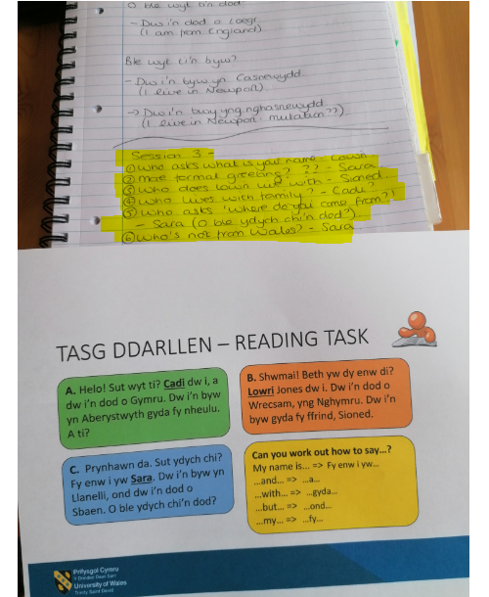

Appendix 4
An example of a lesson resource which shows use of Welsh language


