

Task 1 – Reading Task Template
Upload your photo of your A3 in-class notes here:
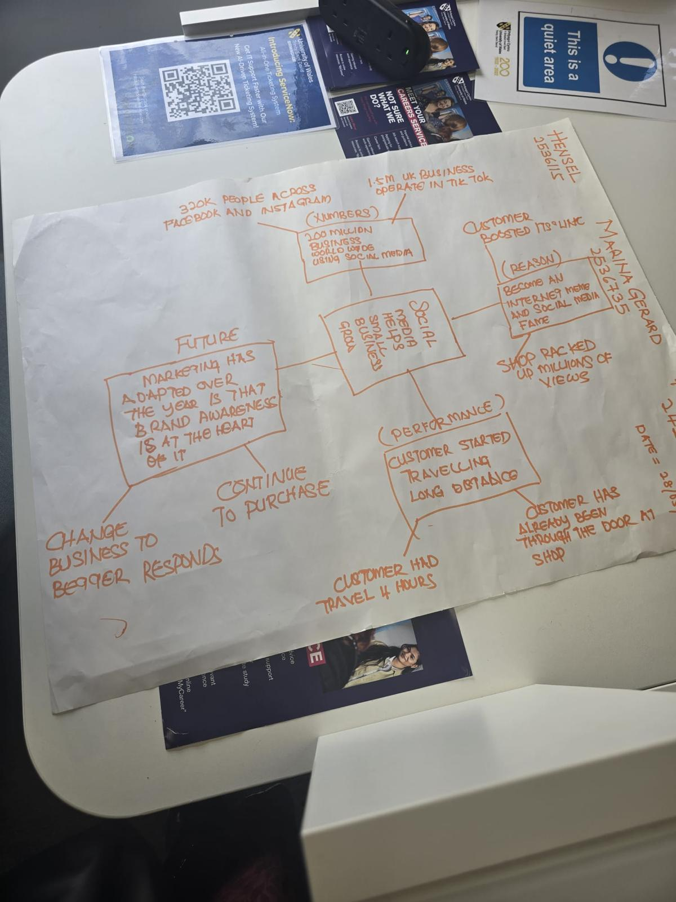
1. Answer these questions using the sentence starters below
a. What is the main idea of the text?
The central theme is that social media aids businesses in expanding their reach, generating more customers, and maintaining customer loyalty.
b. What are two key points?
A critical factor is that numerous companies are using social media to connect to a larger audience and market their goods. The other major thing to keep in mind is that customer posts, reviews and blogging can make a business more popular.
c. What part of the text did you find most important? Why?
The most essential part is that customer's posts and reviews could make a business famous as individuals tend to believe what other customers post online.
d. Was anything unclear or difficult to understand?
Some numbers I didn't quite know the meaning of, nor what they related to the main topic.
e. How did your group help you understand the text better?
My group was very helpful to me sharing ideas, explaining important points and helping me understand how social media can alter business response.
3. One sentence reflection
Question: What did you find challenging about this task?
The most difficult part was determining which information was most pertinent from the text as there were numerous ideas on the A3 notes.

