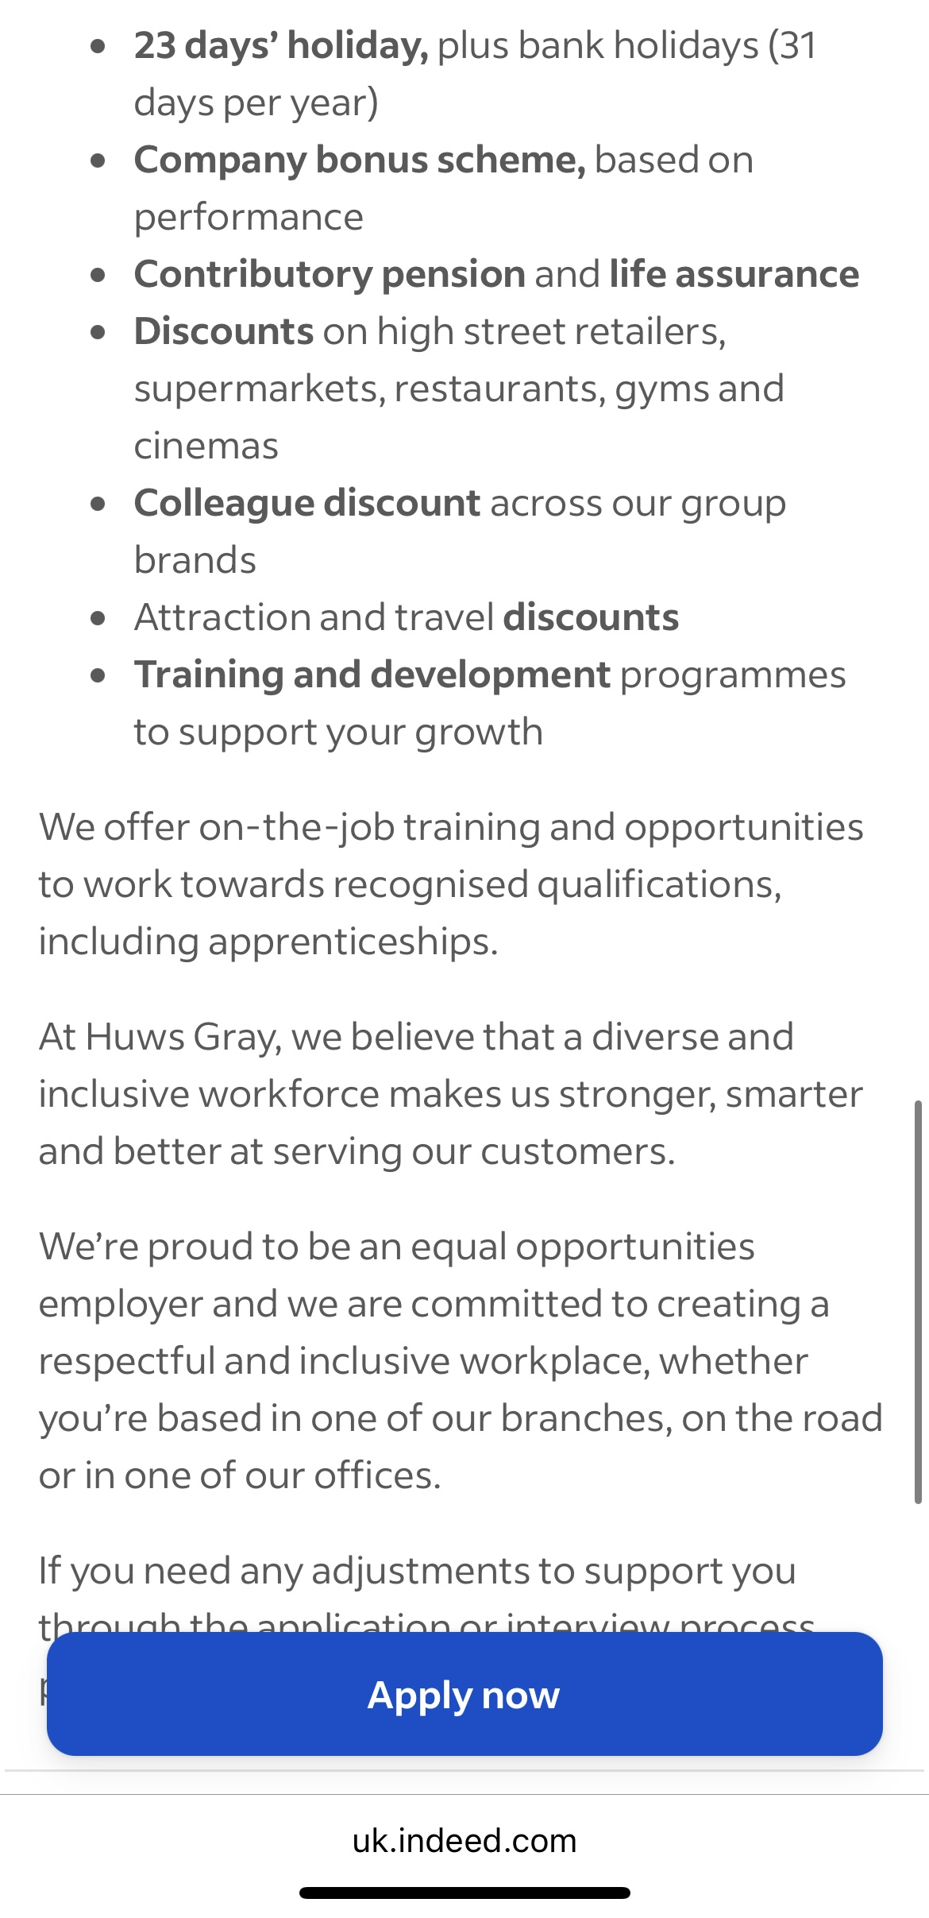
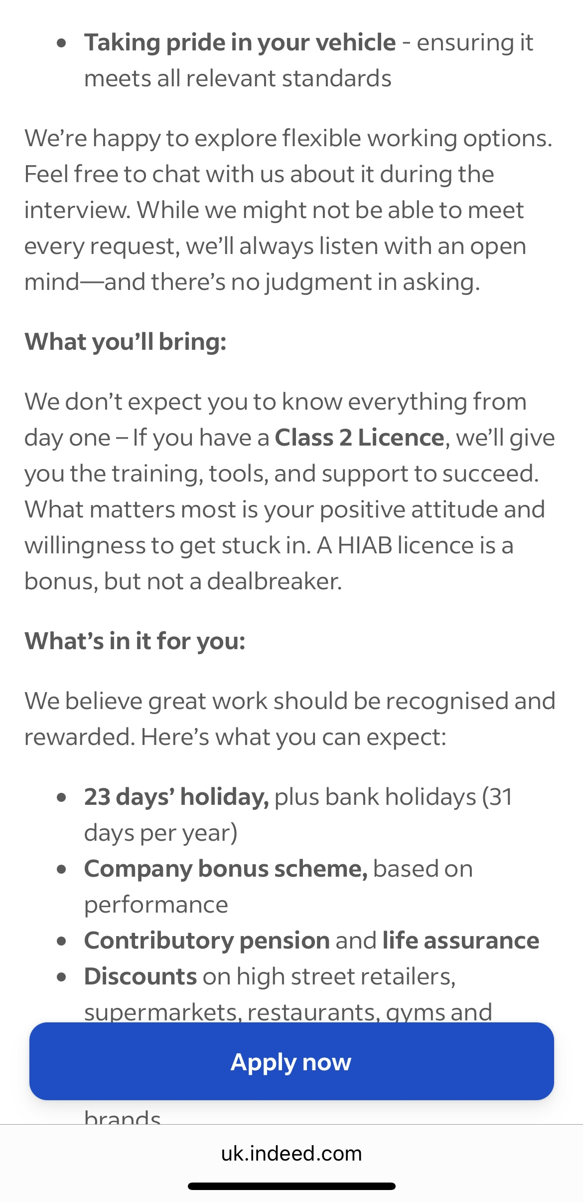
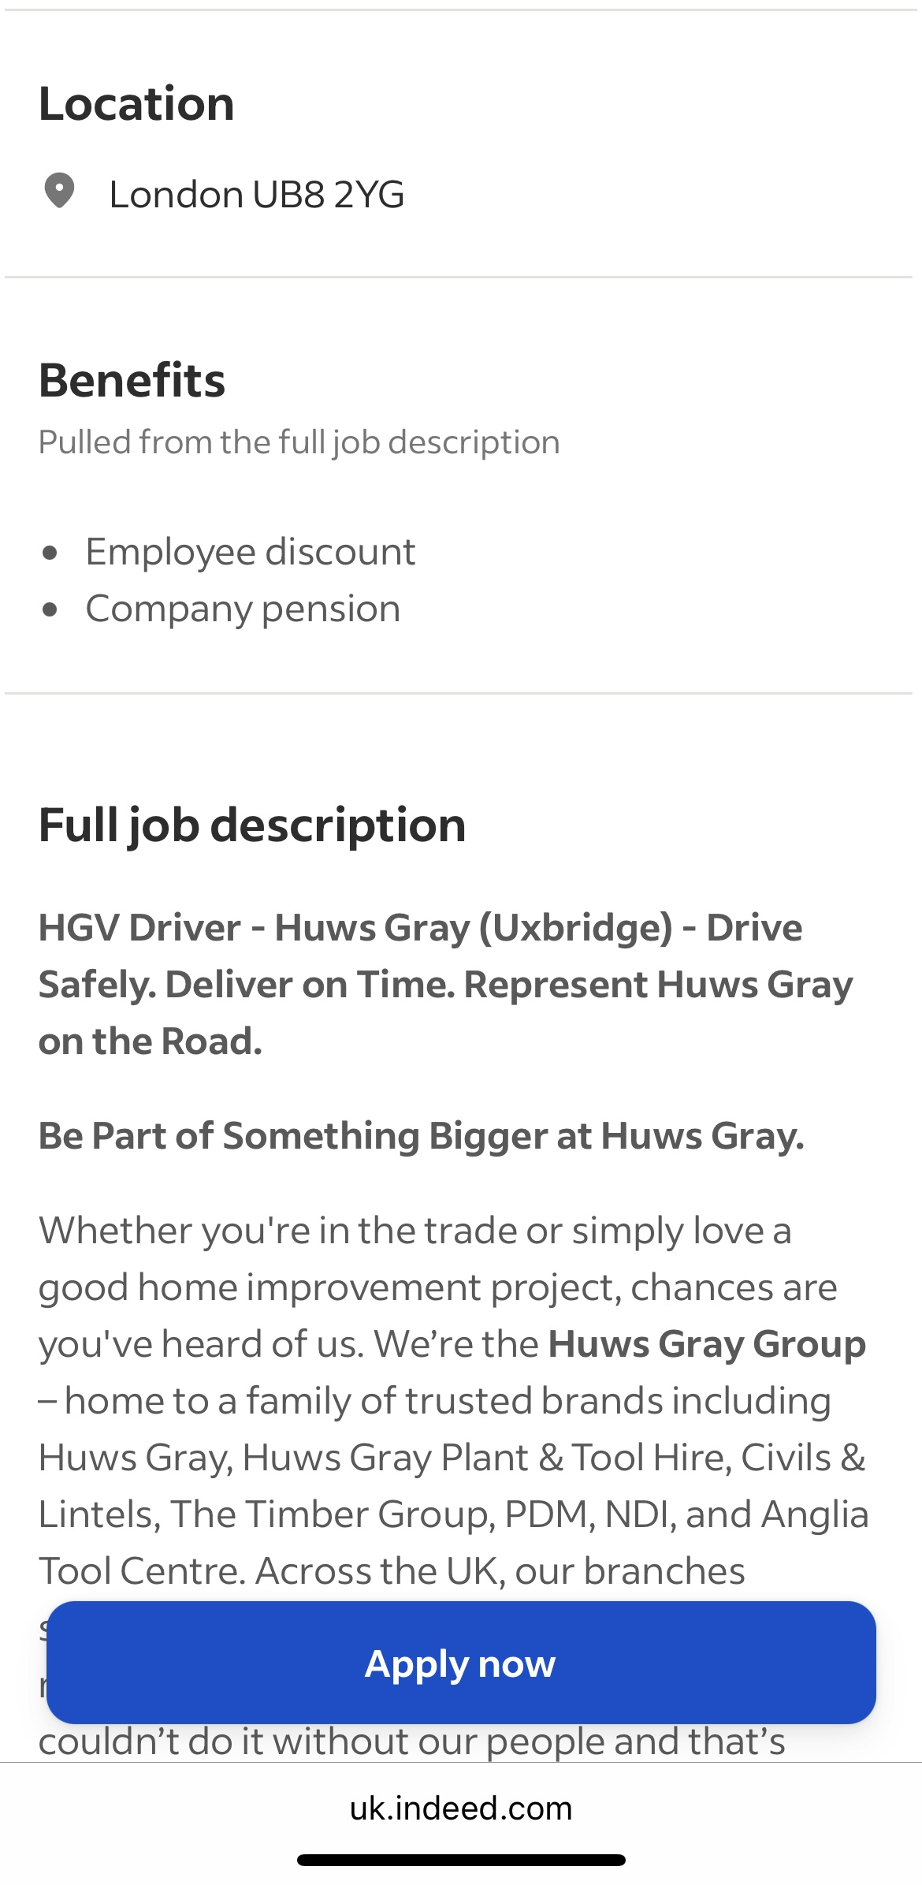
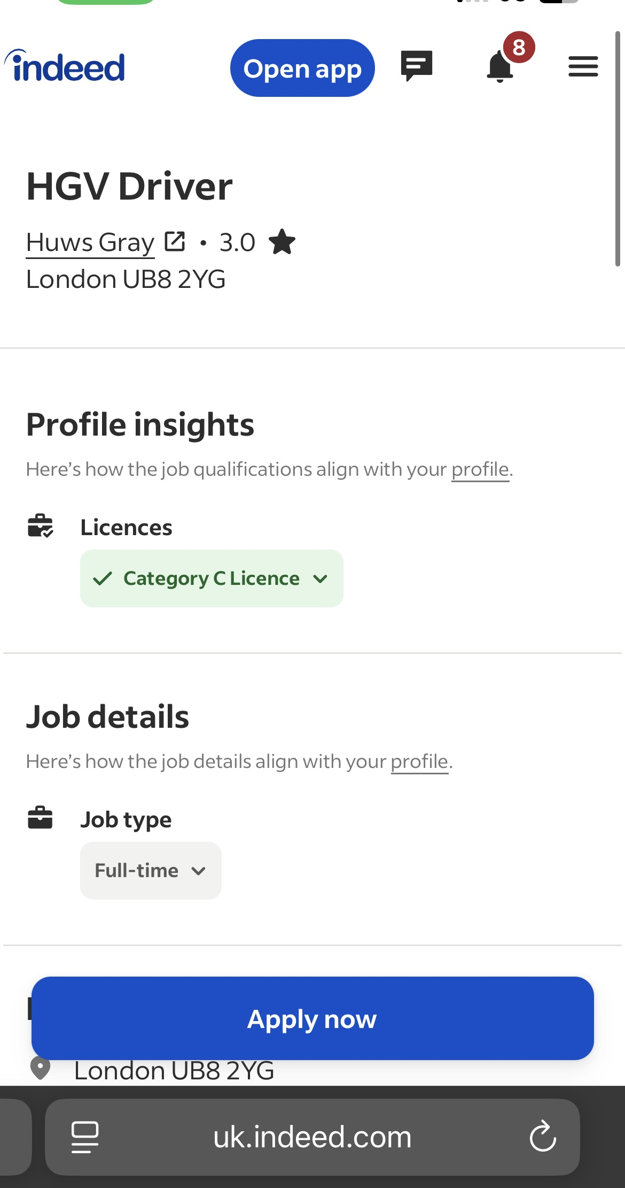

Personal Summary

A capable, professional Class 2 Driver with a valid CPC. I am a very hard working and reliable individual with first rate customer service skills and a responsible attitude to work. I have recently qualified as an HGV Driver and am looking to find a role to fit with my skills.

Work History

Delivery Driver
Amazon
Sept 2024 – Feb 2024
- Used outstanding local knowledge to navigate quickly and safely between delivery points
- Offered flexible working patterns to meet round-the-clock delivery demands
- Updated customers on estimated delivery timeframes and tracking options, optimising service efficiency
- Communicated clearly and professionally to maintain customers to deliver first-class service
- Greeted customers warmly and professionally to maintain positive company reputation
- Observed customer delivery instructions, prioritising safe, secure deliveries
- Logged parcel receipt using mobile device apps
- Followed highway code and traffic laws throughout deliveries

Shift Engineer
Double Tree By Hilton Hotel
Sept 2023 – Present
- Carried out routine maintenance tasks including plumbing, painting, carpentry, and minor electrical repairs across guest rooms and hotel facilities.
- Responded quickly to guest maintenance requests, ensuring timely resolution to enhance customer satisfaction.
- Conducted regular inspections of hotel premises to identify potential hazards or maintenance needs.
- Ensured all maintenance tools and equipment were stored safely and used in compliance with health and safety standards.
- Supported refurbishment and room turnover efforts during peak seasons to maintain high room availability.
- Liaised with external contractors when necessary and supervised on-site work to ensure standards were met.
- Maintained accurate logs of repairs, completed tasks, and materials used.
- Worked flexibly across shifts and responded to emergency callouts, demonstrating a reliable and adaptable attitude.

Training and Education

HGVT
Ongoing
- Category C Licence
- DCPC
- Digital Tachograph Card

Newham College
Mar 2024
- NVQ Railway Maintenance Level 2

Additional Qualifications
- PTS Card
- Sentinel Card

Skills

- Microsoft Office
- Languages: English (advanced), Arabic (native)
- Communication skills
- Strong analytical and problem-solving skills
- Accuracy and attention to detail
- Organisation skills
- Negotiations skills
- Flexibility
- Project management
- Knowledge of relevant building and health and safety legislation

References available upon request

Job advert

HGV Driver
Huws Gray
3.03.0 out of 5 stars
London UB8 2YG

Full-time

Job details

Job type
- Full-tim

Location

London UB8 2YG

Benefits

Pulled from the full job description
- Employee discount
- Company pension

Full job description

HGV Driver - Huws Gray (Uxbridge) - Drive Safely. Deliver on Time. Represent Huws Gray on the Road.
Be Part of Something Bigger at Huws Gray.
Whether you're in the trade or simply love a good home improvement project, chances are you've heard of us. We’re the Huws Gray Group – home to a family of trusted brands including Huws Gray, Huws Gray Plant & Tool Hire, Civils & Lintels, The Timber Group, PDM, NDI, and Anglia Tool Centre. Across the UK, our branches support local communities with everything they need for building, improving, and creating – we couldn’t do it without our people and that’s where you come in!
As a HGV Driver, you play a vital role in ensuring our customers receive their materials on time and in great condition. No long-haul journeys, no late nights—just local deliveries and a strong team backing you up every step of the way.
What you’ll be doing:
- Delivering materials to our local customers - making sure they get exactly what they need, when they need it
- Building great relationships on the road - acting as an ambassador for our brand
- Staying up to date with Health & Safety practices - including tachographs, training, and delivery administration
- Taking pride in your vehicle - ensuring it meets all relevant standards
We’re happy to explore flexible working options. Feel free to chat with us about it during the interview. While we might not be able to meet every request, we’ll always listen with an open mind—and there’s no judgment in asking.
What you’ll bring:
We don’t expect you to know everything from day one – If you have a Class 2 Licence, we’ll give you the training, tools, and support to succeed. What matters most is your positive attitude and willingness to get stuck in. A HIAB licence is a bonus, but not a dealbreaker.
What’s in it for you:
We believe great work should be recognised and rewarded. Here’s what you can expect:
- 23 days’ holiday, plus bank holidays (31 days per year)
- Company bonus scheme, based on performance
- Contributory pension and life assurance
- Discounts on high street retailers, supermarkets, restaurants, gyms and cinemas
- Colleague discount across our group brands
- Attraction and travel discounts
- Training and development programmes to support your growth
We offer on-the-job training and opportunities to work towards recognised qualifications, including apprenticeships.
At Huws Gray, we believe that a diverse and inclusive workforce makes us stronger, smarter and better at serving our customers.
We’re proud to be an equal opportunities employer and we are committed to creating a respectful and inclusive workplace, whether you’re based in one of our branches, on the road or in one of our offices.
If you need any adjustments to support you through the application or interview process, please let us know.

Cover Letter :

Damin Jordan
Huwsgray
London UB8 2YG
16/11/2025

Dear Mr/Damian
I wish to apply for the role of HGV Driver, currently being advertised on Indeed. Please find enclosed my CV for your consideration.
As you can see from my attached CV, I have over 6 months experience in the
delivery industry, and I believe the experience during this time make me the right/perfect candidate for the role.
In my current role as a shift engineer at Double Tree hotel, I have been responsible for the health and safety in the hotel and how to make the guest happy . I have learnt to do the delivery to customer in a proper way in time with smile during my working period with Amazon.

All of this, coupled with my enthusiasm and dedication,Knowledge of relevant road health and safety legislation , Used outstanding local knowledge to navigate quickly and safely between delivery points
has helped to be the perfect candidate.
I am confident that I can bring this level of success with me to your organisation and help to build upon their reputation as the best builders merchant. With my previous experience and expertise, I believe my contribution will have right impact .

Thank you . I look forward to see you soon.

Yours sincerely,

