

Marketing Essentials

BMIH4005

Student Name: Alin Ionut Stefanescu
ID Number: 2230719
Lecturer’s Name: Ruth Taylor Davies
Word Count: 1189
Contents
Components A 1
Introduction 1
Situational Analysis Using the 5Cs 1
Company 1
Customer 2
Competitors 2
Collaborators 2
Climate 2
Objectives 3
Strategy 3
Tactics 4
Marketing mix 4
Actions 4
Control 5
Conclusion 5
References 5
Component B: Presentation 7

Components A

Introduction

The marketing and commercial environment of the Hilton Hotel will be evaluated as part of this research. In addition to this, we shall take into account external circumstances. It is impossible for a business to expand without investing in digital marketing and maintaining open lines of communication with customers. Full-service hotels are operated all over the world by Hilton Hotels & Resorts. New York City serves as the headquarters for the international hotel chain Hilton. Hilton was established in May 1919 by Conrad Hilton, and Christopher J. Nassetta is the current CEO of the company. Hilton Hotels are worldwide. While India only has one organisation, Dubai is home to three. The overall performance was very impressive.

Situational Analysis Using the 5Cs

Company
SWOT analysis (Micro analysis)
A large number of potential customers and an enormous customer base are all strengths of Hilton Hotel in its current market (Krupskyi et al., 2019).
Strength: The resort's perks suggest evaluating the Hilton Hotel's qualities. Economic potential, product innovation, brand value, and intellectual capacity may impact an organization's integrity.
Weakness: Companies' weaknesses are often attributed to operational defects, especially when these defects need to be corrected to improve their reputation. In comparison to its competitors, a company may have weaknesses or strengths that differ from those of its competitors. A company's intense competition impedes its profit margins. Compared to local resort networks, global reach has a wider reach.
Opportunity: Adjustments may be needed to grow a company's clientele. Businesses can expand their local presence, introduce new products, and improve customer communication.
Threat: Increasing rivals, political turmoil, and more low-cost choices have made the hotel market very competitive. ACCOR, DAYS INN global, and Travelodge hotels ltd. are likewise targeting the same population (Bowie et al., 2017).

Customer
It is possible for organizations to serve more customers by growing. Increased offerings, improved communication, and other strategies can be used to build a company abroad. Because of low costs related to product production and distribution, the hotel business benefits from a competitive edge. Companies grow faster than their rate of change when this occurs (Zhou et al., 2009).

Competitors
Every part of the world recognizes the benefits of hotel investments. There is therefore not a great deal of competition in this market. Applicants qualifying for positions in this industry are in short supply, while demand for skilled workers is highly disparate. Taking into consideration the many alternatives available to the client as well as the fact that there are many alternatives to the service provider in most cases, the balance of power is often in favour of the client (Autor, 2015).

Collaborators
Collaborative hotels are likely to provide improved amenities than hotels that operate independently. In business transactions, contracts, and promotions, well-known companies' names may be used as references (Camilleri, 2018).

Climate
PESTLE analysis
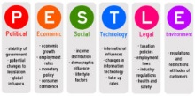
A PESTLE study will examine laws, regulations, economics, the community, and the environment to help the Hilton Hotel succeed in the area. These aspects help attain objectives. These factors must be considered while choosing a firm strategy. In unstable environments, customers may have trouble meeting their demands (Brito & Harkiolakis, 2017).

Political: Immigration restrictions and Brexit have negatively impacted the Hilton Hotel. There has been a decline in demand for hotel services due to tighter travel restrictions.
Economical: Hyperinflation, currency devaluations, and economic recessions have occurred.
Social: Corporate ethics are adhered to by Hilton Hotel in responding to the needs of its customers.
Technological: Online communication, database development, and social media outreach have made Hilton Hotel more creative. It underpins the company's marketing.
Environmental: Solar panels generate most of the hotel's power, helping minimize emissions and prevent climate change.
Legal: Company must update tax and immigration regulations. Employees must follow contracts to be employed.

Objectives

The advertising campaign for the Hilton Hotel is working towards the goal of achieving a five percent increase in profitability. The establishment of the aim should be feasible because of the positive reputation of the brand that is linked with the industry. There is a possibility that advertisements directed exclusively towards this demographic will be successful in recruiting them. As a result, it is essential for the Hilton Hotel to achieve a five percent rise in its operating income. If we put in the effort necessary, we should be able to do this within the next year (Goddard & Standish-Wilkinson, 2002).

Strategy
A facility that meets customer needs better than competitors will attract more customers. Hilton Inn Hotels provides high-quality products and excellent customer service. Online booking is faster and more convenient. As a business seeks to establish its value, its services may be most important (Rauch et al., 2015).

Tactics

Marketing mix
Product: There are a number of amenities available at the Hilton Hotel, including accommodations, entertainment, shipping, and dining. Consumers are able to remain loyal to them due to the variety of services available (Nozdreva & Churakova, 2021).
Price: Hilton Hotel does not offer competitive prices to ensure it offers its guests cheap alternatives. Health-related things aren't only practical but can also be affordable. The availability of discounts may vary from time to time.
Place: Hilton Hotels are found throughout the United Kingdom, including several located-on airport grounds. Each of the organization's locations offers the highest quality housing and services (Tibbetts, 2002).
Promoting: Hilton Hotel rewards customers with exclusive offerings. What to do, where to go, and surrounding attractions are listed. The hotel may employ social media marketing strategies (Nozdreva & Churakova, 2021).

Actions
Beginning February 25, 2023 and ending March 12, 2023
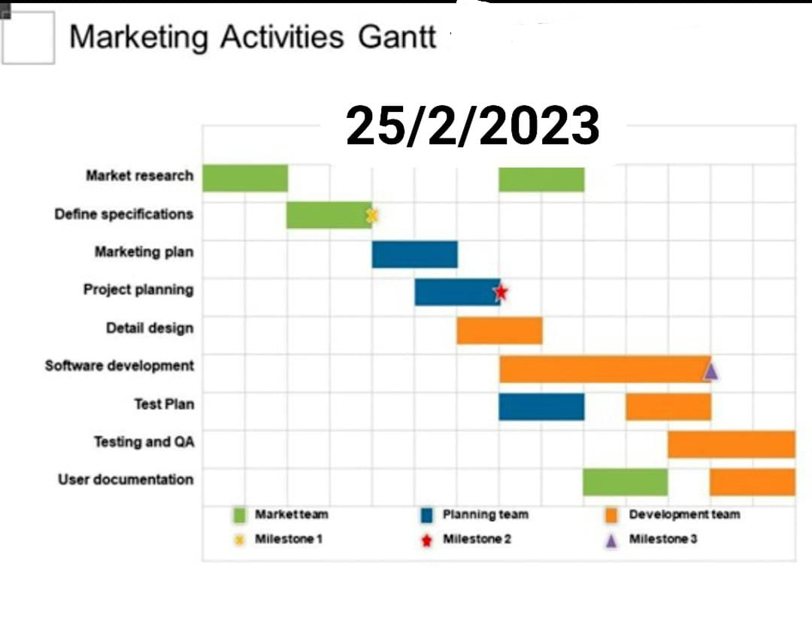

The Gantt chart for the Hilton Hotel anticipates a marketing effort that will last for four or five days. In order to gain an understanding of the target demographic, both primary and secondary sources will be utilised. Throughout the course of seven weeks, data on the target audience will be collected. The information gathered will be put to use in the development of an effective marketing strategy. The next 15 days ought to be completely free of disturbances. Following that, there will be some opportunity for remarks. We will make any necessary adjustments to the product based on the feedback that we receive.

Control

Hotel companies can differentiate themselves from competitors with similar prices through creative marketing. It's possible that one product has a lower production capacity than its competitors. One way a service provider might differentiate themselves from competitors is by going to the customer rather than the customer coming to the firm (Cohen et al., 2006).

Conclusion

The Hilton Hotel employs innovative marketing strategies. Through the use of this strategy, Hilton Hotel is able to convey its services, prices, and specials in an effective manner. These are common destinations for travellers from the United Kingdom for a variety of reasons. They want to minimise their exposure to risks and vulnerabilities so that they don't see a drop in revenue as a result of the economic and political unpredictability. In addition, marketing can be an expensive and time-consuming endeavour. In spite of this, they ought to generate profits. The Hilton Hotel needs to make quick investments if it is going to continue operating, expand, and satisfy its customers.

References
Autor, D.H. (2015) “Why are there still so many jobs? the history and future of Workplace Automation,” Journal of Economic Perspectives, 29(3), pp. 3–30. Available at: https://doi.org/10.1257/jep.29.3.3.
Bowie, D. et al. (2017) Hospitality marketing. London: Routledge.
Brito, T.L. and Harkiolakis, N. (2017) “Influence of UK economic and market policies on a small wine merchant,” International Journal of Teaching and Case Studies, 8(1), p. 29. Available at: https://doi.org/10.1504/ijtcs.2017.084408.
Camilleri, M.A. (2018) Travel Marketing, Tourism Economics and the airline product: An introduction to theory and Practice. Cham: Springer International Publishing.
Cohen, M.A., Agrawal, N. and Agrawal, V. (2006) “Achieving Breakthrough Service Delivery Through Dynamic Asset Deployment Strategies,” Interfaces, 36(3), pp. 259–271. Available at: https://doi.org/10.1287/inte.1060.0212.
Goddard, P. and Standish-Wilkinson, G. (2002) “Hotel Management Contract Trends in the Middle East,” Journal of Retail &amp; Leisure Property, 2(1), pp. 66–80. Available at: https://doi.org/10.1057/palgrave.rlp.5090140.
Krupskyi, O.P. et al. (2019) Oleksandr P. Krupskyi, Oleksii Dzhusov, Nataliіa Meshko, Igor Britchenko &amp; Artem Prytykin, key sources when formulating competitive advantages for hotel chains, PhilArchive. Available at: https://philarchive.org/rec/KRUKSW-2 (Accessed: February 25, 2023).
Nozdreva, R. and Churakova, A. (2021) “Digital Tools in empirical marketing strategies of Global Hotel Companies,” Digital Strategies in a Global Market, pp. 213–227. Available at: https://doi.org/10.1007/978-3-030-58267-8_16.
Rauch, D. et al. (2015) Measuring service quality in mid-scale hotels: Semantic scholar, International Journal of Contemporary Hospitality Management. Available at: https://www.semanticscholar.org/paper/Measuring-service-quality-in-mid-scale-hotels-Rauch-Collins/4fb07dccb56dcc408be9fa910050de75e50acf95 (Accessed: February 25, 2023).
Tibbetts, J. (2002) “Coastal cities: Living on the edge.,” Environmental Health Perspectives, 110(11). Available at: https://doi.org/10.1289/ehp.110-a674.
Zhou, K.Z., Brown, J.R. and Dev, C.S. (2009) “Market orientation, competitive advantage, and performance: A demand-based perspective,” Journal of Business Research, 62(11), pp. 1063–1070. Available at: https://doi.org/10.1016/j.jbusres.2008.10.001.

Component B: Presentation


Introduction
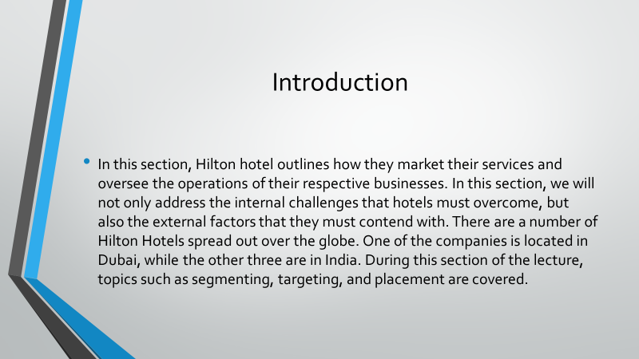

Marketing mix
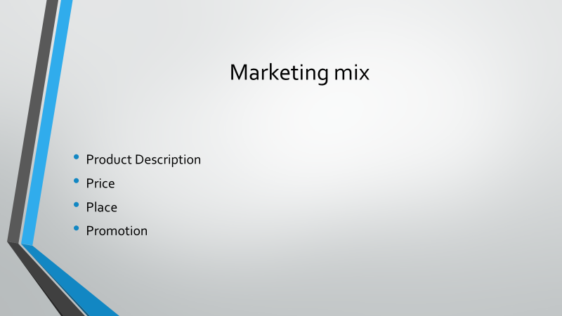

Segmentation
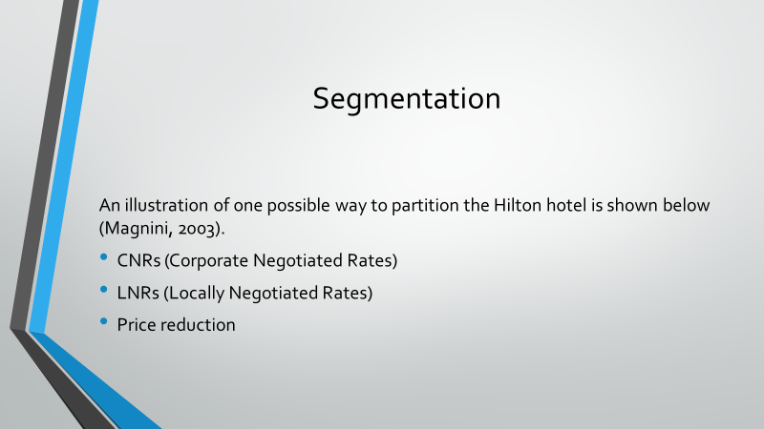

Targeting
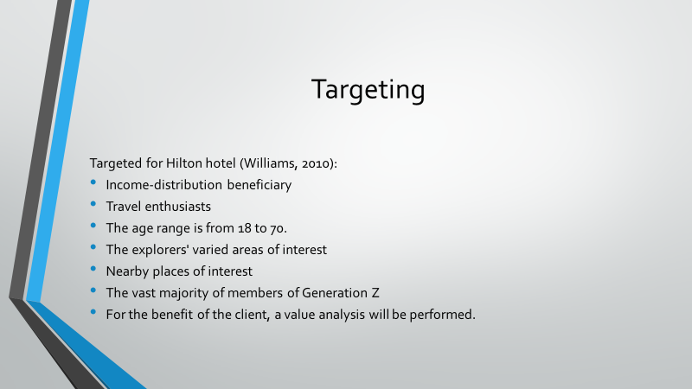

Positioning
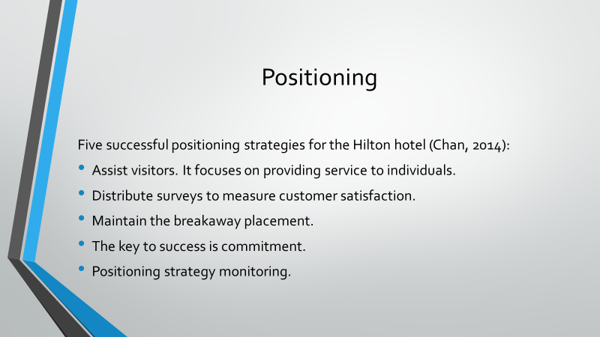

Conclusion
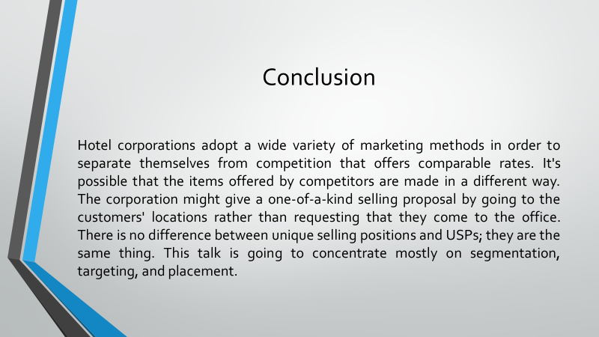

References


