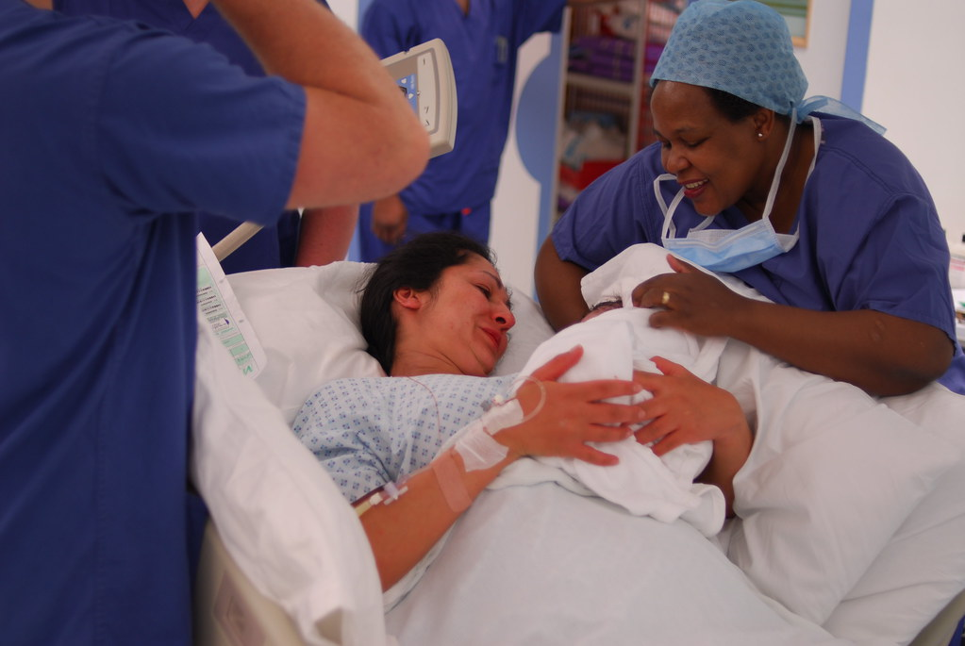

Brief History of Midwifery
Midwifery is one of the oldest caring professions. In the UK, the Midwives Act of 1902 made training and registration mandatory, improving safety. When the NHS began in 1948, midwives became central to maternity care. Today, the role combines traditional support with modern medical practice.

This Photo by Unknown Author is licensed under CC BY-SA
Two Challenges Faced by the Service
Staff Shortages – There are not enough midwives working in the UK, which means the ones who are working often have very high workloads and a lot of pressure. This can lead to stress, tiredness, and sometimes even burnout. Because of the shortage, women might have to wait longer for appointments or may not always see the same midwife throughout their pregnancy, which can affect the quality of care and support they receive.
Health Inequalities – Another big challenge is health inequalities. Women from disadvantaged backgrounds or minority ethnic groups often face barriers to getting good maternity care. This could be due to language differences, financial struggles, or discrimination. As a result, these women sometimes have poorer health outcomes for both them and their babies. The NHS is working to reduce these inequalities and make maternity care fair and accessible for everyone.

Current functioning of the service
Midwifery services in the UK are part of the NHS and play a very important role in supporting women through pregnancy, childbirth, and after the baby is born. Midwives work in hospitals, clinics, and sometimes visit women at home to make sure both mother and baby are healthy and safe. They give advice about pregnancy, birth, breastfeeding, and caring for a newborn. Midwives also provide emotional support and reassurance to new mothers. If any complications or health concerns come up, they refer women to doctors or other healthcare professionals for extra help.

166
A Brief history of the ambulance service
Midwifery is one of the oldest caring professions and has always been an important part of healthcare. In the UK, the Midwives Act of 1902 made it a legal requirement for midwives to have proper training and registration, which helped to make childbirth much safer for mothers and babies. When the NHS was created in 1948, midwives became a key part of maternity care, supporting women before, during, and after birth. Over the years, the role has continued to grow and change. Today, midwives still provide the same care and support as they always have, but they also work closely with doctors and use modern medical knowledge and equipment to make sure every woman and baby receives the best possible care.
MIDWIFERY by Sharlotte Winstanley - 2441177

By Sharlotte Winstanley- 2441177

