
BA Business & Management
Carmarthen Business School

Author: Joshua Lewis
Student number: 1805618
Module: Economics of Sustainability
Module code: BMSP6007
Supervisor: Anthony Burns

Assessment Title: Assessment One
Word Count: 2255

Introduction
The purpose of this essay is to find an industry sector to which a solution to a failing market has been found in terms of an externality of a pollutant produced through the production of a good. The automotive industry has been selected and this essay aims to present how the market was failing prior to any solutions been put in place, the essay will continue by identifying what solutions were used to correct the market failure.
According to the Society of Motor Manufacturers and Traders (SMMT) (2020), the United Kingdom (UK) automotive industry is worth over £78 billion. Contributing a value of £15 billion to the UK economy. Over a million people in the UK are employed directly and indirectly through the automotive industry. The SMMT also state that the automotive industry accounts for 13% of all goods exported from the UK, generating around £44 billion. The Automobile Association (AA) (2021), reports that over 70 different models of vehicles are built in the UK by around 30 manufacturers.
The rate of production in the automotive industry has grown substantially over the past two decades. Research suggests that 56 million vehicles were produced globally in 2001, over the next 18 years this figure has risen to 92 million as of 2019 (Statista, 2021). Of the 92 million vehicles produced globally, the European Automobile Manufacturers Association (ACEA) (2021) states that 18.5 million (20%) vehicles were produced in Europe.
Market Failure in Automotive Industry
The European Commission (2020) reports that the automotive industry contributes up to 12% of the total CO2 emissions throughout Europe. Carbon Dioxide (CO2) is the primary greenhouse gas emitted through human activities. As of 2019, C02 accounted for around 80% of all greenhouse gas emissions from human activities. (EPA, 2021) C02 emissions contribute to global warming issues faced on earth, C02 emissions get into the earths clean air and cause an invisible layer around the earth. (Carbon Stock, 2018) Trapping in the heat, known as the greenhouse effect, causing global warming. Ahmed Ali et al. (2020) identifies the impacts and consequences of CO2 emissions as, a rise of global temperatures causing changes in water supplies, changes of weather patterns, Changes in food supplies and rising sea levels.
Prior to 2009, no legislations or regulations existed in the EU regarding the percentage of C02 emissions produced from vehicles in the automotive industry. Car manufacturers were entitled to produce their vehicles any way they pleased. With 298 automotive factories across Europe (ACEA, 2021) providing for more than 30 different manufacturers, competition in the industry is extensive. Therefore, specific issues such as CO2 emissions were often overlooked with profitability being the priority focus.

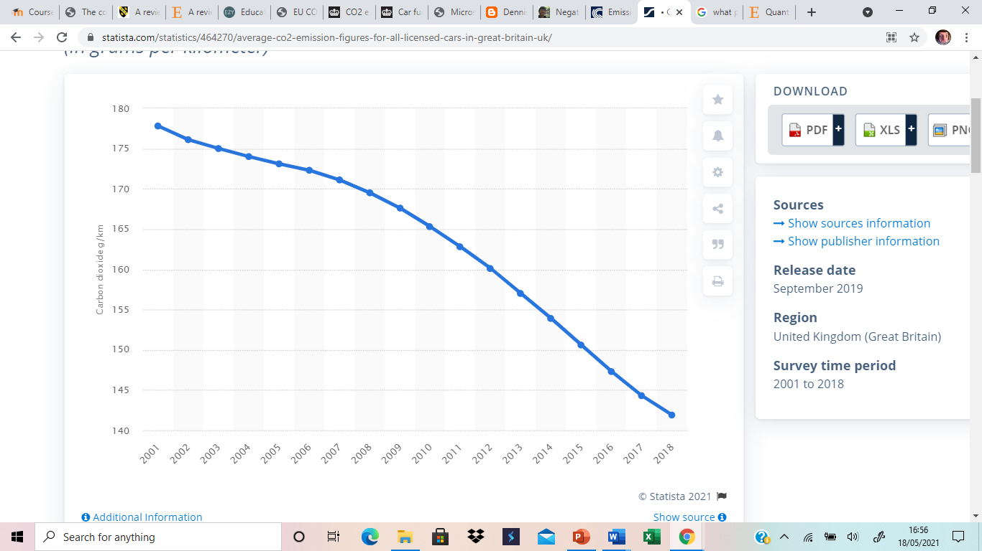
(Statista, 2018)
Prior to any legislations being imposed on the automotive industry, statistics show that the average level of carbon dioxide emissions for licensed cars in the UK was at an all time high. In 2001, the average level of CO2 produced by cars in the UK was 177.8 grams per kilometre. In the following years leading up to 2009, where the idea of regulations and legislations become more apparent the industry saw a reduction on average of 10.2 grams per kilometre, leaving the average level of CO2 emissions in 2009 at 167.6 grams per kilometre.
Market failure is the result of an inefficient market condition, environmental problems can be modelled as market failures using two theories. The theory of public good, which can be described as a commodity that is nonrival in consumption and yields nonexcludable benefits. (Burns, 2021) This theory draws upon two characteristics non-rivalry and nonexcludable, Nonrivalry means when a good is used or consumed it does not generate a reduction in the availability to others. Non excludability occurs when a good is provided and it is not possible to restrict the use or benefit of the good and the good is available for everyone. Pettinger (2019) suggests that due to the nature of the characteristics within the public good theory, public goods are often under provided in a free market because there is an incentive not to pay. An example of a public good would-be services provided by the government, these services are non-excludable, and everyone has equal free access, as everyone’s usage of these services differs it is challenging to charge accordingly, funding for these services is commonly raised through taxes. (Mankiw, 2012)
The second market failure theory, and the theory which will be addressed within this essay is the theory of externalities. An externality in market failure is described as a cost or benefit caused by the producer that is not financially incurred or received by that producer (Kenton & Westfall, 2020). The Externality theory is divided into negative and positive externality. Negative externality occurs when an external effect generates costs to a third party, positive externality occurs when an external effect generates a benefit to a third party.

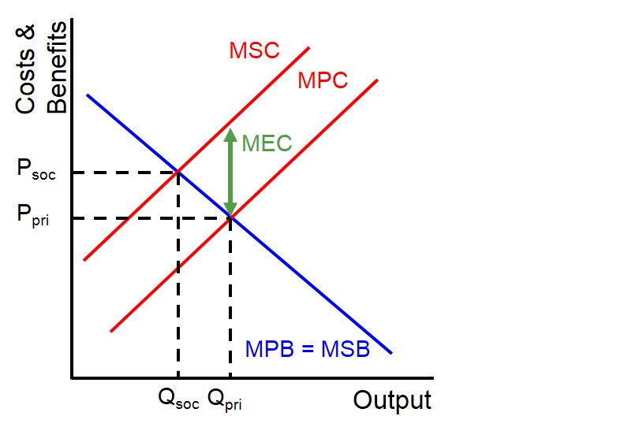(Ezy Education, 2020)
This diagram represents an economic tool used to highlight the external cost present in a market with a negative production externality. The Marginal social cost (MSC) is described as the total cost society pays for an additional unit produced. The MSC reflects the impact that an economy feels from the production of additional units. (Kenton & Walters, 2020). The Marginal private cost (MSP) is the change in the producer's total cost brought about by the production of an additional unit of a good or service. (Edgmand et al., 1996) Finally, the Marginal external cost (MEC) is the change in the cost to parties other than the producer or buyer of the good or service. (Edgmand et al., 1996). For products with negative externalities the MSC is greater than the MPC.
In relation to the automotive industry, air is a public good which is non rival and non-excludable, the damage caused through vehicle CO2 emissions means that market failure in this industry is due to an externality of a pollutant produced through the production of a good. Prior to the 2009 regulations regarding vehicle CO2 emissions, manufacturers lacked incentive to alter the production process because adopting new methods and materials to reduce CO2 emissions would impact the profitability of the business, while the product the create would appear to be exactly the same. Manufacturers in the industry were not accounting for the MSC and MEC therefore creating a negative externality and causing market failure.
Proost et al., (2004) calculates the total marginal external costs (TMEC) for off-peak cars in London as 0.090 euro per kilometre, for peak cars in the same area this figure rises to 0.537 euro per kilometre. Data suggests that within the same area there are currently 2.56 million cars registered. (Transport for London, 2017) These figures suggest that in London the MEC from vehicles ranges from 230,400 euro per kilometre up to 1,374,720 euro per kilometre.
Solution
Centermeri (2009) suggests that once market failure has been recognised within an industry due to negative externalities, there are three potential resolutions to correct the market. These include taxation, regulation, and property rights. Within the automotive industry the property rights approach would not be applicable as air is a public good. Taxation and regulation are the favourable approaches used by legislators in the automotive industry.
The solution to correct the market failure was to introduce new regulations, the first regulation that was introduced came in 2009, the European parliament introduced a mandatory CO2 emissions standard for passenger vehicles. A target of 130 grams per kilometre was set to be achieved by 2015 for the fleet average of all manufacturers. Later in 2013, the European parliament working with the council of the European union reached a further agreement regarding two regulatory proposals that will implement mandatory 2020 CO2 emission targets for new passenger cars and light-commercial vehicles in the European Union. The passenger car standards are 95 g/km of CO2, phasing in for 95% of vehicles in 2020 with 100% compliance in 2021. The light-commercial vehicle standards are 147 g/km of CO2 for 2020 (International Council on Clean Transportation, 2014).
These regulations were imposed in addition to a taxation policy that is already in place, In the UK cars pay a tax dependant on the CO2 emissions of the vehicle. The current rates of tax are as follows:
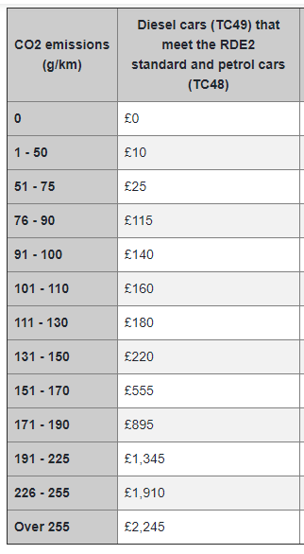

(RAC, 2021)

In addition to the UK, 24 European countries have a taxation policy in place based on vehicle CO2 emissions (ACEA, 2020).

Automotive Market Performance after EU Regulations
The purpose of setting these new regulations was to reduce the MEC that the automotive industry causes through CO2 emissions. The aim of the regulation was to achieve a reduction by the year 2015, however passenger car manufacturers managed to achieve the aim by 2013. The main reason for the target being met two years prior to the original date, was because it was no longer in the best interests of the manufacturers to ignore the social costs if they wanted to stay competitive in the marketplace. (European Commission, 2020)
According to the European Environment Agency (2019) there has been a significant reduction in the average C02 emissions produced by passenger vehicles since the introduction of the regulations. On average a reduction of 27.6 grams per kilometre has occurred. As a result of the reduced emissions, the MPR of the business will increase which in turn increases the equilibrium price and lower the production of the good.
To analyse the improvements within the market, the same tool can be used in this situation as before used to calculate the MEC. Once analysing the new information using the same tool, results can be compared, if the MEC and MSC has decreased then the risk of market failure is reduced.
With regards to environmental policy, the regulations introduced by the EU are that of ambient standard (Callan & Thomas, 2007) Where standards are involved there is always a possibility of impacting the manufacturers efficiency, occurring when the marginal social benefit abatement equates to the marginal social cost abatement. For example, Agarwal (2020) suggests the price society is wiling to pay, must be at least equal to the opportunity cost of manufacturing. Therefore, balancing the benefits of the producers to meet consumer demand and costs of production. Marginal social benefit abatement is measured the reduction in damage to the environment by the pollution of C02 while MSC abatement in the automotive industry is calculated by combing the total polluter marginal abatement and the marginal cost of enforcement of regulation.
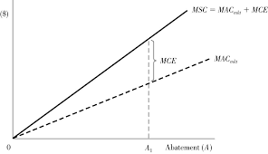
(Callan & Thomas, 2020)

After manufacturers in the industry achieved the first emissions target with significant time spared, the next milestone which was to reduce emissions to 95 grams per kilometre for new vehicles between 2020 and 2025. This target has been more difficult to achieve. Car manufacturer Volkswagen only managed to cut CO2 emissions down to 99.8 grams per kilometre, narrowly missing the 95 g/km target. The business now faces substantial fines in the region of 100 million euros. (Schwartz, 2021). They are not the only manufacturers struggling to achieve 2020 targets with Jaguar land rover expect to receive similar fines in the region of 90 million. (Tudose, 2020) Jaguar recalled around 44,000 after concerns about CO2 emission levels, around 10 models were emitting more greenhouse gasses than expected. (Forrest, 2019). As per the ambient standard, allocative efficiency may not be sustainable for many car manufacturers. The costs associated with implementing standards may require massive overhaul of resources and could potentially put manufacturers in a problematic position as to how to proceed. New regulations are proving difficult for manufacturers to comply with, they are primarily focused on bettering social issues but do not account for issues that are rising for the producers as a result of the changes.
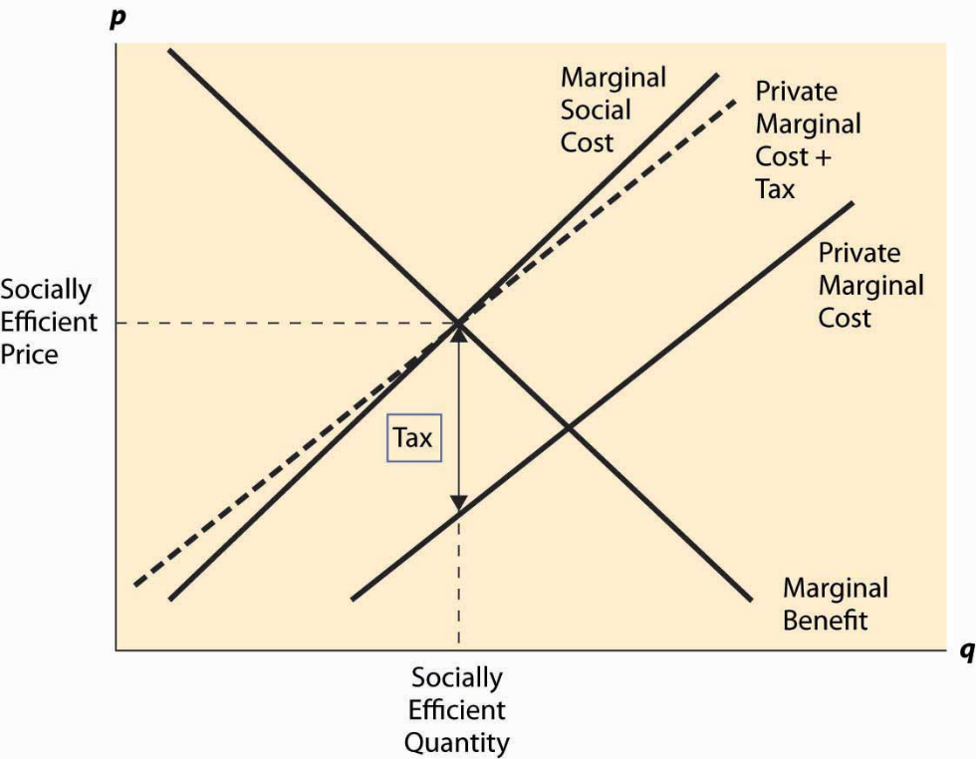
The way in which the market is currently regulated could be set to change once more, it is not sustainable to keep handing out huge fines for unachievable targets. If regulations continue in this form, there will be no market left to regulate. A market incentive approach may likely offer a long term and efficient strategy to regulate the industry. Using this alternative strategy individual businesses would only pay charges in relation to the emissions percentage. A variable rate that is dependant on the amount of CO2 emission produced per vehicle. This encourages producers to adapt and revolutionize their methods in order to pay as little tax as possible.
(Schmitz, 2012)
If the charge imposed on a vehicle is equal to that of the marginal external cost of the vehicle it is deemed as Pigouvian tax (Polinsky & Shavell, 1981) Manufacturers can operate more efficiently when the tax is set in between the PMC and the MSC, instead of being issued with continuous fines when emissions levels are too high.
Conclusion
It is evident that prior to EU regulations, the level of CO2 emissions in the industry was not sustainable. The competitiveness of the market meant that manufacturers were doing enough to reduce emissions at their own accord. It was necessary for regulations to be imposed in the industry and the evidence presents that since regulation were put in place the level of emissions has reduced significantly. It is important that regulations imposed on the industry are realistic and sustainable, the evolvement of regulations incentivises manufacturers to producer vehicles with lower emissions rates to pay less charges. It is difficult to conclude that the market is now running successfully or that it was completely failing prior, as only one segment of this market was analysed. Manufacturers in the industry might offer alternative social benefits which do not fall under the category of emissions.

ACEA. (2021). Interactive map: Automobile plants in Europe. Retrieved 13 May 2021, from https://www.acea.be/statistics/tag/category/european-production-plants-map
ACEA. (2021). Production. Retrieved 13 May 2021, from https://www.acea.be/statistics/tag/category/production
AECA. (2020). Overview - CO2-based motor vehicle taxes in the European Union. Retrieved 15 May 2021, from https://www.acea.be/publications/article/overview-of-co2-based-motor-vehicle-taxes-in-the-eu#:~:text=Today%2C%2024%20EU%20countries%20levy,are%20Estonia%2C%20Lithuania%20and%20Poland.
Agarwal, P. (2020, March 18). Allocative Efficiency . Retrieved from Intelligent Economist : https://www.intelligenteconomist.com/allocative-efficiency/
Ahmed Ali, K., Ahmad, M., & Yusup, Y. (2020). Issues, Impacts, and Mitigations of Carbon Dioxide Emissions in the Building Sector. Sustainability, 12(18). doi: 10.3390/su12187427
Burns, A. (2021). Modelling Market Failure. Presentation, UWTSD.
Callan, S., & Thomas , J. (2007). Environmental Economics and Management: Theory, Policy and Applications. Mason: Thompson South Western.
callan, S., & thomas, J. (2020). Conventional Solutions to Environmental Problems: The Command-and-Control Approach. Retrieved 16 May 2021, from https://aryabhattacollege.ac.in/samplepaper/637205506277598269Week%202_BBE%20Sem%206_Env%20Eco.pdf
Carbon Stock. (2018). Why are CO2 emissions so bad for our environment?. Retrieved 13 May 2021, from https://www.carbonstockstudy.com/why-are-co2-emissions-so-bad-for-our-environment/#:~:text=With%20the%20production%20of%20those,also%20called%20the%20Greenhouse%20effect.
Centermeri, L. (2009). Environemental Damage as Negative Externality: Uncertainty, Moral Complexity, and the Limits of the Market. E-Cadernos CES, 21-39.
Edgmand, M., Moowaw, R., & Olson, K. (1996). Economics and Contemporary Issues (3rd ed.). Dryden Press.
EPA. (2021). Greenhouse Gas Emissions. Retrieved 13 May 2021, from https://www.epa.gov/ghgemissions/overview-greenhouse-gases#:~:text=Global%20Warming%20Potential%20(100%2Dyear,gas%20emissions%20from%20human%20activities.
European Commission. (2020). Fuel Taxation. Retrieved from European Commission: https://ec.europa.eu/transport/modes/road/road_charging/fuel_taxation_en
European Commission. (2020). Reducing CO2 emissions from passenger vehicles. Retrieved from European Commission: https://ec.europa.eu/clima/policies/transport/vehicles/vehicles_en
European Environment Agency. (2019). Are new passenger vehicles becoming more efficient? European Environment Agency.
Ezy Education (2020). Marginal external cost. Retrieved from Ezy Education: https://www.ezyeducation.co.uk/ezyeconomicsdetails/ezylexicon-economic-glossary/741-marginal-external-cost.html
Forrest, A. (2019). Jaguar Land Rover recalls 44,000 cars over excessive CO2 emissions. Retrieved 17 May 2021, from https://www.independent.co.uk/news/business/news/jaguar-land-rover-cars-recall-co2-emissions-a8822701.html
International Council on Clean Transportation. (2014) EU C02 emission standards for passenger cars and light-commercial vehicles
Kenton, W. (2020). Externality. Retrieved 13 May 2021, from https://www.investopedia.com/terms/e/externality.asp
Kenton, W., & Walters, T. (2020). Marginal Social Cost (MSC). Retrieved 13 May 2021, from https://www.investopedia.com/terms/m/marginalsocialcost.asp#:~:text=Marginal%20social%20cost%20(MSC)%20is,further%20action%20in%20the%20economy.
Mankiw, N. (2012). Principles of Economics (6th ed.). South-Western College.
Polinsky, A. M., & Shavell, S. (1981). Pigouvian taxation with administrative costs. National Bureau of Economic Research, 19.
Proost, S., & Van Dender, K. (2004). Marginal Social Cost Pricing for all Transport Modes and the Effects of Modal Budget Constraints. Research In Transportation Economics, 9, 159-177. doi: 10.1016/s0739-8859(04)09007-9
Schmitz, A. (2012). Introduction to Economic Analysis. Saylor Academy.
Schwartz, J. (2021). Volkswagen faces EU fine for missing 2020 emissions targets. Retrieved 18 May 2021, from https://www.reuters.com/article/us-volkswagen-emissions-idUSKBN29Q1JI
Statista. (2018). Average level of carbon dioxide emissions for all licensed cars in Great Britain from 2001 to 2018. Retrieved 13 May 2021, from https://www.statista.com/statistics/464270/average-co2-emission-figures-for-all-licensed-cars-in-great-britain-uk/
Statista. (2021). Worldwide motor vehicle production 2000-2020. Retrieved 13 May 2021, from https://www.statista.com/statistics/262747/worldwide-automobile-production-since-2000/
Supporting UK manufacturing. (2021). Retrieved 13 May 2021, from https://www.theaa.com/car-buying/cars-made-in-britain
The AA. (2021). How much is car tax (VED)?. Retrieved 15 May 2021, from https://www.theaa.com/driving-advice/driving-costs/car-tax
Transport for London. (2017). Roads Task Force – Technical Note 12. London.
Tudose, S. (2020). JLR Bracing For $117 Million CO2 Emissions Fine In Europe. Retrieved 17 May 2021, from https://www.carscoops.com/2020/10/jlr-bracing-for-117-million-co2-emissions-fine-in-europe/#:~:text=Jaguar%20Land%20Rover%20is%20expecting,emissions%20reduction%20targets%20this%20year.&text=%E2%80%9CWe%20are%20not%20happy%20that,Chief%20Financial%20Officer%2C%20Adrian%20Mardell.
Uk Automotive. (2020). Retrieved 13 May 2021, from https://www.smmt.co.uk/industry-topics/uk-automotive/

