Ana Carden-Coyne, David Morris and Tim Wilcox, eds., The Sensory War, 1914–2014(Manchester Art Gallery: Manchester, 2014)
Images from section entitled ‘Aerial Warfare and the Sensation of Flight’

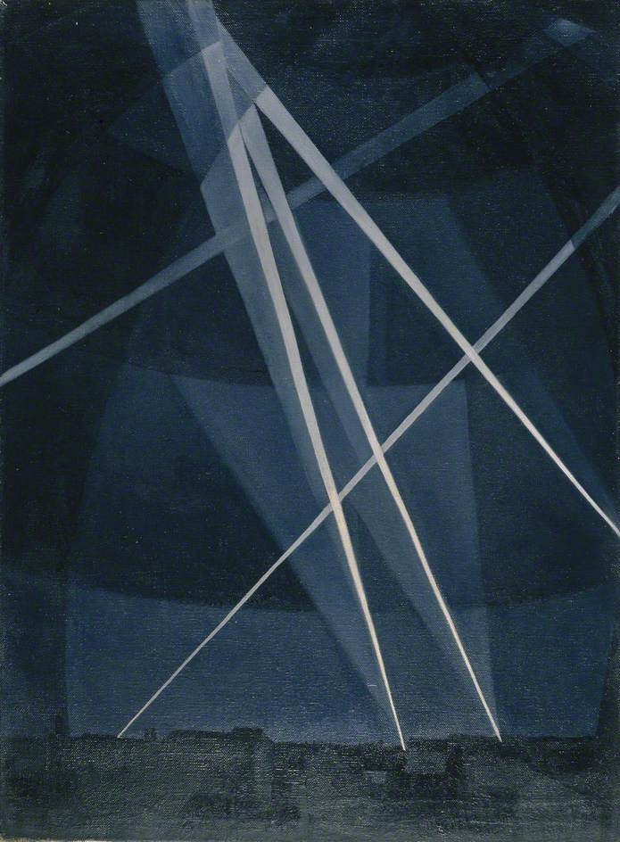
CRW Nevinson, Searchlights, 1916
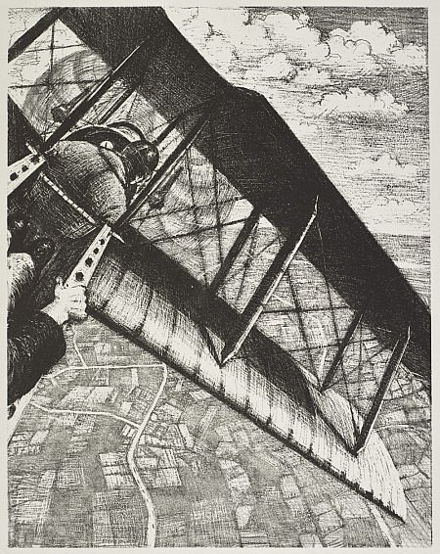
CRW Nevinson, Making Aircraft: Aircraft Banking at 4000ft, 1917
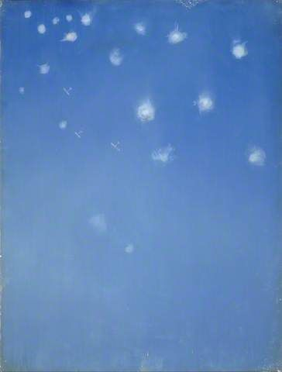
CRW Nevinson, Archies, c. 1916

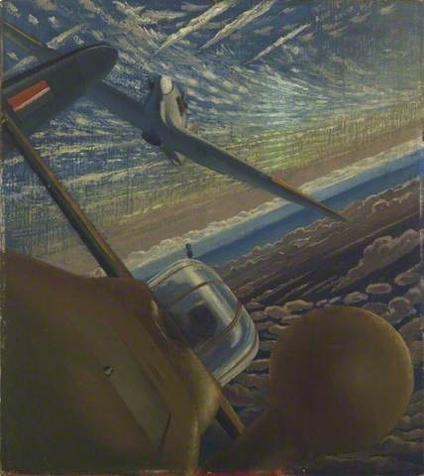
Walter Thomas Monnington, Fighter Affiliation: Halifax and Hurricane Aircraft Co-operating in Action, 1943

