

Analysing the effects of mental health calls demand on policing and identifying challenges and solutions towards a suitable response

Daniel Brookman
2029426

BSc Bachelor of Science: Professional Policing Practice

Acknowledgements
I extend my deepest gratitude to my family, to my partner Shauna, whose unwavering support and understanding for time and commitment required to throughout this dissertation. With their encouragement, and belief in me sustained me through the challenge. My daughter, Ava, their presence has been a constant reminder of the significance of balance and family amid academic and career pursuits.

I would also like to I express my appreciation to my colleagues at work who have been a source of encouragement and support. Their willingness to share insights and engage with my research has assisted the quality of my research.

Declaration
This work has not previously been accepted in substance for any degree and is not being concurrently submitted in candidature for any degree.
Signed:
Date: 02/01/2024

STATEMENT 1
This dissertation is being submitted in partial fulfilment of the requirements for the degree of BA.
Signed:
Date: 02/01/2024

STATEMENT 2
This dissertation is the result of my own independent work/investigation, except where otherwise stated.
Other sources are acknowledged by footnotes giving explicit references. A bibliography is appended.
Signed:
Date: 02/01/2024

STATEMENT 3
I hereby give consent for my dissertation, if accepted, to be available for photocopying and for interlibrary loan, and for the title and summary to be made available to outside organisations.
Signed
Date: 02/01/2024

STATEMENT 4
I hereby give consent for my dissertation, if accepted, to be available on the university’s IT system to those who have consent to use the system.
Signed:
Date: 02/01/2024

Abstract
The researcher has created this dissertation to analyse the impact of responding to mental health calls on police services, combining a examination of existing literature and direct engagement with current police officers. By scrutinizing academic papers, reports, and case studies, the study establishes a foundation to understand the complexities and challenges faced by the police service in managing the demand and response to mental health related incidents.
The data included within this paper was achieved by a combination of quantitative and qualitative data collection. The primary research component involves administering a questionnaire to gather insights directly from police officers, aiming to capture their perspectives on the demand and challenges associated with responding to mental health calls and the impact it has on the ability to respond to crime oriented calls. The results of the questionnaire have been analysed and displayed in forms of graphs.

This approach conducted by the researcher, allows for this academic research to incorporate theoretical frameworks and real world experiences. This will provide an understanding of the demands faced by the police service and mental health issues. The findings contribute to informed policy recommendations and strategies that prioritize both public safety and the wellbeing of individuals in crisis. Including the current research available that

Chapters should be:
- Introduction – Page 6
- Literature Review -Page 8
- Methodology – Page 13
- Analysis of results- Page 15
- Conclusion and recommendations – Page 21
- Bibliography - Page 32
- Appendix

Appendix - to include questionnaires/all data results/charts etc.

Chapter 1
Introduction
This study aims to explore the ever increasing demand for mental health calls and identifying possible solutions for a more appropriate and efficient response and support for those in crisis. In recent years, the escalating frequency of mental health crises has significantly increased the demand for police involvement, creating a pressing challenge for Police Services across the United Kingdom. This dissertation will focus on the existing literature and insights of police officers on responding to mental health calls and the consequential strain on police services. Personally motivated by encounters where the existing models in place of current response mechanisms became evident that they are not practical. This research seeks to address the complexities of balancing public safety with the compassionate handling of individuals in crisis while seeking an appropriate model and response from emergency services.

The significant increase of mental health related incidents has placed emergency services, primarily the police service at the forefront of a delicate dilemma. The need for a researched and updated approach, taking into account both the safety of the public and the well-being of those experiencing mental health crises, underscores the urgency of this research. Drawing from personal experiences and the insights from other colleagues and serving police officers, this study aims to contribute practical insights and evidence-based recommendations to enhance the effectiveness of police responses to mental health calls. By examining the root causes and exploring alternative models, the research endeavours to facilitate a more empathetic, comprehensive, and efficient approach to addressing the growing demand for mental health crisis intervention within the framework of policing.

Aims
The aim of this research is to analyse existing literature and resources such as papers, case studies and articles on the existing topic of mental health. I will be seeking out data referring to the increase in frequency of mental health related calls and the demand on police services responding to these incidents.
I will also be referring to personal experiences as a police officers when dealing with such situations. The researcher that has created a questionnaire which has been sent out and responded by colleagues and other police officer. The data has gathered their own insights and experiences with dealing with mental health related incidents.
With the research gathered from existing literature resources and the data gathered from the results of the questionnaire, I will seek to deliver recommendations for a modern approach in response to these incidents.

Objectives
- Research and analyse existing literature and resources in relation to increase in mental health related calls.

- Research and analyse existing resources and data on the effects of police services in the United Kingdom responding to mental health related calls.

- Analyse the results obtained from the created questionnaire sent out to police officers and review the insights on an alternative approach.

- Collaborate all the data and information researched and obtained and create recommendations for a modern and comprehensive response to mental health related calls. Maintaining a empathetic approach to those in crisis while also reducing the overall strain on demand on the police service.

Chapter 2
Literature Review
The aim of this chapter within this research paper is to research existing literature and resources that are currently available. There the information can be reviewed and analysed through the material using books, case studies and online resources such as articles and data charts.

What is mental health?
What is mental health? Mental health is defined by the World Health Organization as ‘Mental health is a state of mental well-being that enables people to cope with the stresses of life, realize their abilities, learn well and work well, and contribute to their community.’ (World Health Organization, 17 June 2022).
Following on from the initial definition of mental health, it refers to each individuals state of mind. There is a general consensus to the average persons state of mind, where they would each day contributing to society. This could be referred to as functioning on a normal routine, where the individual will attend their job daily and return home and spending time with friends, family and completing personal hobbies.
Excluding the average persons state of mind, the average individual would not stop to think about their current state of mind functioning on a sort of auto pilot. There are other means of someone’s personal mental state, this can be in the form of mental illness or mental disorder. Following on from the world health organization, they continue with their article defining mental disorders as ‘A mental disorder is characterized by a clinically significant disturbance in an individual’s cognition, emotional regulation, or behaviour. It is usually associated with distress or impairment in important areas of functioning.’ (World Health Organization, 2022)
The go on to describe that mental health disorders come in many different forms, such as: mental disorders which are seen more frequently than others which are depression and anxiety. They also come in the form of psychological conditions which are less common are sometimes more serious such as schizophrenia and bipolar disorder. There are also other disorders which have been found in adults but have frequently been identified in children through schools and behaviour such as attention deficit disorder (ADHD) or Autism. World Health Organization refers to a study conducted in 2019 where it was identified that around 1 in 8 people will have the presence of a mental health condition or disorder.

Equality Act 2010
Mental health, although it has been present for many years, people only recently becoming frequently aware over the last two decades. There were recorded instances where persons were falling short in situations such as job applications because of their personal situation such as age, sex or having a disability. Following these incidents which were escalating, the introduced the Equality Act 2010 which is ‘The Equality Act 2010 legally protects people from discrimination in the workplace and in wider society.’ (Gov.co.uk, 2013). The act was brought into parliament legislation to support action to safeguard the protected characteristics which are age, disability, gender reassignment, marriage and civil partnership, pregnancy and maternity, race, religion or belief, sex and sexual orientation. (Equality and Human Rights Commission, 2021). The act brought a legal requirement for public services to safeguard those who were disadvantaged, including those with disabilities physical or mental disorders.

Increase in ADHD Cases.
Mental health is becoming a significant topic across the world, it has become a household discussion with many people having a family member or know of someone with a mental health disorder or condition. The topic of mental health has significantly increased over the last two decades. A significant topic in relation to mental health is to the awareness of some conditions which are frequently identified in children following behaviour in schools. Mental health conditions such as attention deficit disorder (ADHD) and autism are now a regular topic discussed when it comes to children’s behaviour. ‘The research reviewed 7 million individuals aged three to 99 between 2000 and 2018…35,877 had an ADHD diagnosis…a 20-fold increase in ADHD diagnoses’ (National Institute for Heal and Care Research, 2023). This included 18,518 people being prescribed medication to assist with the diagnosis. Where there are also

Increase in Prisoners with Mental Health Conditions
The more frequently that people, public services and the government are becoming more aware of mental health and mental health disorders each year. With more awareness surrounding mental health conditions, it has been identified that there has been a significant increase in people who have entered the criminal justice system with an identified mental health disorder. ‘Criminal justice system failing people with mental health issues – with not enough progress over the last 12 years’ (Criminal Justice Joint Inspection, no date) a joint inspection was carried out throughout prisons in England and Wales where it was identified that prisoners present were not receiving the required care or lengthy delays in receiving the care. The report states there are thousands of persons entering the criminal justice system each year and becoming part of a ‘Broken’ system. Following the joint investigation, there were numerous interviews carried out with prisoners and proffesionals. Some of the people interviewed in and commented on their experience of having a mental health condition and entering the criminal justice system such as a quote from a person named Filip (names were changed for the protection of the identities of the individuals, Filip stated ‘Filip said he was left alone for three days in police custody. He spoke to a mental health nurse briefly about having suicidal thoughts. He said: “(Arrest) was the lowest point in my life. (It was) unbearable, shocking… full of worry and fear… I did not understand what was going on in my mind.’ (Criminal Justice Joint Inspection, no date).
Following this quote and several others, it is saddening and disappointing to read such comments from people who have a mental health condition and have not received the help they require. Reading this quote, it is an indicator that is shows that there is not enough help or training available within prisons and the criminal justice system. There are people who debate that people with mental health conditions should not be entered into the criminal justice system or prisons. There are sources available indicating that there is no link between mental health conditions and becoming a violent offender.
In 2018, Chelsea Halle, Calli Tzani-Pepelasi, Ntaniella – Roumpini Pylarinou and Anita Fumagalli conducted a joint study in relation to ‘The Link Between Mental Health, Crime and Violence’ (C, Halle Et al, 2018) Following their research study, they come to the conclusion that ‘The link between mental health, violence and crime has been over-estimated and may be unrepresentative of reality due to several factors which include imprecise definitions of violence and unrepresentative population samples.’ (C. Halle. Et all., 2018) The conclusion was met that through the research of several studies which they have references in their case study. There is no significant link between a person with a mental health condition that this will make them a violent offender. The study also refers to the pre judgment, of a person who will learn that an individual may have been suffering with a condition such as schizophrenia and relate that individual as being violent because of their mental condition.

Increase in Mental Health Related Incidents
The police service has been a vital part of the frontline emergency services for over century in the United Kingdom. From the iteration of the first constable to modern day policing, there role of a police officer has evolved become far more challenging and demanding. With the advancements of technology, there have increasing demand for new criminal offences such as malicious communications and cases of harassment carried out online using phones and computers. The presence of modern offences require police officers and the police service to evolve and adapt. This requires more training and tools to be provided to officers in order for them to respond to these criminal offences and provide a positive experience and outcome for the victims in the situations.
With the increase in offences, the police service has adapted the way members of the public can engage with police. This relates to the reporting of crimes, previously there were limited methods of being able to report a crime which would include phone the police or attending the local police station. With modern policing, there have become more technical methods available to members of the public to report incidents to police. This can be from contacting police on the phone by dialling 101 or 999, before where there were primarily only landlines available, most people have access to a mobile phone which they carry with them. Police can also be contacted through social media and e-mail. (South Wales Police, no date)
There are several methods available to the members of public to contact police whether it is an emergency or a non-emergency. There has been an overall increase in demand for police, this includes the increase in violent offences including more people carrying weapons and knifes. With the increase in demand, the resources available to deploy to these incidents were at a 20 year low. The police federation of England and Wales reported in relation to the mass recruitment drive for new police officers. ‘The Home Office at the time admitted that, “this is the lowest number of police officers since comparable records began in 1996. While records earlier than this are not directly comparable, this is the lowest number of officers since 1981.” (Police Federation, 2023) They state that following the review in 2023 there were 149,572 police officers, in 2010 there were 146,03. Between 2010 to 2018 the overall number of officers dropped to 122,404. Following the mass recruitment drive, the numbers were at the all time hight but this following the recuperating of the officers lost due to government cuts and officers leaving the force for their own reasons. Reasons for police to leave relate to working hours, pay and for some is the demand.
Crime is not the only increasing demand for the police service, there has been a frequent increase in mental health related calls. These incidents have primarily focused on a response from police officers. 2023, several new outlets including the BBC used the freedom of information act to obtain information in relation to mental health related incidents. The data received and displayed in an article shows that police forces across England and Wales have seen a significant increase year on year of dealing with mental health related incidents over the past five years. ‘In Merseyside, mental health-related incidents increased from 7,629 in 2017 to 28,039 last year - a 313% rise.’ (S. Kotecha, C. Golding, 2023). The increase in 313% is an extensive increase which has left some police officers at breaking point dealing with this demand.

Right Care Right Person
Right person right care, the new comprehensive and efficient model which has been created following the increasing demand of mental health related calls that are being responded to by police officers. The implementation of this model first originated from Humberside Police. The model has been described as ‘It is aimed at making sure the right agency deals with health related calls, instead of the police being the default first responder as is currently the case in most areas. It has been shown to improve outcomes, reduce demand on all services, and make sure the right care is being delivered by the right person.’ (Metropolitan Police, 2023)
Police have become the first point of contact when it comes to responding to mental health related calls. Police are being used to fill the gap between lack of resources at the NHS where they state they are unable to attend these incidents or there will be a significant delay before a response can be made. This is when police are then contacted to attend which has escalated into police being the initial response.
The current method in place when responding to mental health incidents is upsetting and disappointing. As a police officer, I have experienced responding to these situations frequently which carrying out my duty. As a police officer, we are not trained to deal with mental health incidents. One of the primary challenges with involving the police in mental health calls is their lack of specialized training in dealing with psychiatric emergencies. Law enforcement professionals undergo rigorous training to handle criminal activities and maintain public order. However, the intricacies of responding to mental health crises demand a distinct skill set, including empathy, de-escalation techniques, and an understanding of mental health disorders. Unfortunately, many police officers may not possess the necessary expertise, leading to suboptimal outcomes and potential harm to individuals in crisis.
To address these issues, a shift is imperative, where mental health professionals take a central role in responding to mental health crises. This involves the creation of specialized crisis intervention teams composed of professionals trained in mental health care. These teams would be equipped to assess and de-escalate situations effectively, ensuring a more compassionate and informed response to individuals in crisis. While collaboration with law enforcement may still be necessary in some instances, the emphasis should be on mental health professionals leading in situations primarily related to mental health.
Following the review conducted by the Metropolitan Police, they identified on average of spending in excess of 10,000 hours a month responding to mental health incidents. This included Section 135/136 detentions where one section could take around 14 hours in the hospital. This would take one or more officers off the street for that period of time where they will be unable to respond to criminal incidents due to the mental health incident.
I personally welcome the introduction of the right care right person model as there have been positive results. Originating from the Humberside Police, they would attend around 1,500 mental health related incidents each month ‘As a result of implementing Right Care, Right Person, Humberside saw average incidents per month reduce by 508 deployments – equating to 1,132 officer hours.’ (Metropolitan Police, 2023).
The model is very recent and comprehensive approach to a new and more efficient response to mental health incidents. There is very limited case study on the matter, although there are several sources available as mentioned showing the demand on police with the current situation. With the positive results provided by the Humberside Police, it brings a positive approach to police officers and police services which themselves are reaching breaking point with demand. The introduction of the model is a positive step in the right direction.

Chapter 3
Methodology
Mental Health related incidents pose a growing challenge for police forces in England and Wales for both officers and individuals in crisis. This research aims to comprehensively investigate the demands on policing, stemming from mental health related calls. This chapter will outline the methods the researcher will conduct, to carry out a thorough examination of existing demand on police forces and identifying more suitable response such as the model of right care right person.
Following the review of the existing literature and sources available in relation to the demand on police forces responding to mental health related incidents. The data revealed that over the past 5 years, police forces in England and Wales seen a year on year increase. With one of the highest increases originating from the Merseyside Police which saw an increase of 313%.
The sources available show that the demand for policing is increasing in terms of criminal incidents. These sources show that there is an increase in violent and serious crimes being committed. ‘Serious violence rose after lockdown restrictions ended’ (S. Swann, 2022) Swann produced and article following a review of crime after lockdown and restrictions ended. It showed that there was a 23% rise in crime, following the national office of statistics showed that although some offences were on the decrease. Offences such as fraud and sexual offences more serious offences were on the rise.
Analysis of the articles and reviews of sources also shows that with the increase of demand, the resources are at one of their lowest points. The police federation of England and Wales revealed that in 2023 there were around 149,000 officers which is a high of the last two decades. It also shows that that in 2010 there were approximately 146,000 officers in England and Wales. This dropped to as low as approximately 122,000 officers by 2018. This shows the researcher that between 2010 and 2018, the 2023 increase of officers only makes up for the losses over the last decade following government cuts and officers leaving the job.
The review on current conditions of persons who have a mental health diagnosis has also shown that the are not getting the required medical attention while in the criminal justice system. Where it was quoted as a ‘broken’ system by the criminal justice joint inspection. Police officers are lacking the required training in order to cater and respond to these individuals who are in crisis reaching out for help.
I delved into researching for any information in relation to any change in the current methods of dealing with mental health related calls. Through researching online, there were several government and new article covering the modern comprehensive ‘right care right person model’. This model is a empathetic and appropriate method of responding to mental health incidents. Originating from Humberside Police, the right care right model is an agreement between local police forces with government and NHS. It puts the focus on medically trained professionals such as mental health nurse and practitioners being the primary point of contact for these incidents. These professionals who under rigorous and relevant training that is appropriate for those in crisis to receive the right care. Although this is a productive model, this does not mean police will no longer attend mental health related incidents. There will be time where police are required depending on the persons demeanour and possible use of weapons which some calls consist of. This will only relate to the initial attendance, the after care the will focus on the medical staff allowing officers to carry on with their duty dealing with criminal incidents. Where some incidents have had officers waiting 14 hours and more in hospital with a person in crisis. Although the model is relatively new, the initial results are positive for officers and police forces.
There are several different methods for gathering data such as the qualitative and quantitative data approach. Emily Stephens defines these as ‘Quantitative data is anything that can be counted or measured; it refers to numerical data. Qualitative data is descriptive, referring to things that can be observed but not measured—such as colors or emotions.’ (E. Stephens, 2023)
While both approaches have their merits, questionnaires offer a powerful tool for collecting quantitative data swiftly. Questionnaires provide a structured format, ensuring consistency in data collection. I chose to gather my data using the mixed method approach, focussing on quantitative data with some open ended questions for respondents to answer. Considering the extensive demand for police officers and their workload, it was appropriate for a questionnaire to be created. This allows for a quick completion by the officers anytime and for prompt feedback which can be analysed in forms of numerical and graphs. Moreover, the use of questionnaires in quantitative research contributes to objectivity. The standardized questions minimize bias, providing respondents with a clear framework for their answers. This standardization enhances the reliability and validity of the collected data. The efficiency of the questionnaire allows for a further audience to be reached across surveying platforms. This allows the researcher to gather the data quickly compared to other methods such as qualitative data collecting which could include interviewing. Interviewing although it will allow for open ended questions to be asked, can prove to be time consuming which would not be practical for by target audience for police officers.
While there are many pros and cons to each data collecting method, there many pros to the questionnaire and the quantitative approach. Once all the data has been obtained from the questionnaire, the data and results will be formulated into numerical graphs. These will be inserted into this study is pictures of the graphs. The written answers will also be inserted into the this study so that they may be analysed in the conclusion of results.

Chapter 4
Analysis of Results

This chapter will outline the analysis of the data that was obtained from the from the created questionnaire which was mentioned in the previous chapter. The results will be displayed in the format of graphs, also with the inclusion of a few text boxes which the respondents could type if thy wish to. The questionnaire will be the results of the frontline police officers which were the target audience of this questionnaire to gather primary and quantitative data.
Appendix A outlines the questions within the questionnaire
The questionnaire was created using the website surveymonkey.com, there was a total of 10 questions created. Following the completion of the questionnaire, there were 20 respondents with some questions being skipped. This was the quickest and most efficient method of gathering data. It allows the officers to complete the questionnaire when they are able amongst the busy workload and also allow the researcher to obtain the data to analyse quickly. This is a closed questionnaire that was completed anonymously, only those the link to the questionnaire was sent will allow them to view as it will not be published publicly.

Question 1
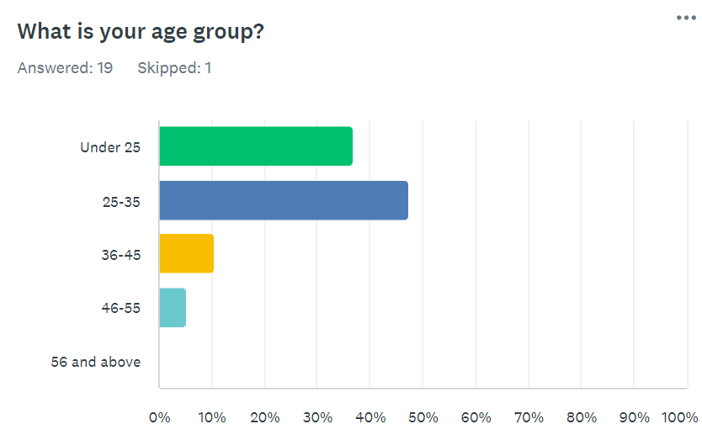

This question along with the first few questions are just to gather information in relation to the respondent, but does not gather any personal information. The results show the highest respondents were in the age category of 25 – 35 years old. With the second highest age group being under 25 which indicated they are usually the new officers currently in their probation.

Question 2
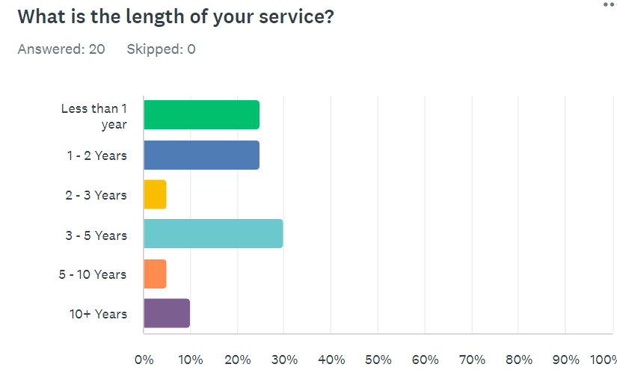
This question also refers to some information gathering of the respondent without gathering any personal information. There is a close margin of the highest respondent having between 3 – 5 year’s service, which indicates that they are all out of their 2 – 3 year probation. Tied in the second most respondents were officers with only 1 – 2 year’s service or less than a years’ service indication they are relatively new and just out of their 6 months initial training. This means that overall, over half of the respondents are in their probationary period.

Question 3
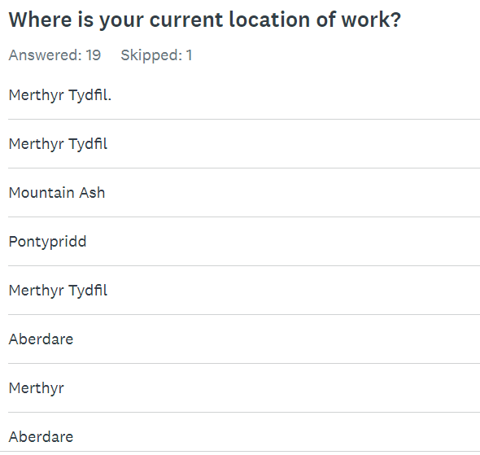
This third question was a again related to the respondent and where their primary location of work was. It shows that all the respondents to tis questionnaire work in the mid Glamorgan area. This also means that the data obtained from this questionnaire will geographically be around the same locations.

Question 4
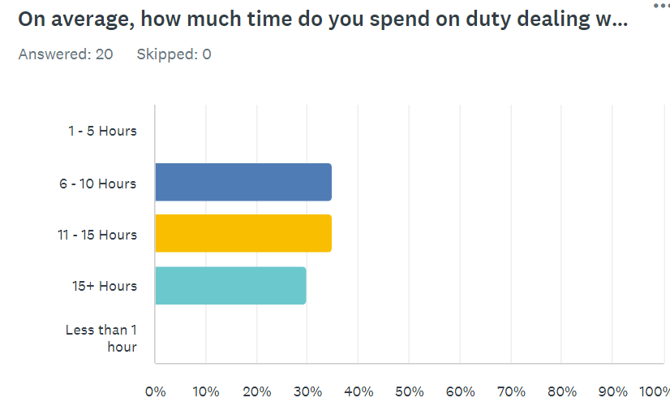
This where the data obtained from the questionnaire indicates the true demand and numerical figures that officers have provided. The question relates to how many hours the respondents spend on average each month as a police officer dealing with mental health calls. From the 20 respondents, there is a joint highest response with nearing 40% of the results between 6 – 10 hours and 11 – 15. With the lowest respondent, which is still 30% showing they spend on average more that 15 hours a month dealing with mental health calls. These results together indicate that 100% of the officers would spend at least 6 hours a month, individually responding to mental health related incidents.

Question 5
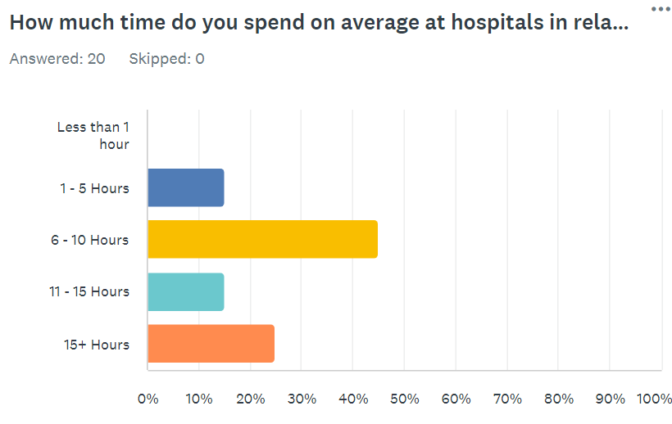
This is a follow on question from the previous in relation to the time spent each month individually as an officer dealing with a mental health question. The results show that when officers are dealing with a mental health related incident, the highest responses will spend at least 6 – 10 hours each moth waiting in a hospital. This could be conveying someone on a voluntary basis or it could involve a section 135/136 detention which usually involves a significant amount of time waiting at the hospital. The surprising results are that over 20% of the responses say that they spend over 15 hours on average each month waiting at a hospital in relation to responding to a mental health related incident.

Question 6
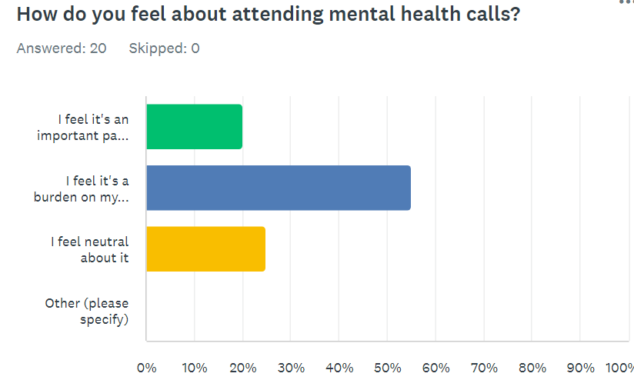
This question delves into the personal opinion of the officers individually and anonymously. The question refers to how the feel as a police officer responding to mental health related incidents. With the highest responses approximately 55% of them state that they feel that responding to mental health calls are a burden on their duties. This is quite surprising results, as an officer we all have a duty to care. But following this and the previous results it shows that the demand on police to answer this call which they are not suitably trained is having an effect on the officers individually.

Question 7
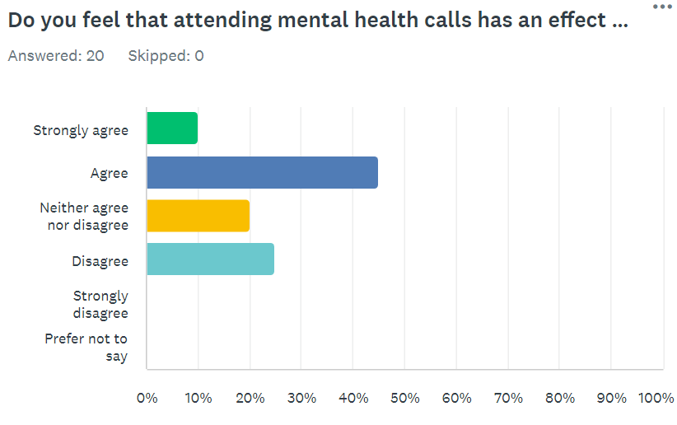
Following on from the previous question, this also reflects the personal opinion of the officer. They were asked if they feel attending mental health calls has a personal effect on their own mental health. This again is quite surprising results, with the highest response from officers at over 40% state that the agree that they personally feel effected in relation to their own mental health following responding to mental health incidents of others in crisis. This indicates that the relentless demand of attending these types of calls may have a long term effect on officers. Especially those that are new officers still in their probationary may deter them from remaining in the job. There are articles and sources present which have reviewed current officers levels are low due to an all time high of officers being on sickness from work due to mental health conditions such as work related stress.

Question 8
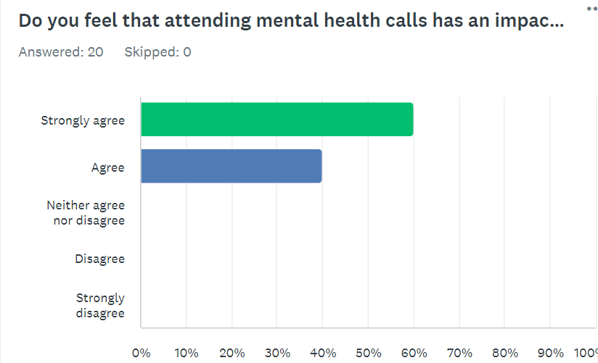
Question 8 results were the most certain and again surprising results from the officers responding. The question asked if as an officer attending a mental health call, do you feel it has an impact on resources and the ability to respond to crime oriented calls. The highest response was 60% strongly agreeing but the whole 100% agreed that attending mental health related calls effects the ability to respond to criminal incidents.

Question 9
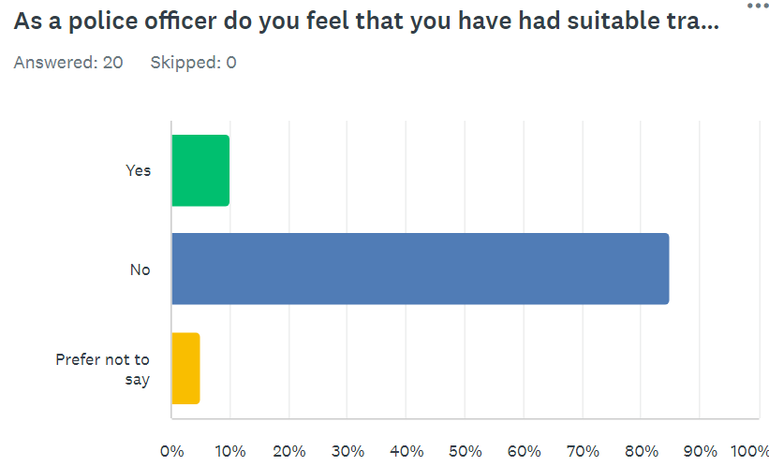
Frontline officers were asked, do you feel that you have had suitable training to deal with mental health related incidents. Over 80% of the responses stated no, they had not received suitable training. Police officers are rigorously trained to deal with criminal aspect calls, this refers back to the model, right care right person.

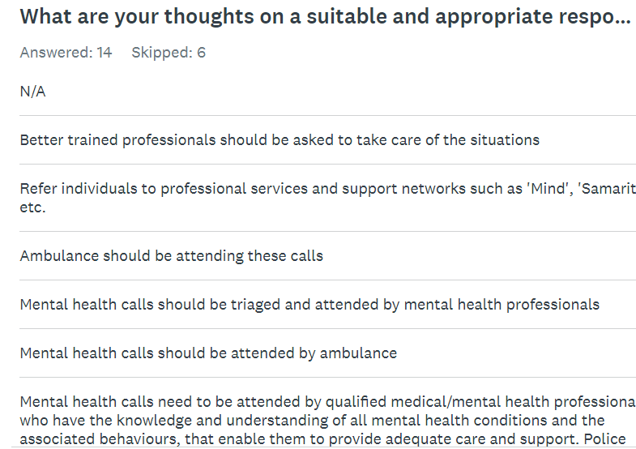
Question 10
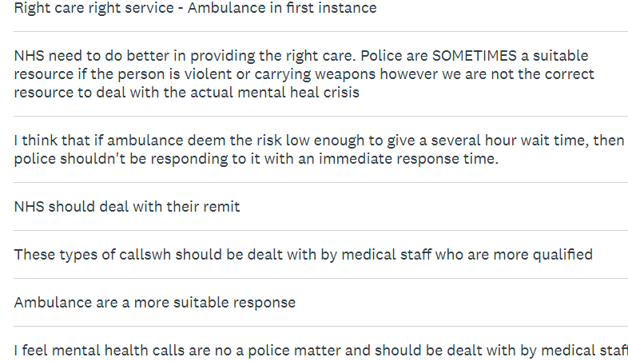
The final question in the questionnaire I feel had the biggest impact. The question was free text which allows the officer to write what they want in relation to the question asked. They were asked what they think would be the most appropriate response to dealing with mental health related questions. Although the answers are different in terms of wording, all the answers state that the more suitably trained mental health professionals should dealing with theses incidents. Police are available to assist with the subject in crisis is violent or carrying a weapon. But primarily medically trainer professionals should be the main point of contact. This again refers to the comprehensive right care right person for the job model.

Chapter 5
Conclusion

Objectives
- Research and analyse existing literature and resources in relation to increase in mental health related calls.

- Research and analyse existing resources and data on the effects of police services in the United Kingdom responding to mental health related calls.

- Analyse the results obtained from the created questionnaire sent out to police officers and review the insights on an alternative approach.

- Collaborate all the data and information researched and obtained and create recommendations for a modern and comprehensive response to mental health related calls. Maintaining a empathetic approach to those in crisis while also reducing the overall strain on demand on the police service.

These were the objects a sought out at the beginning of this research project. I aimed to research existing literature and sources available in relation to the increasing demand on the police services in England and Wales in relation to mental health related calls.
I also aimed to gather the data from active frontline officers and colleagues to gather their insights and opinions in relation to attending these mental health calls. Following gathering the data from the literature review I aimed to collaborate and analyse the data together to identify new methods and models in response to dealing with mental health related incidents.

Demand and Right Care Right Person
Following the research of existing literature in relation to the increase in general demand. The results showed that following the lifting of lockdown and restrictions, crime was on the rise. Not all crimes, some were on the decrease but more serious crimes such as fraud and sexual assaults had increased greatly.
The most impactful increase was the surge in mental health related calls which has undeniably placed an unprecedented burden on police services in England and Wales. The analysis of this escalating demand reveals a critical need for comprehensive reform in the way Police Services responds to mental health incidents.
The literature review revealed the complexities and inadequacies of a police officer response to the incident. The current model which is still actively used by a lot of police forces in England and Wales often falls short as in providing the necessary support for the individual in crisis. With the lack of appropriate support, this risks of escalation of harm to the individual. Following further research and the discovery of the right care right person model. It takes a comprehensive approach including a collaboration with local police forces and the NHS with more suitably trained medical and mental health staff. With the current demand where Merseyside Police saw a 313% increase in mental health related incidents that required a police response. These types of demands can not be sustained, especially with the lack of resources available. Many are aware that all frontline staff are struggling with low resources, it is has proven not appropriate for police officers to be filling the gap in the NHS resources by attending mental health related calls that they cannot provide the correct support required.
There are theoretical ideas in place which could be tested such as initiatives with co responder programmes are conducted. This would include a police officer being deployable in the company of a medically trained mental health staff. These could provide promising alternatives to the current model of police reaction to calls which is not appropriate when their required support is not being provided. These initiatives can offer a more compassionate and informed approach to mental health crisis.
Additionally, police services could invest enhanced training for police officers individually and also engaging in community based education initiatives to contribute to early prevention into support for mental health.

Questionnaire results
In drawing conclusions from the questionnaire results obtained from the police officers regarding the increase in demand for mental health related calls. There was a total of 20 responses from frontline officers where they have provided numerical results to demand of attending mental health calls. They have also provided their insight and person opinions on some of the questions which have been previously analysed and present above as graphs.
The responses reveal a complex and mixture of factors that significantly impact officers ability to effectively respond to these crises. Firstly, the data shows the overall demand and impact that attending these types of calls have on a police officer and their ability to carry out their duty of attending crime oriented incidents. The majority of response state that on average each month, each individual officers will spend at least 5 – 10 hours dealing with mental health incidents. There were also significant response in relation to the average time spent at ta hospital following attending a mental health incident which would average approximately 10 hours per month.
The final question of the questionnaire was the most surprising results. Most of the free text responses from the police officers states in different wording that these incidents should be attended me medical staff. The mental health staff and nurses and more rigorously trained in that field of work and would provided the required support and compassionate support for the individuals in crisis.
In conclusion following the literature review of existing resources and analysis of the response from the questionnaire completed by officers. They all indicate there is a significant increase in mental health related calls that have become a major demand on police. Police officers and statistics show that the current response from a police officers a not suitable. There is a current model taking place called the right care right person and other initiatives being considered which will help provide a positive and more appropriate response to mental health related incidents .

Appendix A
Questionnaire

South Wales Police Responding
to Mental Health Related Incidents

- What is your age group?
Under 25
25 – 35
36 – 45
46 – 55
56 and above
- What is your length in service?
Less than a year
1 – 2 years
2 – 3 years
3 – 5 years
5 – 10 years
10+ years
- What is your current location of work?
Free text
- On average, how much time do you spend on duty dealing with mental health related incidents each month?
1 – 5 hours
6 – 10 hours
11 – 15 hours
15+ hours
Less than an hour
- How much time do you spend on average at hospitals in relation to responding to mental health related health call?
Less than an hour
1 – 5 hours
6 – 10 hours
11 – 15 hours
15+ hours
- How do you feel about attending mental health calls?
I feel it’s an important part of my role
I feel it’s a burden on my duties
I feel neutral about it
Other
- Do you feel attending mental health calls has an effect on your own mental health?
Strongly agree
Agree
Neither agree nor disagree
Disagree
Strongly Disagree

- Do you feel attending mental health calls has an impact on resources and the ability to respond to call involving crime?
Strongly agree
Agree
Neither agree nor disagree
Disagree
Strongly Disagree

- As a police officer, do you feel that you have had suitable training for dealing with mental health incidents?

Yes
No
Prefer not to say

- What are your thoughts on a suitable and appropriate response to mental health calls?
Free text

Appendix B
Questionnaire Results

Question 1
Question 2
Question 3
Question 4
Question 5
Question 6

Question 7
Question 8

Question 9
Question 10
Bibliography

Equality and Human Rights Commission (6th July 2021). Protected Characteristics
Available at: https://www.equalityhumanrights.com/equality/equality-act-2010/protected-characteristics.
(Accessed September 2023 )
‌
Halle, C., Tzani-Pepelasi, C., Pylarinou, N. - R. and Fumagalli, A. (2018). The link between mental health, crime and violence. New Ideas in Psychology, 58(1), p.100779.
Available at: https://doi.org/10.1016/j.newideapsych.2020.100779.
(Accessed September 2023)

‌Kotecha, S. and Golding, C. (9th March 2023). Increase in mental health callouts received by police over past five years. BBC News.
Available at: https://www.bbc.co.uk/news/uk-64891572.
(Accessed October 2023)
‌
NIHR (18th July 2023) Significant rise in ADHD diagnoses in the UK.
Available at: https://www.nihr.ac.uk/news/significant-rise-in-adhd-diagnoses-in-the-uk/33968.
(Accessed September 2023)

Police Federation (11th May 2023). Police Uplift Programme: a Flawed Success Story. Available at: www.polfed.org. Available at: https://www.polfed.org/news/latest-news/2023/police-uplift-programme-a-flawed-success-story/.
(Accessed September 2023)

South Wales Police. (n.d.). Contact Us.
Available at: https://www.south-wales.police.uk/contact/af/contact-us-beta/contact-us/.
(Accessed September 2023)
‌
Stevens, E. (2022). Quantitative vs. Qualitative Data: What’s the Difference?
Available at: https://careerfoundry.com/en/blog/data-analytics/difference-between-quantitative-and-qualitative-data/.
(Accessed December 2023)
‌
UK Government (27th February 2013). Equality Act 2010. GOV.UK.
Available at: https://www.gov.uk/guidance/equality-act-2010-guidance.
(Accessed September 2023)

World Health Organization (17th June 2022). Mental health.
Available at: https://www.who.int/news-room/fact-sheets/detail/mental-health-strengthening-our-response.
(Accessed September 2023)

World Health Organization (8th June 2022). Mental disorders. [online] World Health Organization. Available at: https://www.who.int/news-room/fact-sheets/detail/mental-disorders.
(Accessed September 2023)
‌

