Marianne Dekoven notes that modernists “saw art as the only remaining avenue to truth, meaning, value and transcendence in the otherwise bankrupt twentieth century.” Explore the significance of art as an embodiment of truth.

In the early twentieth century, the aesthetic and cultural sensibilities present in art and literature radically shifted from the values evident in the Enlightenment period. This new era of ways of thinking is defined as the modernist period. Important modernist values that affected the way art was viewed includes the development of technology which provided a greater access to new materials, as well as a loss of faith in God and the government. The movement away from organised religion resulted in a greater focus on the individual. Ezra Pound’s injunction; ‘make it new’ was “borrowed from the inscription in the bathtub of the legendary Chinese emperor Tang”. Incidentally it became the expression of modernism. It is significant that the phrase ‘make it new’ is not an original statement by Pound, but rather he took this inscription from the eighth century. It highlights the importance of using the past and renewing or renovating it with modern concepts. Many literary artists including Pound and Eliot, intended their work to include references to history and myth whilst “globalizing its language and expanding its subject matter to all that the human mind can encompass”. These modernists made language central to artistic exploration whilst maintaining an interest in the rhythm and fragments of everyday language. Before the modernist period, literature was often created to document history or particular lifestyles as they happened. These texts were directed more towards the upper classes who had the education to understand the works. Using common language enabled all social classes to enjoy the text and have the ability to discuss it with each other to discover new values. Theatre and performance were revived from being used primarily in service of a king or queen and their ancestors to exploring new movements of futurism and naturalism. Artwork ceased to deliver divine inspiration and instead became reflected into politics as new ideas emerged such as how to run a country effectively, as well as socialism, capitalism and fascism movements that grew more popular in the early twentieth century. Art became a form to explore “conservation and restoration [by using] technology that brings the remnants of the past into the present and brings things of the present into the future.” This was developed through the use of symbolism and setting which were heavily incorporated into literary works. However, other modernist artists were interested in the practice of art itself rather than the hidden meaning behind texts and visual arts. They took Pound’s phrase ‘make it new’ more literally and thought of it as a way to reject the past and its values. These modernists discussed and explored the form of the art itself. Across all the art forms, each artist believed they could make art objectively better. In this essay I shall explore the techniques artists used to portray truth and meaning through their work and how they expressed themselves during this ever-changing period.

Peter Watson argues that the technological growth and advancements in the scientific field deprived the world of religious and philosophical meaning. He claims that the role of art is “to describe this state of affairs, to assess and criticise it, and, if possible, to redeem it.” The function of pre-modernist art was primarily used to encapsulate the image of serving God or as a reflection of “good conservative moral values”. Those associated with such pieces of art were supporters of the status quo. The early progressive modernists and their art “tended to concern itself with political and social issues”. These pieces reflected images of concern regarding prostitution and the poor. Their intention was to educate the public with these topics to attempt to combat these issues by raising awareness. To some extent this reflected ideals that emerged from the Enlightenment period such as freedom and equality. Artists used these ideals to express their concerns and explore the current issues through their chosen art form. In order to effectively share these matters and the truth they hold, art had to be understood by a greater portion of the population. To one person the art might hold a different meaning or truth than the artist intended based on their personal experiences that shape the way they view art. This was achieved through experimenting with art forms to strip away the essence of a recognisable object and replace it with a series of lines and colour. The result was piece of art that concealed truth behind an image that encouraged people to discuss the composition of the piece. For example, in Kandinsky’s Composition 8, the piece depicts an arrangement of colourful shapes and lines that appear to have no connection with any object of reality. If we look at this piece in relation to the time it was created in 1923, shortly after the end of World War One there is more to be revealed than simply a collection of lines. It is evident that the art work reflects turmoil, upheaval and uncertainty as shown in the harsh straight lines but this is mixed with emotions of relief represented by the overlapping circles that emit a softness with the use of fading colour. Kandinsky believed that “art should serve as a guide to, or an inspiration for, or perhaps help to rekindle in, the spectator the spiritual dimension which [were] being lost in the increasingly materialist contemporary world”.

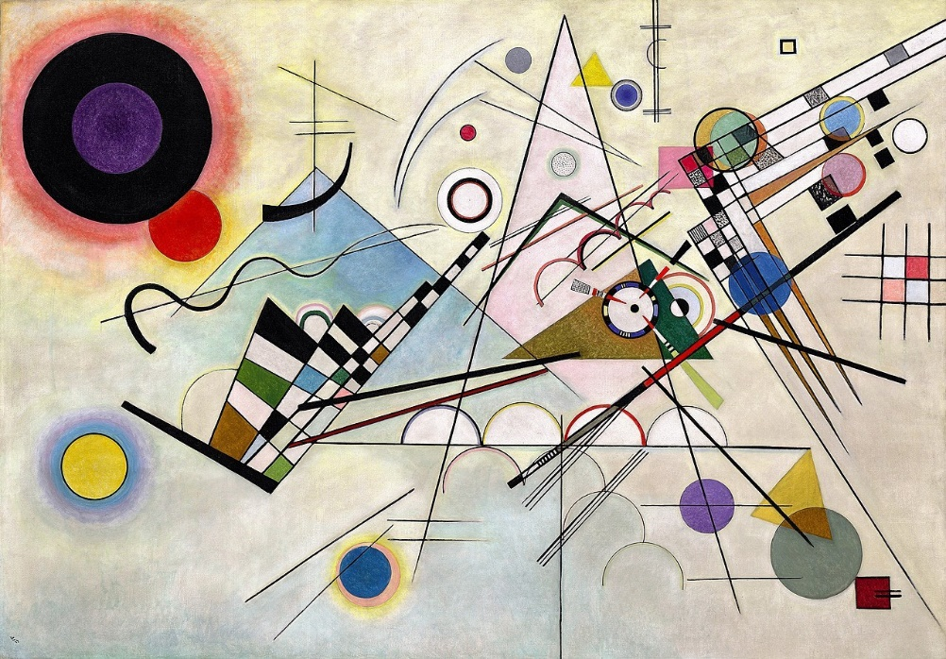
Figure 1 - Vasily Kandinsky, Composition 8, 1923
The movement of abstraction counterbalances the content because people focused their discussions on artistic formal terms such as composition, colour and line, “which effectively removed the question of meaning and purpose from consideration and permitted whatever social, political, or progressive statements the artist had hoped to make in his or her work to be conveniently ignored or played down.”
Ezra Pound places great emphasis on imagery in Cathay, his collection of classical Chinese poetry translated into English. The emphasis on imagery is characteristic of classical Chinese poetry of the Tang Dynasty (eighth century). Pound claims that an image “is that which presents an intellectual and emotional complex in an instant of time”. This suggests that images invoke an immediate response which is a significant factor in the modernist movement. Pound also states that “it is better to present one image in a lifetime than to produce voluminous works” which indicates the power that a single image can have on a person to change the way they think about reality. Ezra Pound challenges Enlightenment ideas of order and prosody by examining another civilisation. The fascination of oriental themes is not a new idea that Pound created. Oriental objects have been used as decor in Western homes long before the twentieth century. It is suggested that “oriental objects in an American home signified an appreciation for what were supposed to be the deepest principles of art, as well as a measure of cosmopolitanism”. The mix of oriental objects and traditional Victorian decoration highlights the changing ideals of the time. There is a strong presence of travel, of wonder about the world and other cultures, as well as an indication of wealth and what was popular at the time. William Leach suggests that “the Oriental theme was popular in merchandising before World War I in large part because the Orient signified the “sensual” element missing from Western society”. To citizens in the Western society “the Oriental object in the living room does not merely cite the other, the far away, the distant; it does not always or merely represent an “escape” or alternative to modernity”. The themes of oriental imagery in the homes and lives of ordinary people reflect the impacts of modernisation across the world.
In discussing Ezra Pound’s poetic translations as a form of art, it is important to note that Chinese characters themselves are an art form. The written Chinese language is both pictographic and ideographic. Each character is either a graphical representation of an object, for example,
人 Rén – the character for person – resembles a person walking, or a representation of an abstract idea, for example, 三 Sān – the number three – depicts three lines. Pound’s interest in imagism may well have branched from the pictorial imagery of Chinese characters. This can be explored further in terms of looking at translation as an art form. Through translation Pound revives past voices, which shows that there are no dead forms or dead languages, there are only derivation and variations through which the past is continuously being made present. The past is always available to those who recognise its ability to be renewed and rediscovered through specific techniques. Pound makes technique a form of inspiration as the sources of the past are brought forward to the future to ‘make it new’. He claims “that part of poetry which strikes upon the imaginative eye of the reader will lose nothing by translation into a foreign tongue; that which appeals to the ear can reach only those who take in the original”. In his collection Cathay, Pound does not give the resources he used to translate the work freely to the reader. This was intended to give the reader a sense of excitement that he felt when accessing the original texts. He appeals to footnotes, the scholarly index, the library archives and second hand bookstores, which were the places he discovered the poems. The result is a body of work that is always returning its reader to the sources. In some poems, he gives more detail in the footnotes as to what certain parts mean, for example in The Jewel Stairs’ Grievance, he notes certain passages such as “jewel stairs, therefore a palace”. In other poems, Pound leaves the reader to interpret lines, for example, in The River Song, where without prior knowledge or research into the poem, such as wondering what “Kutsu's prose song” is or not knowing the names and perhaps the meaning behind the Chinese gardens and rocks that are mentioned. The reader is not supposed to understand each and every reference he creates in the poems, but rather explore the imagery that is presented as an art form.

The following section is an exploration into the practise of art or the artistic freedom from its rules and from public expectations of what art should be. Many modernists thought that art “possessed its own intrinsic value and should not have to be made to satisfy any edifying, utilitarian, or moral function, […] art should be produced not for the public’s sake, but for art’s sake.” This freedom was designed to look for more in art than the demand for meaning and purpose. James Abbott McNeill Whistler suggested that “art should be independent of all claptrap – should stand alone, and appeal to the artistic sense of eye and ear, without confounding this with emotions entirely foreign to it, as devotion, pity, love, patriotism, and the like”. This indicates the struggle many modernist artists had with the public criticising them for not including any hidden meaning behind their work.

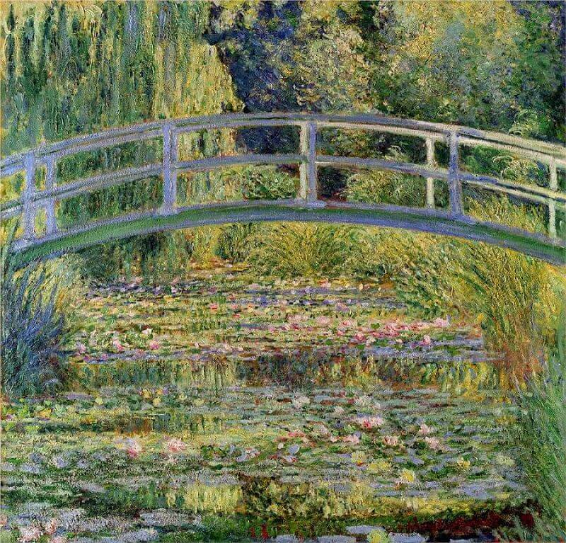
Figure 2 - Claude Monet, The Water Lily Pond, 1899

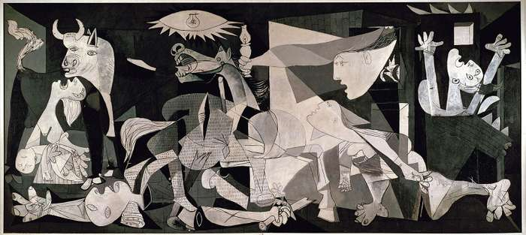
Figure 3 - Pablo Picasso, Guernica, 1937
Figures two and three show examples of work produced by Monet and Picasso. The work produced by both Monet and Picasso are widely considered to be examples of modernist art, yet it is evident that their styles are completely different. Monet and Picasso both chose to reject the artistic forms that came before them. Monet considered himself to be an ‘impressionist’, whereas Picasso defined the ‘cubist’ movement. The impressionists’ approach to capturing art was different to techniques developed in previous movements. Their approach was to sketch outdoors then venture indoors to paint based off of those sketches. They were interested in capturing the ever-changing colours and light that happens in nature rather than capturing nature as it appears to the human eye. Monet’s work focuses on the interplay of light, not on volume and depth. The short, fine brushstrokes give the appearance of water and the leaves on the trees, whilst the bridge has a smoother, rounder look achieved by using long brushstrokes. This contrast gives the painting its depth so that Monet could focus on the way the light hits the space differently. The cubists had very little interest in capturing things as they appeared to humans in the moment. Instead they were interested in capturing the totality of the object of their artwork. They did this by taking how it looked through multiple different viewpoints and placing those together on a single piece of paper. Picasso gave away little information about his painting Guernica, in order to leave the interpretation of the piece to its viewer. It is evident to anyone looking at this piece to see that the characters are in extraordinary distress. The use of shadows and lines force the viewer to look at certain sections. For instance, the eye is immediately drawn to the lightened area off-centre but then the eye follows the lines to look at the other figures in the darkness. In terms of the history of the painting, Picasso was commissioned to paint a mural following the German bombing of Guernica in 1937. With this context we begin to analyse more of the expressions and distortions of the body shapes. Impressionists and cubists were interested in privileging artistic technique when discussing their ideas with little thought for divine inspiration. These two widely different examples are just the start of looking at modernist art. It is clear that modernism is not a collection of thoughts like we might define ‘impressionism’ or ‘cubism’ each as a single thought, but instead it is a way of thinking.
Virginia Woolf suggests that one of the problems modernist writers faced was a society fascinated with the new, consuming the desire to preserve the past: “How can we combine the old worlds in new orders so that they survive, so that they create beauty, so that they tell the truth?”. Female writers looked back on a different legacy to that of the men. In literature, their legacy was the romance plot and the Victorian ideal of the woman as the figure of ‘the Angel of the House’. Marianne Dekoven noted the shifts in gender relations as well as the beginning of feminism as we know it. She states that “the protagonist of this movement was known as the ‘New Woman’: independent, educated, (relatively) sexually liberated, oriented more toward productive life in the public sphere than toward reproductive life in the home”. As working men demanded more rights after the war, so did the women. The educated woman was looking for a role in society. In Woolf’s extended essay A Room of One’s Own, she explores the notion of art as a receptacle for truth. She uses the essay format to search for the essential truth and expose it: “One must strain off what was personal and accidental in all these impressions and so reach the pure fluid, the essential oil of truth”. Over the course of the text the narrator, and ultimately Woolf herself, comes to the realisation that there is no one truth. She understands that personal experiences impact what individuals perceive as truth and ultimately affect one’s understanding of reality. In an essay sketch of Woolf’s own, she explains that “truth requires a merging of observation and imagination”. This indicates that the author or artist can only go so far as to develop their truth in their texts, when it is in the hands of the reader it is their own observation and imagination that shapes the truth behind the text. Woolf explores this further in another text where she states “unless you will allow me to place together two apparently unrelated statements and trust to you to pull them together, you must be content with a mere skeleton of the play I might have given you”.

In A Room of One’s Own, Woolf explores the idea of a lack of true identity. The narrator notes “Call me Mary Beton, Mary Seton, Mary Carmichael or any other name you please—it is not a matter of importance” showing the idea of different identities. Furthermore, this suggests problems with having a fixed identity, as the narrator takes on different voices. It is implied that Woolf is appealing to the reader to be open to change in opinions and views as one is exposed to more concepts offered throughout one’s lifetime. She states that “those who read, whether poetry, fiction or biography, know that some words or scenes have a peculiar power to go on living, [and] possibly growing in the mind long after the context has been forgotten”. This reinforces the idea previously discussed with Pound, that an image, or in Woolf’s context a powerful thought, has the ability to follow alongside one’s life, affecting one’s choices and changing thoughts.

To conclude this essay, I shall offer my opinion on whether I believe art was used to portray truths of the modernist period. It is evident from looking at any review of any piece of art; literary, paintings, performance, music, from any era, that every person responds to it in a different way. With art there is no right or wrong way of thinking, it is about perception and what the viewer can bring or add to the piece with their own experiences. Each artist has an idea of what they want to bring to their work, which messages they want to portray, and how they would like their audience to interpret their work. However, as Oscar Wilde notes “a work of art is the unique result of a unique temperament. Its beauty comes from the fact that the author is what he is”. Therefore, it is my belief that art portrays the truth that the viewer sees, rather than a forced truth that ruins the values of the art itself.

Bibliography

A Few Don’ts, as provided in the Module Docket.

Bartkevicius, Jocelyn, ‘A Form of One's Own: Virginia Woolf's Art of the Portrait Essay’, The Iowa Review, Volume 22, Issue 1, (1992), pp. 123-134.

Bowlby, Rachel, An Introduction to A Room of One's Own (2016) <https://www.bl.uk/20th-century-literature/articles/an-introduction-to-a-room-of-ones-own> [accessed 25 April 2020].

Flippin’ English, Modernism & English Literature, 2016, <https://www.youtube.com/watch?v=1VjMzRcEW90> [Accessed 7 April 2020].

Groys, Boris, The Truth of Art (2016) <https://www.e-flux.com/journal/71/60513/the-truth-of-art/> [accessed 24 April 2020].
James, Jamie, In the Gloom the Gold (n.d.) <https://www.laphamsquarterly.org/arts-letters/gloom-gold> [accessed 24 April 2020].

Kandinsky, Vasily, Composition 8, 1923, oil on canvas, 140.3 x 200.7 cm, Guggenheim Museum, New York, US.

Kim, Thomas W., ‘Being Modern: The Circulation of Oriental Objects,’ American Quarterly, Volume 58, Issue 2, (2006), pp. 379-406.

mdc.edu, History of Modernism (n.d.) <https://www.mdc.edu/wolfson/academic/artsletters/art_philosophy/humanities/history_of_modernism.htm> [accessed 23 April 2020].

Modernism and Modernisms: Sample Essay Questions, as provided in the Module Docket.

Monet, Claude, The Water Lily Pond, 1899, oil on canvas, 88.3 x 93.1 cm, Metropolitan Museum of Art, New York, US.

Nicholas, Tom, Modernism: WTF? An introduction to Modernism in art and literature, 2018, <https://www.youtube.com/watch?v=c_pywMFS8G0> [Accessed 7 April 2020].

North, Michael, The Making of “Make It New” (2020) <https://www.guernicamag.com/the-making-of-making-it-new/> [accessed 25 April 2020].

Picasso, Pablo, Guernica, 1937, oil on canvas, 349 x 777 cm, Museo Nacional Centro de Arte Reina Sofía, Madrid, Spain.
Pound, Ezra, A Few Don'ts by an Imagiste (2020) <https://www.poetryfoundation.org/poetrymagazine/articles/58900/a-few-donts-by-an-imagiste> [accessed 26 April 2020].
Rihaku, ‘The Jewel Stairs' Grievance’, trans. by Ezra Pound, on Project Gutenberg, The Project Gutenberg EBook of Cathay, by Ezra Pound (2015), <https://www.gutenberg.org/files/50155/50155-h/50155-h.htm> [accessed 18 April 2020].

Rihaku, ‘The River Song’, trans. by Ezra Pound, on Project Gutenberg, The Project Gutenberg EBook of Cathay, by Ezra Pound (2015), <https://www.gutenberg.org/files/50155/50155-h/50155-h.htm> [accessed 18 April 2020].

Saylor Academy, Saylor.org ENGL204: Yale University's "Ezra Pound", 2011, <https://www.youtube.com/watch?v=X20rUvO8-l4&feature=related> [Accessed 23 April 2020].

Witcombe, Christopher L.C.E., Art for Art's Sake (n.d.) <http://arthistoryresources.net/modernism/artsake.html> [accessed 23 April 2020].

Woolf, Virginia, On Not Knowing Greek (2020) <https://www.berfrois.com/2018/06/virginia-woolf-not-knowing-greek/> [accessed 25 April 2020].

Woolf, Virginia, A Room of One's Own, (Australia: Project Gutenberg, 2002), in, <http://gutenberg.net.au/ebooks02/0200791.txt> [accessed 18 April 2020].

Jamie James, In the Gloom the Gold (n.d.) <https://www.laphamsquarterly.org/arts-letters/gloom-gold> [accessed 24 April 2020].
James, In the Gloom the Gold.
Boris Groys, The Truth of Art (2016) <https://www.e-flux.com/journal/71/60513/the-truth-of-art/> [accessed 24 April 2020].
Modernism and Modernisms: Sample Essay Questions, as provided in the Module Docket.
Christopher L.C.E. Witcombe, Art for Art's Sake (n.d.) <http://arthistoryresources.net/modernism/artsake.html> [accessed 23 April 2020].
Witcombe, Art for Art's Sake.
Witcombe, Art for Art's Sake.
Vasily Kandinsky, Composition 8, 1923, oil on canvas, 140.3 x 200.7 cm, Guggenheim Museum, New York, US.
Witcombe, Art for Art's Sake.
Ezra Pound, A Few Don'ts by an Imagiste (2020) <https://www.poetryfoundation.org/poetrymagazine/articles/58900/a-few-donts-by-an-imagiste> [accessed 26 April 2020].
Pound, A Few Don’ts by an Imagiste.
Thomas W. Kim, ‘Being Modern: The Circulation of Oriental Objects,’ American Quarterly, Volume 58, Number 2, June 2006, pp. 379-406.
Kim, ‘Being Modern: The Circulation of Oriental Objects’.
Kim, ‘Being Modern: The Circulation of Oriental Objects’.
A Few Don’ts, as provided in the Module Docket.
Rihaku, ‘The Jewel Stairs' Grievance’, trans. by Ezra Pound, on Project Gutenberg, The Project Gutenberg EBook of Cathay, by Ezra Pound (2015), <https://www.gutenberg.org/files/50155/50155-h/50155-h.htm> [accessed 18 April 2020].
Rihaku, ‘The River Song’, trans. by Ezra Pound, on Project Gutenberg, The Project Gutenberg EBook of Cathay, by Ezra Pound (2015), <https://www.gutenberg.org/files/50155/50155-h/50155-h.htm> [accessed 18 April 2020].
Witcombe, Art for Art's Sake.
Witcombe, Art for Art's Sake.
Claude Monet, The Water Lily Pond, 1899, oil on canvas, 88.3 x 93.1 cm, Metropolitan Museum of Art, New York, US.
Pablo Picasso, Guernica, 1937, oil on canvas, 349 x 777 cm, Museo Nacional Centro de Arte Reina Sofía, Madrid, Spain.
Modernism and Modernisms: Sample Essay Questions, as provided in the Module Docket.
Modernism and Modernisms: Sample Essay Questions, as provided in the Module Docket.
Virginia Woolf, A Room of One's Own, (Australia: Project Gutenberg, 2002), in, <http://gutenberg.net.au/ebooks02/0200791.txt> [accessed 18 April 2020].
Jocelyn Bartkevicius, 'A Form of One's Own: Virginia Woolf's Art of the Portrait Essay', The Iowa Review, Volume 22, Issue 1, (1992), pp. 123-134.
Virginia Woolf, On Not Knowing Greek (2020) <https://www.berfrois.com/2018/06/virginia-woolf-not-knowing-greek/> [accessed 25 April 2020].
Woolf, A Room of One's Own.
Bartkevicius, ‘A Form of One's Own: Virginia Woolf's Art of the Portrait Essay’
Witcombe, Art for Art's Sake.

