YS91
BMIH6008
Hotel Placement Research Project

Student Name: Nasima Khatun
Student ID: 2122790
Lecturer: Lan Zhang
Table of Contents
1. Introduction 5
1.1 Context 5
1.2 Aim 5
1.3 Research Questions 5
1.4 Research Objectives 6
2. Literature Review 7
2.1 Staff Shortages and Industry Demand in Urban Hotels 7
2.2 Recruitment Challenges in the Hospitality Sector 7
2.3 Employee Retention and Turnover in the Hospitality Industry 8
2.4 Organizational Culture and Employee Engagement 8
2.5 Compensation and Benefits in the Hospitality Industry 9
3. Research Methodology 10
3.1 Case Study Methodology 10
3.2 Literature Review 10
3.3 Survey Methods 10
3.4 Data Analysis Techniques 11
3.5 Ethical Considerations 11
4. Case Study Discussion: Holiday Inn Sunderland 12
4.1 Background of Holiday Inn Sunderland and InterContinental Hotels Group (IHG) 12
4.2 SWOT Analysis 12
4.3 PEST Analysis 14
4.4 Competitor Analysis (Price vs. Quality) 15
4.4.1 Price Comparison 16
4.4.2 Quality of Service 16
4.5 Netnography Analysis 16
4.5.1 Online Customer Reviews 16
4.5.2 Sentiment on Social Media 17
5. Theme Analysis of Holiday Inn Sunderland 18
5.1 The Hospitality Industry’s Staffing Crisis 18
5.2 Causes of Staff Shortages 19
5.3 Retention Strategies 19
5.4 Areas for Development and Improvement 20
5.4.1 Compensation and Benefits Changes 20
5.4.2 Enhancing Work-Life Balance through Flexible Scheduling 20
5.4.3 Implementing Training and Development Programs 21
5.4.4 Developing a Positive Organizational Culture 21
5.4.5 Using Technology to Aid Recruitment and Employee Engagement 21
6. Research Survey 23
6.1 Analysis 23
6.2 Conclusive Summary 29
7. Conclusions and Recommendations 31
7.1 Key Findings 31
7.2 Recommendations 32
7.2.1 Improve Compensation and Benefits 32
7.2.2 Flexible Scheduling and Work-Life Balance Initiatives 32
7.2.3 Invest in Training and Career Development 32
7.2.4 Foster an enabling and inclusive organizational culture. 32
7.2.5 Expand Digital Engagement and Service Offerings 33
8. Reflective account 34
8.1 Reflective Account on Shortage of Staff and Retention Challenges in Hospitality 34
8.2 Initial Observations and Challenges 34
8.3 Observing the effects of economic and industry trends 34
8.4 Reflections on Employee Satisfaction and Organizational Culture 35
8.5 Personal Development and Lessons Learned 35

1. Introduction

1.1 Context
The hospitality industry is extremely important in both local and international economies, accommodating tourists, business travelers, and events. Unfortunately, the industry faces workforce management problems quite often, particularly in attempts to meet increased demand in urban environments. Below is a research project on Holiday Inn Sunderland, which forms part of the international group InterContinental Hotels Group, popularly known for its comfortable provision of accommodation and reliable services across various locations worldwide. This Holiday Inn was strategically positioned to capture a wide demographic in Sunderland, a city endowed with a tourism base and an increasing business population. While the location of the hotel is considered to be an advantageous one, this hotel still suffers from problems regarding personnel recruitment and retention, which may affect its operational efficiencies and customer satisfaction.
The main focus of this study will be to establish the factors that contribute to staff shortages at the Holiday Inn Sunderland. This project identifies and discusses some of the urban-specific challenges facing Holiday Inn Sunderland, including competition from local employers, a local cost of living, and fewer opportunities for career advancement, as being factors that influence staffing stability within a hotel. Given these problems, the report will seek to state practical recommendations to enhance recruitment and retention with a view of realizing a more viable workforce.

1.2 Aim
The research aims to explore the roots of the problem of staff shortage at Holiday Inn Sunderland and based on the findings of the research would develop some recommendable strategies to improve the status quo for recruitment and retention in the hotel.

1.3 Research Questions
Q1: Which specific factors about staff shortages do Holiday Inn Sunderland currently face and how do these vary across different types of availability within particular job roles?
Q2: Which perceptions of employees on job satisfaction and working conditions influence Holiday Inn Sunderland’s staff retention rates?
Q3: What are some strategies for improving the recruitment and retention of staff within the hospitality industry, particularly at Holiday Inn Sunderland City leading to its current crisis resulting from lack of manpower?

1.4 Research Objectives
1. To understand how local market conditions impact staffing availability in the Holiday Inn Sunderland and to assess how economic factors influence recruitment attempts.
2. To examine the effectiveness of the different training and development programs that exist within Holiday Inn Sunderland, and how these bear on the way staff retention and job satisfaction are maintained.
3. To explore the relationship between the level of workload for hotel staff and the rate of turnover is analyzed to identify the issues in increasing staff turnover in the hotel.

2. Literature Review

2.1 Staff Shortages and Industry Demand in Urban Hotels
Staff shortages remain an overriding concern in urban hospitality as the demand for quality services is on the rise. High turnover, unavailable skilled workforce, and very demanding jobs put extreme pressure on urban hotels as competition is already fierce. Ghani et al (2022), with higher turnover rates and difficulty in staffing generally in customer service-linked roles, place an urban hotel in jeopardy. Sangaran and Jeetesh, (2015) further indicate that city-center hotels often operate in saturated job markets, where candidates have alternative employment options that contribute to acute competition for skilled labor. These shortages will have major implications for service quality and customer satisfaction; inappropriate staff will cause delays, longer waiting times, and low guest experiences (Ntounis et al., 2022). These findings suggest that urban hotels are particularly susceptible to staff shortages due to their higher volume of service demands and increased competition for employment. However, there is still a need for further research regarding how long-term staffing challenges may be influenced specifically by demographic shifts in these urban areas, under changing economic conditions and population dynamics within the urban core.

2.2 Recruitment Challenges in the Hospitality Sector
Recruitment and employment in the service industry, especially within the city center, are influenced by both economic and environmental issues. The challenging jobs and relatively low wages constitute a factor that discourages many potential applicants from seeking these types of jobs (Hassanein & Özgit, 2022) However, according to Guimarães (2022), high costs of housing and transportation challenges are the major deterrent factors developed within urban setting areas that decline the available pool of employees for city-center hotels. The problem is further exacerbated by the fact that this industry's reputation is known for an abundance of overtime and low pay, thus lowering its appeal relative to other industries (Kloutsiniotis & Mihail, 2020). Therefore, hotels have A history of resorting to different recruitment methods whereby they partner with educational institutions and participate in job fairs. Glyptis et al., (2021) suggested that a simple partnership with educational institutions has provided urban hotels with access to a consistent flow of young, motivated talent, though evidence regarding effectiveness has been very limited to date.

2.3 Employee Retention and Turnover in the Hospitality Industry
Employee retention remains one of the major challenges in urban hotels due to limited career prospects, low remunerations, and high demands at work. Farahani et al. (2023) comment that the limited upward mobility in many hotel roles traumatizes employees from making long-term commitments; thus, the need for continuous recruitment and training. According to Cole et al. (2024), high turnover rates are often related to dissatisfaction with working conditions, very long hours, and lack of benefits. Chang and Busser, 2020 also note that retention strategies addressed through flexible scheduling, training, and advancement opportunities have the potential to improve retention rates in city-center hotels facing added pressures from urban competition and a high cost of living. For instance, Green et al. (2021) believe that flexible job policies can reduce turnover in cases where such policies address the personal or family concerns of the employees. However, even though some studies have focused on a variety of retention strategies, few studies have taken into consideration the unique needs of hotel staff in an urban context since these contexts present different problems around commutes and housing costs.

2.4 Organizational Culture and Employee Engagement
Organizational culture significantly influences employee engagement, job satisfaction, and retention. A supportive workplace culture that fosters respect, inclusion, and growth can help develop a sense of belonging and loyalty among the employees. This aspect is especially desirable in the hospitality industry, which has one of the highest attrition rates among all major industries (Budhwar et al., 2023). Such examples are when Ashton, (2018) found that employees working within supportive environments had a greater degree of job satisfaction and were more likely to stay longer with any given employer. A positive workplace culture engenders better guest experiences because motivated employees who desire to perform will provide higher levels of service, as Mody et al. (2021) discuss. This is all the more crucial in the case of urban hotels, where demand for services is higher, and the staff could be put under greater pressure. Organizational culture becomes all the more important, especially in such contexts, where employees are more likely to quit due to perceived unsupportiveness of the work atmosphere. However, there is a lack of research that prominently explores the role of adjustments in organizational culture to suit the needs of urban hotel employees, who may desire flexibility and work-life balance in contrast to other regions.

2.5 Compensation and Benefits in the Hospitality Industry
Compensation and benefits form the core of employee retention in the hospitality industry, as its pay is usually lower compared to that of other industries (Anggraeni et al. 2023). In regard to Cole et al. (2024), most hotel employees responded that one of the main reasons they wish to work somewhere else is because of low pay. The studies have indicated that competitive remuneration packages with health benefits and other conditions can help in decreasing the intention of turnover ratios. Dębski et al. say that it is region-specific; hence, urban hotels could consider other benefits like transportation or housing subsidies to offset the cost of living problems in city centers. Alberti and Iannuzzi (2020) state that good salaries, as well as the provision of health insurance and retirement plans, will significantly improve job satisfaction and turnover reduction in the hospitality industry. Furthermore, Ashton (2018) has found that hotels offering performance-related rewards tend to have higher retention rates. However, these are typically limited by a deficient budget, particularly for smaller hotel businesses. More importantly, this constitutes a research gap that needs to be studied in terms of long-term impacts, especially with comprehensive benefits packages that are tailored to employees' urban needs in high-cost areas, characterized by high life costs and extremely competitive markets.

3. Research Methodology
This method of research will, therefore, employ a case study approach-underpinned by a structured survey and thorough literature review to explore staffing shortfalls within Holiday Inn Sunderland.

3.1 Case Study Methodology
The case study approach is thus most fitting for the research due to the in-depth nature of complex and context-dependent phenomena, an example being staffing shortages within a particular organization. According to Baxter and Jack (2008), case studies have the advantage of allowing researchers to investigate contemporary events in real-life settings wherein the phenomenon and context have no clear boundaries. Case studies are wide in their application in hospitality research because they allow the capture of rich, context-specific insights of real-world challenges (Gerring, 2017). This approach thus allows an in-depth understanding of particular contextual factors that might influence recruitment and retention at Holiday Inn Sunderland, such as location, organizational culture, and workforce demographics. Yet, the case study approach is not without its defects. As Flyvbjerg (2006) considers, one of the major critiques of case studies pertains to generalization; findings from a single case cannot easily be generalized across the industry.

3.2 Literature Review
The literature review is, therefore, a core component of this study, enabling a systematic exploration of the issues of staffing within the hospitality sector. According to Torraco, (2016) the literature reviews in case studies provide a theoretical framework for the case in question by synthesizing knowledge, indicating trends, and identifying gaps in research. It will go a long way towards devising a theoretical framework for understanding the findings of the survey and for identifying connections with broader industrial trends, enhancing this study's external validity.

3.3 Survey Methods
In this research, quantitative data will be collected through the use of a structured survey to be administered to employees at Holiday Inn Sunderland. Surveys are efficient tools used in the collection of standardized and quantifiable data that permit comparisons across the responded surveys (Bryman, 2012). In this research, the survey will contain closed-ended questions as well as Likert scale items in developing the variables of job satisfaction, perceived workload, perceptions of management, and retention factors (Field, 2018). According to DeVellis, (2016) structured questionnaires that incorporate closed-ended questions ensure homogeneity and ease of analysis, and most importantly, statistical comparisons can be drawn, whereas in the case of Likert scales, one can obtain nuanced insights into the attitudes and sentiments of employees. The data for this survey would be collected through an online mode, with the use of Google Forms, which is relevant for easy access and convenience for the respondents.

3.4 Data Analysis Techniques
Collected data from the survey will be analyzed using descriptive and cross-tabulation techniques in order to find out the trends and patterns linked with staffing challenges. Descriptive statistics summarize variables, while cross-tabulations enable comparisons across demographics and job roles to specific issues pertinent to different employee groups. Triangulating the findings of the survey with those of the literature review, this study will identify to what degree the localized aspects of the staffing issues in Holiday Inn Sunderland are representative of the challenges within the industry as a whole, thereby adding depth to the case study findings.

3.5 Ethical Considerations
The research will be carried out with ethical considerations. Informed consent forms will be provided to the participants elaborating on the purpose of the study; they may withdraw at any time, and all participation is voluntarily solicited. The anonymity and confidentiality of the survey method do not collect any personal information that may lead to identification. These ethical principles will bring trust, honest answers, and protection of privacy.

4. Case Study Discussion: Holiday Inn Sunderland
This section provides an appropriate discussion on Holiday Inn Sunderland, along with background information about the company and location, the importance of the hotel to InterContinental Hotels Group, and a critical analysis of key factors impacting the hotel. Other discussions will include a SWOT analysis, PEST analysis, competitor analysis, and netnography, based on appropriate insights from academic literature.

4.1 Background of Holiday Inn Sunderland and InterContinental Hotels Group (IHG)
Holiday Inn Sunderland is a part of one of the world-known InterContinental Hotels Group IHG. Luckily, it happens to be among the biggest franchises of hotels with over 5,900 hotels in 100 countries across the globe (IHG Annual Report, 2023). Some of the portfolio brands operating under this group are InterContinental, Crowne Plaza, and Holiday Inn, among others targeting different market segments. The Holiday Inn brand focuses on mid-range, reasonably priced hotels, making them comfortable and convenient options for leisure and business travelers alike (Tran, 2024). Holiday Inn Sunderland is set amidst a culturally rich area, boasting a mix of historical and contemporary attractions, the fact reflected in its diverse clientele.
Sunderland has to be one of the most attractively sited coastal cities not just in Northeast England but anywhere, with a rich cultural heritage that is increasingly appealing to both intra-national and international visitors. Its tourism market is in development, focusing on regeneration and cultural growth, and has a coastline, industrial heritage, and a vibrant arts sector (Campi, 2024). This leads to strategic opportunities for the Holiday Inn brand but also brings challenges relating to staffing, customer expectations, and competition.

4.2 SWOT Analysis
It analyzes the internal strengths and weaknesses, together with the external opportunities and threats that Holiday Inn Sunderland faces. This analysis will provide insight into those factors that might have an impact on its competitiveness within the region.
Strengths
Some of the key strengths for Holiday Inn Sunderland include a strong brand association with IHG, which therefore can command very strong customer loyalty and strong global booking systems (Rahimi & Gunlu, 2016). The proximity to major transport links and local attractions makes this hotel appealing to business and leisure travelers (Camilleri & Camilleri, 2018). Holiday Inn has mid-range pricing, which appeals to a wide demographic.
Weaknesses
One of the key weaknesses is high employee turnover, mainly because of the exacting nature of any hospitality industry related work and the limited career progression opportunities existing within the sector (Li et al., 2017). This is a problem that will inevitably affect service consistency from the perspective of disrupting employee training and service quality continuity (Poecze et al., 2018). In addition, such midrange positioning could easily make the hotel hardly capable of competing either at the budget or with the luxury hotels in Sunderland.
Opportunities
This tourism development in Sunderland will provide more opportunities for Holiday Inn to increase its customer segment. Investment in employee development and career routes could help resolve some problems in staffing and reduce retention issues as stated by (Leung & Cai, 2021). Other opportunities may arise with the enhancement of digital services-for example, access to online reservations, or proper social networking- in order to enhance customer service as mentioned by Reichstein and Härting, (2018).
Threats
The competition presented by both local and international hotel brands, coupled with fluctuating tourist demand, is considered to be a serious threat (Tsai et al., 2009). Obviously, economic conditions such as inflation and lack of labor make the operation cost high and damage profitability. Lastly, significant concerns include high labor turnover and skill gaps, as Sunderland's hospitality sector finds itself in competition with many other sectors chasing a limited talent pool (Lee et al., 2021).
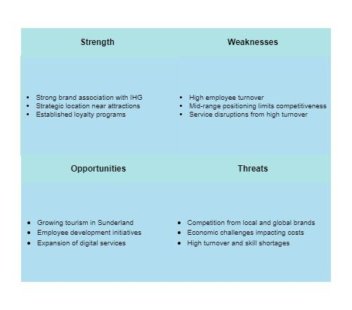
Figure 1 SWOT Analysis of Holiday Inn Sunderland

4.3 PEST Analysis
The following PEST analysis looks into the various external political, economic, social and technological factors that have an effect on Holiday Inn Sunderland.
Political
The political environment in the UK has a deep effect on the hospitality industry. Brexit led to a tightening in immigration legislation; ultimately, this reduced the number of EU workers available (French, 2018). This situation has contributed to an increase in staffing shortages within the sector. A minimum wage and labor regulations have a consequence on operational costs (Cengiz et al., 2019).
Economic
In this regard, economic factors, such as inflation and the growth of wages, have influenced operational budgets and profitability. Many UK cities, including Sunderland, have been impacted by cost-of-living increases, which reduce disposable income in wallets across the UK and lead to the inability to retain staff, simply because employees themselves have to try to afford high living costs (Vik & Wallace, 2022). Apart from that, there is wage inflation, strongly relevant within the hospitality industry, competing for qualified labor against other industries (Liu-Lastres et al., 2023).
Social
This increasing interest in cultural tourism and its process of regeneration from Sunderland creates the scope to attract a wide array of clientele (MacLeod et al., 2018). Employees' expectations of the workforce have also changed, with many employees now seeking flexible work environments and career progression opportunities (Gursoy et al., 2022).
Technological
Technology has transformed ways of customer engagement in hospitality: from digital booking systems and contactless check-ins to social media marketing, which lies at the heart of growing guest experiences. (Morrison et al., 2022) established that Holiday Inn Sunderland could use advanced reservation and customer service technologies developed by IHG in order to meet competitive standards and enhance efficiency in operations (Yang & Nita, 2019).

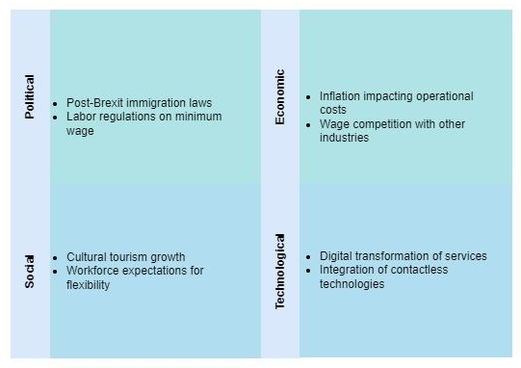
Figure 2 PEST Analysis of Holiday Inn Sunderland

4.4 Competitor Analysis (Price vs. Quality)
On the one hand, competitor analysis will define the main competitors operating within the hospitality market of Sunderland and denote their pricing strategies and service quality.

4.4.1 Price Comparison
Around the middle category, Holiday Inn Sunderland falls between low-budget hotels such as the Travelodge and others in the luxury category like Hilton. Since it differs significantly through its travel experience but with value-for-money pricing, this gives it a segmentation target positioning approach that captures travelers who want an experience but at value prices, with no necessary quality setbacks (Dolnicar, 2022). However, it has to impress its additional services since the low price setting of budget hotels means they operate cheaply.

4.4.2 Quality of Service
Quality of service remains an important aspect in the industry, as increasingly, guests are in need of personalized yet efficient service. A connection with IHG at Holiday Inn Sunderland supports high standards because of established training programs offered to its employees, loyalty rewards, and digital systems that allow reservations to be made with much speed (Knoblich et al., 2017). Competitors such as Hilton and Marriott have better brand prestige with value-added amenities in order to attract more moneyed customers (Rather & Camilleri, 2019).
Hotel Brand | Pricing Strategy | Quality of Service
Travelodge | Budget | Basic amenities, limited services
Holiday Inn | Mid-range | Consistent quality, loyalty programs
Hilton | Luxury | High-end amenities, personalized service

4.5 Netnography Analysis
The netnography research method is a method used in analyzing customer online behavior-which could give insight into the perceptions of Holiday Inn Sunderland guests through online reviews and social medial interactions.

4.5.1 Online Customer Reviews
Analysis of online reviews from sites such as TripAdvisor, Google Reviews, and Booking.com reveals some consistent trends in customer feedback. Most positive reviews promote the hotel's location and the quality of service they received, focusing on how easily accessible the major attractions of the city were from them (Levy et al., 2013). The negative reviews speak to long waiting times and poor housekeeping. These can be associated with staffing shortages (Terziyska, 2024).

4.5.2 Sentiment on Social Media
Sentiment analysis of social media posts for Holiday Inn Sunderland reveals a welcoming service being delivered, with the brand having very minimal laxity in terms of cleanliness and safety measures (Poecze et al., 2018). There were a few instances of delays in responding to customer inquiries, improvement opportunities regarding proper staffing and training.

This extends to the case study analysis of Holiday Inn Sunderland, that, although benefiting from brand association with IHG and being in a strategic location, faces a host of key challenges, significantly in staffing and competitiveness. The SWOT identifies strengths and weaknesses, while the PEST identifies other external factors-identified above-economic pressures and a socially shifting workforce. Competitor analysis puts Holiday Inn in a competitive marketplace differentiated both by quality and value. The Netnography analysis underlines perceptions of the customers and areas for service improvement (Kabel et al., 2024).
To this end, Holiday Inn Sunderland would have to formulate talent attraction and retention policies, such as flexi-work, good remunerations, and a career path. Secondly, investing in digital services and customer engagement through social media will also be crucial in addressing the emerging hospitality needs in Sunderland (Lim and Rasul, 2022).

5. Theme Analysis of Holiday Inn Sunderland
Staff shortages and high turnover are formidable challenges to the hospitality industry, as qualified and consistent human resources are crucial in ensuring smooth service provision and customer satisfaction. High turnover causes disruption in service, results in increased costs for training, and loss of continuity, affecting customers' perception of the hotel performance (Subramony & Holtom, 2012). The Holiday Inn Sunderland is also part of the Inter Continental Hotels Group - IHG, which goes through all the above-mentioned challenges but also has some unique ones particular to an urban setting with high demand and competition. This paper will carry out an in-depth analysis of the nature and causes of the staffing problems, possible effects, and ways to improve the situation by referring to recent literature.

5.1 The Hospitality Industry’s Staffing Crisis
Employee shortages in the hospitality industry result mainly from very high turnover rates, demanding types of jobs in hotels, and limited career growth opportunities. According to Subramony & Holtom, (2012), long working hours, poor remuneration, and job stress are the contributing reasons for this high turnover rate, particularly in urban hotels. This situation not only lends itself to the frequency at which employees leave the service but also often sees a possible threatening environment for skilled professionals to come into or stay within the industry.
Employee turnover also affects the profitability of hotels to a great extent. Chomitz & Ali, (2022) found that while the costs of recruitment, induction, and training are very high, with such high turnover rates these costs become very unbearable for hotel businesses. With a high rate of turnover, disruptions to service consistency affect customer satisfaction and the brand reputation of the hotel consequently. Therefore, turnover rates will pull down the quality and experience for the customers of Holiday Inn Sunderland, since new employees may well lack the relevant experience to consummate their duties at the highest level.
Besides, the COVID-19 pandemic further worsened this staffing problem. According to Wilcoxson (2023), many left the industry when pandemic-related layoffs occurred and never returned. The talent pool has shrunk further, even though the demand for hospitality services has clearly rebounded. Workforce supply hasn't gone up proportionately to the growth in demand, hence leading to shortages within hotels that hamper their operational capacities (Mukhopadhyay, 2022). For Holiday Inn Sunderland, these limitations have put severe deficits on the service provision of the company in its departments, such as housekeeping, reception, and food and beverages.

5.2 Causes of Staff Shortages
Low wage remains one of the main causes that create dissatisfaction and eventual quit from hospitality. Wen et al., (2020) established that the pay structure in most hospitality jobs is not consistent with the physical and emotional demands of the job, leading to dissatisfaction and turnover. This can be more serious for Holiday Inn Sunderland as competitors may be more appealing to the workers based on wages. Another factor relevant in Sunderland is the cost of living. While in relative terms it is rather low compared to the rest of the UK cities, inflation and a rise in the cost of living burdens hospitality workers, especially the ones on entry-level wages.
The other vital factor is working conditions. As pointed out by Martins et al., (2021), the jobs in the hospitality industry are generally expected to work for a long hour while including all weekend and holiday work that interferes with the personal life of workers. Among young individuals, work-life balance is increasingly used to promote opposition to unsavory work hours with no benefits or flexibility. This is an area that might receive improvement by Holiday Inn Sunderland, such as allowing flexible scheduling or swaps of shifts. This could allow employees to take more control over their work hours and improve job satisfaction (Yoopetch et al., 2021).

5.3 Retention Strategies
Training and development opportunities are some of the effective ways of talent retention in the hospitality business. According to Nguyen, (2020), if employees believe that employers can offer them a chance for skill development and career advancement opportunities, they become more satisfied with their jobs and tend to stay longer. It is worth mentioning that Holiday Inn Sunderland should consider implementing training programs which would instill transferable skills in the employees, Benaraba et al., (2022) also mentions how such training should be planned for career goals. Such programs enhance the capabilities of not only the individuals but also a culture of professional growth in this hotel, making it a good workplace.
On the other hand, the levels of labor turnover are also lower in workers who are engaged. Workers who are engaged are generally more satisfied and stay longer with their employers than disengaged workers do (Martin et al., 2023). Holiday Inn Sunderland can develop an engaged workforce by practicing team-building, recognition, and regular feedback sessions. An enabling organizational culture, one that gives value to the opinion of its employees, will go a long way in offering increased levels of both engagement and retention.
Holiday Inn Sunderland faces the same issues of staffing as highlighted from the academic literature, further reduced by the unique demands of an urban location and the competitive environment in Sunderland. The shortage of staff impacts customer satisfaction where understaffed departments may not be in a position to meet the expected level of service (Wei et al., 2024). During the peak tourist seasons for instance, or when other special events are organized in Sunderland, housekeeping and front desk operations are normally under immense pressure due to a lack of adequate staffing levels (Choy et al., 2021).
In the exit interview conducted in Holiday Inn Sunderland, some significant themes have been identified regarding low salary, lack of future prospects, and tougher working conditions. The employees mainly complain that they are overburdened, undervalued, and unrecognized by the management due to which they have decided to quit the organization (Mesha, 2023). Thus, the management has to continuously work on increasing intake to replace the vacant posts. Such labor issues can be handled through the development of a retention-based policy providing scope for increasing pay scale, flexible conditions of job employment as well as career growth opportunities (Rijal, 2022).

5.4 Areas for Development and Improvement

5.4.1 Compensation and Benefits Changes
The first area for improvement is in compensation: adjust the compensation package to industry standard. Here, Subramony & Holtom, (2012) opined that reasonably competitive wages form the bedrock of attraction and retention of employees in hospitality where competition over labor talents is always high. Holiday Inn Sunderland may review its wage structure and adjust entry-level pay rates to retain talent better. Additionally, the provision of health care, means of transport to work, or meal provisions would make Holiday Inn more unique and competitive, offering financial security and motivation for staff (Hu et al., 2021).

5.4.2 Enhancing Work-Life Balance through Flexible Scheduling
Holiday Inn Sunderland could embark on a flexible schedule that enables the company to deal with work-life balance. The flexible nature of work leads to a positive impact on employee satisfaction; in particular, younger employees emphasize work-life balance (Ferdous et al., 2023). Here, flexible scheduling could be readjusted to part-time schedules, shift swap possibilities, and giving preference over scheduling when possible. The direction of this activity leads to decreased turnover rates because it encapsulates the personal needs of employees, enhances their loyalty, and provides a better opportunity for work-life balance (Timsina, 2024).

5.4.3 Implementing Training and Development Programs
Quality in service will also develop employee loyalty. Sangaran and Jeetesh, (2015) conclude that structured career development relates to long-term retention, while employees will be committed to their jobs and their careers in cases where they perceive opportunities for growth. Holiday Inn Sunderland can first of all establish clear paths to advancement, including the possibility of employees' cross-training in different areas, thereby enhancing the diversity of skills and job satisfaction.

5.4.4 Developing a Positive Organizational Culture
Organizational culture significantly influences employee satisfaction and their retention. A supportive culture valuing employees' contribution and recognizing efforts lowers the rate of non-effective turnover and improves performance. Loehr et al., (2021) argue that building an inclusive and engaging culture that enhances Holiday Inn Sunderland might comprise things like regular health meetings, regular feedback sessions, and recognition programs. Acknowledging and celebrating small wins evoke workplace morale to encourage loyalty (Semler, 2024).

5.4.5 Using Technology to Aid Recruitment and Employee Engagement
Digitalization can improve the potential for better recruitment and on-boarding processes through online platforms. According to Karam et al., (2020), technology reduces the complexity of the recruitment process in hotels, making the brand accessible to a wider audience and making easier judgments about candidates. Holiday Inn Sunderland can use social media and online job sites to reach the desired candidate and develop an employer brand which will be appealing to them. Digital on-boarding and training resources could also be offered to create a better hire experience whereby newcomers will be prepared to face the responsibilities in their positions (Sani et al., 2023).
The challenges faced in staffing at Holiday Inn Sunderland reflect the wider problems faced by the hospitality industry such as high mobility of labor, uncongenial working conditions, and lack of job prospects are all critical barriers to stability of labor (Hack-Polay, 2022). The academic literature would suggest that such challenges are responding only through an approach which can combine competitive salaries, flexibility of shift, career prospect, and work culture (Firman, 2021). The implementation of such strategies could increase the retention ratio, which in turn would create a more willing and motivated workforce that could help Holiday Inn Sunderland with service quality and guest satisfaction.

6. Research Survey

6.1 Analysis
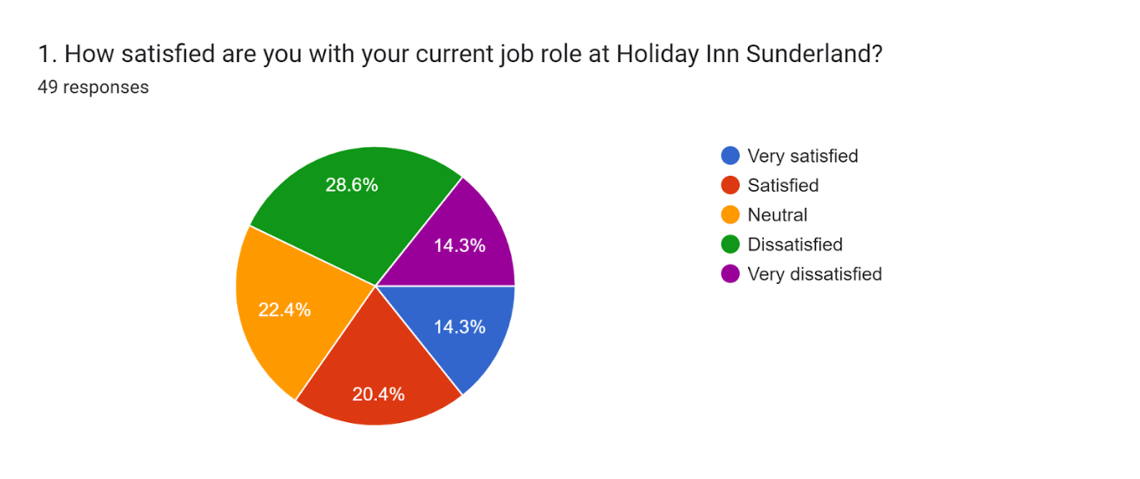
Figure 3 Response of Survey Question 1
This chart shows quite an inconsistent pattern of job satisfaction for Holiday Inn Sunderland. The greater portion, 28.6%, are dissatisfied, which could point to poor management, too much work, or a lack of opportunities to grow. Another 22.4% are satisfied. Adding to that, 20.4% show neutrality, so this majority feels somewhat positive, rather indifferent. The 14.3% who reported being very satisfied reflect a smaller group in which the jobs aligned quite well, while 14.3% being very dissatisfied indicates polarized experiences among the employees. In general, these findings suggest that action needs to be taken to alleviate dissatisfaction to enhance retention and improve workplace morale.

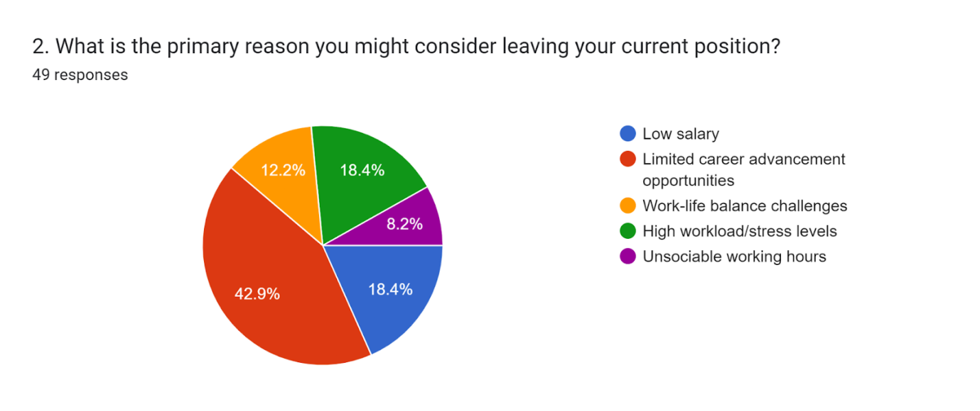
Figure 4 Response of Survey Question 2
The below chart shows that 42.9% of employees intend to leave because of limited career growth opportunities, indicating high growth pathway needs. On the other hand, low salary and working hours/stress are reported by a combination of 18.4% as important reasons; hence, compensation and job demand-related issues have been shown. Work-life balance issues take 12.2%, while 8.2% mention unsociable working hours, indicating localized dissatisfaction with scheduling. On balance, the most significant factors-cum-reasons are constraints of career development, followed by compensation and workload-which indicate the areas where changes might be addressed to improve retention and job satisfaction at Holiday Inn Sunderland.

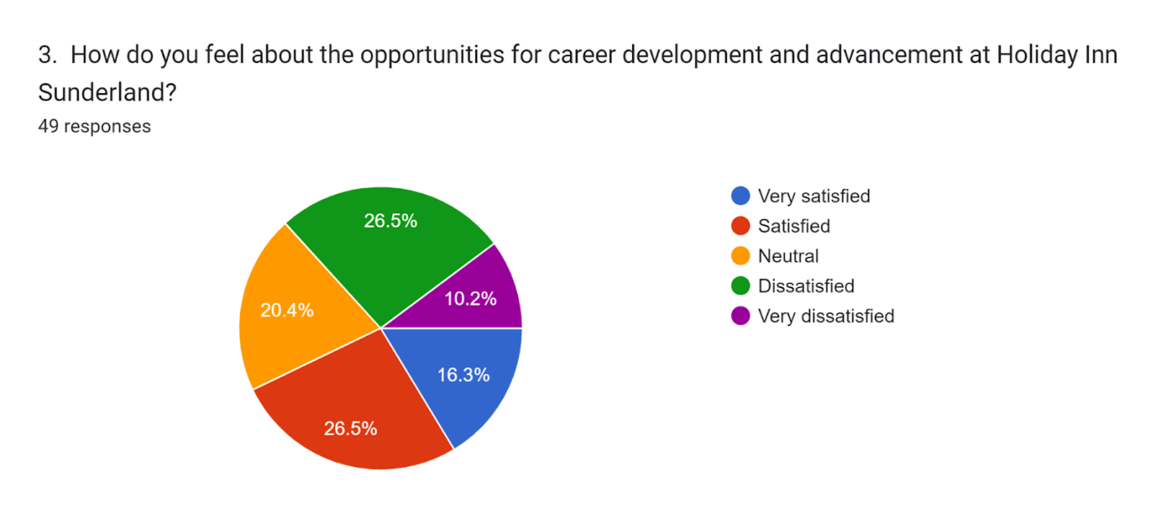
Figure 5 Response of Survey Question 3
From this chart, mixed feelings for career development opportunities at Holiday Inn Sunderland can be ascertained. Whereas 26.5% of the employees are satisfied in this regard, an equal 26.5% show dissatisfaction, thus polarizing the individual opinions. 20.4% were indifferent; hence, no strong opinion about career advancement was evinced from this particular sample. Only 16.3% showed a very satisfied response, while those who were very dissatisfied totaled 10.2%. These results show career development points that need improvement, as the level of dissatisfaction experienced can impact employee retention and motivation. Improvement in opportunities for growth could serve as a means of addressing these concerns and creating an even more positive work environment.

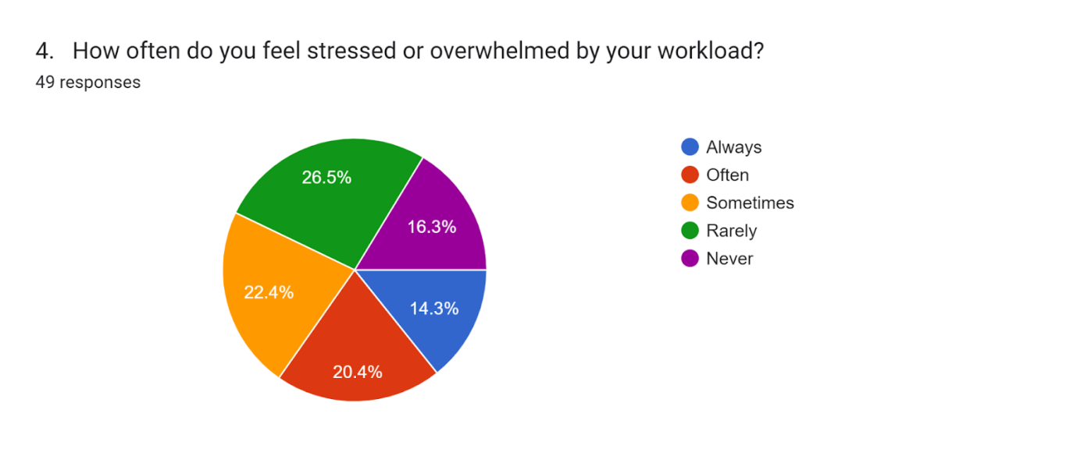
Figure 6 Response of Survey Question 4

This graph represents the level of work-related stress among employees at Holiday Inn Sunderland. For instance, 26.5% feel that they are rarely stressed, whereas 22.4% sometimes feel stressed; thus, some may be moderately experiencing stress. However, 20.4% often feel stressed, while another 14.3% always feel overwhelmed, hence highly stressed; 16.3% report never feeling stressed. These results would suggest that while some employees manage their workload quite well, a remarkable percentage is regularly stressed by it, which may influence job satisfaction and productivity. Workload concerns might be a potential area of improvement in overall employee well-being.

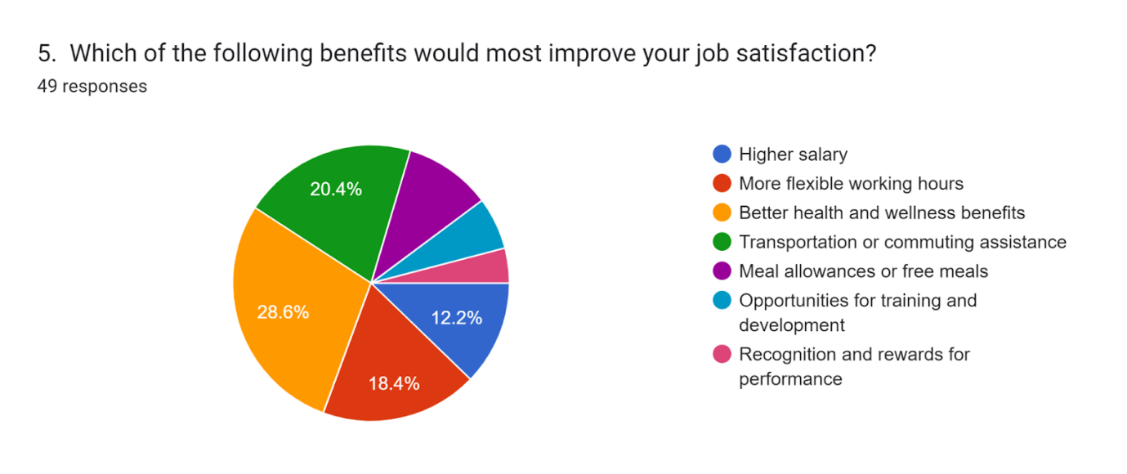
Figure 7 Response of Survey Question 5
From these findings, the major factors to enhance job satisfaction among the responding employees are health and wellness benefits at 28.6%, followed by transportation or commuting assistance at 20.4%. Still, within the context of work-life balance, flexible working hours take 18.4%. A higher remuneration ranks low, with only 12.2% choosing it as the primary factor, indicating that monetary compensation may not be enough to raise job satisfaction. Training and development opportunities and recognition and rewards show the least interest in general, meaning that employees look out more for tangible lifestyle benefits rather than professional growth or acknowledgement in this regard.

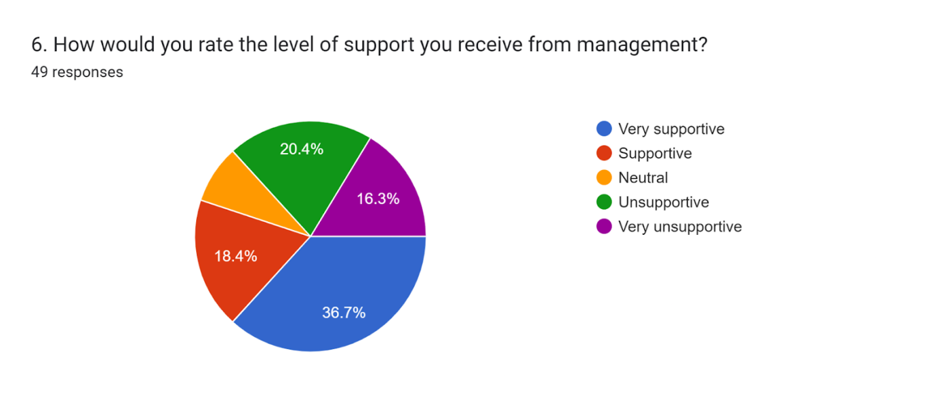
Figure 8 Response of Survey Question 6
The data portrays varying levels of perceived management support by the employees. Contrasting this, while 36.7% of the respondents view management as "very supportive" and 18.4% as "supportive," indicating the majority having a good experience, 20.4% remain "neutral." On negative notes, 20.4% feel "unsupportive," while 16.3% rate management as "very unsupportive." The distribution thus indicates that while many employees were satisfied with management support, a significant proportion still felt unsupported, an area in need of attention in creating a more universally supportive work environment.

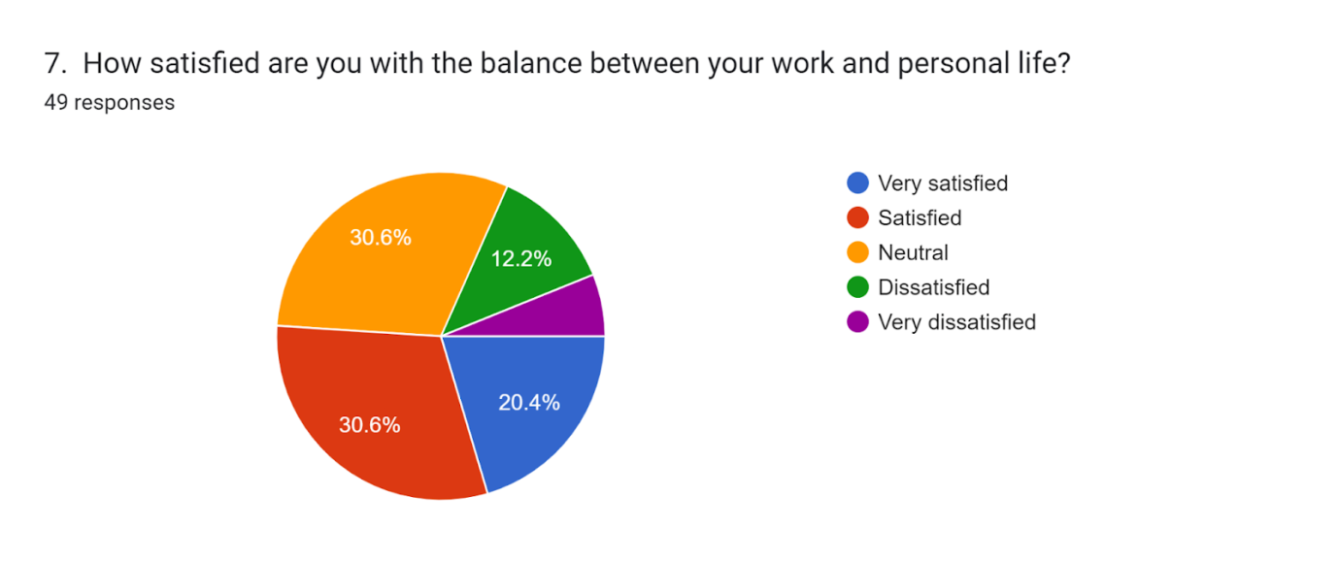
Figure 9 Response of Survey Question 7
Work-Life Balance Satisfaction Results This is a graph of 49 respondents about the overall satisfaction with work-life balance. The total percentage who are satisfied or neutral is 51% (20.4% very satisfied and 30.6% neutral), while another 42.8% report dissatisfaction 12.2% dissatisfied and 10.2% very dissatisfied. In fact, the identical distribution of responses in satisfaction and neutrality, 30.6% in each, represents a split perception whereby while half experience balance, an equal number report room for improvement. The levels of dissatisfaction highlighted in the grid are areas of potential stress or workload that could release an opportunity for increasing overall work-life balance satisfaction.

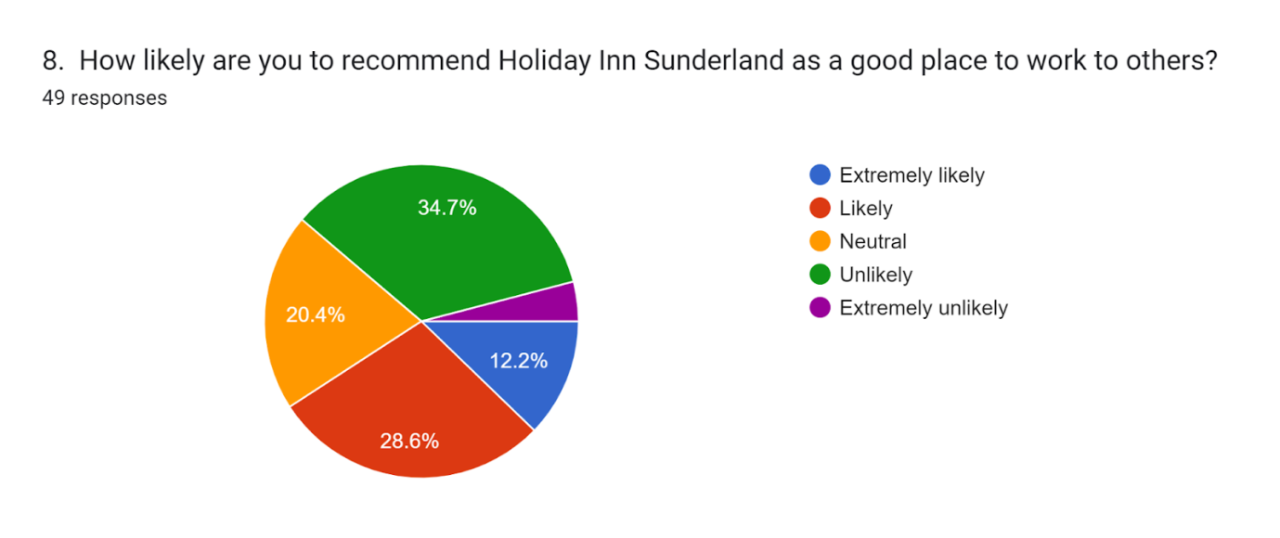
Figure 10 Response of Survey Question 8
This response to recommending Holiday Inn Sunderland as a workplace shows mixed feelings among the 49 respondents. While 40.8% are favorable, 12.2% being extremely likely and 28.6% likely, a large proportion of 34.7% are unlikely to recommend it, with an extra 2% extremely unlikely. Then, 20.4% remained neutral. The split into favorable and unfavorable responses is indicative of a fairly divided perception of workplace experience, with dissatisfaction having the better of the two. Building potential concerns might improve employees' likelihood to recommend it as a good place to work and, therefore, may improve the workplace reputation and morale.

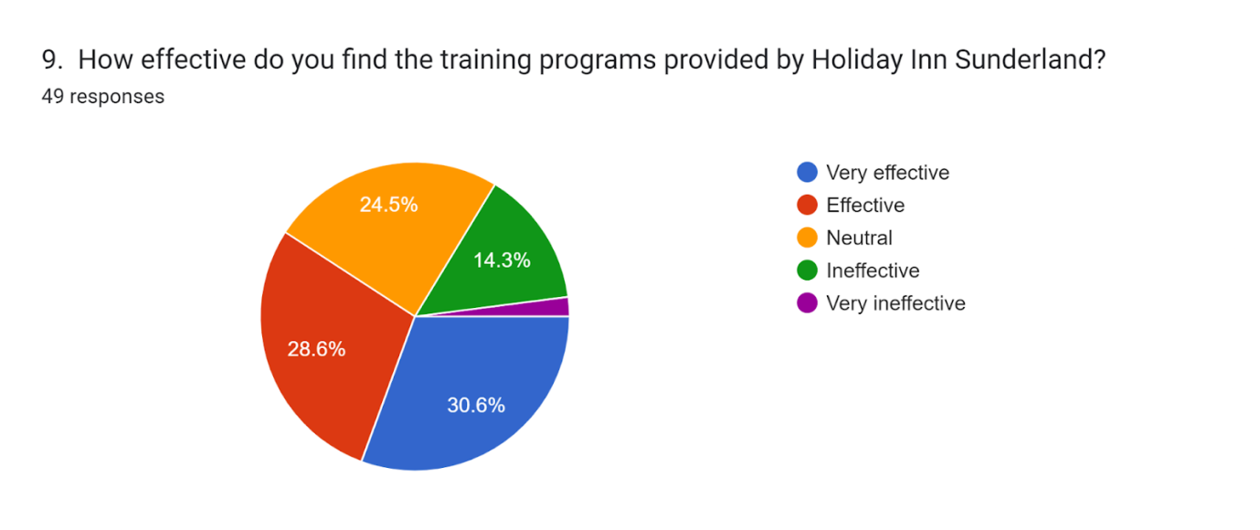
Figure 11 Response of Survey Question 9
This chart represents Holiday Inn Sunderland employees' mixed views on whether training programs are effective or not. The positive responses are 59.2% - 30.6% very effective and 28.6% effective - meaning more than half find the training beneficial. However, 14.3% described it as ineffective and a small percentage of 2% as very ineffective, while 24.5% remain indifferent. On the whole, it indicates that the training programs were found considerably pleasing but still left room for improvement. Addressing specific concerns will increase the effectiveness of the training and make employees more confident in the program.

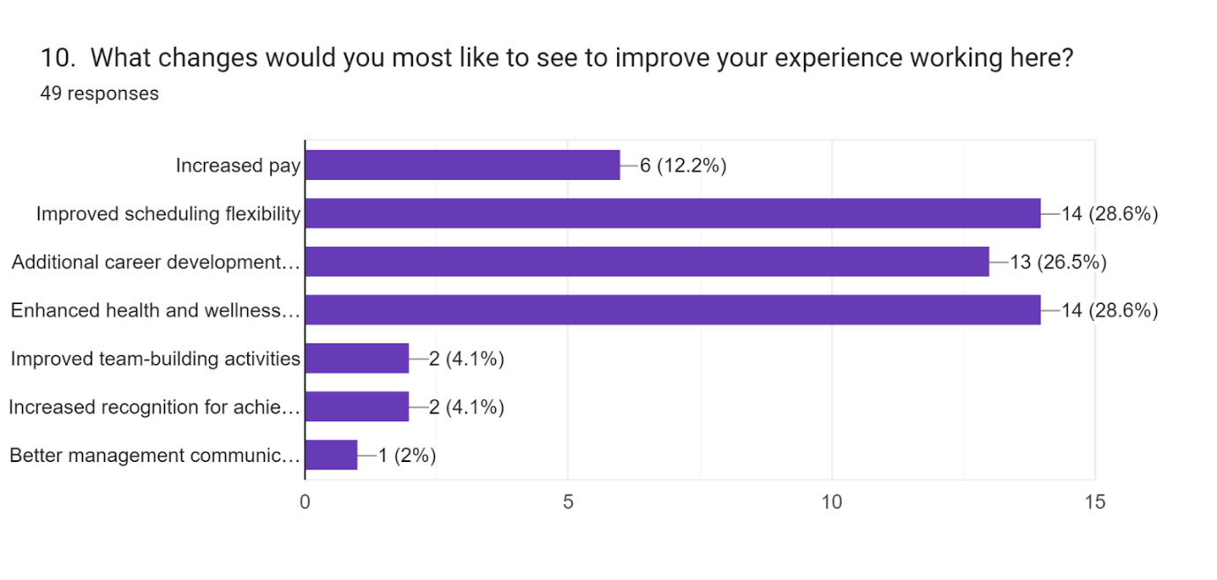
Figure 12 Response of Survey Question 10
Employee interests in improved scheduling flexibility and enhanced health and wellness benefits top the list, selected by 28.6% each. The need for more career development opportunities is a close second at 26.5%, thus showing employees do want to grow with the company. Increased pay is the next priority at a much lower rate of interest: 12.2%. Team-building activities, recognition for achievements, and better communication from management are the least of priorities, all below 5%. It indicates that employees find a supportive and flexible work environment with a chance to develop professionally more important than any financial incentives.

6.2 Conclusive Summary
These survey results identify the key areas for improvement in employee satisfaction at Holiday Inn Sunderland such as flexibility of scheduling, career development opportunities, and health and wellness benefits are more significant factors than increasing pay only. Stress levels appear to be a concern among employees, and their management support awareness seems mixed, which is indicative of the need for an internal communication and support system that has been improved. The divided satisfaction with work-life balance, and recommendation of the workplace, would further suggest a concentration on creating a cohesive, positive work environment. Because these elements are interlinked, addressing them should increase morale, retention, and improve the company's reputation as an employer that truly cares about the growth and well-being of their employees.

7. Conclusions and Recommendations
In this respect, this report carries out an in-depth analysis of staffing problems at Holiday Inn Sunderland in light of the hospitality industry's high turnover, labor shortages, and operational inefficiencies. Critical analysis of the various factors such as employee turnover, recruitment challenges, compensation issues, and organizational culture raised a number of critical insights and recommendations to guide the hotel in the process of improving staff retention, quality of service, and attaining competitive advantage. Data that was gathered during the research survey suggests that flexibility in scheduling, career development opportunities, and health and wellness benefits rank higher than increasing pay. This would explain that a supportive and growth-conducive environment is more motivating than financial rewards alone. Unduly high levels of stress and mixed feelings regarding support by the management suggest areas for improvement: managerial communication, distribution of workload, and support systems.

7.1 Key Findings
General problems in the hospitality industry usually involve high employee turnover and under-staffing, which will also be relevant in the case of urban hotels. Thus, Holiday Inn Sunderland faces operational discontinuity, increased training costs, and an impaired quality of service, all of which will fall on the customer and the hotel profitability.
Post-Brexit immigration restrictions and COVID-19 have been squeezing the talent pools even further and, therefore, exacerbating workforce shortages. Economic and political development has consequently turned into a cause of huge competition for skilled labor forces. The most affected is hospitality, since it offers relatively low wages as compared to other sectors.
Compensation remains an important concern in the hospitality industry. Employees often leave due to low remuneration and lack of career development. Cost-of-living increases in Sunderland burden workers in the hospitality industry, especially entry-level workers; hence, the human resource part becomes increasingly challenging for Holiday Inn.
These are the work conditions, organizational culture, and work-life balance that primarily affect employee engagement and retention. Hospitality work typically involves irregular shifts and weekend shifts that clash with the personal lives of employees. This report also focused on a supportive culture, flexible scheduling, and recognition programs which are helpful in reducing turnover.
Income-increasing technological advances in the hospitality industry, from contactless arrival and digital check-in to digital booking systems, are assuming high importance in enhancing customer experience. With Holiday Inn Sunderland powered by the technology resources of IHG itself, therefore, the capability to capture modern customers' expectations may be complete; however, investments by IHG in better digital engagement may often bring within the organization a hallmark of customer satisfaction.

7.2 Recommendations

7.2.1 Improve Compensation and Benefits
Competitive wages at least for the market value should also be offered. Having examined the wage structure, Holiday Inn Sunderland could offer better wages for entry-level positions by offering better wages in order to improve talent acquisition and retention. The hotel can provide increased financial security to its employees through additional benefits such as health care, transport allowance, and even meal subsidies which would create a differentiation for this hotel from that of the competitors.

7.2.2 Flexible Scheduling and Work-Life Balance Initiatives
Holiday Inn Sunderland hosts can maintain flexible scheduling to meet their work-life balance requirements. Facilitating the visitors' shift swapping, preferred shifts, and part-time work would boost job satisfaction, reducing labor turnover. It would be brilliant if the hotel provided wellness programs and mental health support.

7.2.3 Invest in Training and Career Development
Structured career paths and training programs should be developed in order to increase employee engagement and retention. Holiday Inn Sunderland should train its employees with cross-departmental growth opportunities, transferable skills, and more mentorship and leadership development programs that motivate long-term commitment, especially from the younger staff who seek a career progression route.

7.2.4 Foster an enabling and inclusive organizational culture.
Retention arises when building a positive organizational culture that recognizes employee contributions. Holiday Inn Sunderland can, therefore, consider recognition programs, celebration of small successes, and regular feedback. An inclusive environment will make them feel valued, possibly leading to higher loyalty, reduced turnover, and higher morale in general.

7.2.5 Expand Digital Engagement and Service Offerings
Investing in additional digital tools, such as mobile check-in, guest service applications, and personalized marketing, can help Holiday Inn Sunderland keep pace with technological trends. These tools not only improve guest experiences but also streamline employee workflows, reducing workload pressures in high-demand periods. Active engagement on social media platforms could also strengthen the hotel’s online presence and attract a younger customer demographic.

8. Reflective account

8.1 Reflective Account on Shortage of Staff and Retention Challenges in Hospitality
During my placement in Holiday Inn Sunderland, I had a chance to develop valuable insights into the operation of the hospitality industry and the diverse challenges the latter faces, including staffing shortages and inability to retain employees. The experience has thus enabled me to understand operational needs in a hotel and the huge role that human resource strategies play in the pursuance of quality service and work culture.

8.2 Initial Observations and Challenges
One of the first observations I made at Holiday Inn Sunderland was the direct impacts of staff shortages on service delivery and overall guest satisfaction. The staff turnover has created a situation in which there is constant hiring and training, with gaps in service continuity, especially during periods of peak seasons or high demand for services. The immediate impacts of these shortages were longer waiting times for guests, lesser availability of employees for personalized service, and the overall impact this places on existing staff, often working overtime or juggling more responsibility.
This is further reiterated by the fact that, while working with its management in the same hotel, it could be seen that immense pressure to meet high standards is evident for a few employees. Indeed, this experience resonated with that of literature reviewed indicating how the demanding nature of hospitality work, coupled with relatively long hours and low wages, often contributes to high turnover. The instinctive notion from my own experiences is that such high turnover disrupts service flow and may result in decreasing customer satisfaction. In my observation, though management was very proactive in terms of responding to customer complaints, the need for recruitment and retraining undermined consistency in the provision of service.

8.3 Observing the effects of economic and industry trends
It is in the hospitality industry that it has been particularly tempting to notice the economic pressure of inflation, wage increases, and labor shortages. In recent years, Sunderland welcomed more tourists and businesspeople, which helped increase the number of hotels in this market. However, the strongly competitive local job market, in which retail, logistics, and even entry-level jobs often promise at least as much, if not better, wages, performs hardly any less expensive in recruiting and keeping workers. It was interesting to see how these factors in operation impinged on daily operations at Holiday Inn Sunderland. Observation allowed the researcher to develop a deeper appreciation of how economic conditions can impinge on labor's supply and employees' morale.
Another key feature I noticed is how technology is playing a deep-set role in the operationalization of the work and adding to better guest experiences. In most hotels, including Holiday Inn Sunderland, contactless check-ins have been provided and made easier with mobile bookings and a digital concierge. While these tools definitely facilitate routine task management and ease the load off the staff, I thought this could not replace the personal touch of humans in a service-oriented industry. Meanwhile, the hotel made an effort to balance efficiencies through technology, yet retain personalized service, which was one of the challenges of adjusting to today's customer realities while attending to labor constraints.

8.4 Reflections on Employee Satisfaction and Organizational Culture
The most important aspects of my learning on this placement had to do with the factors contributing to employee satisfaction and, through those, retention. Work-life balance was one of the big issues I came upon, especially for staff members working irregular hours or covering others' shifts because of a shortage. Apart from that, inability to maintain work-life balance was another key factor that had dissatisfied most of the employees here. Some even looked for other companies because of this. Through interaction with colleagues, I also found flexibility, competitive wages, and career growth opportunities to be major priorities of most employees.
Generally speaking, the work culture in Holiday Inn Sunderland is supportive, and managers try to recognize and reward effort. I observed that sometimes team-building activities and engagement initiatives take a backseat to operational needs due to high employee turnover. This thus gave me an opportunity to appreciate how so much importance is attached to fostering a supportive organizational culture. A well-entrenched culture would contribute much toward the level of morale of employees and retention. Without question, an employee would want to remain with a company in which he feels valued and appreciated.

8.5 Personal Development and Lessons Learned
One thing I took away from this placement and shall remember is that people's management is all about empathy and flexibility. Having worked with both management and operation teams, I realized that managers who gave a try to their employees through listening to them, trying to understand their problems, and catering to their preferences proved beneficial. Simple things, like being able to adjust shifts or just recognizing the employee's contribution to certain projects, made a huge difference in morale. Watching this helped me to realize how important flexibility and proactive care by the leader-precepts that I will likely carry with me through work life.
It was these challenges that identified staff shortages and indeed taught me things like resilience, problem-solving skills. Many times, I have had to step in and assist with everything from guest check-ins down to answering queries, helping me develop a hands-on approach in managing situations that are quite unpredictable. I learnt to anticipate necessity, manage time, and think critically of how to optimize work to soften the impact of staff shortage. This was a lesson for me to realize that flexibility and one's disposition to accommodate changes are key features in any customer-oriented field, most especially amidst the dynamism of an industry such as hospitality.

9. References
Alberti, G., & Iannuzzi, F.E. (2020). Embodied intersectionality and the intersectional management of hotel labor: The everyday experiences of social differentiation in customer-oriented work. Gender, Work & Organization, 27(6), 1165-1180. https://doi.org/10.1111/gwao.12454
Anggraeni, R.D., Ismail, T., Lestari, T., & Ramdhani, D. (2023). The Relationship between Strategic Leadership, Competitive Advantage and Intellectual Capital: Evidence from Hotel in Tangerang Indonesia. Britain International of Humanities and Social Sciences (BIoHS) Journal, 5(2), 100-112. https://doi.org/10.31014/aior.1991.02.01
Ashton, A.S. (2018). How human resources management best practice influence employee satisfaction and job retention in the Thai hotel industry. Journal of Human Resources in Hospitality & Tourism, 17(2), pp.175-199. https://doi.org/10.1080/15332845.2017.1340759
Baxter, P. and Jack, S. (2008). Qualitative case study methodology: Study design and implementation for novice researchers. The qualitative report, 13(4), pp.544-559. https://www.academia.edu/download/40131683/case_study_ecmple.pdf
Benaraba, C.M.D., Bulaon, N.J.B., Escosio, S.M.D., Narvaez, A.H.G., Suinan, A.N.A. and Roma, M.N. (2022). A comparative analysis on the career perceptions of tourism management students before and during the COVID-19 pandemic. Journal of Hospitality, Leisure, Sport & Tourism Education, 30, pp.1-15. https://doi.org/10.1016/j.jhlste.2021.100361
Bryman, A. (2012). Social research methods (4th ed.). Oxford University Press.
Budhwar, P., Chowdhury, S., & Wood, G. (2023). Human resource management in the age of generative artificial intelligence: Perspectives and research directions on ChatGPT. Human Resource Management Journal, 33(3), 606-659. https://doi.org/10.1111/1748-8583.12524
Buhalis, D., Harwood, T., Bogicevic, V., Viglia, G., Beldona, S. and Hofacker, C. (2019). Technological disruptions in services: lessons from tourism and hospitality. Journal of service management, 30(4), pp.484-506. https://doi.org/10.1108/JOSM-12-2018-0398
Camilleri, M.A. and Camilleri, M.A. (2018). The tourism industry: An overview. Springer International Publishing, pp. 3-27. https://papers.ssrn.com/sol3/Delivery.cfm?abstractid=3289462
Campi, M. (2024). The regenerative potential of Point of Interest (POIs) in urban renewal: the Pietrarsa Railway Museum for the coast of San Giovanni a Teduccio. 01. Industrial Archaeology. European approach to recovery productive memory, 297. https://books.google.com/books?hl=en&lr=&id=ASEUEQAAQBAJ&oi=fnd&pg=PA297&dq=.+Its+tourism+market+is+in+development,+focusing+on+regeneration+and+cultural+growth,+and+has+a+coastline,+industrial+heritage,+and+a+vibrant+arts+sector&ots=Zcq_YXNAx6&sig=vTJRErulhRoCPoRM158t2r6iPnw
Cengiz, D., Dube, A., Lindner, A. and Zipperer, B. (2019). The effect of minimum wages on low-wage jobs. The Quarterly Journal of Economics, 134(3), pp.1405-1454. https://doi.org/10.1093/qje/qjz014
Chang, W., & Busser, J.A. (2020). Hospitality career retention: the role of contextual factors and thriving at work. International Journal of Contemporary Hospitality Management, 32(1), 193-211. https://doi.org/10.1108/IJCHM-10-2018-0831
Chomitz, J. & Ali, A. (2022). Exploring toxic personalities in resorts: a managerial perspective. Journal of Human resources in Hospitality & tourism, 21(2), pp.226-245. https://doi.org/10.1080/15332845.2022.2031608
Choy, M., Cheng, J., & Yu, K. (2021). Evaluating the environmental sustainability strategies of the housekeeping department: the case of an international hotel chain in Hong Kong, China. Tourism Critiques: Practice and Theory, 2(1), 115-132. https://www.emerald.com/insight/content/doi/10.1108/trc-01-2021-0001/full/pdf
Cole, M., Stuart, M., & Hardy, K. (2024). Wage theft and the struggle over the working day in hospitality work: a typology of unpaid labor time. Work, Employment and Society, 38(1), 103-121. https://doi.org/10.1177/09500170221111719
Dębski, M., & Borkowska-Niszczota, M. (2021). Tourist Accommodation Establishments during the Pandemic–Consequences and Aid Report on a Survey among Polish Micro-enterprises Offering Accommodation Services. Journal of Intercultural Management, 13(1), 1-25. https://doi.org/10.2478/joim-2021-0001
DeVellis, R. F. (2016). Scale Development: Theory and Applications (4th ed.). Sage Publications. https://www.columbusstate.edu/academic-affairs/_docs/eduf_syllabus.pdf
Dolnicar, S. (2022). Market segmentation for e-tourism. In Handbook of e-Tourism pp. 849-863.
Farahani, A., Noorollahi, L., & Nikbakhsh, R. (2023). Designing an e-Business Model in Iranian Sports Tourism with Emphasis on Organizational Factors. Research in Sport Management and Marketing, 4(3), 77-97. https://rsmm.uma.ac.ir/article_2291_58c64e220cc84a0c240048984022e22c.pdf
Ferdous, T., Ali, M. & French, E. (2023). Use of flexible work practices and employee outcomes: the role of work–life balance and employee age. Journal of Management & Organization, 29(5), pp.833-853. https://doi.org/10.1017/jmo.2020.44
Field, A. (2018). Discovering Statistics Using IBM SPSS Statistics (5th ed.). Sage Publications. http://repo.darmajaya.ac.id/5678/1/Discovering%20Statistics%20Using%20IBM%20SPSS%20Statistics%20%28%20PDFDrive%20%29.pdf
Firman, A. (2021). The effect of career development on employee performance at Aswin Hotel and Spa Makassar. Jurnal manajemen bisnis, 8(1), pp.133-146. https://scholar.archive.org/work/lk7i52foqbdofamgaa4fmytqyu/access/wayback/http://jurnal.fe.umi.ac.id/index.php/JMB/article/download/721/497
Flyvbjerg, B. (2006). Five misunderstandings about case-study research. Qualitative Inquiry, 12(2), 219-245. https://doi.org/10.1177/1077800405284363
French, S. (2018). Between globalization and Brexit: Migration, pay and the road to modern slavery in the UK hospitality industry. Research in Hospitality Management, 8(1), pp.23-31. https://www.ajol.info/index.php/rhm/article/view/176707
Gerring, J. (2017). Case study research: Principles and practices (2nd ed.). Cambridge University Press. https://doi.org/10.1017/9781316848593
Ghani, B., Zada, M., Memon, K.R., Ullah, R., Khattak, A., Han, H., Ariza-Montes, A. and Araya-Castillo, L. (2022). Challenges and strategies for employee retention in the hospitality industry: A review. Sustainability, 14(5), 1-26. https://doi.org/10.3390/su14052885
Glyptis, L., Hadjielias, E., Christofi, M., Kvasova, O. & Vrontis, D. (2021). Dynamic familiness capabilities and family business growth: A longitudinal perspective framed within management accounting. Journal of Business Research, 127, pp.346-363. https://doi.org/10.1016/j.jbusres.2021.01.019
Green, A.E., Broughton, K., Qamar, A., & Sissons, P. (2021). Public policy for addressing the low-skills low-wage trap. Regional Studies, 55(2), 333-344. https://doi.org/10.1080/00343404.2020.1802005
Guimarães, P. (2022). Tourism and Authenticity: Analyzing Retail Change in Lisbon City Center. Sustainability, 14(13), 1-21. https://doi.org/10.3390/su14138111
Hack-Polay, D., Dal Mas, F., Mahmoud, A. B., & Rahman, M. (2022). Barriers to the effective exploitation of migrants' social and cultural capital in hospitality and tourism: A dual labor market perspective. Journal of Hospitality and Tourism Management, 50, 168-177. https://doi.org/10.1016/j.jhtm.2022.01.012
Hassanein, F., & Özgit, H. (2022). Sustaining human resources through talent management strategies in the Middle East hotel industry. Sustainability, 14(22), 1-19. https://doi.org/10.3390/su142215365
Hill, A., & Cheshire, J. (2023). The resilience of high streets post-COVID-19 in the UK. Applied Spatial Analysis and Policy, 16(2), 537-559. https://doi.org/10.1007/s12061-022-09494-8
Hu, X., Yan, H., Casey, T., & Wu, C. H. (2021). Creating a safe haven during the crisis: How organizations can achieve deep compliance with COVID-19 safety measures in the hospitality industry. International Journal of Hospitality Management, 92, pp.1-11. https://doi.org/10.1016/j.ijhm.2020.102662
IHG Annual Report. (2023). InterContinental Hotels Group annual report and accounts 2023. Retrieved from https://www.ihgplc.com/en/investors/results-reports
Kabel, D., Martin, J., Elg, M. and Witell, L. (2024). Capturing the voice of the customer: focus groups versus netnography?. Total Quality Management & Business Excellence, 35(11-12), pp.1359-1377. https://doi.org/10.1080/14783363.2024.2369592
Karam, S., Nagahi, M., Dayarathna, V.L., Ma, J., Jaradat, R. & Hamilton, M. (2020). Integrating systems thinking skills with multi-criteria decision-making technology to recruit employee candidates. Expert Systems with Applications, 160, pp.1-40. https://apps.dtic.mil/sti/pdfs/AD1137456.pdf
Kloutsiniotis, P.V., & Mihail, D.M. (2020). High-performance work systems in the tourism and hospitality industry. International Journal of Contemporary Hospitality Management, 32(7), 2365-2395. https://doi.org/10.1108/IJCHM-10-2019-0864
Knoblich, S., Martin, A., Nash, R., & Stansbie, P. (2017). Keys to success in Social Media Marketing (SMM) – Prospects for the German airline industry. Tourism and Hospitality Research, 17(2), 147-164. https://doi.org/10.1177/1467358415610415
Lee, P.C., Xu, S.T. and Yang, W. (2021). Is career adaptability a double-edged sword? The impact of work social support and career adaptability on turnover intentions during the COVID-19 pandemic. International Journal of Hospitality Management, 94, p.102875. https://doi.org/10.1016/j.ijhm.2021.102875
Leung, X.Y. and Cai, R. (2021). How pandemic severity moderates digital food ordering risks during COVID-19: An application of prospect theory and risk perception framework. Journal of Hospitality and Tourism Management, 47, pp.497-505.. https://doi.org/10.1016/j.jhtm.2021.05.002
Levy, S.E., Duan, W. and Boo, S. (2013). An analysis of one-star online reviews and responses in the Washington, DC, lodging market. Cornell Hospitality Quarterly, 54(1), pp.49-63. https://doi.org/10.1177/1938965512464513
Li, Y., Fang, S. and Huan, T.C.T. (2017). Consumer response to discontinuation of corporate social responsibility activities of hotels. International Journal of Hospitality Management, 64, pp.41-50.. https://doi.org/10.1016/j.ijhm.2017.04.001
Lim, W.M. and Rasul, T. (2022). Customer engagement and social media: Revisiting the past to inform the future. Journal of Business Research, 148, pp.325-342. https://doi.org/10.1016/j.jbusres.2022.04.068
Line, N.D., & Dogru, T. (2020). Control, use, and ownership of big data in the hospitality industry. Tourism Management, 80, 1-11. https://doi.org/10.1016/j.tourman.2020.104106
Liu-Lastres, B., Wen, H. and Huang, W.J. (2023). A reflection on the Great Resignation in the hospitality and tourism industry. International Journal of Contemporary Hospitality Management, 35(1), pp.235-249. https://doi.org/10.1108/IJCHM-05-2022-0551
Loehr, J., Dwipayanti, N.M.U., Nastiti, A., Powell, B., Hadwen, W. & Johnson, H. (2021). Safer destinations, healthier staff and happier tourists: Opportunities for inclusive water, sanitation and hygiene in tourism. Tourism management perspectives, 40, p.100883. https://doi.org/10.1016/j.tmp.2021.100883
MacLeod, N., Shelley, J. and Morrison, A.M. (2018). The touring reader: Understanding the bibliophile's experience of literary tourism. Tourism Management, 67, pp.388-398. https://doi.org/10.1016/j.tourman.2018.02.006
Martin, R., Ono, M., Legood, A., Dello Russo, S. & Thomas, G. (2023). Leader–member exchange (LMX) quality and follower well-being: A daily diary study. Journal of occupational health psychology, 28(2), p.103. https://psycnet.apa.org/doi/10.1037/ocp0000346
Martins, D., Amaro, S. & Silva, S. (2021). The importance of shift work: The hospitality sector. Journal of Tourism & Development Revista de Turismo e Desenvolvimento, 36, pp.233-243. http://dx.doi.org/10.34624/rtd.v1i36.10487
Mesha, M. D. (2023). Exploring Employee Retention and Turnover in Finland: Understanding Intentions, Commitment and Departure Patterns, pp.1-100. https://www.doria.fi/handle/10024/187354
Mody, M.A., Cheng, M., & Hanks, L. (2021). Sharing economy research in hospitality and tourism. International Journal of Contemporary Hospitality Management, 33(5), 1711-1745. https://doi.org/10.1108/IJCHM-12-2020-1457
Morrison, A., Coca-Stefaniak, J.A., Yang, L. and Deng, B. (2022). Technology acceptance before and after the COVID-19 pandemic outbreak: No-touch service from robots in hotels. Tourism Review, 77(4), pp.1062-1080. https://doi.org/10.1108/TR-06-2021-0276
Mukhopadhyay, B. R. (2022). Business, Economy, and Society: Tales from the Pandemic Days (Vol. 1). Southampton Solent University, pp.1-36. https://www.solent.ac.uk/media-library/documents/staff/tales-from-the-pandemic-days-spreads.pdf
Nguyen, C. (2020). The impact of training and development, job satisfaction and job performance on young employee retention. Job Satisfaction and Job Performance on Young Employee Retention (May 1, 2020). https://dx.doi.org/10.2139/ssrn.3930645
Ntounis, N., Parker, C., Skinner, H., Steadman, C. & Warnaby, G. (2022). Tourism and Hospitality industry resilience during the Covid-19 pandemic. Current Issues in Tourism, 25(1), 46-59. https://doi.org/10.1080/13683500.2021.1883556
Poecze, F., Ebster, C. and Strauss, C. (2018). Social media metrics and sentiment analysis to evaluate the effectiveness of social media posts. Procedia computer science, 130, pp.660-666.
Rahimi, R., Thelwall, M., Okumus, F., & Bilgihan, A. (2022). Know your guests’ preferences. Consumer Behavior in Tourism and Hospitality, 17(1), 89-106. https://doi.org/10.1108/CBTH-06-2021-0148
Rather, R.A. & Camilleri, M.A. (2019). The effects of service quality and consumer-brand value congruity on hospitality brand loyalty. Anatolia, 30(4), pp.547-559. https://doi.org/10.1080/13032917.2019.1650289
Reichstein, C. and Härting, R.C. (2018). Potentials of changing customer needs in a digital world–a conceptual model and recommendations for action in tourism. Procedia Computer Science, 126, pp.1484-1494. https://doi.org/10.1016/j.procs.2018.08.120
Rijal, R. (2022). Factors influencing employee retention in the Nepalese hotel industry: The pathways to future research. Quest Journal of Management and Social Sciences, 4(1), 110-125. http://doi.org/10.3126/qjmss.v4i1.45873
Sangaran, G. and Jeetesh, K. (2015). The effects of job satisfaction towards employee turnover in the hotel industry: A case study of hotels in Kuala Lumpur City Center. J Tourism Hospit, 4(142), pp.2167-0269. http://dx.doi.org/10.4172/2167-0269.1000142
Sani, K.F., Adisa, T.A., Adekoya, O.D. & Oruh, E.S. (2023). Digital onboarding and employee outcomes: empirical evidence from the UK. Management decision, 61(3), pp.637-654. https://doi.org/10.1108/MD-11-2021-1528
Semler, M. (2024). Setting the Field: A Framework For Leadership Success On and Off The Sports Field... And Why It Matters, pp.1-38. https://digitalcommons.hollins.edu/matltheses/17/
Subramony, M. & Holtom, B.C. (2012). The long-term influence of service employee attrition on customer outcomes and profits. Journal of Service Research, 15(4), pp.460-473. https://doi.org/10.1177/1094670512452792
Terziyska, I. (2024). Drivers of Memorable Wine Tourism Experiences–a Netnography Study. Wine Economics and Policy, pp.17-31. https://doi.org/10.36253/wep-14433
Timsina, S. (2024). Employee Turnover and Engagement Programs for Retention, pp.1-88. https://www.theseus.fi/handle/10024/851623
Torraco, R. J. (2016). Writing integrative literature reviews: Guidelines and examples. Human Resource Development Review, 15(4), 404-428. https://doi.org/10.1177/1534484316671606
Tran, X. (2024). Strategies of Revenue Management. Revenue Management Illustrated. https://pressbooks.uwf.edu/revenuemanagementillustrated/chapter/chapter-5/
Tsai, H., Song, H. and Wong, K.K. (2009). Tourism and hotel competitiveness research. Journal of travel & tourism marketing, 26(5-6), pp.522-546. https://doi.org/10.1007/978-3-030-48652-5_53
Vik, P. M., & Wallace, A. D. (2022). The impact of the cost-of-living crisis on British credit unions and community-lenders. Journal of Co-operative Studies, 55(2), pp.1-16. https://salford-repository.worktribe.com/preview/1503111/2022%20JCS_55%282%29_165_Vik_Wallace.pdf
Wei, N., Wang, Z., Li, X., Zhang, Y., Zhang, J., Huang, Z. and Wang, X., 2024. Improved staffing policies and practices in healthcare based on a conceptual model. Frontiers in Public Health, 12, pp.1-21. https://doi.org/10.3389/fpubh.2024.1431017
Wen, B., Zhou, X., Hu, Y. & Zhang, X. (2020). Role stress and turnover intention of front-line hotel employees: the roles of burnout and service climate. Frontiers in psychology, 11, p.36. https://doi.org/10.3389/fpsyg.2020.00036
Wilcoxson, A. (2023). Coping in Crisis: Restaurant Workers’ Attempts at Dignity Maintenance Amid COVID-19 Layoffs. Michigan State University. https://www.proquest.com/openview/9f23f89a5903777aa5454264ab44f1c9/1?pq-origsite=gscholar&cbl=18750&diss=y
Yang, H., & Nita, C. (2019). Human Resource Management Challenges in the Hotel Industry in Taiwan. Asia Pacific Journal of Tourism Research, 13(4), 399-410. http://dx.doi.org/10.1080/10941660802420978
Yoopetch, C., Nimsai, S. & Kongarchapatara, B. (2021). The effects of employee learning, knowledge, benefits, and satisfaction on employee performance and career growth in the hospitality industry. Sustainability, 13(8), p.4101. https://doi.org/10.3390/su13084101

