Student Name: Farhan Sajid Rahman Student ID: 1802359
Course: Software Engineering
Module: Information Engineering (ACCA4013)

Database Design of
The Book Store

0. Abstract
A book store in Swansea are seeking to have a suitable database built for their company. They require a way to manage and view the orders, customer details, all books they have and the stock. To successfully complete this, the database will first be designed, and then implemented onto Microsoft Access, with the additional use of SQL for the implementation of certain features such as the relationships. Documentation will take place for both design and implementation stages.

Table of Contents
Database Design of The Book Store 0
0. Abstract 0
Table of Contents 1
1. Introduction 3
2. Creating Dylan’s Book Store Database 3
2.1 Designing Dylan’s Book Store Database – 3
2.1.1 Entities created 3
2.1.2 Attributes created 4
2.1.3 Foreign keys created 4
2.1.4 Relationships created 4
2.1.5 Testing Tables relate together correctly 4
2.1.6 Does design meet User Requirements 5
2.1.7 Table design meets the rules of third normal form (3NF) 5
2.1.8 Design Created 5
2.2 Implementing Design – 6
2.2.1 Tables & Relationships created 6
2.2.3 Tables populated with suitable data 6
2.2.4 Creating Forms & Menu Form Navigation 6
2.2.5 Producing Queries & Creating Reports 7
2.3 Brief User Guide 7
3. Conclusion 7
4. Appendices 8
4.1 Appendix A – Design Stage 8
4.1.1 Entities Created 8
4.1.2 Attributes Created 8
4.1.3 Foreign Keys Created 8
4.1.4 Relationships created 9
4.1.5 Testing Table relating correctly 9
4.2 Appendix B – Implementation of Design 10
4.2.1 Tables Created 10
4.2.2 Creating Relationships using SQL 12
4.2.3 Populating Tables with data 14
4.2.4 Forms Created 16
4.2.6 Producing Queries and Reports 23
4.3 Appendix C – Brief User Guide 29
4.3.1 Main Menu page 29
4.3.2 Form Buttons used 29
4.3.3 Adding a new record 30
5. References 31

1. Introduction
A task has been given to create a database for a popular book store that had decided they need to computerise their company for a fast way to retrieve and process information.
The database system that will be created is going to be menu driven and also allow the company to query information for things such as producing relevant reports on availability aswell as for the customers that are looking for books with specific titles for the rare first editions.
The system will be including these following features:
- The ability to add or delete information from any table
- The ability to view, on screen, book, stock , order and customer details
- The ability to view ongoing customer orders
- The ability to query the system and print out relevant reports
Documentation of the database being built will be shown to display that everything done will allow a relational database environment.

2. Creating Dylan’s Book Store Database
This section will contain the documentation of creating a suitable solution for the database of Dylan’s book store.

2.1 Designing Dylan’s Book Store Database –
Firstly, a design will be created to display how the database will be structured and function as a relationship. To do this, an entity relationship diagram will be created using Microsoft Visio. This will display the entities, relationships, degree of relationships, and also include annotations to describe each of the relationships.

2.1.1 Entities created
The first thing that had to be done was identifying each entity that will be a part of the database for the book store, and this is essentially the tables which will be created. This was completed using the information given about the company and its needs.

The entities which were identified are as listed:
- Book – This entity will be holding the information about each book
- Orders – All orders made will be handled with this entity
- Stock – Information on the stock of the books will be handled in this entity
- Customer – Customer details will be handled in this entity

See 4.1.1 Appendix A for a screenshot of Entities created

2.1.2 Attributes created
The next task was to write out the attributes of what each entity will have, and this is the information each entity will hold.

The attributes identified for each entity:
- Book –
‘BookID’, ‘BookName’, ‘BookAuthor’, ‘BookPublisher’, ‘BookGenre’, ‘BookDate’, ‘BookPrice’, ‘FirstEditionAvailable?’

- Orders –
‘OrderID’, ‘BookID’, ‘CustomerID’, ‘BookPrice’, ‘Amount’

- Stock –
‘BookID’, ‘BookQty’

- Customer –
‘CustomerID’, ‘FirstName’, ‘LastName’, ‘PostCode’, ‘Address’, ‘PhoneNo’, ‘EmailAddress’

See 4.1.2 Appendix A for a screenshot of Attributes created

2.1.3 Foreign keys created
A foreign key allows the identifying a primary key of an entity in another entity, meaning it can be seen as a “cross-reference” [1]. The foreign keys that have been assigned will be the BookID attribute and CustomerID attribute within the order entity to know which book was ordered and by who it was ordered by.

See 4.1.3 Appendix A for a screenshot of Foreign Keys created

2.1.4 Relationships created
Now that the entities, attributes, primary and foreign keys have been identified, this allows the next step of getting the tables to link together and creating a relationship.

Relationships will allow information from one table, to be involved in another table, and these can be of different cardinalities [2]:
- One-to-One – A one to one relationship could only have one matching of a field between both tables [2]
- One-to-Many – A one to many relationship means that a field will have many instances of itself in the other table, though there can only be one instance in main table [2]
- Many-to-Many – A many to many relationship means that there will be many instances of the field in both tables linked [2]
See 4.1.4 Appendix A for a screenshot of Relationships created

2.1.5 Testing Tables relate together correctly
The testing of whether the tables will correctly relate together can be done through a temporary Access database to see if there is a connection between the tables.
This has been tested on a temporary access database, when a record gets deleted in the Book table, the book that was deleted should be removed from the Stock table simultaneously.
See 4.1.5 Appendix A for a screenshot of Tables Relating together correctly

2.1.6 Does design meet User Requirements
The bookstore intends to view the ongoing orders, customer details, stock and book details, and each of these are the entities that will be created. They seek to also have capability of adding and deleting records to these tables, and from the relational design that was created, it will allow forms to be made and data to link together and avoid problems when modifying information.

2.1.7 Table design meets the rules of third normal form (3NF)
To avoid data redundancy, normalization has to take place, and normalization is the procedure of removing redundant data from entities, which in the process can remove issues that could have come when making changes to the database [3]. A way to be sure of it is to follow the three normal forms that will be discussed below.

Throughout this section, it will be talking about the design that was created.
See 4.1.4 Appendix A for the screenshot of the ERD design

2.1.7.1 First Normal Form –
The first normal form is the first step of normalization, and to apply the first normal form to the design, it would ask the question, ‘Are there any repeating Groups?’. An example of this can be of multiple fields asking for the same thing [4], such as multiple phone numbers.
From the design, there are no repeating groups asking for the same information in tables, meaning the first normal form is applied.

2.1.7.2 Second Normal Form –
The second normal form must have the first normal form applied, and would then ask, ‘Is the data within the table related to the Primary Key?’ [4]. An example for this can be the field ‘BookName’ in the Customer table, as that would not be related to the primary key of the Customer table. To fix the issue in the example given, the redundant field should be in another table with a primary key related to it.
There are no occasions of data not related to the primary key within the tables, applying the second normal form to the design.

2.1.7.3 Third Normal Form -
The third normal form must have the first normal form and second normal form applied, and to meet the rule of the third normal form, is to check if there is not any redundant data within the tables that does not depend on the primary key [4], for example, ‘BookName’ field should not be in two tables, as it would already be in one table with a primary key identifier.
The third normal form applies to the design that was created as there are no redundant data within other tables.

2.1.8 Design Created
The design created was made within Microsoft Visio, which allow a visual representation to be followed for when the actual database creation begins. Each entity identified acts as the table that will be involved in the database, and the attributes of each entity are the fields within the tables, allowing a fast start to implementing the design as the components have been thought through.

2.2 Implementing Design –
The next step is to begin creating the database based on the entity relationship diagram design that was made using Microsoft Visio. Features of the database will be created manually with Access, aswell as with the use of SQL, which stands for Structured Query Language and is a “standard language for storing, manipulating and retrieving data in databases” [5].

2.2.1 Tables & Relationships created
This section goes through creating the tables and forming the relationships between them.
The tables that will be successfully created are the entities that were identified during the design stage, which are:
- Customer
- Book
- Stock
- Order

2.2.1.1 Tables Created using SQL
In Access, SQL was used to create each of the tables by entering and running the code, the primary key of each table was also set during this process.
See 4.2.1 Appendix B to see screenshots of Tables created with SQL

2.2.1.2 Creating Relationships using SQL
After the tables were created and the primary keys were set, the next step was setting a suitable relationship between each table, and again, this was possible to do with SQL. The relationship that was created follows the design that was made in Microsoft Visio.
See 4.2.2 Appendix B to see screenshots of Relationships created with SQL

2.2.3 Tables populated with suitable data
Now that the tables and relationship between them have formed, the next step is to populate suitable data within each of the tables, as it is currently empty. The use of SQL is involved again, as it can easily allow code to be entered to insert records. This has been done for the Order, Customer and Book table. The stock table has been manually set.
See 4.2.3 Appendix B to see screenshot of Tables populated with data

2.2.4 Creating Forms & Menu Form Navigation
Now there is data to work with, forms can be created to simply handle each action such as viewing, editing, adding and deleting records for the various tables involved, the customer table, Book table, Order table and Stock table. However, the form for the stock table will not include a delete record as in the Book form, deleting the book will remove it from the Stock table simultaneously.
Furthermore, to navigate through each of these forms that will be made, a menu form is necessary to quickly get to the desired form. It can be created with buttons that redirects the user to the form of their choice by clicking it. Additionally, each form will contain a button to redirect them back to the menu to make it more interactive and easier to navigate through everything.
See 4.2.4 Appendix B to see documentation of the forms and menu form created

2.2.5 Producing Queries & Creating Reports
The use of queries and reports allows the user to view relevant information about the data involved in the database. The process of creating a query can be done by either using the normal access query table, or through the use of SQL. Both methods were done to achieve the outcome. For each query made, a report can then be generated using the create report button that access has.
List of relevant reports that were created:
- Books with stock quantity 5 or lower
- Most popular book currently ordered
- View Customers with most orders
- Checking all books with first edition available
See 4.2.6 Appendix B to see documentation of producing queries and reports

2.3 Brief User Guide
With the use of forms, there are a few things to learn and it is a must to know what each button represents. A guide of what each button does, and how to also successfully add a new record can be seen below.
See Appendix 4.3 to see Screenshots of Buttons and explanations

3. Conclusion
From beginning with a design, it provided a structure to follow during the implementation stage. The structure allowed tasks to be completed easily as the entities, attributes and relationships were identified before beginning the creation of the database. During several stages, SQL was used, and this assisted in speeding up the process with its ability to create tables, the fields, relationships and more. The bookstores requirements have been met as the database created satisfies the needs that was listed. The user will be capable of viewing, adding, deleting and editing each table with the use of forms, a menu navigation screen has also been made to allow quick switching between all forms and back to the menu. There are also relevant queries created which give valuable information, such as the book quantity left, most popular books ordered and more. Additionally, these queries were also then produced into a report to display the information that was given from the output.

4. Appendices

4.1 Appendix A – Design Stage

4.1.1 Entities Created
Below is a screen capture of the entities that will be created.
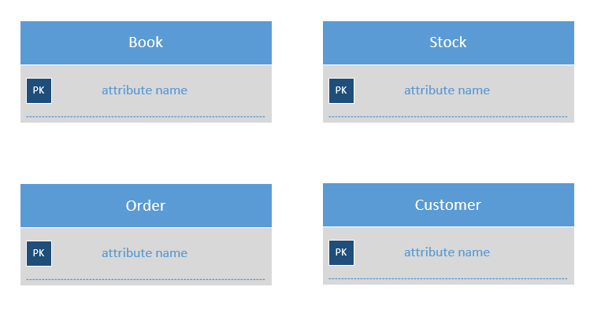

4.1.2 Attributes Created
Below are the attributes each entity will have
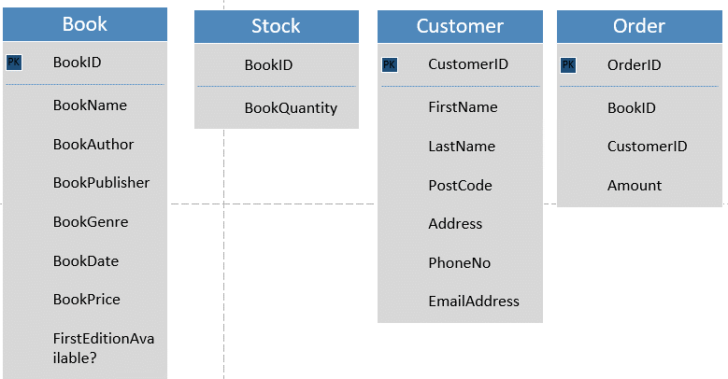

4.1.3 Foreign Keys Created
Below are the foreign keys identified: BookID in Stock, BookID and CustomerID in Order.
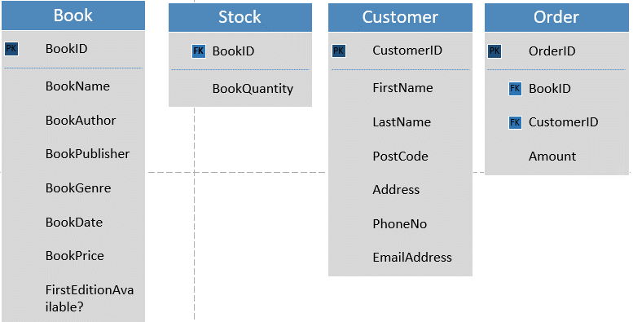

4.1.4 Relationships created
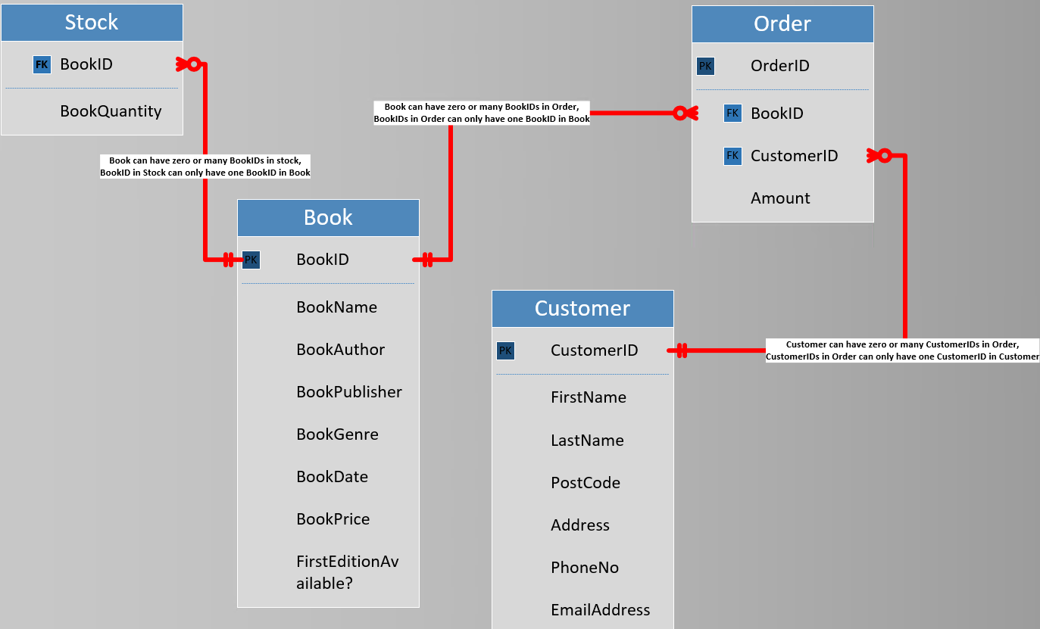
Annotations (Left to right from the image):
- Book can have zero or many BookIDs in stock, BookID in Stock can only have one BookID in Book
- Book can have zero or many BookIDs in Order, BookIDs in Order can only have one BookID in Book
- Customer can have zero or many CustomerIDs in Order, CustomerIDs in Order can only have one CustomerID in Customer

4.1.5 Testing Table relating correctly
When deleting the record with the BookID of 4, the BookID of 4 in the Stock table should be automatically deleted.
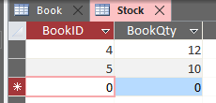
Results:
After deleting the record, it automatically removed the record within the Stock table, as expected. This highlights that both tables relate correctly.
Once closing the stock table, and re-opening, the ‘#Deleted’ record will no longer be there.
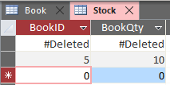

4.2 Appendix B – Implementation of Design
Throughout this Appendix, this will hold the documentation of implementing the design.

4.2.1 Tables Created
The tables have been created using SQL, below are screenshots of how it was done.

4.2.1.1 Customer Table Created with SQL
SQL code entered to create the Customer table:
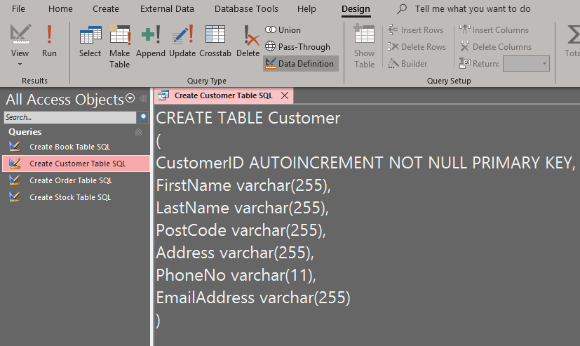
After running the SQL:
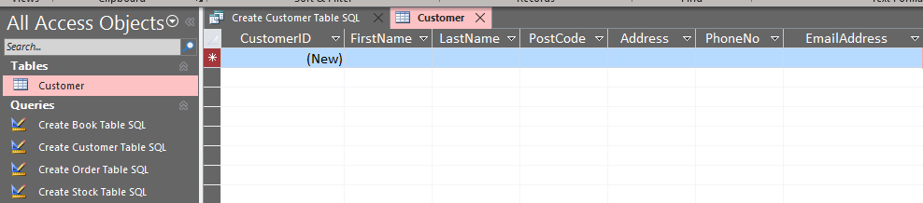

4.2.1.2 Book Table Created with SQL
SQL code entered to create the Book table:
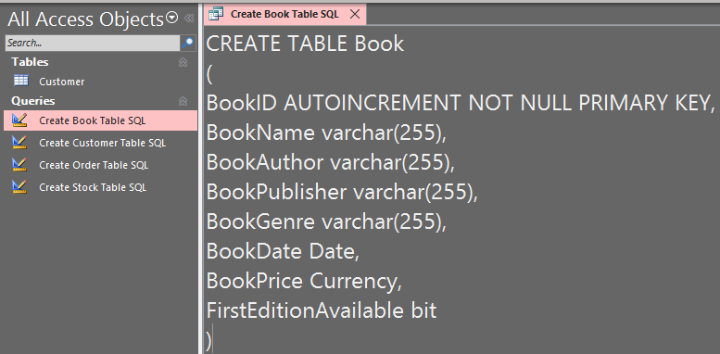
After running the SQL:
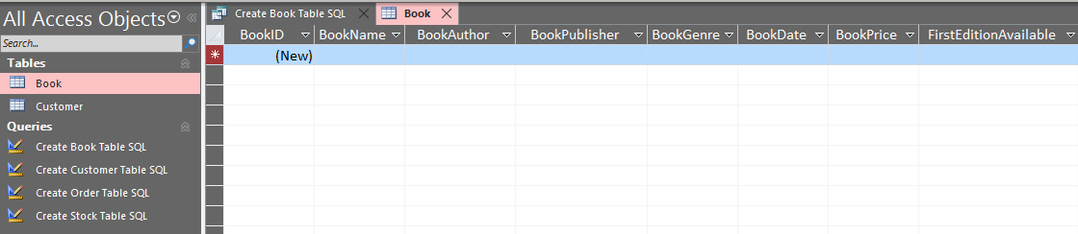

4.2.1.3 Stock Table Created with SQL
SQL code entered to create the Stock table:
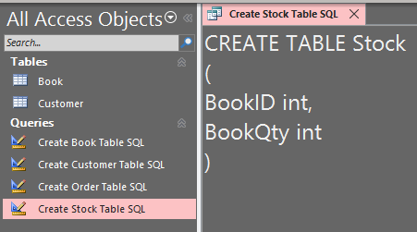
After running the SQL:
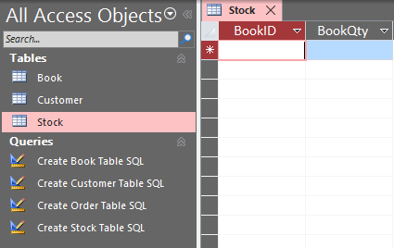

4.2.1.4 Order Table Created with SQL
Here is the SQL code entered to create the Order table:
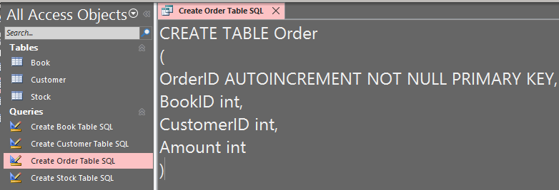
After running the SQL:
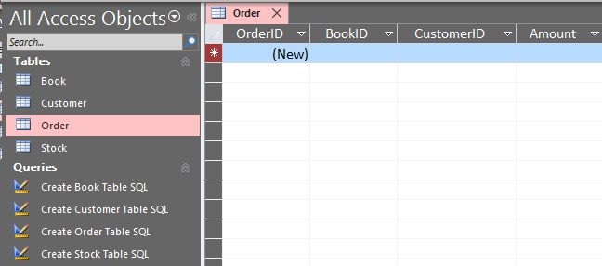

4.2.2 Creating Relationships using SQL
The relationship has been formed using SQL, based off of the design created in Microsoft Visio. Screenshots of the code ran are below:

4.2.2.1 Setting Stock Table Foreign Key
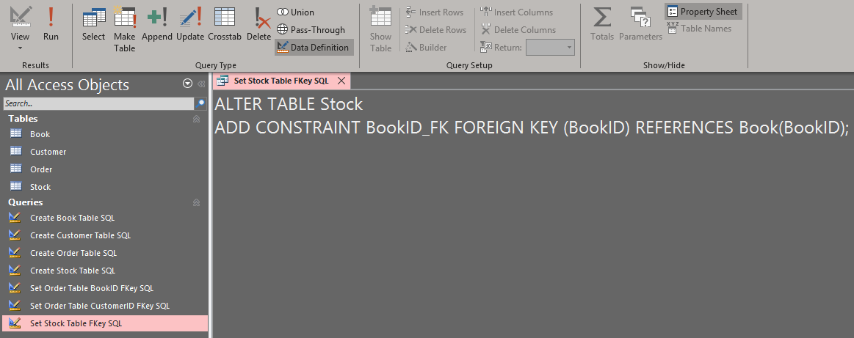
After running the code, it has set a relationship between both the Book and Stock table.
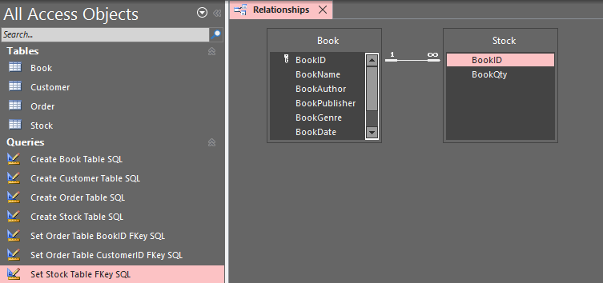

The relationship between the two was then manually edited to enable cascading update related fields and cascade delete related records.
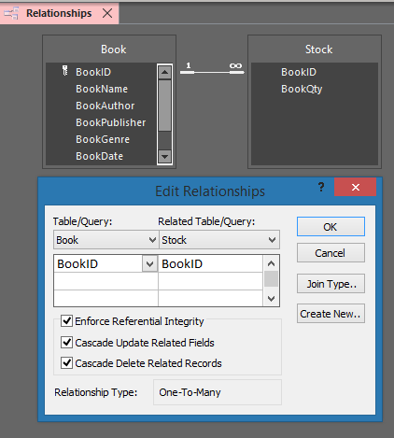

4.2.2.2 Setting Order Table Foreign Keys
There are two foreign keys created within the Order Table, which is CustomerID and BookID.

4.2.2.2.1 Setting CustomerID foreign key:
This will link the CustomerID primary key in the Customer table with the foreign key CustomerID in the Order table.
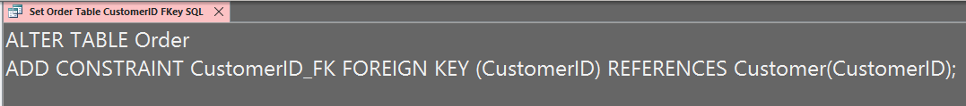
After running the code, a relationship has formed between the customer and order table.
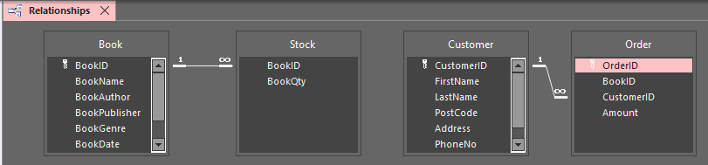

4.2.2.2.2 Setting BookID foreign key:
This will link BookID primary key from the Book table with the foreign key BookID in the Order table.
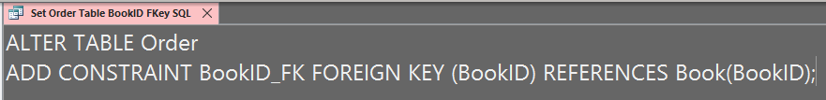
After running the code, it has formed the relationship between the Book table and Order table.
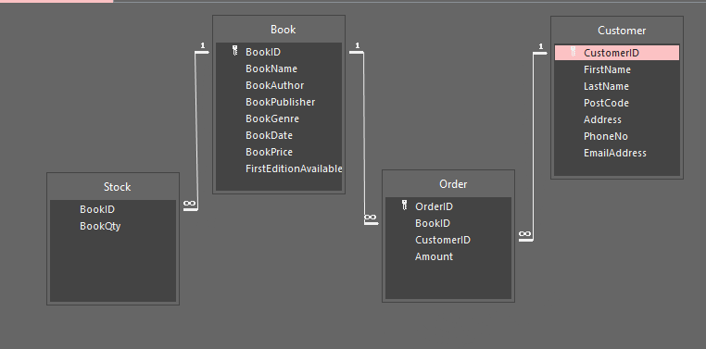

4.2.3 Populating Tables with data
The next step was adding data into the records of the tables, and most of this was completed using SQL. The data populated into the Tables are shown below.

4.2.3.1 Populating Customer Table
A record has been added to the customer table using the INSERT INTO SQL command, the code below will add the record of the values within the parenthesis’.
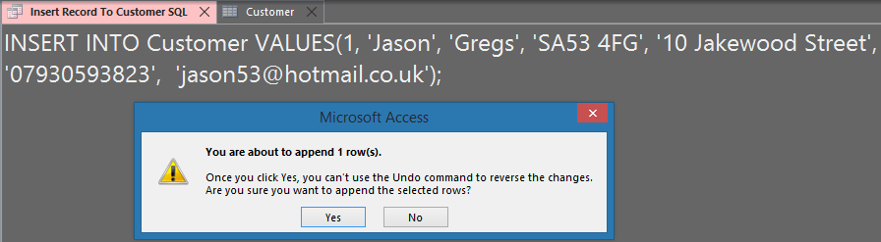
Output:
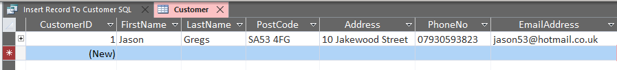

4.2.3.2 Populating Book Table
A record has been added to the Book table using the INSERT INTO SQL command, the code below will add the record of the values within the parenthesis’.
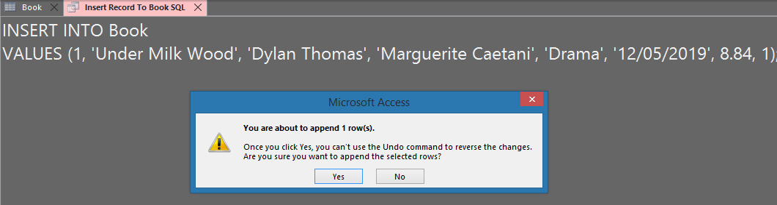
Output:

4.2.3.3 Populating Stock Table
This was manually done by using the cascade button in the Book table, and then entering the quantity. This will then automatically update the Stock table to display BookID 1 with a quantity of 5.
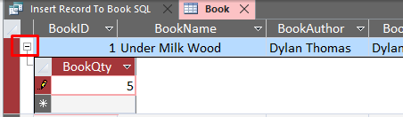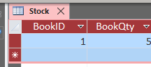
Also, a person should not be capable of adding two quantities for a book, so this was handled by going into design view of the table and adding a constraint to prevent duplicates.
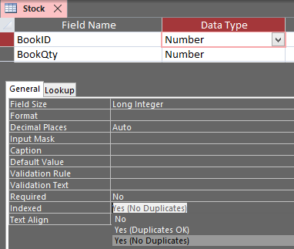

4.2.3.4 Populating Orders Table
To populate the order table, this was completed using SQL with the ‘INSERT INTO’ command. The values within the parenthesis are the values of the record. The yellow text is what the values in the parenthesis represent.
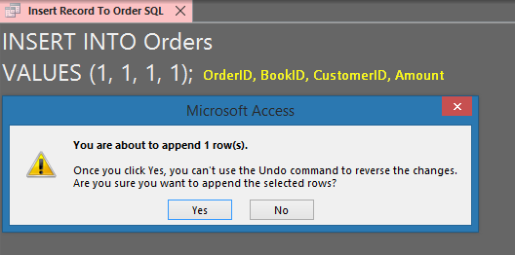
Output:
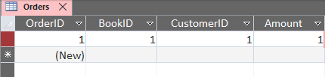
When completing this task, it is also where a problem was found and fixed. An error was shown when attempting to run when the table was called ‘Order’, the simple fix was renaming the table to ‘Orders’, this could possibly be because of a reserved word.

4.2.4 Forms Created
To easily manage the data, forms will be implemented to satisfy the Bookstores requirement of viewing, editing, adding and deleting data. A menu will also be created for the ease of navigating through each of the forms. Below will be the documentation of creating each form using the form wizard that Microsoft Access provides’. The form wizard stages of Customer table will show how each form will be created; the other table forms documentation will go straight into the design.

4.2.4.1 Customer form created
Choosing the fields to be involved in the customer form, as the Bookstore would like to manage all information, all fields will be used.
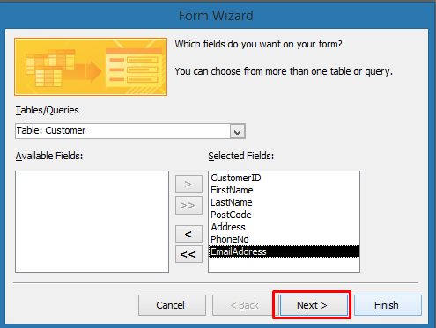
The layout choice will be the default columnar; some alterations may be made in design mode.
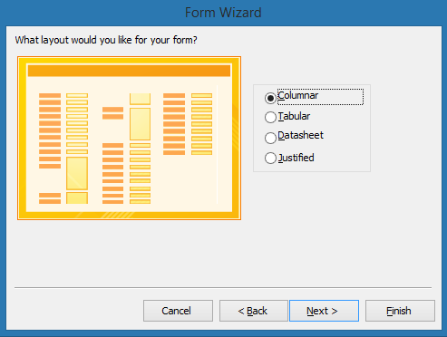
The last stage is sensibly naming the form so it can be identified easily.
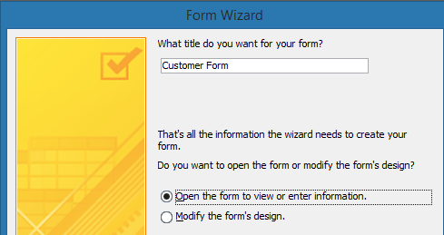
This is the form produced by the form wizard, and as it can be seen, there are no interactive buttons to go through each form, add or delete. This will be done in the next stage.
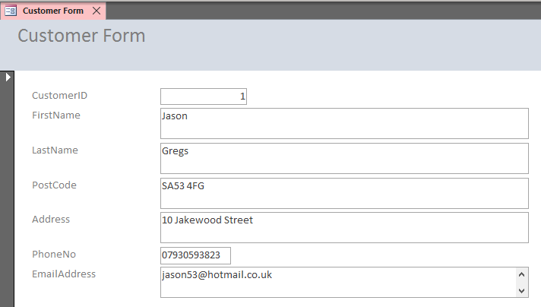
To add the interactive buttons to allow managing of the data, this will be completed in design view. In the design tab of the page, a button can be selected and dropped into the form, which will then open a button wizard to decide what the button should do on action.
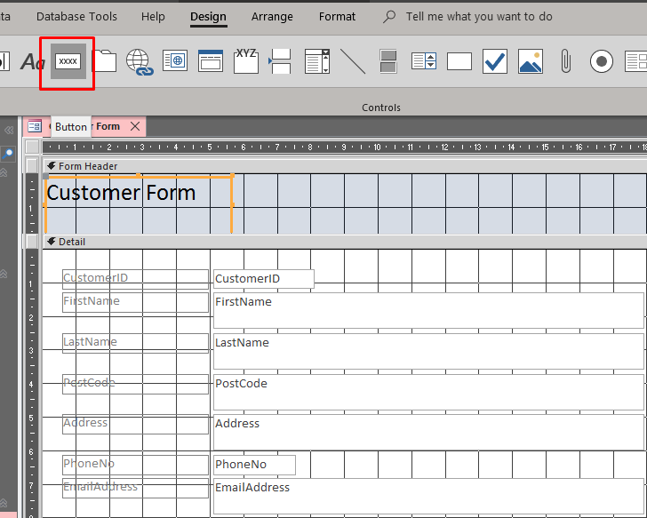
After dropping a button into the form, a list of actions will be shown to tell the button what to do. In this form, there will be a button for the next, previous, to last and to first record in the record navigation category, and then buttons for printing, adding, deleting and saving a record from the record operation category.
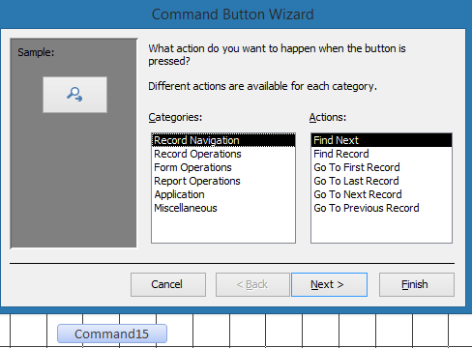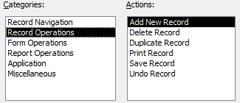
When the action is chosen, a suitable name can then be set for easy future reference.
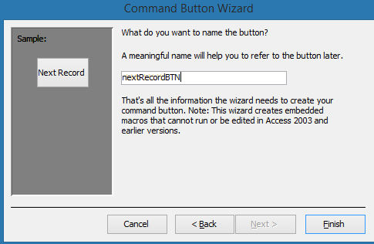
After adding all the buttons, the form was also designed with a different background and bigger text.
The annotations state what the button does when the user clicks it. Now the buttons have already been created, these can simply be pasted onto the other forms to save time.
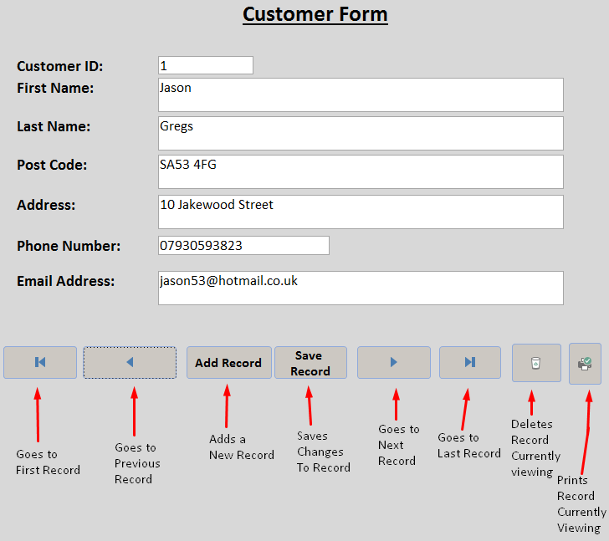
Here, I tested the adding and saving record button, and this automatically added the information entered onto the normal Customer table, as it should.
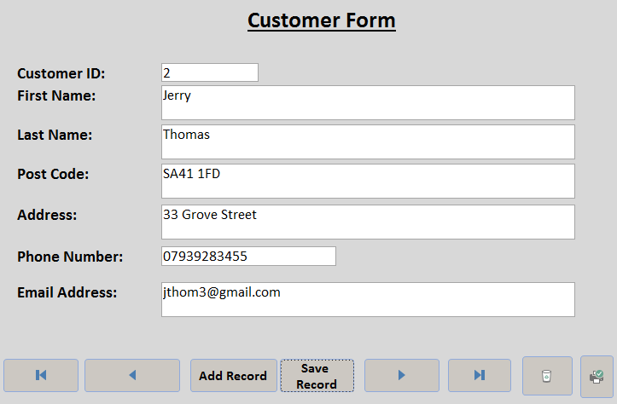
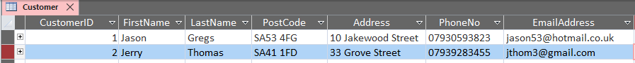

4.2.4.2 Book form created
Following the form wizard stages used to build the customer form, the same was done for the book form. The buttons created for the customer form can also be copied and pasted onto this form with the same functionality which saves time from re-creating them.
To follow a consistent design, the background, text sizes and colours were set the same as the Customer form.
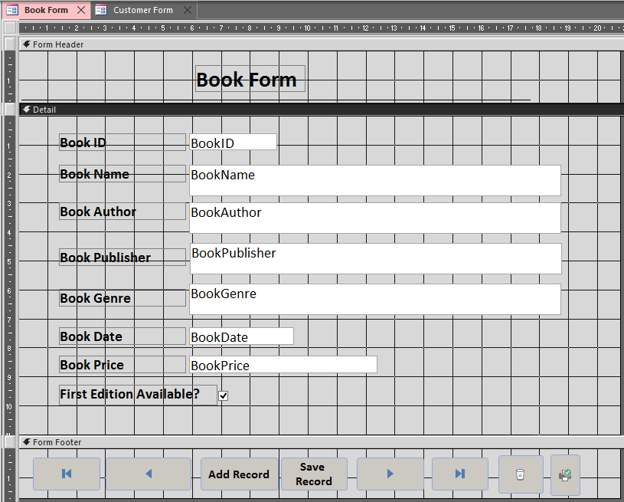
As the quantity of the book also requires to be stated, it has been taken from the stock table and placed at the bottom by dragging and dropping it from the Field List from the right side.
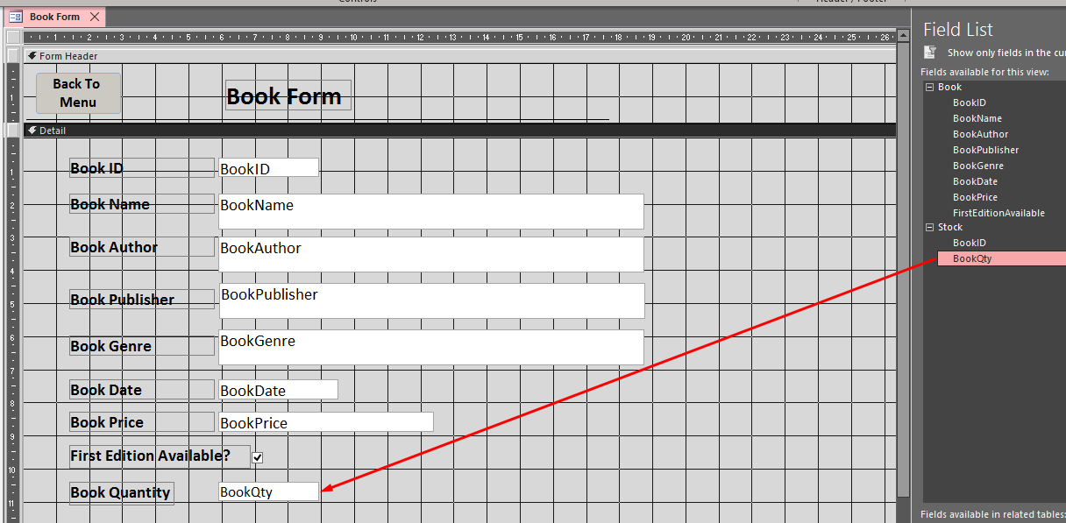

4.2.4.3 Order form created
For the order form, the steps of the form wizard were followed again. Then, the buttons from the other forms were pasted on this form since they will perform the same functionality. To maintain the consistent design, text, background colours and more were set the same.
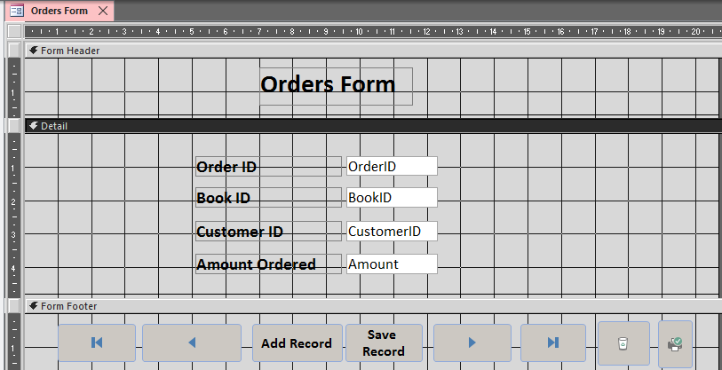
As the order form is the form where the orders are handled, the book price has been dragged onto the page, aswell as a textbox to make a calculation of the total price if the book amount is over 1.
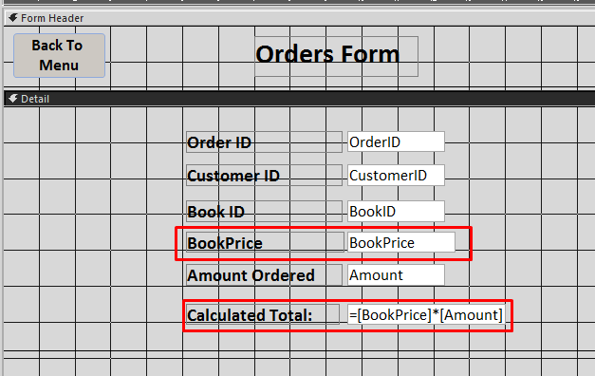
Result:
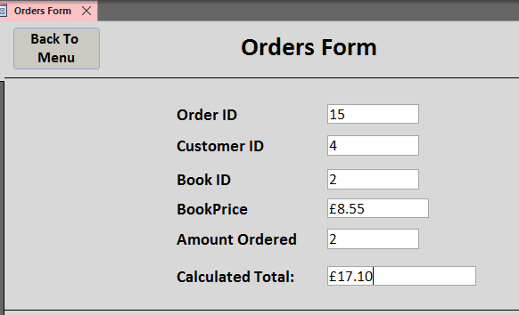

4.2.4.4 Stock form created
For the stock form, the steps of the form wizard were followed again. Then, the buttons from the other forms were pasted on this form since they will perform the same functionality. To maintain the consistent design, text, background colours and more were set the same.
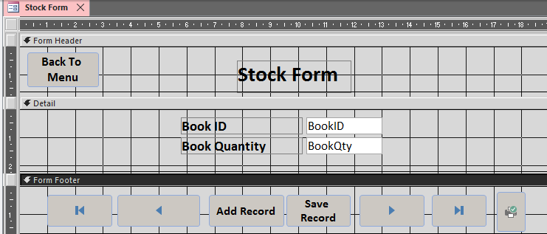

4.2.4.5 Menu Created
Now that all forms have been made, a menu form can be created for easy navigation throughout the forms. This time, normal form design was selected rather than going through the form wizard as all that is required is a heading and buttons that take the user to the form.
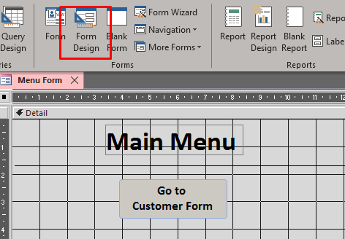
A button was then placed and went through the button wizard, onto the form operation category and set the action of opening a form. On the next page, it then asked which form the button should go to. This process was done to create a button for navigating to each of the forms.
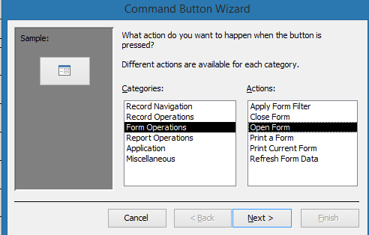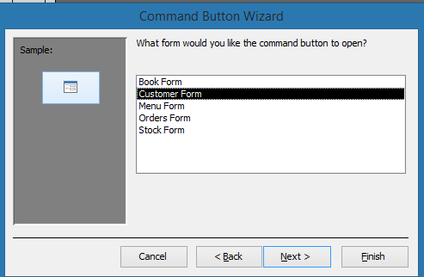
The main menu screen created, each button when clicked will take the user to desired form.
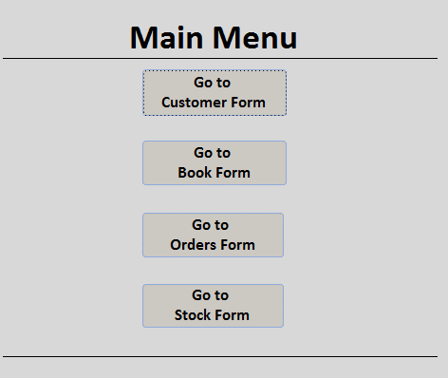
After that, a button was made to place in each form to go back to the main menu screen, and since the main menu screen is a form, the same process above was also done to achieve this. To save time re-creating the button each time, this button was pasted and placed in the other forms.
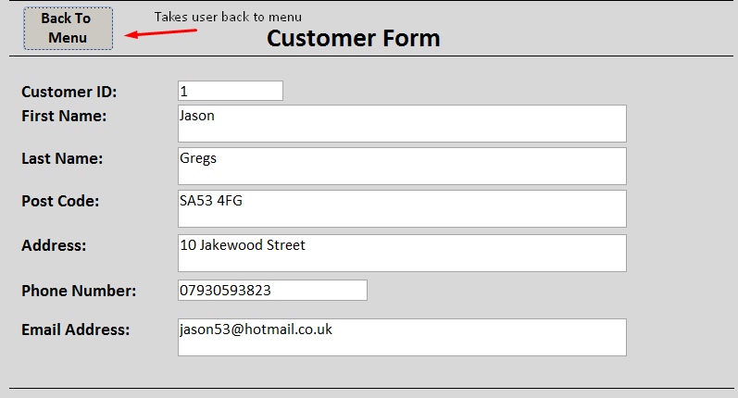

4.2.6 Producing Queries and Reports
From all the data that is available within the database, queries can be made to produce reports. This can output useful information to know things such as, books with low stock, books that are available by author name and more.

4.2.6.1 Queries Produced

4.2.6.1.1 Creating query of Books with stock quantity 5 or lower
To achieve this, it can be simply completed with the use of SQL code using the ‘SELECT’ and ‘WHERE’ command. This selects all columns from the stock table where the ‘BookQty’ is less than or equal to 5. When running the code, it will then display each BookID with a quantity of five or lower.
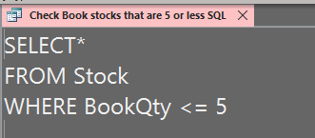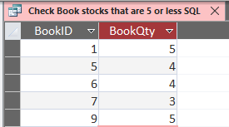

4.2.6.1.2 Creating query of Most popular book currently ordered
This is easily achievable using the Access query wizard that checks for duplicates of a field. The only change required was to change the sort to descending so that the most occurrences of a book will appear at the top and not bottom.
Selecting the desired query to make (Find Duplicates):
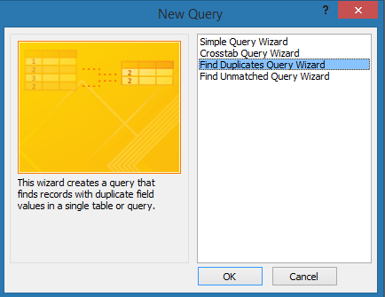
Selecting the table of which data that the query wizard will work with (Orders):
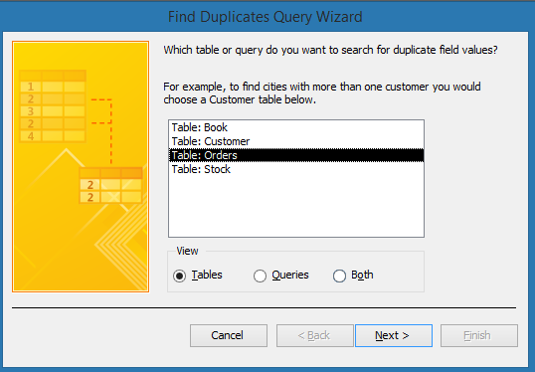
The query wizard then asks which field it should check for duplicates of, and BookID was selected:
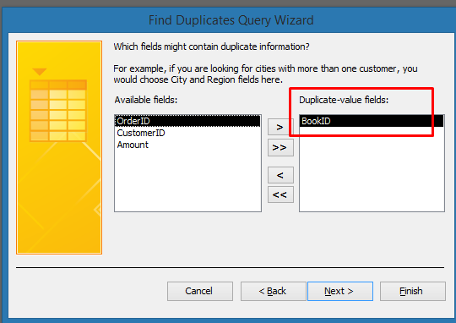
It then asks if it should show any additional fields, and all were selected:
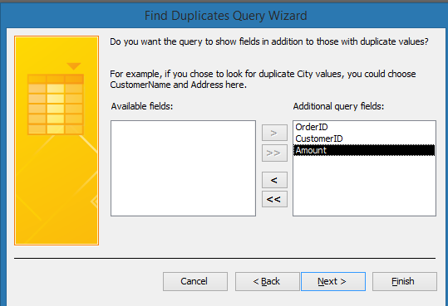
The final stage of the wizard was then to set a sensible name and view the results.
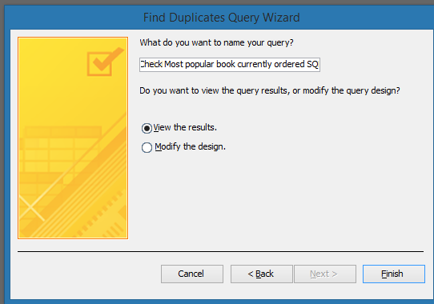
It then displayed these results, however the most books ordered are shown at the bottom of the list, setting the sorting to descending in design view will fix the issue.
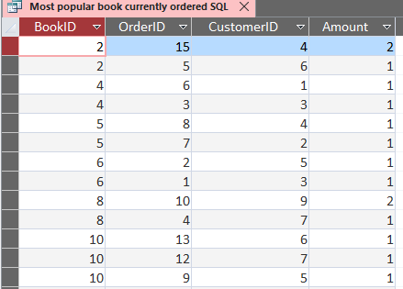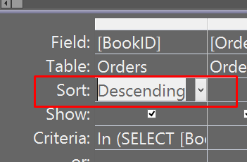
New results now clearly show the most popular books ordered from highest to lowest.
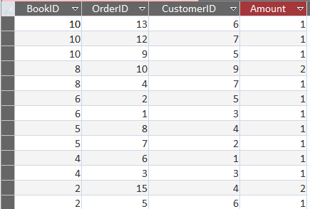

4.2.6.1.3 Creating query of Customer with most orders
To create a query displaying the customers with the most amount of orders placed, the same concept of the query of the most popular book ordered can be used with the query wizard.
Selecting the data to search for duplicates in the Orders table:
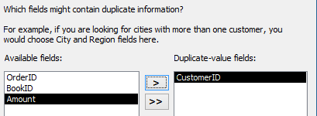
Selecting the data which should show in addition with the duplicates:
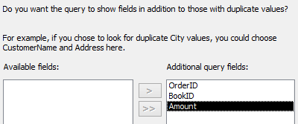
The results after setting the sort mode to descending clearly shows that the customer with the ID 7 has ordered the most books.
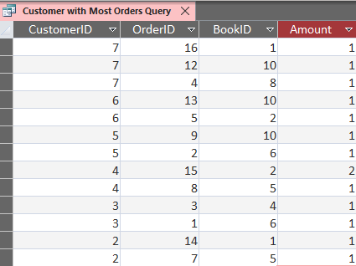

4.2.6.1.4 Creating query of all books with first edition available
Using SQL, finding all Books with first edition available was simply completed. The code selects the columns shown in the top line of the image from the Book table where ‘FirstEditionAvailable’ is not like 0, meaning is not false.
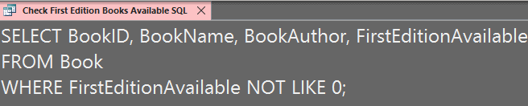
The output then displays all books with the first edition available. When outputting this information, the other column data was not too important as this would be to simply and quickly see the books with first edition available.
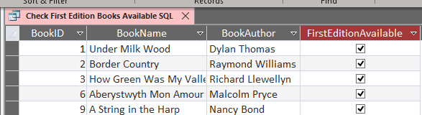

4.2.6.2 Reports Produced
From the queries produced, a report can be quickly generated for each of them using Microsoft Access report feature.

4.2.6.2.1 Producing report of Books with stock quantity of 5 or lower
Selecting the query within the list on the left and clicking report on the top right will create a report layout instantly.
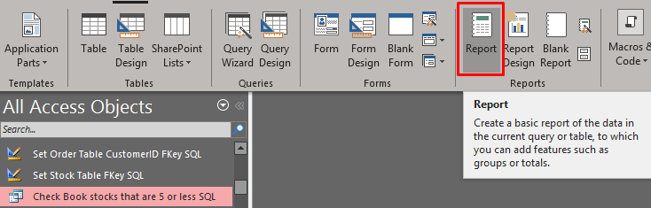
Reports can be printed out by right clicking print preview on the page.
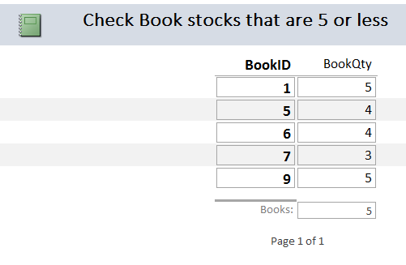

4.2.6.2.2 Producing report of Most Popular ordered book
Using the same method as above, a report layout was instantly made for the most popular ordered book.
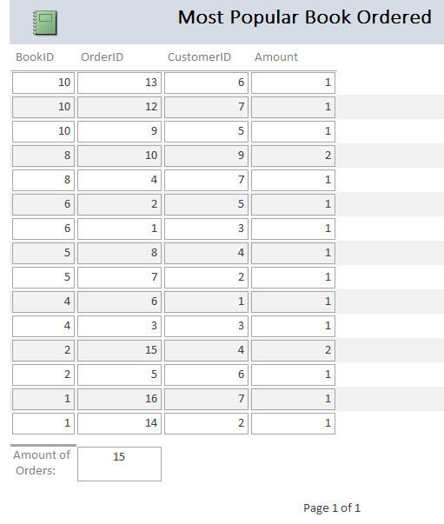

4.2.6.2.3 Producing report of Customer with most orders
The next report created displays the customers with the most orders, and again, this follows the earlier method shown.
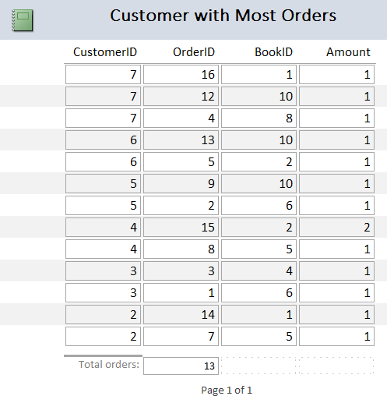

4.2.6.2.4 Producing report of Books with first edition available
Displayed below is the report created of the query showing the books with the first edition available.
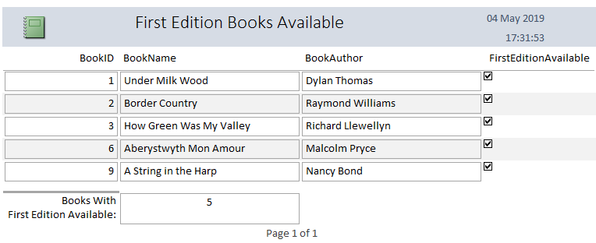

4.3 Appendix C – Brief User Guide
A brief user guide on using the forms.

4.3.1 Main Menu page
Within this page, it contains four buttons which are purely for easy navigation of each of the forms. Upon clicking it, it will instantly take you to the form.
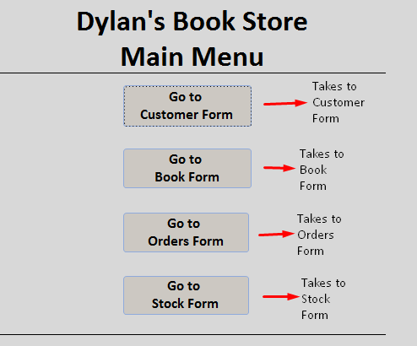

4.3.2 Form Buttons used
Each form that you are taken to, except the main menu, there will be these buttons within the footer, and its functionality is explained within the image. It must be known that the stock form will not have the trash icon to delete records. If you would like to delete a record within Stock, you must delete the record in the Book form, and the book to delete would be recognized by the BookID from both tables.
Also, each form will contain a back to menu button on the top left of the form to redirect back to the menu where you can then select another form if you would like.
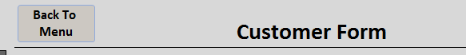

4.3.3 Adding a new record
A demonstration will be made to show how to successfully add a new record. It is to note that this way of adding a new record holds the same concept for the other forms containing the same buttons in this database.
Clicking Add Record button will open a blank record where information can be entered. As Order ID is auto incremented, this field can be ignored as it will automatically enter a number in it once there is something entered in the other fields. For every other record in the form, the data must be filled.
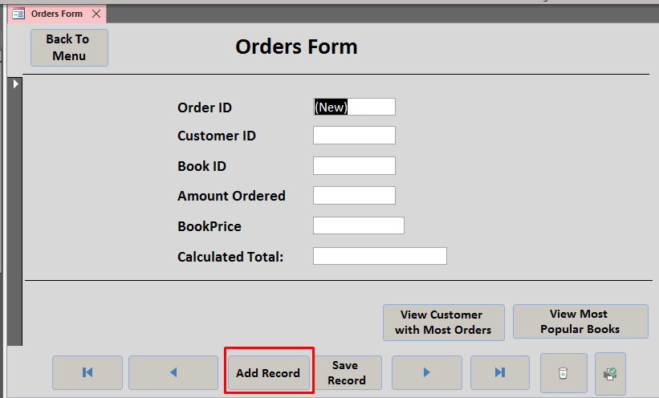
Once filling in the information, the ‘Save Record’ must be clicked on to save the changes and update the database.
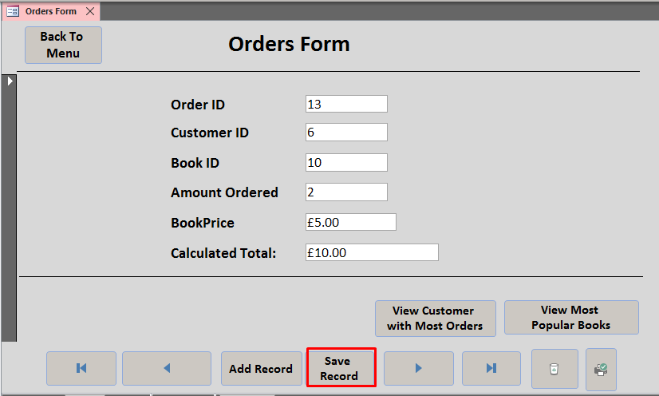
Result:
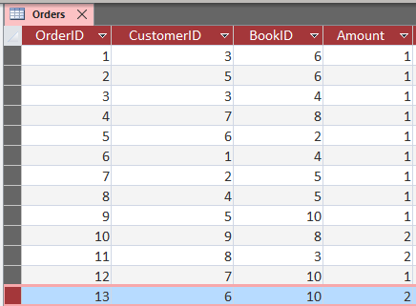

5. References

[1] | “ Foreign Key,” Techopedia, 16 September 2011. [Online]. Available: https://www.techopedia.com/definition/7272/foreign-key. [Accessed 2 May 2019].
[2] | J. Bailey, “What are relationships in Microsoft Access ?,” Sussex, 1 August 2016. [Online]. Available: http://www.sussex.ac.uk/its/help/faq?faqid=898. [Accessed 2 May 2019].
[3] | K. Wenzel, “Database Normalization Explained in Simple English,” EssentialSQL, 12 March 2019. [Online]. Available: https://www.essentialsql.com/get-ready-to-learn-sql-database-normalization-explained-in-simple-english/. [Accessed 2 May 2019].
[4] | “Description of the database normalization basics,” Microsoft Support, 10 May 2017. [Online]. Available: https://support.microsoft.com/en-gb/help/283878/description-of-the-database-normalization-basics. [Accessed 4 May 2019].
[5] | “SQL Tutorial,” W3 Schools, 16 August 2005. [Online]. Available: https://www.w3schools.com/sql/default.asp. [Accessed 2 May 2019].

